The impact of selective survival on sex disparities in stroke incidence: evaluating bias using a simulation model – Supplementary materials

Xiaolei Lin¹, Leah Li²
¹ School of Data Science, Fudan University, Shanghai, China (xiaoleilin@fudan.edu.cn)
² Life Course and Statistics Section, Population, Policy and Practice Teaching and Research Department, University College London Great Ormond Street Institute of Child Health, London, UK (leah.li@ucl.ac.uk)

A1. Method for adjusting stroke incidence rate from the Oxford Vascular Study

In the Oxford Vascular Study, ischaemic stroke incidence rates for men and women are reported every 10 years from age 35. Since the population in the Oxford Vascular Study were less deprived compared to the rest of England, we adjust the incidence rates for women in our hypothetical cohorts upwards by 50% to 100%. To comply with the life table data which are calculated every 5 years, we further decompose the ischaemic stroke incidence data into 5-year interval. Decomposition is done at the log hazard rate level because of the approximate linear relationship between the log hazard rate and age. Specifically, given $r_{t}$, incidence rate per 1000 person-year and $y_{t}$, total person-year in 1000, at age interval t,

1) calculate h(t), the hazard rate of stroke incidence at each age interval t in the Oxford Vascular Study according to Equation (A1), for t = 45,55,65,75,85, where$(t)$ represents length of the interval (in years)
$$h(t) = \frac{-log(1-\frac{\sum_{u≤t}{r_{u}*{ y}_{u}}}{\sum_{u≤t}{y_{u}}}) - \sum_{u < t}{h(u) * (u) }}{(t)}$$
(A1)
2) Built and validate a linear model between log h(t) and t, and estimate h(t) for t=50,60,70,80,90, 95.
3) Calculate the incidence rate (per 1000 person-year) at each 5-year interval using the re-estimated h(t), according to Equation (A2), for t = 45,50,55,60,65,70,75,80,85,90,95.
$$r_{t} = \frac{\sum_{u≤t}{y_{u}} * (1-e^{-\sum_{u≤t}{h(u)*(u)}}) - \sum_{u<t}{r_{u}*y_{u}}}{y_{t}}$$

(A2)
4) Double the $r_{t}$ at each 5-year interval (in the Oxford Vascular Study) and obtain the incidence rates used in our hypothetical birth cohorts.

A2. Details on simulation parameters

Table A2.1 Baseline hazard of death, calculated from US life table for 1959-61 birth cohorts
Baseline hazard of death | Scenario A | Scenario B | Scenario C | Scenario D
r1_0to1 | 0.01984 | 0.01984 | 0.01984 | 0.01984
r1_1to5 | 0.0008341 | 0.0008396 | 0.0008341 | 0.0008396
r1_5to10 | 0.0003770 | 0.0003797 | 0.0003770 | 0.0003798
r1_10to15 | 0.0003079 | 0.0003102 | 0.0003079 | 0.0003103
r1_15to20 | 0.0004935 | 0.0004972 | 0.0004935 | 0.0004974
r1_20to25 | 0.0006001 | 0.0006048 | 0.0006001 | 0.0006051
r1_25to30 | 0.0007137 | 0.0007197 | 0.0007137 | 0.0007202
r1_30to35 | 0.0009828 | 0.0009921 | 0.0009828 | 0.0009924
r1_35to40 | 0.001463 | 0.001478 | 0.001463 | 0.001479
r1_40to45 | 0.002317 | 0.002344 | 0.002317 | 0.002345
r1_45to50 | 0.003654 | 0.003703 | 0.003654 | 0.003705
r1_50to55 | 0.005596 | 0.005688 | 0.005598 | 0.005694
r1_55to60 | 0.008213 | 0.008371 | 0.008214 | 0.008399
r1_60to65 | 0.01335 | 0.01373 | 0.01335 | 0.01376
r1_65to70 | 0.02129 | 0.02217 | 0.02127 | 0.02222
r1_70to75 | 0.03577 | 0.03791 | 0.03572 | 0.03803
r1_75to80 | 0.05887 | 0.06446 | 0.05879 | 0.06447
r1_80to85 | 0.1036 | 0.1194 | 0.1036 | 0.1192
r1_85to90 | 0.1781 | 0.2230 | 0.1785 | 0.2234
r1_90to95 | 0.2894 | 0.4081 | 0.2916 | 0.4093

Table A2.2 Effect of sex/gender on survival calculated from US life table for 1959-61 birth cohorts
Gender on log hazard of death | Scenario A | Scenario B | Scenario C | Scenario D
g1_0to1 | 0.2803 | 0.2803 | 0.2803 | 0.2803
g1_1to5 | 0.1923 | 0.2032 | 0.1937 | 0.2128
g1_5to10 | 0.3418 | 0.3554 | 0.3441 | 0.3667
g1_10to15 | 0.5389 | 0.5544 | 0.5416 | 0.5663
g1_15to20 | 0.9189 | 0.9369 | 0.9221 | 0.9503
g1_20to25 | 1.0289 | 1.0524 | 1.0338 | 1.0669
g1_25to30 | 0.7354 | 0.7674 | 0.7419 | 0.7824
g1_30to35 | 0.5637 | 0.6020 | 0.5719 | 0.6199
g1_35to40 | 0.5354 | 0.5788 | 0.5448 | 0.6002
g1_40to45 | 0.5807 | 0.6347 | 0.5926 | 0.6602
g1_45to50 | 0.6485 | 0.7173 | 0.6651 | 0.7463
g1_50to55 | 0.7211 | 0.8165 | 0.7459 | 0.8551
g1_55to60 | 0.7463 | 0.8826 | 0.7814 | 0.9368
g1_60to65 | 0.6908 | 0.8835 | 0.7423 | 0.9581
g1_65to70 | 0.6025 | 0.8725 | 0.6792 | 0.9648
g1_70to75 | 0.4469 | 0.8219 | 0.5628 | 0.9210
g1_75to80 | 0.3390 | 0.8252 | 0.5053 | 0.9565
g1_80to85 | 0.2223 | 0.8436 | 0.4604 | 0.9954
g1_85to90 | 0.1020 | 0.8804 | 0.4209 | 1.0726
g1_90to95 | 0.02409 | 0.9633 | 0.4648 | 1.2547

Table A2.3 Effect of other covariates on survival
 | Scenario A | Scenario B | Scenario C | Scenario D
g2 (log HR for effect of U on death) | 0 | log(1.5) | 0 | log(1.5)
g3 (log HR for interaction of exposure & U) | 0 | 0 | log(1.5) | (log2.5/1.5)

Table A2.4 Baseline hazard of stroke, calibrated from the Oxford Vascular Study according to A1
Baseline hazard for stroke | Scenario A | Scenario B | Scenario C | Scenario D
stk_r_45to50 | 0.00007043 | 0.00007117 | 0.00007040 | 0.00007121
stk_r_50to55 | 0.0001705 | 0.0001728 | 0.0001703 | 0.0001729
stk_r_55to60 | 0.0004945 | 0.0005041 | 0.0004944 | 0.0005044
stk_r_60to65 | 0.0007049 | 0.0007231 | 0.0007046 | 0.0007244
stk_r_65to70 | 0.001881 | 0.001952 | 0.001879 | 0.001953
stk_r_70to75 | 0.002296 | 0.002417 | 0.002290 | 0.002422
stk_r_75to80 | 0.004216 | 0.004577 | 0.004206 | 0.004575
stk_r_80to85 | 0.006304 | 0.007166 | 0.006292 | 0.007145
stk_r_85to90 | 0.006876 | 0.008417 | 0.006866 | 0.008408
stk_r_90to95 | 0.01330 | 0.01819 | 0.01339 | 0.01805

Table A2.5 Effect of sex/gender on stroke
Baseline hazard for stroke | Scenario A | Scenario B | Scenario C | Scenario D
stk_delta_45to50 | 0.002 | 0.002 | 0.002 | 0.002
stk_delta_50to55 | 0.002 | 0.002 | 0.002 | 0.002
stk_delta_55to60 | 0.002 | 0.002 | 0.002 | 0.002
stk_delta _60to65 | 0.002 | 0.002 | 0.002 | 0.002
stk_delta _65to70 | 0.002 | 0.002 | 0.002 | 0.002
stk_delta _70to75 | 0.002 | 0.002 | 0.002 | 0.002
stk_delta _75to80 | 0.002 | 0.002 | 0.002 | 0.002
stk_delta _80to85 | 0.002 | 0.002 | 0.002 | 0.002
stk_delta _85to90 | 0.002 | 0.002 | 0.002 | 0.002
stk_delta _90to95 | 0.002 | 0.002 | 0.002 | 0.002

Table A2.6 Effect of U on stroke.
 | Scenario A | Scenario B | Scenario C | Scenario D
b1 (log HR for effect of U on stroke) | log(1.5) | log(1.5) | log(1.5) | log(1.5)

Table A2.7 Effect of instantaneous stroke and stroke history on death
 | Scenario A | Scenario B | Scenario C | Scenario D
p_stk_death (Probability of death at stroke) | 0.25 | 0.25 | 0.25 | 0.25
g4 (log HR for effect of stroke history on death) | log(2) | log(2) | log(2) | log(2)

A3. Data generation process

For each hypothetical birth cohort under each causal scenario, survival and stroke data for each individual are generated below.

a) Generate U by sampling from a standard normal distribution N(0,1)

b) For age below 45:
b.1) Generate survival time $T_{i,t}^{survival}$ by inverse variable transformation under Exponential Failure time model
b.2) If $T_{i,t}^{survival}$is smaller than the interval length, individual dies within this interval; otherwise, repeat b.1 and b.2 for the next interval t+1.

c) For age above or equal to 45:
c.1) Generate survival time $T_{i,t}^{survival}$ by inverse variable transformation under Exponential Failure time model
c.2) Generate stroke time $T_{i,t}^{stroke}$ (if still at risk for the first incident stroke) by inverse variable transformation under Exponential Failure time model
c.3) If $T_{i,t}^{stroke}$ is smaller than the interval length and smaller than $T_{i,t}^{survival}$, individual experiences stroke within this interval; if $T_{i,t}^{stroke}$ is smaller than the interval length but greater than $T_{i,t}^{survival}$, individual dies within this interval without experiencing stroke; if if $T_{i,t}^{stroke}$ is greater than $T_{i,t}^{survival}$ is smaller than the interval length, individual dies within this interval without experiencing stroke; if both $T_{i,t}^{stroke}$ and $T_{i,t}^{survival}$ are greater than the interval length, individual survives this interval stroke free, and simulation process continues to the next interval t+1.
c.4) For individual that experiences first incident stroke, update his/her survival status such that there is a 25% probability of dying from instantaneous stroke.

d) All individuals die before age 95.

A4. Detailed simulation results for cumulative death rates, stroke incidence rate and distribution of U in males and females under four causal scenarios.

Figure A4.1. Cumulative death rate based on four causal scenarios for males and females in simulated cohorts
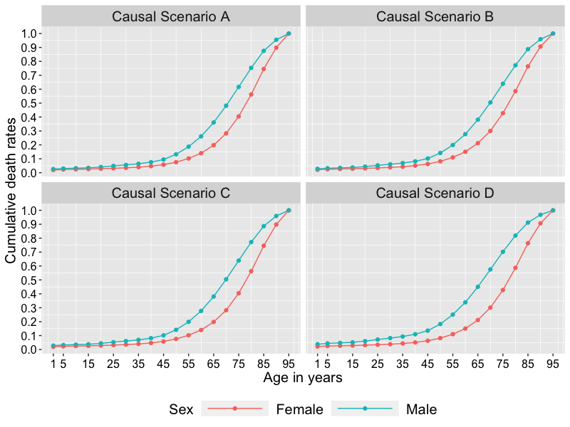

Table A4.1: Cumulative death rates for males and females at all ages under four causal scenarios
Age  (year) | Scenario A |  | Scenario B |  | Scenario C |  | Scenario D
Age  (year) | Male | Female | Male | Female | Male | Female | Male | Female
1 | 0.0260 | 0.0197 | 0.0279 | 0.0214 | 0.0280 | 0.0197 | 0.0382 | 0.0213
5 | 0.0300 | 0.0230 | 0.0321 | 0.0250 | 0.0323 | 0.0229 | 0.0440 | 0.0249
10 | 0.0325 | 0.0248 | 0.0349 | 0.0270 | 0.0350 | 0.0248 | 0.0477 | 0.0269
15 | 0.0351 | 0.0263 | 0.0377 | 0.0286 | 0.0378 | 0.0263 | 0.0515 | 0.0286
20 | 0.0410 | 0.0288 | 0.0442 | 0.0312 | 0.0442 | 0.0287 | 0.0603 | 0.0317
25 | 0.0490 | 0.0317 | 0.0529 | 0.0344 | 0.0529 | 0.0316 | 0.0719 | 0.0343
30 | 0.0561 | 0.0351 | 0.0606 | 0.0381 | 0.0605 | 0.0352 | 0.0820 | 0.0381
35 | 0.0643 | 0.0399 | 0.0693 | 0.0432 | 0.0692 | 0.0399 | 0.0935 | 0.0433
40 | 0.0758 | 0.0470 | 0.0818 | 0.0508 | 0.0816 | 0.0469 | 0.1098 | 0.0508
45 | 0.0947 | 0.0580 | 0.1021 | 0.0627 | 0.1018 | 0.0580 | 0.1357 | 0.0628
50 | 0.1324 | 0.0757 | 0.1417 | 0.0817 | 0.1414 | 0.0757 | 0.1829 | 0.0818
55 | 0.1868 | 0.1022 | 0.1991 | 0.1100 | 0.1988 | 0.1023 | 0.2509 | 0.1102
60 | 0.2612 | 0.1399 | 0.2770 | 0.1505 | 0.2772 | 0.1400 | 0.3391 | 0.1505
65 | 0.3608 | 0.1979 | 0.3808 | 0.2119 | 0.3809 | 0.1979 | 0.4503 | 0.2120
70 | 0.4815 | 0.2824 | 0.5047 | 0.3004 | 0.5046 | 0.2821 | 0.5755 | 0.3009
75 | 0.6161 | 0.4044 | 0.6390 | 0.4269 | 0.6391 | 0.4046 | 0.7020 | 0.4273
80 | 0.7532 | 0.5623 | 0.7719 | 0.5862 | 0.7716 | 0.5624 | 0.8188 | 0.5866
85 | 0.8758 | 0.7453 | 0.8872 | 0.7638 | 0.8863 | 0.7452 | 0.9120 | 0.7635
90 | 0.9552 | 0.8985 | 0.9591 | 0.9065 | 0.9594 | 0.8981 | 0.9682 | 0.9069
95 | 1.0 | 1.0 | 1.0 | 1.0 | 1.0 | 1.0 | 1.0 | 1.0

Table A4.2: Stroke incidence rates per 1000 person-year for males and females at all age bands under four causal scenarios.
Age  (year) | Scenario A |  |  | Scenario B |  |  | Scenario C |  |  | Scenario D
Age  (year) | Male | Female | diff | Male | Female | Diff | Male | Female | Diff | Male | Female | Diff
45-50 | 59.7 | 5.66 | 54.1 | 58.4 | 5.49 | 52.9 | 58.4 | 5.63 | 52.8 | 55.7 | 5.5 | 50.2
50-55 | 62.8 | 9.02 | 53.8 | 61 | 8.88 | 52.1 | 61 | 9.05 | 51.9 | 57.6 | 8.9 | 48.7
55-60 | 68.0 | 14.5 | 53.4 | 65.4 | 14.5 | 50.9 | 65.3 | 14.6 | 50.7 | 60.7 | 14.5 | 46.3
60-65 | 76.4 | 23.5 | 52.8 | 72.7 | 23.7 | 49 | 71.9 | 23.6 | 48.3 | 66.1 | 23.7 | 42.4
65-70 | 89.9 | 37.8 | 52.1 | 84.8 | 38.4 | 46.4 | 82.7 | 37.9 | 44.8 | 75.1 | 38.3 | 36.8
70-75 | 112 | 61 | 50.9 | 104 | 62.1 | 42 | 99.4 | 61.3 | 38.1 | 89.2 | 61.9 | 27.4
75-80 | 147 | 87.8 | 49 | 134 | 98.2 | 35.7 | 125 | 98.4 | 26.6 | 111 | 97.9 | 13.4
80-85 | 203 | 158 | 45.7 | 182 | 155 | 26.4 | 162 | 158 | 3.9 | 146 | 154 | -8.5
85-90 | 291 | 250 | 40.9 | 247 | 234 | 13.6 | 213 | 251 | -38.2 | 193 | 234 | -40.7
90-95 | 428 | 392 | 35.8 | 350 | 352 | -2.37 | 286 | 405 | -119 | 268 | 354 | -86.5

Table A4.3: Mean of U for males and females at risk for the first incident stroke under four causal scenarios.
Age  (year) | Scenario A |  | Scenario B |  | Scenario C |  | Scenario D
Age  (year) | Male | Female | Male | Female | Male | Female | Male | Female
1 | 0.0005 | -0.0004 | 0.0014 | 0.0002 | 0.0008 | -0.0000 | 0.0003 | -0.0002
5 | 0.0007 | -0.0005 | -0.0107 | -0.0090 | -0.0112 | -0.0001 | -0.0360 | -0.0093
10 | 0.0007 | -0.0005 | -0.0120 | -0.0101 | -0.0126 | -0.0001 | -0.0400 | -0.0104
15 | 0.0007 | -0.0005 | -0.0131 | -0.0109 | -0.0137 | -0.0001 | -0.0434 | -0.0112
20 | 0.0007 | -0.0005 | -0.0143 | -0.0116 | -0.0149 | -0.0001 | -0.0469 | -0.0119
25 | 0.0007 | -0.0004 | -0.0171 | -0.0127 | -0.0176 | -00.0001 | -0.0550 | -0.0129
30 | 0.0009 | -0.0005 | -0.0207 | -0.0140 | -0.0212 | -0.0001 | -0.0654 | -0.0143
35 | 0.0010 | -0.0005 | -0.0241 | -0.0156 | -0.0246 | -0.0002 | -0.0746 | -0.0158
40 | 0.0011 | -0.0005 | -0.0278 | -0.0177 | -0.0282 | -0.0001 | -0.0850 | -0.0180
45 | 0.0011 | -0.0005 | -0.0331 | -0.0209 | -0.0336 | -0.0001 | -0.1000 | -0.0214
50 | 0.0008 | -0.0004 | -0.0420 | -0.0259 | -0.0425 | -0.0001 | -0.1236 | -0.0264
55 | -0.0111 | -0.0016 | -0.0685 | -0.0350 | -0.0690 | -0.0001 | -0.1714 | -0.0355
60 | -0.0237 | -0.0033 | -0.1039 | -0.0487 | -0.1047 | -0.0001 | -0.2384 | -0.0490
65 | -0.0371 | -0.0062 | -0.1510 | -0.0688 | -0.1520 | -0.0001 | -0.3261 | -0.0695
70 | -0.0525 | -0.0111 | -0.2163 | -0.1013 | -0.2172 | -0.0013 | -0.4438 | -0.1018
75 | -0.0706 | -0.0180 | -0.3031 | -0.1518 | -0.3038 | -0.0033 | -0.5928 | -0.1522
80 | -0.0924 | -0.0300 | -0.4192 | -0.2328 | -0.4194 | -0.0061 | -0.7787 | -0.2324
85 | -0.1218 | -0.0509 | -0.5778 | -0.3584 | -0.5762 | -0.1095 | -1.0130 | -0.3583
90 | -0.1626 | -0.0825 | -0.8024 | -0.5577 | -0.7956 | -0.0829 | -1.3141 | -0.5567
95 | -0.2179 | -0.1301 | -1.1015 | -0.8542 | -1.1007 | -0.1290 | -1.6847 | -0.8538

A5. Simulation results under additional causal scenario

Figure A5.1. Cumulative death rate based on six causal scenarios for males and females in simulated cohorts

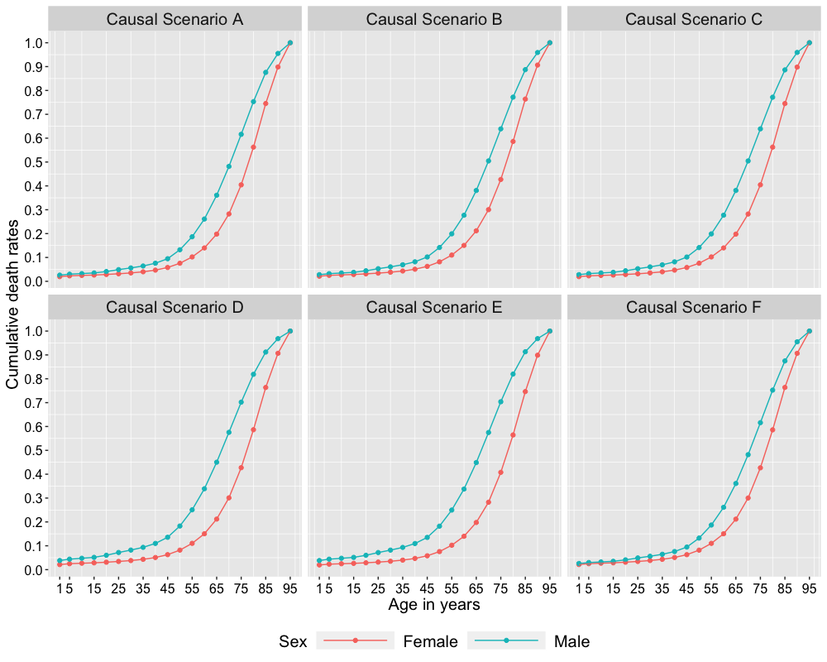

Figure A5.2. Stroke incidence rate based on six causal scenarios for males and females in simulated cohorts.

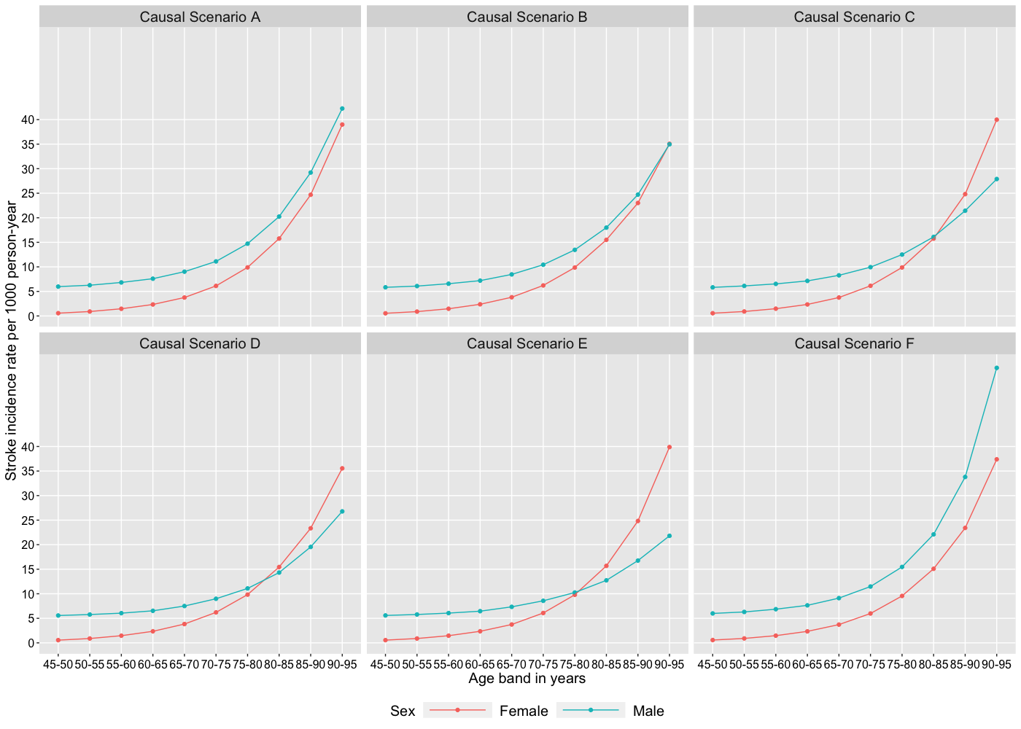

Figure A5.3. Mean of U for people at risk based on six causal scenarios for males and females in simulated cohorts

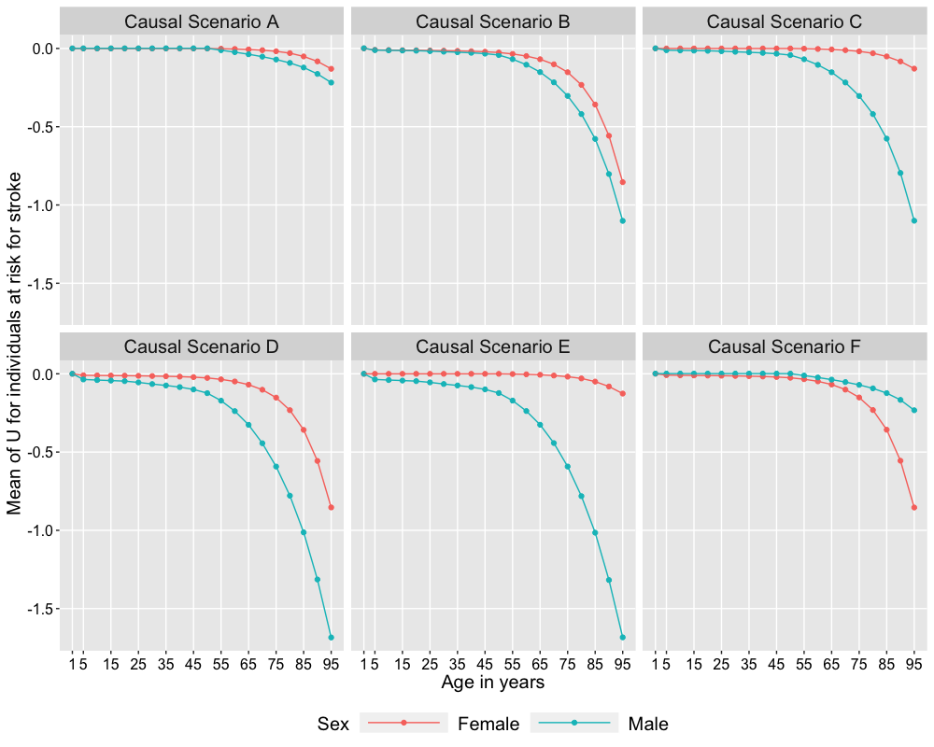

Figure A5.4. Male – female difference in stroke incidence per 1000 person-year based on six causal scenarios for males and females in simulated cohorts.

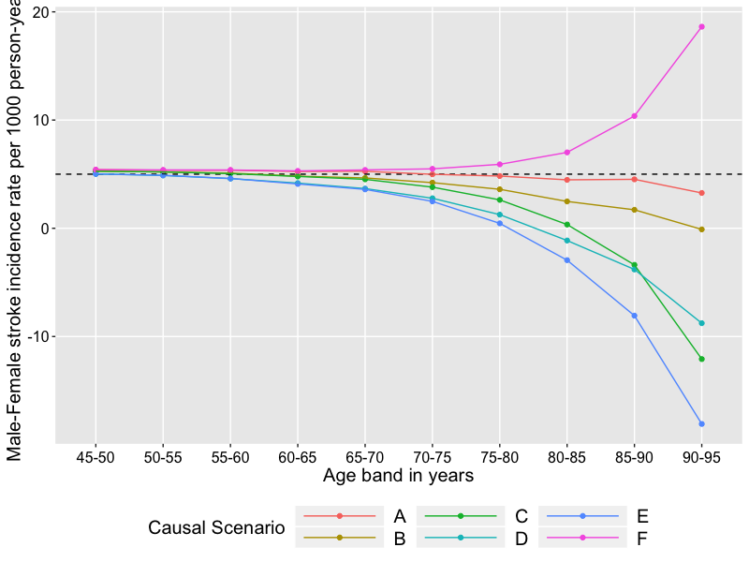

A6. R Code to Simulate the Birth Cohorts and Derive the Main Results

#****************************************************************************/
#*** Below is the code to simulate a single observation
#****************************************************************************/
data_generation_single <- function(scenario=scenario){
preamble_file <- paste0("preamble_Scenario", scenario, ".R")
source(preamble_file)
interval <- c(0, 1, seq(5, 95, 5))
exposure <- rbinom(n=1, size=1, prob=pexp)
U <- rnorm(n=1, mean=0, sd=1)
stk_history <- 0
surv_time <- rep(NA, length(interval)-1)
surv_age <- rep(NA, length(interval)-1)
stk_time <- rep(NA, length(interval)-1)
stk_age <- rep(NA, length(interval)-1)
stk <- rep(0, length(interval)-1)
death <- rep(0, length(interval)-1)
RV_survival <- runif(1)
surv_time[1] <- -log(RV_survival)/(lambda[1] * exp(g1[1]*exposure + g2*U + g3*exposure*U + g4*stk_history))
death[1] <- ifelse(surv_time[1] < 1, 1, 0)
death[2:length(death)] <- ifelse(death[1]==1, rep(1,length(death)-1), rep(0,length(death)-1))
surv_age[1] <- ifelse(death[1]==1, surv_time[1], NA)
if(death[1] == 0){
RV_survival <- runif(1)
surv_time[2] <- -log(RV_survival)/(lambda[2] * exp(g1[2]*exposure + g2*U + g3*exposure*U + g4*stk_history))
death[2] <- ifelse(surv_time[2] < 4, 1, 0)
death[3:length(death)] <- ifelse(death[2]==1, rep(1,length(death)-2), rep(0,length(death)-2))
surv_age[2] <- ifelse(death[2]==1, surv_time[2], NA)
}
for(i in 3:(length(interval)-1)){
if(death[i-1]==0){
RV_survival <- runif(1)
surv_time[i] <- -log(RV_survival)/(lambda[i] * exp(g1[i]*exposure + g2*U + g3*exposure*U + g4*stk_history))
death[i] <- ifelse(surv_time[i] < 5, 1, 0)
death[i:length(death)] <- ifelse(death[i]==1, rep(1, (length(death)-i+1)), rep(0, (length(death)-i+1)))
surv_age[i] <- ifelse(death[i]==1, interval[i] + surv_time[i], NA)
if(interval[i] >= 45 && stk[i-1]==0){
RV_stroke <- runif(1)
stk_time[i] <- ifelse(exposure==0,
-log(RV_stroke)/(stk_lambda_exp0[i] * exp(b1*U)),
-log(RV_stroke)/(stk_lambda_exp1[i] * exp(b1*U)))
stk[i] <- ifelse(stk_time[i] < 5 & stk_time[i] <= surv_time[i], 1, 0)
stk[i:length(stk)] <- ifelse(stk[i]==1, rep(1, (length(stk)-i+1)), rep(0, (length(stk)-i+1)))
stk_history <- as.numeric(sum(stk) !=0)
stk_age[i] <- ifelse(stk[i]==1, interval[i]+stk_time[i], NA)
stk_death <- ifelse((stk[i]==1) && (runif(1) < pstrokedeath), 1,0)
death[i] <- ifelse(stk_death==1, 1, death[i])
death[i:length(death)] <- ifelse(death[i]==1, rep(1, (length(death)-i+1)), rep(0, (length(death)-i+1)))
surv_age[i] <- ifelse(stk_death==1, stk_age[i], surv_age[i])
}
}
}
death[length(death)] <- 1
surv_age[length(surv_age)] <- ifelse(sum(!is.na(surv_age))==0,95,surv_age[length(surv_age)])
stk_any <- as.numeric(sum(stk)!=0)
if(stk_any==0){
stk_age[length(stk_age)] <- surv_age[!is.na(surv_age)]
}
return(list(exposure = exposure,
U = U,
death_interval = interval[min(which(death==1))],
survival_time = surv_time,
age_death = surv_age[!is.na(surv_age)],
stroke_interval = ifelse(stk_any==1,interval[min(which(stk==1))],NA),
age_stroke = stk_age[!is.na(stk_age)]))
}

#****************************************************************************/
#*** Below is the code to simulate multiple observations
#****************************************************************************/
data_generation_multiple <- function(scenario=scenario, nobs=nobs){
data_gen <- matrix(NA, nrow=nobs, ncol=7)
for(n in 1:nobs){
single_sim <- data_generation_single(scenario=scenario)
data_gen[n,] <- c(n, single_sim$exposure, single_sim$U,
single_sim$death_interval, single_sim$stroke_interval,
single_sim$age_death, single_sim$age_stroke)
}
data_gen <- as.data.frame(data_gen)
colnames(data_gen) <- c("id", "exposure", "U", "death_interval", "stroke_interval", "age_death", "age_stroke")
data_gen[data_gen$age_stroke < 45, "age_stroke"] <- NA
return(data_gen)
}

#****************************************************************************/
#*** Below is the code to obtain results for Figure 2, 3, 4 and 5
#****************************************************************************/
Analysis_data <- function(scenario=scenario, nobs=nobs, ndata=ndata){
death_rates <- data.frame(at_0to1 = numeric(), at_1to5 = numeric(),
at_5to10 = numeric(), at_10to15 = numeric(),
at_15to20 = numeric(), at_20to25 = numeric(),
at_25to30 = numeric(), at_30to35 = numeric(),
at_35to40 = numeric(), at_40to45 = numeric(),
at_45to50 = numeric(), at_50to55 = numeric(),
at_55to60 = numeric(), at_60to65 = numeric(),
at_65to70 = numeric(), at_70to75 = numeric(),
at_75to80 = numeric(), at_80to85 = numeric(),
at_85to90 = numeric(), at_90to95 = numeric())
death_rates_exposure0 <- data.frame(at_0to1 = numeric(), at_1to5 = numeric(),
at_5to10 = numeric(), at_10to15 = numeric(),
at_15to20 = numeric(), at_20to25 = numeric(),
at_25to30 = numeric(), at_30to35 = numeric(),
at_35to40 = numeric(), at_40to45 = numeric(),
at_45to50 = numeric(), at_50to55 = numeric(),
at_55to60 = numeric(), at_60to65 = numeric(),
at_65to70 = numeric(), at_70to75 = numeric(),
at_75to80 = numeric(), at_80to85 = numeric(),
at_85to90 = numeric(), at_90to95 = numeric())
death_rates_exposure1 <- data.frame(at_0to1 = numeric(), at_1to5 = numeric(),
at_5to10 = numeric(), at_10to15 = numeric(),
at_15to20 = numeric(), at_20to25 = numeric(),
at_25to30 = numeric(), at_30to35 = numeric(),
at_35to40 = numeric(), at_40to45 = numeric(),
at_45to50 = numeric(), at_50to55 = numeric(),
at_55to60 = numeric(), at_60to65 = numeric(),
at_65to70 = numeric(), at_70to75 = numeric(),
at_75to80 = numeric(), at_80to85 = numeric(),
at_85to90 = numeric(), at_90to95 = numeric())
median_survival <- data.frame(total = numeric(), exposure0 = numeric(), exposure1 = numeric())
meanU <- data.frame(at_birth = numeric(),
above_1 = numeric(), above_5 = numeric(),
above_10 = numeric(), above_15 = numeric(),
above_20 = numeric(), above_25 = numeric(),
above_30 = numeric(), above_35 = numeric(),
above_40 = numeric(), above_45 = numeric(),
above_50 = numeric(), above_55 = numeric(),
above_60 = numeric(), above_65 = numeric(),
above_70 = numeric(), above_75 = numeric(),
above_80 = numeric(), above_85 = numeric(),
above_90 = numeric())
meanU_exposure0 <- data.frame(at_birth = numeric(),
above_1 = numeric(), above_5 = numeric(),
above_10 = numeric(), above_15 = numeric(),
above_20 = numeric(), above_25 = numeric(),
above_30 = numeric(), above_35 = numeric(),
above_40 = numeric(), above_45 = numeric(),
above_50 = numeric(), above_55 = numeric(),
above_60 = numeric(), above_65 = numeric(),
above_70 = numeric(), above_75 = numeric(),
above_80 = numeric(), above_85 = numeric(),
above_90 = numeric())
meanU_exposure1 <- data.frame(at_birth = numeric(),
above_1 = numeric(), above_5 = numeric(),
above_10 = numeric(), above_15 = numeric(),
above_20 = numeric(), above_25 = numeric(),
above_30 = numeric(), above_35 = numeric(),
above_40 = numeric(), above_45 = numeric(),
above_50 = numeric(), above_55 = numeric(),
above_60 = numeric(), above_65 = numeric(),
above_70 = numeric(), above_75 = numeric(),
above_80 = numeric(), above_85 = numeric(),
above_90 = numeric())
IR <- data.frame(at_45to50 = numeric(), at_50to55 = numeric(),
at_55to60 = numeric(), at_60to65 = numeric(),
at_65to70 = numeric(), at_70to75 = numeric(),
at_75to80 = numeric(), at_80to85 = numeric(),
at_85to90 = numeric(), at_90to95 = numeric())
IR_exposure0 <- data.frame(at_45to50 = numeric(), at_50to55 = numeric(),
at_55to60 = numeric(), at_60to65 = numeric(),
at_65to70 = numeric(), at_70to75 = numeric(),
at_75to80 = numeric(), at_80to85 = numeric(),
at_85to90 = numeric(), at_90to95 = numeric())
IR_exposure1 <- data.frame(at_45to50 = numeric(), at_50to55 = numeric(),
at_55to60 = numeric(), at_60to65 = numeric(),
at_65to70 = numeric(), at_70to75 = numeric(),
at_75to80 = numeric(), at_80to85 = numeric(),
at_85to90 = numeric(), at_90to95 = numeric())
percent_stroke <- data.frame(total = numeric(),
female = numeric(),
male = numeric())
age_stroke <- data.frame(total = numeric(),
female = numeric(),
male = numeric())
for(data in 1:ndata){
print(data)
current_data <- data_generation_multiple(scenario = scenario, nobs=nobs)
current_data[!is.na(current_data$stroke_interval) & (current_data$death_interval == current_data$stroke_interval) & (current_data$age_death <= current_data$age_stroke), "age_stroke"] <- current_data[!is.na(current_data$stroke_interval) & (current_data$death_interval == current_data$stroke_interval) & (current_data$age_death <= current_data$age_stroke), "age_death"]
current_data[is.na(current_data$stroke_interval), "stroke_interval"] <- 100
current_data_exposure0 <- current_data[current_data$exposure==0, ]
current_data_exposure1 <- current_data[current_data$exposure==1, ]
percent_stroke[data, ] <- c(mean(!is.na(current_data$stroke_interval)),
mean(!is.na(current_data_exposure0$stroke_interval)),
mean(!is.na(current_data_exposure1$stroke_interval)))
age_stroke[data, ] <- c(mean(current_data[!is.na(current_data$stroke_interval), "age_stroke"]),
mean(current_data_exposure0[!is.na(current_data_exposure0$stroke_interval), "age_stroke"]),
mean(current_data_exposure1[!is.na(current_data_exposure1$stroke_interval), "age_stroke"]))
#****************************************************************************/
# below is the code to obtain figure 2
#****************************************************************************/
death_rates[data,] <- c(mean(current_data$death_interval == 0),
mean(current_data$death_interval <= 1),
mean(current_data$death_interval <= 5),
mean(current_data$death_interval <= 10),
mean(current_data$death_interval <= 15),
mean(current_data$death_interval <= 20),
mean(current_data$death_interval <= 25),
mean(current_data$death_interval <= 30),
mean(current_data$death_interval <= 35),
mean(current_data$death_interval <= 40),
mean(current_data$death_interval <= 45),
mean(current_data$death_interval <= 50),
mean(current_data$death_interval <= 55),
mean(current_data$death_interval <= 60),
mean(current_data$death_interval <= 65),
mean(current_data$death_interval <= 70),
mean(current_data$death_interval <= 75),
mean(current_data$death_interval <= 80),
mean(current_data$death_interval <= 85),
mean(current_data$death_interval <= 90),
mean(current_data$death_interval <= 95))
death_rates_exposure0[data,] <- c(mean(current_data_exposure0$death_interval == 0),
mean(current_data_exposure0$death_interval <= 1),
mean(current_data_exposure0$death_interval <= 5),
mean(current_data_exposure0$death_interval <= 10),
mean(current_data_exposure0$death_interval <= 15),
mean(current_data_exposure0$death_interval <= 20),
mean(current_data_exposure0$death_interval <= 25),
mean(current_data_exposure0$death_interval <= 30),
mean(current_data_exposure0$death_interval <= 35),
mean(current_data_exposure0$death_interval <= 40),
mean(current_data_exposure0$death_interval <= 45),
mean(current_data_exposure0$death_interval <= 50),
mean(current_data_exposure0$death_interval <= 55),
mean(current_data_exposure0$death_interval <= 60),
mean(current_data_exposure0$death_interval <= 65),
mean(current_data_exposure0$death_interval <= 70),
mean(current_data_exposure0$death_interval <= 75),
mean(current_data_exposure0$death_interval <= 80),
mean(current_data_exposure0$death_interval <= 85),
mean(current_data_exposure0$death_interval <= 90),
mean(current_data_exposure0$death_interval <= 95))
death_rates_exposure1[data,] <- c(mean(current_data_exposure1$death_interval == 0),
mean(current_data_exposure1$death_interval <= 1),
mean(current_data_exposure1$death_interval <= 5),
mean(current_data_exposure1$death_interval <= 10),
mean(current_data_exposure1$death_interval <= 15),
mean(current_data_exposure1$death_interval <= 20),
mean(current_data_exposure1$death_interval <= 25),
mean(current_data_exposure1$death_interval <= 30),
mean(current_data_exposure1$death_interval <= 35),
mean(current_data_exposure1$death_interval <= 40),
mean(current_data_exposure1$death_interval <= 45),
mean(current_data_exposure1$death_interval <= 50),
mean(current_data_exposure1$death_interval <= 55),
mean(current_data_exposure1$death_interval <= 60),
mean(current_data_exposure1$death_interval <= 65),
mean(current_data_exposure1$death_interval <= 70),
mean(current_data_exposure1$death_interval <= 75),
mean(current_data_exposure1$death_interval <= 80),
mean(current_data_exposure1$death_interval <= 85),
mean(current_data_exposure1$death_interval <= 90),
mean(current_data_exposure1$death_interval <= 95))
#****************************************************************************/
# below is the code to obtain figure 4 and 5
#****************************************************************************/
IR[data, ] <- c(sum(current_data$stroke_interval == 45) / (sum(apply(cbind(as.vector(current_data[current_data$stroke_interval == 45, "age_death"]),
as.vector(current_data[current_data$stroke_interval == 45, "age_stroke"])), 1, min, na.rm=T)-45) +
sum(as.vector(current_data[current_data$death_interval == 45 & current_data$stroke_interval == 100, "age_death"])-45) +
sum(current_data$death_interval > 45 & current_data$stroke_interval > 45)*5),
sum(current_data$stroke_interval == 50) / (sum(apply(cbind(as.vector(current_data[current_data$stroke_interval == 50, "age_death"]),
as.vector(current_data[current_data$stroke_interval == 50, "age_stroke"])), 1, min, na.rm=T)-50) +
sum(as.vector(current_data[current_data$death_interval == 50 & current_data$stroke_interval == 100, "age_death"])-50) +
sum(current_data$death_interval > 50 & current_data$stroke_interval > 50)*5),
sum(current_data$stroke_interval == 55) / (sum(apply(cbind(as.vector(current_data[current_data$stroke_interval == 55, "age_death"]),
as.vector(current_data[current_data$stroke_interval == 55, "age_stroke"])), 1, min, na.rm=T)-55) +
sum(as.vector(current_data[current_data$death_interval == 55 & current_data$stroke_interval == 100, "age_death"])-55) +
sum(current_data$death_interval > 55 & current_data$stroke_interval > 55)*5),
sum(current_data$stroke_interval == 60) / (sum(apply(cbind(as.vector(current_data[current_data$stroke_interval == 60, "age_death"]),
as.vector(current_data[current_data$stroke_interval == 60, "age_stroke"])), 1, min, na.rm=T)-60) + sum(as.vector(current_data[current_data$death_interval == 60 & current_data$stroke_interval == 100, "age_death"])-60) +
sum(current_data$death_interval > 60 & current_data$stroke_interval > 60)*5),
sum(current_data$stroke_interval == 65) / (sum(apply(cbind(as.vector(current_data[current_data$stroke_interval == 65, "age_death"]),
as.vector(current_data[current_data$stroke_interval == 65, "age_stroke"])), 1, min, na.rm=T)-65) +
sum(as.vector(current_data[current_data$death_interval == 65 & current_data$stroke_interval == 100, "age_death"])-65) +
sum(current_data$death_interval > 65 & current_data$stroke_interval > 65)*5),
sum(current_data$stroke_interval == 70) / (sum(apply(cbind(as.vector(current_data[current_data$stroke_interval == 70, "age_death"]),
as.vector(current_data[current_data$stroke_interval == 70, "age_stroke"])), 1, min, na.rm=T)-70) +
sum(as.vector(current_data[current_data$death_interval == 70 & current_data$stroke_interval == 100, "age_death"])-70) +
sum(current_data$death_interval > 70 & current_data$stroke_interval > 70)*5),
sum(current_data$stroke_interval == 75) / (sum(apply(cbind(as.vector(current_data[current_data$stroke_interval == 75, "age_death"]),
as.vector(current_data[current_data$stroke_interval == 75, "age_stroke"])), 1, min, na.rm=T)-75) +
sum(as.vector(current_data[current_data$death_interval == 75 & current_data$stroke_interval == 100, "age_death"])-75) +
sum(current_data$death_interval > 75 & current_data$stroke_interval > 75)*5),
sum(current_data$stroke_interval == 80) / (sum(apply(cbind(as.vector(current_data[current_data$stroke_interval == 80, "age_death"]),
as.vector(current_data[current_data$stroke_interval == 80, "age_stroke"])), 1, min, na.rm=T)-80) +
sum(as.vector(current_data[current_data$death_interval == 80 & current_data$stroke_interval == 100, "age_death"])-80) +
sum(current_data$death_interval > 80 & current_data$stroke_interval > 80)*5),
sum(current_data$stroke_interval == 85) / (sum(apply(cbind(as.vector(current_data[current_data$stroke_interval == 85, "age_death"]),
as.vector(current_data[current_data$stroke_interval == 85, "age_stroke"])), 1, min, na.rm=T)-85) +
sum(as.vector(current_data[current_data$death_interval == 85 & current_data$stroke_interval == 100, "age_death"])-85) +
sum(current_data$death_interval > 85 & current_data$stroke_interval > 85)*5),
sum(current_data$stroke_interval == 90) / (sum(apply(cbind(as.vector(current_data[current_data$stroke_interval == 90, "age_death"]),
as.vector(current_data[current_data$stroke_interval == 90, "age_stroke"])), 1, min, na.rm=T)-90) +
sum(as.vector(current_data[current_data$death_interval == 90 & current_data$stroke_interval == 100, "age_death"])-90) +
sum(current_data$death_interval > 90 & current_data$stroke_interval > 90)*5))

IR_exposure0[data, ] <- c(sum(current_data_exposure0$stroke_interval == 45) / (sum(apply(cbind(as.vector(current_data_exposure0[current_data_exposure0$stroke_interval == 45, "age_death"]),
as.vector(current_data_exposure0[current_data_exposure0$stroke_interval == 45, "age_stroke"])), 1, min, na.rm=T)-45) +
sum(as.vector(current_data_exposure0[current_data_exposure0$death_interval == 45 & current_data_exposure0$stroke_interval == 100, "age_death"])-45) +
sum(current_data_exposure0$death_interval > 45 & current_data_exposure0$stroke_interval > 45)*5),
sum(current_data_exposure0$stroke_interval == 50) / (sum(apply(cbind(as.vector(current_data_exposure0[current_data_exposure0$stroke_interval == 50, "age_death"]),
as.vector(current_data_exposure0[current_data_exposure0$stroke_interval == 50, "age_stroke"])), 1, min, na.rm=T)-50) +
sum(as.vector(current_data_exposure0[current_data_exposure0$death_interval == 50 & current_data_exposure0$stroke_interval == 100, "age_death"])-50) +
sum(current_data_exposure0$death_interval > 50 & current_data_exposure0$stroke_interval > 50)*5),
sum(current_data_exposure0$stroke_interval == 55) / (sum(apply(cbind(as.vector(current_data_exposure0[current_data_exposure0$stroke_interval == 55, "age_death"]),
as.vector(current_data_exposure0[current_data_exposure0$stroke_interval == 55, "age_stroke"])), 1, min, na.rm=T)-55) +
sum(as.vector(current_data_exposure0[current_data_exposure0$death_interval == 55 & current_data_exposure0$stroke_interval == 100, "age_death"])-55) +
sum(current_data_exposure0$death_interval > 55 & current_data_exposure0$stroke_interval > 55)*5),
sum(current_data_exposure0$stroke_interval == 60) / (sum(apply(cbind(as.vector(current_data_exposure0[current_data_exposure0$stroke_interval == 60, "age_death"]),
as.vector(current_data_exposure0[current_data_exposure0$stroke_interval == 60, "age_stroke"])), 1, min, na.rm=T)-60) +
sum(as.vector(current_data_exposure0[current_data_exposure0$death_interval == 60 & current_data_exposure0$stroke_interval == 100, "age_death"])-60) +
sum(current_data_exposure0$death_interval > 60 & current_data_exposure0$stroke_interval > 60)*5),
sum(current_data_exposure0$stroke_interval == 65) / (sum(apply(cbind(as.vector(current_data_exposure0[current_data_exposure0$stroke_interval == 65, "age_death"]),
as.vector(current_data_exposure0[current_data_exposure0$stroke_interval == 65, "age_stroke"])), 1, min, na.rm=T)-65) +
sum(as.vector(current_data_exposure0[current_data_exposure0$death_interval == 65 & current_data_exposure0$stroke_interval == 100, "age_death"])-65) +
sum(current_data_exposure0$death_interval > 65 & current_data_exposure0$stroke_interval > 65)*5),
sum(current_data_exposure0$stroke_interval == 70) / (sum(apply(cbind(as.vector(current_data_exposure0[current_data_exposure0$stroke_interval == 70, "age_death"]),
as.vector(current_data_exposure0[current_data_exposure0$stroke_interval == 70, "age_stroke"])), 1, min, na.rm=T)-70) +
sum(as.vector(current_data_exposure0[current_data_exposure0$death_interval == 70 & current_data_exposure0$stroke_interval == 100, "age_death"])-70) +
sum(current_data_exposure0$death_interval > 70 & current_data_exposure0$stroke_interval > 70)*5),
sum(current_data_exposure0$stroke_interval == 75) / (sum(apply(cbind(as.vector(current_data_exposure0[current_data_exposure0$stroke_interval == 75, "age_death"]),
as.vector(current_data_exposure0[current_data_exposure0$stroke_interval == 75, "age_stroke"])), 1, min, na.rm=T)-75) +
sum(as.vector(current_data_exposure0[current_data_exposure0$death_interval == 75 & current_data_exposure0$stroke_interval == 100, "age_death"])-75) +
sum(current_data_exposure0$death_interval > 75 & current_data_exposure0$stroke_interval > 75)*5),
sum(current_data_exposure0$stroke_interval == 80) / (sum(apply(cbind(as.vector(current_data_exposure0[current_data_exposure0$stroke_interval == 80, "age_death"]),
as.vector(current_data_exposure0[current_data_exposure0$stroke_interval == 80, "age_stroke"])), 1, min, na.rm=T)-80) +
sum(as.vector(current_data_exposure0[current_data_exposure0$death_interval == 80 & current_data_exposure0$stroke_interval == 100, "age_death"])-80) +
sum(current_data_exposure0$death_interval > 80 & current_data_exposure0$stroke_interval > 80)*5),
sum(current_data_exposure0$stroke_interval == 85) / (sum(apply(cbind(as.vector(current_data_exposure0[current_data_exposure0$stroke_interval == 85, "age_death"]),
as.vector(current_data_exposure0[current_data_exposure0$stroke_interval == 85, "age_stroke"])), 1, min, na.rm=T)-85) +
sum(as.vector(current_data_exposure0[current_data_exposure0$death_interval == 85 & current_data_exposure0$stroke_interval == 100, "age_death"])-85) +
sum(current_data_exposure0$death_interval > 85 & current_data_exposure0$stroke_interval > 85)*5),
sum(current_data_exposure0$stroke_interval == 90) / (sum(apply(cbind(as.vector(current_data_exposure0[current_data_exposure0$stroke_interval == 90, "age_death"]),
as.vector(current_data_exposure0[current_data_exposure0$stroke_interval == 90, "age_stroke"])), 1, min, na.rm=T)-90) +
sum(as.vector(current_data_exposure0[current_data_exposure0$death_interval == 90 & current_data_exposure0$stroke_interval == 100, "age_death"])-90) +
sum(current_data_exposure0$death_interval > 90 & current_data_exposure0$stroke_interval > 90)*5))

IR_exposure1[data, ] <- c(sum(current_data_exposure1$stroke_interval == 45) / (sum(apply(cbind(as.vector(current_data_exposure1[current_data_exposure1$stroke_interval == 45, "age_death"]),
as.vector(current_data_exposure1[current_data_exposure1$stroke_interval == 45, "age_stroke"])), 1, min, na.rm=T)-45) +
sum(as.vector(current_data_exposure1[current_data_exposure1$death_interval == 45 & current_data_exposure1$stroke_interval == 100, "age_death"])-45) +
sum(current_data_exposure1$death_interval > 45 & current_data_exposure1$stroke_interval > 45)*5),
sum(current_data_exposure1$stroke_interval == 50) / (sum(apply(cbind(as.vector(current_data_exposure1[current_data_exposure1$stroke_interval == 50, "age_death"]),
as.vector(current_data_exposure1[current_data_exposure1$stroke_interval == 50, "age_stroke"])), 1, min, na.rm=T)-50) +
sum(as.vector(current_data_exposure1[current_data_exposure1$death_interval == 50 & current_data_exposure1$stroke_interval == 100, "age_death"])-50) +
sum(current_data_exposure1$death_interval > 50 & current_data_exposure1$stroke_interval > 50)*5),
sum(current_data_exposure1$stroke_interval == 55) / (sum(apply(cbind(as.vector(current_data_exposure1[current_data_exposure1$stroke_interval == 55, "age_death"]),
as.vector(current_data_exposure1[current_data_exposure1$stroke_interval == 55, "age_stroke"])), 1, min, na.rm=T)-55) +
sum(as.vector(current_data_exposure1[current_data_exposure1$death_interval == 55 & current_data_exposure1$stroke_interval == 100, "age_death"])-55) +
sum(current_data_exposure1$death_interval > 55 & current_data_exposure1$stroke_interval > 55)*5),
sum(current_data_exposure1$stroke_interval == 60) / (sum(apply(cbind(as.vector(current_data_exposure1[current_data_exposure1$stroke_interval == 60, "age_death"]),
as.vector(current_data_exposure1[current_data_exposure1$stroke_interval == 60, "age_stroke"])), 1, min, na.rm=T)-60) +
sum(as.vector(current_data_exposure1[current_data_exposure1$death_interval == 60 & current_data_exposure1$stroke_interval == 100, "age_death"])-60) +
sum(current_data_exposure1$death_interval > 60 & current_data_exposure1$stroke_interval > 60)*5),
sum(current_data_exposure1$stroke_interval == 65) / (sum(apply(cbind(as.vector(current_data_exposure1[current_data_exposure1$stroke_interval == 65, "age_death"]),
as.vector(current_data_exposure1[current_data_exposure1$stroke_interval == 65, "age_stroke"])), 1, min, na.rm=T)-65) +
sum(as.vector(current_data_exposure1[current_data_exposure1$death_interval == 65 & current_data_exposure1$stroke_interval == 100, "age_death"])-65) +
sum(current_data_exposure1$death_interval > 65 & current_data_exposure1$stroke_interval > 65)*5),
sum(current_data_exposure1$stroke_interval == 70) / (sum(apply(cbind(as.vector(current_data_exposure1[current_data_exposure1$stroke_interval == 70, "age_death"]),
as.vector(current_data_exposure1[current_data_exposure1$stroke_interval == 70, "age_stroke"])), 1, min, na.rm=T)-70) +
sum(as.vector(current_data_exposure1[current_data_exposure1$death_interval == 70 & current_data_exposure1$stroke_interval == 100, "age_death"])-70) +
sum(current_data_exposure1$death_interval > 70 & current_data_exposure1$stroke_interval > 70)*5),
sum(current_data_exposure1$stroke_interval == 75) / (sum(apply(cbind(as.vector(current_data_exposure1[current_data_exposure1$stroke_interval == 75, "age_death"]),
as.vector(current_data_exposure1[current_data_exposure1$stroke_interval == 75, "age_stroke"])), 1, min, na.rm=T)-75) +
sum(as.vector(current_data_exposure1[current_data_exposure1$death_interval == 75 & current_data_exposure1$stroke_interval == 100, "age_death"])-75) +
sum(current_data_exposure1$death_interval > 75 & current_data_exposure1$stroke_interval > 75)*5),
sum(current_data_exposure1$stroke_interval == 80) / (sum(apply(cbind(as.vector(current_data_exposure1[current_data_exposure1$stroke_interval == 80, "age_death"]),
as.vector(current_data_exposure1[current_data_exposure1$stroke_interval == 80, "age_stroke"])), 1, min, na.rm=T)-80) +
sum(as.vector(current_data_exposure1[current_data_exposure1$death_interval == 80 & current_data_exposure1$stroke_interval == 100, "age_death"])-80) +
sum(current_data_exposure1$death_interval > 80 & current_data_exposure1$stroke_interval > 80)*5),
sum(current_data_exposure1$stroke_interval == 85) / (sum(apply(cbind(as.vector(current_data_exposure1[current_data_exposure1$stroke_interval == 85, "age_death"]),
as.vector(current_data_exposure1[current_data_exposure1$stroke_interval == 85, "age_stroke"])), 1, min, na.rm=T)-85) +
sum(as.vector(current_data_exposure1[current_data_exposure1$death_interval == 85 & current_data_exposure1$stroke_interval == 100, "age_death"])-85) +
sum(current_data_exposure1$death_interval > 85 & current_data_exposure1$stroke_interval > 85)*5),
sum(current_data_exposure1$stroke_interval == 90) / (sum(apply(cbind(as.vector(current_data_exposure1[current_data_exposure1$stroke_interval == 90, "age_death"]),
as.vector(current_data_exposure1[current_data_exposure1$stroke_interval == 90, "age_stroke"])), 1, min, na.rm=T)-90) +
sum(as.vector(current_data_exposure1[current_data_exposure1$death_interval == 90 & current_data_exposure1$stroke_interval == 100, "age_death"])-90) +
sum(current_data_exposure1$death_interval > 90 & current_data_exposure1$stroke_interval > 90)*5))
median_survival[data, ] <- c(median(current_data$age_death, na.rm=TRUE),
median(current_data_exposure0$age_death, na.rm=TRUE),
median(current_data_exposure1$age_death, na.rm=TRUE))
#****************************************************************************/
# below is the code to obtain figure 3
#****************************************************************************/
meanU[data, ] <- c(mean(current_data$U),
mean(current_data[current_data$age_death >= 1, "U"]),
mean(current_data[current_data$age_death >= 5, "U"]),
mean(current_data[current_data$age_death >= 10, "U"]),
mean(current_data[current_data$age_death >= 15, "U"]),
mean(current_data[current_data$age_death >= 20, "U"]),
mean(current_data[current_data$age_death >= 25, "U"]),
mean(current_data[current_data$age_death >= 30, "U"]),
mean(current_data[current_data$age_death >= 35, "U"]),
mean(current_data[current_data$age_death >= 40, "U"]),
mean(current_data[!is.na(current_data$age_stroke) & current_data$age_stroke >= 45, "U"]),
mean(current_data[!is.na(current_data$age_stroke) & current_data$age_stroke >= 50, "U"]),
mean(current_data[!is.na(current_data$age_stroke) & current_data$age_stroke >= 55, "U"]),
mean(current_data[!is.na(current_data$age_stroke) & current_data$age_stroke >= 60, "U"]),
mean(current_data[!is.na(current_data$age_stroke) & current_data$age_stroke >= 65, "U"]),
mean(current_data[!is.na(current_data$age_stroke) & current_data$age_stroke >= 70, "U"]),
mean(current_data[!is.na(current_data$age_stroke) & current_data$age_stroke >= 75, "U"]),
mean(current_data[!is.na(current_data$age_stroke) & current_data$age_stroke >= 80, "U"]),
mean(current_data[!is.na(current_data$age_stroke) & current_data$age_stroke >= 85, "U"]),
mean(current_data[!is.na(current_data$age_stroke) & current_data$age_stroke >= 90, "U"]))
meanU_exposure0[data, ] <- c(mean(current_data_exposure0$U),
mean(current_data_exposure0[current_data_exposure0$age_death >= 1, "U"]),
mean(current_data_exposure0[current_data_exposure0$age_death >= 5, "U"]),
mean(current_data_exposure0[current_data_exposure0$age_death >= 10, "U"]),
mean(current_data_exposure0[current_data_exposure0$age_death >= 15, "U"]),
mean(current_data_exposure0[current_data_exposure0$age_death >= 20, "U"]),
mean(current_data_exposure0[current_data_exposure0$age_death >= 25, "U"]),
mean(current_data_exposure0[current_data_exposure0$age_death >= 30, "U"]),
mean(current_data_exposure0[current_data_exposure0$age_death >= 35, "U"]),
mean(current_data_exposure0[current_data_exposure0$age_death >= 40, "U"]),
mean(current_data_exposure0[!is.na(current_data_exposure0$age_stroke) & current_data_exposure0$age_stroke >= 45, "U"]),
mean(current_data_exposure0[!is.na(current_data_exposure0$age_stroke) & current_data_exposure0$age_stroke >= 50, "U"]),
mean(current_data_exposure0[!is.na(current_data_exposure0$age_stroke) & current_data_exposure0$age_stroke >= 55, "U"]),
mean(current_data_exposure0[!is.na(current_data_exposure0$age_stroke) & current_data_exposure0$age_stroke >= 60, "U"]),
mean(current_data_exposure0[!is.na(current_data_exposure0$age_stroke) & current_data_exposure0$age_stroke >= 65, "U"]),
mean(current_data_exposure0[!is.na(current_data_exposure0$age_stroke) & current_data_exposure0$age_stroke >= 70, "U"]),
mean(current_data_exposure0[!is.na(current_data_exposure0$age_stroke) & current_data_exposure0$age_stroke >= 75, "U"]),
mean(current_data_exposure0[!is.na(current_data_exposure0$age_stroke) & current_data_exposure0$age_stroke >= 80, "U"]),
mean(current_data_exposure0[!is.na(current_data_exposure0$age_stroke) & current_data_exposure0$age_stroke >= 85, "U"]),
mean(current_data_exposure0[!is.na(current_data_exposure0$age_stroke) & current_data_exposure0$age_stroke >= 90, "U"]))
meanU_exposure1[data, ] <- c(mean(current_data_exposure1$U),
mean(current_data_exposure1[current_data_exposure1$age_death >= 1, "U"]),
mean(current_data_exposure1[current_data_exposure1$age_death >= 5, "U"]),
mean(current_data_exposure1[current_data_exposure1$age_death >= 10, "U"]),
mean(current_data_exposure1[current_data_exposure1$age_death >= 15, "U"]),
mean(current_data_exposure1[current_data_exposure1$age_death >= 20, "U"]),
mean(current_data_exposure1[current_data_exposure1$age_death >= 25, "U"]),
mean(current_data_exposure1[current_data_exposure1$age_death >= 30, "U"]),
mean(current_data_exposure1[current_data_exposure1$age_death >= 35, "U"]),
mean(current_data_exposure1[current_data_exposure1$age_death >= 40, "U"]),
mean(current_data_exposure1[!is.na(current_data_exposure1$age_stroke) & current_data_exposure1$age_stroke >= 45, "U"]),
mean(current_data_exposure1[!is.na(current_data_exposure1$age_stroke) & current_data_exposure1$age_stroke >= 50, "U"]),
mean(current_data_exposure1[!is.na(current_data_exposure1$age_stroke) & current_data_exposure1$age_stroke >= 55, "U"]),
mean(current_data_exposure1[!is.na(current_data_exposure1$age_stroke) & current_data_exposure1$age_stroke >= 60, "U"]),
mean(current_data_exposure1[!is.na(current_data_exposure1$age_stroke) & current_data_exposure1$age_stroke >= 65, "U"]),
mean(current_data_exposure1[!is.na(current_data_exposure1$age_stroke) & current_data_exposure1$age_stroke >= 70, "U"]),
mean(current_data_exposure1[!is.na(current_data_exposure1$age_stroke) & current_data_exposure1$age_stroke >= 75, "U"]),
mean(current_data_exposure1[!is.na(current_data_exposure1$age_stroke) & current_data_exposure1$age_stroke >= 80, "U"]),
mean(current_data_exposure1[!is.na(current_data_exposure1$age_stroke) & current_data_exposure1$age_stroke >= 85, "U"]),
mean(current_data_exposure1[!is.na(current_data_exposure1$age_stroke) & current_data_exposure1$age_stroke >= 90, "U"]))

}
return(list(death_rates = death_rates,
death_rates_exposure0 = death_rates_exposure0,
death_rates_exposure1 = death_rates_exposure1,
median_survival = median_survival,
meanU = meanU,
meanU_exposure0 = meanU_exposure0,
meanU_exposure1 = meanU_exposure1,
IR = IR,
IR_exposure0 = IR_exposure0,
IR_exposure1 = IR_exposure1))
}

