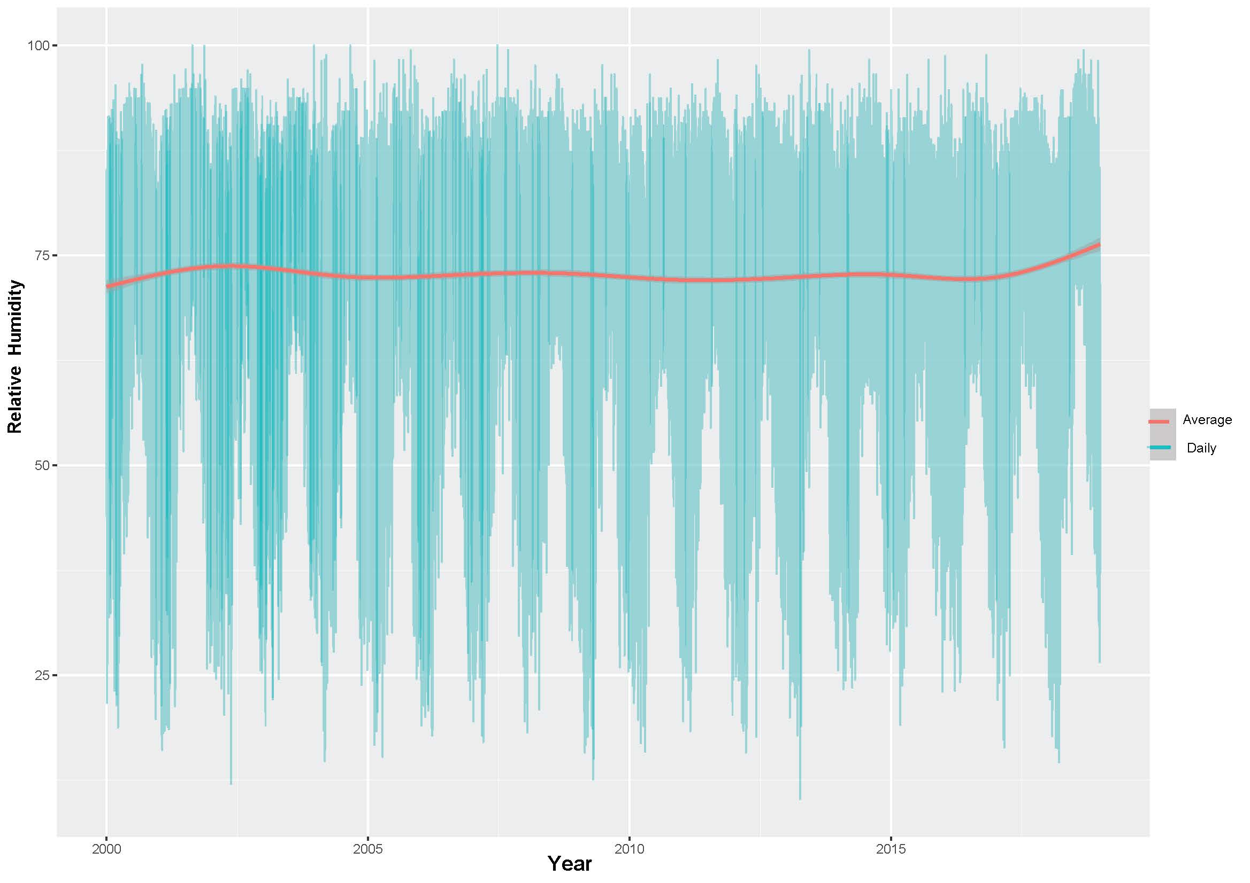
Supplementary Fig.1:
This chart displays the relative humidity of the Balasore coast during the previous two decades, from 2000 to 2018.
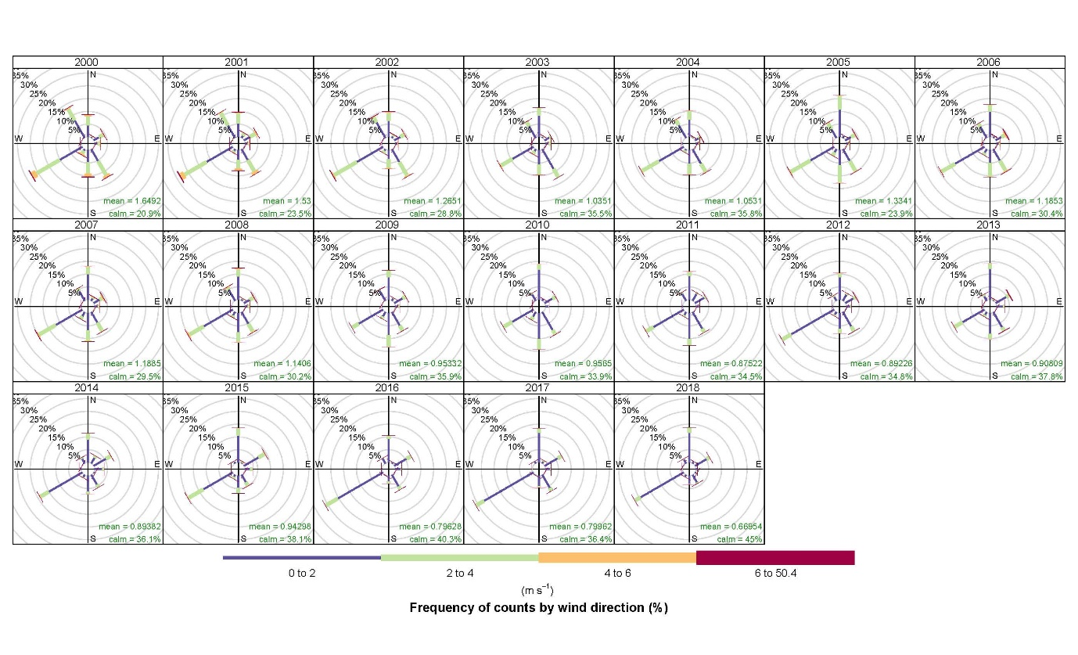
Supplementary Fig.2:
Wind charts spanning two decades (2000–2018) with wind average data from the Balasore station, displaying frequency (%), wind velocities (ms⁻¹), and directions.
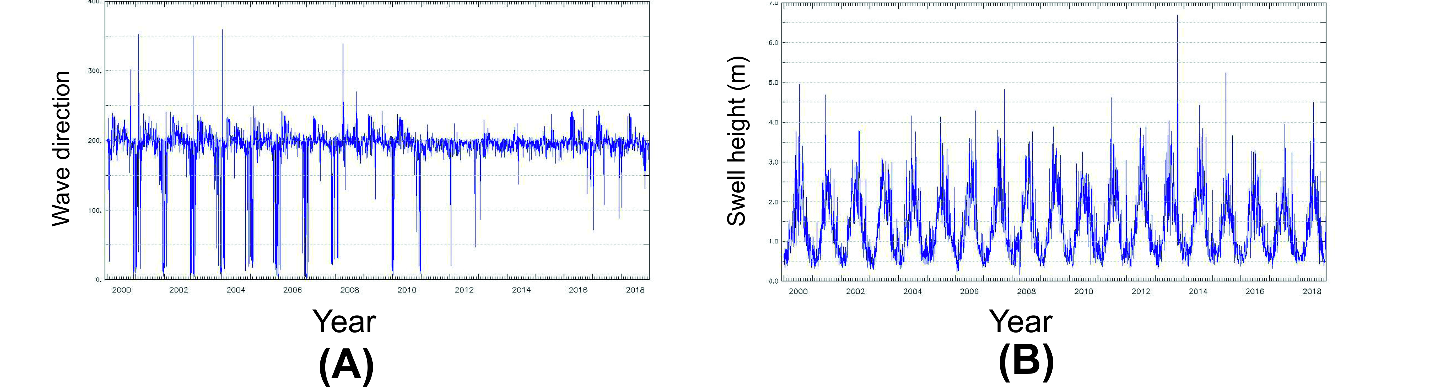
Supplementary Fig.3:
These graphs depict the wave direction (A) and swell height (B) of a NOAA Wavewatch-III model dataset (https://polar.ncep.noaa.gov/waves/ensemble/download.shtml) spanning two decades (2000–2018) in the Bay of Bengal region.

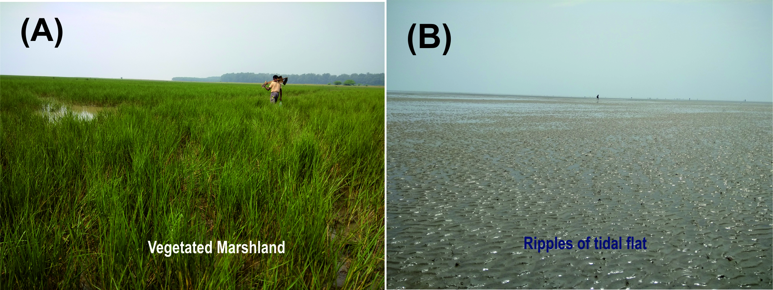

Supplementary Fig.4:
The Chandipur coastal area's densely vegetated marshes (A) and ripple-laminated tidal flat (B) areas are seen in field pictures.

