Additional File 1

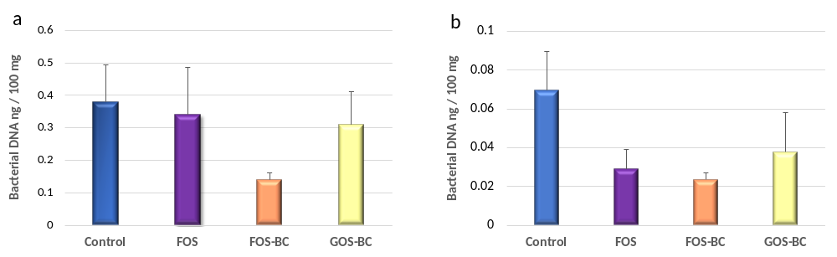

Figure S1. The absolute bacterial DNA levels quantified by qPCR for digesta samples (a) and mucosa samples (b) from each of the treatments. Error bars represent SEM. No significant differences (p ≤ 0.05) found among the treatments.

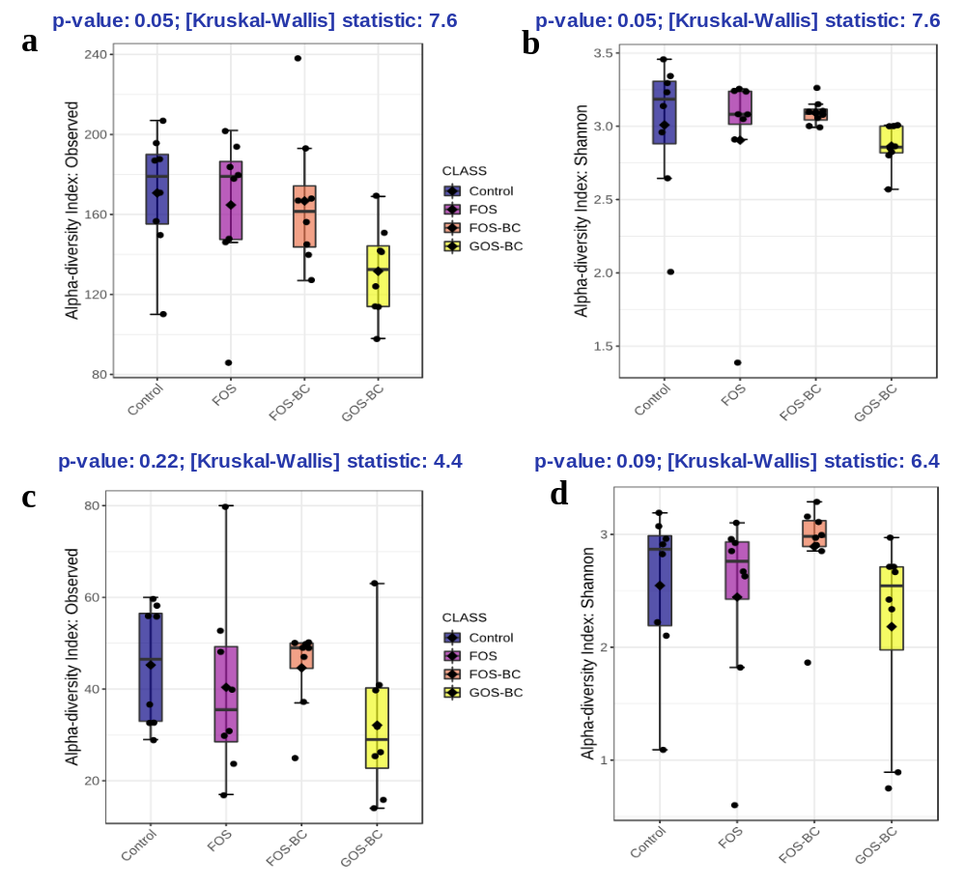
Figure S2. The alpha diversity indices for microbiota in digesta and mucosa of the distal intestine of Atlantic salmon fed four different diets. a) observed species and b) Shannon indices for digesta; c) observed species and d) Shannon indices for mucosa. p-values and Kruskal-Wallis statistics (H values) are presented above each graph.

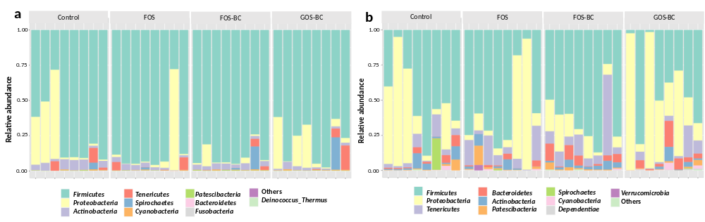

Figure S3. Ten most abundant phyla of the digesta (a) and mucosa (b) from distal intestine of the 8 individual Atlantic salmon observed per treatment, i.e. control, FOS, FOS-BC and GOS-BC diets.

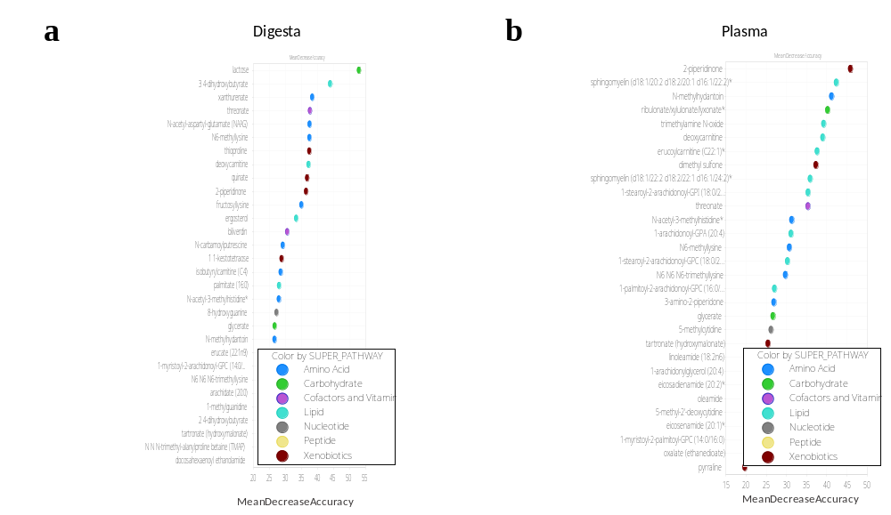

Figure S4. Random Forest importance plots indicating top 30 metabolites in digesta (a) and mucosa (b) vital for discriminating four feeding groups. The importance of the metabolites is ordered from top to bottom and an estimate of their importance is indicated by the corresponding mean decrease accuracy.

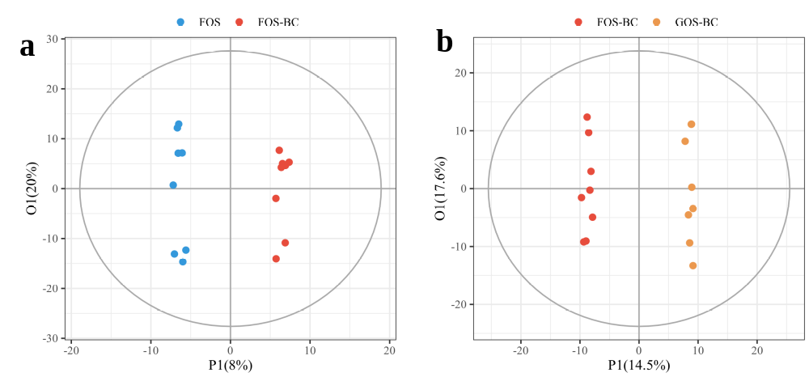

Figure S5. Orthogonal partial least squares discriminant analysis (OPLS-DA) score plots of the combined data matrix of metabolome and microbiome in each of the FOS-BC (a) and GOS-BC (b) groups compared to FOS and GOS-BC groups, respectively. Each dot indicates an individual sample.

