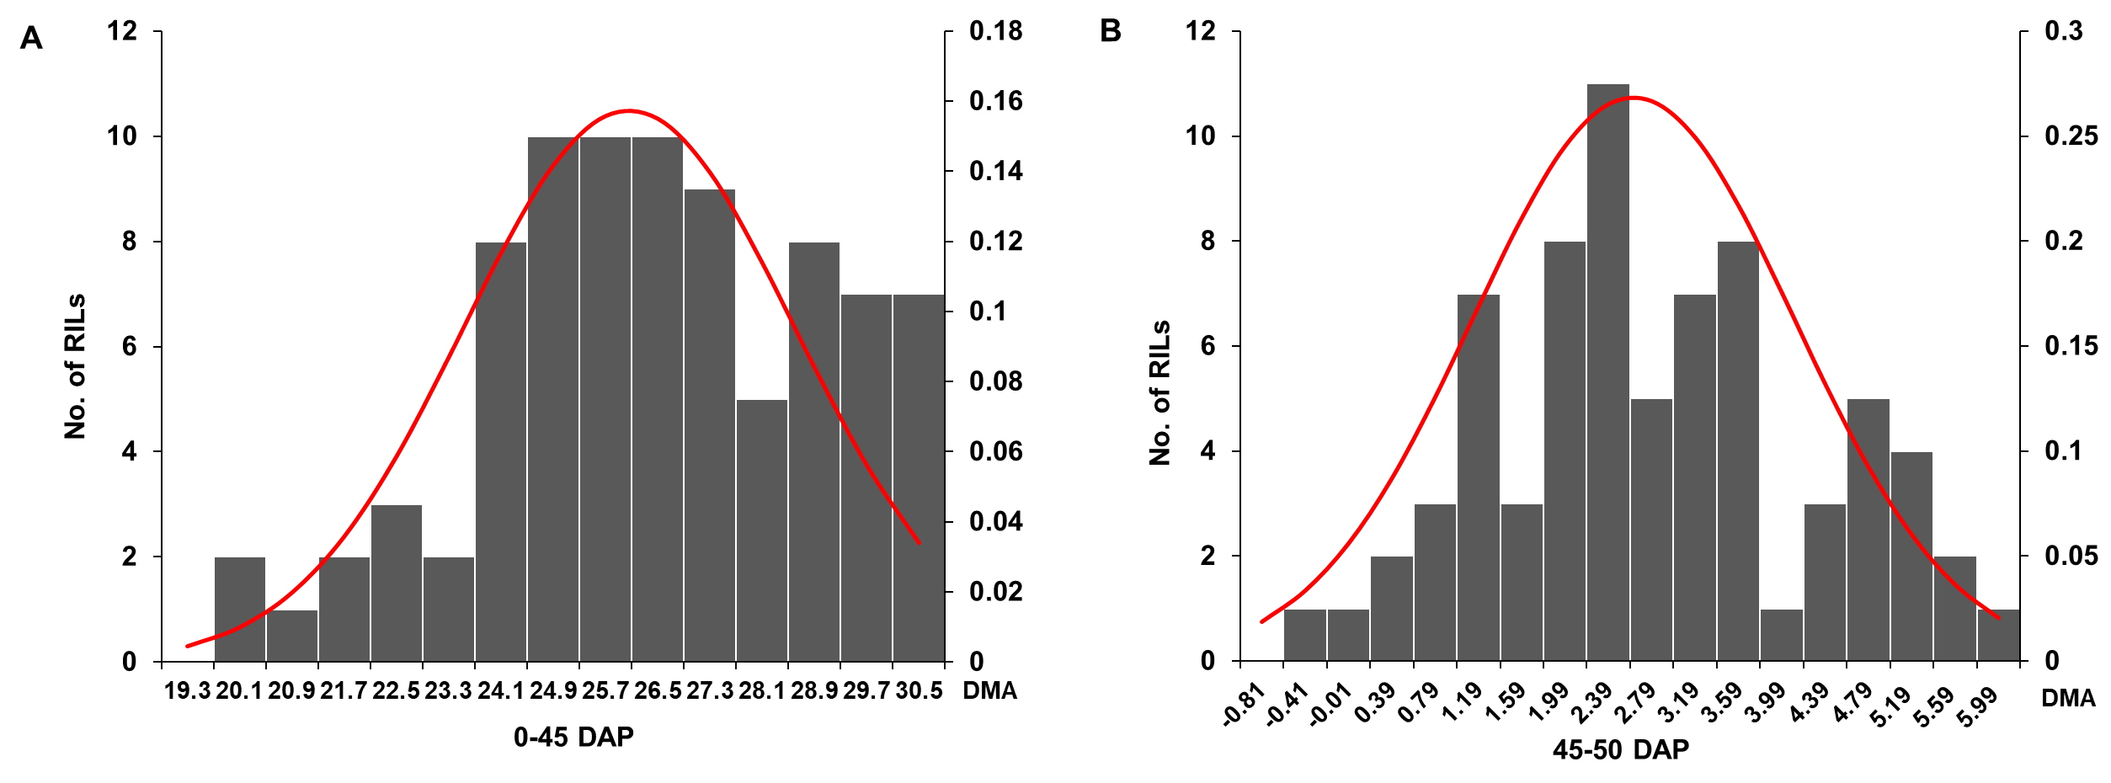

Appendix A Histogram of the frequency distribution and probability density curve of DMA data for the RILs grown in the summer of 2014 at Shandong.

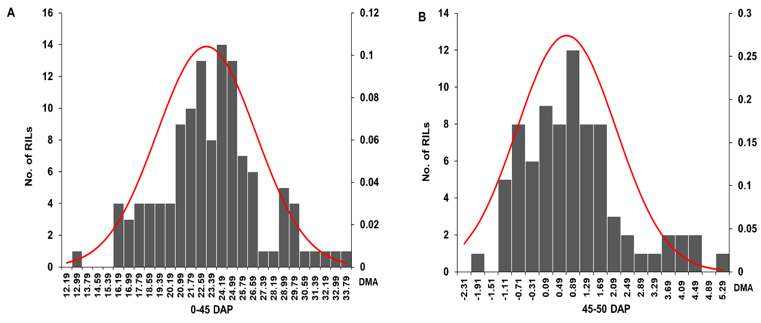

Appendix B Histogram of the frequency distribution and probability density curve of DMA data for the RILs grown in the winter of 2014 at Hainan.

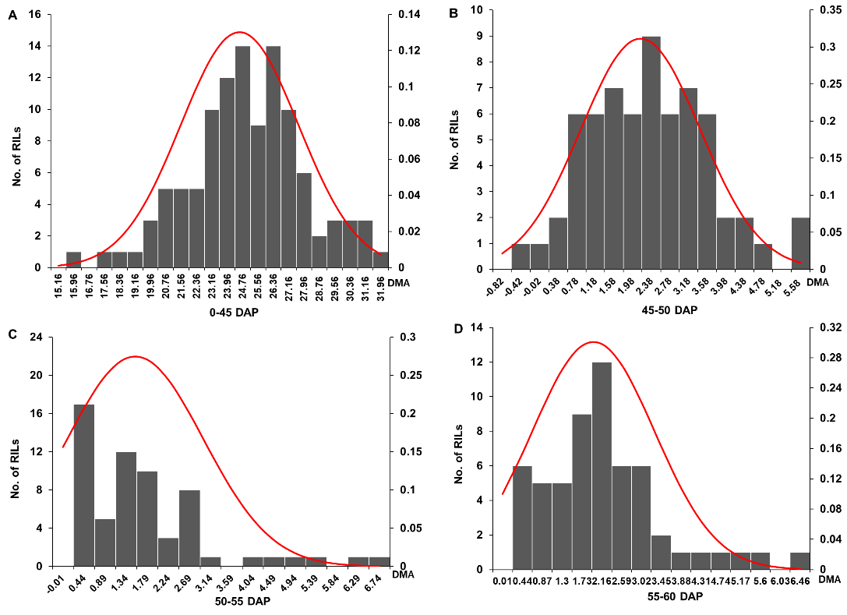

Appendix C Histogram of the frequency distribution and probability density curve of DMA data for the RILs grown in the summer of 2015 at Shandong.

Appendix D The initial QTL mapping results of dry matter accumulation in the summer of Shandong in 2014

DAP | QTL-Name | Traits | Bins | Flanking SNP | Physical Location (Mb) | CI(Mb) | LOD | AE(g) | R²
0-45 | qDMA1.4 | 14sdDMA0-45-R1 | 1.07-1.09 | PZE-101171852-PZE-101201822 | 215.35-251.82 | 36.47 | 6.28 | 1.48 | 23.64%
0-45 | qDMA1.4 | 14sdDMA0-45-ave | 1.08-1.09 | SYN25826-PZE-101201822 | 232.65-251.82 | 19.16 | 5.35 | 1.22 | 18.93%
0-45 | qDMA4.2 | 14sdDMA0-45-R2 | 4.08-4.09 | PZE-104118062-PZE-104146082 | 194.88-234.43 | 39.54 | 3.79 | 0.99 | 12.75%
0-45 | qDMA4.2 | 14sdDMA0-45-ave | 4.08-4.09 | PZE-104126470-PZE-104146082 | 204.42-234.43 | 30.01 | 2.93 | 0.79 | 9.04%
0-45 | qDMA6.4 | 14sdDMA0-45-R2 | 6.05-6.08 | PZE-106080884-SYN24806 | 137.83-167.03 | 29.21 | 3.4 | -1.09 | 15.41%
0-45 | qDMA10.3 | 14sdDMA0-45-R2 | 10.04-10.05 | PZE-110056119-PZE-110073847 | 108.1-130.31 | 22.20 | 3.92 | -1.06 | 12.97%
0-45 | qDMA10.3 | 14sdDMA0-45-ave | 10.04-10.05 | PZE-110056119-PZE-110073847 | 108.1-130.31 | 22.20 | 3.01 | -0.82 | 8.75%
45-50 | qDMA1.2 | 14sdDMA45-50-R1 | 1.05-1.06 | PZE-101126335-SYN28736 | 159.95-196.64 | 36.69 | 4.69 | 0.86 | 18.23%
45-50 | qDMA1.2 | 14sdDMA45-50-ave | 1.05-1.06 | PZE-101093764-PZE-101146598 | 86.84-189.77 | 102.93 | 3.19 | 0.51 | 11.03%
45-50 | qDMA4.1 | 14sdDMA45-50-ave | 4.08 | PZE-104108744-PZE-104118062 | 185.44-194.88 | 9.44 | 3.46 | 0.54 | 12.30%
45-50 | qDMA6.1 | 14sdDMA45-50-R1 | 6.01 | SYN36832-PZE-106038186 | 28.23-86.34 | 58.11 | 5.38 | -1.04 | 21.42%
45-50 | qDMA9.2 | 14sdDMA45-50-ave | 9.02-9.03 | PZE-109013000-PZE-109026030 | 13.45-26.55 | 13.10 | 4.12 | 0.61 | 15.10%
DMA: dry matter accumulation; DAP: days after pollination; Bins: the location of the QTL in the chromosomes; Flanking SNPs: the SNPs at the both sides of QTL; Physical Location (Mb): the physical location of the QTL; CI (Mb): size of confidential interval; AE: addictive effects; R²: explained phenotypic variation.

Appendix E The initial QTL mapping results of dry matter accumulation in the winter of Hainan in 2014
DAP | QTL-Name | Traits | Bins | Flanking SNP | Physical Location (Mb) | CI(Mb) | LOD | AE(g) | R²
0-45 | qDMA1.2 | 14hnDMA0-45-R1 | 1.05-1.06 | PZE-101093040-PZE-101140869 | 85.72-182.09 | 96.37 | 2.83 | 1.08 | 7.48%
0-45 | qDMA5.2 | 14hnDMA0-45-R2 | 5.05-5.07 | SYN14522-ZM004201-0285 | 190.48-207.72 | 17.24 | 2.86 | 1.14 | 7.11%
0-45 | qDMA7.2 | 14hnDMA0-45-ave | 7.03-7.04 | PZA01714.1-PZE-107121485 | 134.14-166.69 | 32.55 | 3.25 | 1.13 | 7.69%
0-45 | qDMA8.3 | 14hnDMA0-45-ave | 8.05-8.06 | PZE-108074338-PZE-108100090 | 129.62-156.21 | 26.59 | 2.94 | 1.05 | 7.14%
0-45 | qDMA9.2 | 14hnDMA0-45-R2 | 9.02 | SYN31970-PZE-109019784 | 12.32-20.23 | 7.91 | 4.35 | 1.48 | 11.18%
0-45 | qDMA9.2 | 14hnDMA0-45-ave | 9.02 | SYN31970-PZE-109019784 | 12.32-20.23 | 7.91 | 5.44 | 1.54 | 13.89%
0-45 | qDMA9.3 | 14hnDMA0-45-R1 | 9.02-9.03 | SYN29878-ZM012889-0482 | 20.82-86.67 | 65.85 | 6.98 | 1.73 | 19.38%
0-45 | qDMA9.5 | 14hnDMA0-45-R2 | 9.06 | PZE-109089936-PZE-109097752 | 137.79-142.95 | 5.16 | 2.84 | 1.22 | 7.68%
45-50 | qDMA3.3 | 14hnDMA45-50-ave | 3.05-3.06 | PZE-103092676-SYN31220 | 153.3-180.98 | 27.68 | 4.06 | -0.67 | 17.47%
45-50 | qDMA5.1 | 14hnDMA45-50-R1 | 5.03-5.05 | ZM013904-0312-PZE-105122012 | 65.46-179.27 | 113.81 | 2.6 | 0.56 | 8.49%
45-50 | qDMA8.1 | 14hnDMA45-50-R1 | 8.01 | PZE-108002532-SYN3168 | 2.76-4.52 | 1.75 | 2.68 | 0.83 | 15.77%
DMA: dry matter accumulation; DAP: days after pollination; Bins: the location of the QTL in the chromosomes; Flanking SNPs: the SNPs at the both sides of QTL; Physical Location (Mb): the physical location of the QTL; CI (Mb): size of confidential interval; AE: addictive effects; R²: explained phenotypic variation.

Appendix F The initial QTL mapping results of dry matter accumulation in the summer of Shandong in 2015
DAP | QTL-Name | Traits | Bins | Flanking SNP | Physical Location(Mb) | CI(Mb) | LOD | AE(g) | R²
0-45 | qDMA3.2 | 15sdDMA0-45-R1 | 3.04-3.05 | PZE-103033919-PZE-103084178 | 26.45-139.51 | 113.06 | 2.85 | 1.03 | 9.56%
0-45 | qDMA5.2 | 15sdDMA0-45-R2 | 5.06-5.07 | PZE-105154006-PZE-105165053 | 204.38-208.94 | 4.55 | 5.44 | 1.49 | 18.36%
0-45 | qDMA5.2 | 15sdDMA0-45-ave | 5.06-5.07 | PZE-105154006-ZM004201-0285 | 204.38-207.72 | 3.34 | 4.05 | 1.15 | 13.41%
0-45 | qDMA6.3 | 15sdDMA0-45-R1 | 6.02-6.04 | PZE-106043310-PZE-106058910 | 93.21-107.81 | 14.60 | 3.69 | 1.18 | 13.38%
0-45 | qDMA6.4 | 15sdDMA0-45-R1 | 6.05 | SYN29972-PHM5529.4 | 137.83-167.01 | 29.18 | 2.87 | -1.39 | 19.07%
0-45 | qDMA7.2 | 15sdDMA0-45-R2 | 7.03-7.04 | PZA01714.1-PZE-107121485 | 134.14-166.69 | 32.55 | 3.58 | 1.21 | 12.14%
0-45 | qDMA7.2 | 15sdDMA0-45-ave | 7.03 | PZE-107077981-PZE-107081254 | 133.03-136.27 | 3.24 | 2.84 | 0.93 | 8.54%
0-45 | qDMA9.2 | 15sdDMA0-45-R1 | 9.02 | PZE-109013000-PZE-109019092 | 13.45-19.29 | 5.84 | 4.07 | 1.21 | 14.06%
0-45 | qDMA9.2 | 15sdDMA0-45-R2 | 9.02 | SYN31970-PZE-109019784 | 12.32-20.23 | 7.91 | 2.6 | 1.07 | 9.96%
45-50 | qDMA1.1 | 15sdDMA45-50-ave | 1.05 | PZE-101098535-PZE-101111015 | 90-120.19 | 30.19 | 2.91 | -0.73 | 12.53%
45-50 | qDMA1.2 | 15sdDMA45-50-R2 | 1.06 | PZE-101135767-PZE-101153599 | 175.64-196.82 | 21.19 | 6.31 | 1.14 | 26.44%
45-50 | qDMA6.5 | 15sdDMA45-50-R2 | 6.05 | PZE-106083557-SYN22024 | 140.85-143.95 | 3.11 | 3.09 | 0.62 | 12.34%
45-50 | qDMA8.2 | 15sdDMA45-50-ave | 8.03 | PZE-108041341-PZE-108052985 | 67.36-94.58 | 27.22 | 2.55 | -0.48 | 11.07%
50-55 | qDMA2.1 | 15sdDMA50-55-R1 | 2.02-2.04 | PZE-102030524-PZE-102062962 | 14.27-41.3 | 27.03 | 3.26 | -1.16 | 17.02%
50-55 | qDMA5.3 | 15sdDMA50-55-R1 | 5.07 | PZE-105157980-PZE-105165053 | 206.03-208.94 | 2.90 | 2.61 | -1.13 | 16.32%
55-60 | qDMA1.5 | 15sdDMA55-60-R2 | 1.10 | PZE-101219724-PZE-101229026 | 271.13-278.71 | 7.58 | 4.08 | 1.08 | 19.80%
55-60 | qDMA1.6 | 15sdDMA55-60-R1 | 1.10-1.11 | PZE-101232138-PZE-101245575 | 280.83-291.54 | 10.71 | 4.83 | 0.98 | 23.60%
55-60 | qDMA1.6 | 15sdDMA55-60-ave | 1.10-1.11 | PZE-101229026-PZE-101240161 | 278.71-287.15 | 8.43 | 3.41 | 0.50 | 13.00%
55-60 | qDMA3.5 | 15sdDMA55-60-R1 | 3.09 | SYN30483-SYN1576 | 225.91-230.02 | 4.11 | 4.79 | -0.92 | 22.61%
55-60 | qDMA5.1 | 15sdDMA55-60-R2 | 5.04-5.05 | PUT-163a-30705690-1902-PZE-105133858 | 155.82-190.2 | 34.38 | 3.99 | 1.08 | 16.01%
55-60 | qDMA5.2 | 15sdDMA55-60-R1 | 5.06-5.07 | SYN14995-PZE-105165053 | 203.82-208.94 | 5.11 | 5.69 | 1.10 | 28.66%
55-60 | qDMA8.3 | 15sdDMA55-60-R1 | 8.03-8.05 | PZE-108058109-SYN19755 | 103.64-138.39 | 34.75 | 2.97 | -0.66 | 12.01%
55-60 | qDMA10.1 | 15sdDMA55-60-ave | 10.03 | SYN17647-PZE-110041164 | 22.1-78.39 | 56.30 | 3.42 | 0.96 | 14.76%
DMA: dry matter accumulation; DAP: days after pollination; Bins: the location of the QTL in the chromosomes; Flanking SNPs: the SNPs at the both sides of QTL; Physical Location (Mb): the physical location of the QTL; CI (Mb): size of confidential interval; AE: addictive effects; R²: explained phenotypic variation.

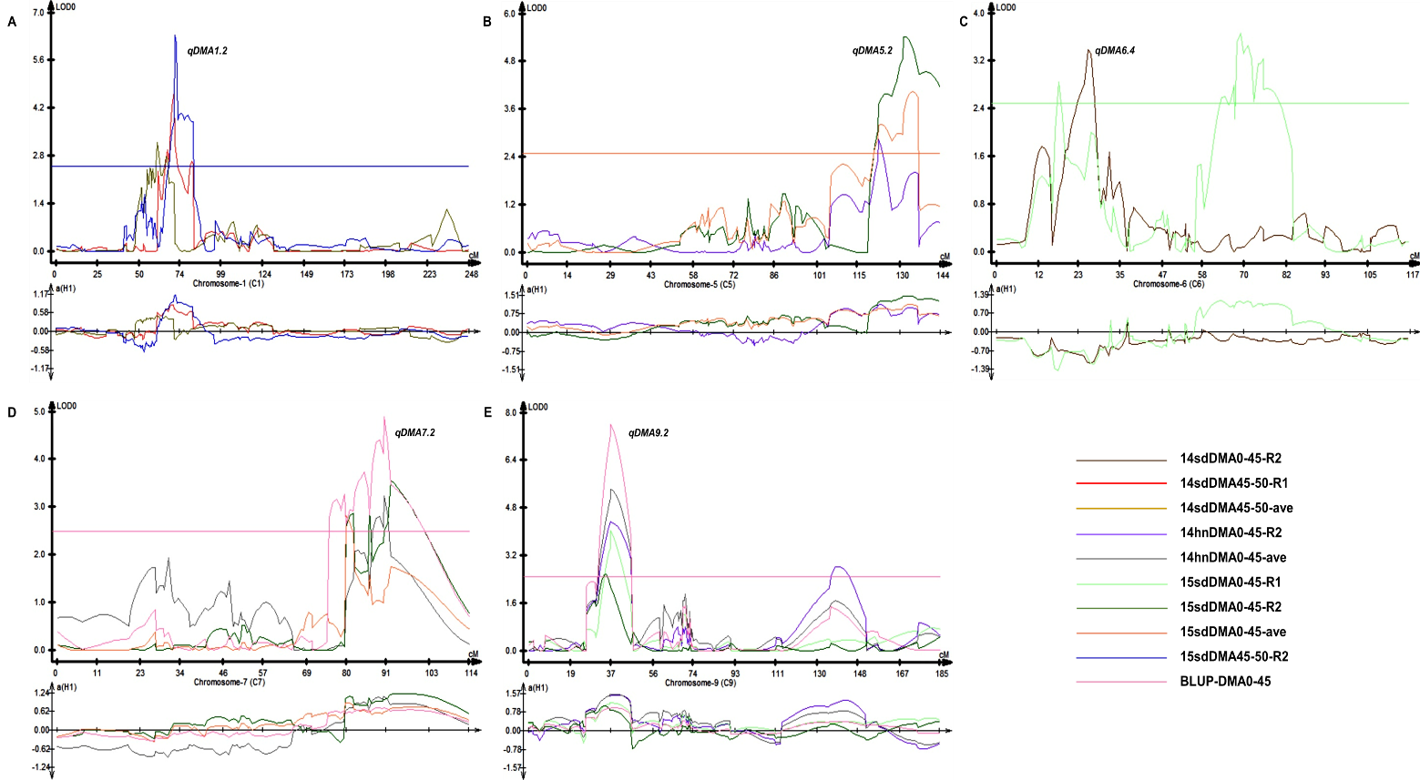

Appendix G Diagrams of QTL mapping results of common QTLs in three field trials.

