Supplementary Tab.S1. Factors and their assignments
Factors | Assignments | Population | Percent（%）
COPD(Y) | YES=1 | 277 | 13.4
COPD(Y) | NO=2 | 1795 | 86.6
Gender($x_{1}$) | Male=1 | 1073 | 51.8
Gender($x_{1}$) | Female=2 | 999 | 48.2
Age($x_{2}$) | ≤49=1 | 759 | 36.6
Age($x_{2}$) | 50~=2 | 726 | 35.0
Age($x_{2}$) | 60~=3 | 484 | 23.4
Age($x_{2}$) | 70~=3 | 103 | 5.0
Cultural level($x_{3}$) | Junior high and below=1 | 1557 | 75.1
Cultural level($x_{3}$) | Senior high school=2 | 391 | 18.9
Cultural level($x_{3}$) | College diploma or above=3 | 124 | 6.0
BMI($x_{4}$) | <18.5=1 | 16 | 0.8
BMI($x_{4}$) | 18.5∼=2 | 675 | 32.6
BMI($x_{4}$) | 24.0∼=3 | 909 | 43.9
BMI($x_{4}$) | 28.0∼=4 | 472 | 22.8
COPD awareness ($x_{5}$) | YES=1 | 110 | 5.3
COPD awareness ($x_{5}$) | NO=2 | 1962 | 94.7
Cough ($x_{6}$) | YES=1 | 183 | 8.8
Cough ($x_{6}$) | NO=2 | 1889 | 91.2
Expectoration ($x_{7}$) | YES=1 | 269 | 13.0
Expectoration ($x_{7}$) | NO=2 | 1803 | 87.0
Air hunger or dyspnea($x_{8}$) | YES=1 | 381 | 18.4
Air hunger or dyspnea($x_{8}$) | NO=2 | 1691 | 81.6
Childhood respiratory infections ($x_{9}$) | YES=1 | 37 | 1.8
Childhood respiratory infections ($x_{9}$) | NO=2 | 2035 | 98.2
Respiratory disease ($x_{10}$) | YES=1 | 263 | 12.7
Respiratory disease ($x_{10}$) | NO=2 | 1809 | 87.3
Cardiovascular and cerebrovascular diseases ($x_{11}$) | YES=1 | 141 | 6.8
Cardiovascular and cerebrovascular diseases ($x_{11}$) | NO=2 | 1931 | 93.2
Hypertension ($x_{12}$) | YES=1 | 449 | 21.7
Hypertension ($x_{12}$) | NO=2 | 1623 | 78.3
Family history ($x_{13}$) | YES=1 | 536 | 25.9
Family history ($x_{13}$) | NO=2 | 1536 | 74.1
Smoking status($x_{14}$) | YES=1 | 858 | 41.4
Smoking status($x_{14}$) | NO=2 | 1214 | 58.6
Household air pollution($x_{15}$) | YES=1 | 1432 | 69.1
Household air pollution($x_{15}$) | NO=2 | 640 | 30.9
Occupational exposure ($x_{16}$) | YES=1 | 903 | 43.6
Occupational exposure ($x_{16}$) | NO=2 | 1169 | 56.4

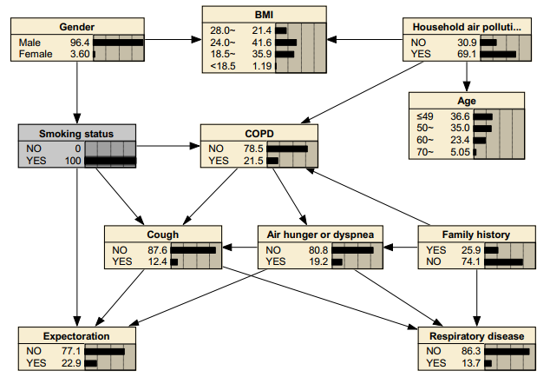
Supplementary Fig.S1. The Bayesian networksⅠunder known evidence variables. The figure was plotted using Netica (www.norsys.com).

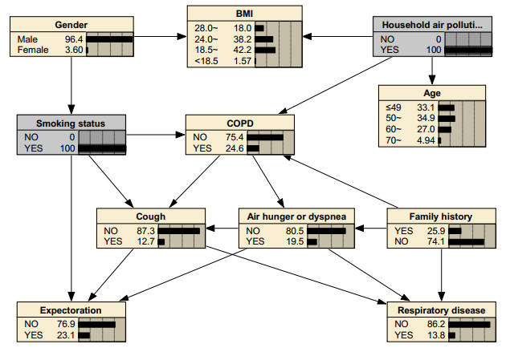
Supplementary Fig.S2. The Bayesian networks Ⅱ under known evidence variables. The figure was plotted using Netica (www.norsys.com).

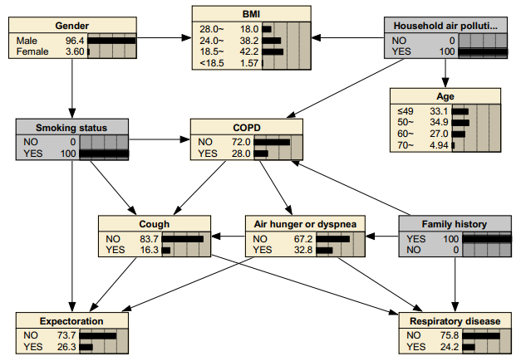
Supplementary Fig.S3. The Bayesian networks Ⅲ under known evidence variables. The figure was plotted using Netica (www.norsys.com).

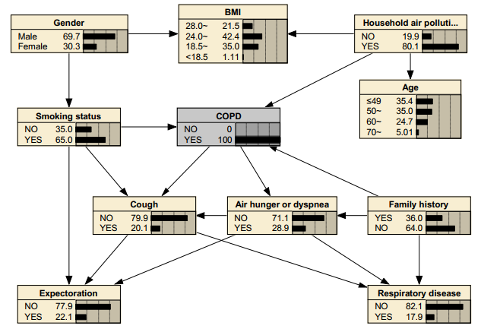
Supplementary Fig.S4. The Bayesian networks Ⅳ under known evidence variables. The figure was plotted using Netica (www.norsys.com).
Supplementary Tab.S2. Conditional probability table
Family history | Smoking status | Household air pollution | COPD
Family history | Smoking status | Household air pollution | NO | YES
Yes | No | No | 93.939 | 6.061
Yes | No | Yes | 80.928 | 19.072
Yes | Yes | No | 82.609 | 17.391
Yes | Yes | Yes | 71.978 | 28.022
No | No | No | 95.775 | 4.225
No | No | Yes | 93.488 | 6.512
No | Yes | No | 86.225 | 13.775
No | Yes | Yes | 76.611 | 23.389
.

