Fig. S1.
Heatmap of importance or significance ranking of each species in tests for each original and corresponding twin cohort. Each column indicates the ranks in permutation importance for original cohorts and FDR for twin cohorts, and the last column of both cohort categories display the ranks for pooled samples. Colors indicates the range of rank. NA, not significant or absent in all samples of the cohort according to the taxonomic annotation.

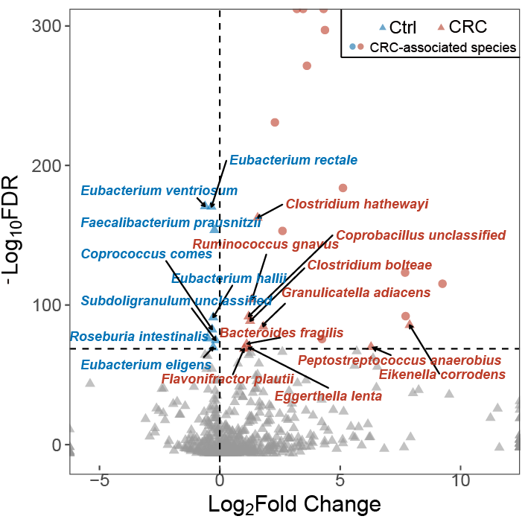

Fig. S2. Volcano plots of the differential species in Vtwins analysis of the pooled samples. Fold change of the species abundance and Benjamini-Hochberg-adjusted P value (FDR) are plotted for each species. Top 30 species with highest significance (FDR > 10-75) are labeled with red (enriched in CRC samples) or blue triangles (enriched in control samples). Colored circles indicates the 13 CRC-associated species identified by the two meta-analyses. Type or paste caption here. Create a page break and paste in the Figure above the caption.

Fig. S3. Prediction performances at increasing number of features in LODO cross-validation setting. Features are top-ranking species selected by VTwins

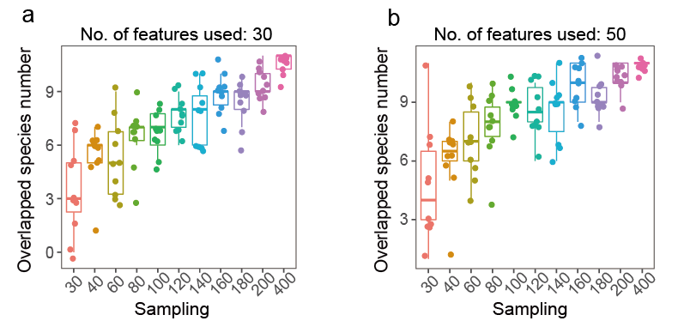

Fig. S4. The number of species in the 13 CRC-associated species recalled by Vtwins. The left panel indicates the settings where 30 top-ranking features are used, and right panel indicates settings of 50 features. The X-axis indicates the sample size in the random sampling test.

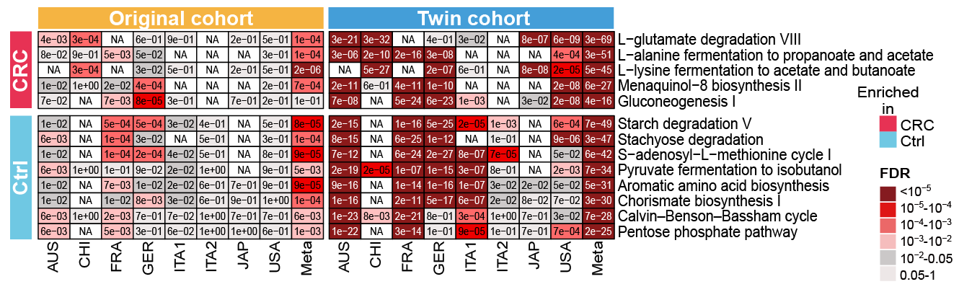

Fig. S5. The heatmap of the significance of the 13 CRC-associated pathways. Numbers are the P values of these pathways tested with each original cohort (Wilcoxon rank-sum test, left panel) and corresponding “twin” cohort (Wilcoxon signed-rank test, right panel). The last columns of both cohort types show the P value calculated with pooled samples. All the P values were Benjamini-Hochberg adjusted and the colors indicated the rank of significance. NA, absent in the samples of the cohort.

