Mathematical rationale and statistical guidelines used in the methodology (Ref. fig. 7 to10, pg. 8 - 9).

When translating this analysis into a mathematical expression, the FAC correlation denoted by k as a function of k is defined as:
$⍴k=\frac{Ƴk}{Ƴ0}$ = $\frac{covariance with lag k}{Variance}$ (1)

where the value of k is the chosen delay (1), and the system considers covariance with lag k and variance already calculated according to the data. In practice, as we have a stochastic uniequational series, we can compute the function of sample correlation, . For such, we first need to calculate the covariance of the sample with lag k,, and the variance of the sample, defined as:

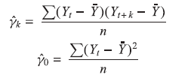 (2)

where n is the sample size and Ȳ is the sample mean.
Thus, the function of sample correlation, with lag k is:
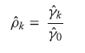 (3)

which is simply the ratio of sample covariance (with klag) and sample variance. The k-versus-k graph is known as a sample correlogram.

Modeling the time series according to the methods
(AR) of moving averages (MA) and ARIMA (p. 07 to 10).

Once the parking period is conquered, we can model it with an autorregressive process (AR),which we will represent by Yt, the Median (Md) in the t period (Holocene) as:
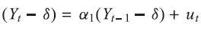 (4)
in which δ is the mean of Y and uₜ is an error that’s not correlated with m is day zero and constant variance ᾳ² (this is a white noise),so we will say that Yt follows a first-order stochastic autorregressive process or AR (1). Here the value of Y in period t depends on its value in the previous period and on a random term; y values are expressed as deviations based on an average value. In other words, this model states that the predicted value of Y in period t is simply some proportion (= ᾳ) plus a random shock or disturbance in the t-period; again, the Y values are expressed around their mean values.
The AR process we just discussed is not just a mechanism that may have generated Y. In this case, Y can evolve into a first-order moving average process, or an MA (1). If we model Y this way: 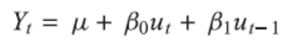 (5)
in which μ is a constant and u,as before, is a stochastic error term of white noise. Here Y in period t is equal to a constant plus a moving average of the current and past terms of error. In a more general way, we can represent
(6)
which is an MA process(q). In short, a moving average process is just a linear combination of white noise error terms.

Self-regressive process of moving averages (ARMA)

It is most likely that Y has both AR and MA characteristics and is therefore ARMA. So, Yt follows an ARMA process (1.1), and can be written as
(7)
because there is an autoregressive term and a moving average term. In the Equation, ɵ represents a constant term. In general, in an ARMA process (p, q), there will be autoregressive terms p and moving average terms q.

Graphical configuration of the uncertainty set (p. 5 to 10, v. Data and methods).

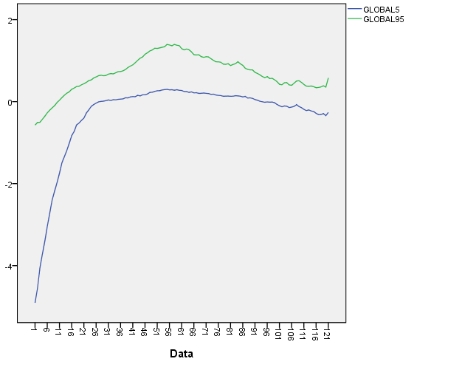
Figure 1. Graphic description ofthe 5th and 95th percentiles decomposed (uncertainties)

Next, we represent the graphs of the correlations of both models, the ACF and ACFp, and their subsequent differentiation for parking.
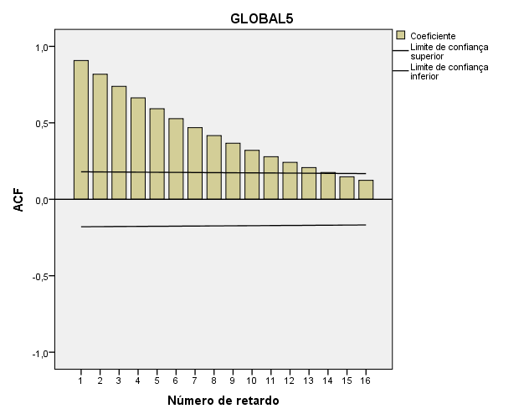
Figure 2. 5th percentile Autocorrelation Graphic Test (Automatic ACF)
Source: Prepared by the authors (SPSS - Statistics v. 22)

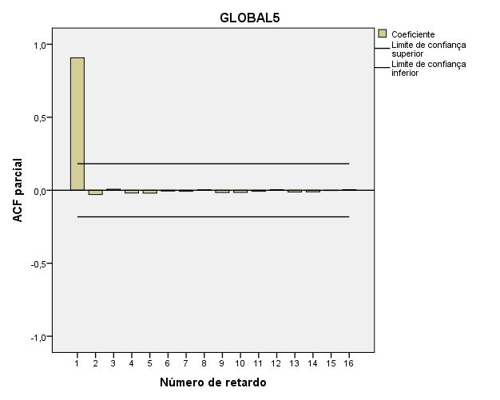
Figure 3. Partial autocorrelation graphic test 5th percentile - ACFP.
Source: prepared by the authors (SPSS- Statistics v. 22).
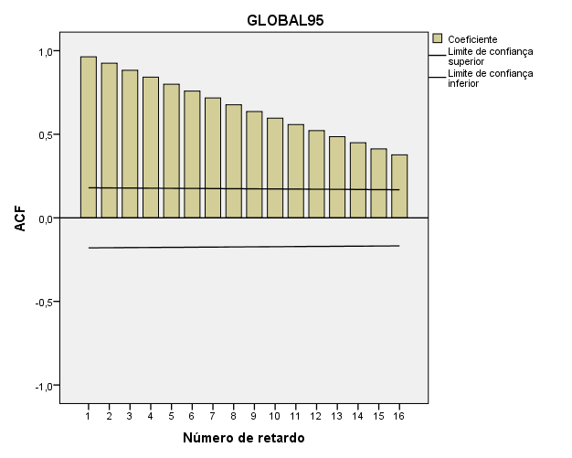
Figure 4. 95th percentile autocorrelation graph test (automatic ACF)
Source: Prepared by the authors (SPSS - Statistics v. 22)

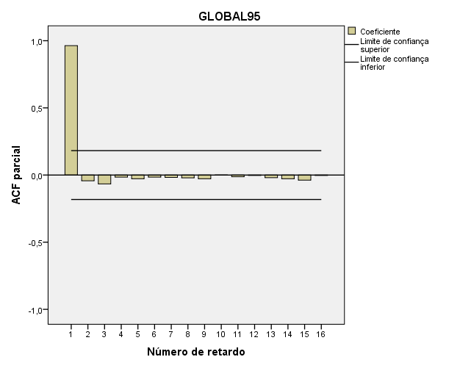
Figure 5. 95th percentilepartial autocorrelation graph test - ACFP.
Source: prepared by the authors (SPSS- Statistics v. 22).
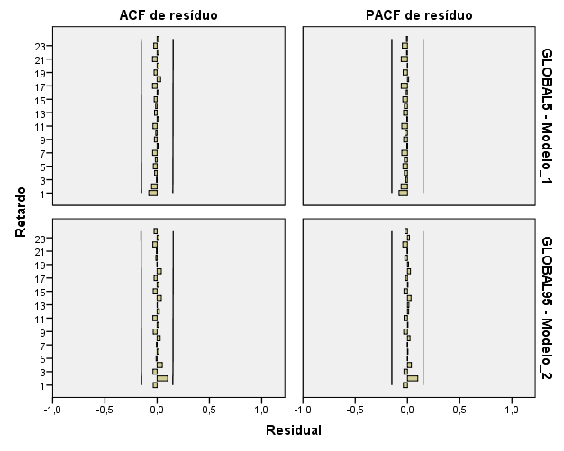

Figure 6. Residues of the ACF and PACF correlograms – 5th and 95th percentiles (White noise).

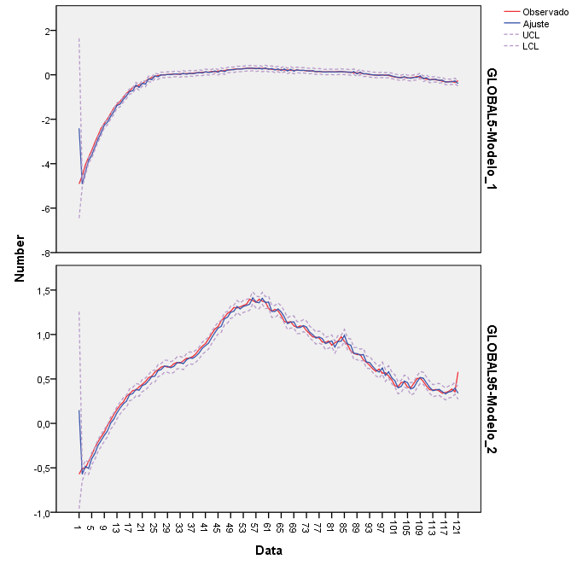
Figure 7. Adjustment chart of the 5th and 95th percentiles parameters.
Source: SPSS output - Statistics powered by the authors.

