A simple micropreparative gel electrophoresis technique for purification of proteins, nucleic acids, and bioconjugates
Sayyed Hashem Sajjadi,^{a,b} Shang-Jung Wu,ª Vitalijs Zubkovs,ª Hossein Ahmadzadeh,^{b,}* Elaheh K. Goharshadi,^{b} and Ardemis A. Boghossian^{a,}*

ª École Polytechnique Federale de Lausanne (EPFL), CH-1015, Lausanne, Switzerland
^{b} Chemistry Department, Faculty of Science, Ferdowsi University of Mashhad, Mashhad 9177948974, Iran

*ardemis.boghossian@epfl.ch
*h.ahmadzadeh@um.ac.ir

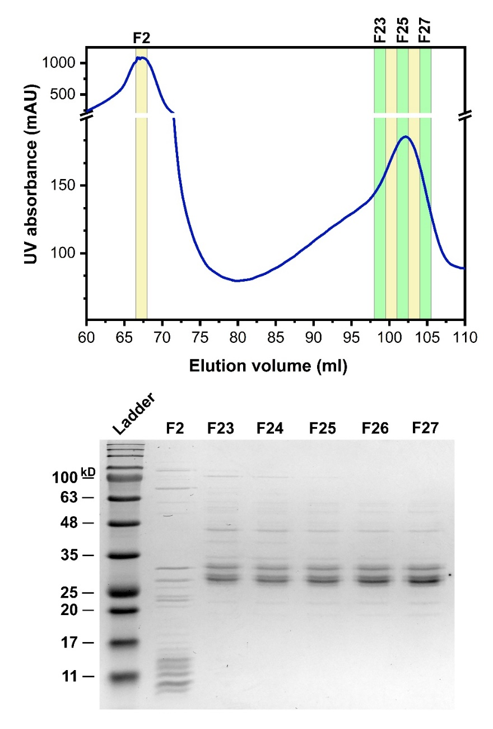
Fig. S1 Chromatogram (top) and Coomassie Brilliant Blue (CB)-stained reducing SDS-PAGE profiles (bottom) of fractions eluted from the SEC column.
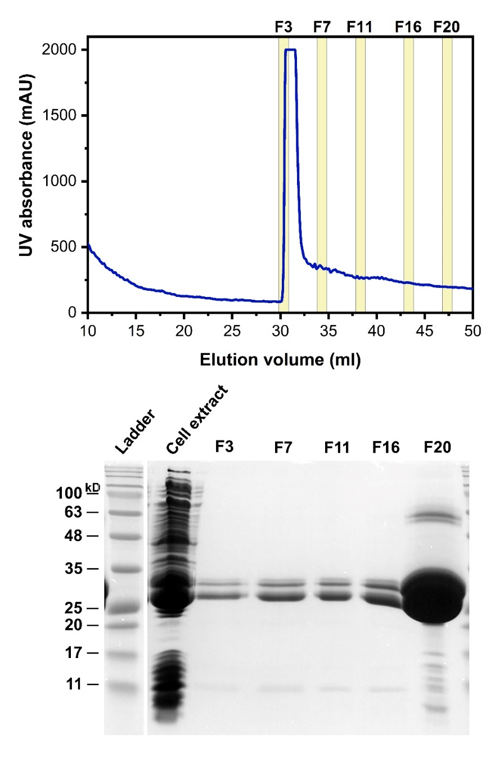
Fig. S2 Chromatogram (top) and Coomassie Brilliant Blue (CB)-stained reducing SDS-PAGE profiles (bottom) of fractions eluted from the IMAC column.

