SUPPLEMENTARY INFORMATION

Data-science driven autonomous process optimization

Melodie Christensen^{1,2}, Lars P. E. Yunker¹, Folarin Adedeji², Florian Häse^{3,4,5,7,9}, Loïc M. Roch^{3,4,5,9}, Tobias Gensch⁶, Gabriel dos Passos Gomes^{4,5,7}, Tara Zepel¹, Matthew S. Sigman*⁶, Alán Aspuru-Guzik*^{3,4,5,7,8} and Jason E. Hein^{1*}
¹Department of Chemistry, University of British Columbia, Vancouver, British Columbia V6T 1Z1, Canada.
²Department of Process Research and Development, Merck & Co., Inc., Rahway, NJ 07065, United States.
³Department of Chemistry and Chemical Biology, Harvard University, Cambridge, MA 02138, United States.
⁴Department of Chemistry, University of Toronto, Toronto, Ontario M5S 3H6, Canada.
⁵Department of Computer Science, University of Toronto, Toronto, Ontario M5T 3A1, Canada.
⁶Department of Chemistry, University of Utah, Salt Lake City, Utah 84112, United States.
⁷Vector Institute for Artificial Intelligence, Toronto, Ontario M5S 1M1, Canada.
⁸Canadian Institute for Advanced Research, Toronto, Ontario M5G 1Z8, Canada.
⁹ChemOS Sàrl, Lausanne, Vaud 1006, Switzerland.
*Corresponding authors: Matthew S. Sigman sigman@chem.utah.edu, Alán Aspuru-Guzik aspuru@utoronto.ca, Jason E. Hein jhein@chem.ubc.ca

Table of Contents
1. General remarks 3
1.1 Chemical suppliers 3
1.2 Equipment 3
1.3 Analytical methods 4
2. Experimental procedures 5
2.1 Procedure for stock mixture preparations 5
2.2 Procedure for autonomous optimization experiments 9
2.3 Procedure for manual experiments 10
2.4 Procedures for the preparation of non-commercial compounds 11
4. Autonomous optimization protocol 14
4.1 Sample csv file with dispense volumes 14
4.2 Sample Chemspeed Autosuite protocol 14
5. Machine learning algorithms 16
5.1 Process constrained optimization in the context of autonomous experimentation 16
6. Analytical data 17
6.1 ¹H NMR weight % purity determinations 17
6.2 Calibration curves 19
6.3 Preliminary data 20
6.4 Campaign 1 data 21
6.5 Campaign 2 data 24
6.6 Campaign 3 data 28
6.7 Campaign 3 visualization 33
6.8 Standard experiments 34
7. Descriptor computation 35
8. Training set selection 36
9. Predictive modeling 37

General remarks

Chemical suppliers
Commercial reagents were purchased from Millipore Sigma, Oakwood, Combi-Blocks, Alfa Aesar, Acros, Strem, Apollo and Alichem; and used as received. Anhydrous solvents were purchased from Millipore Sigma and used as received. Aqueous solutions were deoxygenated through subsurface nitrogen sparge for a minimum of 30 minutes.

Equipment
Flash chromatography was performed on a CombiFlash purification system employing Redisep Rf Gold silica gel columns. ¹H NMR spectra for weight % purity determinations were recorded on a Bruker 500 MHz instrument with a delay time of 20 sec in 32 scans. Samples were prepared in CDCl₃ and spectra were calibrated to the CDCl₃ reference peak at 7.26 ppm.
Autonomous optimization experiments were carried out on a Chemspeed Swing liquid handling robot equipped with an adjustable-pitch four needle (0.8 mm ID) liquid dispense tool, a V&P Scientific tumble stirrer and a Huber Unistat 82T chiller. The robot was integrated with an Agilent 1100 HPLC-UV system through installation of a two position, 6-port HPLC valve on the Chemspeed Swing deck and connection to the Agilent 1100 through 0.17 mm ID tubing. Valve switching and chromatographic resolutions were triggered through contact closures. A 5 µL sample loop was installed.
Reactions were carried out in 96-well aluminum reaction blocks (Analytical Sales 96973) with 8 x 30 mm glass vial inserts (Analytical Sales 884001). Vials were sealed with a layer of two PFA films (Analytical Sales 96967), one tan fluoropolymer mat (Analytical Sales 78040) and a custom aluminum needle-guiding top cover (figure SI-1). Vigorous agitation was achieved with 5 mm PVDF-encapsulated NdFeB magnetic tumble stir discs (VP 772DP-N42-5-2). Reaction aliquots were sampled into 96-well dilution plates (Analytical Sales 17P687) capped with pre-slit silicone/PTFE cap mats (Analytical Sales 965075).
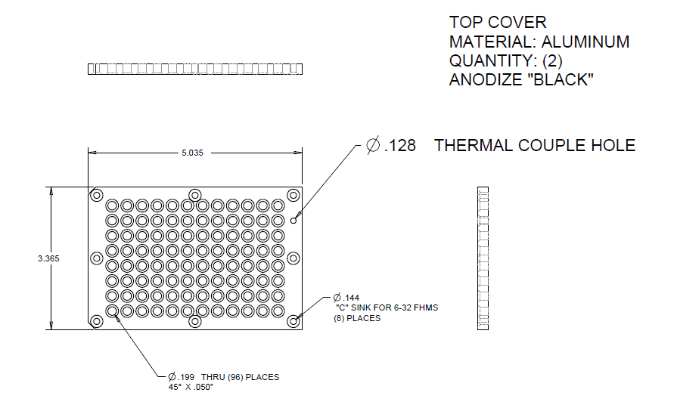
Figure SI-1. Custom aluminum needle-guiding top cover

Analytical methods
Reaction analysis was carried out through utilization of the HPLC-UV method described in Table SI-1.
Table SI-1. HPLC-UV method for yield determination
Column: | Cortecs C18 2.7 µm, 4.6 x 150 mm
Column Temperature: | 55 ºC
Flow Rate: | 1.5 ml/min
Detection: | 210 nm
Acquisition Time: | 10 min
Mobile Phase: | Solvent A = 2 mM ammonium formate in water; Solvent B = 2 mM ammonium formate in acetonitrile 10% water
Mobile Phase Program: | Time  0.00 min  6.00 min  8.00 min  8.10 min  10.00 min | B%  5  95  95  5  5
Injection Volume: | 5 µL
Compound Name: | Retention time:
3-(benzyloxy)phenyl)boronic acid (3) | 4.75 min
1,3,5-trimethoxybenzene | 4.93 min
(E)-Methyl 3-cyclopropyl-2-methyl-3-(tosyloxy)acrylate (1-E) | 6.13 min
(Z)-Methyl 3-(3-(benzyloxy)phenyl)-3-cyclopropyl-2-methylacrylate (2-Z) | 6.98 min
(E)-Methyl 3-(3-(benzyloxy)phenyl)-3-cyclopropyl-2-methylacrylate (2-E) | 7.10 min
Example Chromatogram
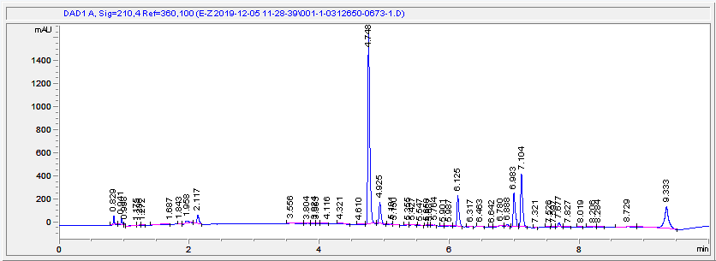

Experimental procedures

Procedure for stock mixture preparations
Fresh stock mixtures were prepared in 4 - 20 ml vials in a positive nitrogen pressure glove box, sealed with septa caps and transferred to the positive nitrogen pressure Chemspeed robot deck. Stock mixture concentrations were selected based on factors such as solubility, minimum accurate dispense volume, and a 200 µl total organic reaction volume (Tables SI-2 and SI-3). The mixtures were prepared by weighing the solids or oils on an analytical balance followed by adding anhydrous ACN through manual pipetting. The recipes followed in stock mixture preparation are provided in Tables SI-4 and SI-5.
Table SI-2. Campaign 1 stock mixture concentrations and parameter ranges
Chemical | Eq low | Eq high | µmol low | µmol high | µl low | µl high | M
Pd(ACN)₂Cl₂ | 0.01 | 0.05 | 0.1 | 0.5 | 10 | 50 | 0.010
P Ligand | 0.005 | 0.20 | 0.05 | 2 | 1 | 50 | 0.040
E-Tosyl (1-E) | 1.00 | 1.00 | 10 | 10 | 20 | 20 | 0.500
Internal Std* | 0.10 | 0.10 | 1 | 1 | 20 | 20 | 0.050
ArBA (3) | 1.00 | 2.00 | 10 | 20 | 40 | 80 | 0.250
K₃PO₄ | 3.00 | 3.00 | 30 | 30 | 60 | 60 | 0.500
ACN |  |  |  |  | 129
Total Org |  |  |  |  | 200 | 200
Total Aq |  |  |  |  | 60 | 60
*1,3,5-trimethoxybenzene
Table SI-3. Campaigns 2 and 3 stock mixture concentrations and parameter ranges
Chem | Eq low | Eq high | µmol low | µmol high | µl low | µl high | M
Pd(ACN)₂Cl₂ | 0.01 | 0.05 | 0.1 | 0.5 | 10 | 50 | 0.010
P Ligand | 0.01 | 0.20 | 0.05 | 2 | 3 | 100 | 0.020
E-Tosyl (1-E) | 1.00 | 1.00 | 10 | 10 | 20 | 20 | 0.500
Internal Std* | 0.10 | 0.10 | 1 | 1 | 20 | 20 | 0.050
ArBA (3) | 1.50 | 1.50 | 15 | 15 | 30 | 30 | 0.500
K₃PO₄ | 3.00 | 3.00 | 30 | 30 | 60 | 60 | 0.500
ACN |  |  |  |  | 138
Total Org |  |  |  |  | 200 | 200
Total Aq |  |  |  |  | 60 | 60
*1,3,5-trimethoxybenzene
Table SI-4. Campaign 1 stock mixture recipes
Mixture | Chemical | MW (g/mol) | Amount (mg) | Density (g/ml)* | Amount (ml)
Pd(ACN)₂Cl₂ | 14592-56-4 | 259.43 | 31.13 | 1.00 | 0.03
Pd(ACN)₂Cl₂ | ACN | 41.05 |  | 0.79 | 11.97
PPh₃ (L1) | 603-35-0 | 262.29 | 125.90 | 1.00 | 0.13
PPh₃ (L1) | ACN | 41.05 |  | 0.79 | 11.87
PoTol₃ (L2) | 6163-58-2 | 304.37 | 146.10 | 1.00 | 0.15
PoTol₃ (L2) | ACN | 41.05 |  | 0.79 | 11.85
PtBu_{3.}HBF₄ (L3) | 131274-22-1 | 202.32 | 97.11 | 1.00 | 0.10
PtBu_{3.}HBF₄ (L3) | ACN | 41.05 |  | 0.79 | 11.90
AtaPhos (L4) | 932710-63-9 | 265.38 | 127.38 | 1.00 | 0.13
AtaPhos (L4) | ACN | 41.05 |  | 0.79 | 11.87
MorDalPhos (L5) | 1237588-12-3 | 463.65 | 222.55 | 1.00 | 0.22
MorDalPhos (L5) | ACN | 41.05 |  | 0.79 | 11.78
QPhos (L6) | 312959-24-3 | 710.72 | 341.15 | 1.00 | 0.34
QPhos (L6) | ACN | 41.05 |  | 0.79 | 11.66
DPPF (L7) | 12150-46-8 | 554.39 | 266.11 | 1.00 | 0.27
DPPF (L7) | ACN | 41.05 |  | 0.79 | 11.73
DTBPF (L8) | 84680-95-5 | 474.43 | 227.73 | 1.00 | 0.23
DTBPF (L8) | ACN | 41.05 |  | 0.79 | 11.77
XPhos (L9) | 564483-18-7 | 476.73 | 228.83 | 1.00 | 0.23
XPhos (L9) | ACN | 41.05 |  | 0.79 | 11.77
BrettPhos (L10) | 1070663-78-3 | 536.78 | 257.65 | 1.00 | 0.26
BrettPhos (L10) | ACN | 41.05 |  | 0.79 | 11.74
AdBrettPhos (L11) | 1160861-59-5 | 640.93 | 307.65 | 1.00 | 0.31
AdBrettPhos (L11) | ACN | 41.05 |  | 0.79 | 11.69
RockPhos (L12) | 1262046-34-3 | 468.71 | 224.98 | 1.00 | 0.22
RockPhos (L12) | ACN | 41.05 |  | 0.79 | 11.78
E-Tos | E-Tos (1-E) | 310.36 | 744.87 | 1.00 | 0.74
E-Tos | 1,3,5-trimethoxybenzene | 168.19 | 40.37 | 1.00 | 0.04
E-Tos | ACN | 41.05 |  | 0.79 | 4.01
ArBA | ArBA (3) | 228.05 | 1094.64 | 1.00 | 1.09
ArBA | Water | 18.02 |  | 1.00 | 0.91
ArBA | ACN | 41.05 |  | 0.79 | 18.11
K₃PO₄ | potassium phosphate, tribasic | 212.27 | 3056.62 | 1.00 | 3.06
K₃PO₄ | ACN | 41.05 |  | 0.79 | 25.74
*Density of 1.00 g/ml was assumed for all solids.
Table SI-5. Campaigns 2 and 3 stock mixture recipes
Mixture | Chemical | MW | Amount (mg) | Density (g/ml)* | Amount (ml)
Pd(ACN)₂Cl₂ | 14592-56-4 | 259.43 | 37.36 | 1.00 | 0.04
Pd(ACN)₂Cl₂ | ACN | 41.05 |  | 0.79 | 14.36
PEt₃ (L13) | 554-70-1 | 118.16 | 17.02 | 0.80 | 0.0212
PEt₃ (L13) | ACN | 41.05 |  | 0.79 | 7.18
PCy₂Ph (L19) | 6476-37-5 | 274.38 | 39.51 | 1.00 | 0.04
PCy₂Ph (L19) | ACN | 41.05 |  | 0.79 | 7.16
1-Cy₂P-2’,4’,6’-MeO-Ph₂ (L28) | 1000171-05-0 | 440.55 | 63.44 | 1.00 | 0.06
1-Cy₂P-2’,4’,6’-MeO-Ph₂ (L28) | ACN | 41.05 |  | 0.79 | 7.14
PPh₂(2,6-Me-Ph) (L20) | 117672-33-0 | 290.34 | 41.81 | 1.00 | 0.04
PPh₂(2,6-Me-Ph) (L20) | ACN | 41.05 |  | 0.79 | 7.16
PPh₂(2-OMe-Ph) (L21) | 53111-20-9 | 292.31 | 42.09 | 1.00 | 0.04
PPh₂(2-OMe-Ph) (L21) | ACN | 41.05 |  | 0.79 | 7.16
PallylPh₂ (L22) | 2741-38-0 | 226.25 | 32.58 | 1.05 | 0.03
PallylPh₂ (L22) | ACN | 41.05 |  | 0.79 | 7.17
JohnPhos (L29) | 224311-51-7 | 298.40 | 42.97 | 1.00 | 0.04
JohnPhos (L29) | ACN | 41.05 |  | 0.79 | 7.16
P(C₆F₅)₂Ph (L23) | 5074-71-5 | 442.20 | 63.68 | 1.00 | 0.06
P(C₆F₅)₂Ph (L23) | ACN | 41.05 |  | 0.79 | 7.14
RockPhos (L12) | 1262046-34-3 | 468.69 | 67.49 | 1.00 | 0.07
RockPhos (L12) | ACN | 41.05 |  | 0.79 | 7.13
PhAtaPhos (L24) | 739-58-2 | 305.35 | 43.97 | 1.00 | 0.04
PhAtaPhos (L24) | ACN | 41.05 |  | 0.79 | 7.16
SPhos (L31) | 657408-07-6 | 410.53 | 59.12 | 1.00 | 0.06
SPhos (L31) | ACN | 41.05 |  | 0.79 | 7.14
(R)SITCP (L18) | 856407-37-9 | 354.42 | 51.04 | 1.00 | 0.05
(R)SITCP (L18) | ACN | 41.05 |  | 0.79 | 7.15
P(mesityl)₃ (L14) | 23897-15-6 | 388.52 | 55.95 | 1.00 | 0.06
P(mesityl)₃ (L14) | ACN | 41.05 |  | 0.79 | 7.14
P(3,5-Me-4-OMe-Ph)₃ (L15) | 121898-64-4 | 436.52 | 62.86 | 1.00 | 0.06
P(3,5-Me-4-OMe-Ph)₃ (L15) | ACN | 41.05 |  | 0.79 | 7.14
Et-PhenCarPhos (L32) | 1308652-66-5 | 331.39 | 47.72 | 1.00 | 0.05
Et-PhenCarPhos (L32) | ACN | 41.05 |  | 0.79 | 7.15
PoTol₃ (L2) | 6163-58-2 | 304.37 | 43.83 | 1.00 | 0.04
PoTol₃ (L2) | ACN | 41.05 |  | 0.79 | 7.16
Ph₂P(CH₂)₃Si(OEt)₃ (L25) | 52090-23-0 | 390.53 | 56.24 | 1.00 | 0.06
Ph₂P(CH₂)₃Si(OEt)₃ (L25) | ACN | 41.05 |  | 0.79 | 7.14
PPh(4-(2,2-CF₃-F₇pent)-Ph)₂ (L26) | 322647-83-6 | 926.41 | 133.40 | 1.00 | 0.13
PPh(4-(2,2-CF₃-F₇pent)-Ph)₂ (L26) | ACN | 41.05 |  | 0.79 | 7.07
m-CroPhos (L27) | 1620882-90-7 | 200.30 | 28.84 | 1.00 | 0.03
m-CroPhos (L27) | ACN | 41.05 |  | 0.79 | 7.17
AtaPhos (L4) | 932710-63-9 | 265.37 | 38.21 | 1.00 | 0.04
AtaPhos (L4) | ACN | 41.05 |  | 0.79 | 7.16
PhSPhos (L30) | 819867-24-8 | 398.43 | 57.37 | 1.00 | 0.06
PhSPhos (L30) | ACN | 41.05 |  | 0.79 | 7.14
P(nOct)₃ (L16) | 4731-53-7 | 370.64 | 53.37 | 0.83 | 0.06
P(nOct)₃ (L16) | ACN | 41.05 |  | 0.79 | 7.14
PnPr₃ (L17) | 2234-97-1 | 160.24 | 23.07 | 0.80 | 0.0288
PnPr₃ (L17) | ACN | 41.05 |  | 0.79
E-Tos | E-Tos (1-E) | 310.36 | 893.85 | 1.00 | 0.89
E-Tos | 1,3,5-trimethoxybenzene | 168.19 | 48.44 | 1.00 | 0.05
E-Tos | ACN | 41.05 |  | 0.79 | 4.82
ArBA | ArBA (3) | 228.05 | 985.18 | 1.00 | 0.99
ArBA | Water | 18.02 |  | 1.00 | 0.38
ArBA | ACN | 41.05 |  | 0.79 | 7.65
K₃PO₄ | potassium phosphate, tribasic | 212.27 | 2445.29 | 1.00 | 2.45
K₃PO₄ | ACN | 41.05 |  | 0.79 | 20.59
*Density of 1.00 g/ml was assumed for all solids.

Procedure for autonomous optimization experiments
General: Two fluoropolymer and PFA mat-sealed 96-well metal blocks with 1 mL glass vial inserts were equilibrated at the designated reaction temperature under 20 psig of nitrogen with 500 rpm agitation.
Representative procedure for test reactions: In campaigns involving 192 iterations, eight wells from each 96-well reaction block were dedicated to standard reactions to test for reproducibility. To each well was dispensed Pd(ACN)₂Cl₂ (0.25 µmol, 25 µl of 0.01 M stock solution), and L2 (PoTol₃) (0.38 µmol, 19 µl of 0.02 M stock mixture), followed by 7 min of age time. Then, E-tosylate 1-E (10 µmol) with 1,3,5-trimethoxybenzene (1 µmol) was dispensed (20 µl of 0.5 M/ 0.05 M stock solution), followed by (3-(benzyloxy)phenyl)boronic acid 3 (15 µmol, 30 µl of 0.5 M stock solution in degassed ACN 5% H₂O), followed by anhydrous ACN (106 µl) to ensure a total organic solvent volume of 200 µl. Then, a dispense of degassed aqueous K₃PO₄ (30 µmol, 60 µl of 0.5 M stock solution) was carried out to initiate the reaction. This procedure was executed sequentially for each well within a loop of eight replicates in 15-minute intervals. Each replicate was time stamped individually, aged for 120 min, and sampled for online analysis.
Representative procedure for optimization reactions: In campaigns involving 192 iterations, 88 wells from each 96-well reaction block were dedicated to the optimization reactions. To each well was dispensed Pd(ACN)₂Cl₂ (0.1 - 0.5 µmol, 10 - 50 µl of 0.01 M stock solution), and phosphine ligand (0.05 - 2.0 µmol, 3 - 100 µl of 0.02 M stock mixture), followed by 7 min of age time. Then, E-tosylate 1-E (10 µmol) with 1,3,5-trimethoxybenzene (1.0 µmol) was dispensed (20 µl of 0.5 M/ 0.05 M stock solution), followed by (3-(benzyloxy)phenyl)boronic acid 3 (15 µmol, 30 µl of 0.5 M stock solution in degassed ACN 5% H₂O), followed by anhydrous ACN (0 - 138 µl) to ensure a total organic solvent volume of 200 µl. Then, a dispense of degassed aqueous K₃PO₄ (30 µmol, 60 µl of 0.5 M stock solution) was carried out to initiate the reaction. This procedure was executed sequentially for each well within a loop of eight experiments in 15-minute intervals. Each reaction was time stamped individually, aged for 120 min, and sampled for online analysis.
Sampling and analysis: Two polypropylene 96-well collection blocks sealed with a silicone mats were manually prefilled with 800 µl of acetonitrile 10% aqueous pH 3.5 ammonium formate buffer and placed on the robot deck. Upon reaching the reaction end point at 120 min, 10 ul of reaction mixture was aliquoted and dispensed into the 800 ul quench solution in the collection block. Upon needle-mixing, 40 ul of quenched sample from the collection block was aliquoted and injected to the on-deck sampling valve outfitted with a 5 µl loop. The valve was automatically switched to transfer the sample to the Agilent 1100 HPLC for analysis.
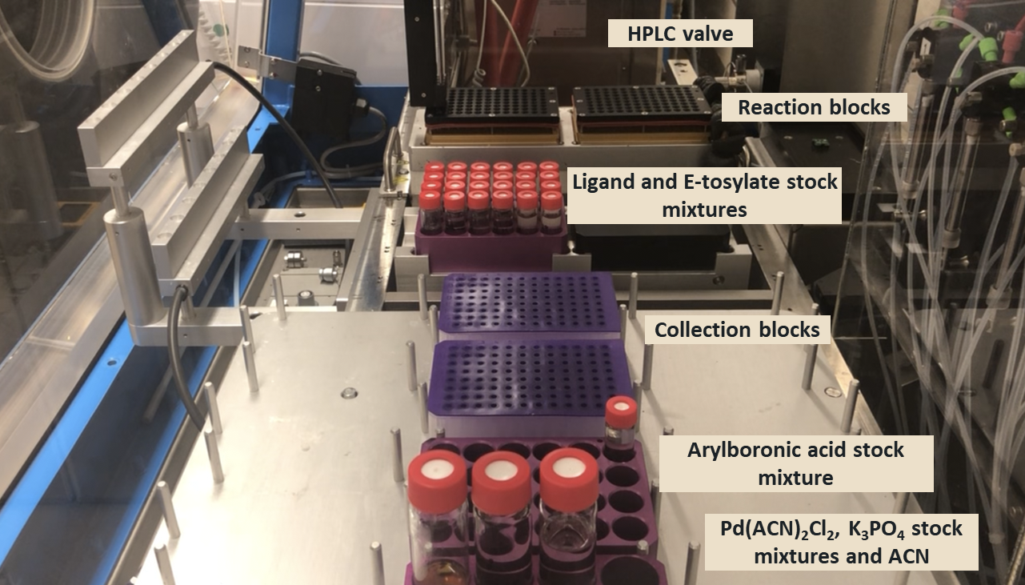
Figure SI-2: Chemspeed robot deck during autonomous experiments

Procedure for manual experiments

Manual experiments were carried out in in a positive nitrogen pressure glove box, in 96-well aluminum reaction blocks with 8 x 30 mm glass vial inserts. To each well was pipet dispensed Pd(ACN)₂Cl₂ (0.38 µmol, 38 µl of 0.01 M stock solution), and phosphine ligand (0.92 µmol, 46 µl of 0.02 M stock mixture), followed by 7 min of age time. Then, E-tosylate 1-E (10 µmol) with 1,3,5-trimethoxybenzene (1 µmol) was pipet dispensed (20 µl of 0.5 M/ 0.05 M stock solution), followed by (3-(benzyloxy)phenyl)boronic acid 3 (15 µmol, 30 µl of 0.5 M stock solution in degassed ACN 5% H₂O), followed by anhydrous ACN (66 µl) to ensure a total organic solvent volume of 200 µl. Then, degassed aqueous K₃PO₄ (30 µmol, 60 µl of 0.5 M stock solution) was pipet dispensed. The block was sealed and agitated for 120 minutes at 35 °C under 500 rpm tumble stirring. Upon reaction completion, 10 ul of reaction mixture was aliquoted and quenched into 800 µl of acetonitrile 10% aqueous pH 3.5 ammonium formate buffer. Each sample was analyzed via the Chemspeed online HPLC for consistency.

Procedures for the preparation of non-commercial compounds

Methyl 3-cyclopropyl-2-methyl-3-oxopropanoate 5:
To a round-bottomed flask under nitrogen atmosphere was charged methyl 3-cyclopropyl-3-oxopropanoate 4 (40.0 g, 281 mmol), K₂CO₃ (58.3 g, 422 mmol) and CPME (100 ml). Methyl iodide (17.6 ml, 281 mmol) was added slowly and the reaction was agitated at 25° C for 1.5 h. Additional methyl iodide (17.6 ml, 281 mmol) was added slowly and the reaction was agitated at 25° C for an additional 16 h. K₂CO₃ was removed through filtration and the cake was washed with CPME (50 ml). The filtrate was concentrated to an oil that was purified by normal phase column chromatography to give methyl 3-cyclopropyl-2-methyl-3-oxopropanoate 5 in 59% yield.
(E)-Methyl 3-cyclopropyl-2-methyl-3-(tosyloxy)acrylate 1-E:
To an oven-dried round-bottomed flask under nitrogen atmosphere was added methyl 3-cyclopropyl-2-methyl-3-oxopropanoate 5 (26.0 g, 166 mmol) and THF (260 ml). The mixture was cooled to -78 °C and 1M NaHMDS solution in THF (200 ml, 200 mmol) was added over 20 min, maintaining the internal temperature below -60 °C, followed by a THF rinse (65 ml). The reaction was agitated at -78 °C for 20 min and Ts₂O (65.2 g, 200 mmol) in THF (520 ml) was added over 20 min, maintaining the internal temperature below -60 °C. The reaction was agitated at -78 °C for 20 min, then warmed to 25 °C and agitated for 16 h. A thick slurry formed. The reaction was quenched with 750 ml of aqueous 0.5M NaHCO₃ and the phases were separated. The aqueous layer was back-extracted twice with 250 ml of EtOAc. The organic layers were combined and washed with 500 ml of saturated aqueous NaCl, dried over MgSO₄ and filtered. Upon concentration to an oil, the crude product was purified by normal phase column chromatography to give (E)-methyl 3-cyclopropyl-2-methyl-3-(tosyloxy)acrylate 1-E¹ in 31% yield.
(E)-Methyl 3-(3-(benzyloxy)phenyl)-3-cyclopropyl-2-methylacrylate 2-E and (Z)-Methyl 3-(3-(benzyloxy)phenyl)-3-cyclopropyl-2-methylacrylate 2-Z:
To a reaction vial in a positive nitrogen pressure glove box was charged (E)-methyl 3-cyclopropyl-2-methyl-3-(tosyloxy)acrylate 1-E (1.00 g, 3.22 mmol), (3-(benzyloxy)phenyl)boronic acid 3 (0.808 g, 3.54 mmol), and palladium precatalyst 6 (0.298 g, 0.322 mmol). Anhydrous ACN (15 ml) and degassed 1M aqueous K₃PO₄ (9.67 ml, 9.67 mmol) were added and the reaction was agitated at 25 °C for 8 h. To the reaction was added 10 ml of saturated aqueous NH₄Cl and the organic layer was separated from the aqueous layer. The aqueous layer was back-extracted twice with 10 ml of EtOAc. The combined organic layers were washed with 10 ml of saturated aqueous NaCl, dried over MgSO₄ and filtered. Upon concentration to an oil, the crude product was purified by normal phase column chromatography to give (E)-methyl 3-(3-(benzyloxy)phenyl)-3-cyclopropyl-2-methylacrylate 2-E in 52% and (Z)-methyl 3-(3-(benzyloxy)phenyl)-3-cyclopropyl-2-methylacrylate 2-Z¹ in 33% yield.
(2,6-dimethylphenyl)diphenylphosphane L20:
To a reaction vial in a positive nitrogen pressure glove box was charged Cu(OTf)₂ (0.268 g, 0.742 mmol), diphenylphosphine oxide 7 (1.00 g, 4.95 mmol), anhydrous toluene (20 ml) and TMDS (1.76 ml, 9.89 mmol). The reaction was agitated at 100 °C for 5 h with needle venting to avoid pressure build-up. Additional TMDS (0.868 ml, 4.95 mmol) was charged and the reaction was agitated at 100 °C for an additional 16 h with no venting. Upon cooling to 25 °C, to the reaction vial was added DMEDA (0.106 ml, 0.989 mmol), Cs₂CO₃ (3.22 g, 9.89 mmol) and 2-iodo-1,3-dimethylbenzene 8 (1.15 g, 4.95 mmol). The suspension was agitated at 110 °C for 48 h. The reaction was cooled to 0 °C and KOH (20.6 ml, 61.8 mmol) in MeOH (3N) was added slowly to maintain the temperature below 0 °C. The mixture was agitated at 25 °C for 5 h. The quenched mixture was removed from the glovebox and 30 ml water was added. The resulting solution was back-extracted three times with 50 ml EtOAc. The combined organic layers were washed with 50 ml of 1M aqueous HCl, followed by 50 ml of 0.5M aqueous NaHCO₃. The organic layer was decanted to remove elemental copper, dried over Na₂SO₄ and filtered. Upon concentration to an oil, the crude product was purified by normal phase column chromatography to give (2,6-dimethylphenyl)diphenylphosphane L20 in 13% yield.
- Data integration script
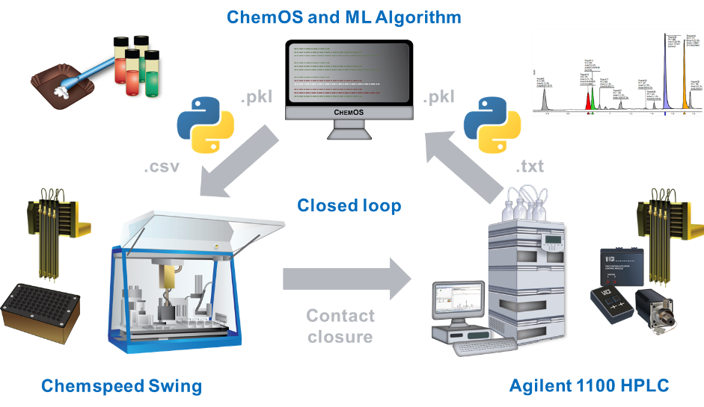
Figure SI-3: Schematic of data integration established through Python
The Python script used in this work provided an interface between the tools involved in the optimization. This script performed three primary operations: receiving instructions from ChemOS, conveying them to the Chemspeed, monitoring for HPLC results, and conveying those results back to ChemOS. The script has been made publicly available on Gitlab at https://gitlab.com/heingroup/cs-auto-optimization under the MIT open source license.
ChemOS parameters were conveyed to the experimental computer via a file syncing service in the form of pickled dictionaries (dictionaries written to file with Python’s pickle standard library). Parameter values were provided in ratios and equivalents, which were converted to volumes for the Chemspeed to dispense based on stored concentrations. Stock mixture concentrations were defined in a separate file, and all dispensing volumes were determined by their relation to the volume and concentration of the vinyl tosylate (held constant for every reaction). For every value, the volume to dispense was determined, rounded to the nearest microliter (the smallest practically accurate volume that the Chemspeed SWING was capable of dispensing), then back-calculated to the actual ratio used. The parameter dictionary was updated with these values so that ChemOS was provided with the true values used to run the experiment. Finally, the total volume was calculated and the total well volume was made up to 200 µL with acetonitrile. Every volume was then written to a csv file which the Chemspeed was programmed to reference for dispensing volumes.
For interpreting and returning experiment result to Chemspeed, the script monitored the sample data directory for the Agilent HPLC. The HPLC method was configured to output a text report after method completion, which the script parsed and related to the E- and Z-product peaks by retention time, and a predetermined response factor was used to calculate the assay yield (see SI section 6.2). The result data was then returned to ChemOS via the file syncing service.

Autonomous optimization protocol

Sample csv file with dispense volumes

A sample csv file is provided as a separate SI document (Chemspeed dispense volumes sample file.csv). This file was automatically generated through the Python script as ChemOS instructions became available and referenced in the Chemspeed Autosuite protocol for dispense volumes, with each column being mapped to a distinct protocol source zone. The Python script also recorded analytical results to this csv file as Chemstation report files became available, mainly for recordkeeping purposes.

Sample Chemspeed Autosuite protocol

The below Chemspeed Autosuite protocol was executed in campaigns 2 and 3, running autonomously over four days.
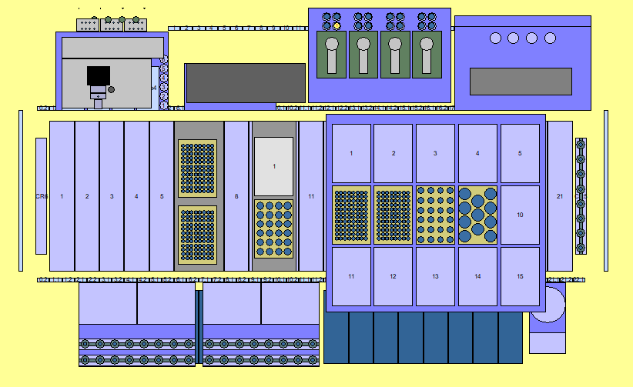
Figure SI-4: Chemspeed deck layout
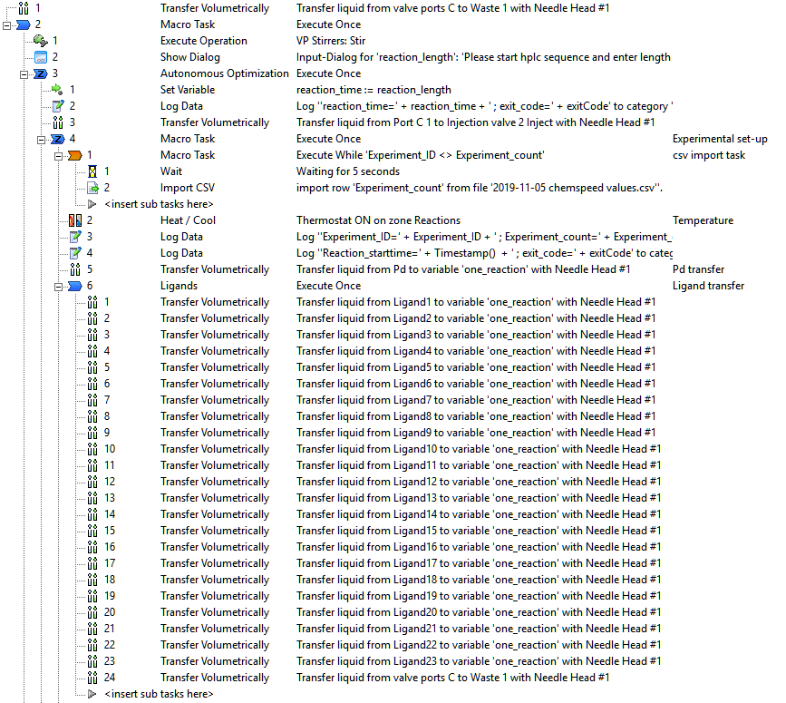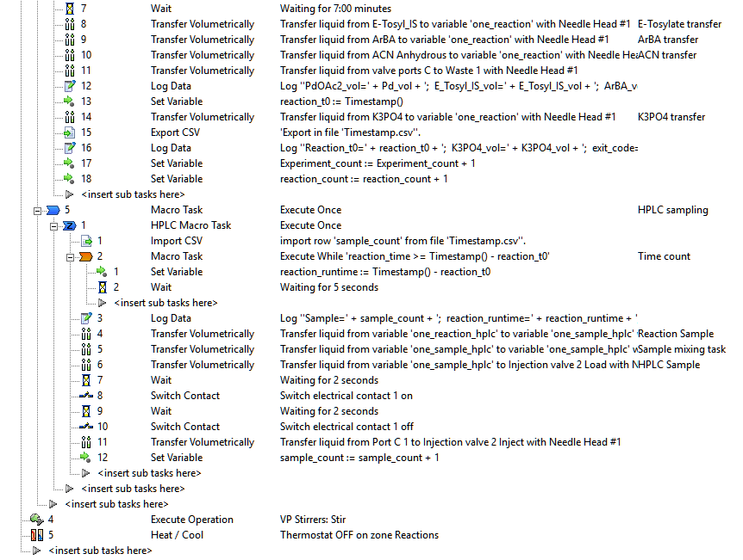

Machine learning algorithms
The ML algorithms used for experiment planning in this study, Phoenics and Gryffin, leverage fundamental concepts from Bayesian optimization in combination with kernel density estimation. Bayesian optimization is an approach to global optimization for applications where the evaluation of a single parameter point is highly time or resource demanding. While several formulations exist, Bayesian optimization follows a two-step strategy to suggest parameter points for future evaluation: (1) constructing a statistical approximation to the considered experiment based on collected measurements, and (2) locating parameter points for which the approximation predicts promising performance. Phoenics and Gryffin construct the statistical approximation based on kernel density estimates of evaluated parameters and suggest promising parameter points with an explicit balance of exploitative and explorative sampling behavior with native support for batch optimization.

Process constrained optimization in the context of autonomous experimentation
The autonomous experimentation workflow described in the main text targeted the optimization of both processing conditions and categorical design choices with the goal to maximize the stereoselectivity of a Suzuki-Miyaura coupling reaction. One such reaction can be executed within about two hours on the employed Chemspeed system. However, the Chemspeed system offers the opportunity to run multiple reactions at once. With this parallelization capability, the overall runtime of an experimental campaign consisting of 192 experiments could, in principle, be reduced substantially.

Executing multiple reactions on this system simultaneously introduces a critical limitation to the decision-making process concerning the suggestion of promising reaction parameters: the temperature can only be controlled collectively for all concurrent reactions as opposed to an independent control for all other reaction parameters. This limitation requires adaptations to the decision-making algorithm to account for this process constraint.

For a mathematical formulation of this adaption, we consider a parameter domain X, which we can split into a domain Xc on which parameters are process constrained and a domain Xuc on which parameters are not process constrained, such that X = X^{c} ∪ X^{uc}. The basic process constrained batch algorithm implemented in this study is inspired by a previously reported algorithm. Following the aforementioned partitioning of the parameter domain, we first search for promising values for the constrained parameter values x^{c} ∈ X^{c}, for which we marginalize the collected feedback onto the X^{c} domain. Subsequently, we search for promising parameter choices for x^{uc} ∈ X^{uc} while considering the feedback on the entire domain X given the specific choice of x^{c} which we determined in the first step. Implementing this process in the kernel-based Bayesian optimization framework provided by Phoenics allows us to choose different sampling policies for the constrained and the unconstrained parameters. In this study, we choose two sampling policies for the constrained parameter and eight policies for the unconstrained parameters to reflect the fact that we executed eight reactions simultaneously.

Analytical data

¹H NMR weight % purity determinations

Vinyl tosylate 1-E, coupled product 2-E, and coupled product 2-Z were assayed for weight % purity by ¹H NMR against an internal standard of known weight and purity (99% 1,3,5-trimethoxybenzene). The tables and figures below show the weight % purity calculations based on ¹H NMR spectra using the equation Purity_{cpd}= Purity_{std}*Area_{cpd}/Area_{std}*Protons_{std}/Protons_{cpd}*MW_{cpd}/MW_{std}*Weight_{std}/Weight_{cpd}.
Table SI-6: Weight % purity calculation for 1-E
 | Peak Area  (counts) | Protons  (#) | MW (g/mol) | Weight (mg) | Purity  (wt%)
Internal Std. | 5.30 | 3 | 168.19 | 19.75 | 99%
1-E | 2.02 | 2 | 310.36 | 21.41 | 96%

Table SI-7: Weight % purity calculation for 2-E
 | Peak Area  (counts) | Protons  (#) | MW (g/mol) | Weight (mg) | Purity  (wt%)
Internal Std. | 5.35 | 3 | 168.19 | 19.83 | 99%
2-E | 2.03 | 2 | 322.40 | 22.75 | 94%

Table SI-8: Weight % purity calculation for 2-Z
 | Peak Area  (counts) | Protons  (#) | MW (g/mol) | Weight (mg) | Purity  (wt%)
Internal Std. | 5.26 | 3 | 168.19 | 17.90 | 99%
2-Z | 1.96 | 2 | 322.40 | 19.55 | 97%

Figure SI-5: ¹H NMR for weight % purity determination of vinyl tosylate 1-E
Figure SI-6: ¹H NMR for weight % purity determination of Suzuki product 2-E
Figure SI-7: ¹H NMR for weight % purity determination of Suzuki product 2-Z

Calibration curves

HPLC-UV calibration curves were generated to determine the mol % distribution of reaction components 1-E, 2-E and 2-Z through measuring the ratio of their peak areas to an internal standard (IS) peak area (10 mol% 1,3,5-trimethoxybenzene). Four mixtures were prepared containing 10 mol% IS and 100, 75, 50 or 25 mol% of each compound. Each mixture was acquired on the Chemspeed online HPLC system at 210 nm in duplicate. The mol% of compound in each mixture was plotted against the measured peak area ratio of each compound to IS, generating the calibration curves provided in figure SI-8. Linear regression with the intercept set at zero allowed for the determination of response factors for straightforward conversion of compound to IS ratio to mol % compound through the following equation: mol % compound = m * peak area of compound at 210 nm / peak area of IS at 210 nm, where m = the response factor determined through calibration. These response factors were included in the Python script for automated calculation of mol % compound from the HPLC data.

Figure SI-8: Calibration curves for conversion of compound (1-E, 2-E, 2-Z) to internal standard (IS) HPLC area ratios at 210 nm to mol % distribution in the reaction mixture.

Preliminary data

Table SI-9: Reaction conditions and data included in Figure 1 of the main manuscript
Expt | Temp | Pd mol% | P ligand | P/Pd | ArBA eq. | 1-E mol% | 2-E mol% | 2-Z mol%
1 | 25.00 | 4.10 | None | 0.00 | 1.95 | 1 | 3 | 91
2 | 25.00 | 1.70 | L11 | 2.35 | 1.05 | 45 | 1 | 48
3 | 25.00 | 1.70 | L7 | 2.35 | 1.05 | 2 | 60 | 35

Campaign 1 data

Table SI-10: Reaction conditions and data included in Figure 3 of the main manuscript
Expt | Temp | Pd mol% | P ligand | P/Pd | ArBA eq. | 1-E mol% | 2-E mol% | 2-Z mol%
1 | 29.14 | 2.50 | L5 | 3.36 | 1.25 | 95 | 1 | 5
2 | 29.14 | 3.90 | L2 | 2.36 | 1.03 | 86 | 3 | 3
3 | 29.14 | 2.80 | L1 | 1.71 | 1.30 | 43 | 25 | 45
4 | 29.14 | 2.70 | L11 | 1.93 | 1.03 | 9 | 2 | 88
5 | 29.14 | 2.00 | L8 | 2.80 | 1.45 | 59 | 3 | 31
6 | 29.14 | 1.20 | L8 | 3.33 | 1.75 | 61 | 2 | 29
7 | 29.14 | 1.90 | L4 | 1.47 | 1.33 | 11 | 10 | 78
8 | 29.14 | 2.90 | L3 | 2.07 | 1.53 | 86 | 0 | 2
9 | 25.50 | 4.90 | L3 | 1.80 | 1.95 | 41 | 4 | 46
10 | 25.50 | 4.90 | L12 | 0.82 | 1.93 | 1 | 2 | 95
11 | 25.50 | 4.90 | L7 | 3.59 | 1.98 | 79 | 1 | 1
12 | 25.50 | 4.00 | L7 | 0.60 | 1.90 | 1 | 26 | 75
13 | 25.50 | 1.30 | L10 | 4.00 | 1.90 | 48 | 1 | 33
14 | 25.50 | 4.90 | L10 | 3.76 | 1.85 | 8 | 2 | 70
15 | 25.50 | 1.80 | L1 | 0.44 | 1.43 | 54 | 26 | 41
16 | 25.50 | 2.50 | L1 | 3.68 | 1.08 | 76 | 2 | 6
17 | 10.33 | 4.80 | L12 | 3.42 | 1.20 | 2 | 3 | 98
18 | 10.33 | 1.40 | L1 | 0.57 | 1.33 | 47 | 23 | 23
19 | 10.33 | 2.50 | L2 | 1.12 | 2.00 | 41 | 26 | 21
20 | 10.33 | 1.00 | L6 | 3.20 | 1.38 | 75 | 0 | 11
21 | 10.33 | 1.40 | L10 | 0.57 | 1.88 | 36 | 1 | 52
22 | 10.33 | 1.90 | L1 | 0.63 | 1.23 | 38 | 26 | 23
23 | 10.33 | 2.40 | L1 | 0.50 | 1.33 | 30 | 4 | 64
24 | 10.33 | 4.60 | L6 | 0.61 | 1.08 | 11 | 2 | 80
25 | 13.10 | 3.60 | L5 | 3.56 | 1.90 | 77 | 0 | 10
26 | 13.10 | 4.80 | L9 | 0.50 | 1.20 | 12 | 5 | 78
27 | 13.10 | 2.80 | L1 | 3.00 | 1.93 | 77 | 1 | 1
28 | 13.10 | 2.20 | L5 | 0.91 | 1.08 | 27 | 2 | 70
29 | 13.10 | 1.90 | L1 | 1.47 | 1.00 | 86 | 6 | 10
30 | 13.10 | 4.90 | L3 | 0.90 | 1.23 | 28 | 5 | 53
31 | 13.10 | 1.70 | L2 | 0.71 | 1.05 | 57 | 17 | 19
32 | 13.10 | 2.70 | L12 | 3.26 | 1.93 | 1 | 3 | 94
33 | 39.90 | 4.50 | L7 | 0.89 | 1.38 | 2 | 6 | 93
34 | 39.90 | 1.10 | L4 | 0.73 | 1.98 | 64 | 1 | 21
35 | 39.90 | 1.90 | L9 | 0.63 | 2.00 | 26 | 2 | 70
36 | 39.90 | 5.00 | L10 | 0.56 | 1.48 | 1 | 3 | 87
37 | 39.90 | 4.10 | L9 | 3.71 | 1.60 | 76 | 3 | 4
38 | 39.90 | 2.40 | L12 | 1.17 | 1.95 | 3 | 2 | 92
39 | 39.90 | 4.90 | L4 | 3.18 | 1.55 | 76 | 1 | 9
40 | 39.90 | 3.50 | L1 | 1.03 | 2.00 | 10 | 35 | 40
41 | 12.00 | 3.50 | L9 | 2.29 | 1.43 | 30 | 8 | 61
42 | 12.00 | 1.90 | L11 | 0.42 | 1.25 | 37 | 1 | 62
43 | 12.00 | 2.20 | L7 | 1.45 | 1.90 | 12 | 32 | 54
44 | 12.00 | 2.80 | L3 | 2.43 | 1.45 | 86 | 0 | 1
45 | 12.00 | 1.90 | L4 | 0.42 | 1.25 | 28 | 2 | 65
46 | 12.00 | 4.80 | L5 | 1.58 | 1.70 | 73 | 0 | 8
47 | 12.00 | 2.10 | L1 | 0.57 | 1.15 | 30 | 28 | 26
49 | 39.61 | 1.20 | L2 | 3.00 | 1.15 | 41 | 33 | 23
50 | 39.61 | 2.70 | L6 | 3.26 | 1.88 | 99 | 1 | 8
51 | 39.61 | 3.90 | L3 | 1.23 | 1.88 | 8 | 7 | 74
52 | 39.61 | 3.90 | L7 | 1.23 | 1.88 | 1 | 47 | 49
53 | 39.61 | 3.90 | L1 | 1.54 | 2.00 | 4 | 32 | 52
54 | 39.61 | 4.10 | L4 | 1.46 | 1.90 | 1 | 13 | 89
55 | 39.61 | 1.10 | L10 | 2.18 | 1.03 | 43 | 1 | 48
56 | 39.61 | 2.30 | L11 | 4.00 | 1.93 | 8 | 3 | 95
57 | 39.58 | 3.90 | L1 | 3.69 | 1.15 | 49 | 6 | 19
58 | 39.58 | 1.30 | L11 | 1.85 | 1.65 | 76 | 1 | 34
59 | 39.58 | 4.30 | L7 | 3.53 | 1.03 | 83 | 1 | 1
60 | 39.58 | 4.60 | L7 | 1.22 | 1.80 | 1 | 31 | 70
61 | 39.58 | 4.30 | L10 | 4.00 | 1.03 | 3 | 1 | 45
62 | 39.58 | 4.10 | L7 | 1.37 | 1.90 | 1 | 49 | 61
63 | 39.58 | 3.40 | L7 | 1.88 | 1.80 | 2 | 51 | 44
64 | 39.58 | 4.60 | L7 | 1.22 | 1.80 | 1 | 38 | 61
65 | 24.47 | 1.00 | L6 | 0.80 | 1.90 | 65 | 0 | 18
66 | 24.47 | 4.60 | L4 | 3.83 | 1.35 | 93 | 0 | 2
67 | 24.47 | 1.00 | L3 | 0.80 | 1.90 | 83 | 0 | 19
68 | 24.47 | 3.40 | L2 | 4.00 | 1.55 | 109 | 0 | 0
69 | 24.47 | 4.60 | L6 | 3.83 | 1.35 | 77 | 0 | 11
70 | 24.47 | 4.00 | L7 | 1.00 | 1.98 | 1 | 41 | 55
71 | 24.47 | 4.60 | L11 | 3.39 | 1.38 | 1 | 3 | 96
72 | 24.47 | 4.50 | L8 | 3.38 | 1.40 | 86 | 1 | 2
73 | 35.96 | 4.20 | L11 | 2.38 | 1.33 | 2 | 2 | 63
74 | 35.96 | 3.20 | L7 | 2.00 | 1.68 | 2 | 48 | 48
75 | 35.96 | 3.80 | L5 | 2.53 | 1.38 | 90 | 1 | 4
76 | 35.96 | 3.10 | L8 | 2.06 | 1.73 | 35 | 5 | 54
77 | 35.96 | 3.50 | L4 | 2.06 | 1.73 | 6 | 11 | 80
78 | 35.96 | 3.00 | L1 | 2.13 | 1.88 | 14 | 24 | 47
79 | 35.96 | 1.70 | L8 | 0.47 | 1.55 | 60 | 1 | 39
80 | 35.96 | 2.30 | L12 | 0.70 | 1.53 | 12 | 2 | 89
81 | 30.03 | 1.20 | L4 | 2.00 | 2.00 | 29 | 7 | 51
82 | 30.03 | 1.20 | L7 | 2.00 | 2.00 | 68 | 12 | 50
83 | 30.03 | 3.40 | L7 | 1.65 | 1.75 | 2 | 45 | 58
84 | 30.03 | 3.90 | L3 | 0.51 | 1.05 | 17 | 5 | 71
85 | 30.03 | 3.80 | L7 | 2.74 | 1.70 | 50 | 17 | 16
86 | 30.03 | 3.80 | L5 | 0.74 | 1.03 | 3 | 3 | 92
87 | 30.03 | 3.90 | L11 | 0.62 | 1.50 | 1 | 3 | 98
88 | 30.03 | 4.80 | L10 | 2.00 | 1.55 | 1 | 3 | 78
89 | 36.51 | 3.00 | L7 | 1.87 | 2.00 | 3 | 46 | 38
90 | 36.51 | 3.80 | L5 | 3.89 | 1.98 | 102 | 1 | 4
91 | 36.51 | 2.80 | L7 | 2.86 | 1.73 | 14 | 45 | 34
92 | 36.51 | 1.60 | L3 | 1.00 | 1.03 | 44 | 3 | 45
93 | 36.51 | 3.00 | L7 | 1.87 | 2.00 | 2 | 59 | 46
94 | 36.51 | 1.30 | L12 | 4.00 | 1.38 | 40 | 2 | 66
95 | 36.51 | 4.60 | L3 | 2.87 | 1.98 | 101 | 0 | 2
96 | 36.51 | 2.30 | L7 | 2.09 | 1.63 | 1 | 52 | 44
97 | 12.39 | 2.90 | L12 | 3.17 | 1.03 | 17 | 2 | 68
98 | 12.39 | 1.30 | L5 | 2.46 | 2.00 | 72 | 0 | 7
99 | 12.39 | 2.40 | L4 | 1.50 | 1.80 | 49 | 5 | 43
100 | 12.39 | 2.90 | L7 | 3.31 | 1.03 | 87 | 0 | 0
101 | 12.39 | 4.50 | L4 | 1.96 | 1.03 | 59 | 4 | 31
102 | 12.39 | 3.50 | L6 | 0.69 | 1.63 | 19 | 2 | 74
103 | 12.39 | 3.10 | L4 | 3.48 | 1.10 | 91 | 0 | 1
104 | 12.39 | 1.30 | L7 | 3.08 | 1.83 | 50 | 28 | 14
105 | 35.27 | 2.10 | L7 | 2.67 | 1.03 | 2 | 40 | 40
106 | 35.27 | 2.00 | L1 | 2.00 | 1.63 | 30 | 20 | 39
107 | 35.27 | 2.80 | L3 | 3.86 | 1.48 | 91 | 0 | 1
108 | 35.27 | 2.20 | L4 | 2.00 | 1.65 | 2 | 13 | 90
109 | 35.27 | 4.80 | L8 | 1.50 | 1.15 | 17 | 6 | 69
110 | 35.27 | 3.30 | L12 | 1.70 | 2.00 | 1 | 4 | 104
111 | 35.27 | 3.00 | L11 | 4.00 | 1.33 | 2 | 3 | 90
112 | 35.27 | 2.80 | L5 | 3.86 | 1.48 | 74 | 0 | 4
113 | 23.50 | 1.00 | L12 | 2.40 | 1.13 | 59 | 0 | 22
114 | 23.50 | 2.80 | L11 | 2.29 | 1.98 | 17 | 3 | 89
115 | 23.50 | 1.10 | L10 | 2.91 | 1.08 | 55 | 1 | 32
116 | 23.50 | 3.70 | L7 | 1.51 | 1.93 | 2 | 56 | 39
117 | 23.50 | 1.10 | L2 | 2.91 | 1.05 | 103 | 0 | 0
118 | 23.50 | 3.70 | L7 | 1.51 | 1.93 | 2 | 65 | 42
119 | 23.50 | 1.10 | L7 | 2.91 | 1.08 | 1 | 57 | 34
120 | 23.50 | 2.30 | L6 | 0.52 | 1.03 | 26 | 2 | 63

Campaign 2 data

Table SI-11: Reaction conditions and data included in Figure 5 of the main manuscript
Expt | Temp | Pd mol% | P ligand | P/Pd | 1-E mol% | 2-E mol% | 2-Z mol%
9 | 32.81 | 2.70 | L31 | 2.59 | 85 | 17 | 6
10 | 32.81 | 1.30 | L30 | 1.69 | 35 | 51 | 20
11 | 32.81 | 2.80 | L29 | 2.86 | 77 | 1 | 5
12 | 32.81 | 1.80 | L22 | 1.67 | 55 | 15 | 34
13 | 32.81 | 3.40 | L12 | 1.88 | 1 | 2 | 99
14 | 32.81 | 1.90 | L29 | 3.26 | 87 | 0 | 3
15 | 32.81 | 1.90 | L13 | 1.58 | 74 | 16 | 16
16 | 32.81 | 2.00 | L27 | 1.60 | 13 | 8 | 85
17 | 35.15 | 1.00 | L30 | 4.00 | 48 | 45 | 17
18 | 35.15 | 4.80 | L20 | 3.79 | 30 | 34 | 40
19 | 35.15 | 4.20 | L15 | 3.90 | 106 | 0 | 0
20 | 35.15 | 1.40 | L30 | 0.57 | 20 | 38 | 48
21 | 35.15 | 5.00 | L16 | 3.68 | 104 | 1 | 1
22 | 35.15 | 4.30 | L30 | 0.60 | 1 | 58 | 46
23 | 35.15 | 1.30 | L30 | 2.00 | 27 | 57 | 22
24 | 35.15 | 5.00 | L26 | 3.92 | 1 | 51 | 54
25 | 10.37 | 1.00 | L4 | 0.60 | 43 | 2 | 67
26 | 10.37 | 1.00 | L32 | 0.60 | 93 | 6 | 10
27 | 10.37 | 4.70 | L2 | 2.43 | 107 | 1 | 0
28 | 10.37 | 1.20 | L21 | 4.00 | 108 | 1 | 0
29 | 10.37 | 1.80 | L18 | 3.89 | 106 | 0 | 0
30 | 10.37 | 4.80 | L17 | 1.88 | 88 | 9 | 9
31 | 10.37 | 4.80 | L24 | 1.17 | 69 | 18 | 17
32 | 10.37 | 5.00 | L19 | 1.44 | 69 | 8 | 30
33 | 36.37 | 4.50 | L30 | 0.76 | 4 | 63 | 41
34 | 36.37 | 5.00 | L25 | 2.32 | 4 | 30 | 65
35 | 36.37 | 5.00 | L19 | 2.32 | 108 | 0 | 0
36 | 36.37 | 1.40 | L30 | 2.86 | 28 | 57 | 22
37 | 36.37 | 3.30 | L25 | 0.55 | 8 | 34 | 67
38 | 36.37 | 1.30 | L30 | 2.62 | 25 | 60 | 23
39 | 36.37 | 4.90 | L14 | 0.94 | 1 | 3 | 101
40 | 36.37 | 1.60 | L30 | 2.63 | 27 | 58 | 22
41 | 14.32 | 4.50 | L23 | 3.78 | 109 | 3 | 3
42 | 14.32 | 3.00 | L14 | 1.27 | 7 | 3 | 98
43 | 14.32 | 2.30 | L24 | 2.17 | 108 | 0 | 0
44 | 14.32 | 2.70 | L27 | 1.63 | 42 | 5 | 62
45 | 14.32 | 4.40 | L16 | 1.14 | 11 | 6 | 89
46 | 14.32 | 3.80 | L32 | 3.95 | 106 | 0 | 0
47 | 14.32 | 2.60 | L28 | 2.08 | 106 | 0 | 1
48 | 14.32 | 3.20 | L29 | 1.06 | 67 | 1 | 24
49 | 37.96 | 1.10 | L30 | 2.73 | 36 | 54 | 21
50 | 37.96 | 1.10 | L2 | 2.91 | 75 | 20 | 12
51 | 37.96 | 1.10 | L21 | 2.73 | 84 | 7 | 15
52 | 37.96 | 1.10 | L24 | 2.91 | 102 | 1 | 2
53 | 37.96 | 1.00 | L30 | 2.60 | 36 | 51 | 19
54 | 37.96 | 1.10 | L4 | 2.91 | 64 | 5 | 35
55 | 37.96 | 2.20 | L17 | 0.55 | 4 | 10 | 92
56 | 37.96 | 1.10 | L14 | 2.73 | 29 | 2 | 77
57 | 22.52 | 1.10 | L14 | 3.09 | 32 | 2 | 84
58 | 22.52 | 1.10 | L30 | 0.91 | 55 | 37 | 17
59 | 22.52 | 4.60 | L28 | 0.83 | 28 | 2 | 76
60 | 22.52 | 1.00 | L19 | 2.80 | 107 | 0 | 0
61 | 22.52 | 1.20 | L12 | 3.17 | 14 | 2 | 91
62 | 22.52 | 4.10 | L30 | 0.59 | 5 | 56 | 43
63 | 22.52 | 1.10 | L25 | 3.09 | 107 | 0 | 1
64 | 22.52 | 1.00 | L30 | 2.80 | 61 | 34 | 13
65 | 25.98 | 4.70 | L30 | 0.85 | 9 | 65 | 33
66 | 25.98 | 4.60 | L18 | 2.43 | 100 | 0 | 4
67 | 25.98 | 4.20 | L4 | 3.14 | 105 | 0 | 3
68 | 25.98 | 2.80 | L28 | 3.93 | 105 | 1 | 1
69 | 25.98 | 4.10 | L13 | 3.17 | 106 | 0 | 0
70 | 25.98 | 3.10 | L32 | 4.00 | 103 | 2 | 2
71 | 25.98 | 4.20 | L22 | 3.24 | 99 | 1 | 5
72 | 25.98 | 3.70 | L30 | 0.76 | 9 | 62 | 34
73 | 27.45 | 4.70 | L30 | 0.81 | 7 | 63 | 37
74 | 27.45 | 3.30 | L21 | 0.97 | 38 | 39 | 26
75 | 27.45 | 3.40 | L12 | 0.53 | 4 | 3 | 103
76 | 27.45 | 3.40 | L18 | 0.65 | 19 | 16 | 70
77 | 27.45 | 3.20 | L32 | 0.81 | 48 | 28 | 29
78 | 27.45 | 3.40 | L4 | 0.76 | 10 | 9 | 85
79 | 27.45 | 5.00 | L26 | 1.08 | 1 | 41 | 62
80 | 27.45 | 5.00 | L23 | 1.04 | 77 | 4 | 27
81 | 27.40 | 4.20 | L30 | 1.38 | 5 | 72 | 30
82 | 27.40 | 1.40 | L19 | 0.57 | 13 | 10 | 85
83 | 27.40 | 3.60 | L30 | 0.94 | 12 | 64 | 29
84 | 27.40 | 3.30 | L25 | 1.94 | 38 | 23 | 40
85 | 27.40 | 1.70 | L29 | 0.59 | 16 | 2 | 82
86 | 27.40 | 1.70 | L16 | 0.59 | 19 | 5 | 84
87 | 27.40 | 4.80 | L22 | 0.75 | 33 | 27 | 44
88 | 27.40 | 3.60 | L31 | 2.39 | 75 | 20 | 8
89 | 10.11 | 4.60 | L24 | 0.87 | 66 | 22 | 19
90 | 10.11 | 1.00 | L30 | 2.20 | 87 | 14 | 5
91 | 10.11 | 3.10 | L15 | 2.97 | 108 | 0 | 0
92 | 10.11 | 3.10 | L31 | 3.16 | 106 | 2 | 1
93 | 10.11 | 1.10 | L31 | 2.73 | 107 | 1 | 0
94 | 10.11 | 1.00 | L13 | 1.80 | 93 | 5 | 9
95 | 10.11 | 1.00 | L20 | 1.80 | 98 | 4 | 5
96 | 10.11 | 3.60 | L30 | 3.06 | 74 | 21 | 9
105 | 22.38 | 2.50 | L16 | 2.72 | 42 | 7 | 60
106 | 22.38 | 1.40 | L22 | 1.71 | 75 | 11 | 19
107 | 22.38 | 3.80 | L30 | 0.74 | 16 | 55 | 34
108 | 22.38 | 4.80 | L30 | 0.71 | 8 | 59 | 37
109 | 22.38 | 4.70 | L30 | 1.62 | 28 | 55 | 22
110 | 22.38 | 2.00 | L20 | 1.70 | 26 | 35 | 45
111 | 22.38 | 1.30 | L23 | 1.69 | 105 | 2 | 4
112 | 22.38 | 4.70 | L30 | 1.57 | 26 | 57 | 23
113 | 27.86 | 4.20 | L30 | 1.52 | 16 | 64 | 26
114 | 27.86 | 1.70 | L32 | 3.88 | 103 | 2 | 2
115 | 27.86 | 1.70 | L26 | 3.88 | 30 | 38 | 39
116 | 27.86 | 1.60 | L17 | 3.88 | 108 | 0 | 0
117 | 27.86 | 4.40 | L30 | 1.59 | 11 | 67 | 27
118 | 27.86 | 3.90 | L30 | 1.69 | 13 | 66 | 26
119 | 27.86 | 1.60 | L19 | 4.00 | 107 | 0 | 0
120 | 27.86 | 4.00 | L30 | 1.50 | 13 | 66 | 27
121 | 39.07 | 4.10 | L19 | 0.54 | 3 | 28 | 76
122 | 39.07 | 4.80 | L30 | 0.63 | 1 | 61 | 43
123 | 39.07 | 4.40 | L30 | 0.68 | 1 | 64 | 40
124 | 39.07 | 3.30 | L20 | 3.94 | 31 | 33 | 40
125 | 39.07 | 2.60 | L31 | 4.00 | 71 | 23 | 7
126 | 39.07 | 2.60 | L26 | 3.85 | 9 | 46 | 50
127 | 39.07 | 2.90 | L16 | 3.93 | 106 | 0 | 0
128 | 39.07 | 2.70 | L2 | 4.00 | 100 | 5 | 3
129 | 31.77 | 4.10 | L30 | 2.05 | 10 | 69 | 28
130 | 31.77 | 4.40 | L21 | 1.86 | 18 | 46 | 41
131 | 31.77 | 4.80 | L29 | 3.08 | 59 | 0 | 4
132 | 31.77 | 4.20 | L30 | 1.95 | 7 | 69 | 28
133 | 31.77 | 4.10 | L30 | 2.05 | 11 | 67 | 27
134 | 31.77 | 4.10 | L30 | 2.05 | 8 | 69 | 28
135 | 31.77 | 4.80 | L23 | 3.08 | 99 | 3 | 6
136 | 31.77 | 4.10 | L30 | 1.90 | 6 | 72 | 29
137 | 17.56 | 4.90 | L30 | 2.08 | 49 | 41 | 17
138 | 17.56 | 4.70 | L30 | 0.51 | 22 | 46 | 37
139 | 17.56 | 4.00 | L13 | 2.05 | 99 | 5 | 3
140 | 17.56 | 3.70 | L25 | 2.59 | 75 | 12 | 18
141 | 17.56 | 1.90 | L24 | 0.63 | 47 | 30 | 30
142 | 17.56 | 1.90 | L15 | 0.53 | 21 | 14 | 71
143 | 17.56 | 3.80 | L23 | 2.00 | 99 | 3 | 5
144 | 17.56 | 1.90 | L25 | 0.63 | 38 | 18 | 52
145 | 33.85 | 4.10 | L12 | 2.83 | 1 | 3 | 98
146 | 33.85 | 4.20 | L30 | 1.81 | 4 | 71 | 29
147 | 33.85 | 3.80 | L30 | 1.74 | 7 | 68 | 27
148 | 33.85 | 3.80 | L13 | 2.63 | 107 | 0 | 0
149 | 33.85 | 3.90 | L4 | 3.13 | 100 | 1 | 6
150 | 33.85 | 3.60 | L4 | 3.22 | 100 | 1 | 7
151 | 33.85 | 3.90 | L28 | 3.13 | 98 | 4 | 2
152 | 33.85 | 4.50 | L30 | 1.87 | 1 | 73 | 30
153 | 16.67 | 2.80 | L22 | 4.00 | 109 | 0 | 0
154 | 16.67 | 5.00 | L14 | 3.12 | 10 | 3 | 93
155 | 16.67 | 2.80 | L4 | 4.00 | 106 | 0 | 1
156 | 16.67 | 4.90 | L15 | 0.65 | 13 | 28 | 64
157 | 16.67 | 2.80 | L23 | 3.86 | 104 | 2 | 3
158 | 16.67 | 4.20 | L30 | 0.57 | 22 | 50 | 33
159 | 16.67 | 5.00 | L28 | 3.04 | 106 | 0 | 0
160 | 16.67 | 5.00 | L27 | 3.24 | 49 | 10 | 59
161 | 35.05 | 3.80 | L30 | 2.42 | 6 | 73 | 29
162 | 35.05 | 4.50 | L30 | 2.31 | 3 | 72 | 29
163 | 35.05 | 3.80 | L30 | 1.21 | 3 | 73 | 31
164 | 35.05 | 4.50 | L30 | 2.31 | 1 | 73 | 30
165 | 35.05 | 4.00 | L31 | 1.05 | 40 | 19 | 42
166 | 35.05 | 4.20 | L30 | 1.81 | 2 | 72 | 29
167 | 35.05 | 1.70 | L17 | 2.47 | 107 | 0 | 0
168 | 35.05 | 1.70 | L23 | 2.24 | 102 | 2 | 4
169 | 11.26 | 4.20 | L13 | 0.52 | 35 | 15 | 58
170 | 11.26 | 2.00 | L30 | 2.90 | 82 | 18 | 7
171 | 11.26 | 1.90 | L2 | 1.05 | 67 | 25 | 14
172 | 11.26 | 3.90 | L18 | 1.49 | 72 | 10 | 24
173 | 11.26 | 3.90 | L26 | 1.49 | 16 | 42 | 48
174 | 11.26 | 2.00 | L30 | 2.90 | 83 | 18 | 7
175 | 11.26 | 2.20 | L12 | 2.91 | 7 | 2 | 96
176 | 11.26 | 4.60 | L30 | 0.61 | 33 | 46 | 27
177 | 29.84 | 1.10 | L4 | 2.55 | 87 | 3 | 20
178 | 29.84 | 4.10 | L2 | 1.22 | 30 | 45 | 31
179 | 29.84 | 3.90 | L27 | 1.49 | 6 | 10 | 89
180 | 29.84 | 1.10 | L18 | 2.55 | 104 | 0 | 2
181 | 29.84 | 1.90 | L21 | 2.32 | 98 | 3 | 5
182 | 29.84 | 4.20 | L16 | 1.48 | 14 | 9 | 80
183 | 29.84 | 1.80 | L15 | 2.44 | 56 | 13 | 37
184 | 29.84 | 3.80 | L30 | 1.74 | 13 | 68 | 28
185 | 21.92 | 3.20 | L26 | 2.06 | 7 | 49 | 53
186 | 21.92 | 4.30 | L30 | 0.98 | 19 | 59 | 25
187 | 21.92 | 3.00 | L17 | 1.40 | 72 | 12 | 22
188 | 21.92 | 3.00 | L12 | 1.40 | 1 | 3 | 99
189 | 21.92 | 3.00 | L31 | 1.40 | 48 | 9 | 50
190 | 21.92 | 4.60 | L13 | 1.43 | 51 | 24 | 28
191 | 21.92 | 2.60 | L22 | 1.00 | 63 | 16 | 25
192 | 21.92 | 4.80 | L27 | 1.38 | 13 | 8 | 85

Campaign 3 data

Campaign 3 incorporated 15 manually selected computed phosphine descriptors into the algorithmic optimization to relate ligands among one another with respect to steric and electronic features. The selected properties and the computed values for each ligand are provided in a separate SI document (Phosphine descriptors campaign 3.xlsx).
Table SI-12: Reaction conditions and data included in Figure SI-9
Expt | Temp | Pd mol% | P ligand | P/Pd | 1-E mol% | 2-E mol% | 2-Z mol%
9 | 32.81 | 2.00 | L27 | 1.60 | 12 | 6 | 86
10 | 32.81 | 1.90 | L29 | 3.26 | 69 | 1 | 7
11 | 32.81 | 2.80 | L29 | 2.86 | 66 | 1 | 7
12 | 32.81 | 2.70 | L31 | 2.59 | 63 | 23 | 8
13 | 32.81 | 1.30 | L30 | 1.69 | 23 | 56 | 24
14 | 32.81 | 1.90 | L13 | 1.58 | 46 | 23 | 29
15 | 32.81 | 1.80 | L22 | 1.67 | 40 | 18 | 12
16 | 32.81 | 3.40 | L12 | 1.88 | 6 | 3 | 92
17 | 27.45 | 4.90 | L32 | 3.10 | 87 | 8 | 7
18 | 27.45 | 1.00 | L31 | 1.20 | 41 | 5 | 56
19 | 27.45 | 4.80 | L14 | 3.83 | 1 | 3 | 94
20 | 27.45 | 1.10 | L4 | 0.73 | 10 | 3 | 88
21 | 27.45 | 1.20 | L24 | 0.67 | 26 | 33 | 44
22 | 27.45 | 4.80 | L16 | 0.83 | 1 | 8 | 86
23 | 27.45 | 2.10 | L27 | 0.86 | 2 | 4 | 95
24 | 27.45 | 1.10 | L19 | 0.73 | 13 | 13 | 74
25 | 10.15 | 1.50 | L26 | 3.87 | 35 | 36 | 35
26 | 10.15 | 2.20 | L12 | 3.45 | 3 | 5 | 93
27 | 10.15 | 4.80 | L31 | 1.25 | 60 | 7 | 33
28 | 10.15 | 1.40 | L19 | 2.57 | 105 | 0 | 0
29 | 10.15 | 4.30 | L14 | 0.51 | 6 | 3 | 92
30 | 10.15 | 2.20 | L16 | 3.82 | 46 | 5 | 50
31 | 10.15 | 4.70 | L28 | 0.64 | 11 | 2 | 88
32 | 10.15 | 1.50 | L13 | 3.73 | 101 | 0 | 0
33 | 31.07 | 1.30 | L27 | 2.31 | 16 | 6 | 82
34 | 31.07 | 3.40 | L16 | 3.29 | 36 | 8 | 55
35 | 31.07 | 3.50 | L26 | 3.94 | 1 | 45 | 54
36 | 31.07 | 1.10 | L20 | 2.00 | 11 | 50 | 51
37 | 31.07 | 3.30 | L14 | 3.82 | 6 | 3 | 91
38 | 31.07 | 1.30 | L2 | 2.15 | 34 | 39 | 26
39 | 31.07 | 1.00 | L4 | 2.00 | 24 | 9 | 69
40 | 31.07 | 1.10 | L19 | 2.18 | 53 | 17 | 30
41 | 11.12 | 5.00 | L12 | 3.56 | 3 | 3 | 95
42 | 11.12 | 1.80 | L23 | 4.00 | 97 | 2 | 4
43 | 11.12 | 4.70 | L16 | 3.02 | 28 | 6 | 66
44 | 11.12 | 1.50 | L16 | 0.67 | 21 | 3 | 77
45 | 11.12 | 1.50 | L30 | 4.00 | 79 | 16 | 6
46 | 11.12 | 2.00 | L26 | 0.60 | 22 | 24 | 55
47 | 11.12 | 2.00 | L14 | 0.70 | 8 | 3 | 90
48 | 11.12 | 1.70 | L26 | 3.88 | 28 | 37 | 36
49 | 28.03 | 2.70 | L30 | 3.70 | 20 | 65 | 23
50 | 28.03 | 3.20 | L26 | 3.56 | 1 | 47 | 53
51 | 28.03 | 3.40 | L16 | 0.88 | 2 | 16 | 87
52 | 28.03 | 2.80 | L28 | 3.71 | 97 | 2 | 1
53 | 28.03 | 3.50 | L14 | 0.57 | 1 | 3 | 96
54 | 28.03 | 4.00 | L26 | 3.95 | 1 | 46 | 54
55 | 28.03 | 3.50 | L14 | 3.89 | 5 | 13 | 90
56 | 28.03 | 4.00 | L28 | 3.95 | 97 | 2 | 1
57 | 15.81 | 3.60 | L26 | 2.33 | 5 | 44 | 54
58 | 15.81 | 3.00 | L16 | 2.07 | 14 | 11 | 78
59 | 15.81 | 1.20 | L14 | 3.67 | 17 | 2 | 82
60 | 15.81 | 3.10 | L31 | 2.00 | 37 | 5 | 59
61 | 15.81 | 1.20 | L23 | 3.67 | 95 | 2 | 4
62 | 15.81 | 1.90 | L28 | 3.89 | 101 | 0 | 0
63 | 15.81 | 3.20 | L17 | 2.19 | 80 | 9 | 11
64 | 15.81 | 3.20 | L13 | 2.06 | 64 | 17 | 17
65 | 23.80 | 3.40 | L30 | 3.53 | 27 | 54 | 22
66 | 23.80 | 4.20 | L28 | 3.86 | 101 | 1 | 1
67 | 23.80 | 4.80 | L26 | 1.67 | 1 | 39 | 59
68 | 23.80 | 1.90 | L27 | 3.68 | 30 | 12 | 64
69 | 23.80 | 2.00 | L29 | 3.80 | 77 | 2 | 6
70 | 23.80 | 2.30 | L22 | 3.74 | 65 | 8 | 25
71 | 23.80 | 4.90 | L16 | 2.29 | 8 | 8 | 81
72 | 23.80 | 2.30 | L16 | 2.35 | 25 | 7 | 68
73 | 38.76 | 4.90 | L16 | 3.71 | 28 | 12 | 59
74 | 38.76 | 3.50 | L26 | 3.89 | 2 | 44 | 54
75 | 38.76 | 4.80 | L17 | 1.71 | 24 | 35 | 39
76 | 38.76 | 3.60 | L31 | 3.94 | 51 | 30 | 10
77 | 38.76 | 4.90 | L13 | 1.59 | 11 | 41 | 43
78 | 38.76 | 4.90 | L23 | 1.06 | 43 | 4 | 52
79 | 38.76 | 3.50 | L28 | 3.54 | 86 | 7 | 2
80 | 38.76 | 1.10 | L2 | 1.27 | 13 | 49 | 37
81 | 21.11 | 3.20 | L32 | 3.81 | 96 | 1 | 1
82 | 21.11 | 3.00 | L16 | 1.07 | 18 | 6 | 77
83 | 21.11 | 3.30 | L13 | 3.64 | 102 | 0 | 0
84 | 21.11 | 3.50 | L22 | 3.31 | 49 | 13 | 35
85 | 21.11 | 3.30 | L27 | 3.64 | 27 | 8 | 72
86 | 21.11 | 3.30 | L19 | 3.64 | 103 | 0 | 0
87 | 21.11 | 3.20 | L4 | 3.69 | 99 | 1 | 2
88 | 21.11 | 1.00 | L16 | 2.40 | 45 | 5 | 53
89 | 38.19 | 1.10 | L2 | 0.73 | 11 | 48 | 43
90 | 38.19 | 3.00 | L16 | 0.73 | 1 | 10 | 86
91 | 38.19 | 1.40 | L27 | 0.86 | 3 | 4 | 87
92 | 38.19 | 1.10 | L19 | 0.55 | 6 | 2 | 91
93 | 38.19 | 1.00 | L32 | 1.40 | 43 | 29 | 27
94 | 38.19 | 1.00 | L31 | 1.40 | 57 | 8 | 36
95 | 38.19 | 3.00 | L12 | 0.73 | 5 | 3 | 94
96 | 38.19 | 2.90 | L14 | 0.97 | 2 | 3 | 97
105 | 10.72 | 3.20 | L24 | 0.88 | 50 | 29 | 24
106 | 10.72 | 3.60 | L23 | 3.78 | 97 | 2 | 4
107 | 10.72 | 4.00 | L30 | 2.70 | 59 | 30 | 12
108 | 10.72 | 3.20 | L16 | 0.50 | 16 | 3 | 79
109 | 10.72 | 3.80 | L28 | 2.89 | 101 | 0 | 0
110 | 10.72 | 3.30 | L14 | 1.15 | 8 | 2 | 90
111 | 10.72 | 3.80 | L14 | 2.89 | 16 | 2 | 82
112 | 10.72 | 3.80 | L26 | 2.16 | 14 | 41 | 47
113 | 29.63 | 2.90 | L16 | 1.59 | 59 | 12 | 35
114 | 29.63 | 2.60 | L14 | 2.15 | 6 | 3 | 89
115 | 29.63 | 2.40 | L27 | 3.83 | 13 | 10 | 80
116 | 29.63 | 4.00 | L13 | 2.65 | 100 | 0 | 0
117 | 29.63 | 3.40 | L26 | 3.65 | 1 | 46 | 54
118 | 29.63 | 2.40 | L32 | 3.83 | 93 | 11 | 2
119 | 29.63 | 2.40 | L22 | 3.67 | 40 | 13 | 43
120 | 29.63 | 3.50 | L28 | 3.37 | 96 | 2 | 1
121 | 15.13 | 3.90 | L30 | 2.36 | 48 | 38 | 15
122 | 15.13 | 3.50 | L26 | 2.80 | 8 | 45 | 49
123 | 15.13 | 1.40 | L26 | 1.57 | 24 | 38 | 42
124 | 15.13 | 4.00 | L28 | 2.50 | 100 | 3 | 0
125 | 15.13 | 1.10 | L16 | 1.45 | 36 | 3 | 65
126 | 15.13 | 1.40 | L24 | 1.57 | 77 | 13 | 12
127 | 15.13 | 1.30 | L28 | 1.38 | 100 | 1 | 2
128 | 15.13 | 3.80 | L14 | 2.53 | 6 | 3 | 91
129 | 34.30 | 4.20 | L23 | 0.52 | 2 | 4 | 93
130 | 34.30 | 4.20 | L14 | 0.57 | 6 | 3 | 93
131 | 34.30 | 5.00 | L16 | 2.36 | 12 | 11 | 72
132 | 34.30 | 1.20 | L22 | 1.67 | 49 | 18 | 12
133 | 34.30 | 4.00 | L26 | 0.70 | 1 | 29 | 70
134 | 34.30 | 4.20 | L28 | 3.86 | 90 | 7 | 2
135 | 34.30 | 4.20 | L26 | 3.81 | 0 | 44 | 55
136 | 34.30 | 3.70 | L23 | 3.89 | 94 | 5 | 5
137 | 14.31 | 2.30 | L13 | 2.70 | 99 | 2 | 1
138 | 14.31 | 3.50 | L28 | 3.03 | 101 | 0 | 0
139 | 14.31 | 3.40 | L26 | 2.76 | 10 | 43 | 48
140 | 14.31 | 2.10 | L23 | 2.38 | 95 | 4 | 5
141 | 14.31 | 2.30 | L28 | 2.43 | 104 | 0 | 1
142 | 14.31 | 3.30 | L31 | 3.09 | 84 | 9 | 11
143 | 14.31 | 3.40 | L12 | 3.18 | 1 | 2 | 94
144 | 14.31 | 2.20 | L14 | 2.64 | 11 | 2 | 86
145 | 15.40 | 5.00 | L13 | 2.00 | 49 | 25 | 25
146 | 15.40 | 3.60 | L14 | 2.67 | 5 | 3 | 90
147 | 15.40 | 3.30 | L30 | 2.73 | 52 | 35 | 14
148 | 15.40 | 2.60 | L26 | 1.31 | 10 | 39 | 52
149 | 15.40 | 3.40 | L26 | 2.94 | 4 | 48 | 51
150 | 15.40 | 2.30 | L23 | 1.30 | 76 | 12 | 23
151 | 15.40 | 3.90 | L16 | 1.38 | 16 | 5 | 78
152 | 15.40 | 3.80 | L28 | 2.47 | 100 | 1 | 0
153 | 39.60 | 2.80 | L28 | 3.93 | 90 | 6 | 3
154 | 39.60 | 3.50 | L23 | 3.94 | 93 | 3 | 6
155 | 39.60 | 1.50 | L16 | 2.80 | 64 | 8 | 27
156 | 39.60 | 3.40 | L16 | 2.41 | 30 | 12 | 57
157 | 39.60 | 1.10 | L13 | 3.82 | 102 | 0 | 0
158 | 39.60 | 1.30 | L26 | 3.85 | 11 | 42 | 48
159 | 39.60 | 2.90 | L30 | 4.00 | 2 | 74 | 28
160 | 39.60 | 3.30 | L26 | 3.82 | 1 | 45 | 54
161 | 27.71 | 3.00 | L14 | 3.73 | 10 | 4 | 85
162 | 27.71 | 3.20 | L23 | 3.75 | 93 | 3 | 5
163 | 27.71 | 3.10 | L26 | 3.48 | 1 | 46 | 53
164 | 27.71 | 3.30 | L31 | 3.70 | 91 | 17 | 3
165 | 27.71 | 4.10 | L32 | 1.56 | 49 | 24 | 25
166 | 27.71 | 4.10 | L17 | 1.46 | 44 | 20 | 33
167 | 27.71 | 1.20 | L23 | 3.33 | 96 | 2 | 4
168 | 27.71 | 4.10 | L13 | 1.51 | 32 | 30 | 37
169 | 23.43 | 3.70 | L4 | 3.68 | 97 | 1 | 4
170 | 23.43 | 3.50 | L28 | 1.94 | 95 | 2 | 1
171 | 23.43 | 3.30 | L26 | 2.36 | 0 | 45 | 54
172 | 23.43 | 3.20 | L14 | 2.31 | 4 | 4 | 92
173 | 23.43 | 2.60 | L23 | 1.62 | 92 | 3 | 7
174 | 23.43 | 5.00 | L30 | 1.60 | 11 | 61 | 27
175 | 23.43 | 3.80 | L24 | 2.05 | 46 | 23 | 29
176 | 23.43 | 3.70 | L25 | 3.68 | 88 | 3 | 7
177 | 18.35 | 4.90 | L18 | 1.06 | 26 | 15 | 57
178 | 18.35 | 5.00 | L27 | 1.12 | 4 | 5 | 88
179 | 18.35 | 4.70 | L23 | 2.94 | 94 | 2 | 5
180 | 18.35 | 5.00 | L22 | 1.04 | 45 | 20 | 33
181 | 18.35 | 5.00 | L13 | 0.84 | 14 | 25 | 57
182 | 18.35 | 3.90 | L26 | 0.51 | 5 | 24 | 70
183 | 18.35 | 4.80 | L19 | 0.96 | 10 | 26 | 64
184 | 18.35 | 4.90 | L22 | 1.06 | 47 | 20 | 32
185 | 21.54 | 4.70 | L22 | 1.53 | 46 | 19 | 33
186 | 21.54 | 4.70 | L22 | 1.53 | 46 | 19 | 33
187 | 21.54 | 1.60 | L32 | 1.13 | 69 | 15 | 18
188 | 21.54 | 4.60 | L18 | 1.26 | 28 | 17 | 54
189 | 21.54 | 4.70 | L22 | 1.53 | 42 | 19 | 35
190 | 21.54 | 4.70 | L22 | 1.53 | 45 | 19 | 33
191 | 21.54 | 1.30 | L16 | 1.38 | 24 | 4 | 71
192 | 21.54 | 1.80 | L26 | 0.78 | 10 | 32 | 60

Campaign 3 visualization
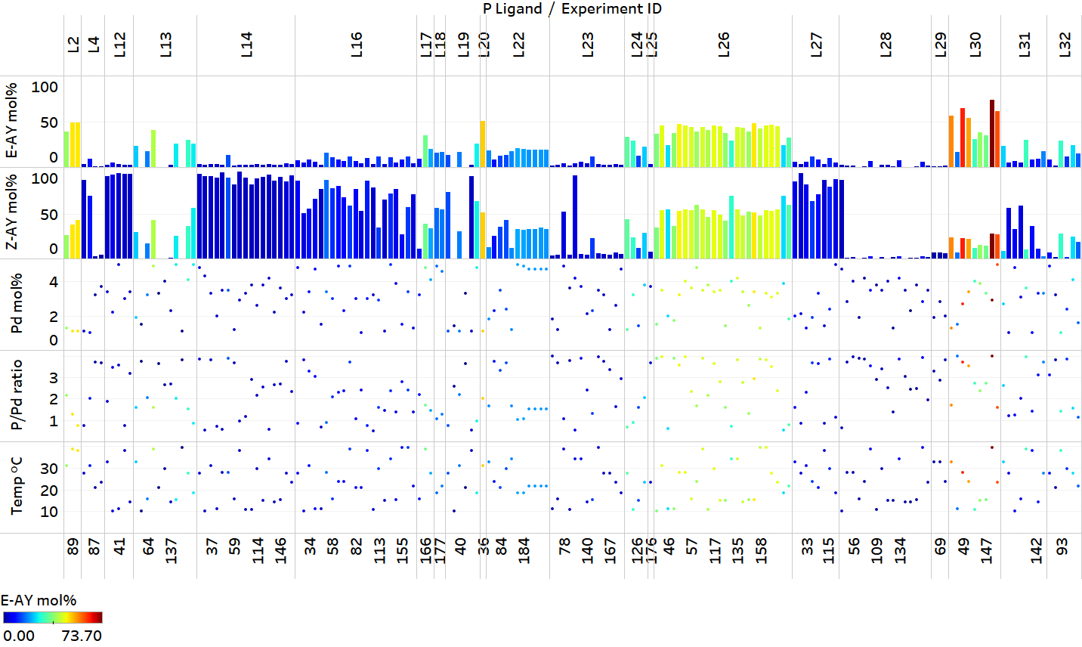
Figure SI-9. Parameters and results of optimization with ligands selected through descriptor clustering with 15 selected phosphine descriptors included in algorithmic optimization (campaign 3).
Conditions: 10 µmol 1-E, 1 µmol 1,3,5-trimethoxybenzene, 15 µmol 3, 0.1 - 0.5 µmol Pd(ACN)₂Cl₂, 0.05 - 2 µmol L, 30 µmol K₃PO₄ (0.5M aq) in ACN (0.05M), 2 h at 10 - 40 °C.

Standard experiments

In campaigns involving 192 iterations, two sets of eight standard experiments (conditions provided in Figure SI-10) were carried out in in each reaction block in order to measure reproducibility and system performance. We determined that the relative standard deviation (RSD) of measured 2-E and 2-Z yields fell between 6-8 %.
Figure SI-10: Standard experimental conditions
Conditions: 10 µmol 1-E, 1 µmol 1,3,5-trimethoxybenzene, 15 µmol 3, 0.3 µmol Pd(ACN)₂Cl₂, 0.4 µmol L2 (PoTol₃), 30 µmol K₃PO₄ (0.5M aq) in ACN (0.05M), 2 h at 20 °C.
Table SI-13: Standard experiments from blocks 1 and 2 of campaign 2
Expt | Temp | Pd mol% | P ligand | P/Pd | 2-E mol% | 2-Z mol%
1 | 20 | 2.5 | L2 | 1.52 | 34 | 22
2 | 20 | 2.5 | L2 | 1.52 | 32 | 20
3 | 20 | 2.5 | L2 | 1.52 | 28 | 17
4 | 20 | 2.5 | L2 | 1.52 | 31 | 19
5 | 20 | 2.5 | L2 | 1.52 | 30 | 19
6 | 20 | 2.5 | L2 | 1.52 | 28 | 17
7 | 20 | 2.5 | L2 | 1.52 | 30 | 18
8 | 20 | 2.5 | L2 | 1.52 | 31 | 19
Average |  |  |  |  | 30 | 19
SD |  |  |  |  | 2 | 1
RSD% |  |  |  |  | 6 | 8
97 | 20 | 2.5 | L2 | 1.52 | 28 | 17
98 | 20 | 2.5 | L2 | 1.52 | 31 | 18
99 | 20 | 2.5 | L2 | 1.52 | 30 | 18
100 | 20 | 2.5 | L2 | 1.52 | 28 | 17
101 | 20 | 2.5 | L2 | 1.52 | 25 | 15
102 | 20 | 2.5 | L2 | 1.52 | 27 | 16
103 | 20 | 2.5 | L2 | 1.52 | 28 | 17
104 | 20 | 2.5 | L2 | 1.52 | 28 | 18
Average |  |  |  |  | 28 | 17
SD |  |  |  |  | 2 | 1
RSD% |  |  |  |  | 6 | 6

Descriptor computation

Detailed electronic and steric descriptor calculations for 365 commercially available phosphine ligands and will be disclosed subsequently.
The main steps are:
- conformational sampling of each ligand using Crest at the GFN2-xTB level in two model states: free ligand, [LNi(CO)₃] complex
- selection of a representative set of conformers based on steric properties as relative energies
- DFT computations for the selected conformers in Gaussian 16 rev C.01:
  - geometry optimization and frequency calculation at the PBE-D3(BJ)/6-31+G(d) level
  - single points for electronic properties at the PBE0-D3(BJ)/def2-TZVP level, including a population analysis with NBO 7.0.7, SMD solvation single point with the preset parameters for chloroform, and single points for the radical cation and radical anion
- reading steric and electronic properties from the DFT computations
The following descriptors (118 total) were used in the subsequent analysis.
Table SI-14: Only Boltzmann-weighted average (suffix _boltz)
descriptor | brief description
vmin_vmin | Vmin = minimum of molecular electrostatic potential in P-lone pair
vmin_r | distance of Vmin from P
fmo_e_homo | HOMO energy
fmo_e_lumo | LUMO energy
fmo_mu | chemical potential = average of HOMO/LUMO energies
fmo_eta | softness = difference of HOMO/LUMO energies
fmo_omega | Global electrophilicity parameter ω
nbo_P | Phosphorus natural population (NBO)
nmr_P | isotropic chemical shielding constant P
nmrtens_sxx_P | anisotropic shielding tensor XX-eigenvalue P
nmrtens_syy_P | anisotropic shielding tensor YY-eigenvalue P
nmrtens_szz_P | anisotropic shielding tensor ZZ-eigenvalue P
efg_amp_P | Electric field gradient tensor amplitude P
efgtens_xx_P | Electric field gradient tensor XX-eigenvalue P
efgtens_yy_P | Electric field gradient tensor YY-eigenvalue P
efgtens_zz_P | Electric field gradient tensor ZZ-eigenvalue P
nuesp_P | Electrostatic potential at P
nbo_lp_P_percent_s | s-orbital percentage of P lone pair (NBO)
nbo_lp_P_occ | P lone pair occupancy (NBO)
nbo_lp_P_e | P lone pair energy (NBO)
nbo_bd_e_max | P-C bonding orbital energy, highest (NBO)
nbo_bd_e_avg | P-C bonding orbital energy, average (NBO)
nbo_bds_e_min | P-C antibonding orbital energy, lowest (NBO)
nbo_bds_e_avg | P-C antibonding orbital energy, average (NBO)
nbo_bd_occ_min | P-C bonding orbital occupancy, lowest (NBO)
nbo_bd_occ_avg | P-C bonding orbital occupancy, average (NBO)
nbo_bds_occ_max | P-C antibonding orbital occupancy, highest (NBO)
nbo_bds_occ_avg | P-C antibonding orbital occupancy, average (NBO)
E_solv_total | Energy of solvation
E_solv_cds | Electrostatic component of energy of solvation
E_solv_elstat | Non-electrostatic component of energy of solvation
fukui_m | Atom-condensed Fukui index f–
fukui_p | Atom-condensed Fukui index f+
vbur_ratio_vbur_vtot | Ratio buried-to-total volume

Table SI-15: All “condensed properties”: Boltzmann-weighted average (_boltz), minimum (_min) and maximum (_max) across all conformers, difference between the conformer minimum and maximum (_delta)
descriptor | brief description
dipolemoment | Dipole moment
qpole_amp | Quadrupole moment amplitude
qpoletens_xx | Quadrupole moment tensor XX component
qpoletens_yy | Quadrupole moment tensor YY component
qpoletens_zz | Quadrupole moment tensor ZZ component
pyr_P | Pyramidalization
pyr_alpha | Pyramidalization angle alpha
vbur_vbur | buried volume
vbur_vtot | total volume
vbur_qvbur_min | buried quadrant volume, lowest
vbur_qvbur_max | buried quadrant volume, highest
vbur_qvtot_min | total quadrant volume, lowest
vbur_qvtot_max | total quadrant volume, highest
vbur_max_delta_qvbur | largest volume difference of neighborisc quadrants, buried
vbur_max_delta_qvtot | largest volume difference of neighborisc quadrants, total
sterimol_B1 | Sterimol B1
sterimol_B5 | Sterimol B5
sterimol_L | Sterimol L
sterimol_burB1 | buried Sterimol B1
sterimol_burB5 | buried Sterimol B5
sterimol_burL | buried Sterimol L

Training set selection

The 118-dimensional descriptor space was transformed using principal component analysis in scikit-learn, retaining the first 4 principal components. The resulting 4-dimensional space was divided into 24 regions by k-means clustering. Candidates for the training set were considered by increasing distance to each cluster center, taking practical considerations such as availability of the candidates into account. More aspects considering this workflow will be disclosed subsequently.

Predictive modeling

Suggestions for E-selective ligands were obtained by two different approaches:
- regression modeling
- classification
Experimental data from campaigns 2 and 3 were used for this procedure. In order to account for the subsequent changes to various reaction parameters during the autonomous optimization runs, the natural log of the highest yield of 2-E that was obtained with each ligand under any reaction conditions in all experiments was used as optimization target. This is a practical approximation that is limited by the number of experiments that each ligand was used in and how optimal the other reaction conditions were for each ligand in any experiment.

Regression modeling:

A model ensemble was generated consisting of three sparse linear models (four features each), identified by forward stepwise feature selection as described previously. After feature selection, each model was refit using ridge regression, automatically selecting alpha using internal cross-validation (RidgeCV in scikit-learn). The three models were chosen by diversity of the features and their validation statistics from a 75:25 training:test split determined by the Kennard-Stone algorithm based on the ligand descriptors. The models were then applied to the descriptors of ca. 900 P-based ligands to obtain predicted max(yield 2-E) of each model. Ligand candidates were selected based on the variance and average of predictions of each model in the ensemble, as well as practical considerations. Sometimes that entailed changing to a similar but commercially available ligand.

Model 1:

Ridge alpha = 0.001

Features:
p-value coefficient
1.32E-10 -1.7133 +
2.73E-04 -2.6077 * x5 fmo_mu_boltz
1.34E-03 -2.1383 * x7 fmo_omega_boltz
1.32E-05 1.0014 * x30 nbo_bds_e_min_boltz
3.35E-04 -0.7124 * x98 vbur_qvtot_min_boltz

Training R2 = 0.844
Training Q2 = 0.747
Training MAE = 0.200
Training K-fold R2 = 0.711 (+/- 0.005)

Test R2 = 0.958
Test MAE = 0.169
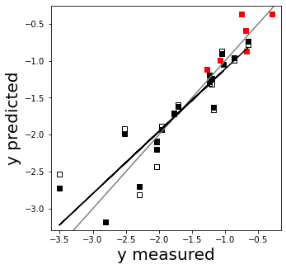
Figure SI-11: Model 1
y is ln(highest yield of 2-E) per ligand in any experiment

Model 2:

Ridge alpha = 1.0

Features:
p-value coefficient
6.96E-10 -1.7133 +
3.79E-03 0.3742 * x30 nbo_bds_e_min_boltz
5.62E-05 0.5771 * x69 pyr_P_min
7.01E-02 0.1831 * x86 vbur_vtot_delta
4.50E-02 -0.2260 * x160 sterimol_B1_max

Training R2 = 0.784
Training Q2 = 0.673
Training MAE = 0.273
Training K-fold R2 = 0.613 (+/- 0.006)

Test R2 = 0.812
Test MAE = 0.398
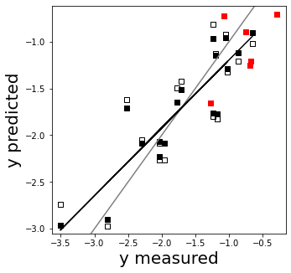
Figure SI-12: Model 2
y is ln(highest yield of 2-E) per ligand in any experiment
Model 3:

Ridge alpha = 0.1

Features:
p-value coefficient
2.92E-10 -1.7133 +
1.22E-03 0.4852 * x30 nbo_bds_e_min_boltz
1.27E-02 -0.4867 * x51 qpole_amp_delta
3.31E-05 -0.7806 * x75 pyr_alpha_max
9.73E-03 0.3891 * x86 vbur_vtot_delta

Training R2 = 0.820
Training Q2 = 0.708
Training MAE = 0.263
Training K-fold R2 = 0.648 (+/- 0.011)

Test R2 = 0.778
Test MAE = 0.364
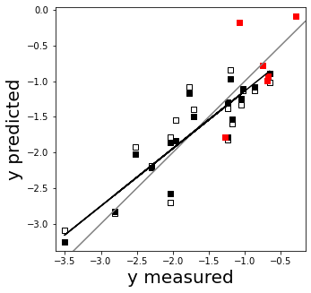
Figure SI-13: Model 3
y is ln(highest yield of 2-E) per ligand in any experiment

Classification suggestion:
Candidates were selected by their similarity to the most selective ligand (PhSPhos) in the reduced chemical space representation. More details for this procedure will be disclosed subsequently.¹¹ This procedure entails:
- assign ligands to the classes most selective (PhSPhos) and less selective (all others) based on their experimental results
- train k-nearest neighbors (k = 1) classifier on the 4-dimensional PC space (see above) and apply that classifier to ca. 900 other P-based ligands for an estimate of the “most selective” region in this chemical space representation.
- select ligand candidates that were classified “most selective” based on availability
Results:
Figure SI-14: Selected ligands

Ligands L35 and L36 were selected as commercially available alternatives to the related compounds shown below. The model predictions for both furyl phosphines had high variances, normally precluding the ligands as candidates, but the simple structure of L35 warranted further investigation nonetheless. The diazaphosphinane predictions were higher average (83% 2-E) and lower variance (0.136) than the commercially available ligand L36. The regression predictions for the ligands proposed by classification are shown for comparison.
Figure SI-15: Compounds related to selected ligands

The two ligands with the biggest discrepancy between prediction and experimental results are L33 and L35. The training data did not contain information for heteroatom-substituted phosphorus compounds such as the phosphoramidite L33, so a poor prediction is not surprising. As discussed above, L35 showed a large variance between the predictions, indicating an unsafe prediction that would not normally be taken into consideration, so a large discrepancy is also not unexpected.
Table SI-16: Comparison of predicted vs. experimentally determined yields of product 2-E
 | name | source | %2-E pred, mean | ln(%2-E) pred, variance | %2-E, exp
L33 | (R)-MonoPhos | Regression | 68 | 0.040 | 11.9
L34 | PhDBP | Regression | 74 | 0.136 | 52
L35 | P(2-furyl)₃ | R.+Similarity | 62 | 0.270 | 23
L36 | PhP(NEt₂)₂ | R.+Similarity | 60 | 0.241 | 52.7
L37 | Ph-PhenCarPhos | Classification | 22 | 0.001 | 39.1
L38 | cataCXiumPInCy | Classification | 13 | 0.039 | 13.2

This compound was previously characterized in Christensen, M. et al. Enantioselective synthesis of α-methyl-β-cyclopropyldihydrocinnamates. J. Org. Chem. 81, (2016).
This compound was previously characterized in Christensen, M. et al. Development of an automated kinetic profiling system with online HPLC for reaction optimization. React. Chem. Eng. 4, 1555–1558 (2019).
This compound was previously characterized in Li, Y., Das, S., Zhou, S., Junge, K. & Beller, M. General and selective copper-catalyzed reduction of tertiary and secondary phosphine oxides: Convenient synthesis of phosphines. J. Am. Chem. Soc. 134, 9727–9732 (2012).
Häse, F., Roch, L. M., Kreisbeck, C. & Aspuru-Guzik, A. Phoenics: A Bayesian Optimizer for Chemistry. ACS Cent. Sci. 4, 1134–1145 (2018).
Häse, F., Roch, L. M. & Aspuru-Guzik, A. Gryffin: An algorithm for Bayesian optimization for categorical variables informed by physical intuition with applications to chemistry. (2020).
Algorithm 1 reported in Vellanki, P. et al. Process-constrained batch Bayesian Optimisation. (2017).
Gomes, et. al. Mapping the Property Space of Monodentate Organophosphorus Ligands for Catalysis. Preprint will be available at DOI: 10.26434/chemrxiv.12996665 (2020).
Pracht, P., Bohle, F. & Grimme, S. Automated exploration of the low-energy chemical space with fast quantum chemical methods. Phys. Chem. Chem. Phys. 22, 7169–7192 (2020); Bannwarth, C., Ehlert, S. & Grimme, S. GFN2-xTB - An Accurate and Broadly Parametrized Self-Consistent Tight-Binding Quantum Chemical Method with Multipole Electrostatics and Density-Dependent Dispersion Contributions. J. Chem. Theory Comput. 15, 1652–1671 (2019).
Gaussian 16, Revision C.01, M. J. Frisch, G. W. Trucks, H. B. Schlegel, G. E. Scuseria, M. A. Robb, J. R. Cheeseman, G. Scalmani, V. Barone, G. A. Petersson, H. Nakatsuji, X. Li, M. Caricato, A. V. Marenich, J. Bloino, B. G. Janesko, R. Gomperts, B. Mennucci, H. P. Hratchian, J. V. Ortiz, A. F. Izmaylov, J. L. Sonnenberg, D. Williams-Young, F. Ding, F. Lipparini, F. Egidi, J. Goings, B. Peng, A. Petrone, T. Henderson, D. Ranasinghe, V. G. Zakrzewski, J. Gao, N. Rega, G. Zheng, W. Liang, M. Hada, M. Ehara, K. Toyota, R. Fukuda, J. Hasegawa, M. Ishida, T. Nakajima, Y. Honda, O. Kitao, H. Nakai, T. Vreven, K. Throssell, J. A. Montgomery, Jr., J. E. Peralta, F. Ogliaro, M. J. Bearpark, J. J. Heyd, E. N. Brothers, K. N. Kudin, V. N. Staroverov, T. A. Keith, R. Kobayashi, J. Normand, K. Raghavachari, A. P. Rendell, J. C. Burant, S. S. Iyengar, J. Tomasi, M. Cossi, J. M. Millam, M. Klene, C. Adamo, R. Cammi, J. W. Ochterski, R. L. Martin, K. Morokuma, O. Farkas, J. B. Foresman, and D. J. Fox, Gaussian, Inc., Wallingford CT, 2019.
E. D. Glendening, J. K. Badenhoop, A. E. Reed, J. E. Carpenter, J. A. Bohmann, C. M. Morales, P. Karafiloglou, C. R. Landis, and F. Weinhold, Theoretical Chemistry Institute, University of Wisconsin, Madison, WI (2018)
Gensch, et. al. Design and Application of a Training Set for Monophosphine Ligands in Metal Catalysis. Preprint will be available at DOI: 10.26434/chemrxiv.13160939 (2020).
Guo, J. Y., Minko, Y., Santiago, C. B. & Sigman, M. S. Developing Comprehensive Computational Parameter Sets to Describe the Performance of Pyridine-Oxazoline and Related Ligands. ACS Catal. 7, 4144–4151 (2017).

