Supplementary Information

2D PdCu alloy nanodendrites manifest effective peroxidase-like activity against biofilms

Guotao Yuan,^{a,b,‖} Shitong Zhang,^{a,‖} Zaixing Yang,ª Xin Tian,^{a,*} Si Cheng,^{c} Yue Pan,^{b,*} and Ruhong Zhou^{a,d,e,*}
ª State Key Laboratory of Radiation Medicine and Protection, School for Radiological and Interdisciplinary Sciences (RAD-X), Collaborative Innovation Center of Radiation Medicine of Jiangsu Higher Education Institutions, Soochow University, Suzhou 215123, China
^{b} Guangdong Provincial Key Laboratory of Malignant Tumor Epigenetics and Gene Regulation, Guangdong-Hong Kong Joint Laboratory for RNA Medicine, Medical Research Center, Sun Yat-Sen Memorial Hospital, Sun Yat-Sen University, Guangzhou 510120, China
^{c} National Engineering Laboratory for Modern Silk, College of Textile and Clothing Engineering, Soochow University, Suzhou 215021, China
^{d} Institute of Quantitative Biology, College of Life Sciences, Zhejiang University, Hangzhou 310058, China
^{e} Department of Chemistry, Columbia University, New York, NY 10027, United States
‖ These authors contributed equally to this work.
* Corresponding authors. E-mail: xtian@suda.edu.cn, panyue@mail.sysu.edu.cn, rz24@columbia.edu

Experimental section
Materials
All chemicals were of analytical grade. Palladium (II) chloride (PdCl₂), Copper (II) chloride (CuCl₂, 99%), 3,3,5,5-tetramethylbenzidine (TMB) and terephthalic acid (TA) were purchased from Sigma-Aldrich. Hydrogen chloride (HCl, 35-36%), ascorbic acid (AA, 99%) were purchased from Sinopharm Chemical Reagent Co., Ltd. Ultrafiltered water used in all the reactions was obtained by using a Millipore purification system. All chemicals were of analytical grade without further purification.
Synthesis of PdCu NDs
In a typical procedure for the synthesis of 2D PdCu NDs, H₂PdCl₄ (100 μL, 0.01 M) and CuCl₄ (30 μL, 0.01 M) were simultaneously added to octadecyltrimethylammonium chloride (OTAC) solution (5 mL, 0.01 M). After sonicating 30 min, ascorbic acid solution (140 μL, 0.1 M) was added into the above solution. This reaction was proceeding under 10 ºC for 4 h. The products were collected by centrifugation at 8,000 rpm and washed three times with ethanol. The PdCu nanostructures with other Pd/Cu molar ratios were obtained by using the same synthetic method with different molar ratios of Pd and Cu precursors.
Characterization
Transmission electron microscopy (TEM) images were collected on a Hitachi HT7700 transmission electron microscope at an acceleration voltage of 120 kV. High resolution TEM (HRTEM) (Tecnai F20, FEI, USA) images were taken on a field-emission high-resolution transmission electron microscope operated at 200 kV. Atomic force microscopy (AFM) was performed on Bruker Dimension Icon atomic force microscope and analyzed with the software of Nano Scope Analysis. X-ray powder diffraction (XRD) energy dispersive X-ray spectroscopy mapping (EDX) was carried out on X′Pert-Pro MPD diffractometer with a Cu Kα X-ray source. Pd/Cu molar ratios were conducted on Varian 710-ES inductively coupled plasma optical emission spectrometry (ICP-OES).
Measurement of peroxidase-like activity and steady-state kinetic assays
The peroxidase-like activity of the PdCu nanostructures was measured using TMB as the substrate in the presence of H₂O₂. The PdCu nanostructures dispersions were diluted with NaAc buffer (0.2 M, pH = 3.6) as the substrate and then TMB solution (40 mM) and H₂O₂ (0.1 M) was added. The absorbance of the reaction solution at 652 nm was recorded at different times using a UV spectrometer (UV-3600, Shimadzu, Japan). For the assay of the product, hydroxyl radicals (•OH), a fluorescence probe TA (hydroxyterephthalic acid) was added into the reaction solution, and then the fluorescence spectra of the samples were collected using fluorescence spectroscopy (FLS980, Edinburgh). The steady-state kinetic assays were conducted at room temperature in a 200 μL NaAc buffer (0.2 M, pH = 3.6) with PdCu nanostructures (10 μg mL⁻¹) as catalyst in the presence of H₂O₂ and TMB. The kinetic assays of PdCu nanostructures with TMB as the substrate were performed by adding H₂O₂ (0.1 M) and different amounts of TMB solution. The kinetic assays of PdCu nanostructures with H₂O₂ as the substrate were performed by adding TMB (40 mM) and different amounts of H₂O₂ solution. All the reactions were monitored by measurement of absorbance at different reaction time. The apparent kinetic parameters were calculated based on the Michaelis-Menten equation (Equation 1):
V = V_{max} × [S]/(K_{m} × [S]) (1)
V: initial reaction velocity, V_{max}: maximal reaction rate, [S]: substrate concentration, and K_{m}: Michaelis constant.
Density function theory calculation
The Pd(111) surface was first built as a p(5 × 5) slab with a thickness of four Pd atom layers (dimension size: 13.76 Å × 13.76 Å × 5.84 Å), and 100 Pd atom was contained in the initial slab model. It has been shown that the p(5 × 5) slab is large enough to avoid the interactions between neighboring adsorbed H₂O₂ and to fully release the interfacial strain energy. To simulate the effects of Pd/Cu ratio on the adsorption of H₂O₂, a series of surface models of PdCu alloy were created by substituting Pd atoms with Cu evenly. The number of the replaced Pd ranged from 8 to 13. The neighboring slabs were separated in the direction perpendicular to the surface by a vacuum region of 20 Å, and only the bottom atoms in the slab were frozen to their crystal lattice positions.
Density function theory (DFT) calculations were performed using Dmol software with the conductor-like screening model (COSMO). The exchange-correlation potential was described by the revised Perdew-Burke-Ernzerhof (rPBE) generalized gradient approach (GGA), which improves the calculated adsorption energetics. The atomic orbitals were represented by a double numerical basis set plus polarization function (DNP). The SCF convergence criterion was set at 1.0 × 10⁻⁶ hartree/atom and the convergence criterion for structure optimization at 1.0 × 10⁻⁵ hartree/bohr. Brillouin zone sampling was performed using a 4 × 4 × 1 k-point mesh. The adsorption energy is defined as Equation 2:
E_{ads} = E(slab + H₂O₂) − [E(slab) + E(H₂O₂)] (2)
where E(slab + H₂O₂) represents the energy of the optimized slab model with adsorbed H₂O₂; E(slab) and E(H₂O₂) denote the energies of the separately optimized slab and H₂O₂, respectively.
P. aeruginosa biofilm model
Pseudomonas aeruginosa (P. aeruginosa) was cultured overnight in Luria-Bertani (LB) broth at 37 °C, and then diluted to 10⁷ colony forming units (CFU) mL⁻¹ in fresh LB with 1% sucrose. Sterilized glass slides (24 mm × 24 mm) were firstly put in the bottom of 6-well plates. 1.5 mL of bacterial suspension were seeded onto glass slides. The plates were then incubated at 37 °C for 12 h.
Bioﬁlm disruption with PdCu NDs activated H₂O₂
The bioﬁlms were continuously treated to PdCu NDs and H₂O₂ every 12 h for 48 h. The glass slide and bioﬁlms were treated by placing them in 1.5 mL of PdCu NDs (50 μg mL⁻¹) in 0.1 M NaOAc (pH 4.6) or control (buffer only) for 10 min, then H₂O₂ (30 mM) was added to the well for 10 min. After H₂O₂ exposure, The treated bioﬁlms were washed three times in sterile saline solution (0.9% NaCl) to remove excess agents and transferred to the fresh culture medium. After four treatments, the biofilms were incubated at 37 °C for another 12 h. Then, the biofilms were placed in 15 mL sterile saline solution, and subjected to water bath sonication by a KQ-250E Soniﬁer (twice, each time consisting of 30 s pulses with 30 s intervals at 250 W). The homogenized suspension was used for bacterial viability analyses. After serially diluted, the suspension was plated on solid LB agar. The plates were incubated at 37 °C for 12 h, and then the number of CFU was determined. The 3D images of P. aeruginosa biofilms were collected and analyzed by means of fluorescence imaging using confocal laser scanning microscopy and computational analysis (Image J).
Statistical analysis
Data were shown as mean ± s. d. Statistical analysis was performed using Student’s test for two-group differences. *p < 0.05, **p < 0.01 and ***p < 0.001.

Table S1. Comparison of the kinetic parameters of various catalysts toward the oxidation of TMB by H₂O₂ª
Catalyst | [S] (μM) | Substrate | V_{max} (M s⁻¹) | K_{m} (mM) | k_{cat} (s⁻¹)
Pd_{11.8}Cu | 23.5 | TMB | 1.2 × 10⁻⁷ | 0.12 | 0.5 × 10⁻²
 |  | H₂O₂ | 2.0 × 10⁻⁷ | 1.6 × 10⁻³ | 0.8 × 10⁻²
Pd_{10.2}Cu | 23.5 | TMB | 2.1 × 10⁻⁷ | 0.81 | 0.9 × 10⁻²
 |  | H₂O₂ | 2.4 × 10⁻⁷ | 0.7 × 10⁻³ | 1.0 × 10⁻²
Pd_{9.2}Cu | 23.5 | TMB | 3.0 × 10⁻⁷ | 0.36 | 1.3 × 10⁻²
 |  | H₂O₂ | 6.6 × 10⁻⁷ | 0.5 × 10⁻³ | 2.7 × 10⁻²
Pd_{8.1}Cu | 23.5 | TMB | 2.2 × 10⁻⁷ | 0.05 | 0.9 × 10⁻²
 |  | H₂O₂ | 4.9 × 10⁻⁷ | 0.3 × 10⁻³ | 2.1 × 10⁻²
Pd₇Cu | 23.5 | TMB | 1.0 × 10⁻⁷ | 0.11 | 0.4 × 10⁻²
 |  | H₂O₂ | 0.6 × 10⁻⁷ | 0.1 × 10⁻³ | 0.3 × 10⁻²
^{a)}[S] represents the catalyst concentration, K_{m} is the Michaelis constant, V_{max} is the maximal reaction velocity, and k_{cat} is the catalytic constant that equals V_{max}/[S].

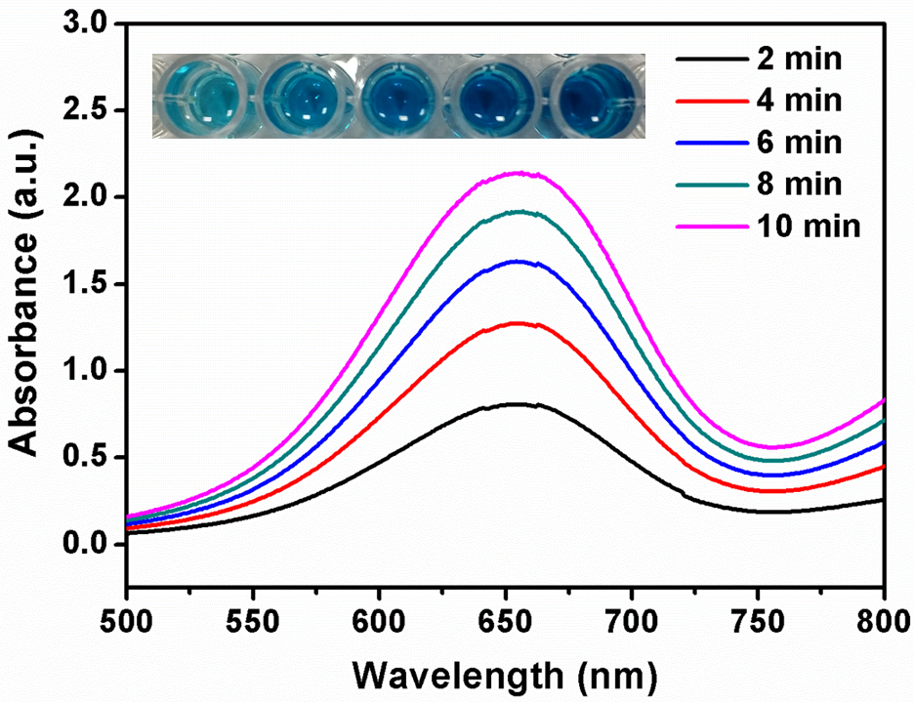
Fig. S1. UV-vis spectroscopy of samples containing 40 mM TMB, 0.1 M H₂O₂, and 10 µg mL⁻¹ Pd_{9.2}Cu NDs in 0.2 M acetate buffer (pH 3.6) for 10 min. The wells (inset) show the color change of TMB at different time points.

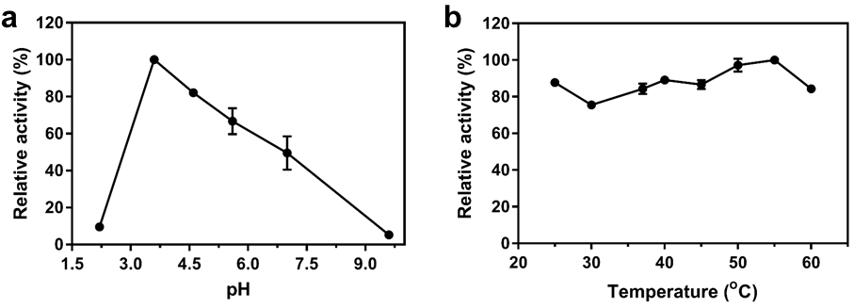
Fig. S2. Effects of (a) pH and (b) temperature on peroxidase-like activity of Pd_{9.2}Cu NDs. [H₂O₂] = 0.1 M, [Pd_{9.2}Cu NDs] = 10 µg mL⁻¹, [TMB] = 40 mM.

Fig. S3. Adsorptions of H₂O₂ on Pd_{11.5}Cu (111) surface at Pd-top and Cu-top sites with two typical orientations: (a) H₂O₂ adsorbed on Pd with O-O tilt to the alloy surface (white, H; red, O; cyan, Pd). (b) H₂O₂ adsorbed on Pd with O-O parallel to the alloy surface. (c) H₂O₂ adsorbed on Cu with O-O tilt to the alloy surface. (d) H₂O₂ adsorbed on Cu with O-O parallel to the alloy surface. The calculated total energy (yellow text; unit: Hartree) suggests that H₂O₂ prefers to adsorb on Pd with O-O tilt to the alloy surface.

Fig. S4. Hirshfeld charge analysis on the PdCu slab models with different Pd/Cu ratios.

Fig. S5. (a) The EP of Pd_{11.5}Cu slab model (white, H; red, O; cyan, Pd). (b) The separately scanned EP of Pd_{11.5}Cu, Pd_{6.7}Cu and H₂O₂ along the path denoted in panel (a).

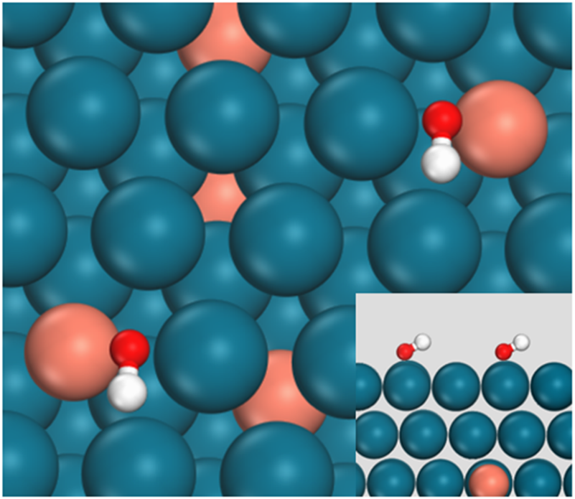
Fig. S6. The lowest-energy adsorption structures for the coadsorption of two •OH on PdCu bimetallic surface (white, H; red, O; cyan, Pd) on Pd_{11.5}Cu. The inset is the side view.

