Title: Production and Characterization of Novel Board-spectrum Antimicrobial 5-butyl-2-pyridine carboxylic acid from Aspergillus fumigatus nHF-01
Supplementary files:
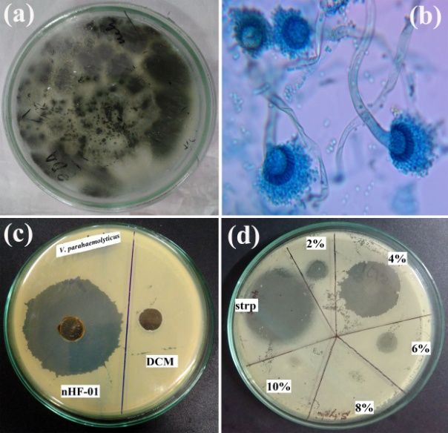
Figure S1: The strainAspergillus fumigatus nHF-01 and its antibacterial assessment. (a) Plate culture; (b) Micro-morphology of the strain; (c) Screening of the antibacterial efficacy of the strain against pathogenic bacteria, Vibrio parahaemolyticus MTCC 451, and (d) media % variations against Salmonella Typhimurium MTCC 98. Here, the code 'strp' indicates streptomycin (20 µg/ml).
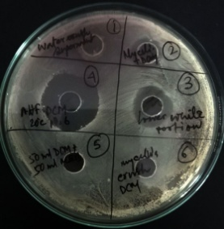
Figure S2: Antibacterial assay of different DCM extracts of culture aliquot of A. fumigatus nHF-01, against E. coli. Here, the numbers indicate the different extracts, viz. 1, extracts with water; 2, DCM with mycelia; 3, extract precipitate; 4, a crude compound of nHF-01; 5, an equal volume of DCM and MEB; 6, mycelia crushed with DCM.
Figure S3: Standardizing the optimum days, agitation, temperature and pH for antibacterial compound production. (a) optimum days; (b) optimum days, agitation; (c and d) optimum temperature and pH. The figure indicates the assay of compounds extracted from different temperatures and pHs against Gram-positive bacterium B. cereus and Gram-negative bacterium E. coli. The rhomboid dotted line indicates 20 ºC, the round dotted line 28 ºC, the triangle dotted line 37 ºC, and the square dotted line indicates 45 ºC.

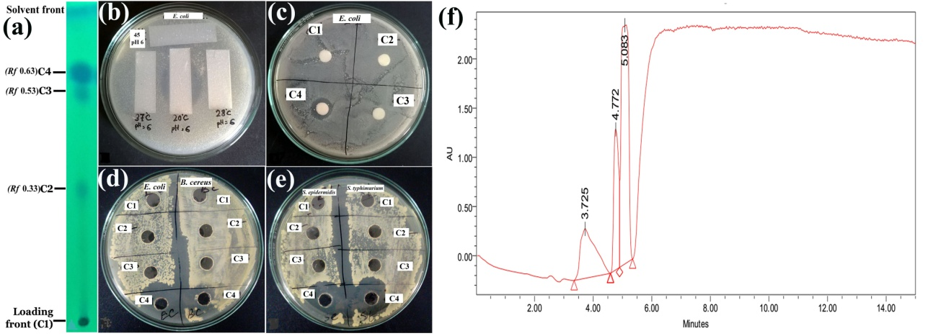
Figure S4: Chromatographic analysis of the active extract. (a) TLC of crude DCM extract; (b) TLC plate zymogram assay; (c) Paper disk assay of TLC scraps; (d-e) Agar-well diffusion assay of TLC scraps against the bacteria strain; and (f) HPLC of active C4 fraction. Here, TLC strips in fig. 'b' indicate the TLC of active fraction from different pH and temperature levels.

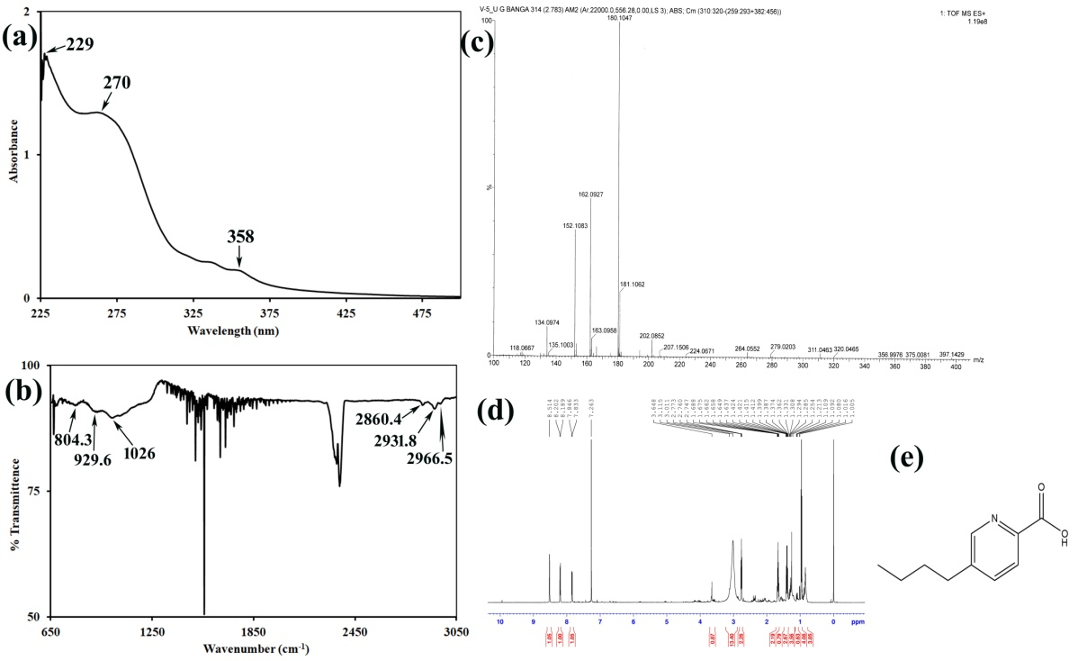
Figure S5: Spectral analysis of pure compound of A. fumigatus nHF-01. (a) UV-Vis spectrum; (b) FT-IR spectrum, (c) ESI-MS spectra, (d) ¹H NMR; and (e) Chemical structure of 5-butyl-2-pyridine carboxylic acid.
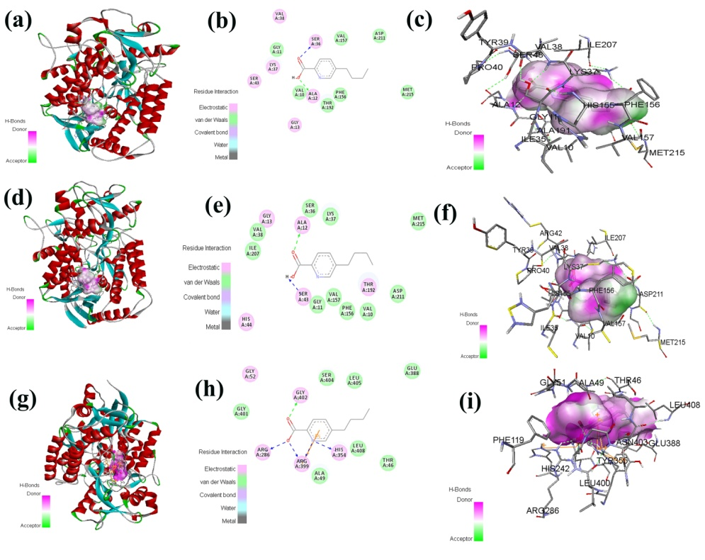
Figure S6: Docked confirmations of the active compounds of A. fumigatus nHF-01 with E. coli Quinol-Fumarate Reductase with Bound Inhibitor HQNO (PDB id- 1kf6; Fig. a-c), Quinol-Fumarate Reductase with Menaquinol Molecules (PDB id- 1l0v; Fig. d-f), and E. coli succinate: quinone oxidoreductase (SQR) SdhB His207Thr (PDB id- 2wp9 Fig. g-i).

Table S1: Sensitivity of 7 different antifungal drugs against A. fumigatus nHF-01
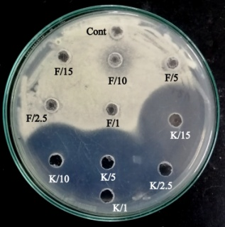 | 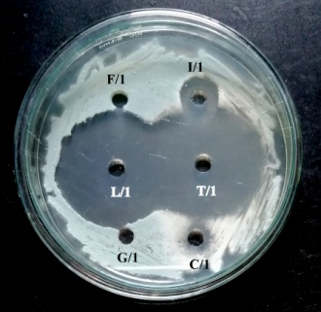 | 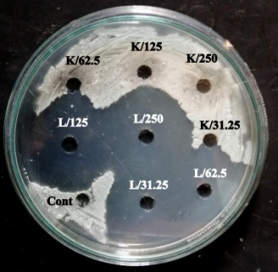
(Conc. 15-1 mg/ml; 20 µl) | (Conc. 1 mg/ml; 15 µl) | (Conc. 250-31.25 µg/ml; 12 µl)
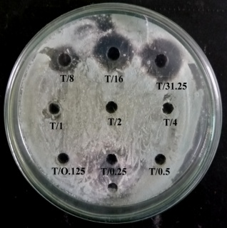 | 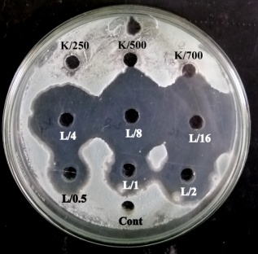 | 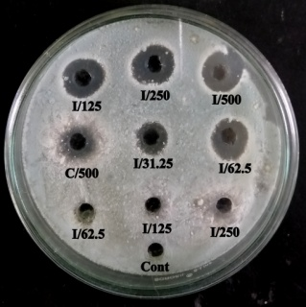
(Conc. 31.25-0.125 µg/ml; 12 µl) | (Conc. 700-250 µg/ml & 16-0.5 µg/ml; 12 µl) | (Conc. 500-125 µg/ml & 500-62.5 µg/ml; 12 µl)

Abbreviation: ‘F’= Fluconazole; ‘K’= Ketoconazole; ‘L’= Luliconazole; ‘I’= Itraconazole; ‘G’= Gresiofulvin; ‘C’= Clotrimazole; ‘T’= Terbinafine

Table-S2: Antibacterial spectrum of the A. fumigatus nHF-01 compound in different media and solvents as evidenced by the diameter of growth inhibition zones.
Culture media |  |  |  | Inhibition zone (35.7 mg/ml,mm) against
Culture media |  |  |  | Gram-negative strains |  |  |  |  | Gram-positive strains
Culture media | Biomass (g/100 ml) | Extractable compound (mg/100 ml) | Extraction Solvents | E. coli | S. typhimurium | K. pneumonia | P. aeruginosa | S. epidermidis |  | B. cereus | B. subtilis | E. faecalis
CMB | 0.24 | 42 | DCM | 15.14 ± 0.76 | 11 ± 0.55 | 11 ± 0.55 | 10 ± 0.5 | 14.11 ± 0.7 |  | 00 | 07.2 ± 0.36 | 11 ± 0.55
CZB | 0.72 | 68.4 | DCM | 17.17 ± 0.86 | 15.13 ± 0.75 | 11 ± 0.55 | 00 | 16 ± 0.8 |  | 11 ± 0.55 | 07.8 ± 0.39 | 14 ± 0.7
MEB | 0.96 | 68.8 | DCM | 22 ± 0.975 | 16 ± 0.8 | 16 ± 0.8 | 18.3 ± 0.91 | 17.21 ± 0.86 |  | 19.2 ± 0.96 | 19.5 ±0.97 | 20 ± 0.1
NB | 0.12 | 46.4 | DCM | 09.17 ± 0.42 | 08.2 ± 0.4 | 00 | 05 ± 0.25 | 00 |  | 00 | 08 ± 0.45 | 00
PDB | 0.16 | 38 | DCM | 00 | 09.1 ± 0.45 | 08.2 ± 0.41 | 00 | 09.11 ± 0.45 |  | 09 ± 0.45 | 12 ± 0.6 | 00
CMB | 0.24 | 34.1 | Ethyl acetate | 09 ± 0.45 | 00 | 11 ± 0.55 | 09 ± 0.45 | 00 |  | 07.1 ± 0.35 | 09.1 ± 0.45 | 00
CZB | 0.72 | 56.8 | Ethyl acetate | 00 | 09.07 ± 0.4 | 00 | 00 | 00 |  | 08.1 ± 0.40 | 11 ± 0.55 | 00
MEB | 0.96 | 62 | Ethyl acetate | 11 ± 0.55 | 09.1 ± 0.45 | 09 ± 0.45 | 10.2 ± 0.51 | 07.1 ± 0.32 |  | 07 ± 0.33 | 07.8 ± 0.39 | 10.2 ± 0.5
NB | 0.12 | 43.8 | Ethyl acetate | 00 | 00 | 00 | 07 ± 0.35 | 08 ± 0.4 |  | 08 ± 0.4 | 00 | 00
PDB | 0.16 | 21.9 | Ethyl acetate | 07.2 ± 0.36 | 01.12 ± 0.05 | 07.1 ± 0.35 | 07.8 ± 0.39 | 08 ± 0.40 |  | 09 ± 0.45 | 07.1 ± 0.35 | 11 ± 0.55
CMB | 0.24 | 41 | n-hexane | 00 | 08 ± 0.45 | 08 ± 0.4 | 10 ± 0.5 | 08.26 ± 0.41 |  | 00 | 09 ± 0.45 | 05 ± 0.25
CZB | 0.72 | 65.2 | n-hexane | 16.1 ± 0.805 | 00 | 00 | 11 ± 0.55 | 16.1 ± 0.805 |  | 00 | 10 ± 0.5 | 00
MEB | 0.96 | 66.7 | n-hexane | 14 ± 0.68 | 12.06 ± 0.6 | 12 ± 0.6 | 10 ± 0.5 | 14.02 ± 0.7 |  | 11.1 ± 0.55 | 11 ± 0.55 | 15 ± 0.75
NB | 0.12 | 38.9 | n-hexane | 09 ± 0.41 | 00 | 00 | 05 ± 0.25 | 00 |  | 00 | 00 | 00
PDB | 0.16 | 39.12 | n-hexane | 00 | 00 | 05 ± 0.25 | 00 | 00 |  | 00 | 00 | 00
Note: Here, the number indicates the diameter of the inhibition zone (mm), and '00' indicates no inhibition zone. The values are the average of triplicate trials ± Standard error. Malt Extract Broth (MEB), Czapekdox Broth (CZB), Potato Dextrose Broth (PDB), Nutrient Broth (NB) and Corn Meal Broth (CMB) were the media used.

Table-S3: GC-MS profiling of active compound of Aspergillus fumigatus nHF-01:
Sl. No. | Chemical name | Peak number | Molecular formula | Retention time (min) | Molecular weight (g/mol) | Molecular structure | Mole %
 | Dimethyl trisulfide | 1 | C₂H₆S₃ | 7.689 | 126.25 |  | 0.201
 | Pyridine, 3-butyl | 2 | C₉H₁₁Cl₂N | 11.365 | 135.21 |  | 0.843
 | Methanol, oxo-, benzoate | 3 | C₈H₆O₃ | 11.476 | 168.15 |  | 0.148
 | Tetrasulfide, dimethyl | 4 | C₂H₆S₄ | 12.639 | 158.31 |  | 0.236
 | Benzoic acid, 3,4-dimethyl-, methyl ester | 5 | C₁₀H₁₂O₂ | 14.186 | 164.204 |  | 0.146
 | Phenol, 2,4-bis(1,1-dimethylethyl)- | 6 | C₁₄H₂₂O | 17.319 | 206.329 |  | 0.49
 | Gamma-Lumicolchicine | 7 | C₂₂H₂₅NO₆ | 18.024 | 399.443 | 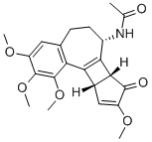 | 1.175
 | Diethyl Phthalate | 8 | C₆H₄(COOC₂H₅)₂ | 18.584 | 222.24 |  | 0.147
 | 2-Pyridinecarboxylic acid, 5-butyl | 9 | C₁₀H₁₃NO₄S | 18.996 | 179.22 |  | 5.15
 | o-Anisic acid, 4-nitrophenyl ester | 10 | C₁₄H₁₁NO₅ | 19.056 | 273.244 |  | 0.023
 | 2'-Hydroxy-5'-methoxyacetophenone, tert-butyldimet | 11 | C₁₅H₂₂O₃ | 19.886 | 250.16 |  | 0.075
 | Nonadecane | 12 | C₁₉H₄₀ | 20.069 | 268.529 |  | 0.143
 | Tetracontane, 3,5,24-trimethyl | 13 | C₄₃H₈₈ | 20.673 | 605.177 |  | 0.16
 | Estra-1,3,5(10)-trien-17-one, 3,4-bis[(trimethylsilyl)oxy] | 14 | C₂₄H₃₈O₃Si₂ | 20.806 | 430.24 |  | 0.833
 | Silane, dimethyl(2-methylphenoxy)docosyl | 15 | C₃₁H₅₈O₂Si | 20.956 | 490.8765 |  | 4.65
 | Tetratriacontyl heptafluorobutyrate | 16 | C₃₈H₆₉F₇O₂ | 21.541 | 690.94 |  | 0.232
 | Isopropyl myristate | 17 | C₁₇H₃₄O₂ | 21.762 | 270.457 |  | 0.211
 | L-Proline, N-valeryl-, decyl ester | 18 | C₂₀H₃₇NO₃ | 21.873 | 339.52 |  | 0.288
 | 7-(1,3-Dimethylbuta-1,3-dienyl)-1,6,6-trimethyl-3, | 19 | C₁₅H₂₂O₂ | 21.922 | 236.17 |  | 0.316
 | Propenamide, N-(2-bromo-4,6-difluorophenyl)-3-(2-m | 20 | C₉H₆BrF₂NO | 22.681 | 262.019 |  | 0.373
 | Hydroxylamine, O-decyl | 21 | C₁₀H₂₃NO | 22.862 | 173.3 |  | 1.237
 | No match | 22 |  | 22.964 |  |  | 7.04
 | Pyrrolo[1,2-a]pyrazine-1,4-dione, hexahydro-3-(2-m | 23, 25 | C₁₁H₁₈N₂O₂ | 23.118 | 210.2728 | 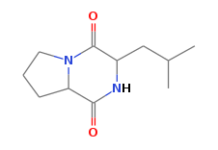 | 1.49
 | Benzenepropanoic acid, 3,5-bis(1,1-dimethylethyl)- | 24 | C₁₇H₂₆O₂ | 23.207 | 262.39 |  | 0.164
 | Oxalic acid, isohexyl tetradecyl ester | 26 | C₂₂H₄₂O₄ | 23.413 | 370.56648 |  | 0.535
 | n-Hexadecanoic acid | 27 | C₁₆H₃₂O₂ | 23.620 | 256.4241 |  | 2.282
 | 3,5-di-tert-Butyl-4-hydroxyphenylpropionic acid | 28 | C₁₇H₂₆O₃ | 23.877 | 278.39 |  | 0.237
 | Hexatriacontyl pentafluoropropionate | 29 | C₃₉H₇₃F₅O₂ | 24.010 | 669 |  | 0.248
 | Cyclodecasiloxane, eicosamethyl | 30 | C₂₀H₆₀O₁₀Si₁₀ | 24.633 | 741.5394 |  | 0.552
 | No match | 31 |  | 24.918 |  |  | 7.0
 | Cyclic octaatomic sulfur | 32 | S₈ | 25.245 | 256.520 | 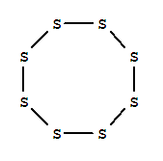 | 0.70
 | Tritetracontane | 33 | C₄₃H₈₈ | 25.456 | 605.1588 |  | 0.471
 | 1,2-Bis-[2,7-dimethoxyfluoren-9-ylidene]hydrazine | 34 | C₃₀H₂₄N₂O₄ | 26.043 | 476.52256 |  | 3.972
 | 1-Ethyl-3-(pyrrolidin-2-ylidene)-2-indolinone | 35 | C₁₄H₁₆N₂O | 26.291 | 228.29 |  | 0.849
 | 3,9.beta.:14,15-Diepoxypregn-16-en-20-one, 3,11.be | 36 | C₂₁H₂₈O₃ | 26.409 | 330.21 |  | 0.592
 | dl-Alanine-beta-naphthylamide | 37, 38 | C₁₃H₁₄N₂O | 26.665 | 214.26 |  | 5.54
 | Xanthurenic acid, O,O'-bis(tert-butyldimethylsilyl | 39 | C₂₂H₃₅NO₄Si₂ | 26.817 | 433.7 |  | 5.552
 | Pyrazino[1,2-a]indole-1,4-dione, 2,3-dihydro-2-met | 40 | C₁₃H₁₀ N₂O₂ | 27.015 | 226.2307 | 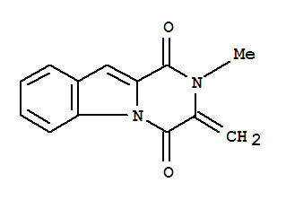 | 13.921
 | 6,6'-Diacetyl-7,7'-dihydroxy-2,2',4,4',5,5'-hexame | 41 | C₂₄H₂₆O₁₂ | 27.562 | 506.45600 | 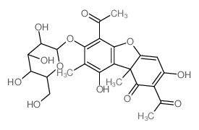 | 2.733
 | 2,3,7,7,12,13,17,18-Octaethyl-21H,23H-porphine-8-o | 42 | C₃₆H₄₆N₄O | 27.722 | 550.77700 | 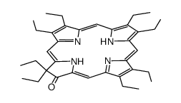 | 4.236
 | l-Leucine, N-(2,3,4-trifluorobenzoyl)-, octyl este | 43 | C₂₁H₃₀F₃NO₃ | 28.207 | 401.46301 |  | 0.421
 | 2,2-Dichloro-1,1-bis(4-methoxyphenyl)ethane | 44 | C₁₆H₁₆Cl₂O₂ | 28.632 | 311.20300 |  | 3.951
 | No match | 45 |  | 28.766 |  |  | 3.295
 | Bis(heptamethylcyclotetrasiloxy)hexamethyltrisilox | 46 | C₂₀H₆₀O₄Si₁₁ | 28.861 | 673.6285 | 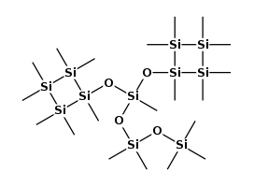 | 3.181
 | 3-Phorbinepropanoic acid, 9-acetyl-14-ethyl-13,14- | 47, 48 | C₂₉H₃₀N₄O₃ | 29.362 | 484.24 |  | 6.05
 | 1,2,3,4-Tetrahydro-6-methylthio-9-acridinol | 49 | C₁₃H₁₄N₂ | 30.347 | 245.34 |  | 2.1
 | Bis(pentamethylcyclotrisiloxy)hexamethyltrisiloxan | 50, 51 | C₁₆H₄₈O₁₀Si₉ | 31.701 | 557.32 |  | 5.82

Table S4: Docking scores of the target enzymes/proteins.
PDB Id | Enzyme details | Functions | Docking score
4RUL | Crystal structure of full-length E. coli topoisomerase I in complex with ssDNA  - doi: 10.2210/pdb4RUL/pdb | Prevents hyper negative supercoiling of DNA of transcription driven negative supercoils  (Tan et al. 2015; doi:10.1093/nar/gkv1073) | -6.3
5YIG | Crystal structure of Streptococcus pneumonia ParE with inhibitor  - doi: 10.2210/pdb5YIG/pdb | Permeability across Gram-negative bacterial membrane as well as bacterial efflux mechanisms.  (Ho et al. 2018; doi:10.1016/j.ejmech.2018.08.025) | -5.9
7DQW | E. coli GyrB ATPase domain in complex with 4-chlorophenol  - doi: 10.2210/pdb7DQW/pdb | ATPase domain of E. coli GyrB plays an essential role in regulating DNA topology during transcription and replication.  (Yu et al. 2021; doi:10.1016/j.bioorg.2021.105040) | -6.1
7DQS | E. coli GyrB ATPase domain in complex with 2-chlorophenol  - doi: 10.2210/pdb7DQS/pdb |  | -5.9
7DQM | E. coli GyrB ATPase domain in complex with Naringenin  - doi: 10.2210/pdb7DQM/pdb |  | -5.7
7DQL | E. coli GyrB ATPase domain in complex with 4-chlorobenzene-1,2-diol  - doi: 10.2210/pdb7DQL/pdb |  | -5.6
7DQJ | E. coli GyrB ATPase domain in complex with 3,4-Dihydroxyacetophenone  - doi: 10.2210/pdb7DQJ/pdb |  | -5.2
7DQI | E. coli GyrB ATPase domain in complex with Esculetin  - doi: 10.2210/pdb7DQI/pdb |  | -5.9
7DQF | E. coli GyrB ATPase domain in complex with methyl 2,4-dihydroxybenzoate  - doi: 10.2210/pdb7DQF/pdb |  | -5.4
7DPS | E. coli GyrB ATPase domain in complex with Methyl 4-hydroxycinnamate  - doi: 10.2210/pdb7DPS/pdb |  | -6.0
7DPR | E. coli GyrB ATPase domain in complex with methyl 3,4-dihydroxybenzoate  - doi: 10.2210/pdb7DPR/pdb |  | -5.9
7DOR | E. coli GyrB ATPase domain in complex with 4-nitropheno  - doi: 10.2210/pdb7DOR/pdb |  | -4.8
7DQH | E. coli GyrB ATPase domain in complex with 2-hydroxybenzamide  - doi: 10.2210/pdb7DQH/pdb |  | -6.3
1KSE | Solution Structure of a quinolone-capped DNA duplex  - doi: 10.2210/pdb1KSE/pdb | Quinolones are gyrase inhibitors. Quinolones block re-ligation of DNA strands in the active site of gyrases.  (Tuma et al. 2002; doi:10.1021/ja0125117) | -5.5
6JX9 | Structure of Y17107 complexed HPPD  - doi: 10.2210/pdb6JX9/pdb | 4-hydroxyphenylpyruvate dioxygenase (HPPD, EC 1.13.11.27) is a potential target for herbicides  (He et al. 2019; doi:10.1021/acs.jafc.9b04917) | -6.2
3W9H | Structural basis for the inhibition of bacterial multidrug exporters  - doi: 10.2210/pdb3W9H/pdb | Principal multidrug exporters in Pseudomonas aeruginosa8–10.  (Nakashima et al. 2013; doi:10.1038/nature12300) | -6.1
2LQV | YebF  - doi: 10.2210/pdb2LQV/pdb | E. coli protein transport  (Prehna et al. 2012; doi:10.1016/j.str.2012.04.014) | -5.8
5NUQ | Structural basis for maintenance of bacterial outer membrane lipid asymmetry  - doi: 10.2210/pdb5NUQ/pdb | The Gram-negative bacterial outer membrane (OM) lipoprotein MlaA that selectively removes outer leaflet phospholipids to help maintain the essential barrier function of the bacterial OM.  (Abellón-Ruiz et al. 2017; doi: 10.1038/s41564-017-0046-x) | -5.8
5NUR | Structural basis for maintenance of bacterial outer membrane lipid asymmetry  - doi: 10.2210/pdb5NUR/pdb |  | -5.3
5NUP | Structural basis for maintenance of bacterial outer membrane lipid asymmetry  doi: 10.2210/pdb5NUP/pdb |  | -6.2
5O79 | Klebsiella pneumoniae OmpK36  - doi: 10.2210/pdb5O79/pdb | The principal general porins of Enterobacteriaceae that determine antibiotic permeabilities  (Acosta-Gutiérrez et al. 2018; doi:10.1021/acsinfecdis.8b00108) | -6.2
5O77 | Klebsiella pneumoniae OmpK35  - doi: 10.2210/pdb5O77/pdb |  | -5.5
4JFB | Crystal structure of OmpF in C2 with tNCS  - doi: 10.2210/pdb4JFB/pdb | The outer membrane protein OmpF of E. coli  (Wiseman et al. 2014; doi:10.1371/journal.pone.0114864) | -1.6
3NB3 | The outer membrane proteins OmpA and OmpC of Shigella phage Sf6 virion.  doi: 10.2210/pdb3NB3/pdb | Outer membrane protein (OMP) porins for the lysogenic cycle.  (Zhao et al. 2011; doi:10.1016/j.virol.2010.10.030) | -4.8
1KZN | E. coli 24 kDa domain in Complex of DNA gyrase.  - doi: 10.2210/pdb1KZN/pdb | DNA Gyrase subunit B (protein)  (Lafitte et al. 2002; doi:10.1021/bi0159837) | -4.8
6YD9 | E. coli GyrB24 with inhibitor 16a  - doi: 10.2210/pdb6YD9/pdb | DNA gyrase and DNA topoisomerase IV of Gram-negative bacteria.  (Skok et al. 2020; doi:10.1021/acsmedchemlett.0c00416) | -6.2
4KPE | Topoisomerase IV from S. pneumoniae  - doi: 10.2210/pdb4KPE/pdb | Topoisomerase IV relaxes supercoiled DNA; is essential for chromosome segregation.  (Leo et al. 2005; doi:10. 1074/jbc.M500156200; Laponogov et al. 2016; doi:10.1098/rsob.160157) | -5.9
3RAD | Type IV topoisomerase from S. pneumoniae  - doi: 10.2210/pdb3RAD/pdb |  | -6.0
1KF6 | E. coli Quinol-Fumarate Reductase  doi: 10.2210/pdb1KF6/pdb | The quinol-fumarate reductase (QFR) is a respiratory complex that catalyzes the final step of anaerobic respiration  (Iverson et al. 2002; doi:10.1074/jbc.m200815200) | -7.0
1L0V | Quinol-Fumarate Reductase with Menaquinol Molecules  - doi: 10.2210/pdb1L0V/pdb |  | -7.1
2WP9 | E. coli succinate:quinone oxidoreductase (SQR) doi: 10.2210/pdb2WP9/pdb | Succinate-ubiquinone oxidoreductase (SQR) is a member of the complex II family of enzymes.  (Ruprecht et al. 2011; doi:10.1074/jbc.m110.209874) | -6.9

