Supplementary Information
- Supplementary Figures
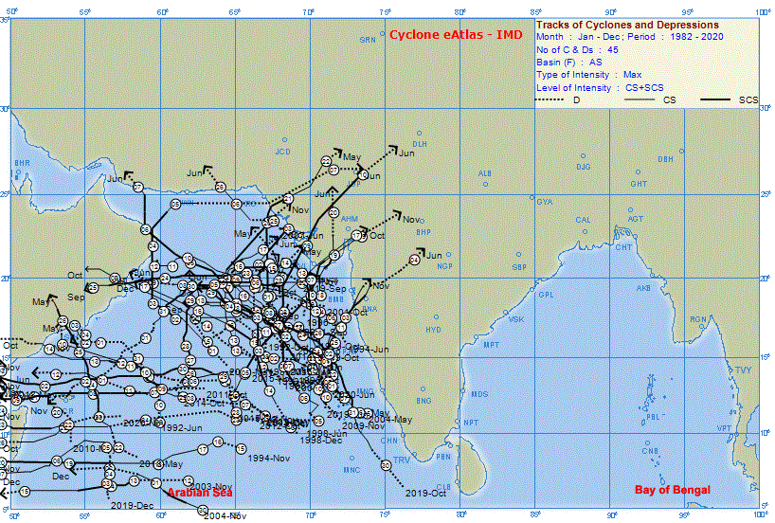
Fig. S1 Track of tropical cyclones (tropical system with wind speed above 34 knots) in Arabian Sea from 1982-2020 as recorded by cyclone e-atlas – IMD. The month of year of occurrence along with arrowed tracks is shown in the figure.

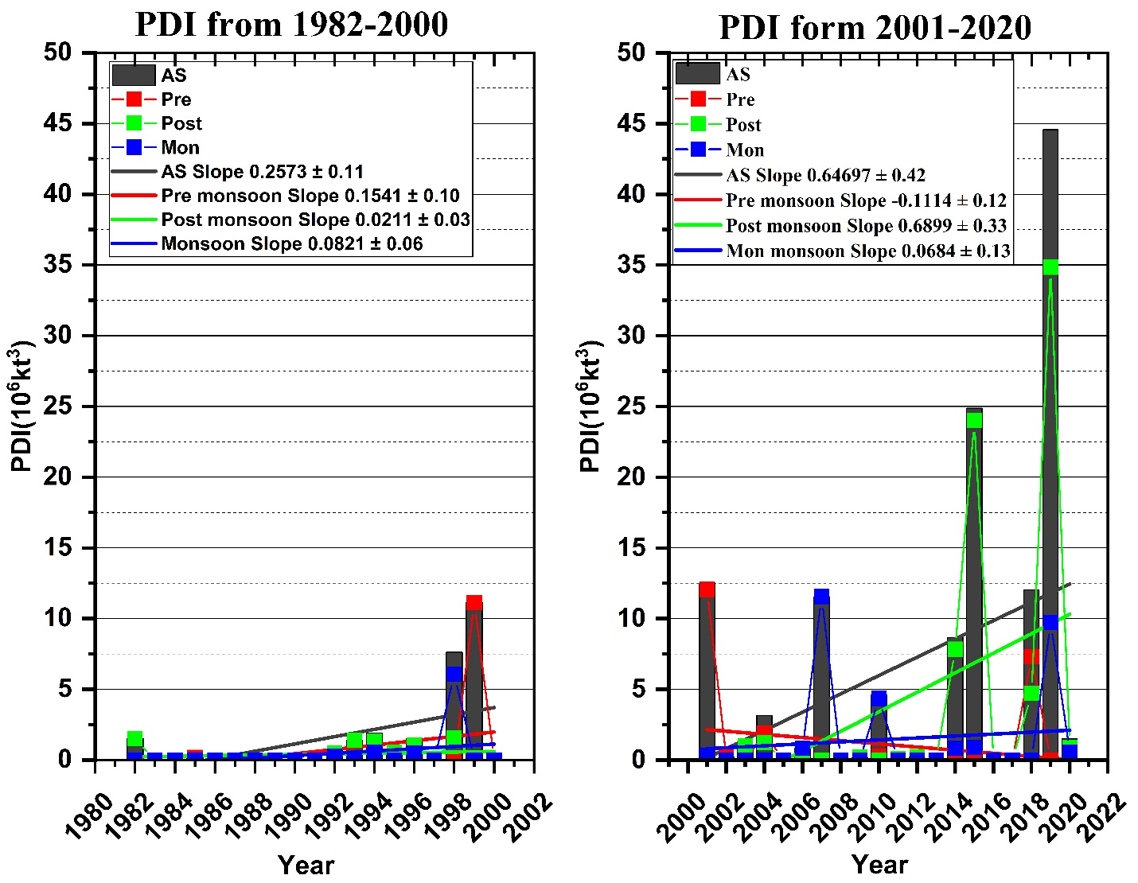
Fig S2. Depiction of annual PDI, pre-monsoon PDI, post-monsoon PDI and monsoon PDI with trendlines for bygone era and contemporary era. The figure clearly shows that the PDI values for all seasons and annual values increase many folds in CE compared to BE. Even within CE the values are extremely high after 2014. A negative slope is observed for CE pre monsoon PDI analogous to pre monsoon ACE. Post monsoon PDI shows a steep increase in CE.

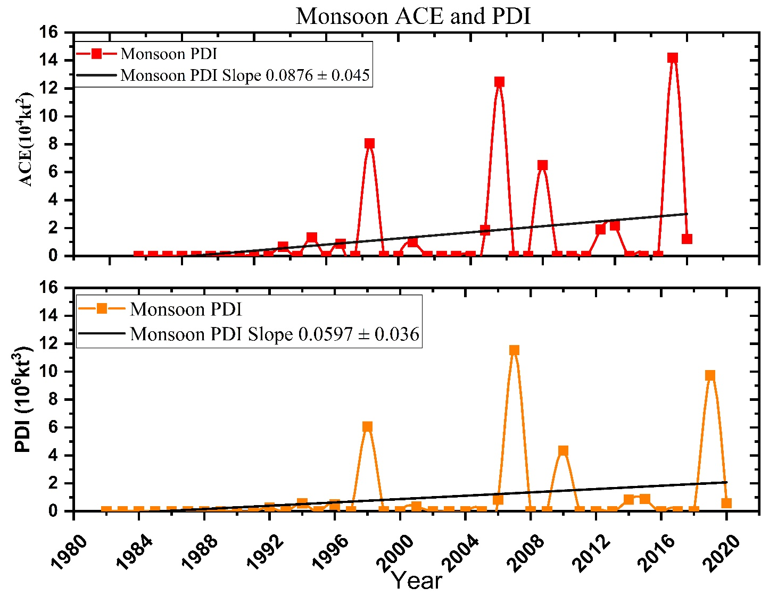
Fig S3. Representation of ACE and PDI for monsoon season from 1982 to 2020. An increasing trend is observed for both ACE and PDI with a slope of 0.0876 ± 0.045 and 0.0597 ± 0.036 respectively. This indicates that the storm intensity and damage potential of TC are increasing in monsoon season. Monsoon season is traditionally known for depressions and deep depressions. But lately the season is becoming active in TCs.

Fig S4. Monthly distribution of frequency of tropical cyclones from 1982-2020. It is observed that the months of October, June and May make major contribution to annual TC frequency in ARB. Most of the cyclones occur in the month of October, followed by June and May.

Supplementary Tables
Table S1: Classification of cyclonic storms by Indian Meteorological Department (IMD). Column 1 gives the category of cyclones and column 2 gives the wind speed in knots.
Category | Wind speed observed or estimated
Cyclonic Storm (CS) | 34-47 knots
Severe Cyclonic Storms (SCS) | 48-63 knots
Very Severe Cyclonic Storms (VSCS) | 64-90 knots
Extremely Severe Cyclonic Storms (ESCS) | 91-119 knots
Super Cyclonic Storms (SuCS) | 120 knots & more

Table S2: States in the western coast of India and their cyclone prone districts according to the hazard proneness classification of Regional Specialized Meteorological Center.
State | Districts | Degree of Proneness
Gujarat | Junagadh | P2
 | Kutch district | P2
 | Ahmedabad | P3
 | Bhavnagar | P3
 | Amreli | P3
 | Jamnagar | P3
 | Anand | P3
 | Navsari | P3
 | Surat | P3
 | Valsad | P3
 | Bharuch district | P3
 | Porbandar | P3
 | Rajkot | P3
 | Vadodara | P3
Maharashtra | Thane | P3
 | Mumbai Suburban | P3
 | Ratnagiri | P3
 | Raigarh | P3
 | Sindhudurg | P3
Goa | North Goa | P3
 | South Goa | P3
Karnataka | Udupi | P3
 | Uttar Kannada | P3
 | Dakshin Kannada | P3
Kerala | Kozhikode | P3
 | Malappuram | P3
 | Thrissur | P3
 | Kannur | P3
 | Kollam | P3
 | Alappuzha | P3
 | Thiruvananthapuram | P3
 | Kasaragod | P4
 | Ernakulam | P4
Daman & Diu | Daman | P3
 | Diu | P2
Lakshadweep | Lakshadweep | P2

Table S3: Proneness category and the degree of proneness as obtained from RSMC list of districts.
Proneness category | Degree of proneness
P1 | Very highly prone
P2 | Highly prone
P3 | Moderately prone
P4 | Less prone

Table S4: Category of houses based on the type of material used for walls
Category of houses | Wall material
A1 | Unburnt brick houses, clay houses
A2 | Stone Wall  not packed with mortar
B | Burnt Bricks Wall Rural & Stone wall packed Urban with mortar
C1 | Concrete Wall
C2 | Wood wall
X | Other materials not covered in A, B, C like light sheets and biomass materials
Source: Vulnerability Atlas of India, 3rd edition

Table S5: Category of houses based on the type of material used for roofs
Category of houses | Roof material
R1 | Light Weight (Grass, Thatch,  Bamboo, Wood, Mud, Plastic, Polythene,  GI Metal, Asbestos Sheets, Other Materials
R2 | Heavy Weight (Tiles, Stone/Slate)
R3 | Flat Roof (Brick, Concrete)
Source: Vulnerability Atlas of India, 3rd edition

Statistical tests for data analysis
Mann Kendall Test and Sen’s Slope Estimator
The null hypothesis, H₀, is that the data shows no monotonic trend and are identically distributed. The alternate hypothesis, H_{A}, is that data follow a monotonic trend. The MK test statistics S is calculated as:
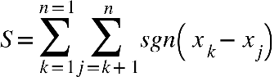

where n is the number of data points, and are data values in the time series (k>j). The sign function sgn (x) is as:
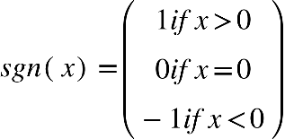

The variance is
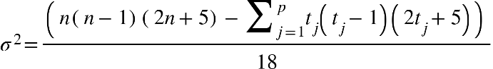

where n is the number of data points, p is the number of the tied groups in the data set and t_{j} is the number of data points in the jth tied group. Tied group is the set of sample data having the same values (Gocic and Trajkovic 2012). The standard normal test statistics Z when n>10 is given by:
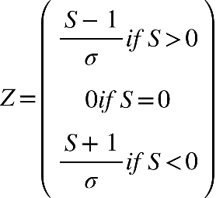

The value of Z determines an upward or downward trend. If Z yields a positive value, then there is an increasing trend in the time series and if Z yields a negative value, which means there is a downward trend. The values of Z are significant if the value of p is less than α (0.05), or |Z| >1.96 (Gocic and Trajkovic 2012).

Sens’s slope estimator, a non-parametric method to estimate the slope and intercept of the trend, is also used in this study (Pohlert 2020). The slope is calculated as follows:
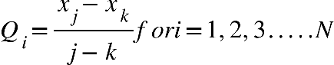

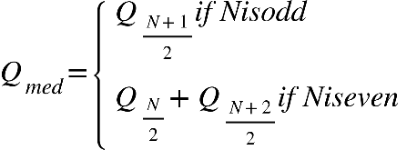
where x_{j} and x_{k} are data values at times j and k (j>k), respectively. N values are ranked from smallest to largest and the median of the slope is calculated as:

The sign of Q_{med} reveals data trend and magnitude indicates the steepness of the trend. In this study, Sen’s slope is computed at significance level α =0.05 and results are stated with 95% confidence.

