An appendix
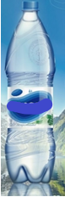 | Hermetically sealed non-carbonated original drinking water before the observation.  Hermetically sealed non-carbonated original drinking water after four-year follow-up. | 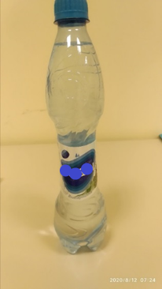
The hermetically sealed eight elastic plastic bottles with different liquids after a not-opened four years observational period (in front and obliquely from above).
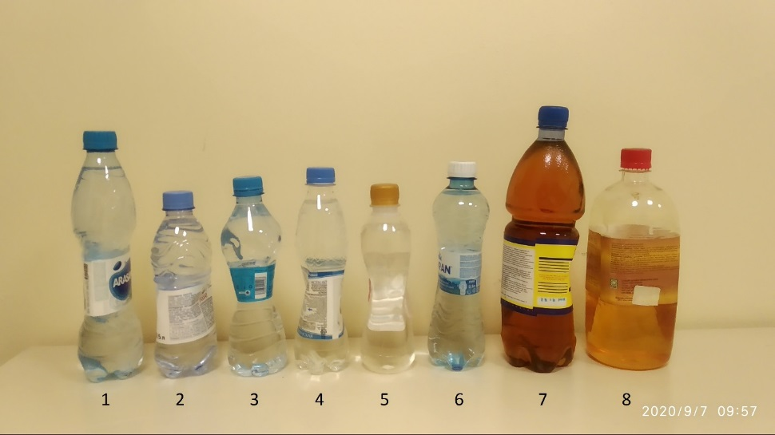
Attributes: The #1-4 and #6 bottles are non-carbonated drinking water from various manufacturers; #5 bottle is chemical solvent "646"; #7 bottle is drying oil; and #8 bottle is alkyd varnish (the bottle was initially incomplete). The bottles were evaluated at a temperature of 24 ^{о}С.