SUPPLEMENTARY MATERIAL for
Beyond mood: judgement bias is not associated with maternal aggression in canaries
Putteneers, S.¹, *Garcia-Co, C.^{1,2,3}; Verbruggen, F.^{2,3}; Morales, J.⁴; Müller, W.¹
Simon Putteneers and Clara Garcia-Co contributed equally to this work.
¹ Department of Biology, Behavioural Ecology and Ecophysiology Research Group. University of Antwerp (Belgium).
² Centre for Research on Ecology, Cognition and Behaviour of Birds. University of Ghent (Belgium)
³ Department of Experimental Psychology. University of Ghent (Belgium)
⁴ Department of Evolutionary Ecology, National Museum of Natural Sciences, Spanish National Research Council (MNCN-CSIC; Madrid, Spain).

Contact information:
- Name: Clara Garcia-Co
- Address: Department of Biology, Behavioural Ecology and Ecophysiology Group, University of Antwerp, Universiteitsplein 1, 2610 Antwerp, Wilrijk, Belgium
- Email address: Clara.GarciaiCo@uantwerpen.be

SUPPLEMENTARY INFORMATION 1: PILOT STUDIES
Two pilot studies were conducted prior to the main experiment to establish the most effective protocol for training female canaries to (i) discriminate between rewarded and unrewarded stimuli based on lid colour, and (ii) remove a lid from to access food. Each pilot comprised a habituation phase and a test phase.

S1.1 Pilot 1
During the habituation phase, birds were presented simultaneously with two Petri dishes, one with a black lid, one with a white lid, placed equidistantly on opposite sides of the cage. Lids were fixed to the dish bases and were not removable during this phase. The rewarded dish (containing egg food) was always presented in the same spatial position with the same lid colour, allowing females to form associations between colour, location, and food availability. The rewarded dish was refilled daily.
In the test phase, lids became removable. Each bird completed five trials (both dishes present) and was considered to have passed if it approached the rewarded dish first in at least four of the five trials. Willingness to engage with the apparatus was also recorded.

S1.2 Pilot 2
The habituation phase of Pilot 2 was divided into three sub-phases, each lasting two days, designed to progressively increase the motor demand associated with accessing the reward:
- Phase 1 (Days 1-2): identical setup to Pilot 1. Lids were fixed to the dish bases and were not removable, with the rewarded dish in a consistent color and position.
- Phase 2 (Days 3-4): the unrewarded dish lid was glued shut; the rewarded dish lid was partially displaced, requiring the female to move it slightly to access the food.
- Phase 3 (Days 5-6): the rewarded dish was fully covered, requiring complete lid removal to access the food. The unrewarded dish remained glued shut.
In the test phase, the rewarded and unrewarded dishes were each presented separately in their designated positions, and latency to approach each dish was recorded individually. A female was considered to have successfully learned the discrimination if she approached the rewarded dish faster than the unrewarded dish.
Pilot 2 produced a higher success rate than Pilot 1 because the progressive three-phase habituation more effectively established both the colour–reward association and the lid-removal behaviour before testing, whereas Pilot 1 required females to acquire both simultaneously. Pilot 2 was therefore adopted as the habituation procedure for the main experiment.

SUPPLEMENTARY INFORMATION 2: HABITUATION PROCEDURE
The habituation procedure for the main experiment replicated Pilot 2 protocol, spanning six days divided into three phases of two days each (see Supplementary Table S1 for the full experimental timeline). The procedure was designed to gradually familiarize females with the apparatus and progressively establish reliable lid-removal behavior (see Supplementary Figure S2).
- Phase 1 (Days 1-2): lids of both dishes were placed beneath the dishes, leaving the contents fully visible. This allowed females to associate lid colour with the presence or absence of food without any motor requirement.
- Phase 2 (Days 3-4): the rewarded dish was partially covered, requiring slight lid displacement to access the food. The unrewarded dish lid was glued shut, ensuring that females consistently encountered a non-rewarding stimulus at the unrewarded location.
- Phase 3 (Days 5-6): the rewarded dish was fully covered, requiring complete lid removal to access the food. The unrewarded dish remained glued shut.
Throughout the habituation, spatial position and lid colour associated with the rewarded and unrewarded stimuli remained constant within each cage. Lid colour assignment (black or white for reward) was counterbalanced across females to control for colour preference. Dishes were placed equidistantly on opposite sides of the cage (see Supplementary Figure S1)., and egg food was refilled twice daily during all habituation phases.

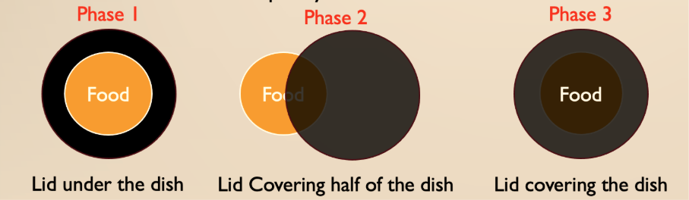Supplementary Figure S1: Habituation lid positions – rewarded dish across three phases. Phase 1: lid placed beneath dish (contents visible). Phase 2: lid partially displaced. Phase 3: dish fully covered.
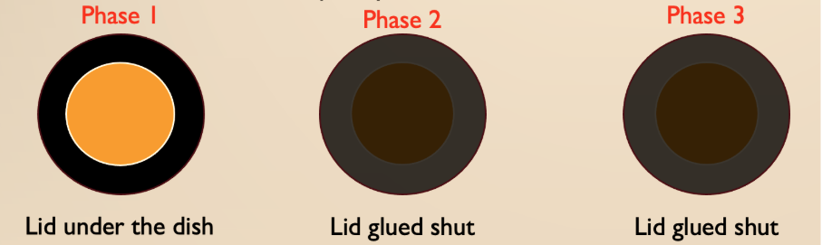Supplementary Figure S2: Habituation lid positions, unrewarded dish across three phases. The unrewarded dish lid was glued shut from Phase 2 onwards.

SUPPLEMENTARY TABLE S1: EXPERIMENTAL TIMELINE
Supplementary Table S1: Overview of the experimental timeline. HB = habituation phase; TR = training trial; T = test trial. On Day 7, the training phase (TR1–TR4) was conducted in the morning (09:00–09:40) and the test phase (T1–T5) was conducted four hours later in the afternoon (13:00–13:50), with food provided ad libitum between sessions.
 | Day 1 | Day 2 | Day 3 | Day 4 | Day 5 | Day 6 | Day 7
Phase | HB Phase 1 | HB Phase 1 | HB Phase 2 | HB Phase 2 | HB Phase 3 | HB Phase 3 | Training (TR1-TR4) +  Test (T1-T5)
Time | Entire day | Entire day | Entire day | Entire day | Entire day | Entire day | TR: 09:00–09:40 (4 × 10 min) Test: 13:00–13:50 (5 × 10 min)

SUPPLEMENTARY TABLE S2: ETHOGRAM
Supplementary Table S2: Ethogram of behaviours recorded during the judgement bias test. Behaviours were annotated using BORIS v8.27.7 (Friard & Gamba, 2016). Point events were recorded as a single timestamp; state events were recorded with onset and offset times.
Behaviour | Behaviour type | Description
Start of the test | State event | Onset: the moment the trial information sign is no longer visible.  Offset: end of the 10-minute trial window.
Approach the dish | Point event | The first moment the female comes within one body length of the dish.
Open the dish | Point event | The moment the female removes the lid such that the interior of the dish is accessible.
Peck at the dish | Point event | The moment the female pecks at the dish or lid.
Success in previous trial | Binary covariate | Whether the female successfully opened the dish in the immediately preceding trial (yes/no).

SUPPLEMENTARY INFORMATION S3: FULL STATISTICAL MODELS

The following supplementary tables support the two analyses reported in the main text. Table S3 provides a sensitivity check for the normalized bias score (brood size as covariate). Tables S4a–S5 report the full model for the validation analysis, including the Test phase × Brood size interaction. Tables S6a–S7 and Figure S3 report the secondary open latency analysis. Brood size was treated as a categorical variable throughout; broods of 1 and 2 were pooled (n = 14) and broods of 5 and 6 were pooled (n = 10). Brood size 2 (pooled) is the reference category for brood size contrasts; MA females are the reference category for MA contrasts.

S3.1 Normalized bias score — sensitivity check
The normalised bias score was calculated as [Latency(ambiguous) − Latency(rewarded)] / [Latency(unrewarded) − Latency(rewarded)] following Harding et al. (2004). Descriptive statistics (median MA = 0.11, noMA = 0.02) and primary tests (Wilcoxon W = 226, p = 0.459; population mean vs 0.5: t = −0.09, p = 0.925) are reported in the main text. The table below provides a sensitivity check confirming that brood size does not confound the null MA result.
Supplementary Table S3. Type III ANOVA for the effect of MA and brood size on raw normalized bias scores (linear model, N = 40). Neither MA nor brood size significantly predicted the bias score.
 | Sum Sq | df | F | P
MA | 0.10 | 1 | 0.005 | 0.943
Brood size (grouped) | 6.55 | 3 | 0.111 | 0.953
Residuals | 689.95 | 35

S3.2 Latency to approach the rewarded and unrewarded stimuli – full model
A linear mixed-effects model (lmer; lme4 v1.1-37, Bates et al., 2015) was fitted with log-transformed latency to approach the rewarded and unrewarded stimuli as the response variable. Fixed effects included MA status, success on the preceding trial, stimulus type (rewarded vs. unrewarded), brood size, and the stimulus type × brood size interaction. Nest identity was included as a random intercept to account for the repeated-measures structure (N = 96 observations from 53 nests).
Supplementary Table S4a. Type III Wald chi-square tests. The Test phase × Brood size interaction is highly significant, indicating that discrimination between rewarded and unrewarded stimuli varies by brood size.
 | χ² | df | P
MA | 0.02 | 1 | 0.883
Success in previous trial | 0.62 | 1 | 0.431
Test phase (Rewarded) | 1.16 | 1 | 0.282
Brood size | 5.17 | 3 | 0.160
Test phase × Brood size | 20.07 | 3 | < 0.001

Supplementary Table S4b. Full linear mixed-effects model for log-transformed latency to approach rewarded and unrewarded stimuli. Nest identity included as a random intercept. Reference categories: noMA females for MA; unrewarded stimulus for stimulus type; brood size 2 for brood size contrasts. The overall Test phase × Brood size interaction is highly significant (χ²₃ = 20.07, p < 0.001), indicating that stimulus discrimination (rewarded vs. unrewarded) varies by brood size. Bold P-values indicate P < 0.05.
 | Estimate (SE) | t | df | P
Intercept | 3.42 (0.50) | 6.80 | 82.1 | < 0.001
MA (yes) | 0.05 (0.36) | 0.15 | 52.3 | 0.883
Success in previous trial | −0.26 (0.33) | −0.79 | 95.4 | 0.433
Rewarded stimulus | 0.53 (0.49) | 1.08 | 49.6 | 0.287
Brood size 3 | 1.19 (0.58) | 2.06 | 82.3 | 0.043
Brood size 4 | 1.01 (0.54) | 1.85 | 86.7 | 0.068
Brood size 5 | 0.52 (0.63) | 0.83 | 87.5 | 0.410
Rewarded × Brood size 3 | −1.78 (0.65) | −2.73 | 45.5 | 0.009
Rewarded × Brood size 4 | −2.60 (0.63) | −4.12 | 47.0 | < 0.001
Rewarded × Brood size 5 | −2.65 (0.72) | −3.68 | 47.4 | < 0.001

Supplementary Table S5: Pairwise comparisons of stimulus type (unrewarded − rewarded) at each level of brood size for log-transformed latency to approach (emmeans). Females with larger broods (sizes 3–5) showed significantly faster approach to the rewarded than the unrewarded stimulus; no significant discrimination was observed for brood size 2. Bold P-values indicate P < 0.05.
Contrast | Estimate (SE) | t | df | P
Brood size 2: Unrewarded − Rewarded | −0.53 (0.52) | −1.02 | 57.7 | 0.314
Brood size 3: Unrewarded − Rewarded | 1.25 (0.47) | 2.69 | 54.9 | 0.010
Brood size 4: Unrewarded − Rewarded | 2.07 (0.42) | 4.91 | 52.6 | < 0.001
Brood size 5: Unrewarded − Rewarded | 2.12 (0.55) | 3.84 | 53.2 | < 0.001

S3.3 Latency to open the ambiguous stimuli – full model
A linear model was fitted with raw (untransformed) latency to open the ambiguous stimulus as the response variable (N = 31 females who successfully opened the dish). Fixed effects included MA status, success on the preceding trial, brood size, and the MA status × brood size interaction. The overall MA × brood size interaction was marginal (p = 0.086; see Type III ANOVA below). This analysis is reported as a secondary measure; the main finding is that MA females at brood size 2 opened the dish significantly faster than noMA females, a pattern that should be interpreted cautiously given the marginal overall interaction and small cell sizes.
Supplementary Table S6a. Type III ANOVA for the full linear model for latency to open the ambiguous stimulus. The main effect of MA is significant (F₁,₂₂ = 8.55, p = 0.008), while the overall MA × Brood size interaction is marginal and non-significant (F₃,₂₂ = 2.50, p = 0.086). Bold P-values indicate P < 0.05.
 | Sum Sq | df | F | P
MA | 217 978 | 1 | 8.55 | 0.008
Success in previous trial | 47 532 | 1 | 1.86 | 0.186
Brood size | 55 013 | 3 | 0.72 | 0.551
MA × Brood size | 191 012 | 3 | 2.50 | 0.086

Supplementary Table S6b. Full linear model for latency to open the ambiguous stimulus. Reference categories: MA females for MA status; brood size 2 for brood size contrasts. The main effect of MA reflects the difference at the reference brood size (brood size 2). Bold P-values indicate P < 0.05.
 | Estimate (SE) | t | P
Intercept | −74.1 (129.0) | −0.58 | 0.571
MA (noMA) | 446.1 (152.6) | 2.92 | 0.008
Success in previous trial | 123.2 (90.2) | 1.37 | 0.186
Brood size 3 | 221.1 (152.6) | 1.45 | 0.161
Brood size 4 | 82.2 (110.2) | 0.75 | 0.464
Brood size 5 | 100.7 (112.9) | 0.89 | 0.382
MA × Brood size 3 | −380.5 (210.5) | −1.81 | 0.084
MA × Brood size 4 | −361.2 (183.4) | −1.97 | 0.062
MA × Brood size 5 | −501.1 (185.0) | −2.71 | 0.013

Supplementary Table S7: Pairwise comparisons of MA status (MA − noMA) at each level of brood size for latency to open the ambiguous stimulus (emmeans). Within the brood size 2 group, MA females opened the dish significantly faster than noMA females (p = 0.008). No significant differences were found at larger brood sizes. This finding should be interpreted cautiously given the marginal overall interaction (p = 0.086) and the small cell sizes. Bold P-values indicate P < 0.05.
Brood size | Estimate (SE) | t | df | P
Brood size 2 | −446.1 (152.6) | −2.92 | 22 | 0.008
Brood size 3 | −65.6 (136.0) | −0.48 | 22 | 0.635
Brood size 4 | −84.9 (114.0) | −0.74 | 22 | 0.465
Brood size 5 | 55.0 (117.0) | 0.47 | 22 | 0.643

Supplementary Figure S3: Predicted latency to open the ambiguous stimulus (seconds) as a function of brood size and MA status, from the full model (Supplementary Table S6b). Error bars indicate 95% confidence intervals. Note the significant difference at brood size 2 (see Supplementary Table S7) and absence of differences at larger brood sizes.

