A Phosphite-Based Sscreening Platform for Identification of Enzymes Favoring Nonnatural Cofactors
Yuxue Liu,^{1,2,*} Zhuoya Li,¹ Xiaojia Guo,² Xueying Wang,² Zongbao K. Zhao²
¹ Henan Engineering Laboratory for Bioconversion Technology of Functional Microbes, College of Life Science, Henan Normal University, Xinxiang 453007, China
² Laboratory of Biotechnology, Dalian Institute of Chemical Physics, Chinese Academy of Sciences, Dalian 116023, China
*Corresponding author.

Supplementary information:
1. Strains (Table S1)
2. Plasmids (Table S2)
3. Method used to determine the activity of NadD variants by detecting the transformation efficiency
4. Western blot assay (Figure S1)
5. Schematic presentation of constructing plasmids (Figure S2)

1. Strains
The strains used in this study are summarized in Table S1.
Table S1 Strains used in this study.
Strains and Plasmids | Genotypes | Source
BL21(DE3) | F-, dcm, ompT, hsdS (Rb-, Mb-), gal, λ(DE3) | Novagen
BW14329 | F-, Δ(argF-lac)169, ΔphoA532, λ-, rpoS396(Am), rph-1, Δ(phnP-mel)522(Tn5-1/132), hsdR514, creC510, Mu+ | CGSC
BW16787 | F-, Δ(argF-lac)169, ΔphoA532, λ⁻, rpoS396(Am), rph-1, Δ(phnP-phnH)523(Tn5-1/132), hsdR514, creC510, Mu+ | CGSC
BW16847 | F-, Δ(codB-lacI)3, ΔphoA532, pdxH15(Am), purR106::Tn10, Δ(phnP-phnD)3330(phnC?) | CGSC
BW22246 | F-, Δ(codB-lacI)3, ΔphoA532, ΔuidA3::pir⁺, recA1, Δ(phnP-phnD)3330(phnC?) | CGSC
BW25141 | F-, Δ(araD-araB)567, ΔlacZ4787(::rrnB-3), Δ(phoB-phoR)580, λ-, galU95, ΔuidA3::pir+, recA1, endA9(del-ins)::FRT, rph-1, Δ(rhaD-rhaB)568, hsdR514 | CGSC
BW14329-YX00 | BW14329, pUC-(P_{araB})ME*+NTT4 | This study
BW14329-YX01 | BW14329, pUC-(P_{araB})ME*+NTT4+Pdh | This study
BW14329-YX09 | BW14329, pUC-(P_{araB})ME*+NTT4+Pdh_I151R | This study
BW14329-YX10 | BW14329, pUC-(P_{araB})ME*+NTT4+Pdh* | This study
BW14329-YX11 | BW14329, pUC-(P_{araB})ME*+NTT4+Pdh_I151R/P176E | This study
BW-PB01 | BW14329, pUC-chl-NcdS2+Pdh*, pTrc99K-ME* | This study
BW-PB03 | BW14329, pUC-chl-NcdS3+Pdh*, pTrc99K-ME* | This study
BW-PB05 | BW14329, pUC-chl-3G8+Pdh*, pTrc99K-ME* | This study
BW-PB07 | BW14329, pUC-chl-NcdS2+Pdh*, pTrc99K-ME | This study

2. Plasmids
The plasmids used in this study are summarized in Table S2.
Table S2 Plasmids used in this study.
Plasmids | Genotypes | Source
pUC18 | lacZ, pBR322 ori, bla, cloning vector | Takara
pK | pUC18, bla::kan | [1]
pK-Pdh* | pK with lacZ substituted by Pdh* | [2]
pTrc99K-ME | pTrc99a with wild-type ME expression, bla::kan | Lab collection
pTrc99K-ME* | pTrc99a with ME-L310R/Q401C expression, bla::kan | Lab collection
pUC-kan-NadD | pK with wild-type NadD expression | [3]
pUC-kan-NadD* | pK with NadD variants expression, including 22C8 23F7, 109H9, 1C1, and 22D8 | [3]
pUC-kan-3G8 | pK with NadD-V23Q/W176E expression | [4]
pUC-kan-NcdS-2 | pK with NcdS-2 expression | [4]
pUC-kan-NcdS-3 | pK with NcdS-3 expression | [4]
pUC-(P_{araB})ME*+NTT4 | pUC with lacZ substituted by ME* with ara operon and NTT4 with gapAP1 promoter | This study
pUC-(P_{araB})ME*+NTT4+Pdh | pUC with lacZ substituted by ME* with ara operon, NTT4 with gapAP1 promoter and wild type Pdh with lac operon | This study
pUC-(P_{araB})ME*+NTT4+ Pdh_I151R | pUC with lacZ substituted by ME* with ara operon, NTT4 with gapAP1 promoter and mutant Pdh_I151R with lac operon | This study
pUC-(P_{araB})ME*+NTT4+Pdh* | pUC with lacZ substituted by ME* with ara operon, NTT4 with gapAP1 promoter and Pdh* with lac operon | This study
pUC-(P_{araB})ME*+NTT4+ Pdh_I151R/P176E | pUC with lacZ substituted by ME* with ara operon, NTT4 with gapAP1 promoter and mutant Pdh_I151R/P176E with lac operon | This study
pUC-chl-(P_{araB})ME*+Pdh* | pUC with lacZ substituted by ME* with ara operon and Pdh* with lac operon, bla::cat | This study
pUC-chl-NcdS2+Pdh* | pUC with lacZ substituted by NcdS2 and Pdh* with lac operon, bla::cat | This study
pUC-chl-NcdS3+Pdh* | pUC with lacZ substituted by NcdS and Pdh* with lac operon, bla::cat | This study
pUC-chl-3G8+Pdh* | pUC with lacZ substituted by NadD-V23Q/W176E and Pdh* with lac operon, bla::cat | This study

3. Method of determining the activity of NadD variants by detecting the transformation efficiency
Add 1 µg pUC-kan-NadD or pUC-kan-NadD* plasmid DNA and 1 µg pUC-chl-(P_{araB})ME*+Pdh* plasmid DNA within 100 µl electro-competent cells of BW14329, and mix by gentle pipetting. The cell-DNA mixture was transferred into an ice chilled 2 mm gap electroporation cuvette, and electroporated at 2.5kV. Immediately add 1 mL LB and and transfer into a microcentrifuge tube. Rescue at 37 °C with shaking for 45 min. Cells were collected by centrifugation at 10000×g at 4 °C for 2 min, washed thrice and resuspended with 1 mL of MOPS medium without P source. A 100 μL volume of cell suspension was coated on the MOPS agar plate with 0.4% glucose, 50 μg/mL kanamycin, 30 μg/mL chloramphenicol, 0.1 mM IPTG, 1 mM L-arabinose, and with 50 mM phosphite as the sole P source. After incubation at 25 °C for ~2 days, colonies formed were counted.

4. Schematic presentation of constructing plasmids
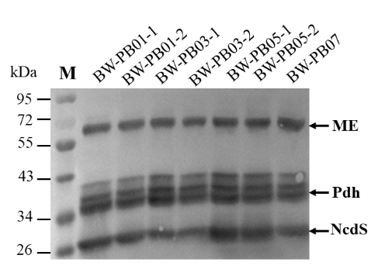
Figure S1 Western blot assay of enzyme expression of engineered E. coli cultured in liquid minimal media with 50 mM Phi.

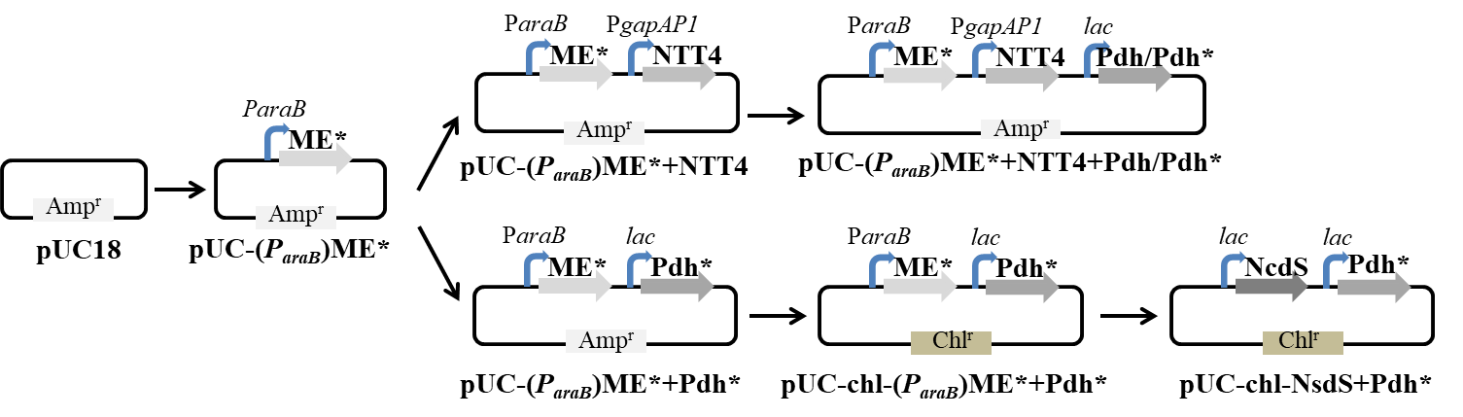
Figure S2 Schematic presentation of constructing plasmids. RF cloning strategy was used to construct the vectors.

References
1. Wang L, Ji D, Liu Y, Wang Q, Wang X, Zhou YJ, Zhang Y, Liu W and Zhao ZK (2017) Synthetic cofactor-linked metabolic circuits for selective energy transfer. ACS Catal 7:1977-1983. doi: 10.1021/acscatal.6b03579
2. Liu Y, Feng Y, Wang L, Guo X, Liu W, Li Q, Wang X, Xue S and Zhao ZK (2019) Structural insights into phosphite dehydrogenase variants favoring a non-natural redox cofactor. ACS Catal 9: 1883-1887. doi: 10.1021/acscatal.8b04822
3. Wang X, Zhou YJ, Wang L, Liu W, Liu Y, Peng C and Zhao ZK (2017) Engineering Escherichia coli nicotinic acid mononucleotide adenylyltransferase for fully active amidated NAD biosynthesis. Appl Environ Microbiol 83:e00692-17. doi: 10.1128/AEM.00692-17
4. Wang X, Feng Y, Guo X, Wang Q, Ning S, Li Q, Wang J, Wang L and Zhao ZK (2021) Creating enzymes and self-sufficient cells for biosynthesis of the non-natural cofactor nicotinamide cytosine dinucleotide. Nat Commun 12:2116-2116. doi: 10.1038/s41467-021-22357-z

