Electronic supplementary material for article: “Insigths of sphalerite weathering under simulated acidic, circumneutral and alkaline conditions to account for mineral activity and potential Zn release”
Fabiola S. Sosa-Rodríguezª, Jorge Vázquez-Arenas^{b}, Patricia Ponce-Peña^{c}, Antonio Aragón-Piña^{d}, Martine Mallet^{e}, Gabriel Trejo-Córdova^{f}, Diola M. Núñez-Ramírez^{c}, Miguel A. Escobedo-Bretado^{c}, René H. Lara^{c, *}
ª Research Area of Growth and Environment, Metropolitan Autonomous University (UAM), Azcapotzalco, Av. San Pablo 180, Mexico City, 02200, Mexico.
^{b} Conacyt-Departament of Chemistry, Metropolitan Autonomous University (UAM), Iztapalapa, Av. San Rafael Atlixco No 186, 09340, Mexico City, Mexico.
^{c} Department of Materials Science, Faculty of Chemical Sciences, Universidad Juárez del Estado de Durango (UJED), Av. Veterinaria S/N, Circuito Universitario, 34120, Durango, DGO, Mexico.
^{d} Institute of Metallurgy, Autonomous University of San Luis Potosí (UASLP), Av. Sierra Leona 550, Lomas 2da, 78210, San Luis Potosi, SLP, Mexico.
^{e} Université de Lorraine, CNRS, LCPME, F-54000 Nancy, France.
^{f} Centro de Investigación y Desarrollo Tecnológico en Electroquímica (CIDETEQ), Parque Tecnológico Sanfandila, Querétaro, 76703, Mexico.
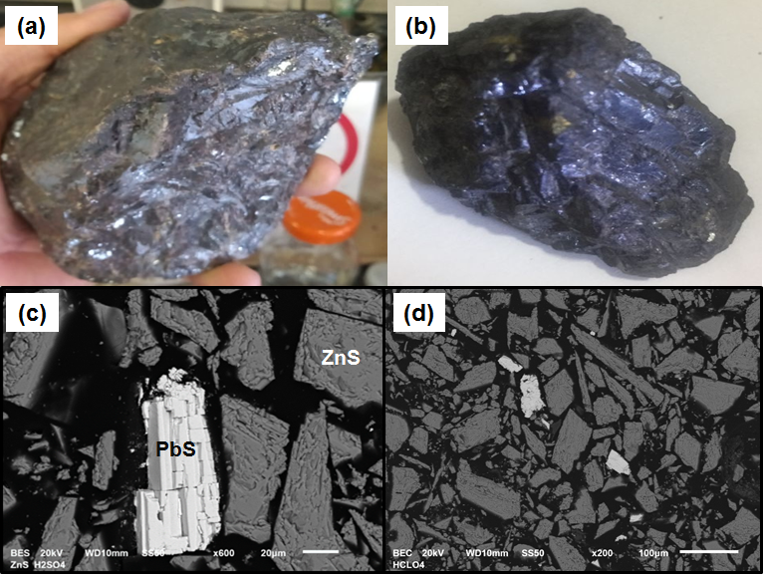
Fig. S1. Massive mineral specimens: (a) low-Fe bearing and Pb-bearing sphalerite sample (i.e., PbS-ZnS crystal); (b) marmatite-like sample (i.e., FeZnS crystal); (c) and (d) 2D SEM images for the PbS-ZnS sample (<106 μm). Carbon paste electrodes (CPE) were constructed using these mineral samples. Solid phases identification was carried out under EDS basis (n= 10 analyses).

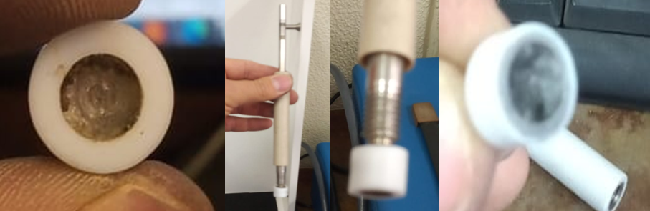
Fig. S2. Teflon-coated stainless steel electrode system with hole to be loaded with carbon paste containing the PbS-ZnS and/or FeZnS grain samples (50 wt. %, <106 μm).

Table S1. Summary of Raman transitions in terms of sulfur, zinc and lead species used to identify main secondary compounds on altered sphalerite samples (vi, indicates the transition order).
Chemical compound | Raman peak position, cm⁻¹ | References
Polysulfides (S_{n}²⁻) | from 443 to 475, main at 470 (v1) | Mycroft et al. 1990  This study
Elemental sulfur (S⁰) | 155 (v3), 220 (v2), 470 (v1) | Karimi et al., 2017  Mycroft et al. 1990  Ward, 1968
Sphalerite (FeZnS) | 180 (v2), 220 (v2), 298 (v1), 330 (v1), 349 (v1) | Karimi et al., 2017  Kharbish, 2007  Osadchii and Gorbaty, 2010  Buzatu et al. 2013  This study
Galena (PbS) | Not any active peak due to cubic structure | Shapter et al. 2000
Anglesite (PbSO₄) | 968 (v2), 1054 (v1) | Shapter et al. 2000  Batonneau et al. 2000  This study
Zinc sulfate (ZnSO₄) | 982 (v1) | Hayes et al. 1984

Table S2. Summary of XPS (S2p_{3/2} and Zn2p_{3/2}) binding energy (BE) positions of chemical species for pristine and leached surfaces of sphalerite.
Chemical species | Binding energy (BE) |  |  | Reference
Sphalerite (monosulfide, S²⁻)  Disulphide (S₂²⁻) | ~161.2 to  ~161.6  ~162.2 |  | Harmer et al., 2008  Fornassiero et al. 2006  Buckley and Woods, 1989  Mikhlin et al., 2016  Harmer et al., 2008  Schaufuβ et al. 1998  Pratt et al. 1994, 1998  Mikhlin et al. 2000
Polysulfides (S_{n}²⁻)  Elemental sulfur (S⁰)  Undetermined sulfoxyspecies (SO_{x}²⁻) to SO₃²⁻  Sulfate (SO₄²⁻)  Zn(II)-S²⁻ | ~162.5 to 163.3  ~163.3 to 164.6  ~163.5 to 164.3  ~168.5  1021.2 to  ~1022.1 |  | Mycroft et al. 1990  Sandström et al. 2005  Mikhlin et al., 2016  Fornassiero et al., 2006  Mikhlin et al. 1998, 2000  Mycroft et al. 1990  Eggleston et al. 1996  Buckley and Woods, 1989  Tonniazo et al. 1999  Nesbitt et al. 1998a,b  Mycroft et al. 1990  Eggleston et al. 1996  Nesbitt et al. 1995, 1998a  Schaufuβ et al. 1998  Tonniazo et al. 1999  Mullet et al. 2007  Buckley and Woods 1987  Nesbitt and Muir 1994  Tonniazo et al. 1999  Mullet et al. 2007  Nowak and Laahajaleto 2000  Fornassiero et al., 2006  Thomas et al. 2003  Nowak and Laajalehto 2000  Richardson and Vaughan 1989  Nesbitt et al. 1995  Nesbitt and Muir 1998  Fornassiero et a., 2006  Harmer et al., 2008  Buckley and Woods, 1989  Mikhlin et al., 2016

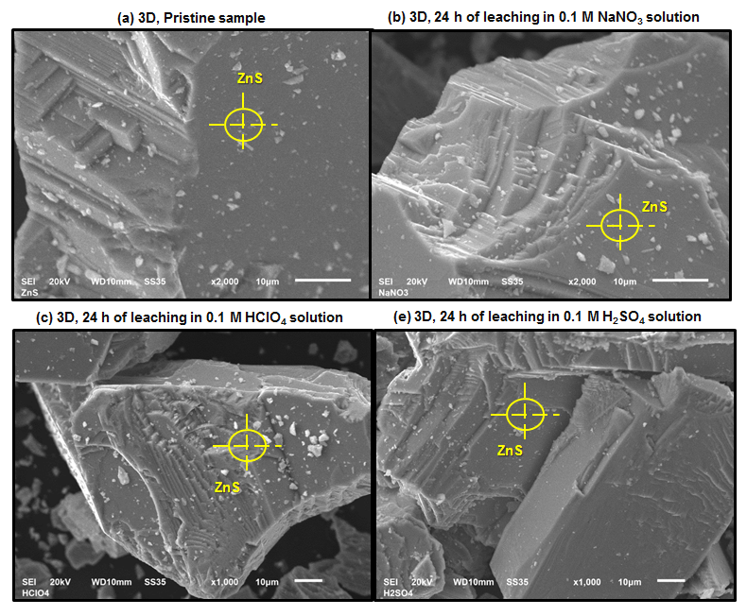
Fig. S3. 3D SEM images of pristine (a) and leached sphalerite (i.e., PbS-ZnS) samples obtained from simulated leaching devices in 0.1 M NaNO₃ (b), 0.1 M HClO₄ (c) and 0.1 M H₂SO₄ (d) conditions. Secondary phases identification was carried out under EDS basis (data, n= 10) where it was indicated the analyzed points in Figure. ZnS= sphalerite.

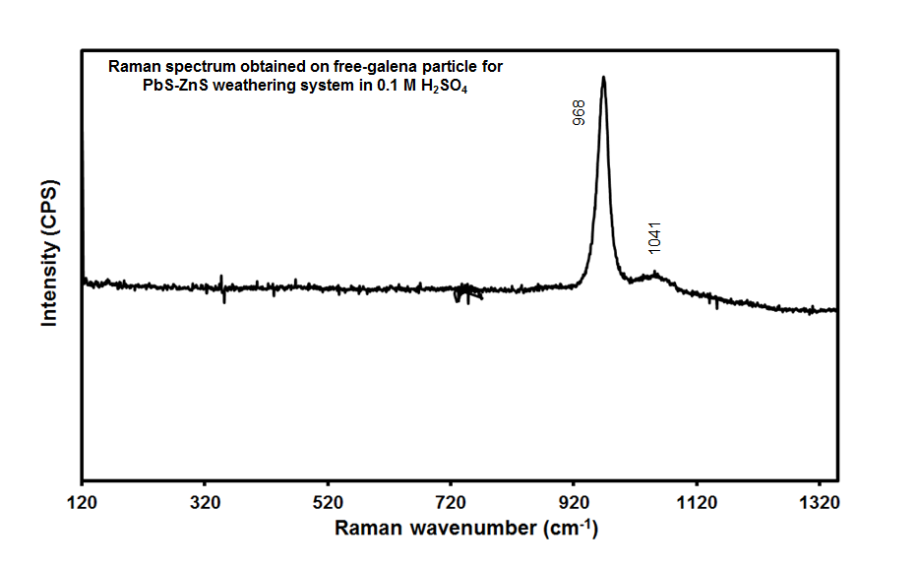
Fig. S4. Raman spectrum obtained on altered free-galena particle in 0.1 M H₂SO₄ solution from the PbS-ZnS weathering system. Raman peaks corresponded to anglesite (i.e., PbSO₄)-like compound. Galena has no known Raman peaks according to specific crystalline structure.

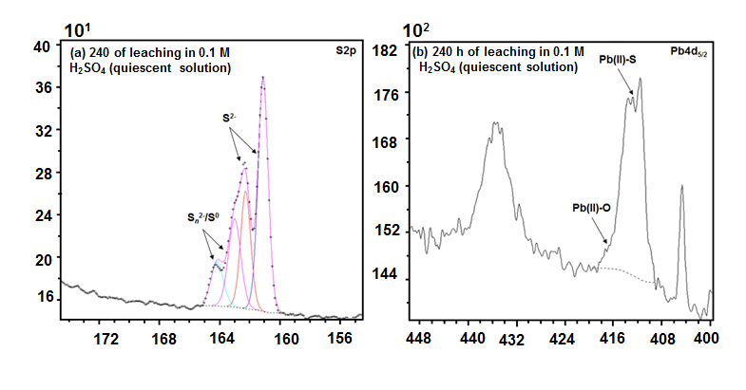
Fig. S5. XPS S2p (a) and Pb4d (b) high-resolution spectra obtained from leached PbS-ZnS samples after 240 h in 0.1 M H₂SO₄ solution. Quiescent and ambient conditions.

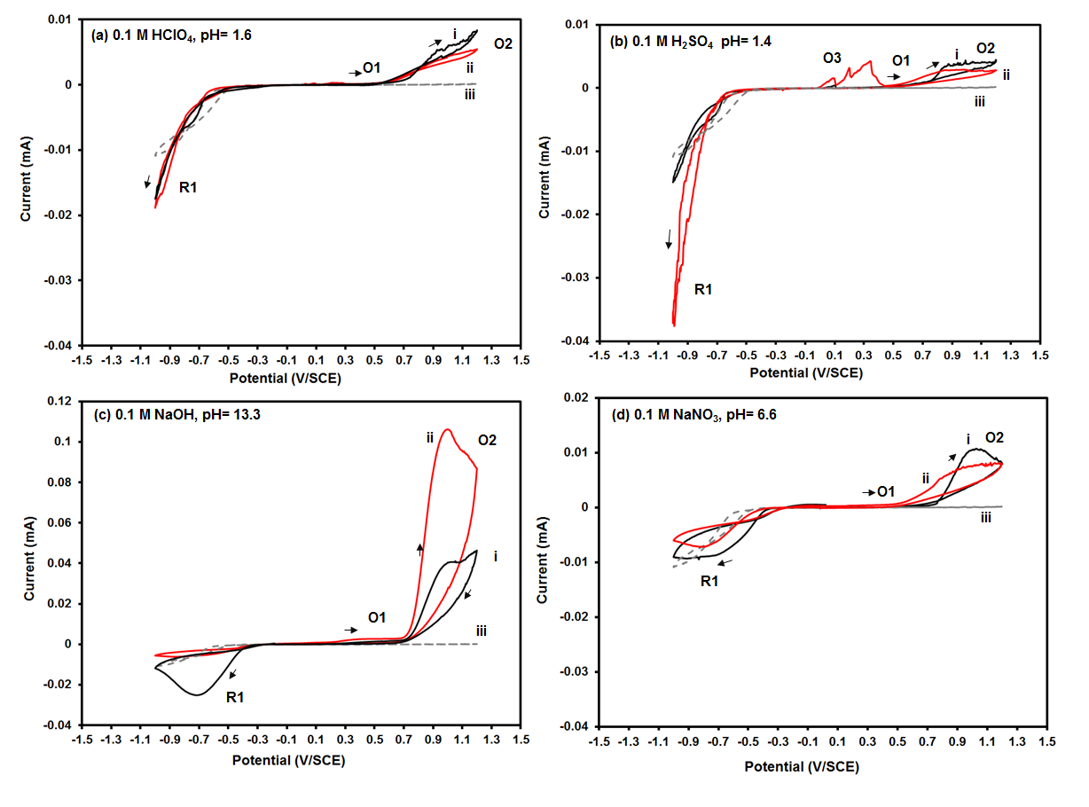
Fig. S6. Cyclic voltammograms initiated into the positive scans (i, black curves) and negative scans (ii, red curves) direction using CPE-marmatite-like sample (50 wt. %) under different simulated weathering conditions. 5 mV· s⁻¹. Ambient conditions. Quiescent systems. The inert response of the CPE without mineral species (100 % graphite) was included for comparison purposes (iii, gray curve).

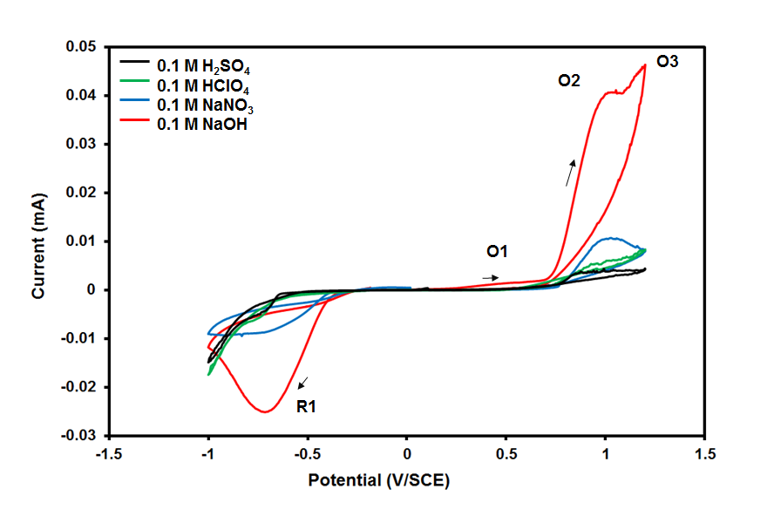 Fig. S7. Cyclic voltammograms (positive scans) using CPE-marmatite-like sample (50 wt. %) under different simulated conditions. Scan rate= 5 mV· s⁻¹. Ambient conditions. Quiescent system.

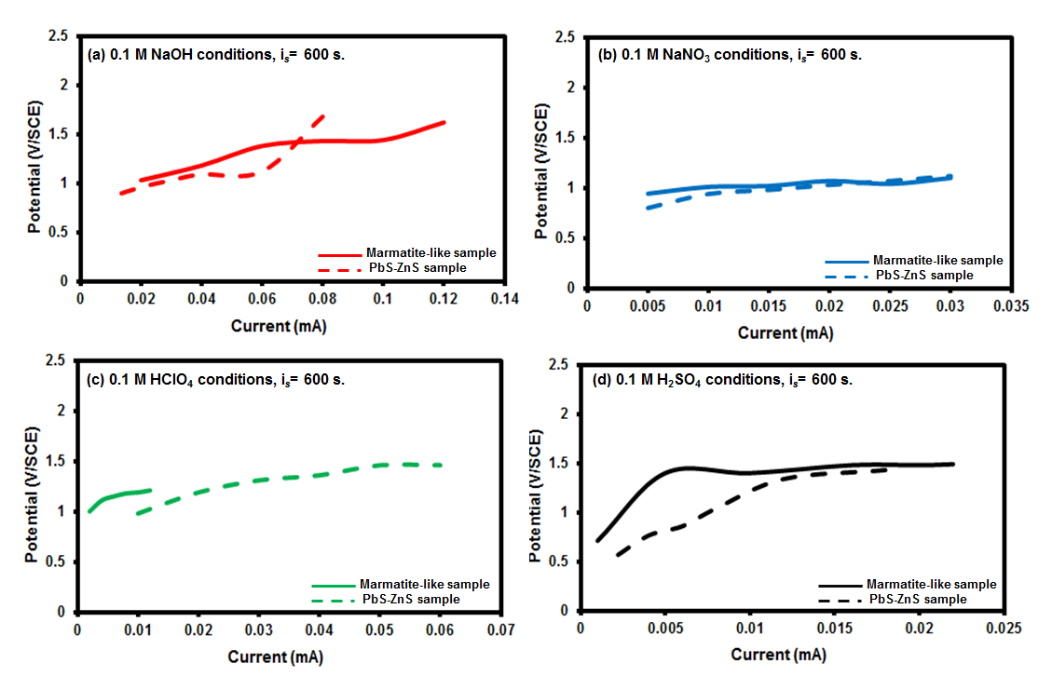
Fig. S8. Potential vs Current curves obtained from Chronopotentiometric (CP) experiments using the CPE-PbS-ZnS sample (50 wt. %) and CPE-FeZnS sample (50 wt. %) under different simulated weathering conditions. Selected time was 600 s. Current pulses were applied based on Cyclic voltammetry. Ambient conditions. Quiescent systems.

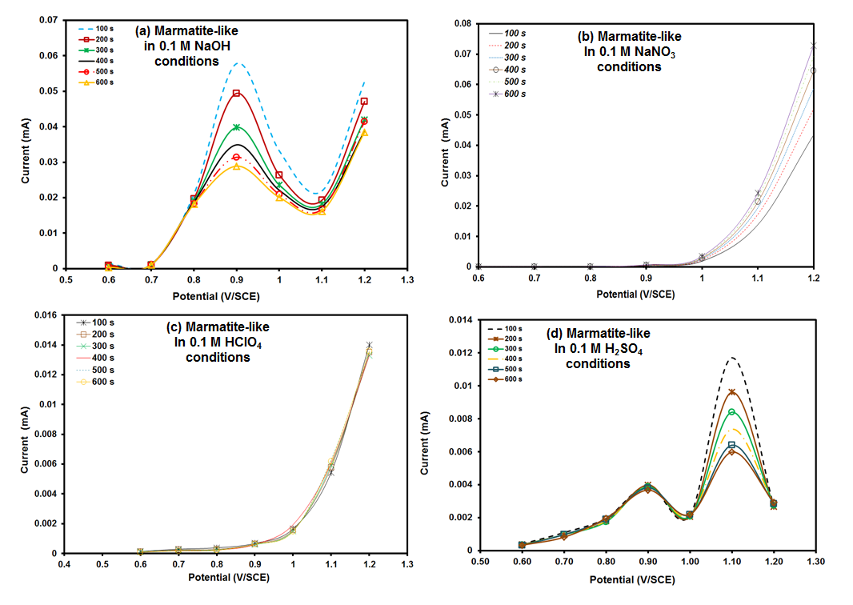
Fig. S9. Current vs Potential curves obtained from Chronoamperometric (CA) experiments using CPE-FeZnS sample (50 wt. %) under different simulated weathering conditions. Potential pulses were applied based on Cyclic voltammetry results. Ambient and quiescent conditions.

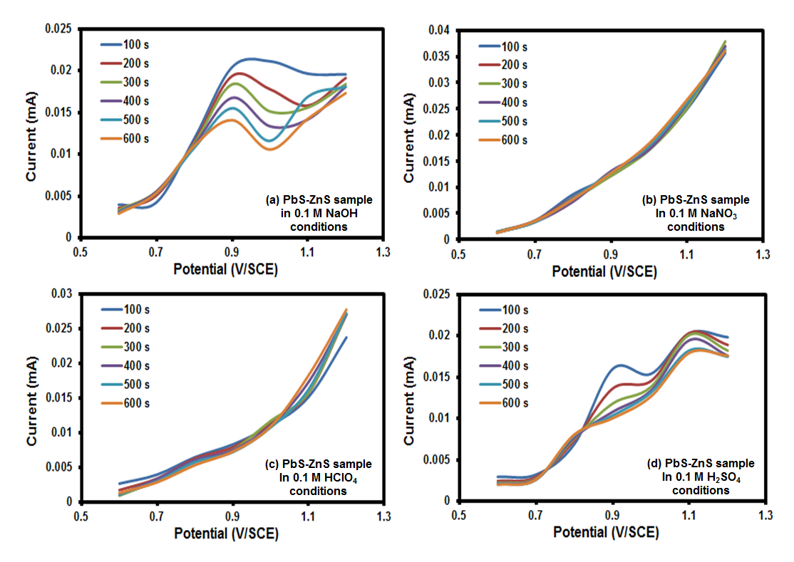
Fig. S10. Current vs Potential curves obtained from Chronoamperometric (CA) experiments using CPE-PbS-ZnS sample (50 wt. %) under different simulated weathering conditions. Potential pulses were applied based on Cyclic voltammetry. Ambient and quiescent conditions.
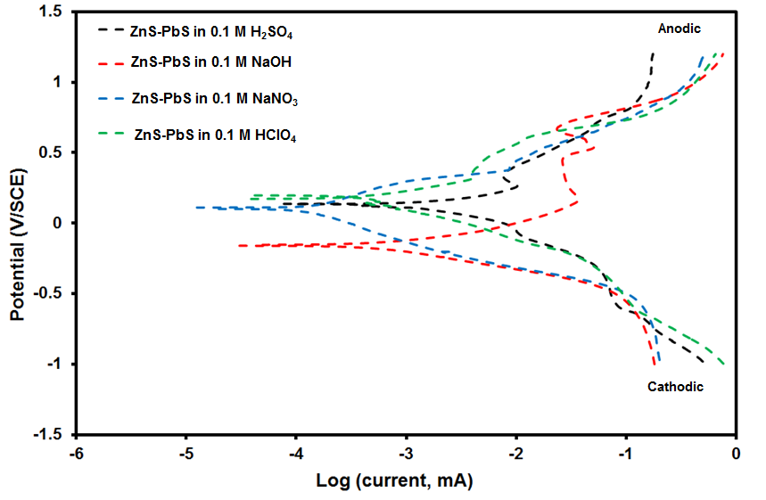
Fig. S11. Comparison of Tafel plots obtained using CPE-PbS-ZnS sample (50 wt. %) under different simulated weathering conditions. 1 mV· s⁻¹. Ambient conditions. Stirring conditions= 300 rpm.

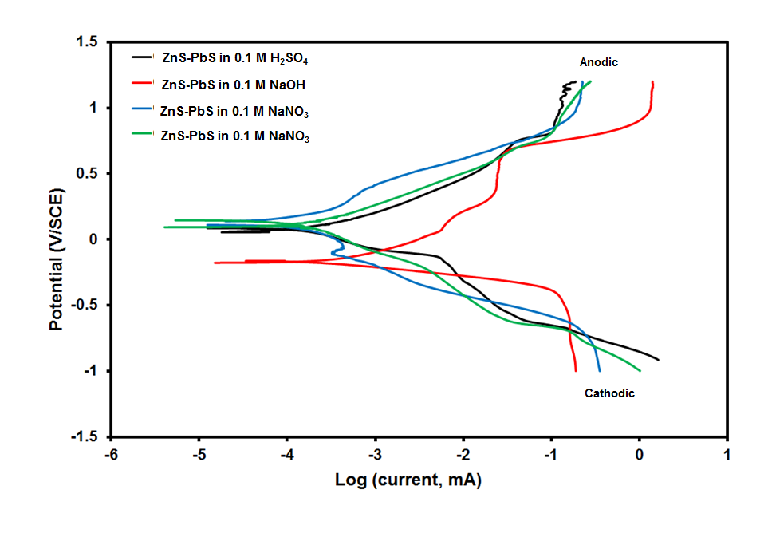
Fig. S12. Comparison of Tafel plots obtained using CPE-FeZnS sample (50 wt. %) under different simulated weathering conditions. 1 mV· s⁻¹. Ambient conditions. Stirring conditions= 300 rpm.

The Buttler-Volmer equation was utilized to elucidate Tafel parameters under the following general procedure (an example is given in Fig. S15, see below):
Anodic branch
$I= nFk_{f}*C_{R}^{b}exp\left(\frac{α_{A}nF}{RT}E\right)$ $α_{A}=1{-α}_{C}$ (1)
$i_{0}$, exchange current
$η$, overpotential
$α_{A, B},$transfer charge coefficient anodic(A) or cathodic (B)
n, transfered electron number for the limitant step
$log⁡(I)= log⁡(nFk_{f}*C_{R}^{b}exp\left(\frac{α_{A}nF}{RT}E\right))$ $α_{A}=1{-α}_{C}$
log(a*b)=log(a)+log(b)
$\log\left(I\right)=\log\left(nFk_{f}*C_{R}^{b}\right)+\left(\frac{2.303α_{A}nF}{RT}E\right)$
Catodic branch
$I=-nFk_{b}*C_{O}^{b}exp\left(\frac{{-α}_{C}nF}{RT}E\right)$
$log⁡(I)= log⁡(-nFk_{b}*C_{O}^{b}exp\left(\frac{{-α}_{C}nF}{RT}E\right))$
log(a*b)=log(a)+log(b)
$\log\left(I\right)=\log\left(-nFk_{b}*C_{O}^{b}\right)+\left(\frac{{-2.303α}_{C}nF}{RT}E\right)$
Recall that the definition of the exchange current (i₀) is the current when one is located at the equilibrium potential (E_{eq}), and the oxidation and reduction currents are the same:
$i_{0}=nFk_{f}*C_{R}^{b}exp\left(\frac{α_{A}nF}{RT}E_{eq}\right)=-nFk_{b}*C_{O}^{b}exp\left(\frac{{-α}_{C}nF}{RT}E_{eq}\right)$ (2)
$C_{R}^{b}$, bulk concentration of reduced species
$C_{O}^{b}$, bulk concentration of oxidized species
$k_{f}$, rate constant for oxidation
$k_{b}$, rate constant for reduction
The definition of the overpotential is known:
$η=E-E_{eq}$ (3)
If (2) is substituted in (1) to avoid dealing with overpotentials and simultaneously definition of overpotential in eq. (3), remains of the following shape:
$I= nFk_{f}*C_{R}^{b}exp\left(\frac{α_{A}nF}{RT}E\right)-nFk_{b}*C_{O}^{b}exp\left(\frac{{-α}_{C}nF}{RT}E\right)$ (4)
Particular assumptions for the PbS-ZnS and FeZnS samples analysis (Eqs. 1 to 4):
- The difference E-E_{eq} is minor for E beyond equilibrium; accordingly, catodic branch is easily omitted from Tafel analysis.
$I≈-nFk_{b}*C_{O}^{b}exp\left(\frac{{-α}_{C}nF}{RT}E\right)$ (5)
- Aforementioned processes are kinetically controlled, whereby the following approach can be drawn for practical purposes:
$I≈-nF{k'}_{b}*C_{O}^{s}exp\left(\frac{{-α}_{C}nF}{RT}E\right)$ (6)

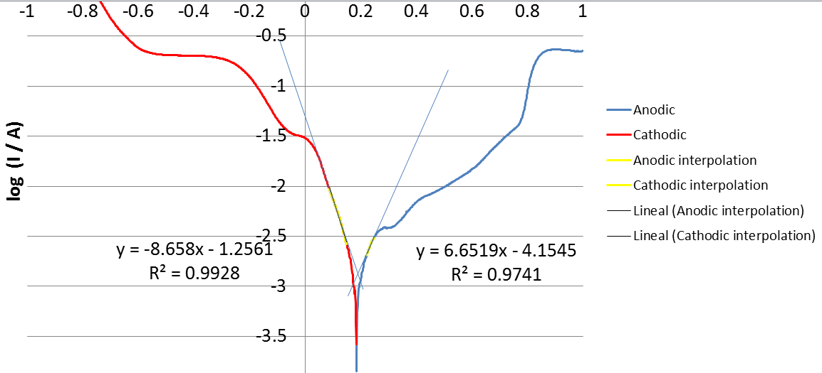
Fig. S13. General procedure for obtaining Tafel parameters. Scan rate of 1 mV· s⁻¹. Ambient conditions. Stirring conditions= 300 rpm. The Tafel plot was acquired for the CPE-inert system in this figure.

From the Figure 8:

CPE-Marmatite-like in 0.1 M H₂SO₄ conditions:
$\frac{2.303α_{A}nF}{RT}=3.5912$ $\log\left(nFk_{f}*C_{R}^{b}\right)=-3.6689$, whereby
$α_{A}=0.04$ for n=1 $k_{f}*C_{R}^{b}=2.22x{10}^{-09}$ mol/s → $\frac{{cm}^{3}}{s}*\frac{mol}{{cm}^{3}}$
$$E_{corr}=0.07 V$$
CPE-ZnS-PbS in 0.1 M H₂SO₄ conditions:
$α_{A}=0.12$ for n=1 $k_{f}*C_{R}^{b}=4.97x{10}^{-10}$ mol/s → $\frac{{cm}^{3}}{s}*\frac{mol}{{cm}^{3}}$
$$E_{corr}=0.13 V$$
CPE-Marmatite-like in 0.1 M NaOH conditions:
$α_{A}=0.04$ for n=1 $k_{f}*C_{R}^{b}=3.14x{10}^{-8}$ mol/s → $\frac{{cm}^{3}}{s}*\frac{mol}{{cm}^{3}}$
$$E_{corr}=-0.164 V$$
CPE-ZnS-PbS in 0.1 M NaOH conditions:
$α_{A}=0.05$ for n=1 $k_{f}*C_{R}^{b}=1.07x{10}^{-7}$ mol/s → $\frac{{cm}^{3}}{s}*\frac{mol}{{cm}^{3}}$
$$E_{corr}=-0.165 V$$
CPE-Marmatite-like in 0.1 M NaNO₃ conditions:
$α_{A}=0.02$ for n=1 $k_{f}*C_{R}^{b}=1.19x{10}^{-9}$ mol/s → $\frac{{cm}^{3}}{s}*\frac{mol}{{cm}^{3}}$
$$E_{corr}=0.11 V$$
CPE-ZnS-PbS in 0.1 M NaNO₃ conditions:
$α_{A}=0.05$ for n=1 $k_{f}*C_{R}^{b}=4.15x{10}^{-10}$ mol/s → $\frac{{cm}^{3}}{s}*\frac{mol}{{cm}^{3}}$
$$E_{corr}=0.1 V$$

CPE-Marmatite-like in 0.1 M HClO₄ conditions:
$α_{A}=0.02$ for n=1 $k_{f}*C_{R}^{b}=2.11x{10}^{-9}$ mol/s → $\frac{{cm}^{3}}{s}*\frac{mol}{{cm}^{3}}$
$$E_{corr}=0.07 V$$
CPE-ZnS-PbS in 0.1 M HClO₄ conditions:
$α_{A}=0.05$ for n=1 $k_{f}*C_{R}^{b}=4.02x{10}^{-10}$ mol/s → $\frac{{cm}^{3}}{s}*\frac{mol}{{cm}^{3}}$
$$E_{corr}=0.05 V$$

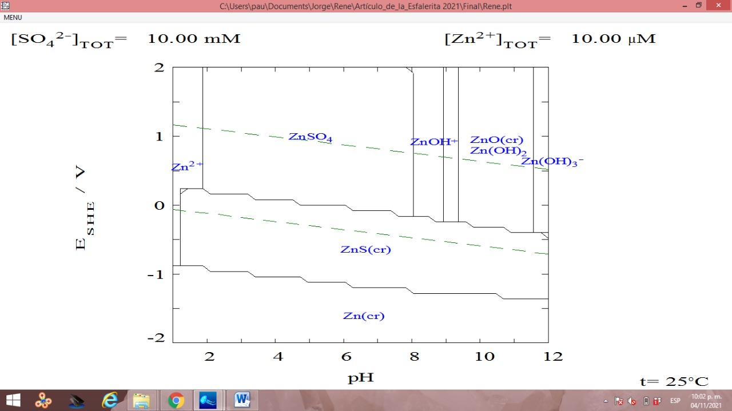
Fig. S14. Pourbaix diagram of the Zn-S-H₂O system.

