Supplemental Information

Halide perovskites: empowered by an unconventional bonding mechanism

Matthias Wuttig^{1,2,3}, Carl-Friedrich Schön¹, Mathias Schumacher⁴, John Robertson⁵, Pavlo Golub⁶, Eric Bousquet⁷, Jean-Yves Raty^{7,8}

- I. Institute of Physics, Physics of Novel Materials, RWTH Aachen University, 52056 Aachen, Germany
- Jülich-Aachen Research Alliance (JARA FIT and JARA HPC), RWTH Aachen University, 52056 Aachen, Germany
- PGI 10 (Green IT), Forschungszentrum Jülich GmbH, 52428 Jülich, Germany
- Institute for Theoretical Solid State Physics, RWTH Aachen University, 52056 Aachen, Germany
- Engineering Dept, Cambridge University, Cambridge CB3 0FA, UK
- J. Heyrovský Institute of Physical Chemistry, Department of Theoretical Chemistry, Dolejškova 2155/3, 182 23 Prague 8, Czech Republic
- CESAM and Physics of Solids, Interfaces and Nanostructures, B5, Université de Liège, B4000 Sart-Tilman, Belgium
- UGA, CEA-LETI, MINATEC campus, 17 rue des Martyrs, F38054 Grenoble Cedex 9, France
Table of Contents:
- Properties and quantum-chemical bonding descriptors for oxide and halide perovskites

Band structure and density of states for oxide (BaTiO₃) and halide perovskite (CsPbI₃)
- DAFH orbitals for CsPbI₃, CsPbBr₃, CsPbCl₃ and BaTiO₃
- Perovskite band model and effective masses
- Bonding and properties in the hybrid perovskite MAPI
- Effect of Peierls distortion on the properties of CsPbI₃.
- Trends in optical properties going from iodide perovskites to chloride perovskites
- Comparison with Pb-chalcogenides
- References
The supplementary information summarizes crucial information about the presented and conclusions drawn. At first, property and bonding trends for oxide perovskites are presented and compared to halide perovskites, followed by a discussion of the related bands structures and relevant orbitals. Furthermore, a simple model based on a tight binding approach is utilized to explain both the effective mass of electrons and holes, as well as the pronounced optical absorption. This model reveals that a simple half-filled σ–bond of p-states can explain both the small effective masses of holes and electrons, as well their exceptional asymmetry. Subsequently, the quantum chemical bonding indicators for a hybrid halide perovskite are provided; followed by a discussion of the role of distortions on material properties and chemical bonding. Finally, property and bonding trends for halide perovskites are and compared to lead chalcogenides.
- Properties and quantum-chemical bonding descriptors for oxide and halide perovskites
0BMaterial | Species | Z* |  | Z*_{n} |  | ECoN |  | $$ε_{∞}$$ | E_{g} (eV) | ET | ES
CaHfO₃ | Ca | 2.53 |  | 1.26 |  | 13.92 |  | 4.07 | 4.26 | Ca-O
CaHfO₃ | Ti | 5.76 |  | 1.44 |  | 6 |  | 4.07 | 4.26 | 0.817 | 0.152
CaHfO₃ | O | -4.61 |  | -2.30 |  | 2.04 |  | 4.07 | 4.26 | Hf-O
CaHfO₃ | O | -1.81 |  | -0.90 |  |  |  | 4.07 | 4.26 | 0.651 | 0.982
CaHfO₃ | O | -1.81 |  | -0.90 |  |  |  | 4.07 | 4.26
CaTiO₃ | Ca | 2.61 |  | 1.31 |  | 13.92 |  | 6.56 | 2.03 | Ca-O
CaTiO₃ | Ti | 6.82 |  | 1.71 |  | 6 |  | 6.56 | 2.03 | 0.8 | 0.168
CaTiO₃ | O | -5.54 |  | -2.77 |  | 2.04 |  | 6.56 | 2.03 | Ti-O
CaTiO₃ | O | -1.98 |  | -0.99 |  |  |  | 6.56 | 2.03 | 0.561 | 1.081
CaTiO₃ | O | -1.98 |  | -0.99 |  |  |  | 6.56 | 2.03
CaZrO₃ | Ca | 2.61 |  | 1.30 |  | 13.92 |  | 4.20 | 3.91 | Ca-O
CaZrO₃ | Ti | 5.86 |  | 1.47 |  | 6 |  | 4.20 | 3.91 | 0.866 | 0.146
CaZrO₃ | O | -4.79 |  | -2.40 |  | 2.039 |  | 4.20 | 3.91 | Zr-O
CaZrO₃ | O | -1.80 |  | -0.90 |  |  |  | 4.20 | 3.91 | 0.642 | 1.024
CaZrO₃ | O | -1.80 |  | -0.90 |  |  |  | 4.20 | 3.91
SrTiO₃ | Sr | 2.50 |  | 1.25 |  | 13.92 |  | 5.66 | 2.19 | Sr-O
SrTiO₃ | Ti | 7.12 |  | 1.78 |  | 6 |  | 5.66 | 2.19 | 0.799 | 0.212
SrTiO₃ | O | -5.65  -1.99  -1.99 |  | - -2.82  -0.99  -0.99 |  | 2.04 |  | 5.66 | 2.19 | Ti-O
 |  |  |  |  |  |  |  |  |  | 0.558 | 1.072
SrZrO₃ | Sr | 2.52 |  | 1.26 |  | 13.92 |  | 4.19 | 3.90 | Sr-O
SrZrO₃ | Zr | 5.93 |  | 1.48 |  | 6 |  | 4.19 | 3.90 | 0.808 | 0.184
SrZrO₃ | O | -4.78  -1.84  -1.84 |  | -2.39  -0.92  -0.92 |  | 2.04 |  | 4.19 | 3.90 | Zr-O
 |  |  |  |  |  |  |  |  |  | 0.625 | 1.020
SrHfO₃ | Sr | 2.54 |  | 1.27 |  | 13.92 |  | 4.03 | 2.12 | Sr-O
SrHfO₃ | Hf | 5.73 |  | 1.43 |  | 6 |  | 4.03 | 2.12 | 0.802 | 0.194
SrHfO₃ | O | -4.55  -1.85  -1.85 |  | -2.28  -0.93  -0.93 |  | 2.04 |  | 4.03 | 2.12 | Hf-O
 |  |  |  |  |  |  |  |  |  | 0.652 | 0.972
BaTiO₃ | Ba | 2.78 |  | 1.39 |  | 13.92 |  | 6.00 | 3.18** | Ba-O
BaTiO₃ | Ti | 7.17 |  | 1.79 |  | 6 |  | 6.00 | 3.18** | 0.776 | 0.288
BaTiO₃ | O | -5.57  -2.12  -2.12 |  | -2.79  -1.06  -1.06 |  | 2.04 |  | 6.00 | 3.18** | Ti-O
 |  |  |  |  |  |  |  |  |  | 0.553 | 1.060
BaZrO₃ | Ba | 2.70 |  | 1.35 |  | 13.92 |  | 4.49 | 3.67 | Ba-O
BaZrO₃ | Zr | 6.03 |  | 1.51 |  | 6 |  | 4.49 | 3.67 | 0.757 | 0.256
BaZrO₃ | O | -4.76  -1.84  -1.84 |  | -2.38  -0.92  -0.92 |  | 2.04 |  | 4.49 | 3.67 | Zr-O
 |  |  |  |  |  |  |  |  |  | 0.634 | 1.010
BaHfO₃ | Ba | 2.71 |  | 1.36 |  | 13.92 |  | 4.34 | 4.13 | Ba-O
BaHfO₃ | Hf | 5.79 |  | 1.45 |  | 6 |  | 4.34 | 4.13 | 0.800 | 0.262
BaHfO₃ | O | -4.53  -2.01  -2.01 |  | -2.26  -1.00  -1.00 |  | 2.04 |  | 4.34 | 4.13 | Hf-O
 |  |  |  |  |  |  |  |  |  | 0.610 | 0.996
CsSnCl₃ | Cs |  | 1.30 |  | 1.30 |  | 13.92 |  | 3.53 | 1.01 | Cs-Cl
CsSnCl₃ | Sn |  | 4.63 |  |  |  | 6 |  | 3.53 | 1.01 | 0.895 | 0.096
CsSnCl₃ | Cl |  | -4.86  -0.58  -0.58 |  | 4.86  -0.58  -0.58 |  | 2.04 |  | 3.53 | 1.01 | Sn-Cl
 |  |  |  |  |  |  |  |  |  |  | 0.640 | 0.740
CsPbCl₃ | Cs |  | 1.29 |  | 1.29 |  | 13.92 |  | 3.10 | 2.29 | Cs-Cl
CsPbCl₃ | Pb |  | 4.01 |  |  |  | 6 |  | 3.10 | 2.29 | 0.900 | 0.087
CsPbCl₃ | Cl |  | -3.86  -0.71  -0.71 |  | -3.86  -0.71  -0.71 |  | 2.04 |  | 3.10 | 2.29 | Pb-Cl
 |  |  |  |  |  |  |  |  |  |  | 0.635 | 0.710
CsSnBr₃ | Cs |  | 1.31 |  | 1.31 |  | 13.92 |  | 6.23 | 0.63 | Cs-Br
CsSnBr₃ | Sn |  | 5.32 |  | 1.33 |  | 6 |  | 6.23 | 0.63 | 0.983 | 0.094
CsSnBr₃ | Br |  | -5.33  -0.60  -0.60 |  | -5.33  -0.60  -0.60 |  | 2.04 |  | 6.23 | 0.63 | Sn-Br
 |  |  |  |  |  |  |  |  |  |  | 0.561 | 0.788
CsPbBr₃ | Cs |  | 1.30 |  | 1.30 |  | 13.92 |  | 4.38 | 1.86 | Cs-Br
CsPbBr₃ | Pb |  | 4.36 |  | 1.09 |  | 6 |  | 4.38 | 1.86 | 0.983 | 0.094
CsPbBr₃ | Br |  | -4.25  -0.72  -0.72 |  | -4.25  -0.72  -0.72 |  | 2.04 |  | 4.38 | 1.86 | Pb-Br
 |  |  |  |  |  |  |  |  |  |  | 0.564 | 0.741
CsSnI₃ | Cs |  | 1.34 |  | 1.34 |  | 13.92 |  | 8.59 | 0.36 | Cs-I
CsSnI₃ | Sn |  | 6.13 |  | 1.53 |  | 6 |  | 8.59 | 0.36 | 0.870 | 0.088
CsSnI₃ | I |  | -6.09  -0.69  -0.69 |  | -6.09  -0.69  -0.69 |  | 2.04 |  | 8.59 | 0.36 | Sn-I
 |  |  |  |  |  |  |  |  |  |  | 0.455 | 0.844
In CsPbI₃ | Cs |  | 1.34 |  | 1.34 |  | 13.92 |  | 5.56 | 1.54 | Cs-I
In CsPbI₃ | Pb |  | 5.08 |  | 1.27 |  | 6 |  | 5.56 | 1.54 | 0.880 | 0.078
In CsPbI₃ | I |  | -4.93  -0.75  -0.75 |  | -4.93  -0.75  -0.75 |  | 2.04 |  | 5.56 | 1.54 | Pb-I
 |  |  |  |  |  |  |  |  |  |  | 0.470 | 0.794
Table S1: Comparison of material properties for different perovskites with $Pm\overline{3}m$ structure. The table lists the Born effective charge Z*, Z* divided by the oxidation state (Z_{n}*), the Effective Coordination Number (ECoN), the optical dielectric constant ε∞, the band gap E_{g} (** HSE06 value) as well as the values for the electrons shared (ES) and the normalized electron transfer (ET), after division by the oxidation state. ES and ET are denoted for the respective bonds. The Effective Coordination Number (ECoN) (1) describes a distance-weighted average over all neighbors and is well-suited to characterize trends in the atomic arrangement for systems which undergo local distortions. The value of ECoN for a single atom within a crystal can be calculated according to:
$ECoN=\sum_{j}{exp\left(1-{\left(\frac{d_{j}}{d_{r}}\right)}^{6}\right)}$,
where d_{j} is the distance to the j-th neighbor, and d_{r} is an effective distance defining the first coordi-nation shell and the sum extending over all neighbors (1),
$d_{r}=\frac{\sum{d_{j}\exp\left(1-{({d_{j}}/{d_{1})}}^{6}\right)}}{\sum{\exp\left(1-{({d_{j}}/{d_{1})}}^{6}\right)}}$.
For those solids, where the distance to the second nearest neighbor is considerably larger than the one to the nearest neighbors, ECoN resembles the number of nearest neighbors.

Figure 1 reveals that the A-X bond is always ionic, both for the oxide and the halide perovskites. On the contrary, the B-X bonds differ between the two perovskite families. The assignment of a bond as being ionic or covalent is accomplished based on the corresponding material properties (2). To distinguish between ionic and covalent bonds, the coordination number and the chemical bond polarizability are employed. The Born effective charge Z* provides a measure of the chemical bond polarizability. For an ionic bond, for example, it is expected that Z* resembles the nominal ionic charge (3), i.e. the formal oxidation state of the ions involved. Hence, Z* should be close to 1 for the ion cores in NaCl and about 2 for MgO. To facilitate the comparison, we consider the renormalized Born effective charge (Z_{n}*), obtained after dividing Z* by the oxidation state. For both oxide and halide perovskites, Z_{n}* is calculated to be about 1.35 for the A atom. These findings are perfectly in line with our expectations and confirm that the A-X bond in the oxide and halide perovskite resemble each other and are clearly ionic. For the B-X bond, on the contrary, much higher values for Z_{n}* are found for the motion of the B atom in the direction of neighboring X atoms. Z_{n}* is significantly enhanced compared to the expected value of 1, for both halide and oxide perovskites (Tab. S2). The highest (absolute) values of Z_{n}* are found for the halide perovskites, ranging between 3.86 to 6.09. The large deviations of Z_{n}* from 1 observed for all perovskites imply that the bonding cannot be purely ionic. This is also supported by the pronounced sharing of electrons between adjacent atoms.
Material | Z_{n}*  (X atom) | E_{G} (eV) | ε∞ | E_{max} (ε_{2,max} )
CsSnI₃ | -6.09 | 0.36 | 8.59 | 2.20 eV (7.26)
CsSnBr₃ | -5.33 | 0.62 | 6.23 | 2.71 eV (4.06 )
CsSnCl₃ | -4.86 | 1.04 | 4.92 | 3.36 eV (3.00)
CsPbI₃ | -4.93 | 1.54 | 5.56 | 3.27 eV (7.59)
CsPbBr₃ | -4.25 | 1.86 | 4.38 | 4.25 eV (4.28)
CsPbCl₃ | -3.86 | 2.32 | 3.69 | 4.10 eV (2.98)
BaTiO₃ | -2.79 | 3.18 | 6.00 | 5.31 eV (8.05)
Table S2: Optical properties of halide perovskites compared with a typical oxide perovskite. The table lists the Born effective charge divided by the formal oxidation state (Z_{n}*), the band gap E_{g}, the optical dielectric constant ε∞ as well as the maximum value of the imaginary part of the dielectric function ε₂(ω) and its position E_{max}.

Further insights can be obtained upon analysis of the atomic arrangement. Goldschmidt’s tolerance factor concept, which is based upon the ionic radii, is often employed to explain the stability and structure of perovskites (4, 5). The perfect octahedral arrangement of the different atoms in the cubic perovskite lattice is repeatedly altered by rotations or distortions, which are indicative of a covalent bond contribution. Furthermore, the low coordination number of the oxygen or halogen anion is not fully compatible with the ratio of the ionic radii. Both oxygen and the halogen atoms have two nearest neighbors in the perovskite lattice. For oxygen, this is in line with the 8-N rule for a covalent oxygen bond, which is substantiated by our quantum chemical analysis. Since there is both considerable charge transfer and significant sharing of electrons the bond is best described as iono-covalent, i.e. a combination of significant ionic and covalent bonding contributions.

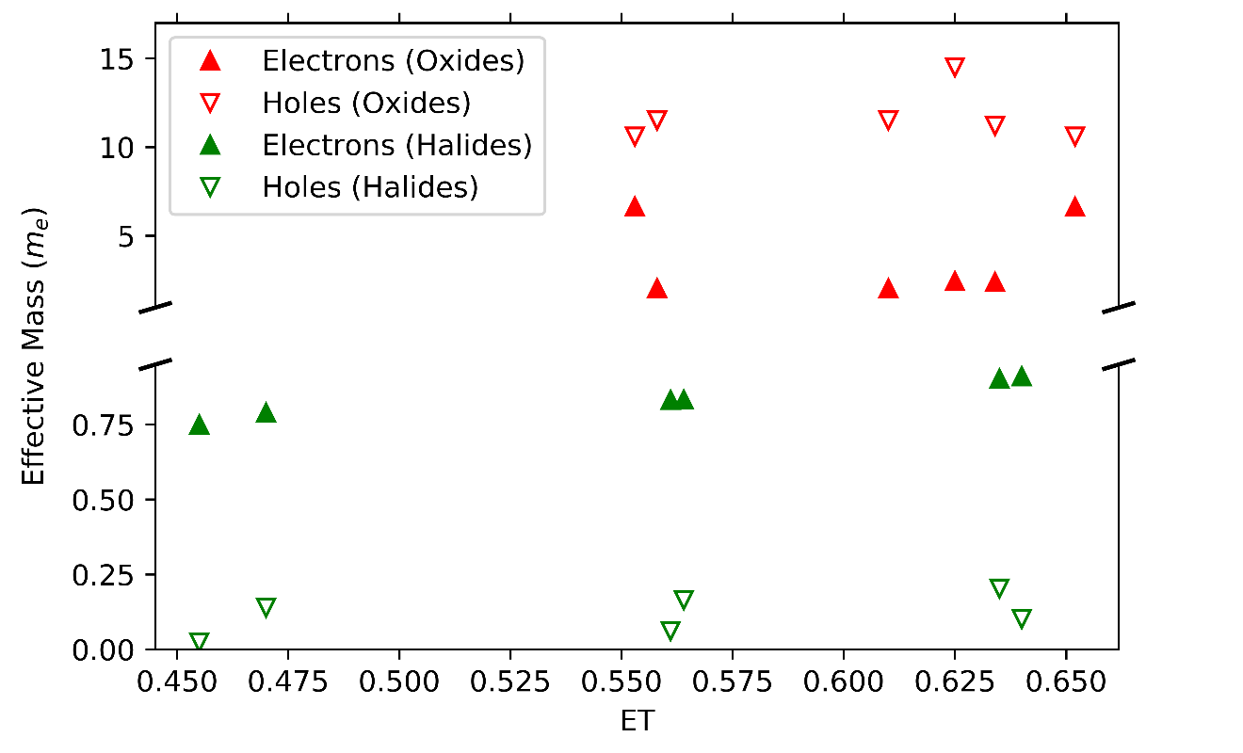
Figure S1: Effective mass of electron and holes for oxide (red) and halide (green) perovskites. The effective masses of the halides are significantly smaller than those of the oxides. It is also striking that the effective mass of the holes are significantly smaller than the ones of the electrons for the halide perovskites.

Band structure and density of states for typical oxide and halide perovskite
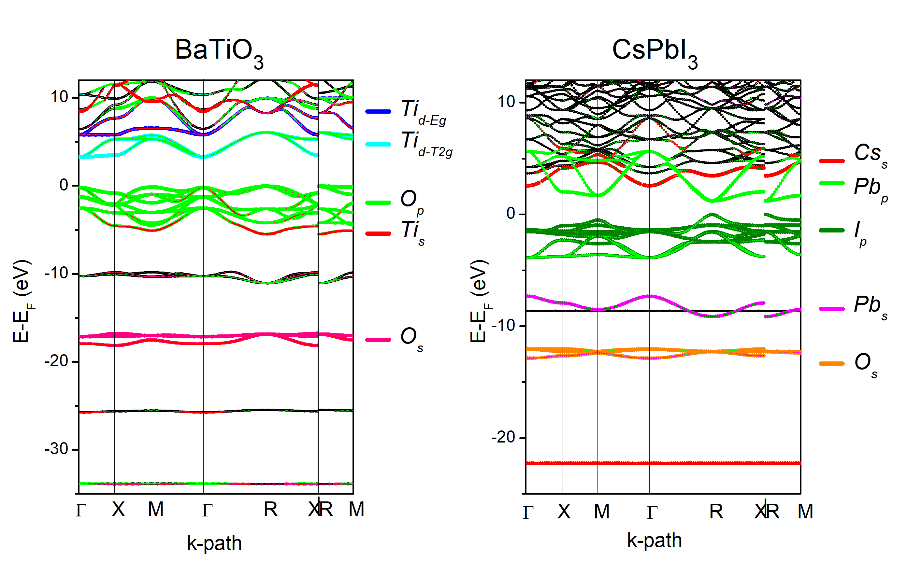Figure S2: Band structure of two characteristic perovskites, cubic BaTiO₃ and CsPbI₃. Selected orbital contributions are highlighted in color (see legends). The area of the symbol is proportional to the orbital contribution. The corresponding DOS is shown in Figure S3. A scissors correction was applied to the BaTiO₃ eigenvalues to match the gap value (3.18eV) computed with the HSE06 functional (6). The projections have been computed using the LOBSTER code (15B). The area of the symbols is proportional to the orbital contribution to the state. Left: BaTiO₃, highlighted orbitals are Ti-d (Eg in blue, T2g in cyan) and O-p (green, plotted on top). Right CsPbI₃; highlighted orbitals are Cs-s (red), Pb-s (violet), Pb-p (green, plotted on top) and I-p (dark green).

A more detailed analysis of the band structure reveals a number of interesting findings. The states in the valence band, i.e. below the Fermi energy, are dominated by the p-states of the X atom. In total, there are 9 such states for the 3 I atoms in CsPbI₃. Three of these states show significant dispersion, while 6 are rather dispersion-less. These dispersion-less states are derived from p-electrons located in the vicinity of the I atom, with negligible overlap to adjacent Pb atoms, sometimes called lone pairs. For PV applications they are not relevant, since they have a high effective mass and do not contribute to the optical absorption. Interestingly, the p-states above the Fermi level (conduction band), which are derived from Pb p-states are almost a mirror image of the I p-states which show dispersion (if the Fermi level is employed as the mirror plane). This electronic band structure is characteristic for metavalent bonded system, which form σ–bonds of half- filled p-states. This electronic configuration is ideal for solar absorbers since it leads to low effective masses of the charge carriers, yet strong optical absorption.
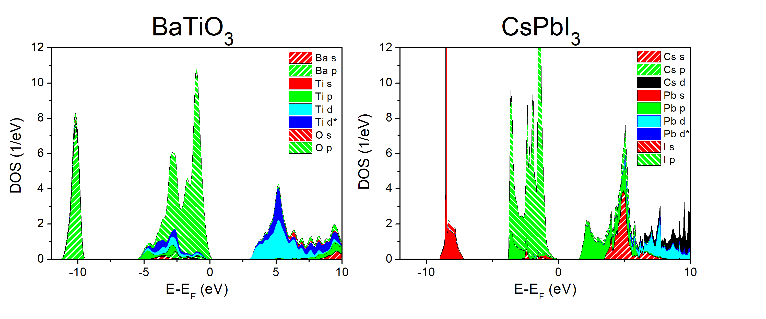
Figure S3: Density of states around the Fermi energy for BaTiO₃ and CsPbI₃. For BaTiO₃, the density of states below the Fermi energy is dominated by oxygen p-states, and Ti d-states above E_{F}. For CsPbI₃, on the contrary, the density of states below the Fermi energy is governed by I (and a lesser extent Pb) p-states, while above E_{F} Pb (and a lesser extent I) p-states dominate. A small (13%) contribution of Pb-s orbitals at the top of the valence band is seen, too.

- DAFH orbitals for CsPbI₃, CsPbBr₃, CsPbCl3₃ and BaTiO₃
The following tables show the DAFH (domain-averaged Fermi hole) orbitals for CsPbI₃, CsPbBr₃, CsPbCl₃ and BaTiO₃. DAFH orbitals represent one-electron decomposition of the multielectron density for specific real space domains (basins). Since the real space domains in the QTAIM framework are associated with atoms, the corresponding DAFH orbitals can be associated with atomic states (orbitals), affected by their surroundings. Therefore, they show the probability distribution of electrons for a particular atom and how much they are involved in covalent interaction with the surroundings (7, 8).
The tables are showing the numerical characteristics of the DAFH orbitals. Each orbital by construction is normalized, so that the integration of this orbital over the entire space gives 1. If we integrate the orbital over some basin, a number between 0 to 1 is obtained. Hence, if upon integration a value of 0.91 is found, this DAFH orbital is localized within this basin by 91%. Since the occupation number is known, too, the number of electrons from this orbital can be calculated, which are localized within the same basin. One can thus how many electrons this DAFH orbital contributes to the number of electrons shared between adjacent atoms. The corresponding bond contribution is listed in electron pairs (ep).
- CsPbI₃:
Pb
DAFH Orbitals | Occupation, e | Localization within native basin | Localization within bond partner basin | Bond contribution (ep)
6p (3×)  σ-bond | 0.35 | 17.3% | 33.7% | 56.6% (0.232)  (Pb-I)
6s | 1.81 | 90.4% | 1.4% | 12.7% (0.052)  (Pb-I)

I
DAFH Orbitals | Occupation, e | Localization within native basin | Localization within bond partner basin | Bond contribution (ep)
5p  σ-bond | 1.60 | 79.80% | 7.9% | 61.6% (0.253)  (I-Pb)
5p (2×)  Lone pair | 1.88 | 93.9% | 0.8% | 7.6% (0.031)  (I-Pb)
Table S3: DAFH Orbitals for CsPbI₃. For their explanation see text above.

- CsPbBr₃:
Pb
DAFH orbitals | Occupation, e | Localization within native basin | Localization within bond partner basin | Bond contribution (ep)
6p (3×)  σ-bond | 0.30 | 14.8% | 35.1% | 54.0% (0.208)  (Pb-Br)
6s | 1.80 | 89.9% | 1.5% | 14.1% (0.054)  (Pb-Br)

Br
DAFH orbitals | Occupation, e | Localization within native basin | Localization within bond partner basin | Bond contribution (ep)
4p  σ-bond | 1.66 | 82.9% | 6.9% | 59.5% (0.229)  (Br-Pb)
4p (2×)  Lone pair | 1.89 | 94.6% | 0.8% | 8.2% (0.032)  (Br-Pb)
Table S4: DAFH Orbitals for CsPbBr₃.
- CsPbCl₃:
Pb
DAFH orbitals | Occupation, e | Localization within native basin | Localization within bond partner basin | Bond contribution (ep)
6p (3x)  σ-bond | 0.314 | 11.80% | 32.1% | 54.4% (0.201)  (Pb-Cl)
6s | 1.803 | 90.10% | 1.49% | 14.52% (0.054)  (Pb-Cl)

Cl
DAFH orbitals | Occupation, e | Localization within native basin | Localization within bond partner basin | Bond contribution (ep)
3p  σ-bond | 1.70 | 84.9% | 6.3% | 57.3% (0.213)  (Cl-Pb)
3p (2×)  Lone pair | 1.91 | 95.2% | 0.8% | 8.5% (0.032)  (Cl-Pb)
Table S5: DAFH Orbitals for CsPbCl₃.
- BaTiO₃:
Ti
DAFH orbitals | Occupation, e | Localization within native basin | Localization within bond partner basin | Bond contribution (ep)
3d (3x)  d_{xz}, d_{zy}, d_{xy} | 0.24 | 11.9% | 19.0 | 17.4% (0.091)  (Ti-O)
mixed type (6x) | 0.18 | 14.1% | 66.8 | 45.6 (0.240)  (Ti-O)

O
DAFH orbitals | Occupation, e | Localization within native basin | Localization within bond partner basin | Bonds contribution (ep)
2p  bond | 1.62 | 81.2% | 7.6% | 46.9% (0.246)  (O-Ti)
2p (2x)  Lone pair | 1.70 | 85.2% | 2.9% | 18.8% (0.099)  (O-Ti)

Table S6: DAFH Orbitals for BaTiO₃

Perovskite band model and effective masses
In the classical 1D model for two p orbitals with energies $ε_{1}$ and $ε_{2}$ (1 and 2 stand for Pb-p and I-p), and a resonance integral $β$ (pp$σ)$ between them, the Hamiltonian writes
$$H_{0}=\left(\begin{matrix}ε_{1} & β{{(e}^{ika/2}+e}^{-ika/2}) \\ β{{(e}^{-ika/2}+e}^{+ika/2}) & ε_{2}\end{matrix}\right)$$
If we set ($ε_{i}$+$ε_{j}$)/2 = 0 and ($ε_{i}$-$ε_{j}$)/2=Δ,
The eigenvalues are:
$E=±\sqrt{Δ^{2}+{4β}^{2}\cos^{2}{(\frac{ka}{2})}}$ (*)
- At the Γ-point, in the limiting case, when $β$ =0, the solutions are -Δ and Δ. The monoatomic case is recovered for Δ=0, as the solutions are E=$±2β$.
- At the zone boundary (k= $π$/a), the solutions are again E=$ε_{1}$ and E=$ε_{2}$, which leads to the expected metallic case for $Δ=0$ (i.e., vanishing electronegativity difference).
Since the bottom and top of the valence band are found at Γ and $π$/a , the bandwidth is
$$ω=\sqrt{Δ^{2}+{4β}^{2}}-Δ$$
- The effective mass at zone boundary is derived from (*). Since
$\frac{∂^{2}E}{{∂k}^{2}}=±\frac{a^{2}β^{2}((4β^{2}+{2Δ}^{2})cos(ka){+β^{2}(3+cos\left(2ka\right)))}}{{2(Δ^{2}+{2β}^{2}(1+\cos\left(ka\right))}^{3/2}}$
we obtain the effective masses (VBM and CBM ate located at k=$π$ /a),
m* $=\frac{1}{ℏ}{\left(\frac{∂^{2}E}{{∂k}^{2}}\right)}^{-1}=±\frac{1}{ℏ}\frac{Δ}{a^{2}β^{2}}$ (**)
The smallest possible effective mass value is obtained for Δ→0. Importantly, m* decreases for increasing value of the ppσ resonance integral ($β)$, which decays exponentially with the interatomic distance.
To evaluate the consequences for the optical properties, one should compute the transition matrix elements. The contribution to the dielectric function arising from any transition from valence state i to conduction state j (with energies $E_{i}$ and $E_{j})$is given by (22)
$g_{ab}=\frac{2{\left|\left\langle i\right.\left.\left|x\right.\right|\left.j\right\rangle \right|}^{2}}{{(E_{i}-E_{j})}^{3}}$.
The transition matrix elements are thus proportional to the square of the interatomic distance multiplied by the square of the overlap integral (that also decays exponentially). One can directly understand the trend for the dielectric function in the lead halides, as its maximum decreases from CsSnI₃ to CsSnBr₃ and CsSnCl₃ (see Fig. S9). In this sequence, the distance decreases (DFT calculations show that the overlap actually increases), but the energy differences appearing in the denominator increase more strongly, as evidenced for instance in the measured band gap.
Among the various type of orbital overlaps, the directional, aligned (or quasi-aligned) p-orbitals located on neighboring atoms obviously produce a maximized overlap.
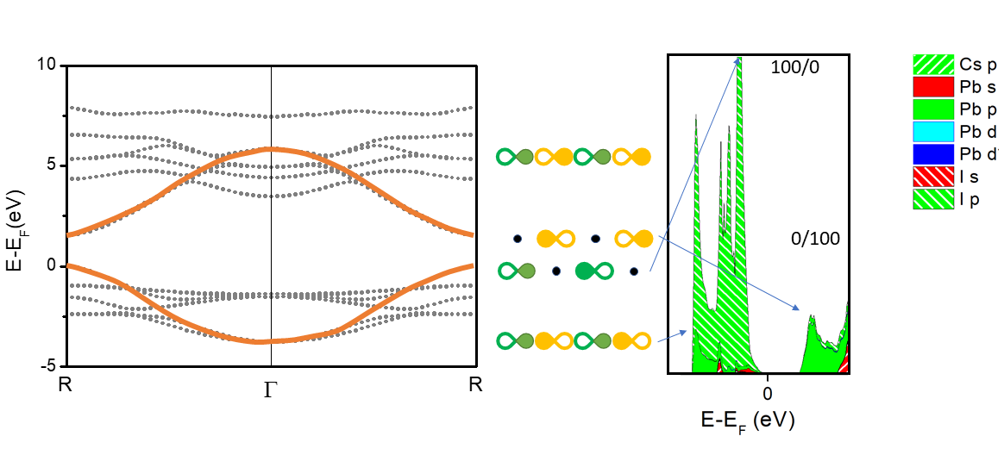
Figure S4: Left panel: R-Γ-R band structure plot around E_{F} for CsPbI₃. Superposed band structure model for a linear chain of p-orbitals. The corresponding eigenstates are sketched in the central panel. The model is confirmed by looking at the density of states, since the bottom (around -3eV) states consist almost equally of Pb-p and I-p states, the top of the valence band is close to 90% I-p and the bottom of the conduction band close to 100% Pb-p.

Role of the Pb-s orbital.
So far we have considered pure p bands, however, the DFT wavefunction analysis shows a contribution of Pb-S at the top of the valence band (see Fig. 3 and S.2).
Let us first extend the basis from $\left\{\left.\left|I_{p}\right.\right\rangle ,\left.\left|{Pb}_{p}\right.\right\rangle \right\}to \left\{\left.\left|I_{p}\right.\right\rangle ,\left.\left|{Pb}_{p}\right.\right\rangle ,\left.\left|{Pb}_{s}\right.\right\rangle \right\}$.
In this new basis, the Hamiltonian writes
$$H=H_{0}+H^{'}$$
In absence of an s-p resonance, an additional eigenvalue is found for the unperturbed H₀, with $λ=ε_{Pb-s}$. Then in case of a small s-p resonance, we can write
$$H'=\left(\begin{matrix}0 & 0 & β_{sp}{{(e}^{ika/2}-e}^{-ika/2}) \\ 0 & 0 & 0 \\ {{β_{sp}(e}^{-ika/2}-e}^{+ika/2}) & 0 & 0\end{matrix}\right)$$
We have to suppose a small contribution of the s orbital to the unperturbed eigenstates in order to observe some effect.
At k=$π$ /a, let us pose $\left.\left|ψ_{0}\right.\right\rangle =\left(1-δ\right)\left.\left|I_{p}\right.\right\rangle +δ\left.\left|{Pb}_{s}\right.\right\rangle$
To first order, $E^{'}=E_{0}+\frac{\left\langle ψ_{0} | H^{'} | ψ_{0}\right\rangle }{\left\langle ψ_{0} | ψ_{0}\right\rangle }$ =$E_{0}-2β_{sp}(1-δ)δe^{ika/2}$
There is thus no effect at the zone boundary.
To second order, we obtain $E^{''}=E^{'}+\frac{4ⅇ^{\frac{ⅈak}{2}}{β_{sp}}^{4}{(-1+Cos[ak])}^{2}}{\sqrt{ⅇ^{ⅈak}(8β^{2}+Δ^{2}+8β^{2}Cos[ak])}}$
At the CBM at VBM, (k=$π$ /a),
$$\frac{∂^{2}E''}{{∂k}^{2}}=\frac{∂^{2}E_{0}}{{∂k}^{2}}+\frac{16a^{2}{β_{sp}}^{4}(4β^{2}+Δ^{2})}{{\left|Δ\right|}^{3}}$$
There is thus indeed an additional curvature that is proportional to the square of the $\left.\left|I_{p}\right.\right\rangle \left.\left|{Pb}_{s}\right.\right\rangle$ resonance, $β_{sp}$. One can note that this correction has the same sign for both eigenvalues, which means that if the curvature is larger for the holes ($ε_{s}$is smaller than $ε_{1}$and $ε_{2})$ , it gets smaller for the electrons.

Bonding and Properties in the hybrid perovskite MAPI

MAPI
Phase | Orthorhombic (a,b,c) in Å | (8.54; 12.73; 9.04)
Distances (Å) & angles | I-Pb-I  I-Pb-I  I-Pb-I  Pb-I-Pb | (3.22; 3.22) 180°  (3.20; 3.20) 180°  (3.20; 3.20) 180°  (3.20;3.20) 168°
Eg (eV) | SCAN-no SOC  SCAN-SOC  PBE-SOC | 1.40  0.50  0.83
ε ∞ | SCAN-no SOC  PBE-SOC | 4.887; 5.219; 4.960  5.773 ; 5.961 ; 5.973
Ζ∗  Pb  I  Pb  Ι | SCAN-no SOC  SCAN-no SOC  PBE-SOC  PBE-SOC | 4,23; 4,70; 4,77  -0,879; -0,645; -4,488  4.40; 5.25; 4.97  -0.71; -0.45; -5.01
Effective masses:  holes  electrons | SCAN-no SOC  SCAN- SOC  PBE-SOC  SCAN-no SOC  SCAN- SOC  PBE-SOC | 0.244; 0.149; 0.238  0.166; 0.118; 0.192  0.256; 0.193; 0.283  1.000; 0.065; 0.933  0.144; 0.088; 0.148  0.205 ; 0.131 ; 0.201
Pair properties (Pb-I basins)  Electrons transferred ET  Normalized ET  Electrons Shared ES | PBE no SOC  PBE SOC  PBE no SOC  PBE SOC  PBE no SOC  PBE SOC | 0.97  0.96  0.485  0.480  0.78; 0.78; 0.75  0.80; 0.80; 0.68
Table S7: Properties of MAPI relaxed with the scan functional. The distortion around I atoms is similar to the orthorhombic CsPbI₃ model (Fig. S6 and S7). The anomalous effective charges (along the Pb-I direction) are comparable for CsPbI₃. Including a spin-orbit correction yields smaller gaps and effective masses, but preserves the anomalous effective charges without significantly changing the bonding indicators (see Fig. 1).

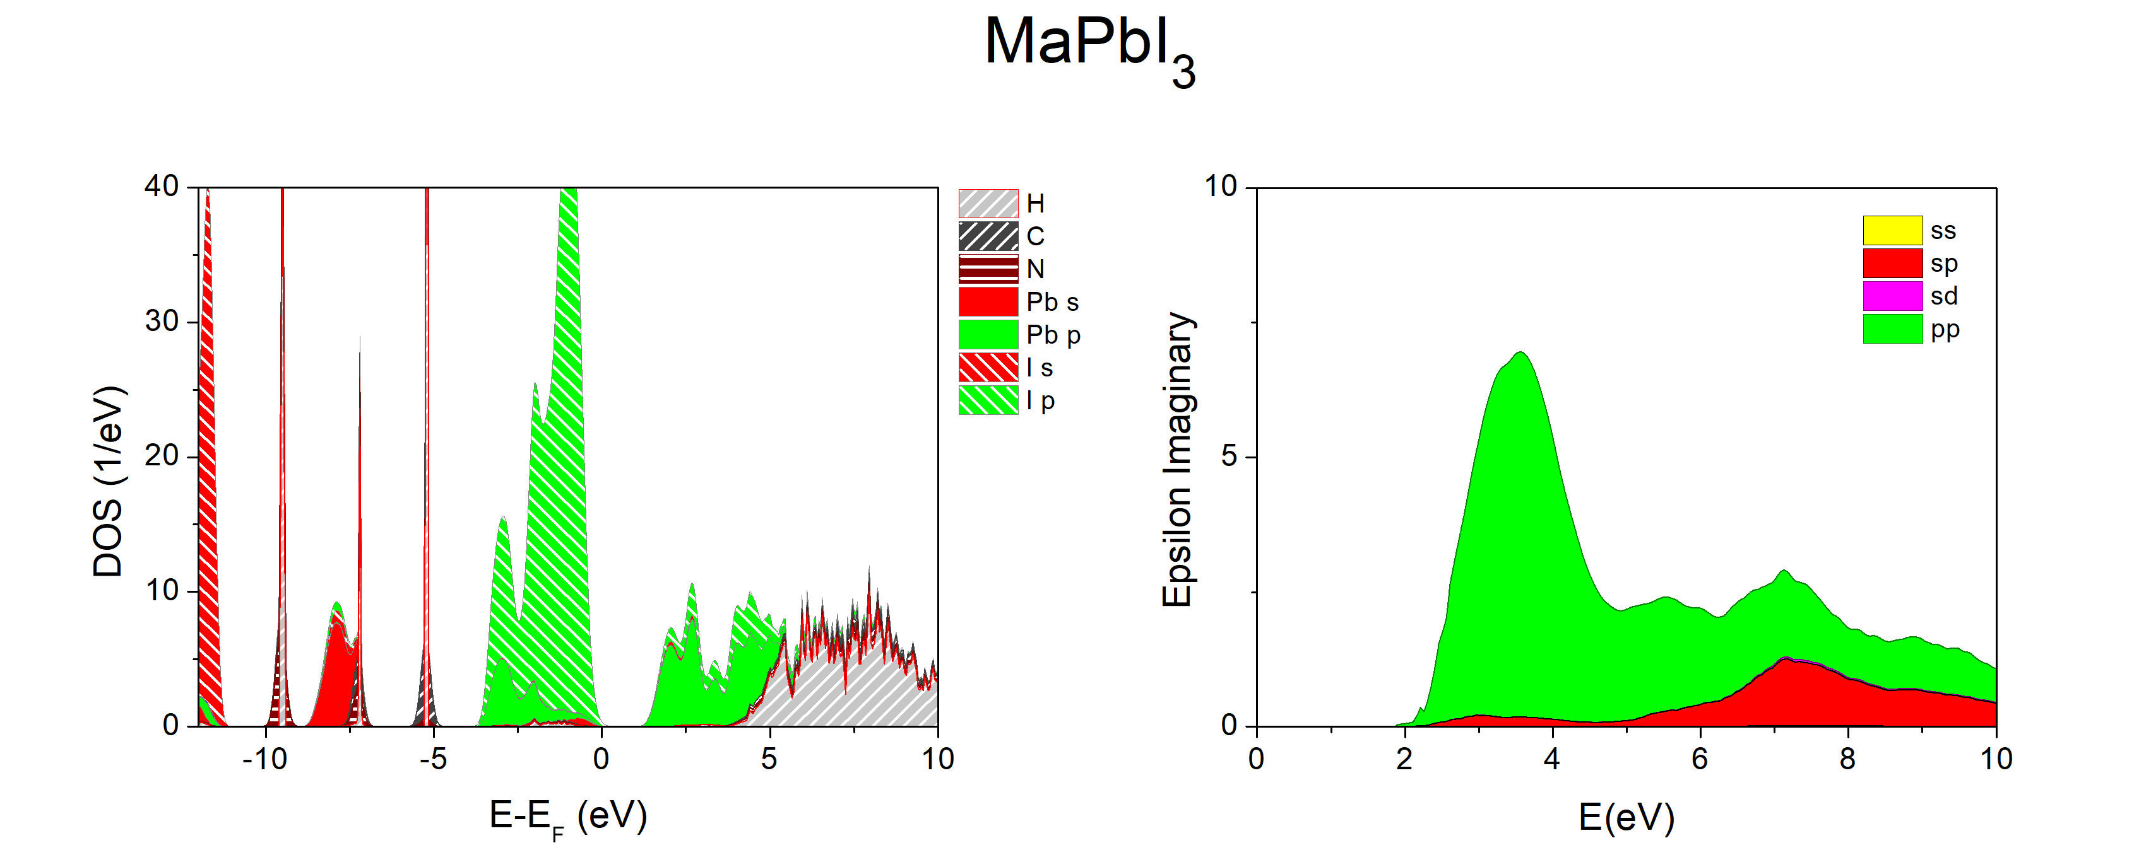
Figure S5: Projected density of states (left) and absorption (right) for the (SCAN) relaxed MAPI compound. The absorption is dominated by I-p to Pb-p transitions, revealing a spectrum that is remarkably close to that of cubic CsPbI₃ (Fig. 4).

In summary, in MAPI, the Pb-I distances are slightly larger than in cubic CsPbI₃, and marginally misaligned. This does not affect the nature of Pb-I bonds and their absorption, which is still dominated by the pronounced p-p matrix elements at low photon energies.

Effect of Peierls distortion on the properties of CsPbI₃
So far, we have studied cubic CsPbI₃, in which symmetry imposes Pb to possess six neighboring I atoms at equal distance, forming 90° bond angles. As a consequence, the I atoms have two aligned Pb neighbors at an equal distance of 3.15 Å.
In the actual hybrid MAPbI₃ perovskite, the Pb environment is distorted (see Fig. S6)
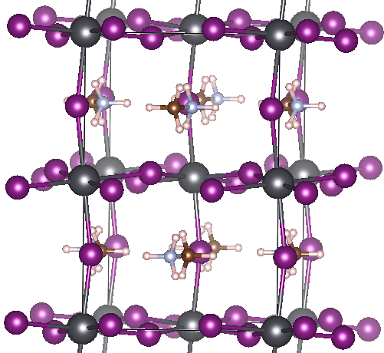
Fig.S6 Hybrid perovskite structure relaxed with the SCAN functional (Pb atoms in grey, I in purple).

One can wonder how the distortions, both angular and in distances, affect the different computed properties studied here. Therefore, a tetragonal distortion has been enforced in cubic CsPbI₃, similar to those observed in ferroelectric perovskites, as shown in Figure S7.
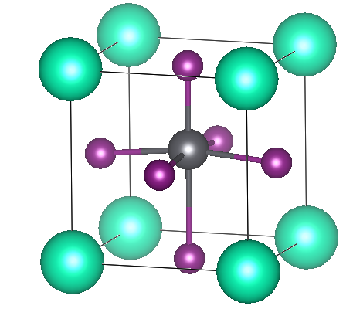
Fig.S7: Tetragonal structure. The distortion is angular in the x and y direction (Pb-I bonds are 3.168 Å long and form 169° angles), and linear in the z direction (lengths 2.89 Å and 3.76 Å). Pb atoms are shown in grey, I in purple and Cs in green.

The resulting distances are slightly smaller in the 2 directions with less alignment, while a strong distortion is present in the third direction, where the alignment is preserved.
 | Cubic CsPbI₃ | Distorted CsPbI₃
Eg (eV) | 1.54 (R-point) | 1.69 (R)
Effective masses (m_{e}):  Holes  Electrons | 0.139  0.789 | (0.136; 0.136; 0.681)  (0.717; 0.717; 0.884)
ε(ω) :  Max value  E max. | 7.59  3.27 eV | (7.51; 7.51; 6.31)  (2.86; 2.86; 4.09)
Z* I atom | (-4.93; -4.93; -4.93) | (-4.86; -4.86; -2.82)
ECoN  Cs  Pb  I | 13.92  6.00  2.04 | 13.37  4.81  (2.03/2.03/1.06)
Charges (lobster): Cs | Cs total 6.1  6s 0.10  5p_y 2.00  5p_z 2.00  5p_x 2.00  Pb total 3.53  6s 2.00  6p_x 0.51  6p_y 0.51  6p_z 0.51  I total 7.46  5s 1.96  5p_x 1.95  5p_y 1.95  5p_z 1.60 | Cs total 6.13  6s 0.13  5p_y 2.00  5p_z 2.00  5p_x 2.00  Pb total 3.64  6s 1.99  6p_x 0.55  6p_y 0.55  6p_z 0.55  I total 7.41  5s 1.96  5p_x 1.94  5p_y 1.93  5p_x 1.58
Table S8: Properties of cubic and tetragonal CsPbI₃, computed with the SCAN functional. One can see that the distortions lead to an increased band gap. The angular distortions (I atom ECoN = 2.03) cause the first absorption to occur at smaller energy, preserving the anomalous effective mass tensor values and the small effective masses. The large linear (Peierls-like) distortion (I atom ECoN=1.06) increases the effective masses, lowers the effective charge and shifts the absorption peak to larger energies and decreases its amplitude. The repartition of electrons is not significantly altered by the distortions. In particular, each I atom carries two lone pairs in the direction orthogonal to the Pb-I bonds. The Pb-I bond involves about (1.6+0.5)/2, thus 1.05 electrons (numbers in italics in the table). These numbers are consistent with the pair density analysis for cubic CsPbI₃.

- Trends in optical properties going from iodide to chloride perovskites
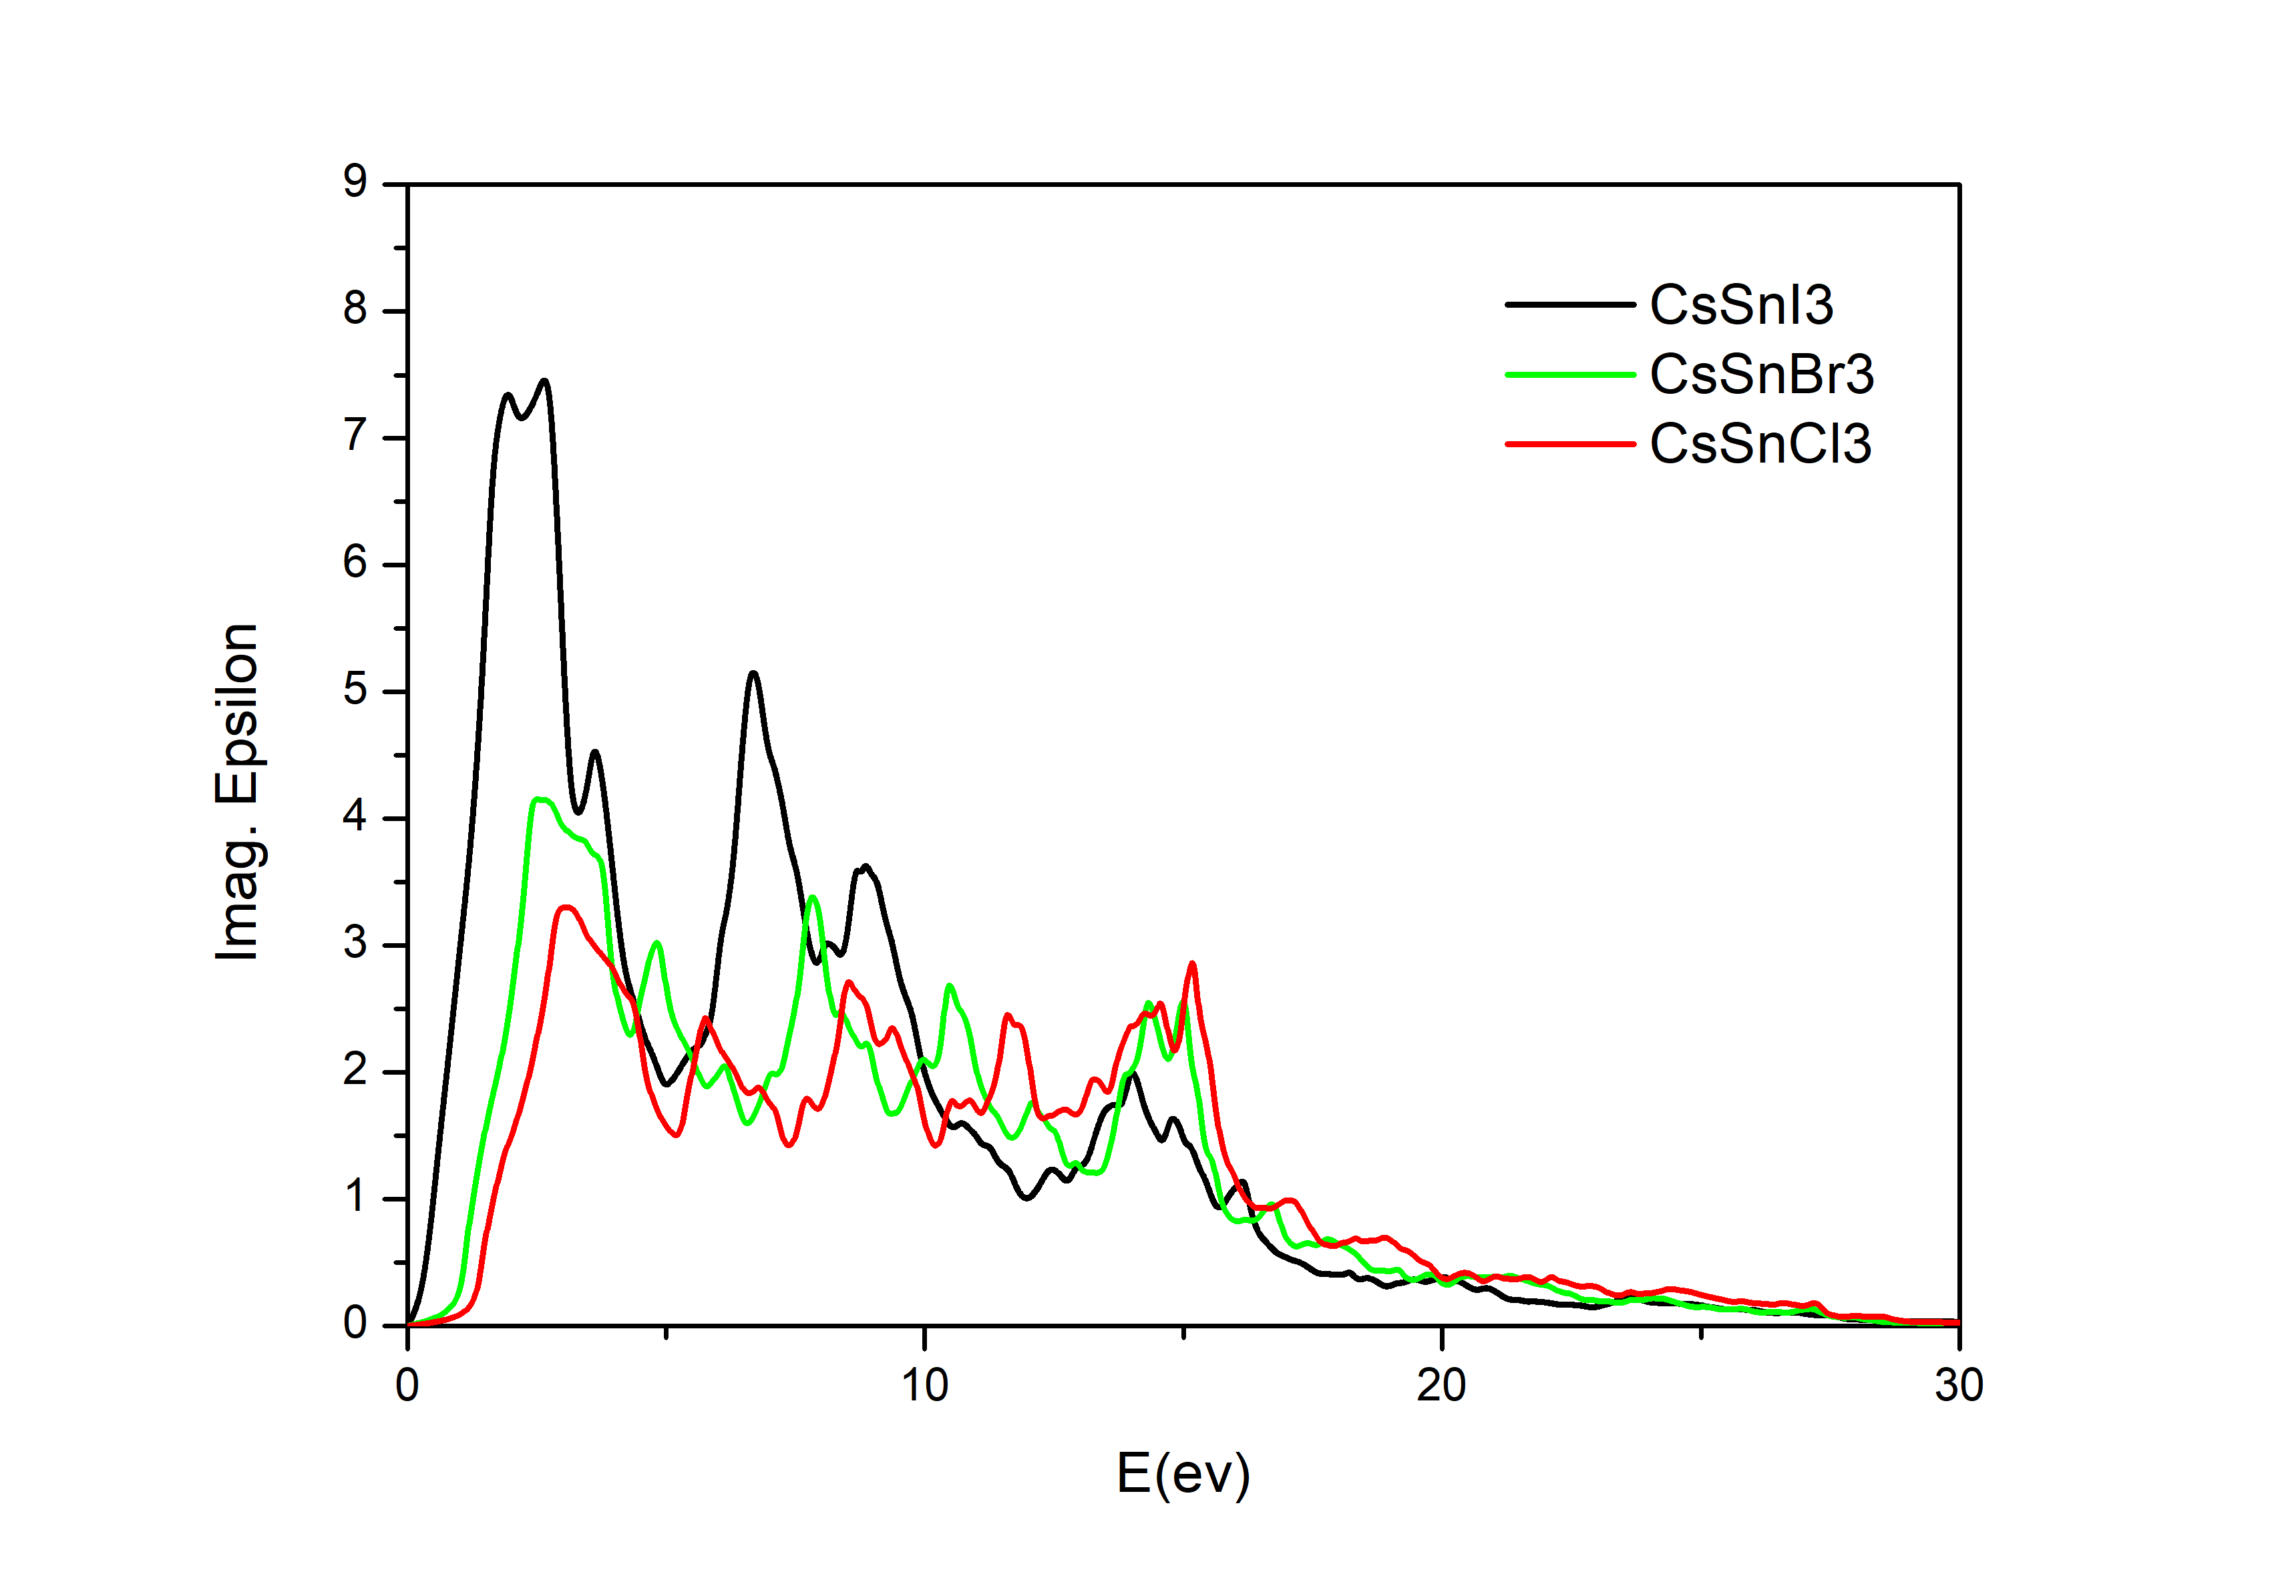
Figure S9: Imaginary part of the dielectric function of three tin halide perovskites. Replacing I by Br and Cl increases the band gap and reduces the strength of the maximum in the absorption (see model in section V). The trends are similar to those observed in lead chalcogenides (23), which exhibit similar bonding mechanism as shown in the present manuscript.

- Comparison with Pb-chalcogenides
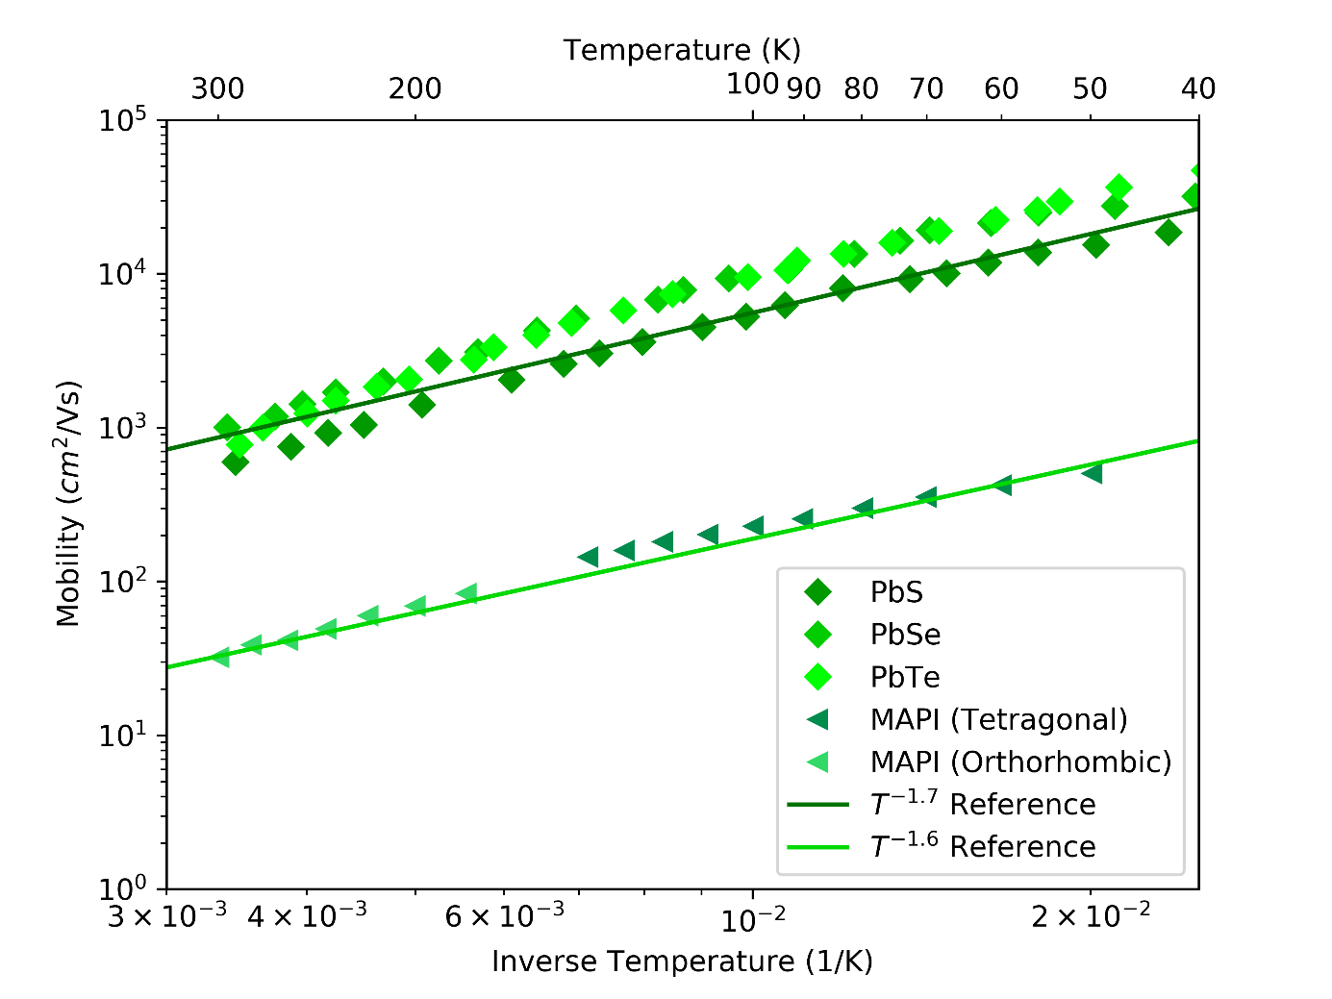
Figure S10. Temperature dependence of the mobility of the charge carriers in three lead chalcogenides (PbTe, PbSe and PbS (9)) compared with MAPI (tetragonal and orthorhombic structure) (10). The strong temperature dependence is caused by pronounced electron – phonon coupling, mediated by the anomalously large Born effective charges, which are characteristic for MAPI and the lead chalcogenides.

Material | E_{G} values (eV) | m* values (m_{e})
SnTe | ~0.06 | $m_{h}^{*}$=0.075, $m_{e}^{*}$=0.069
PbS | 0.495 | $m_{h}^{*}$=0.201, $m_{e}^{*}$=0.164
+SOC | 0.180 | $m_{h}^{*}$=0.115, $m_{e}^{*}$=0.105
PbSe | 0.445 | $m_{h}^{*}$=0.203, $m_{e}^{*}$=0.163
+SOC | 0.091 | $m_{h}^{*}$=0.098, $m_{e}^{*}$=0.089
PbTe | 0.807 | $m_{h}^{*}$=0.499, $m_{e}^{*}$=0.310
+SOC | 0.147 | $m_{h}^{*}$=0.337, $m_{e}^{*}$=0.240

Table S8: Effective masses and band gap in SnTe, PbTe, PbSe and PbS (with and without spin-orbit correction). As in the halide perovskites, small band gaps and small effective masses characterize the electronic states in the vicinity of the Fermi level.

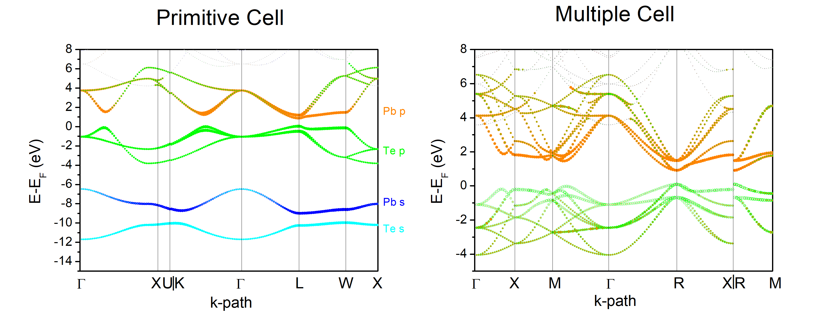
Figure S11: Band structure of PbTe (PBE calculations without SO) in the Brillouin zone of the primitive and the conventional cell. The colors correspond to the various orbitals involved, with sizes that are proportional to their contribution. The Pb-s and Te-s orbitals do not contribute to the valence and conduction bands (left). In the right panel, a dominant Te-p contribution is observed in the valence band and a Pb-p contribution in the conduction band. Around VBM and CBM (at R), the relative contributions match the model given in section V for the halide perovskites.
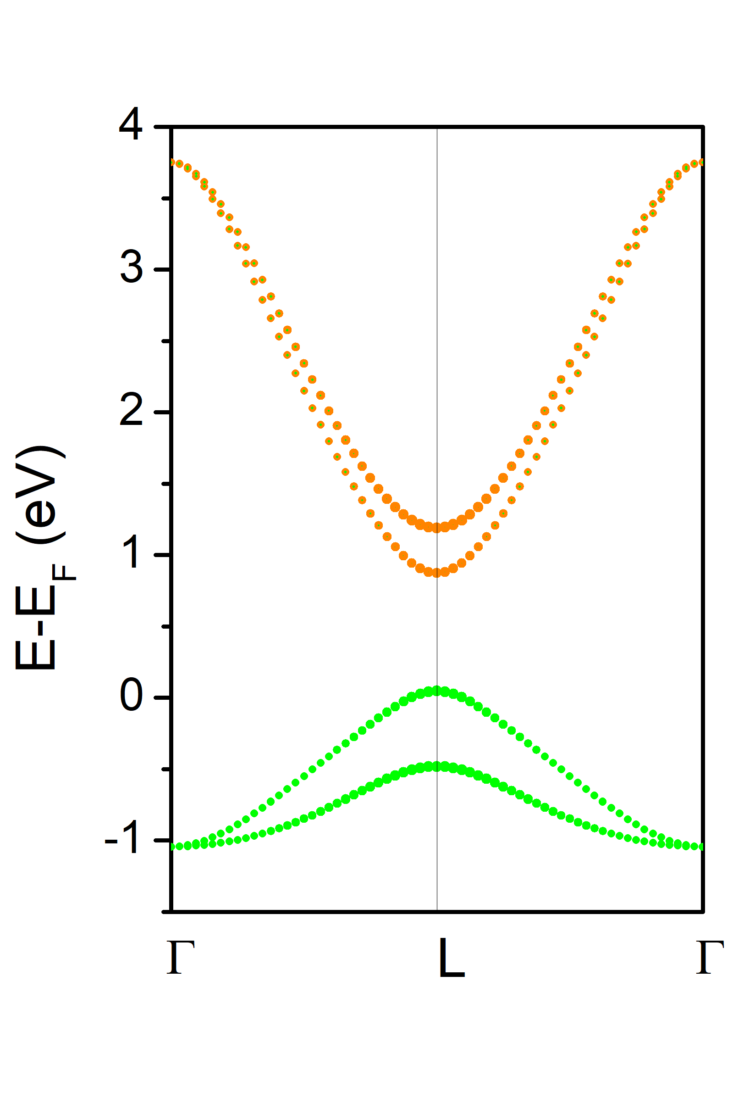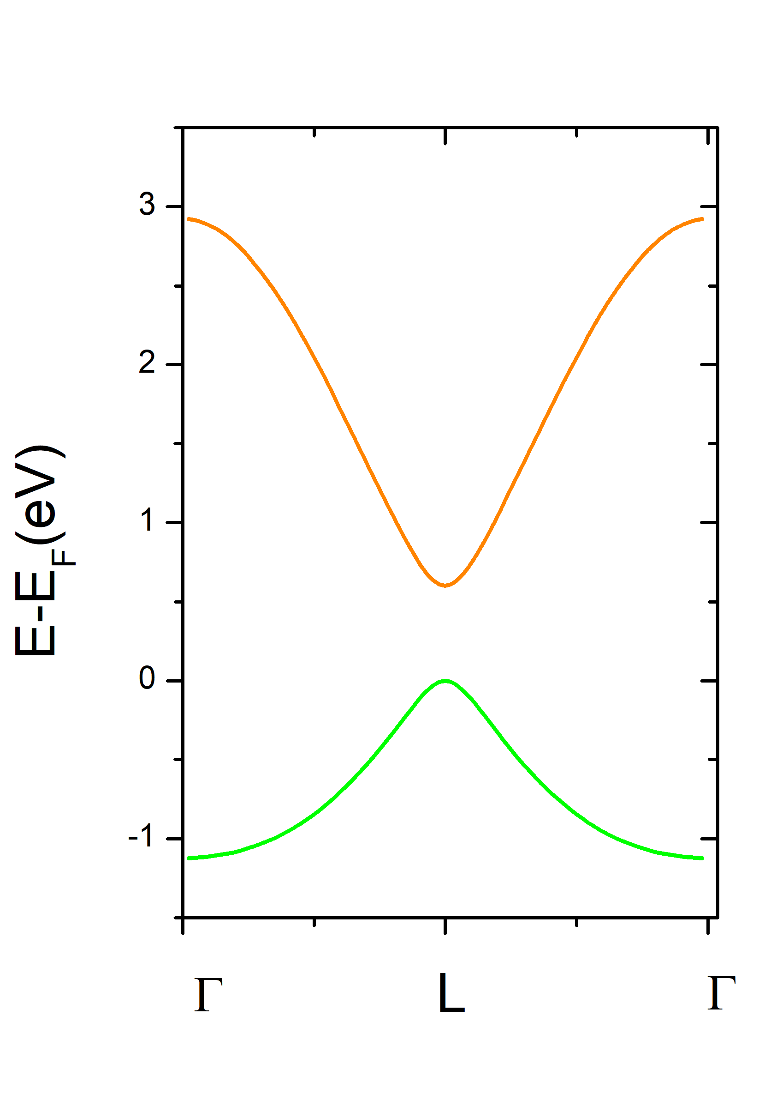
Figure S12. Comparison between PbTe (no SOC) DFT-PBE band structure (left) and the linear chain of p-orbitals model (right). In the model, a small 2nd neighbor contribution was included.

- References
1. R. Hoppe, EFFECTIVE COORDINATION NUMBERS (ECON) AND MEAN FICTIVE IONIC-RADII (MEFIR). Z. Kristall. 150, 23-52 (1979).
2. M. Wuttig, V. L. Deringer, X. Gonze, C. Bichara, J.-Y. Raty, Incipient Metals: Functional Materials with a Unique Bonding Mechanism. Adv. Mater. 30, 1803777 (2018).
3. A. C. Garcia-Castro, N. A. Spaldin, A. H. Romero, E. Bousquet, Geometric ferroelectricity in fluoroperovskites. Physical Review B 89, 5 (2014).
4. V. M. Goldschmidt, Die Gesetze der Krystallochemie (1926).
5. D. B. Mitzi, N4H9Cu7S4: A hydrazinium-based salt with a layered Cu7S4- framework. Inorg. Chem. 46, 926-931 (2007).
6. A. V. Krukau, O. A. Vydrov, A. F. Izmaylov, G. E. Scuseria, Influence of the exchange screening parameter on the performance of screened hybrid functionals. Journal of Chemical Physics 125, (2006).
7. R. Ponec, Electron pairing and chemical bonds. Chemical structure, valences and structural similarities from the analysis of the Fermi holes. J Math Chem 21, 323-333 (1997).
8. R. Ponec, Electron pairing and chemical bonds. Molecular structure from the analysis of pair densities and related quantities. J Math Chem 23, 85-103 (1998).
9. R. S. Allgaier, W. W. Scanlon, Mobility of Electrons and Holes in PbS, PbSe, and PbTe between Room Temperature and 4.2°K*. Phys Rev 111, 1029-1037 (1958).
10. A. Biewald et al., Temperature-Dependent Ambipolar Charge Carrier Mobility in Large-Crystal Hybrid Halide Perovskite Thin Films. Acs Appl Mater Inter 11, 20838-20844 (2019).

