Additional file 1
Gel Electrophoresis Pictograms
Amplification of the atr housekeeping gene
PCR was done to detect the presence of housekeeping genes. Forty-three genomic DNA samples were amplified using primers targeting for presence of the gene: atr (780bp) in GBS. Fig 1 shows the results for the housekeeping gene, atr.
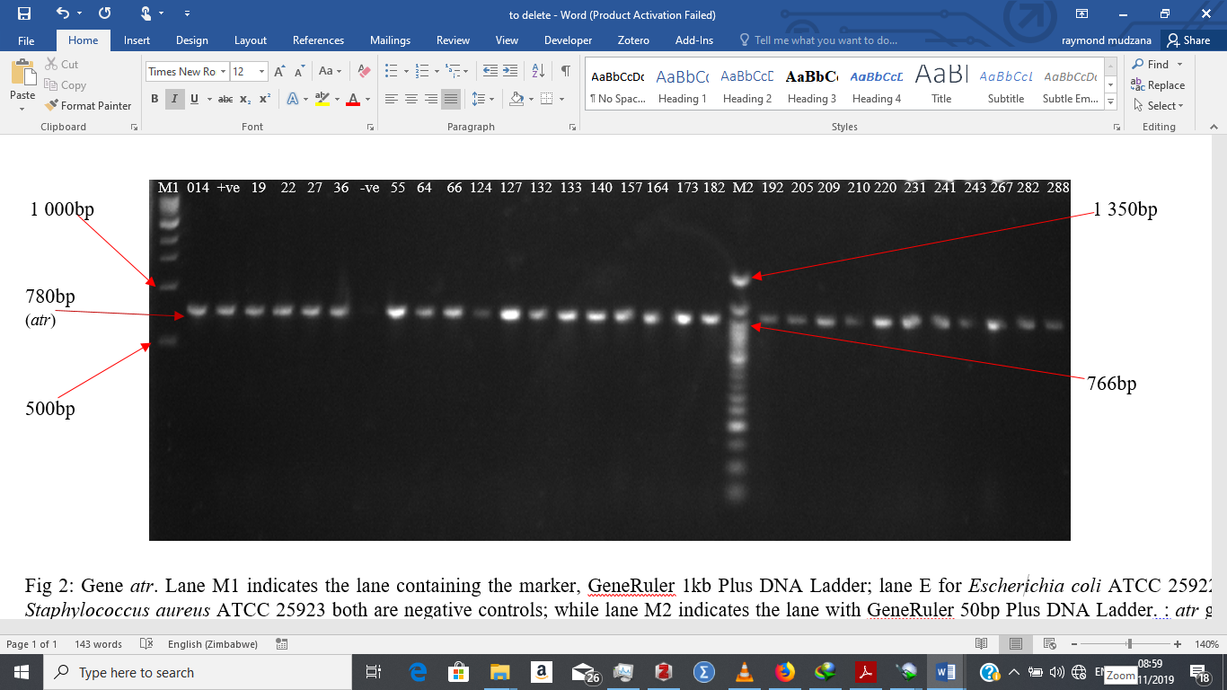
Fig 1: Gel electrophoresis of the atr gene. Lane M1 indicates the lane containing the marker, GeneRuler 1kb Plus DNA Ladder; lane +ve for the positive control; lane -ve for the negative control;; while lane M2 indicates the lane with GeneRuler 50bp Plus DNA Ladder. : atr gene (780bp) present in all the other 43 GBS isolate.
Amplification of the Mobile Genetic Element, IS1548
PCR was done to detect the presence of MGE. All forty-three genomic DNA samples were amplified using primers targeting for presence of the gene: IS1548 (690bp) in GBS. Fig 2 shows the results for the MGE, IS1548.
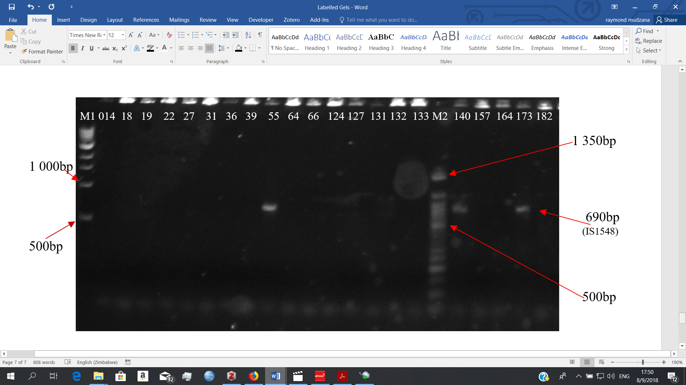
Fig 2: Gel electrophoresis of the Mobile Genetic Element IS1548. Lane M1 indicates the lane containing the marker, GeneRuler 1kb Plus DNA Ladder; while lane M2 indicates the lane with GeneRuler 50bp Plus DNA Ladder. : IS1548 gene (690bp) present in GBS isolates 55, 140 and 173 but absent in the rest of the isolates.
Amplification of the genes atr, bac and tetO
All forty-three genomic DNA samples were amplified using PCR primers targeting for presence of the following genes: atr (780bp), bac (592bp) and tetO (538) in GBS. Fig 3 shows the results for three genes.
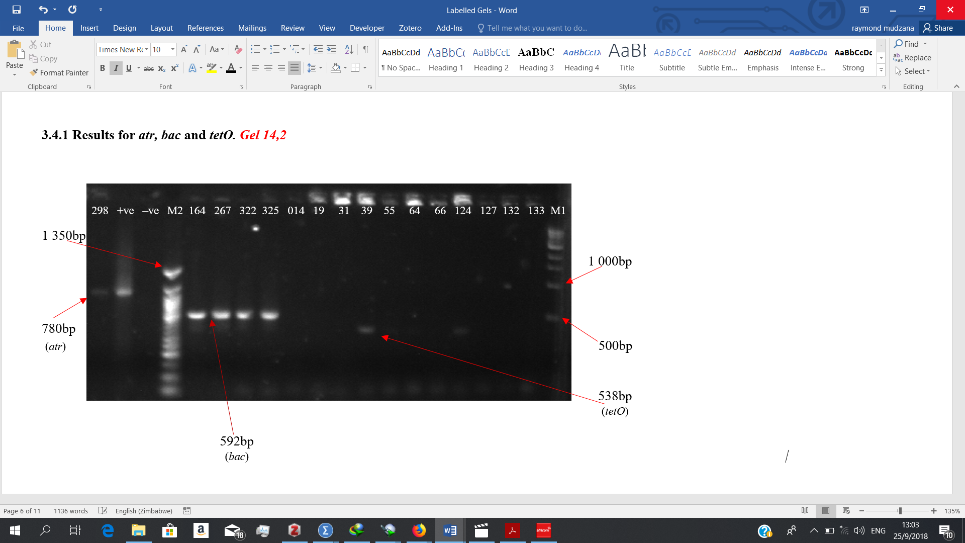
Fig 3: Gel electrophoresis of the atr, bac and tetO genes. Lane M1 indicates the lane containing the marker, GeneRuler 1kb Plus DNA Ladder; while lane M2 indicates the lane with GeneRuler 50bp Plus DNA Ladder. : atr gene (780bp) present in GBS isolate 298 and the positive control but absent in the negative control. bac gene (592bp) present in GBS isolate 164, 267, 322 and 325. tetO gene (538) present in GBS isolates 39 and 124 but absent in isolates 014, 19, 31, 55, 64, 66, 127, 132 and 133.
Amplification of the genes scpB, ermB and rib
All forty-three genomic DNA samples were amplified using PCR primers targeting for presence of the following genes: scpB (255), ermB (640) and rib (369) in GBS. Fig 4 shows the results for three genes.

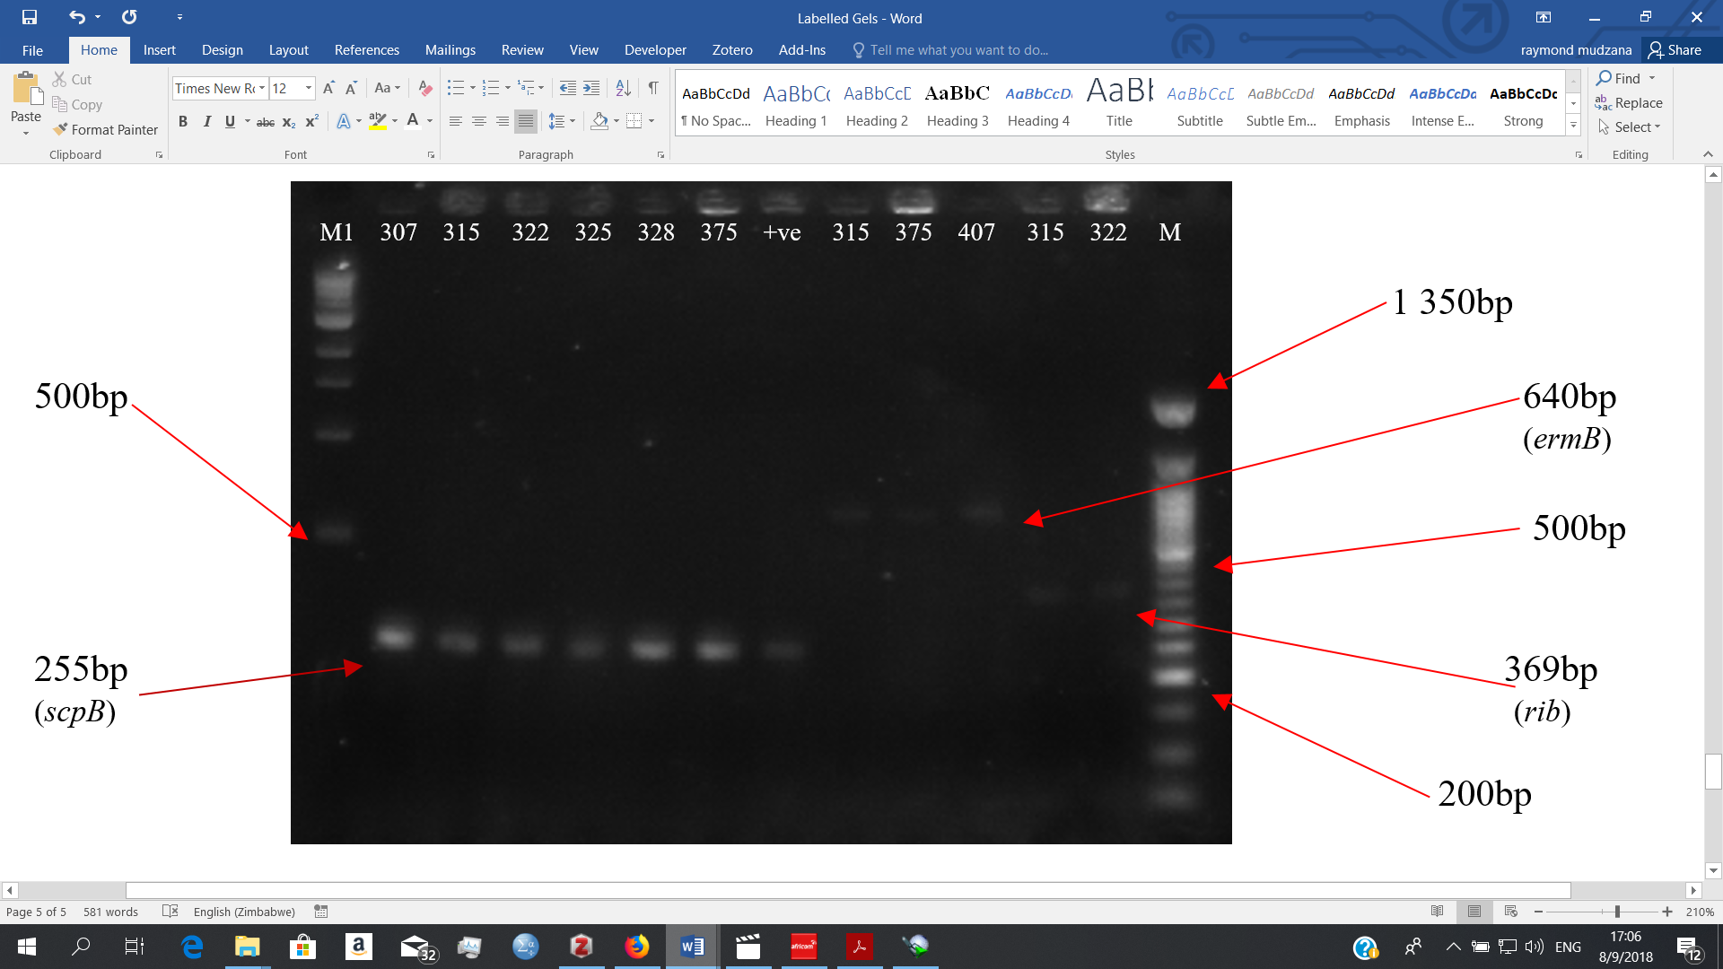
Fig 4: Gel electrophoresis of the scpB, ermB and rib genes. Lane M1 indicates the lane containing the marker, GeneRuler 1kb Plus DNA Ladder; lane +ve for the positive control; while lane M2 indicates the lane with GeneRuler 50bp Plus DNA Ladder. : scpB (255bp) present in GBS isolates 307, 315, 322, 325, 328, 375 and the positive control. ermB (640bp) present in GBS isolates 315, 375 and 407. rib (369bp) present in GBS isolates 315 and 322.
Amplification of the genes linB, rib, hly and scpB
All forty-three genomic DNA samples were amplified using PCR primers targeting for presence of the following genes: linB (944), rib (369), hly (199) and scpB (255) in GBS. Fig 5 shows the results for three genes.
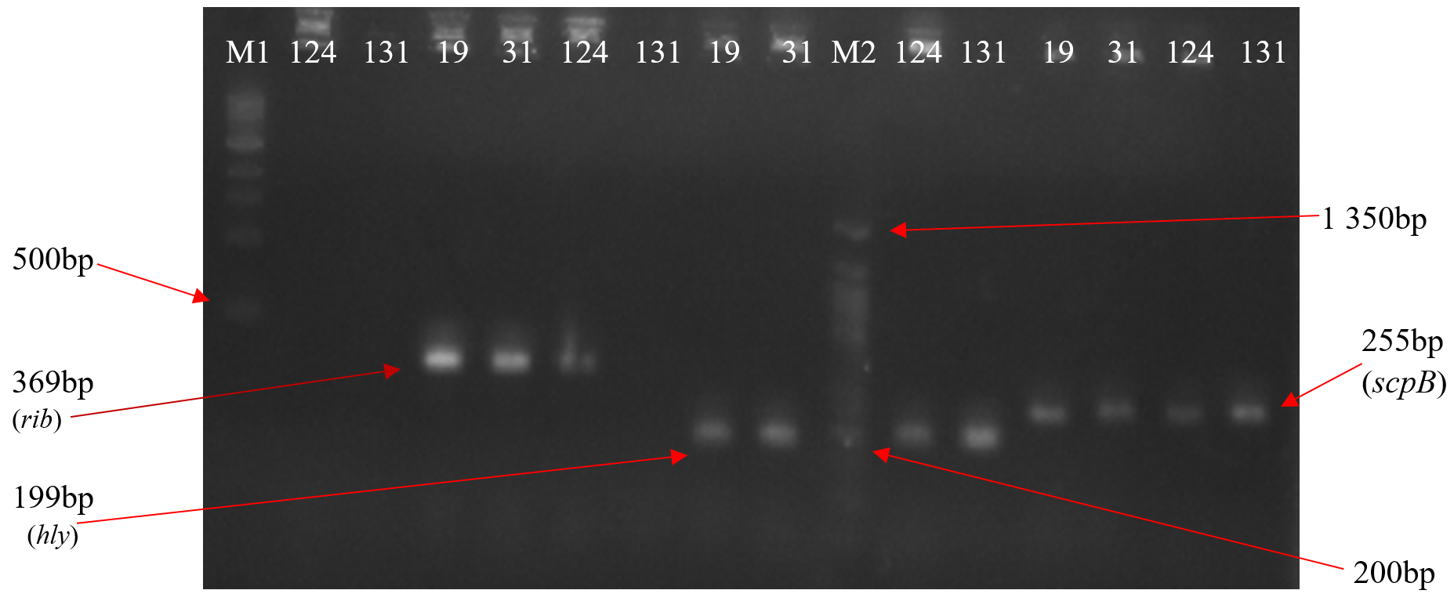
Fig 5: Gel electrophoresis of the linB, rib, hly and scpB genes. Lane M1 indicates the lane containing the marker, GeneRuler 1kb Plus DNA Ladder; while lane M2 indicates the lane with GeneRuler 50bp Plus DNA Ladder. : linB (944bp) absent in GBS isolate 124 and 131. rib (369bp) present in GBS isolates 19, 31, 124 but absent in 131. hly (199bp) present in GBS isolates 19, 31,124 and 131. scpB (255bp) present in GBS isolates19,31,124 and 131.
Amplification of the gene bca
All forty-three genomic DNA samples were amplified using PCR primers targeting for presence of the virulence gene: bca (535bp) in GBS. Fig 6 shows the results for the bca gene.

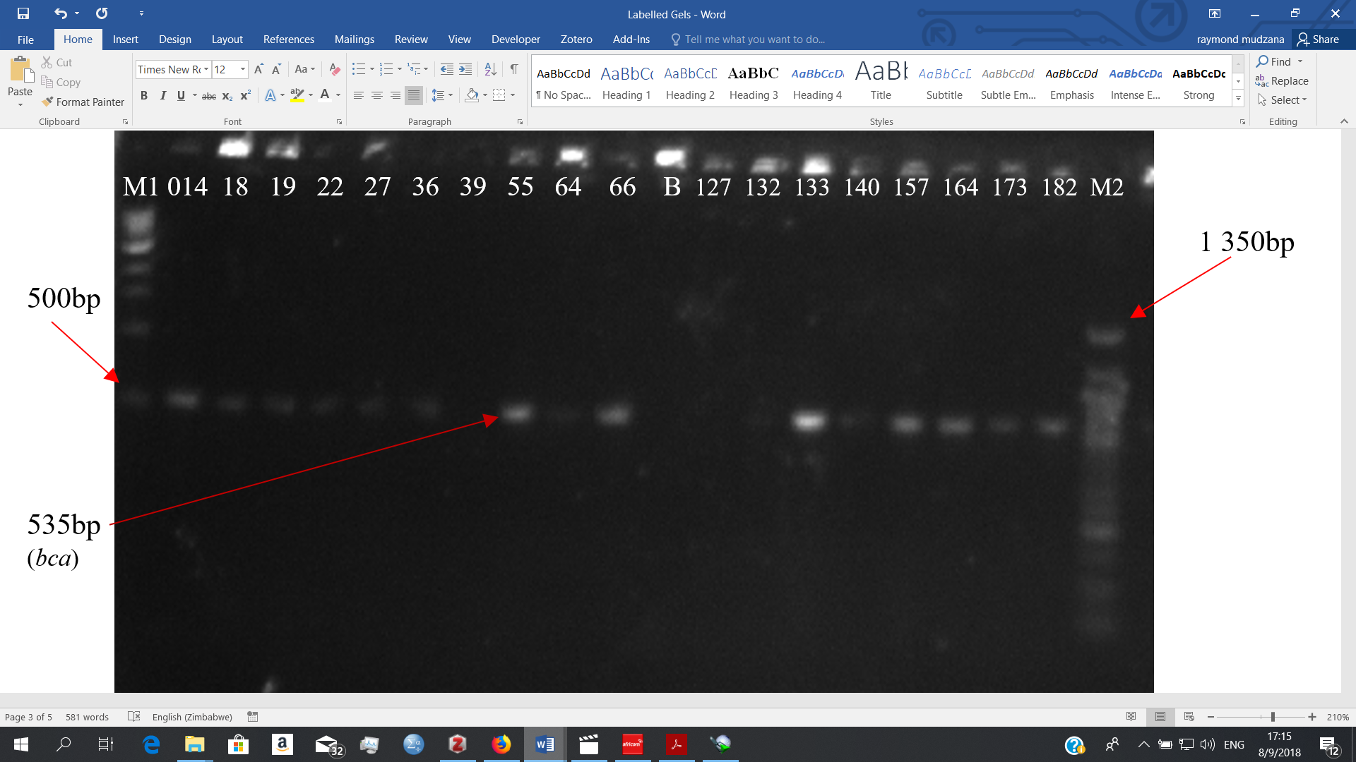
Fig 6: Gel electrophoresis of the bca gene. Lane M1 indicates the lane containing the marker, GeneRuler 1kb Plus DNA Ladder; lane B for the blank/negative control; while lane M2 indicates the lane with GeneRuler 50bp Plus DNA Ladder. : bca (535bp) absent in GBS isolate B(blank), 39, 127 and 131.
Amplification of the genes bac, mefA and tetO
All forty-three genomic DNA samples were amplified using PCR primers targeting for presence of the following genes: bac (592bp), mefA (348bp) and tetO (538bp) in GBS. Fig 7 shows the results for three genes.

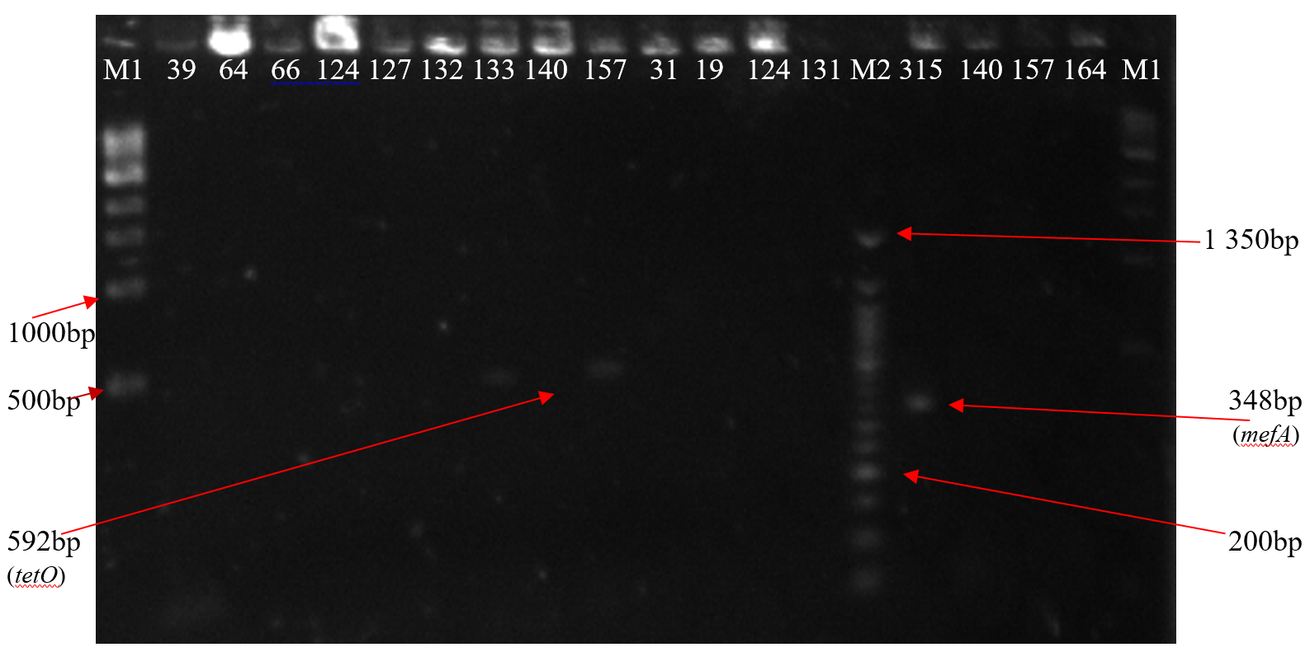
Fig 7: Gel electrophoresis of the bac, mefA and tetO genes. Lane M1 indicates the lane containing the marker, GeneRuler 1kb Plus DNA Ladder; while lane M2 indicates the lane with GeneRuler 50bp Plus DNA Ladder. : bac (592bp) present in GBS isolate 133 and 157 but absent in GBS isolates 39, 64, 66, 124, 127, 132, 140, 31, 19, 124 and 131. mefA gene (348bp) present in GBS isolate 315. tetO (538bp) absent in GBS isolates 140, 157 and 164.
Amplification of the genes ermTR and bac
All forty-three genomic DNA samples were amplified using PCR primers targeting for presence of the following genes: ermTR (400bp) and bac (592bp) in GBS. Fig 8 shows the results for two genes.
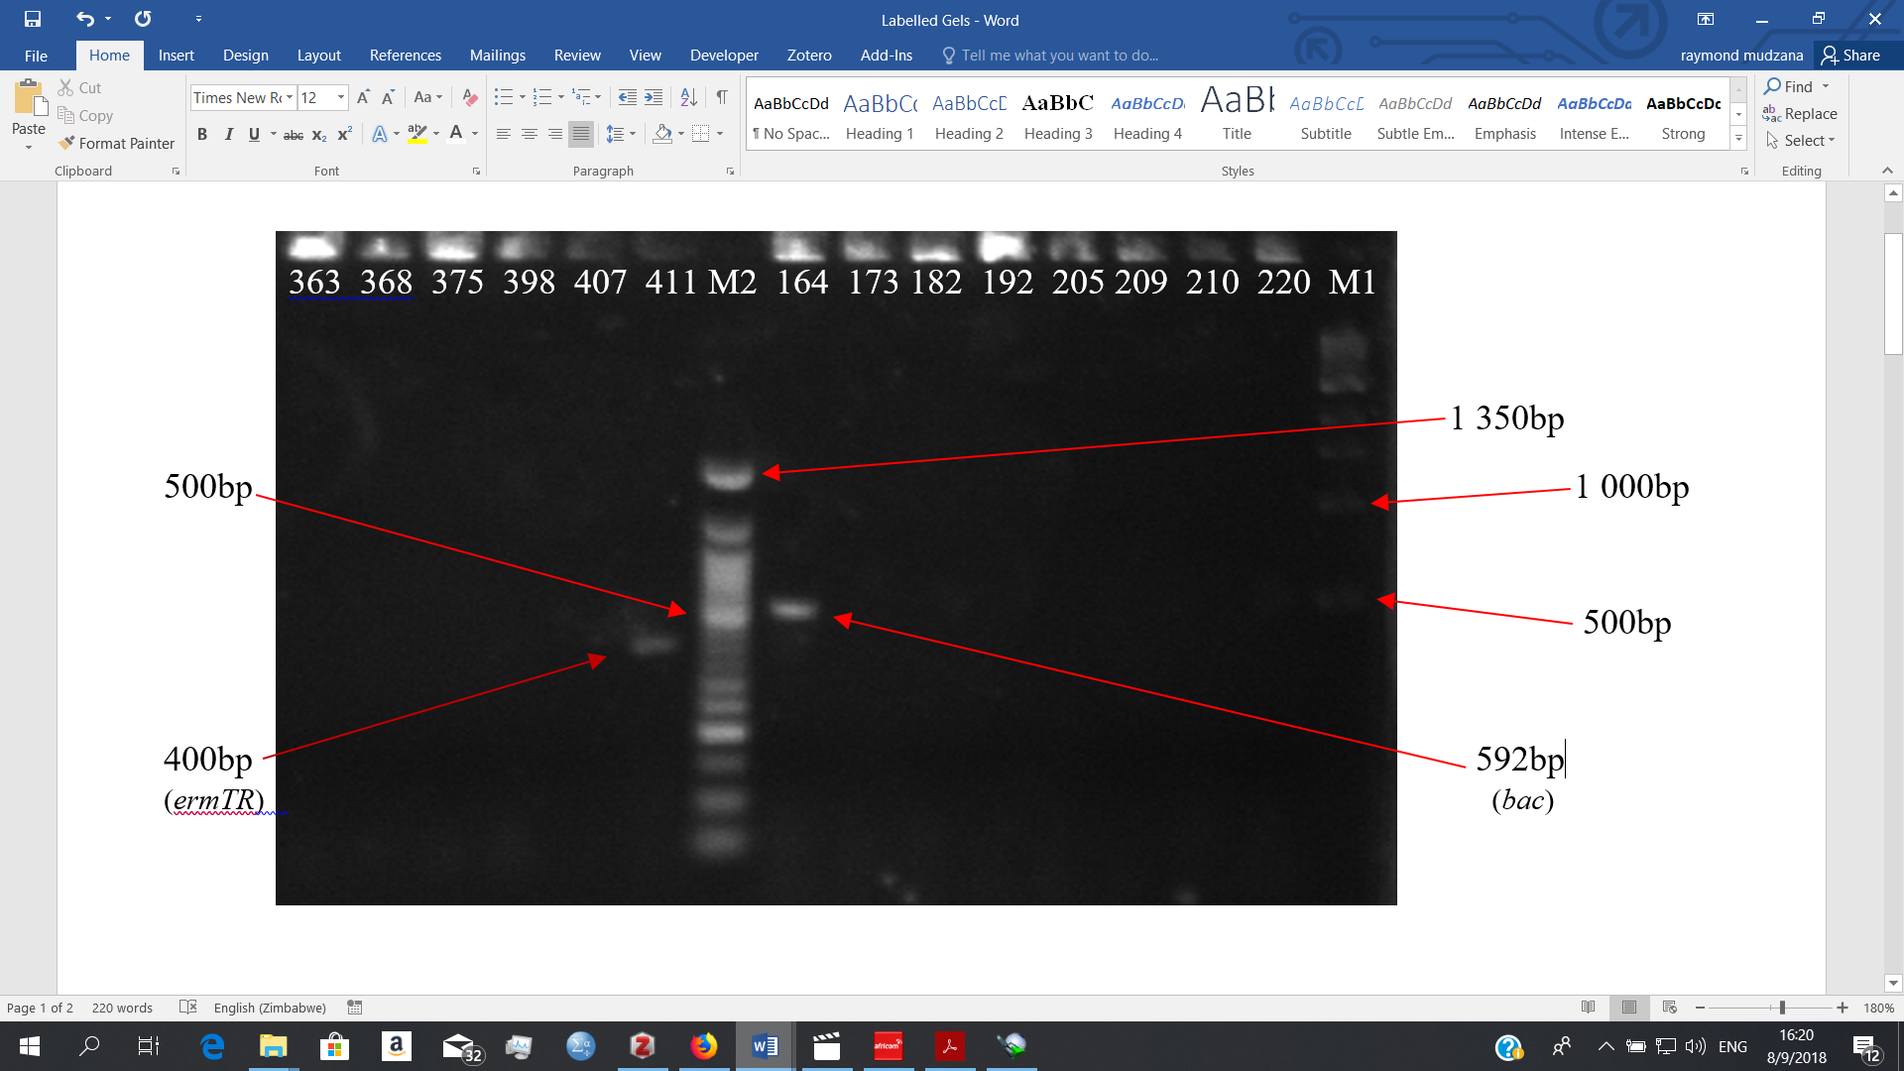
Fig 8: Gel electrophoresis of the ermTR and bac genes. Lane M1 indicates the lane containing the marker, GeneRuler 1kb Plus DNA Ladder; while lane M2 indicates the lane with GeneRuler 50bp Plus DNA Ladder. : ermTR gene (400bp) present in GBS isolate 411 but absent in 363, 368, 375 and 407. bac (592bp) present in GBS isolate 164 but absent in GBS isolates 173, 182, 192,205, 209, 210 and 220.
Amplification of the gene tetM
All forty-three genomic DNA samples were amplified using PCR primers targeting for presence of the following antibiotic resistance gene: tetM (359) in GBS. Fig 9 shows the results for one gene.
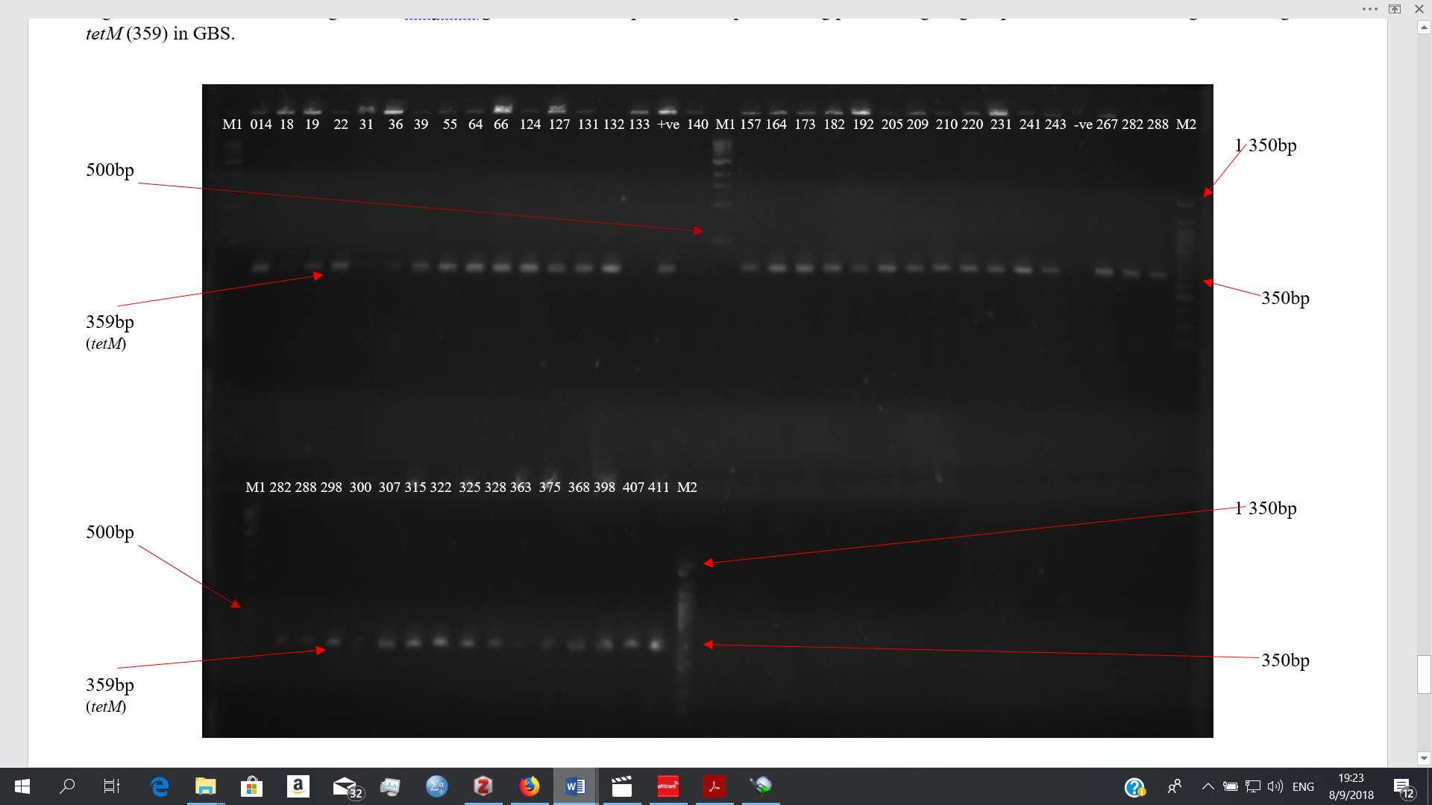Fig 9: Gel electrophoresis of the tetM gene. Lane M1 indicates the lane containing the marker, GeneRuler 1kb Plus DNA Ladder; lane +ve for the positive control; lane -ve for the negative control; while lane M2 indicates the lane with GeneRuler 50bp Plus DNA Ladder. : tetM (359bp) present in all the other 43 GBS isolates except for sample 140
Additional File 2
All the genes discussed in this article are all summarized below (Table S1).
Table S1: The oligonucleotide primers used for amplifying various genes in GBS
Primer Name | Name of Gene | Primer sequence (5’ to 3’) | Expected Product size | Reference
atr |  | F- CAA CGA TTC TCT CAG CTT TGT TAA  R- TAA GAA ATC TCT TGT GCG GAT TTC | 780 | (28)
IS1548 |  | F- TTG CGC AGT TGA ATT GGA TAG  R- TTC TCT AAC TTC AAT CTG TCC CCT A | 690 | (7)
bac | beta/β antigens of the C protein | F- CTA TTT TTG ATA TTG ACA ATG CAA  R- GTC GTT ACT TCC TTG AGA TGT AAC | 592 | (7)
bca | alpha/α antigens of the C protein | F- TAA CAG TTA TGA TAC TTC ACA GAC  R- ACG ACT TTC TTC CGT CCA CTT AGG | 535 | (7)
hly | Hyaluronate lyase | F- TCC ATT TAA AGC CCT TGG TG  R- GGC GCC AGT ATA AGC AAC AT | 199 | (7)
rib | Surface protein Rib | F- CAG GAA GTG CTG TTA CGT TAA AC  R- CGT CCC ATT TAG GGT CTT CC | 369 | (7)
scpB | C5a peptidase | F- ACA ACG GAA GGC GCT ACT GTT C  R- ACC TGG TGT TTG ACC TGA ACT A | 255 | (27)
ermB | Erythromycin Ribosomal Methylase | F- GAA AAG GTA CTC AAC CAA ATA  R- AGT AAC GGT ACT TAA ATT GTT TAC | 640 | (12)
ermTR | Erythromycin Ribosomal Methylase | F- GAA GTT TAG CTT TCC TAA  R- GCT TCA GCA CCT GTC TTA ATT GAT | 400 | (12)
mefA | Erythromycin resistance efflux pump | F- AGT ATC ATT AAT CAC TAG TGC  R- TTC TTC TGG TAC TAA AAG TGG | 348 | (12)
linB | Lincosamide nucleotidyltransferases | F- CCT ACC TAT TGT TTG TGG AA  R- ATA ACG TTA CTC TCC TAT TC | 944 | (12)
tetM | Tetracycline Resistance | F- GTG GAG TAC TAC ATT TAC GAG  R- GAA GCG GAT CAC TAT CTG AG | 359 | (23)
tetO | Tetracycline Resistance | F- GCG GAA CAT TGC ATT TGA GGG  R- CTC TAT GGA CAA CCC GAC AGA AG | 538 | (23)
All the primers used in this study were from Inqaba biotech, South Africa
Table S2: Presence or absence of the expected amplicons in the 43 GBS isolates
No. | Sample # | Housekeeping gene | MGE | Virulence Genes |  |  |  |  | Antibiotic Resistance Genes
 |  | atr | IS1548 | rib | hly | scpB | bca | bac | tetM | tetO | ermB | ermTR | mefA | linB
1 | 014 | + | _ | _ | + | + | + | _ | + | _ | _ | _ | _ | _
2 | 19 | + | _ | + | + | + | + | _ | + | _ | _ | + | _ | _
3 | 22 | + | _ | + | + | _ | + | _ | + | _ | _ | _ | _ | _
4 | 27 | + | _ | + | + | + | + | _ | + | _ | _ | _ | _ | _
5 | 31 | + | _ | + | + | + | + | _ | + | _ | + | _ | _ | _
6 | 36 | + | _ | + | + | + | + | _ | + | _ | _ | _ | _ | _
7 | 55 | + | + | + | _ | + | + | _ | + | _ | _ | _ | _ | _
8 | 64 | + | _ | + | + | + | + | _ | + | _ | _ | _ | _ | _
9 | 66 | + | _ | + | + | + | + | _ | + | _ | _ | _ | _ | _
10 | 124 | + | _ | + | + | + | + | _ | + | + | _ | _ | _ | _
11 | 127 | + | _ | + | + | + | _ | _ | + | _ | _ | _ | _ | _
12 | 131 | + | _ | _ | + | + | + | _ | + | _ | + | _ | _ | _
13 | 132 | + | _ | + | + | _ | + | _ | + | _ | _ | _ | _ | _
14 | 133 | + | _ | _ | + | _ | + | _ | + | _ | _ | _ | _ | _
15 | 140 | + | + | + | + | + | + | _ | _ | _ | _ | _ | _ | _
16 | 157 | + | _ | _ | + | + | + | + | + | _ | _ | _ | _ | _
17 | 164 | + | _ | _ | + | + | + | + | + | _ | + | _ | _ | _
18 | 173 | + | + | + | + | + | + | _ | + | _ | _ | _ | _ | _
19 | 182 | + | _ | + | + | + | + | _ | + | _ | _ | _ | _ | _
20 | 192 | + | _ | + | + | + | _ | _ | + | _ | + | _ | _ | _
21 | 205 | + | _ | + | + | + | _ | _ | + | _ | _ | + | _ | _
22 | 209 | + | _ | + | + | + | _ | _ | + | _ | _ | _ | _ | _
23 | 210 | + | _ | + | + | + | + | _ | + | _ | _ | _ | _ | _
24 | 220 | + | _ | + | + | + | + | _ | + | _ | _ | _ | _ | _
25 | 231 | + | _ | + | + | + | + | _ | + | _ | _ | _ | _ | _
26 | 241 | + | _ | + | + | + | + | _ | + | _ | _ | _ | _ | _
27 | 243 | + | _ | + | + | + | _ | _ | + | _ | _ | + | _ | _
28 | 267 | + | _ | _ | + | + | + | + | + | _ | _ | _ | _ | _
29 | 282 | + | _ | + | + | + | + | _ | + | _ | _ | _ | _ | _
30 | 288 | + | _ | _ | + | + | + | _ | + | _ | _ | _ | _ | _
31 | 298 | + | _ | + | + | + | + | _ | + | _ | _ | _ | _ | _
32 | 300 | + | _ | + | + | _ | + | _ | + | _ | _ | _ | _ | _
33 | 307 | + | _ | + | + | + | + | _ | + | _ | _ | _ | _ | _
34 | 315 | + | + | + | + | + | + | _ | + | _ | + | _ | + | _
35 | 322 | + | _ | + | + | + | + | + | + | _ | _ | _ | + | _
36 | 325 | + | _ | _ | + | + | + | + | + | _ | + | _ | _ | _
37 | 328 | + | _ | _ | + | + | + | _ | + | _ | _ | _ | _ | _
38 | 363 | + | _ | + | + | + | _ | _ | + | _ | + | _ | _ | _
39 | 368 | + | _ | _ | + | + | + | _ | + | _ | _ | _ | _ | _
40 | 375 | + | _ | + | + | + | + | _ | + | _ | + | _ | _ | _
41 | 398 | + | _ | _ | + | + | + | _ | + | _ | + | _ | _ | _
42 | 407 | + | _ | _ | + | + | + | _ | + | _ | + | _ | _ | _
43 | 411 | + | _ | _ | + | + | + | _ | + | _ | _ | + | _ | _
Presence (+) or absence (-) of the expected amplicon during the PCRs.
Table S3: Presence or absence of antibiotic resistance genes in the resistant and intermediate isolates
Number | Sample # | CLN  (2µg) | linB | ERY (15µg) | ermB | ermTR | mefA | TET (30µg) | tetM | tetO | PEN G  (10units) | AMP  (10µg)
1 | 014 | R | _ | I | _ | _ | _ | R | + | _ | S | R
2 | 19 |  |  | R | _ | + | _ | R | + | _ | S | S
3 | 22 | R | _ |  |  |  |  | R | + | _ | R | R
4 | 27 | R | _ | I | _ | _ | _ | R | + | _ | R | R
5 | 31 | R | _ | R | + | _ | _ | R | + | _ | R | R
6 | 36 | R | _ | R | _ | _ | _ | R | + | _ | R | R
7 | 55 | R | _ | I | _ | _ | _ | R | + | _ | R | R
8 | 64 | R | _ | R | _ | _ | _ | R | + | _ | R | R
9 | 66 | I | _ | I | _ | _ | _ | R | + | _ | R | R
10 | 124 | R | _ | I | _ | _ | _ | R | + | + | R | S
11 | 127 | I | _ |  |  |  |  |  |  |  | S | S
12 | 131 | R | _ | R | + | _ | _ | R | + | _ | R | R
13 | 132 |  |  |  |  |  |  | R | + | _ | R | S
14 | 133 |  |  |  |  |  |  | R | + | _ | R | R
15 | 140 | I | _ | I | _ | _ | _ | R | _ | _ | S | S
16 | 157 | I | _ |  |  |  |  | R | + | _ | S | S
17 | 164 | R | _ | R | + | _ | _ | R | + | _ | R | R
18 | 173 | R | _ | R | _ | _ | _ | R | + | _ | R | R
19 | 182 |  |  |  |  |  |  | R | + | _ | S | S
20 | 192 | R | _ | R | + | _ | _ | R | + | _ | R | R
21 | 205 | I | _ | R | _ | + | _ | R | + | _ | R | R
22 | 209 | I | _ | I | _ | _ | _ | R | + | _ | R | R
23 | 210 | R | _ |  |  |  |  | R | + | _ | S | S
24 | 220 | I | _ |  |  |  |  | R | + | _ | R | R
25 | 231 | R | _ | I | _ | _ | _ | R | + | _ | R | R
26 | 241 | R | _ | I | _ | _ | _ | R | + | _ | R | S
27 | 243 |  |  |  |  |  |  | R | + | _ | S | S
28 | 267 |  |  |  |  |  |  | R | + | _ | S | S
29 | 282 | I | _ |  |  |  |  | R | + | _ | R | R
30 | 288 | R | _ |  |  |  |  | R | + | _ | R | R
31 | 298 |  |  | I | _ | _ | _ | R | + | _ | R | S
32 | 300 | R | _ | R | _ | _ | _ | R | + | _ | R | S
33 | 307 | R | _ | I | _ | _ | _ | R | + | _ | R | R
34 | 315 | R | _ | R | + | _ | + | R | + | _ | S | S
35 | 322 |  |  |  |  |  |  | R | + | _ | S | S
36 | 325 | R | _ | I | + | _ | _ | R | + | _ | R | R
37 | 328 | I | _ |  |  |  |  | R | + | _ | S | S
38 | 363 | R | _ | R | + | _ | _ | R | + | _ | R | R
39 | 368 | I | _ | I | _ | _ | _ | R | + | _ | R | R
40 | 375 | R | _ | R | + | _ | _ | R | + | _ | S | S
41 | 398 | R | _ | I | + | _ | _ | R | + | _ | R | R
42 | 407 | I | _ | I | + | _ | _ | R | + | _ | R | S
43 | 411 | R | _ | I | _ | + | _ | R | + | _ | R | R
Presence (+) or absence (-) of the expected amplicon during the PCRs.

Spearman Rank Correlations
Table S4 below shows that there was a negative correlation between tetO and all the macrolide resistant determinants; between ermB and ermTR and also between ermTR and mefA. A positive correlation was observed between the tetM and all the macrolide resistant determinants (such as ermB); between tetM and tetO and also between ermB and mefA. However, the P values for all these correlations are greater than the level of significance implying that correlations are not statistically significant, meaning they have occurred by chance. Hence, they cannot be generalized into the general GBS population. The linB gene could not be computed because it was a constant. Table 3 also shows that there is a negative correlation between hly and IS1548 as well as between bac and rib and this is statistically significant at (p < 0.01). These relationships can be generalized into the pregnant women GBS population. However, some non-statistically significant positive correlations were also observed between IS1548 and (rib/scpB/bca) as well as bac and (hly/scpB/bca). The remainder of the genes had a negative correlation which was also not statistically significant.

Table S4: GBS Virulence and Antibiotic Resistance Genes Spearman Rank Correlations
Virulence Genes | IS1548 | rib | hly | scpB | bca | bac
IS1548 | 1 | 0.18 | -.563** | 0.088 | 0.11 | -0.099
rib | 0.18 | 1 | -0.102 | -0.036 | -0.265 | -.393**
hly | -.563** | -0.102 | 1 | -0.049 | -0.062 | 0.056
scpB | 0.088 | -0.036 | -0.049 | 1 | -0.129 | 0.116
bca | 0.11 | -0.265 | -0.062 | -0.129 | 1 | 0.146
bac | -0.099 | -.393** | 0.056 | 0.116 | 0.146 | 1
Antibiotic Resistance Genes | tetM | tetO | ermB | ermTR | mefA | linB
tetM | 1 | 0.024 | 0.085 | 0.049 | 0.034 | .a
tetO | 0.024 | 1 | -0.085 | -0.049 | -0.034 | .a
ermB | 0.085 | -0.085 | 1 | -0.176 | 0.14 | .a
ermTR | 0.049 | -0.049 | -0.176 | 1 | -0.071 | .a
mefA | 0.034 | -0.034 | 0.14 | -0.071 | 1 | .a
linB | .a | .a | .a | .a | .a | .a
* Correlation is significant at the 0.05 level (2-tailed).
** Correlation is significant at the 0.01 level (2-tailed).
a Cannot be computed because at least one of the variables is constant.

