Supplementary material

Table S1. Trials contributing serious fall or fracture events, ordered by mean age
Source: ClinicalTrials.gov posted results. Values are GLP-1 RA / placebo; events are participants affected in the serious adverse-event tables. Fracture counts are summed across MedDRA fracture terms. The other 83 included trials reported no serious falls or fractures.
NCT | Trial | Drug | Mean age | n (GLP-1 RA / placebo) | Serious falls | Serious fractures | Hip/femur
NCT02443155 | - | liraglutide | 28.4 | 76 / 77 | 0 / 0 | 2 / 1 | 0 / 0
NCT05024032 | SURMOUNT-CN | tirzepatide | 36.1 | 141 / 69 | 0 / 0 | 2 / 0 | 0 / 0
NCT06041217 | STEP 12 | semaglutide | 41.0 | 161 / 81 | 0 / 0 | 1 / 0 | 0 / 0
NCT02098395 | ADJUNCT TWO | liraglutide | 43.2 | 626 / 206 | 0 / 0 | 4 / 1 | 0 / 0
NCT01836523 | ADJUNCT ONE | liraglutide | 43.7 | 1045 / 348 | 1 / 0 | 3 / 0 | 0 / 0
NCT04184622 | SURMOUNT-1 | tirzepatide | 44.9 | 1896 / 643 | 0 / 0 | 8 / 0 | 0 / 0
NCT01272219 | SCALE Obesity-Prediabetes | liraglutide | 45.1 | 2481 / 1242 | 0 / 4 | 12 / 1 | 0 / 0
NCT03548987 | STEP 4 | semaglutide | 46.0 | 535 / 268 | 1 / 0 | 1 / 1 | 0 / 0
NCT03611582 | STEP 3 | semaglutide | 46.0 | 407 / 204 | 0 / 0 | 2 / 1 | 1 / 0
NCT03548935 | STEP 1 | semaglutide | 46.0 | 1306 / 655 | 0 / 0 | 6 / 1 | 1 / 0
NCT02453711 | - | semaglutide | 46.6 | 821 / 136 | 1 / 0 | 1 / 0 | 0 / 0
NCT05646706 | STEP UP | semaglutide | 47.0 | 1205 / 201 | 0 / 0 | 1 / 1 | 0 / 0
NCT03693430 | STEP 5 | semaglutide | 47.0 | 152 / 152 | 0 / 0 | 0 / 2 | 0 / 0
NCT02963935 | SCALE IBT | liraglutide | 47.2 | 142 / 140 | 0 / 0 | 0 / 1 | 0 / 0
NCT05073835 | BARI-STEP | semaglutide | 47.3 | 35 / 35 | 0 / 0 | 0 / 1 | 0 / 0
NCT04660643 | SURMOUNT-4 | tirzepatide | 47.7 | 335 / 335 | 0 / 0 | 0 / 1 | 0 / 0
NCT05564117 | OASIS 4 | semaglutide | 48.0 | 204 / 102 | 0 / 0 | 0 / 1 | 0 / 0
NCT01557166 | - | liraglutide | 48.5 | 176 / 179 | 0 / 0 | 1 / 0 | 0 / 0
NCT05963022 | - | tirzepatide | 48.8 | 155 / 51 | 0 / 0 | 2 / 0 | 0 / 0
NCT05132088 | OASIS 2 | semaglutide | 49.0 | 134 / 66 | 0 / 0 | 0 / 1 | 0 / 0
NCT05412004 | SURMOUNT-OSA | tirzepatide | 50.0 | 233 / 234 | 0 / 0 | 0 / 1 | 0 / 0
NCT05035095 | OASIS 1 | semaglutide | 50.0 | 334 / 333 | 0 / 0 | 2 / 1 | 0 / 0
NCT03811574 | STEP 6 | semaglutide | 51.0 | 299 / 101 | 0 / 0 | 0 / 1 | 0 / 0
NCT04109547 | PIONEER 11 | semaglutide | 52.0 | 389 / 131 | 0 / 0 | 4 / 0 | 0 / 0
NCT00849017 | - | albiglutide | 52.9 | 200 / 101 | 0 / 0 | 1 / 0 | 0 / 0
NCT05040971 | STEP 10 | semaglutide | 53.0 | 138 / 69 | 0 / 0 | 1 / 0 | 0 / 0
NCT00688701 | GETGOAL-MONO | lixisenatide | 53.7 | 478 / 244 | 0 / 0 | 0 / 2 | 0 / 0
NCT01652729 | DURATION-NEO-2 | exenatide | 53.7 | 181 / 61 | 0 / 1 | 0 / 0 | 0 / 0
NCT04657003 | SURMOUNT-2 | tirzepatide | 54.2 | 623 / 315 | 0 / 0 | 2 / 1 | 1 / 0
NCT00712673 | GETGOAL-M | lixisenatide | 54.7 | 1020 / 340 | 2 / 0 | 10 / 0 | 0 / 0
NCT01272232 | SCALE Diabetes | liraglutide | 54.9 | 632 / 212 | 1 / 0 | 1 / 0 | 0 / 0
NCT03552757 | STEP 2 | semaglutide | 55.0 | 805 / 402 | 1 / 0 | 9 / 1 | 1 / 0
NCT02906930 | PIONEER 1 | semaglutide | 55.0 | 525 / 178 | 0 / 0 | 1 / 0 | 0 / 0
NCT01064687 | AWARD-1 | dulaglutide + exenatide | 55.6 | 837 / 141 | 0 / 0 | 1 / 0 | 0 / 0
NCT00763815 | GETGOAL-P | lixisenatide | 55.8 | 323 / 161 | 0 / 0 | 2 / 0 | 0 / 0
NCT02863419 | PIONEER 4 | semaglutide | 56.0 | 569 / 142 | 0 / 0 | 3 / 0 | 0 / 0
NCT05064735 | - | semaglutide | 56.0 | 269 / 135 | 0 / 0 | 1 / 0 | 0 / 0
NCT00763451 | GETGOAL-F1 | lixisenatide | 56.1 | 644 / 320 | 2 / 0 | 6 / 4 | 0 / 0
NCT01149421 | - | dulaglutide | 56.5 | 505 / 250 | 0 / 0 | 1 / 0 | 0 / 0
NCT05691712 | SURPASS-CN-INS | tirzepatide | 56.7 | 193 / 64 | 0 / 0 | 1 / 0 | 0 / 0
NCT03235050 | - | liraglutide | 56.8 | 110 / 112 | 0 / 0 | 0 / 1 | 0 / 0
NCT02963922 | SCALE Insulin | liraglutide | 56.8 | 195 / 197 | 0 / 1 | 2 / 1 | 0 / 0
NCT03086330 | SUSTAIN 9 | semaglutide | 57.0 | 150 / 151 | 0 / 0 | 0 / 2 | 0 / 0
NCT00713830 | GETGOAL-S | lixisenatide | 57.2 | 574 / 285 | 0 / 0 | 4 / 1 | 0 / 0
NCT03131687 | - | tirzepatide | 57.2 | 265 / 51 | 0 / 0 | 0 / 1 | 0 / 0
NCT00715624 | GETGOAL-L | lixisenatide | 57.2 | 328 / 167 | 0 / 0 | 2 / 1 | 0 / 0
NCT02597049 | AWARD-10 | dulaglutide | 57.3 | 283 / 140 | 0 / 0 | 1 / 0 | 1 / 0
NCT02229383 | - | exenatide | 57.7 | 231 / 229 | 0 / 0 | 1 / 0 | 0 / 0
NCT01769378 | AWARD-8 | dulaglutide | 57.8 | 239 / 60 | 0 / 0 | 1 / 0 | 0 / 0
NCT01784965 | - | liraglutide | 58.0 | 35 / 33 | 1 / 0 | 0 / 0 | 0 / 0
NCT04591626 | AWARD-CHN3 | dulaglutide | 58.1 | 144 / 147 | 0 / 0 | 0 / 1 | 0 / 0
NCT01617434 | - | liraglutide | 58.4 | 225 / 225 | 1 / 0 | 1 / 1 | 0 / 0
NCT00866658 | GETGOAL-L-ASIA | lixisenatide | 58.4 | 154 / 157 | 0 / 0 | 1 / 1 | 0 / 0
NCT05048719 | - | dulaglutide | 58.9 | 50 / 55 | 0 / 0 | 2 / 2 | 0 / 0
NCT03018028 | PIONEER 9 | semaglutide | 59.0 | 194 / 49 | 0 / 1 | 0 / 1 | 0 / 0
NCT00765817 | - | exenatide | 59.0 | 137 / 122 | 1 / 0 | 0 / 1 | 0 / 0
NCT03987451 | - | semaglutide | 59.5 | 47 / 24 | 0 / 0 | 1 / 0 | 0 / 0
NCT01800968 | FIGHT | liraglutide | 59.7 | 154 / 146 | 0 / 0 | 0 / 1 | 0 / 0
NCT03713684 | AMPLITUDE-L | efpeglenatide | 60.1 | 278 / 92 | 0 / 0 | 1 / 0 | 0 / 0
NCT01147250 | ELIXA | lixisenatide | 60.3 | 3031 / 3032 | 7 / 7 | 18 / 28 | 4 / 11
NCT04039503 | SURPASS-5 | tirzepatide | 60.6 | 355 / 120 | 0 / 0 | 3 / 0 | 1 / 0
NCT03021187 | PIONEER 8 | semaglutide | 61.0 | 546 / 184 | 0 / 0 | 3 / 2 | 0 / 0
NCT03574597 | SELECT | semaglutide | 61.6 | 8803 / 8801 | 51 / 35 | 128 / 159 | 35 / 23
NCT01144338 | EXSCEL | exenatide | 61.9 | 7344 / 7372 | 12 / 14 | 130 / 109 | 33 / 25
NCT02465515 | HARMONY Outcomes | albiglutide | 64.1 | 4717 / 4715 | 7 / 6 | 31 / 33 | 8 / 6
NCT01179048 | LEADER | liraglutide | 64.3 | 4668 / 4672 | 84 / 81 | 32 / 56 | 14 / 14
NCT03496298 | AMPLITUDE-O | efpeglenatide | 64.5 | 2718 / 1355 | 6 / 0 | 31 / 8 | 9 / 1
NCT01720446 | SUSTAIN-6 | semaglutide | 64.6 | 1648 / 1649 | 16 / 19 | 9 / 12 | 3 / 0
NCT04847557 | SUMMIT | tirzepatide | 65.2 | 364 / 367 | 1 / 2 | 3 / 3 | 0 / 1
NCT04865770 | REMODEL | semaglutide | 65.3 | 71 / 35 | 1 / 0 | 1 / 0 | 1 / 0
NCT02692716 | PIONEER 6 | semaglutide | 66.0 | 1591 / 1591 | 5 / 11 | 12 / 15 | 4 / 4
NCT03914326 | SOUL | semaglutide | 66.1 | 4825 / 4825 | 25 / 44 | 114 / 161 | 27 / 53
NCT01394952 | REWIND | dulaglutide | 66.2 | 4943 / 4949 | 110 / 124 | 156 / 161 | 34 / 45
NCT03819153 | FLOW | semaglutide | 66.6 | 1767 / 1766 | 17 / 20 | 46 / 47 | 12 / 9
NCT04560998 | STRIDE | semaglutide | 66.6 | 396 / 395 | 0 / 0 | 7 / 1 | 2 / 0
NCT01620489 | - | liraglutide | 67.2 | 140 / 137 | 0 / 1 | 0 / 0 | 0 / 0
NCT04788511 | STEP-HFpEF | semaglutide | 68.0 | 263 / 266 | 0 / 1 | 2 / 2 | 2 / 0
NCT02827708 | PIONEER 5 | semaglutide | 70.0 | 163 / 161 | 0 / 0 | 1 / 2 | 0 / 0
NCT01798706 | GetGoal-O | lixisenatide | 74.2 | 176 / 174 | 1 / 0 | 2 / 1 | 1 / 0

Table S2. Trials contributing DXA lean-mass data
MD = GLP-1 RA minus placebo, change from baseline. "Imputed" trials were used in the sensitivity analysis only.
Trial | Drug | Population | Weeks | Mean age | MD, kg (SE) | Analysis | Data source
STEP 1 DXA substudy (Wilding 2021) | semaglutide 2.4 mg | obesity | 68 | 46 | -4.00 (0.64) | primary | ClinicalTrials.gov NCT03548935 results: -5.8 (SD 4.6) vs -1.8 (SD 2.5) kg
SURMOUNT-1 DXA substudy (Look 2025) | tirzepatide 5/10/15 mg | obesity | 72 | 45 | -4.40 (0.61) | primary | Look 2025: ETD -4.4 (95% CI -5.6, -3.2) kg
NCT04081337 | tirzepatide 15 mg | obesity | 18 | 46.8 | -4.08 (0.53) | primary | Registry results: LS mean difference -4.08 (95% CI -5.12, -3.05) kg, DXA fat-free mass
NCT04019197 | semaglutide 1.0 mg | HIV lipohypertrophy | 32 | 53 (median) | -2.98 (1.95) | primary | Registry results: beta -2.98 (95% CI -6.83, 0.83) kg
Schmidt 2022 (Lira Pump) | liraglutide 1.8 mg | type 1 diabetes | 26 | 49.5 | -2.50 (0.52) | primary | Abstract: -2.5 (-3.2, -1.7) vs 0.0 (-0.7, 0.7) kg
Johansen 2020 | exenatide 10 µg three times daily | type 1 diabetes | 26 | NA | -1.10 (0.38) | primary | Abstract: -1.1 (95% CI -1.9, -0.4) kg
Frøssing 2018 (LIPT) | liraglutide 1.8 mg | PCOS | 26 | 29 | -2.50 (0.57) | primary | Beavers 2025 Table 1: -2.4 ± 0.4 vs 0.1 ± 0.4 kg (taken as SE)
Kadouh 2020 | liraglutide 3.0 mg | obesity | 16 | 39.5 | -0.83 (0.49) | primary | Beavers 2025 Table 1: median (IQR) -1.3 (-1.8, -0.1) vs -0.7 (-1.1, 1.1) kg, converted [6]
Mok 2023 (BARI-OPTIMISE) | liraglutide 3.0 mg | after bariatric surgery | 24 | 47.6 | -3.00 (0.92) | primary | Beavers 2025 Table 1: -4.2 ± 3.0 vs -1.2 ± 3.3 kg (SD); arm sizes taken as 24/23
Ghanim 2020 | liraglutide 1.8 mg | type 1 diabetes | 26 | 46 | 1.60 (1.37) | imputed | Beavers 2025 Table 1, pre/post mean (SEM); r = 0.9
Elkind-Hirsch 2022 | liraglutide 3.0 mg | PCOS | 32 | 31.5 | -0.60 (0.97) | imputed | Beavers 2025 Table 1, pre/post mean (SEM); r = 0.9
Ishøy 2017 / Eriksson 2019 (TAO) | exenatide 2 mg weekly | schizophrenia | 12 | 35.5 | 0.30 (1.46) | imputed | Beavers 2025 Table 1, pre/post mean (SD); r = 0.9

Figure S1. Serious hip or femur fracture adverse events
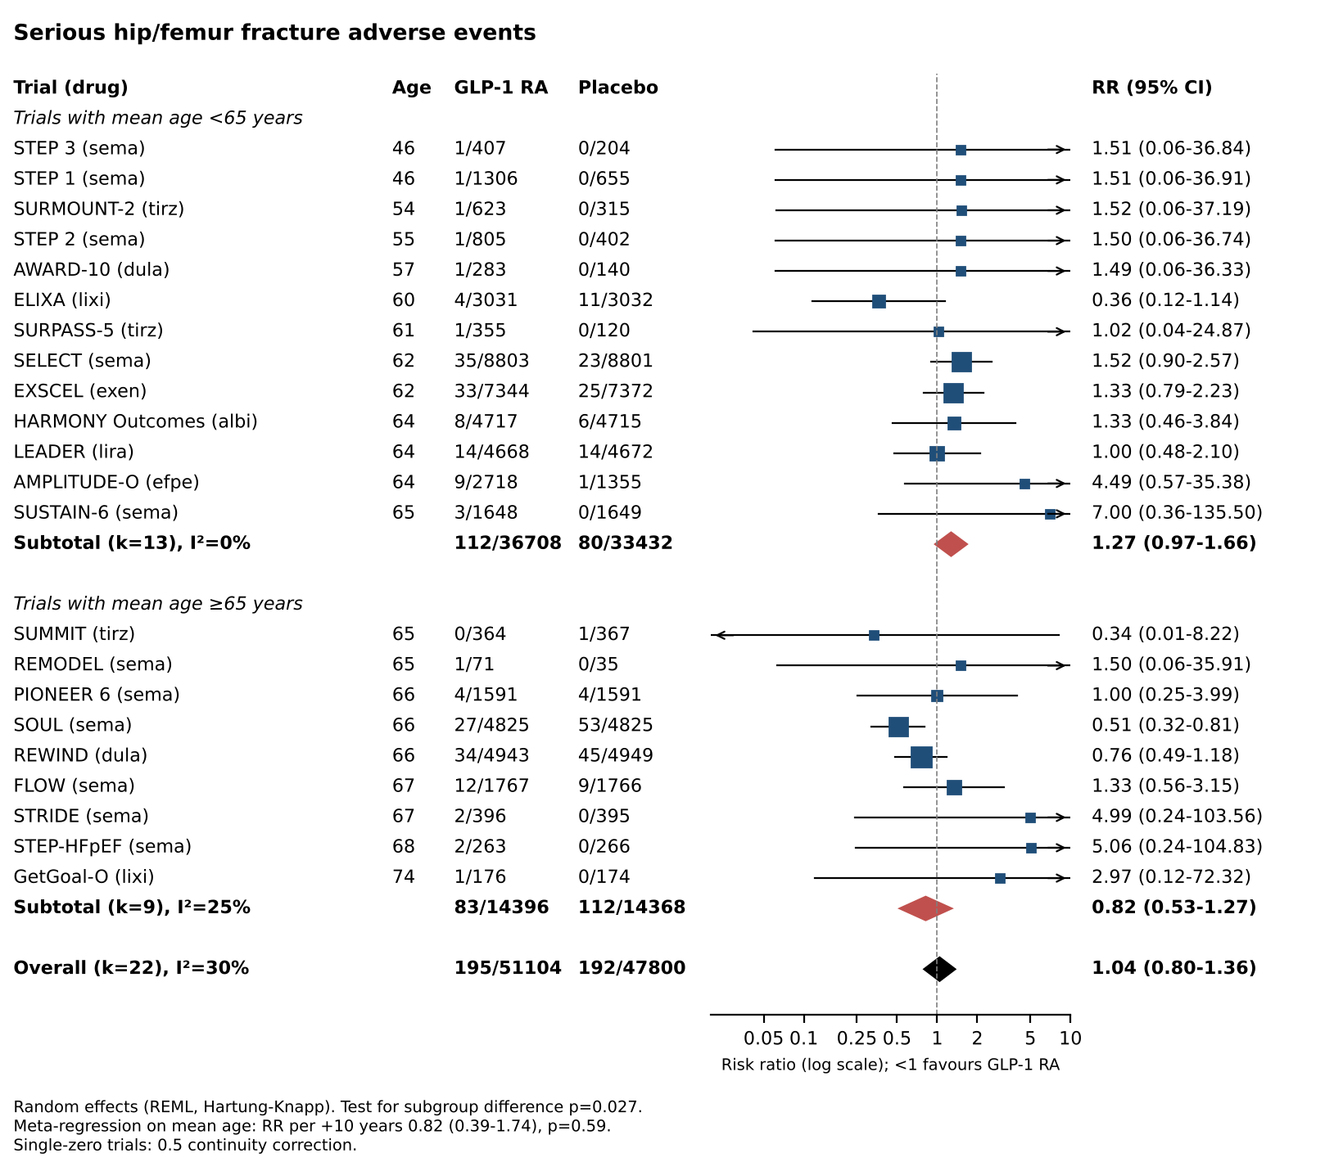

Table S3. Placebo-controlled trials reporting muscle function or bone-turnover markers
MD = drug minus placebo, change from baseline; 95% CI from the reported SE. NR = not reported. No trial reported grip strength, gait speed or SPPB.
Outcome | Trial | Drug | Population | Age, y | Weeks | MD (95% CI) | n drug / placebo | Source
6MWD, m | STEP-HFpEF | semaglutide 2.4 mg | obesity HFpEF | 69 (median) | 52 | 20.3 (8.56 to 32) | 263 / 266 | Kosiborod 2023 NEJM abstract: 20.3 (8.6 to 32.1)
6MWD, m | STEP-HFpEF DM | semaglutide 2.4 mg | obesity HFpEF T2D | 70 (median) | 52 | 14.3 (3.7 to 24.9) | NR | Kosiborod 2024 NEJM abstract: 14.3 (3.7 to 24.9)
6MWD, m | SUMMIT | tirzepatide | obesity HFpEF | 65.2 | 52 | 18.3 (9.89 to 26.7) | 326 / 314 | ClinicalTrials.gov NCT04847557: 18.3 (9.9 to 26.7)
6MWD, m | SCALE IBT | liraglutide 3.0 mg | obesity | 47.2 | 56 | 3.12 (-12.7 to 18.9) | 142 / 140 | ClinicalTrials.gov NCT02963935: 3.12 (-12.68 to 18.92)
6MWD, m | FIGHT | liraglutide 1.8 mg | HFrEF post-discharge | 61 (median) | 26 | 0.4 (-29.1 to 29.9) | 154 / 146 | ClinicalTrials.gov NCT01800968: 55.7 (SD 133.9) vs 55.3 (SD 127.2)
6MWD, m | Lepore 2016 | albiglutide 30 mg | HFrEF | NR | 12 | 9 (-22.9 to 40.9) | 27 / 30 | Abstract: 18 (SE 12) vs 9 (SE 11) m
CTX, µg/L | Hansen 2024 | semaglutide 1.0 mg | increased fracture risk | 63 | 52 | 0.166 (0.0255 to 0.307) | 64 total | Abstract/PMC: ETD 166.4 ng/L (25.5 to 307.3)
CTX, µg/L | Hygum 2020 | liraglutide 1.8 mg | T2D | NR | 26 | 0.04 (-0.00606 to 0.0861) | 30 / 30 | Abstract: 0.07 (0.03;0.10) vs 0.03 (0.00;0.06) µg/L
CTX, µg/L | NCT02020616 | exenatide ER 2 mg | T2D | 55.3 | 12 | 0.028 (-0.0857 to 0.142) | 10 / 10 | Registry LS mean (SE): -0.010 (0.040) vs -0.038 (0.042) ng/mL
P1NP, µg/L | Hansen 2024 | semaglutide 1.0 mg | increased fracture risk | 63 | 52 | 3.8 (-5.71 to 13.3) | 64 total | Abstract: ETD 3.8 (-5.6 to 13.3)
P1NP, µg/L | NCT02020616 | exenatide ER 2 mg | T2D | 55.3 | 12 | -2.7 (-10.6 to 5.2) | 10 / 10 | Registry LS mean (SE): 2.3 (2.9) vs 5.0 (2.8) ng/mL
Knee-extension torque, Nm | S-LiTE | liraglutide 3.0 mg | obesity after LCD | 43 | 52 | 1.9 (-7.8 to 11.6) | 49 / 48 | Jensen 2026 (Sports Med): ETD 1.9 (-7.8 to 11.6)

Table S4. Results for participants aged about 75 years or older
Upper rows: participants with events / participants by age group. Lower rows: hazard ratio or HbA1c difference (drug minus placebo). NR = not reported.
Source | Trial or pool | Drug | Age group | Outcome | Drug | Comparator | Note
FDA review NDA 215256 S-011 (2024) Table 85 | SELECT | semaglutide 2.4 mg | <55 | selected fracture SAEs (FMQ) | 13/2057 | 28/2094 (placebo) | post hoc response to FDA information request
FDA review NDA 215256 S-011 (2024) Table 85 | SELECT | semaglutide 2.4 mg | 55-<65 | selected fracture SAEs (FMQ) | 23/3387 | 41/3338 (placebo)
FDA review NDA 215256 S-011 (2024) Table 85 | SELECT | semaglutide 2.4 mg | 65-<75 | selected fracture SAEs (FMQ) | 43/2656 | 49/2706 (placebo)
FDA review NDA 215256 S-011 (2024) Table 85 | SELECT | semaglutide 2.4 mg | ≥75 | selected fracture SAEs (FMQ) | 29/703 | 21/663 (placebo)
FDA review NDA 215256 S-011 (2024) p225; Wegovy label 6.1 | SELECT | semaglutide 2.4 mg | ≥75 | hip and pelvis fractures | 17/703 | 4/663 (placebo) | labelled
FDA review NDA 215256 S-011 (2024) Table 93 | SELECT | semaglutide 2.4 mg | ≥75 | any SAE | 337/703 | 338/663 (placebo)
FDA review NDA 213051 (2019) Table 135 | PIONEER phase 3a pool | oral semaglutide | >75 | fall (any) | 7/NR | 1/NR (placebo or active) | adjusted % 3.5 vs 1.2; denominators not given
FDA review NDA 213051 (2019) Table 135 | PIONEER phase 3a pool | oral semaglutide | >75 | weight decrease (AE) | 4/NR | 0/NR (placebo or active) | adjusted % 1.6 vs 0
Pandey 2025 Table 3 | STEP-HFpEF + STEP-HFpEF DM | semaglutide 2.4 mg | ≥75 | serious bone and joint injuries | 4/136 | 3/156 (placebo) | denominators derived from %
Pandey 2025 | STEP-HFpEF + STEP-HFpEF DM | semaglutide 2.4 mg | ≥75 | any SAE | 31/136 | 61/156 (placebo) | denominators derived from %
FDA review NDA 022341 (LEADER) | LEADER | liraglutide | 75-84 | any SAE | 252/401 | 248/393 (placebo) | T2D
FDA review NDA 022341 (LEADER) | LEADER | liraglutide | 75-84 | all-cause death | 54/401 | 70/393 (placebo) | T2D
Gilbert 2024 (Harmony post hoc) | Harmony Outcomes | albiglutide | ≥75 | MACE | n = 1140; HR 0.70 (0.48 to 1.01) |  | T2D
Bain 2025 | SUSTAIN-6 + PIONEER 6 | semaglutide sc/oral | >70 (mean 75.1) | MACE | n = 1554; HR 0.93 (0.63 to 1.36) |  | T2D
FDA review NDA 215256 S-011 Fig 4 | SELECT | semaglutide 2.4 mg | ≥75 | MACE | n = 1366; HR 0.92 (0.67 to 1.25) |  | obesity without diabetes
Bain 2025 | SUSTAIN-6 + PIONEER 6 | semaglutide | >70 | HbA1c, %-points | n = 1554; -0.7 |  | CI shown in figure only
ClinicalTrials.gov NCT01798706 | GetGoal-O | lixisenatide | ≥70 (mean 74.2) | HbA1c, %-points | n = 344; -0.64 (-0.81 to -0.46) |  | LS mean difference, week 24

