Supplementary Material
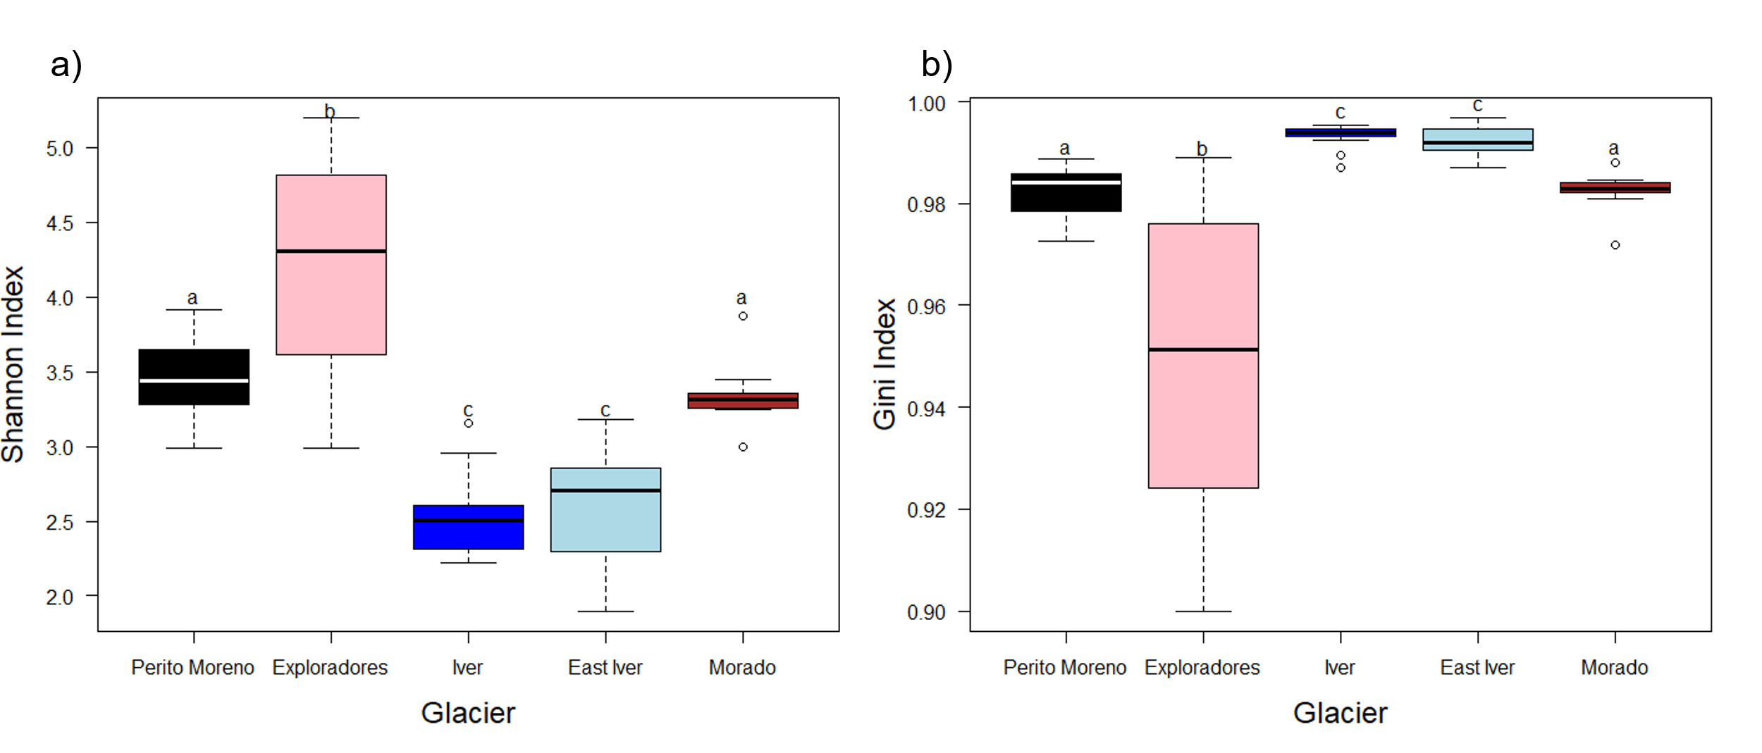
Figure S1 Boxplots of Shannon (a) and Gini (b) diversity indices of cryoconite hole bacterial communities. The thick lines represent the median, boxes upper and lower limits the 25th and the 75th percentiles respectively, whiskers the data that go beyond the 5th and the 75th percentile (upper whisker), dots represent the outliers and different letters indicate significant differences at post-hoc tests.

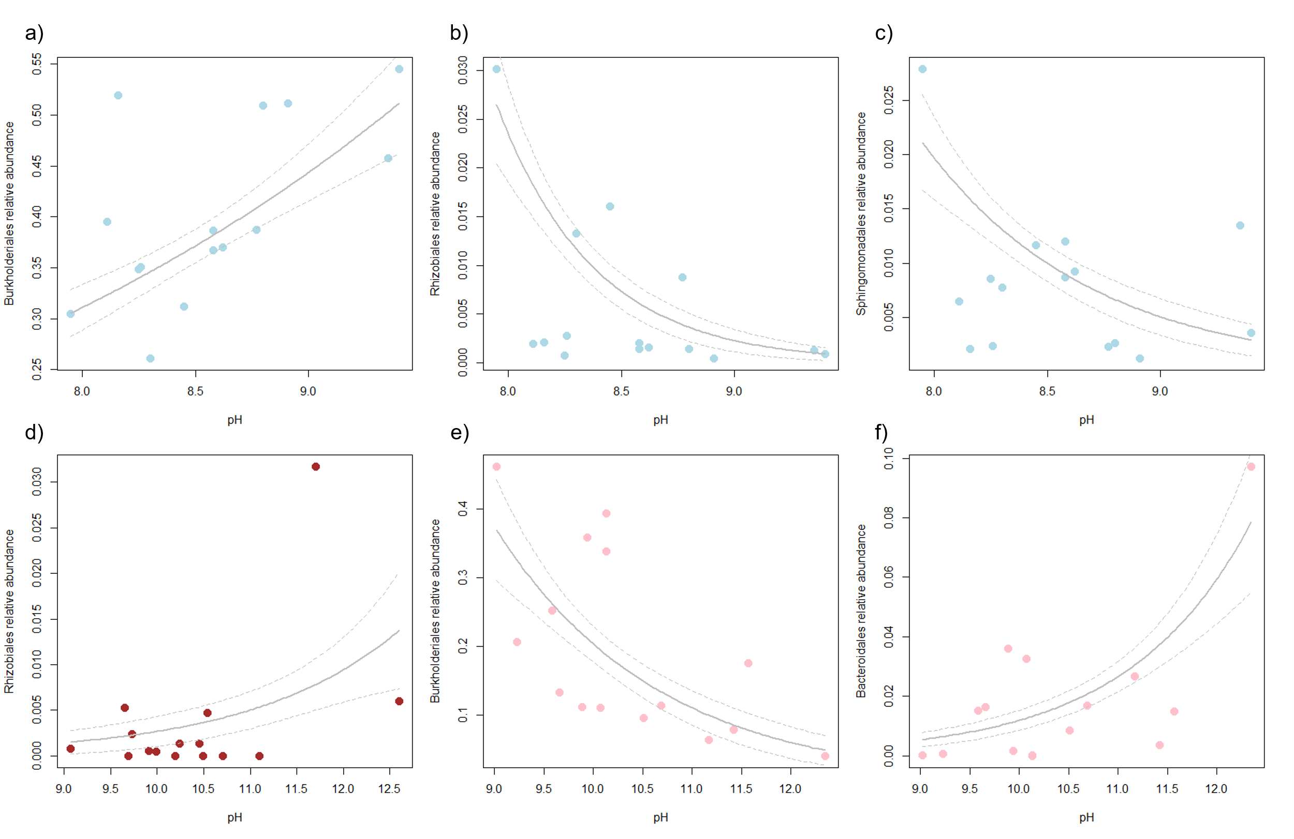
Figure S2 GLM biplots showing the trend of Burkholderiales (a), Rhizobiales (b), Sphingomonadales (c) on the East Iver glacier (light blue), Rhizobiales (d) on the Morado glacier (brown), Burkholderiales (e) and Bacteroidales (f) on the Exploradores glacier (pink) according to pH.
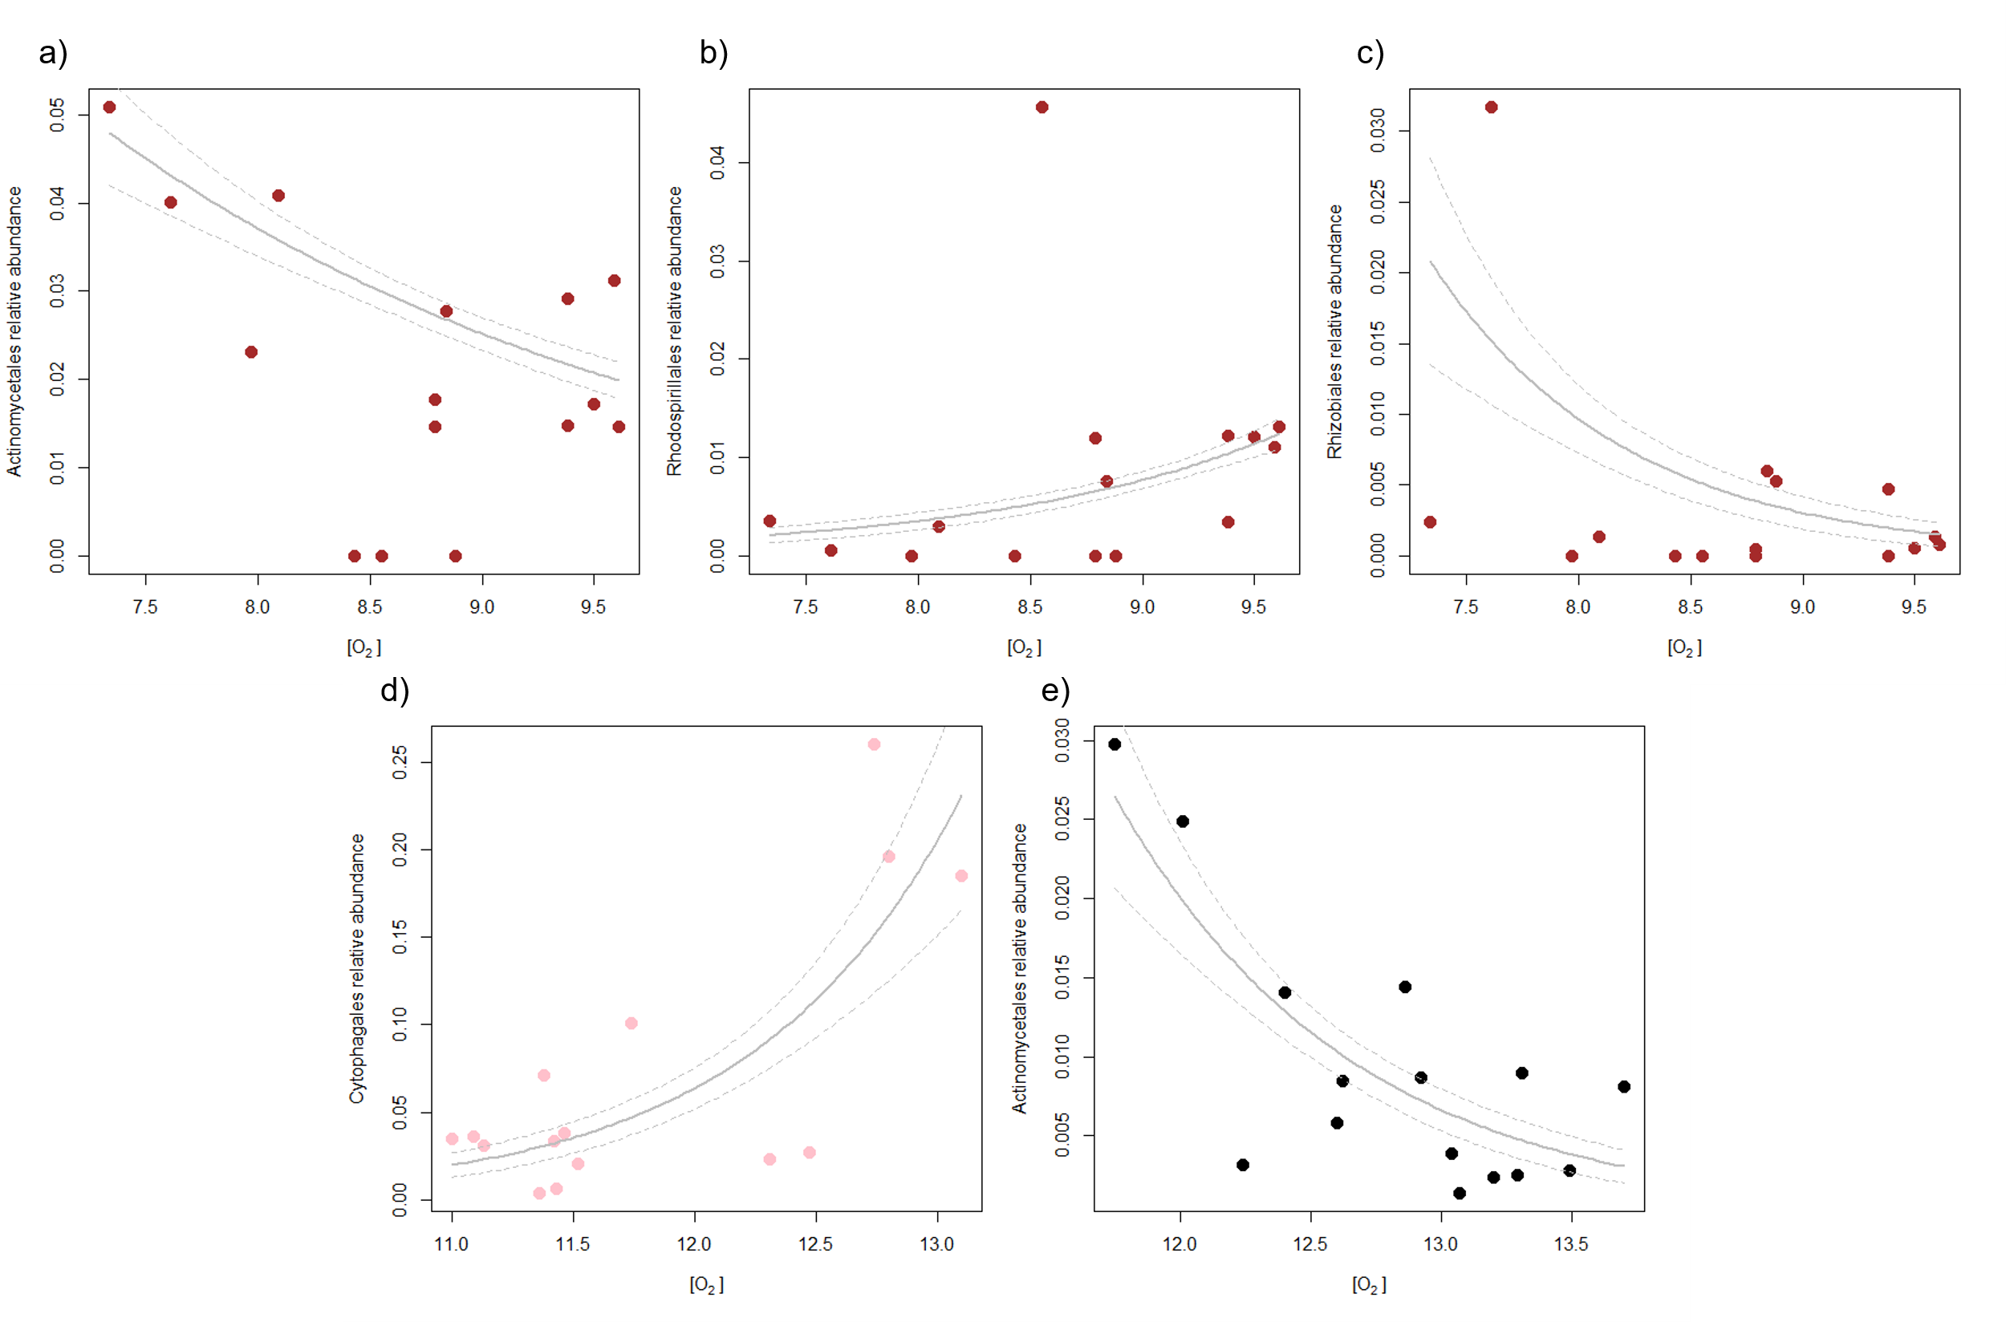
Figure S3 GLM biplots showing the trend of Actinomycetales (a), Rhodospirillales (b), Rhizobiales (c) on the Morado glacier (brown), Cytophagales (d) on the Exploradores glacier (pink) and Actinomycetales (e) on the Perito Moreno glacier (black) according to [O₂].

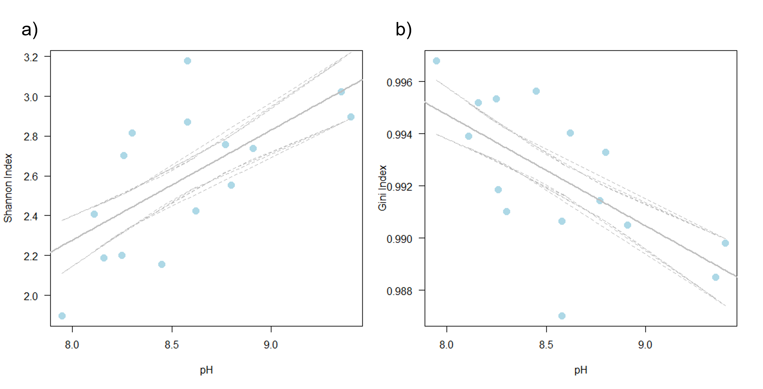
Figure S4 GLS biplots showing the trend of Shannon (a) and Gini (b) indexes on the East Iver according to pH.

