Supplementary Information

Table S1 Environmental variables recorded in 37 ponds sampled in the coastal plains of the state of São Paulo in Southeastern Brazil.
Variable | Parameter description
Hydroperiod | ephemeral: retained water for a period of time less than sample period; temporary: retained water throughout the entire sampling period, but not for 100% of the year; permanent: retained water throughout the entire sampling period and throughout the year
Area | surface area of the pond (m²)
Water depth | maximum depth of the pond (cm)
Canopy cover | percentage of canopy cover above the pond
Diversity of internal vegetation structure | percentage of each vegetation type present in the pond (macrophytes submerged, floating and upright herbaceous, shrubby and arboreal vegetation)
Diversity of external vegetation structure | percentage of each vegetation types present around the pond (upright herbaceous, shrubby and arboreal vegetation)
Presence of potential predator (fish) | collected by a dipnet: absent (0) or present (1)
pH | pH of the pond water
Dissolved oxygen | dissolved oxygen of the pond water (ppm)
Water conductivity | Level of conductivity of the pond water (µs/cm)
Water temperature | temperature of the pond water (°C)

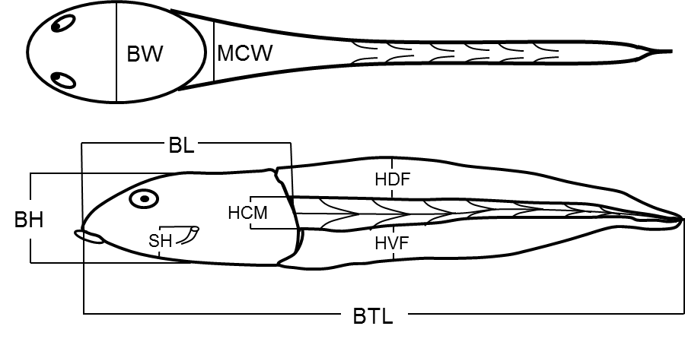
Fig. S1 Morphological characters recorded for calculation of ecomorphological attributes: body width (BW), musculature caudal width (MCW), height of caudal musculature (HCM), height of dorsal fin (HDF), height of ventral fin (HVF), body length (BL), body height (BH), spiracle’s height (SH), and body total length (BTL).

