Influence of sub-inhibitory concentrations of antimicrobials on micrococcal nuclease and biofilm formation in Staphylococcus aureus

Colin W.K. Rosman, Henny C. van der Mei, Jelmer Sjollema
Supplemental material

Fig. S1 Difference in total biomass and polysaccharide content between the Staphylococcus aureus Newman Δnuc1 mutant and its parent strain. Units on y-axis are relative differences (in percent) as related to the average difference between both strains grown in absence of antibiotics (control). Data shown are 3 averages of triplicate measurements, error bars indicate standard error of the mean. Each experiment had its own control. No significant differences were found.
Fig. S2 Calibration of the nuclease probe with micrococcal nuclease (MN). Graph showing the linear correlation (dotted lines = 95% CI) between fluorescence intensity increase per minute of the nuclease probe versus the quantity of the probe in U/mL. Due to photobleaching of the probe the fluorescence increase without MN is negative. Vertical dotted lines indicate the 5th and 95th percentile of all MN activities measures, excluding cultures with an inhibitory, or higher, concentration of antibiotics.

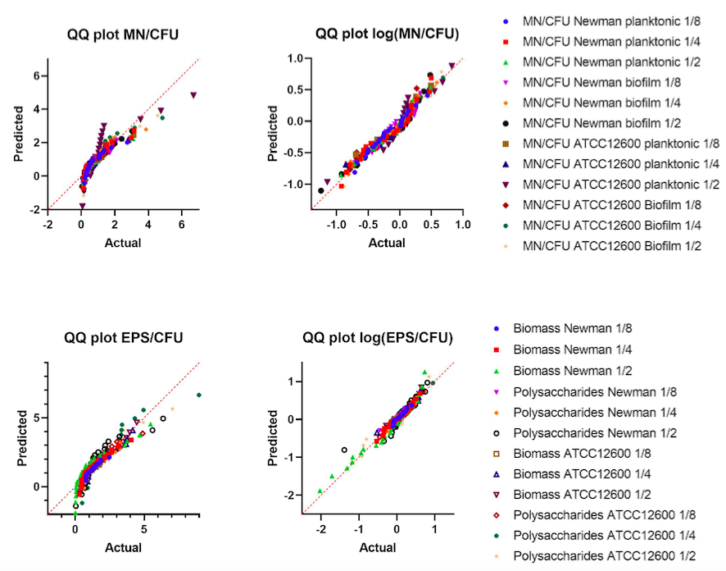
Fig. S3 Quantile-Quantile (QQ) plots of micrococcal nuclease per colony forming unit of both planktonic and biofilm mode of growth, and biofilm parameters biomass and polysaccharides (summarized as extracellular polymeric substance (EPS)) for both Staphylococcus aureus ATCC12600 and Newman lux. Data on the horizontal axes are quantiles of actual distributions (or from distributions of log-value data), data on the y-axis represent quantiles on a theoretical normal distribution (or log-normal distribution). The graph shows that the distribution of data can be described by a log-normal distribution (both Figures on the right side of the panel) rather than by a normal distribution (Left part of the panel). Fractions in the legend refer to fraction of inhibitory concentration.

