Fewer Children, Fewer Stars? Top PISA Performers in Europe

Supplementary Materials

S1. Data, Country Frame and Estimation
Section S1 documents the country frame, the data sources and the estimators used in the main text and in Sections S2–S5.

S1.1 Country frame and participation
The frame contains 38 countries: PISA participants in UN M49 Europe (United Nations Statistics Division, 2026) plus Kosovo, reported as national units, each with at least three comparable mathematics cycles between 2003 and 2025. Table S1.1 lists each country’s regional group and its first and last comparable cycles.
Twenty-two countries are observed in both 2003 and 2025 and form the common-endpoint set. The fixed panel in Table 1 and Table S3.3 comprises the 21 of them observed in all eight cycles; Luxembourg is excluded because it has no comparable 2022 observation.
The following cases depart from the general rule:
- United Kingdom: the 2003 observation is excluded because school and student response did not meet PISA standards (OECD, n.d.-a), so the series starts in 2006.
- Serbia and Montenegro: the 2003 assessment covered both jointly; the separate national series start in 2006.
- Russia: no observations after 2018.
- Liechtenstein: the series ends in 2012.
- Albania: the series ends in 2022 because OECD excludes its 2025 results from trend reporting owing to incomplete target-population representation.
- Not in the frame: PISA participants that M49 places in Western Asia, such as Türkiye, Cyprus and Georgia, and European participants with fewer than three comparable cycles (Bosnia and Herzegovina, Belarus and Ukraine).
Table S1.1. Country frame, regional group and comparable mathematics cycles.
Country | Group | First cycle | Last cycle | 2003 and 2025 endpoints | Comparable cycles (n)
Albania | P | 2009 | 2022 | No | 5
Bulgaria | P | 2006 | 2025 | No | 7
Croatia | P | 2006 | 2025 | No | 7
Czechia | P | 2003 | 2025 | Yes | 8
Estonia | P | 2006 | 2025 | No | 7
Hungary | P | 2003 | 2025 | Yes | 8
Kosovo | P | 2015 | 2025 | No | 4
Latvia | P | 2003 | 2025 | Yes | 8
Lithuania | P | 2006 | 2025 | No | 7
Moldova | P | 2009 | 2025 | No | 5
Montenegro | P | 2006 | 2025 | No | 7
North Macedonia | P | 2015 | 2025 | No | 4
Poland | P | 2003 | 2025 | Yes | 8
Romania | P | 2006 | 2025 | No | 7
Russia | P | 2003 | 2018 | No | 6
Serbia | P | 2006 | 2025 | No | 6
Slovakia | P | 2003 | 2025 | Yes | 8
Slovenia | P | 2006 | 2025 | No | 7
Austria | N | 2003 | 2025 | Yes | 8
Belgium | N | 2003 | 2025 | Yes | 8
Denmark | N | 2003 | 2025 | Yes | 8
Finland | N | 2003 | 2025 | Yes | 8
France | N | 2003 | 2025 | Yes | 8
Germany | N | 2003 | 2025 | Yes | 8
Greece | N | 2003 | 2025 | Yes | 8
Iceland | N | 2003 | 2025 | Yes | 8
Ireland | N | 2003 | 2025 | Yes | 8
Italy | N | 2003 | 2025 | Yes | 8
Liechtenstein | N | 2003 | 2012 | No | 4
Luxembourg | N | 2003 | 2025 | Yes | 7
Malta | N | 2009 | 2025 | No | 5
Netherlands | N | 2003 | 2025 | Yes | 8
Norway | N | 2003 | 2025 | Yes | 8
Portugal | N | 2003 | 2025 | Yes | 8
Spain | N | 2003 | 2025 | Yes | 8
Sweden | N | 2003 | 2025 | Yes | 8
Switzerland | N | 2003 | 2025 | Yes | 8
United Kingdom | N | 2006 | 2025 | No | 7
Note. P = post-socialist (18 countries); N = non-post-socialist (20 countries). First and last cycles are the first and last comparable mathematics observations. The cycle counts and the continuation below use the archive’s comparable, trend-eligible mathematics observations with finite estimates (270 country–cycles). For Moldova and Malta, the nominal 2009 cycle was administered in 2010 (PISA 2009+).
Table S1.1 (continued). Main-assessment mode by comparable cycle and archived response/exclusion diagnostics.
Country | Paper cycles | Computer cycles | 2022 flags | 2025 flags
Albania | 2009, 2012, 2015 | 2018, 2022 | None | I, S, T
Bulgaria | 2006, 2009, 2012 | 2015, 2018, 2022, 2025 | None | None
Croatia | 2006, 2009, 2012 | 2015, 2018, 2022, 2025 | E | E
Czechia | 2003, 2006, 2009, 2012 | 2015, 2018, 2022, 2025 | None | None
Estonia | 2006, 2009, 2012 | 2015, 2018, 2022, 2025 | E | E
Hungary | 2003, 2006, 2009, 2012 | 2015, 2018, 2022, 2025 | None | None
Kosovo | 2015 | 2018, 2022, 2025 | None | None
Latvia | 2003, 2006, 2009, 2012 | 2015, 2018, 2022, 2025 | E, I | E
Lithuania | 2006, 2009, 2012 | 2015, 2018, 2022, 2025 | E | None
Moldova | 2009, 2015, 2018 | 2022, 2025 | None | None
Montenegro | 2006, 2009, 2012 | 2015, 2018, 2022, 2025 | NR | None
North Macedonia | 2015, 2018 | 2022, 2025 | NR | E
Poland | 2003, 2006, 2009, 2012 | 2015, 2018, 2022, 2025 | None | E
Romania | 2006, 2009, 2012, 2015, 2018 | 2022, 2025 | None | None
Russia | 2003, 2006, 2009, 2012 | 2015, 2018 | n/a | n/a
Serbia | 2006, 2009, 2012 | 2018, 2022, 2025 | None | E*
Slovakia | 2003, 2006, 2009, 2012 | 2015, 2018, 2022, 2025 | None | None
Slovenia | 2006, 2009, 2012 | 2015, 2018, 2022, 2025 | None | None
Austria | 2003, 2006, 2009, 2012 | 2015, 2018, 2022, 2025 | None | None
Belgium | 2003, 2006, 2009, 2012 | 2015, 2018, 2022, 2025 | I | I
Denmark | 2003, 2006, 2009, 2012 | 2015, 2018, 2022, 2025 | E | E, I, S
Finland | 2003, 2006, 2009, 2012 | 2015, 2018, 2022, 2025 | None | None
France | 2003, 2006, 2009, 2012 | 2015, 2018, 2022, 2025 | None | E
Germany | 2003, 2006, 2009, 2012 | 2015, 2018, 2022, 2025 | None | None
Greece | 2003, 2006, 2009, 2012 | 2015, 2018, 2022, 2025 | NR | I
Iceland | 2003, 2006, 2009, 2012 | 2015, 2018, 2022, 2025 | NR | E
Ireland | 2003, 2006, 2009, 2012 | 2015, 2018, 2022, 2025 | R | None
Italy | 2003, 2006, 2009, 2012 | 2015, 2018, 2022, 2025 | None | None
Liechtenstein | 2003, 2006, 2009, 2012 | — | n/a | n/a
Luxembourg | 2003, 2006, 2009, 2012 | 2015, 2018, 2025 | n/a | E
Malta | 2009, 2015 | 2018, 2022, 2025 | NR | None
Netherlands | 2003, 2006, 2009, 2012 | 2015, 2018, 2022, 2025 | E, I, Q | E, I, R, Q
Norway | 2003, 2006, 2009, 2012 | 2015, 2018, 2022, 2025 | E | E
Portugal | 2003, 2006, 2009, 2012 | 2015, 2018, 2022, 2025 | None | None
Spain | 2003, 2006, 2009, 2012 | 2015, 2018, 2022, 2025 | None | E*
Sweden | 2003, 2006, 2009, 2012 | 2015, 2018, 2022, 2025 | E | E
Switzerland | 2003, 2006, 2009, 2012 | 2015, 2018, 2022, 2025 | NR | E
United Kingdom | 2006, 2009, 2012 | 2015, 2018, 2022, 2025 | I, S, R | E, I
Note. Mode columns list only comparable cycles retained in the main trends. The 2025 diagnostics also show Albania’s excluded observation. E = overall exclusions >5%; I = initial school response <85%; S = final school response <85%; R = final student response <80%; Q = Netherlands-specific response-quality flag in the sensitivity code; T = excluded from trend reporting. None = none of these flags; NR = response profile not recorded in the archive; n/a = no comparable observation. These diagnostics are available for 2022 and 2025. Initial school response (I) alone does not trigger the study’s response-quality exclusion. Response flags do not by themselves remove observations from the main trends.
* Additional archived 2025 notes: Serbia excluded non-Serbian-language schools and postponed assessment after school strikes; Spain has increased within-school exclusions and a Catalonia reporting restriction. The Netherlands has a non-response uncertainty note. Sources: archived OECD 2022 response/exclusion profiles and supplied PISA 2025 Technical Report, Tables 14.A.1, 14.A.4, 14.A.6 and 14.A.8, and Chapter 18 (Data Adjudication). Mode sources: Table S1.2.

S1.2 Data sources
Every quantity in the paper comes from one of the sources in Table S1.2. Resident-population figures come from OECD annex tables, with Eurostat figures substituted where OECD figures were unavailable.
Table S1.2. Data sources by quantity.
Quantity | Source | Detail
Mathematics, reading and science scores | PISA student files, 2003–2025 | Five plausible values per domain through 2012, ten from 2015
Sampling weights | PISA student files | Final student weight W_FSTUWT; 80 Fay replicate weights (W_FSTR1–W_FSTR80 through 2012, W_FSTURWT1–W_FSTURWT80 from 2015)
Immigrant background | PISA student files | IMMIG
Administration mode | OECD, PISA 2015 Results, Volume I (2016), pp. 56 and 189; PISA 2018 Results, Volume I (2019), Annex A5; PISA 2022 Results, Volume I (2023), Annex A5; supplied PISA 2025 Technical Report, Annex Table 1.A.2 | Country–cycle classification of the main mathematics assessment as paper or computer. All cycles through 2012 are paper; later cycles are computer from each country’s first computer-based main assessment onward. Optional computer modules do not change this classification. Table S1.1 lists the resulting cycles.
Covered population (S) | PISA student files | Sum of final student weights
Resident 15-year-olds (P) | OECD (2023c, Table II.A2.2) for 2003–2022; OECD (2025, Table 14.A.1) for 2025 | Eurostat (2022b, demo_pjan) where OECD figures were unavailable
Coverage Index 3 | OECD (2023c, Table II.A2.2); OECD (2025, Table 14.A.1) | Published values, used in Section S2
Live births (B) | Eurostat (2022a, demo_gind) | Births in year t − 15; see S1.3
Tertiary attainment, ages 25–34 | Eurostat (2026b, edat_lfse_03), ISCED 5–8 | Counts use population totals from Eurostat (2022b, demo_pjan)
Mathematics linking errors | OECD (2014, Table 12.31); OECD (2019, Table I.A7.1); OECD (2024, Table 14.A.19); OECD (2025, Annex Table 15.A.20) | Pairwise errors between cycles
Proficiency cut-points | OECD (2023b) | Level 4: 544.68; Level 5: 606.99; Level 6: 669.30
Eurostat resident-population figures replace OECD figures in: Switzerland, Greece and Iceland (each: 2003, 2006, 2009, 2012, 2015, 2018 and 2022); Luxembourg (2003, 2006, 2009, 2012, 2015 and 2018); North Macedonia (2015, 2018 and 2022); Malta (2009, 2015, 2018 and 2022); Montenegro (2006, 2009, 2012, 2015, 2018 and 2022); and Liechtenstein (2003, 2006, 2009 and 2012, in the birth-accounting analysis only). These are the substitutions in the retained analysis samples; all retained 2025 observations use OECD population figures.

S1.3 Estimation
Every statistic is computed for each plausible value and each replicate weight, then combined. For country c and cycle t, student i has final weight w and plausible value θ for draw m = 1, …, M.
Counts and rates. Point estimates average over plausible values.
Nctm=i​wi 1{θim≥606.99}, Sct=i​wi, rctm=NctmSct
Sampling and imputation variance. Fay balanced repeated replication with G = 80 replicates and k = 0.5, combined across plausible values with Rubin’s rules. With these values the first factor equals 1/20.
$$V_{samp}^{\left(m\right)}=\frac{1}{G{\left(1-k\right)}^{2}}\sum_{g=1}^{G}{{\left({\hat{β}}_{g}^{\left(m\right)}-{\hat{β}}^{\left(m\right)}\right)}^{2}}$$
$$V=\frac{1}{M}\sum_{m=1}^{M}{V_{samp}^{\left(m\right)}}+\left(1+\frac{1}{M}\right)\frac{1}{M-1}\sum_{m=1}^{M}{{\left({\hat{β}}^{\left(m\right)}-\overset{‾}{β}\right)}^{2}}$$
Linking uncertainty. A relative scale shift between cycles 0 and 1, with published standard error σ, is split symmetrically between them. Its effect on a count change is approximated through f, the weighted share of students per score point at 606.99. The shift is common to all countries, so sensitivities are summed across countries before the variance is computed.
SElinkΔN≈12c​Sc0fc0+Sc1fc1σ01
For a trend slope b fitted over several cycles, cycle errors are expressed relative to 2025 and bounded without assuming independence:
SDlinkb≤t​∂b∂δtσt,2025
Design and linking variances are added under independence.
Two-factor decomposition (Kitagawa). The count change splits exactly into a covered-cohort and a rate component.
$$ΔN=\underset{\text{covered cohort}}{\underset{⏟}{\left(S_{1}-S_{0}\right)\frac{r_{0}+r_{1}}{2}}}+\underset{\text{rate}}{\underset{⏟}{\left(r_{1}-r_{0}\right)\frac{S_{0}+S_{1}}{2}}}$$
Three-factor decomposition (LMDI-I). The count is written as resident population × alignment × rate, with alignment C = S / P.
$$N=P⋅C⋅r, ΔN_{X}=L\left(N_{1},N_{0}\right)ln\frac{X_{1}}{X_{0}}, X∈\{P,C,r\}, L\left(a,b\right)=\frac{a-b}{lna-lnb}$$
The three effects sum exactly to the count change; the shares in Table S5.3 are each effect divided by that change. C is computed from the weights and resident figures, so it can differ slightly from the published Coverage Index 3 in Section S2.
Birth-cohort accounting. With B the live births in year t − k, where k = 15:
$$lnS_{ct}=lnB_{c,t-k}+ln\frac{P_{ct}}{B_{c,t-k}}+lnC_{ct}$$
Each term’s annual trend (100 × annual log change) is pooled by region with the same country weights for every term, so the regional gaps add up exactly:
ΔS=ΔB+ΔP/B+ΔC, ΔX=c∈P​ωc bcX-c∈N​ωc bcX
The earlier-birth share in Table S5.5 is the birth gap divided by the total gap.
Birth-year convention. PISA’s target population is aged 15 years 3 months to 16 years 2 months at the start of testing, so students tested in cycle t are born mostly in year t − 16. We use births in year t − 15; the resident-to-birth term therefore absorbs a one-year offset for most students, together with migration, mortality and register revisions.

S2. PISA Coverage Diagnostics

S2.1 Rationale
PISA is designed to represent enrolled 15-year-olds in eligible schools and grades, not the full resident population aged 15. The weighted participating population and the external resident denominator are constructed independently. Their ratio, Coverage Index 3, is an alignment diagnostic rather than a literal inclusion rate and can exceed 100%. Selection into the assessed population can change measured Level 5+ rates whenever newly represented or newly omitted groups differ in performance. The direction is not identified from C3 alone.

S2.2 Measures and Data Availability
The historical coverage observations come from the retrospective OECD annex table (OECD, 2023c, Table II.A2.2), supplemented by the 2025 sampling tables (OECD, 2025, Tables 14.A.1, 14.A.4, 14.A.6 and 14.A.8). The coverage-by-wave table includes 36 countries with at least one observation; 29 have sufficient matched historical data for endpoint diagnostics. Mathematics coverage endpoints start at each country’s first matched comparable observation from 2003 onward.

S2.3 Zero-Uncovered Denominator Exercise
As a denominator sensitivity, we assign zero high performers outside the PISA-weighted participating population and express the Level 5+ count relative to the external resident age-15 denominator: r_zero-uncovered = r × C3. This is a conservative convention only when C3 ≤ 1. The exercise preserves count changes by construction and leaves the dominant accounting component unchanged in 27 of 29 countries.

S2.4 Summary of Diagnostics
Across the 29 matched countries, the correlation between endpoint changes in published C3 and the mathematics Level 5+ rate is r = 0.41. The alignment screen flags 22 countries for absolute C3 changes exceeding three percentage points or latest C3 below 85%.

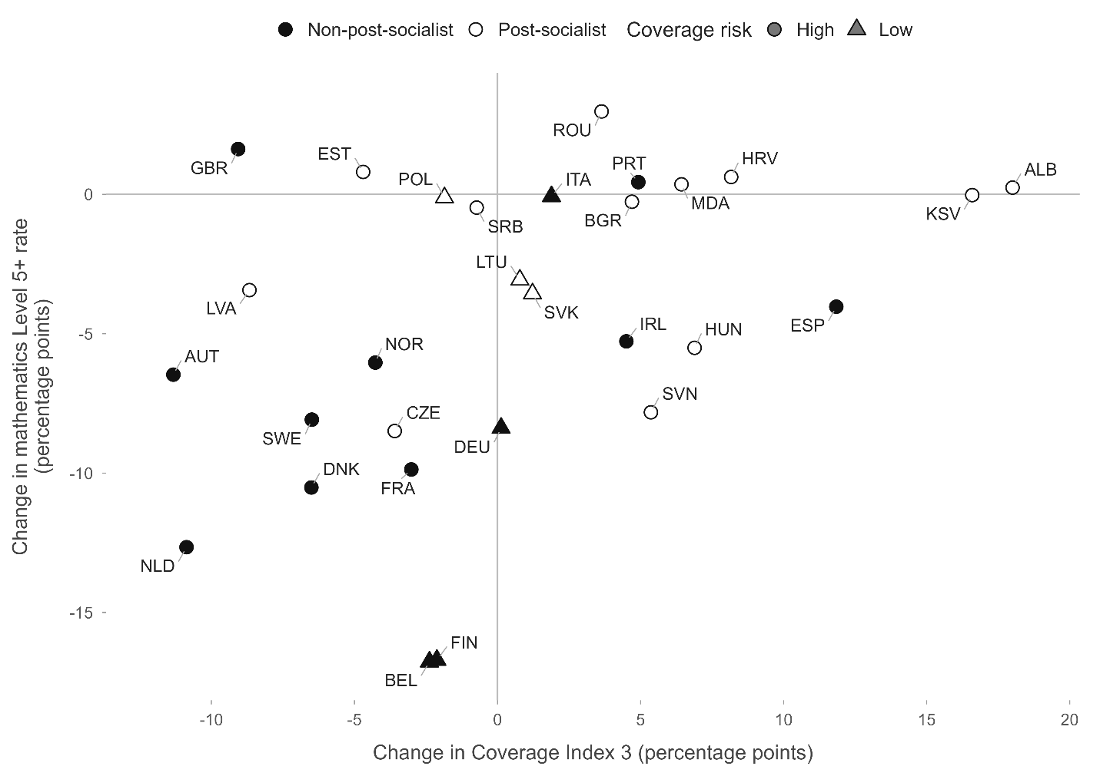
Figure S2.1. Change in Coverage Index 3 alignment and change in mathematics Level 5+ rate.
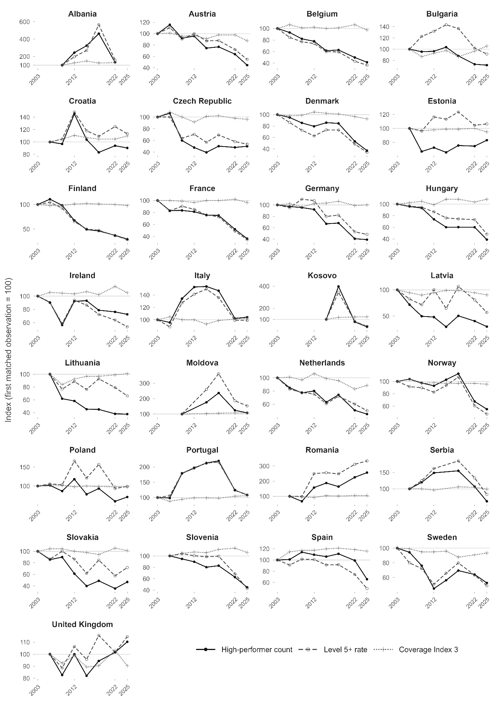
Figure S2.2. Indexed PISA high-performer count, Level 5+ rate, and Coverage Index 3 alignment ratio by country.
Table S2.1. Published Coverage Index 3 by country and PISA wave, including 2025.
CNT | Country | 2003 | 2006 | 2009 | 2012 | 2015 | 2018 | 2022 | 2025
ALB | Albania | NA | NA | 61.0 | 77.0 | 90.0 | 76.0 | 79.0 | 72.2
AUT | Austria | 91.0 | 92.0 | 87.0 | 88.0 | 83.0 | 89.0 | 89.0 | 79.7
BEL | Belgium | 93.0 | 99.0 | 94.0 | 95.0 | 93.0 | 94.0 | 99.0 | 90.6
BGR | Bulgaria | NA | 83.0 | 72.0 | 77.0 | 81.0 | 72.0 | 80.0 | 87.7
CZE | Czechia | 93.0 | 101.0 | 93.0 | 85.0 | 94.0 | 95.0 | 91.0 | 89.4
DEU | Germany | 93.0 | 95.0 | 90.0 | 95.0 | 96.0 | 99.0 | 92.0 | 93.1
DNK | Denmark | 87.0 | 85.0 | 86.0 | 91.0 | 89.0 | 88.0 | 84.0 | 80.5
ESP | Spain | 76.0 | 87.0 | 89.0 | 89.0 | 91.0 | 92.0 | 90.0 | 87.8
EST | Estonia | NA | 94.0 | 91.0 | 92.0 | 93.0 | 93.0 | 94.0 | 89.3
FIN | Finland | 95.0 | 93.0 | 93.0 | 96.0 | 97.0 | 96.0 | 95.0 | 92.9
FRA | France | 91.0 | 91.0 | 90.0 | 88.0 | 91.0 | 91.0 | 93.0 | 88.0
GBR | United Kingdom | 91.0 | 94.0 | 87.0 | 93.0 | 84.0 | 85.0 | 97.0 | 84.9
HRV | Croatia | NA | 85.0 | 89.0 | 94.0 | 91.0 | 89.0 | 89.0 | 93.2
HUN | Hungary | 83.0 | 85.0 | 87.0 | 82.0 | 90.0 | 90.0 | 86.0 | 89.9
IRL | Ireland | 89.0 | 94.0 | 93.0 | 92.0 | 95.0 | 91.0 | 102.0 | 93.5
ITA | Italy | 86.0 | 90.0 | 86.0 | 86.0 | 80.0 | 85.0 | 87.0 | 87.9
KSV | Kosovo | NA | NA | NA | NA | 71.0 | 84.0 | 86.0 | 87.6
LTU | Lithuania | NA | 93.0 | 78.0 | 86.0 | 90.0 | 90.0 | 92.0 | 93.8
LVA | Latvia | 90.0 | 85.0 | 81.0 | 85.0 | 89.0 | 89.0 | 85.0 | 81.3
MDA | Moldova | NA | NA | 90.0 | NA | 93.0 | 95.0 | 97.0 | 96.4
NLD | Netherlands | 95.0 | 96.0 | 92.0 | 101.0 | 94.0 | 91.0 | 79.0 | 84.1
NOR | Norway | 94.0 | 97.0 | 91.0 | 92.0 | 91.0 | 91.0 | 91.0 | 89.7
POL | Poland | 91.0 | 94.0 | 93.0 | 89.0 | 91.0 | 90.0 | 89.0 | 89.1
PRT | Portugal | 89.0 | 78.0 | 84.0 | 88.0 | 88.0 | 87.0 | 93.0 | 93.9
ROU | Romania | NA | 72.0 | 69.0 | 66.0 | 75.0 | 73.0 | 76.0 | 75.6
SRB | Serbia | NA | 83.0 | 83.0 | 80.0 | NA | 88.0 | 87.0 | 82.3
SVK | Slovakia | 91.0 | 95.0 | 95.0 | 91.0 | 89.0 | 86.0 | 96.0 | 92.2
SVN | Slovenia | NA | 88.0 | 92.0 | 94.0 | 93.0 | 98.0 | 100.0 | 93.4
SWE | Sweden | 98.0 | 97.0 | 93.0 | 93.0 | 94.0 | 86.0 | 89.0 | 91.5
Note. Entries are percentages from the historical annex table (OECD, 2023c, Table II.A2.2) and the 2025 sampling table (OECD, 2025, Table 14.A.1). Values above 100% reflect independently estimated populations. NA denotes unavailable country-waves. Russia has no matched Annex series here. Countries with fewer than three matched waves (Switzerland, Greece, Iceland, Luxembourg, North Macedonia, Malta, Montenegro) are documented in the replication archive.
Table S2.2. Matched endpoint coverage diagnostics and alignment flags.
CNT | Country | Period | C3 first | C3 latest | Δ C3 | Δ L5+ rate | Δ L5+ count | Alignment flag
ALB | Albania | 2009–2022 | 61.0 | 79.0 | +18.0 | +0.2 | 46 | High
AUT | Austria | 2003–2025 | 91.0 | 79.7 | −11.3 | −6.5 | −6,797 | High
BEL | Belgium | 2003–2025 | 93.0 | 90.6 | −2.4 | −16.8 | −17,279 | Low
BGR | Bulgaria | 2006–2025 | 83.0 | 87.7 | +4.7 | −0.3 | −651 | High
CZE | Czechia | 2003–2025 | 93.0 | 89.4 | −3.6 | −8.5 | −11,084 | High
DEU | Germany | 2003–2025 | 93.0 | 93.1 | +0.1 | −8.4 | −87,173 | Low
DNK | Denmark | 2003–2025 | 87.0 | 80.5 | −6.5 | −10.5 | −5,186 | High
ESP | Spain | 2003–2025 | 76.0 | 87.8 | +11.8 | −4.0 | −9,371 | High
EST | Estonia | 2006–2025 | 94.0 | 89.3 | −4.7 | +0.8 | −394 | High
FIN | Finland | 2003–2025 | 95.0 | 92.9 | −2.1 | −16.7 | −9,535 | Low
FRA | France | 2003–2025 | 91.0 | 88.0 | −3.0 | −9.9 | −70,727 | High
GBR | UK | 2006–2025 | 94.0 | 84.9 | −9.1 | +1.6 | 8,398 | High
HRV | Croatia | 2006–2025 | 85.0 | 93.2 | +8.2 | +0.6 | −211 | High
HUN | Hungary | 2003–2025 | 83.0 | 89.9 | +6.9 | −5.5 | −6,980 | High
IRL | Ireland | 2003–2025 | 89.0 | 93.5 | +4.5 | −5.3 | −1,716 | High
ITA | Italy | 2003–2025 | 86.0 | 87.9 | +1.9 | −0.1 | 1,414 | Low
KSV | Kosovo | 2015–2025 | 71.0 | 87.6 | +16.6 | −0.0 | −6 | High
LTU | Lithuania | 2006–2025 | 93.0 | 93.8 | +0.8 | −3.1 | −2,844 | Low
LVA | Latvia | 2003–2025 | 90.0 | 81.3 | −8.7 | −3.4 | −1,880 | High
MDA | Moldova | 2009–2025 | 90.0 | 96.4 | +6.4 | +0.4 | 23 | High
NLD | Netherlands | 2003–2025 | 95.0 | 84.1 | −10.9 | −12.7 | −25,855 | High
NOR | Norway | 2003–2025 | 94.0 | 89.7 | −4.3 | −6.0 | −2,710 | High
POL | Poland | 2003–2025 | 91.0 | 89.1 | −1.9 | −0.1 | −15,583 | Low
PRT | Portugal | 2003–2025 | 89.0 | 93.9 | +4.9 | +0.4 | 454 | High
ROU | Romania | 2006–2025 | 72.0 | 75.6 | +3.6 | +3.0 | 4,452 | High
SRB | Serbia | 2006–2025 | 83.0 | 82.3 | −0.7 | −0.5 | −790 | High
SVK | Slovakia | 2003–2025 | 91.0 | 92.2 | +1.2 | −3.6 | −5,193 | Low
SVN | Slovenia | 2006–2025 | 88.0 | 93.4 | +5.4 | −7.8 | −1,550 | High
SWE | Sweden | 2003–2025 | 98.0 | 91.5 | −6.5 | −8.1 | −8,003 | High
Note. The alignment screen is High when latest C3 < 85% or the absolute C3 endpoint change exceeds 3 percentage points. Albania’s trend ends in 2022. Full 2025 exclusion and response diagnostics are available in the replication archive.

S3. Formal Regional Tests and Observation-Window Sensitivities

S3.1 Country and Wave Inclusion
The 18 post-socialist countries are Albania, Bulgaria, Croatia, Czechia, Estonia, Hungary, Kosovo, Latvia, Lithuania, Moldova, Montenegro, North Macedonia, Poland, Romania, Russia, Serbia, Slovakia, Slovenia. The 20 non-post-socialist countries are Austria, Belgium, Denmark, Finland, France, Germany, Greece, Iceland, Ireland, Italy, Liechtenstein, Luxembourg, Malta, Netherlands, Norway, Portugal, Spain, Sweden, Switzerland, United Kingdom. The primary available-window frame has 38 countries and 270 country-waves. Complete country-wave inventories, assessment-mode tables, and geographic-scope decisions are documented in the replication archive.

S3.2 Formal Models
For each country and window, the annual slope is the OLS coefficient with variance that explicitly allows measurement error and extra temporal variation. Random-effects meta-regressions combine country slopes using REML and Knapp–Hartung inference (Knapp & Hartung, 2003). Secondary pooled country-year models include country and wave fixed effects with country-clustered standard errors.
Table S3.2. Selected primary-frame tests of annual PISA cohort and Level 5+ rate trends.
Frame · window | N (P/N) | Cohort: P−N [95% CI] | p | Rate: P−N [95% CI] | p
P · Available full 2003–2025 | 38 (18/20) | −1.517 [−2.129, −0.906] | <.001 | 0.247 [0.092, 0.401] | .003
P · Exclude Russia | 37 (17/20) | −1.440 [−2.037, −0.843] | <.001 | 0.238 [0.077, 0.399] | .005
P · Through 2018 | 36 (16/20) | −2.813 [−3.708, −1.918] | <.001 | 0.222 [0.029, 0.415] | .025
P · Paper 2003–2012 | 33 (14/19) | −3.948 [−5.462, −2.434] | <.001 | 0.245 [−0.050, 0.539] | .100
P · Calendar 2015–2025 | 36 (17/19) | 0.114 [−0.795, 1.024] | .800 | 0.325 [0.165, 0.485] | <.001
P · Common 2003–2025 | 22 (5/17) | −1.972 [−2.957, −0.987] | <.001 | 0.147 [−0.090, 0.384] | .211
P · Common 2006–2025 | 31 (13/18) | −1.366 [−2.016, −0.716] | <.001 | 0.241 [0.076, 0.407] | .006
P · Actual paper assessments | 35 (16/19) | −3.647 [−5.146, −2.148] | <.001 | 0.252 [−0.024, 0.529] | .072
P · Actual computer assessments | 32 (13/19) | −0.031 [−1.146, 1.083] | .955 | 0.268 [0.106, 0.431] | .002
P · Through 2022 (historical) | 38 (18/20) | −2.070 [−2.774, −1.365] | <.001 | 0.230 [0.071, 0.389] | .006
Note. P−N is the regional coefficient from REML/Knapp–Hartung meta-regression. Cohort slopes are 100 × annual log change; rate slopes are percentage points per year. Models containing 2025 use released pairwise linking errors and a first-order arbitrary-correlation bound. The complete set of 30+ specifications, including balanced-frame replications, appears in the replication archive.

S3.3 Results
The cohort contrast is −1.517 log-percentage points per year in the full frame and −1.440 without Russia (both p < .001). The historical paper-era contrast is −3.948; the 2015–2025 contrast is +0.114 (p = .800). Long-window contraction therefore does not imply a negative contrast in the separately fitted recent segment.
The primary-frame rate contrast is 0.247 (p = .003); it remains positive across all windows but its precision varies. The common 2003–2025 endpoint (22 countries) gives 0.147 (p = .211). The positive direction is more stable than the statistical resolution across windows. In the available-window frame, the two-way cohort component is dominant in 10 of 18 post-socialist and 3 of 20 non-post-socialist countries (Fisher p = .016).

S3.4 Scope of Uncertainty
All estimates use Fay BRR sampling variance (k = 0.5, 80 replicates) combined with Rubin imputation variance across plausible values (OECD, 2014, 2017; Rubin, 1987). Historical mathematics linking errors come from the 2012 technical table (OECD, 2014, Table 12.31), the 2018 results annex (OECD, 2019, Table I.A7.1) and the 2022 technical annex (OECD, 2024, Table 14.A.19). Released mathematics linking standard errors for 2025 comparisons are 5.67 (2003), 4.27 (2006), 4.45 (2009), 3.78 (2012), 3.00 (2015), 2.55 (2018) and 1.22 (2022) score points (OECD, 2025, Annex Table 15.A.20). Endpoint relative shifts are split symmetrically between assessments and propagated through local densities at the Level 5 boundary; the same shift is shared across countries, so aggregate linking sensitivities are summed before computing variance. For multi-cycle trends containing 2025, cycle errors are expressed relative to 2025 and the linking standard deviation is bounded by the sum of each cycle’s absolute model gradient multiplied by its published linking standard error. This first-order bound permits arbitrary cycle correlations rather than assuming independent linking errors. Design and linking variances are combined assuming independence; pre-2025 analyses retain their historical linking calculations. Threshold and migration-count diagnostics labelled design-only, and the observed-series Mann–Kendall tests, retain their stated uncertainty scope.
With the released pairwise errors, the regional rate interval is [0.092, 0.401], the fixed 2003–2025 count-change interval is [−389,628, −195,086], and the 2022–2025 interval is [−63,950, −10,237].

S3.5 Fixed-Frame Summed Totals
Table S3.3. Fixed-frame mathematics Level 5+ totals and endpoint checks.
Panel A. Cycle totals (fixed 21 countries)
Cycle | L5+ count (design SE) | Covered population | L5+ %
2003 | 583,840 (12,150) | 4,318,172 | 13.5
2006 | 554,810 (12,723) | 4,444,147 | 12.5
2009 | 536,208 (11,768) | 4,110,167 | 13.0
2012 | 532,485 (11,878) | 3,982,364 | 13.4
2015 | 447,149 (9,465) | 3,937,587 | 11.4
2018 | 463,069 (10,840) | 3,960,369 | 11.7
2022 | 328,577 (7,213) | 3,996,434 | 8.2
2025 | 291,484 (8,070) | 4,116,335 | 7.1
Panel B. Selected endpoint checks
Frame or check | Period | First → last count | Change (%) | 95% CI
Fixed 21 headline | 2003–2025 | 583,840 → 291,484 | −50.1 | [−389,628, −195,086]
Common 31 endpoints | 2006–2025 | 655,912 → 398,936 | −39.2 | [−350,747, −163,205]
Recent, fixed 21 | 2022–2025 | 328,577 → 291,484 | −11.3 | [−63,950, −10,237]
Exclude Germany | 2003–2025 | 440,404 → 235,220 | −46.6 | [−281,774, −128,595]
Pre-2022, fixed 21 | 2003–2018 | 583,840 → 463,069 | −20.7 | [−184,459, −57,084]
Note. Intervals combine BRR/PV variance and released pairwise linking errors for 2025 endpoints under the symmetric shift approximation. Historical comparisons retain published pairwise-error calculations. An exact aggregate LMDI partition assigned −18,984 students to resident-population change, −1,163 to alignment, and −272,210 to the Level 5+ rate.

S4. Non-Cohort-Aligned Tertiary Indicator Comparison
The PISA indicator is a single cohort observed at age 15, whereas tertiary attainment pools ten cohorts aged 25–34, creating a 10-to-19-year cohort offset. Tertiary-attainment rates come from Eurostat (2026b), using dataset edat_lfse_03 and selecting ages 25–34, both sexes and tertiary education (ED5-8). Estimated credential counts multiply these rates by resident population totals summed over ages 25–34 from dataset demo_pjan (Eurostat, 2022b). The attainment rates refer to private households, whereas the demographic denominators cover all residents; the resulting counts are derived estimates. Comparisons are restricted to separate periods before 2014, from 2014 to 2020 and from 2021 onward, accounting for the change in education classification and the revised EU Labour Force Survey framework (Eurostat, 2024, 2026a). Across the 33 countries with matched data, tertiary attainment generally rose within each break-free segment: in the pre-2014 segment, credential counts increased in 30 of 33 countries; in 2014–2020, in 24 of 33; in 2021–2025, in 22 of 30 countries with data. These increases occurred even as adolescent high-performer counts declined in most countries. Germany’s Level 5+ count index stands at 39.2 (2003 = 100) while its credential-count index reached 178.2. The full country-by-segment results are in the replication archive (Table S4.1).

S5. Detailed Results and Additional Displays

Country trends and endpoint changes
Table S5.1. PISA mathematics Level 5+ trends across European countries (selected).
Country | n | Period | L5+ % | τ rate | p/q | τ cohort | p/q | Δ Count | Cohort % | Rate %
Germany | 8 | 2003–2025 | 7.8 | −0.64 | .035/.079 | −0.86 | .004/.084 | −87,173 | 23 | 77
France | 8 | 2003–2025 | 5.2 | −0.86 | .004/.028 | 0.57 | .063/.172 | −70,727 | −5 | 105
Russia | 6 | 2003–2018 | 8.1 | 0.60 | .133/.266 | −0.73 | .060/.172 | −50,172 | 135 | −35
Netherlands | 8 | 2003–2025 | 12.8 | −0.93 | .002/.019 | −0.21 | .536/.815 | −25,855 | 14 | 86
Belgium | 8 | 2003–2025 | 9.7 | −1.00 | <.001/.016 | 0.36 | .266/.531 | −17,279 | −16 | 116
Poland | 8 | 2003–2025 | 10.0 | −0.07 | .902/1.000 | −0.64 | .035/.123 | −15,583 | 97 | 3
Finland | 8 | 2003–2025 | 6.7 | −0.93 | .002/.019 | −0.21 | .536/.815 | −9,535 | −3 | 103
Sweden | 8 | 2003–2025 | 7.7 | −0.64 | .035/.079 | −0.07 | .902/1.000 | −8,003 | −12 | 112
Hungary | 8 | 2003–2025 | 5.2 | −1.00 | <.001/.016 | −0.71 | .019/.089 | −6,980 | 24 | 76
Austria | 8 | 2003–2025 | 7.8 | −0.71 | .019/.079 | −0.64 | .035/.123 | −6,797 | 26 | 74
Slovakia | 8 | 2003–2025 | 9.1 | −0.64 | .035/.079 | −0.71 | .019/.089 | −5,193 | 56 | 44
Lithuania | 7 | 2006–2025 | 6.0 | −0.43 | .230/.363 | −0.81 | .016/.089 | −2,844 | 57 | 43
Romania | 7 | 2006–2025 | 4.2 | 0.71 | .035/.079 | 0.05 | 1.000/1.000 | 4,452 | −32 | 132
UK | 7 | 2006–2025 | 12.7 | 0.43 | .230/.363 | −0.14 | .764/.989 | 8,398 | n.r. | n.r.
Note. L5+ % and covered population refer to each country’s latest cycle. τ is the Mann–Kendall statistic; p/q reports raw and BH-adjusted p-values. These tests omit linking uncertainty. Kitagawa shares are accounting partitions; n.r. suppresses them when the change is below 10% of baseline or its interval includes zero. The complete 38-country table is in the replication archive.

Regional rate contrasts across specifications
Table S5.2. Regional Level 5+ rate contrast under selected checks.
Analysis | N (P/N) | P−N rate slope | 95% CI | p
Primary available window | 38 (18/20) | 0.247 | [0.092, 0.401] | .003
Actual paper assessments | 35 (16/19) | 0.252 | [−0.024, 0.529] | .072
Actual computer assessments | 32 (13/19) | 0.268 | [0.106, 0.431] | .002
Calendar 2015–2025 | 36 (17/19) | 0.325 | [0.165, 0.485] | <.001
Exclude flagged/poor 2025 profiles | 21 (11/10) | 0.232 | [−0.003, 0.466] | .053
Native/non-immigrant | 38 (18/20) | 0.252 | [0.087, 0.417] | .004
Level 4+ threshold | 38 (18/20) | 0.410 | [0.196, 0.623] | <.001
Level 6 threshold | 37 (17/20) | 0.070 | [0.020, 0.119] | .007
Note. Intervals involving 2025 use released pairwise linking errors with a first-order arbitrary-correlation bound. Threshold rows report design-only intervals. The complete table with log-odds contrasts is in the replication archive.

Country-level three-way decomposition
Table S5.3. Three-way decomposition of high-performer count change (countries with reportable shares).
Country | Period | Pop Δ% | Align Δpp | Rate Δpp | Pop effect % | Align effect % | Rate effect %
Germany | 2003–2025 | −19.0 | +0.2 | −8.4 | 23 | 0 | 78
France | 2003–2025 | +7.9 | −2.8 | −9.9 | −8 | 3 | 104
Netherlands | 2003–2025 | +1.5 | −11.1 | −12.7 | −2 | 16 | 86
Belgium | 2003–2025 | +16.1 | −2.0 | −16.8 | −17 | 2 | 115
Poland | 2003–2025 | −26.8 | −1.6 | −0.1 | 91 | 5 | 3
Czechia | 2003–2025 | −3.2 | −3.3 | −8.5 | 5 | 5 | 90
Finland | 2003–2025 | +5.5 | −1.8 | −16.7 | −4 | 2 | 103
Spain | 2003–2025 | +15.3 | +12.0 | −4.0 | −34 | −35 | 169
Sweden | 2003–2025 | +15.4 | −6.3 | −8.1 | −22 | 10 | 112
Hungary | 2003–2025 | −25.9 | +7.0 | −5.5 | 32 | −9 | 77
Austria | 2003–2025 | −6.9 | −11.2 | −6.5 | 9 | 16 | 75
Switzerland | 2003–2025 | +2.3 | −13.5 | −6.1 | −5 | 31 | 74
Slovakia | 2003–2025 | −35.3 | +0.7 | −3.6 | 57 | −1 | 44
Denmark | 2003–2025 | +18.6 | −7.0 | −10.5 | −17 | 8 | 109
Lithuania | 2006–2025 | −43.2 | +0.5 | −3.1 | 58 | −1 | 42
Norway | 2003–2025 | +22.7 | −4.5 | −6.0 | −34 | 8 | 126
Greece | 2003–2025 | −12.0 | +8.7 | −1.9 | 19 | −15 | 95
Latvia | 2003–2025 | −42.1 | −8.3 | −3.4 | 45 | 8 | 47
Slovenia | 2006–2025 | −1.1 | +5.5 | −7.8 | 1 | −8 | 106
Serbia | 2006–2025 | −24.1 | −1.2 | −0.5 | 58 | 3 | 39
Iceland | 2003–2025 | +25.9 | −2.7 | −11.4 | −20 | 3 | 118
Malta | 2009–2025 | −14.6 | +5.2 | −2.3 | 34 | −12 | 78
Romania | 2006–2025 | −27.2 | +4.0 | +3.0 | −34 | 6 | 128
Note. Effect columns are exact LMDI-I shares. n.r. countries (change < 10% of baseline or interval includes zero) are in the replication archive.

Birth-cohort and alignment accounting
Table S5.5. Common-weight decomposition of the regional covered-population trend gap.
Component | Estimate | 95% interval | p
A. Component contrasts (log-percentage points per year)
Births fifteen years earlier | −1.242 | — | —
Resident-to-birth ratio | −0.587 | [−1.152, −0.156] | .023
Population alignment | 0.418 | [0.119, 0.799] | .017
Total covered-population trend gap | −1.412 | — | —
B. Shares (%)
Earlier-birth share | 88.0 | [53.0, 133.8] | —
Joint non-birth share | 12.0 | [−33.8, 47.0] | —
C. Register-correction sensitivity
Resident-to-birth ratio, 4 countries excluded | −0.660 | [−1.347, −0.187] | .029
Note. Components use common weights and are additive. Shares refer to the between-region covered-population trend gap. A dash means an interval or p-value was not reported.

Migration-background endpoint counts
Table S5.6. Change in the estimated immigrant-background mathematics Level 5+ count.
Country | Period | Count change | 95% interval
United Kingdom | 2006–2025 | 19,865 | [15,167, 24,564]
Ireland | 2003–2025 | 832 | [523, 1,142]
Austria | 2003–2025 | 227 | [−89, 543]
Germany | 2003–2025 | −25 | [−3,799, 3,749]
Note. Design uncertainty only; linking uncertainty omitted.
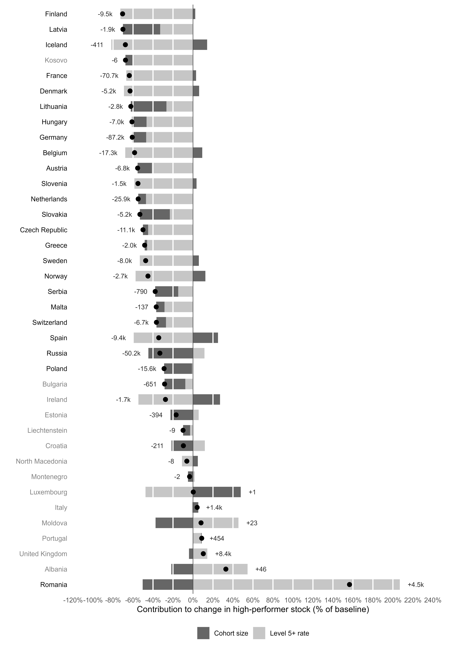
Figure S5.1. Two-way endpoint accounting of covered-cohort and Level 5+ rate contributions.
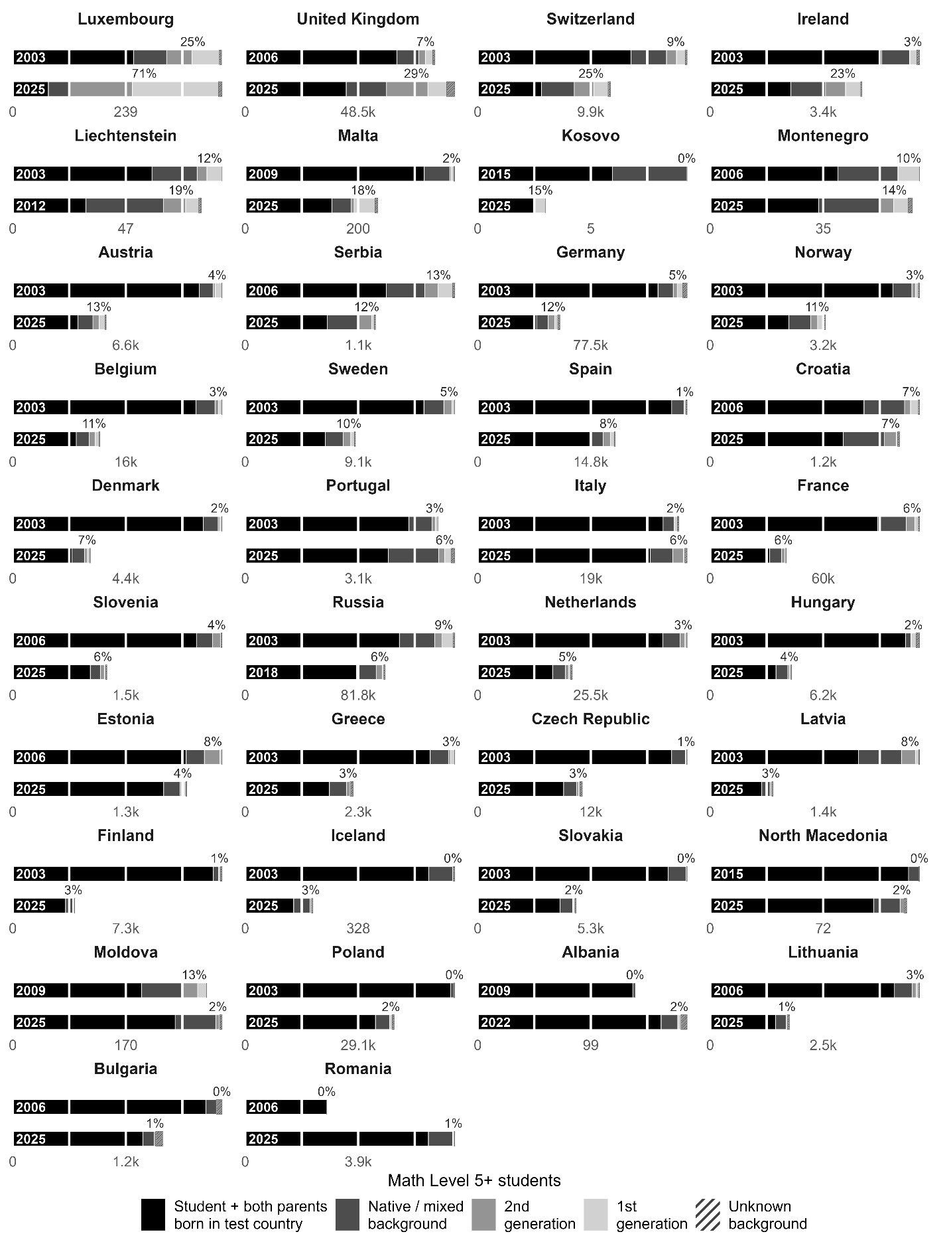
Figure S5.2. Migration-background composition of the absolute Level 5+ count.

