Supplemental information:

Title: Neural underpinning of Japanese particle processing in non-native speakers

Supplemental information:
Supplementary Method and Result
Supplementary Table S1. Demographic data for non-native learner.
Supplementary Table S2. Demographic data for native speaker.
Supplementary Table S3. Stimulus sentence.
Supplementary Table S4. Stimulus sentence translated in English.
Supplementary Table S5: Results of linear mixed effects modeling on RT and error rate
Supplementary Figure S1: Behavioral result (log1p RT)
Supplementary Figure S2: Regions associated with grammar processing (modelled all trials including error trials)

Supplementary Method and Result
ANOVA on RT and error rate
Two-way analysis of variance (ANOVA; 2 levels of Groups × 2 levels of Conditions) of the log transformed RT revealed a significant main effect of Groups (F(1,42)= 9.0610, p = 0.0044), a significant main effect of Conditions (F(1,42)= 49.3693, p < 0.0001), and a significant interaction (F(1,42)= 51.2092, p < 0.0001). Post hoc pairwise comparisons confirmed that Native participants were significantly faster at Grammar condition than Non-native participants (p < 0.0001), but no significant difference at Letter condition (p = 0.5967). Also, Non-native participants were significantly slower reaction at Grammar condition then Letter condition (p < 0.0001), but not in Native group (p= 0.8882). In addition to the Figure 2A which shown the result with row value, we added the figure of log transformed RT in supplemental file (Figure S1).
Two-way ANOVA of the error rate revealed a significant main effect of Groups (F(1,42)= 91.7194, p < 0.0001), a significant main effect of Conditions (F(1,42)= 151.1731, p < 0.0001), and a significant interaction (F(1,42)= 82.1094, p < 0.0001). Post hoc pairwise comparisons confirmed that Native participants are significantly accurate at Grammar condition than Non-native participants (p < 0.0001), but no significant difference at Letter condition (p = 0.2333). Furthermore, both Native and Non-native participants were significantly less accurate at Grammar condition then Letter condition (p < 0.0001).

Supplementary Table S1. Demographic data for non-native learner.
ID | Sex | Age | M-Test  (*1) | Academic background  (*2) | First  language | Starting age of Japanese learning | Length of Japanese learning (year)  (*3) | Length of stay in Japan (year)
F_01 | m | 28 | 45 | 2 | Swedish | 20 | 8 | 2.24
F_02 | m | 27 | 38 | 2 | Chinese | 18 | 4 | 3.5
F_03 | f | 25 | 36 | 2 | Chinese | 19 | 4 | 0.08
F_04 | f | 28 | 46 | 1 | Chinese | 22 | 2.48 | 5.48
F_05 | f | 23 | 42 | 1 | Chinese | 18 | 5 | 0.48
F_06 | f | 24 | 41 | 1 | Chinese | 19 | 4 | 0.48
F_07 | m | 29 | 42 | 2 | Chinese | 26 | 3 | 3
F_08 | m | 24 | 30 | 2 | Chinese | 24 | 2 | 0.48
F_09 | f | 29 | 32 | 2 | Chinese | 25 | 2.48 | 5
F_10 | f | 27 | 35 | 2 | Chinese | 21 | 6 | 3.48
F_11 | m | 34 | 44 | 2 | Mongolian | 22 | 5 | 12
F_12 | m | 28 | 37 | 2 | Mongolian | 21 | 7 | 7
F_13 | f | 35 | 31 | 2 | Mongolian | 25 | 3 | 10
F_14 | f | 28 | 46 | 2 | Mongolian | 21 | 7 | 7
F_15 | f | 40 | 39 | 2 | Mongolian | 24 | 16 | 15
F_16 | m | 26 | 39 | 1 | Chinese | 24 | 2 | 1.56
F_17 | f | 24 | 41 | 1 | Korean | 15 | 5 | 1
F_18 | f | 21 | 45 | 1 | Chinese | 18 | 3 | 3
F_19 | f | 19 | 43 | 1 | Chinese | 15 | 4 | 2
F_20 | f | 26 | 35 | 1 | Chinese | 25 | 1 | 0.48
F_21 | m | 23 | 44 | 1 | Chinese | 19 | 2 | 2.32
F_22 | f | 21 | 41 | 1 | Malay | 19 | 2.48 | 3.48
F_23 | m | 44 | 25 | 1 | Swedish | 19 | 8 | 5
*1: Minimal Test (M-Test), full score = 46 points
*2: Academic background, 0 = not certain, 1 = Bachelor, 2 = Master of Arts or Science, 3 = Doctor of Philosophy
*3: The participants learned Japanese in their home countries through school education and self-learning and continued their study in Japanese universities.

Supplementary Table S2. Demographic data for native speaker.
ID | Sex | Age | M-Test  (*1) | Academic background  (*2) | First language
J_01 | m | 21 | 44 | 1 | Japanese
J_02 | m | 22 | 45 | 1 | Japanese
J_03 | m | 21 | 46 | 1 | Japanese
J_04 | m | 25 | 46 | 2 | Japanese
J_05 | m | 21 | 43 | 1 | Japanese
J_06 | m | 20 | 46 | 1 | Japanese
J_07 | m | 36 | 46 | 3 | Japanese
J_08 | f | 39 | 44 | 3 | Japanese
J_09 | m | 21 | 45 | 1 | Japanese
J_10 | f | 19 | 45 | 1 | Japanese
J_11 | m | 21 | 45 | 1 | Japanese
J_12 | f | 18 | 45 | 1 | Japanese
J_13 | f | 18 | 46 | 1 | Japanese
J_14 | f | 21 | 46 | 1 | Japanese
J_15 | f | 21 | 46 | 1 | Japanese
J_16 | f | 20 | 46 | 1 | Japanese
J_17 | m | 21 | 43 | 1 | Japanese
J_18 | m | 32 | 43 | 3 | Japanese
J_19 | m | 24 | 46 | 1 | Japanese
J_20 | f | 26 | 41 | 1 | Japanese
J_21 | f | 28 | 42 | 1 | Japanese
J_22 | f | 26 | 46 | 1 | Japanese
J_23 | m | 24 | 46 | 2 | Japanese
J_24 | m | 28 | 46 | 0 | Japanese
J_25 | f | 19 | 45 | 1 | Japanese
*1: Minimal Japanese Test (full score = 46 points)
*2: Academic background, 0 = not certain, 1 = Bachelor, 2 = Master of Arts or Science, 3 = Doctor of Philosophy

Supplementary Table S3. Stimulus sentence.
 | the predicate | the subject | particles
1 | くれましたか | だれ | が
2 | くれました | ちち | が
3 | ふっています | あめ | が
4 | できましたよ | ごはん | が
5 | ついています | テレビ | が
6 | いいですか | どちら | が
7 | ながいです | あし | が
8 | いたいです | あたま | が
9 | おおいですね | くるま | が
10 | たかいです | くるま | は
11 | さむかったですね | きのう | は
12 | あつかったですか | ロンドン | は
13 | いいです | あたま | が/は
14 | すてきですね | デザイン | が/は
15 | たのしみです | たべるの | が/は
16 | どちらですか | おたく | は
17 | どちらですか | たなかさん | は
18 | なんですか | あれ | は
19 | いくらですか | これ | は
20 | どこのですか | そのカメラ | は
21 | いかがでしたか | パリ | は
22 | いかがですか | コーヒー | は
23 | いけませんか | たべて | は
24 | ありがとう | せんじつ | は
25 | ははです | わたし | の/は/が
26 | カメラです | ちち | の
27 | ほんです | りょうり | の
28 | すきですか | どんなひと | が
29 | すきです | バナナ | が/は
30 | すきですか | どれ | が
31 | ほしいです | デジカメ | が
32 | ほしいです | くるま | が
33 | みせてください | メニュー | を
34 | かいましたか | なに | を
35 | つけてください | テレビ | を
36 | つれていきます | こども | を
37 | ください | こうちゃ | を
38 | たべませんか | ケーキ | を
39 | かざりましょう | しゃしん | を
40 | あけてください | ドア | を
41 | つけてください | テレビ | を
42 | あるきます | みち | を
43 | あるきましょう | みぎがわ | を
44 | あげました | いもうと | に
45 | のせてあげました | くるま | に
46 | もらいました | ともだち | に
47 | いきましたか | なんがつ | に
48 | しましたか | なんようび | に
49 | いきました | すいようび | に
50 | かいました | かようび | に
51 | たべます | たま | に
52 | はじまります | ９じ | に
53 | もどります | ひるまで | に
54 | すんでいます | パリ | に
55 | つとめています | かいしゃ | に
56 | すんでいます | ここ | に
57 | とまっています | ホテル | に
58 | かいました | パリ | で
59 | たべたいです | ホテル | で
60 | ねています | へや | で
61 | かいましたか | どこ | で
62 | およぎます | プール | で
63 | たべます | うち | で
64 | たべます | うち | で
65 | たべます | へや | で
66 | たべましょう | レストラン | で
67 | たべます | はし | で
68 | きました | バス | で
69 | いきました | バス | で
70 | いくらですか | ぜんぶ | で
71 | おなじです | あべさん | と/に
72 | あそびにきます | ともだち | と
73 | いきたいですか | だれ | と
74 | いきたいですか | だれ | と
75 | いきたいですね | どこ | か
76 | たべたいですね | なに | か
77 | たべましょうか | なに | か
78 | ありません | いちど | も
79 | やさしいです | しんせつ | で
80 | やすいです | おいしく | て
81 | ひとですか | がんこ | な
82 | ところです | すてき | な
83 | ひとです | ゆうめい | な
84 | さむくありません | そんな | に
85 | よくありません | そんな | に
86 | よくないです | そんな | に
87 | あらいましょう | きれい | に
88 | なりました | べんり | に
89 | なりました | あたたか | く
90 | なりました | いくこと | に

Supplementary Table S4. Stimulus sentence translated in English.
 | the predicate | the subject | case-particle | intended meaning
1 | gave (it) | who | ga | Who gave (it to you)?
2 | gave (it) | my father | ga | My father gave (it to me).
3 | falling | rain | ga | It is raining.
4 | be ready | meal | ga | The meal is ready.
5 | be on | TV | ga | The TV set is on.
6 | do (you) prefer | which | ga | Which do you prefer?
7 | be long | legs | ga | You have long legs.
8 | hurt | head | ga | I have a headache.
9 | (there are) many | cars | ga | There are many cars.
10 | be expensive | cars | wa | Cars are expensive.
11 | was cold | yesterday | wa | It was cold yesterday.
12 | was hot | (in) London | wa | Was it hot in London?
13 | be good | head | ga/wa | (S/he) is smart.
14 | be nice | the design | ga/wa | The design is nice.
15 | be looking forward to | eating | ga/wa | (I ) am looking forward to eating (it).
16 | where | your house | wa | Where is your house?
17 | which is | Ms./Mr. Tanaka | wa | Which is Ms./Mr. Tanaka?
18 | what is | that | wa | What is that?
19 | how much is | this | wa | How much is this?
20 | which make is | the camera | wa | Which make is the camera?
21 | how was | Paris | wa | How was Paris?
22 | what about | coffee | wa | How about coffee?
23 | be not good | eat | wa | Isn't it good to eat?
24 | thank you | the other day | wa | Thank you for the other day.
25 | be (someone's) mother | my | no/wa/ga | (This) is my mother.
26 | be a camera | father | no | (This) is my father's camera.
27 | be a book | cookery | no | (This) is a cook book.
28 | do (you) like | what person | ga | What persons do you like?
29 | like | banana | ga/wa | (I) like bananas.
30 | do (you) like | which | ga | Which do (you) like?
31 | want | a degital camera | ga | (I) want a degital camera.
32 | want | a car | ga | (I) want a car.
33 | show (me) | the menu | o | Please show (me) the menu.
34 | bought | what | o | What did (you) buy?
35 | turn on | TV | o | Please turn on the TV.
36 | will take | children | o | (I) will take (my) children.
37 | give (me) | tea | o | Please give (me) some tea.
38 | shall (we) eat | cake | o | Shall (we) eat cake?
39 | let's decorate | a photo | o | Let's put photos (somewhere).
40 | please open | the door | o | Please open the door.
41 | turn on | TV | o | Please turn on the TV.
42 | walk | road | o | (We) walk on the road.
43 | let's walk | the right side | o | Let's walk on the right side.
44 | gave | sister | ni | (I) gave (it) to my sister.
45 | gave a lift | car | ni | (I) gave a lift (to someone).
46 | received | friend | ni | (I) received (something) from my friend.
47 | did (you) go | what month | ni | What month did (you) go?
48 | did (you) do | which day of the week | ni | Which day of the week did (you) do (it)?
49 | went | Wednesday | ni | (I) went (there) on Wednesday.
50 | bought | Tuesday | ni | (I) bought (it) on Tuesday.
51 | eat | sometimes | ni | (I) sometimes eat (it).
52 | (it) starts | nine o'clock | ni | (It) starts at nine o'clock.
53 | will return | till noon | ni | (I) will return till noon.
54 | live | Paris | ni | (I) live in Paris.
55 | work | a company | ni | (I) am working for a company.
56 | live | here | ni | (I) live here.
57 | (be) staying | a hotel | ni | (I) am staying at (this) hotel.
58 | bought | Paris | de | (I) bought (it) in Paris.
59 | want to eat | a hotel | de | (I) want to eat (It) at the hotel.
60 | be sleeping | a room | de | (I) am sleeping in the room.
61 | did (you) buy | where | de | Where did (you) buy (it)?
62 | Swim | a swimming pool | de | (I) swim in the swimming pool.
63 | Eat | home | de | (I) eat at home.
64 | Eat | home | de | (I) eat at home.
65 | Eat | room | de | (I) eat in the room.
66 | let's eat | restaurant | de | Let's eat at the restaurant.
67 | Eat | chopsticks | de | (I) eat with chopsticks.
68 | Came | bus | de | (I) came (here) by bus.
69 | Went | bus | de | (I) went (there) by bus.
70 | how much | all | de | How much is the total?
71 | the same | Ms./Mr. Abe | to/ni | (I have) the same (idea) with Ms./Mr. Abe
72 | come to play | friend | to | (I) come (here) with my friends to play.
73 | do (you) want to go | who | to | Who do (you) want to go with?
74 | do (you) want to go | where | to | Who do (you) want to go with?
75 | want to go | somewhere | ka | (I) want to go somewhere.
76 | want to eat | something | ka | (I) want to eat something.
77 | shall we eat | something | ka | Shall (we) eat something?
78 | have not (done) | never | mo | (I) have never (done it before).
79 | be gentle | kind | de | (That person) is kind and gentle.
80 | be cheap | delicious | te | (That) is delicious and cheap.
81 | be person | stubborn | na | Is (s/he) a stubborn person?
82 | be a place | nice | na | (This) is a nice place.
83 | be a person | famous | na | (S/he) is a famous person.
84 | be not cold | that | ni | (It) is not that cold.
85 | be not good | that | ni | (It) is not that good.
86 | be not good | that | ni | (It) is not that good.
87 | let's wash | clean | ni | Let's wash (it) clean.
88 | became | convenient | ni | (It) became convenient.
89 | became | warm | ku | (It) became warm.
90 | came to | go | ni | (I) have come to go (there).

Supplementary Table S5: Results of linear mixed effects modeling on RT and error rate

Supplementary Figure S1: Behavioral result (log1p RT)

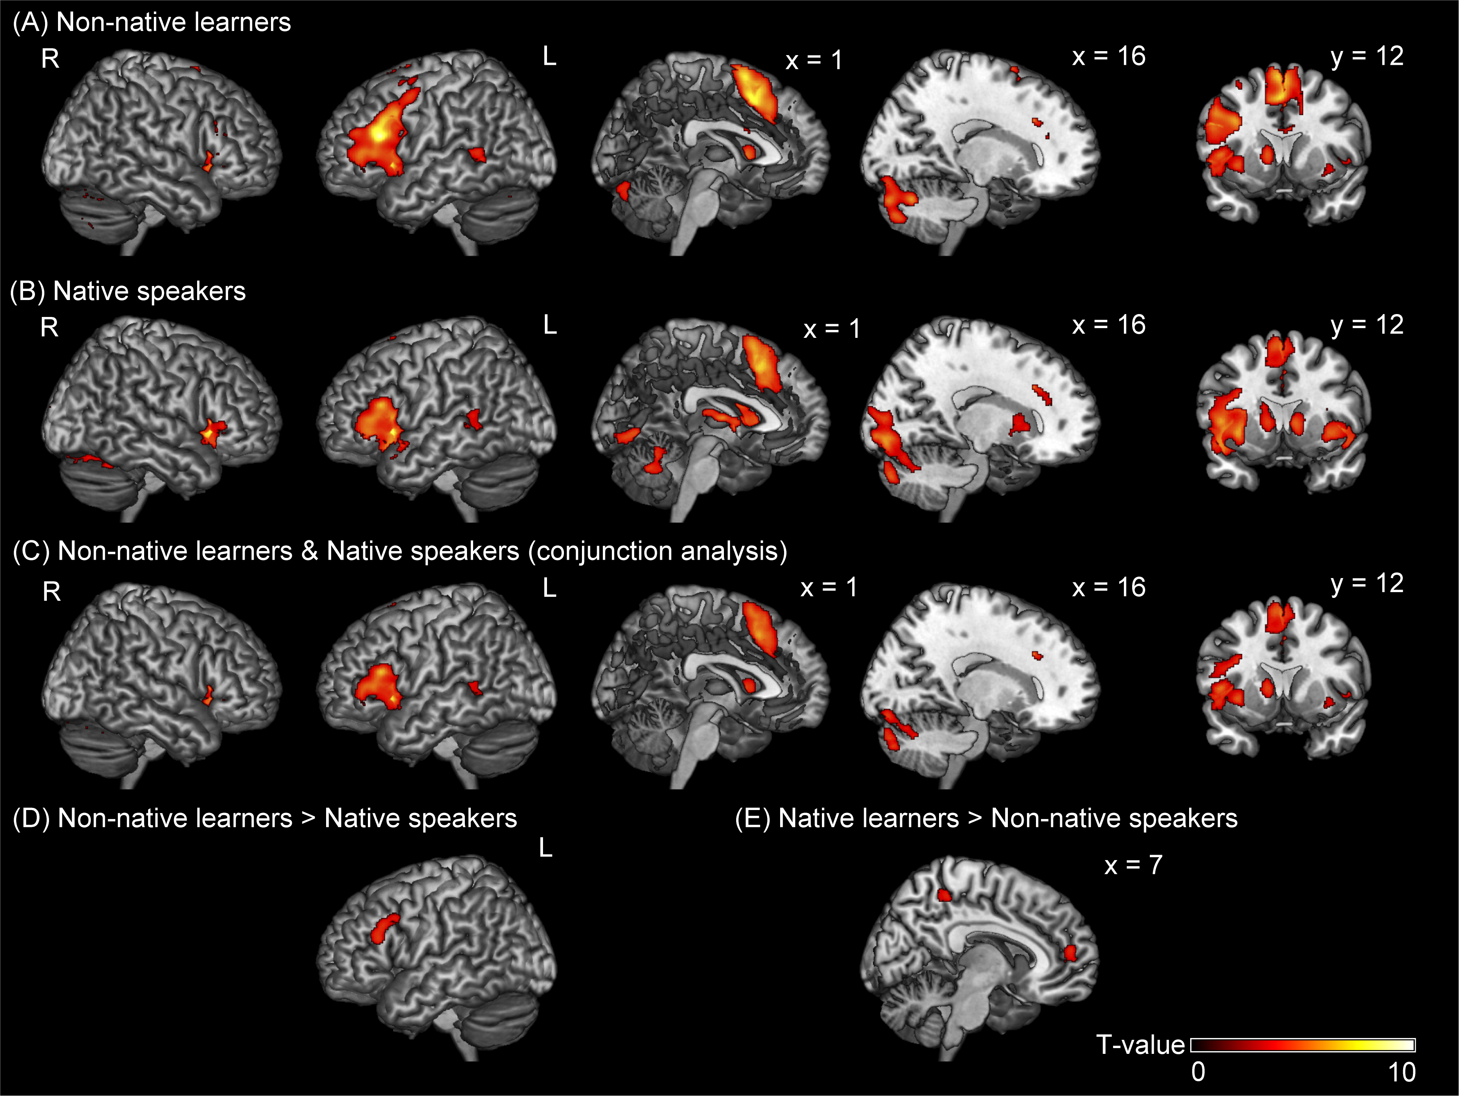
Supplementary Figure S2: Regions associated with grammar processing (modelled all trials including error trials)

