Supplementary Material

Emergence of within-host SARS-CoV-2 recombinant genome after coinfection by Gamma and Delta variants

Ronaldo da Silva Francisco Junior¹, Luiz G P de Almeida¹, Alessandra P Lamarca¹, Liliane Cavalcante¹, Yasmmin Martins¹, Alexandra L Gerber¹, Ana Paula de C Guimarães¹, Ricardo Barbosa Salviano², Fernanda Leitão dos Santos², Thiago Henrique de Oliveira², Isabelle Vasconcellos de Souza³, Erika Martins de Carvalho³, Mario Sergio Ribeiro⁴, Silvia Carvalho⁴, Flávio Dias da Silva⁵, Marcio Henrique de Oliveira Garcia⁵, Leandro Magalhães de Souza⁶, Cristiane Gomes Da Silva⁶, Caio Luiz Pereira Ribeiro⁵, Andréa Cony Cavalcanti⁶, Claudia Maria Braga de Mello⁴, Amilcar Tanuri², Ana Tereza R Vasconcelos¹*
*Corresponding author: atrv@lncc.br
¹ Laboratório de Bioinformática, Laboratório Nacional de Computação Científica, Petrópolis, Brazil.
² Departamento de Genética, Instituto de Biologia, Universidade Federal do Rio de Janeiro, Rio de Janeiro, Brazil.
³ Unidades de Apoio ao Diagnóstico da Covid-19, Rio de Janeiro, Brazil.
⁴ Secretaria Estadual de Saúde do Rio de Janeiro, Rio de Janeiro, Brazil.
⁵ Secretaria Municipal de Saúde Rio de Janeiro, Rio de Janeiro, Brazil
⁶ Laboratório Central de Saúde Pública Noel Nutels, Rio de Janeiro, Brazil.

Supplementary Methods

Sample collection, RNA extraction, and sequencing
The nasopharyngeal swab for SARS-CoV-2 RT-PCR test was collected and referred to the Noel Nutels Central Laboratory (LACEN-RJ). The viral RNA was extracted at the Molecular Virology Laboratory (LVM-UFRJ) with MagMAX Viral / Pathogen Nucleic Acid Isolation kit and KingFisher automatic platform. Annealing of cDNA was conducted with 8,5 µl of the viral RNA extracted. Next-generation sequencing steps including library preparation were performed at the DFA/LNCC Genomics Unit with Illumina COVIDSeq Test (Illumina), according to the manufacturer’s protocol. Purification was then conducted using 5 µl of each library combined, and the TapeStation (Agilent) system was used for quality control. NextSeq 500/550 Mid Output Kit v2.5 (300 Cycles) was used to generate reads of 2x149 bp in the NextSeq (Illumina). The study was approved by the Ethics Committee (30161620.0.1001.5257 and 34025020.0.0000.5257).

Bioinformatic analysis
Initially, adapter sequences generated next-generation sequencing were removed using cutadapt (v.3.0)¹. We then performed the short read mapping to the SARS-CoV-2 reference genome (NC_045512.2) using bowtie2 (v.2.2.1)² and bwa (v.0.7.12-r1039)³. The post-processing steps and variant calling were performed independently for each output file. SAM format files were converted to BAM and sorted using samtools (v.1.11)⁴. Next, duplicate reads were marked and removed using MarkDuplicates from Picard (v2; https://broadinstitute.github.io/picard/). We performed the variant calling using HaplotypeCaller from GATK (v.4.1.7.0)⁵ and LoFreq (v2.1.5)⁶. Next, iSNVs identified were annotated with snpEff/SnpSift (v5.0e)⁷. Coinfection events were detected with a hypergeometric distribution approach described by Zhou et al., 2021, and later confirmed by RegressHaplo⁸. We retrieved the mosaic reads covering the genomic windows selected using sam2tsv ⁹. IGV (v.2.9.4) was used to visualize the mapping in the target regions. Finally, consensus sequences were classified according to the Pango Lineage classification using the PangoLEARN model database (v3.5.3).

Supplementary Information

During a routine analysis for coinfection events across the 5,073 SARS-CoV-2 genomes from Corona-ômica-RJ project data (http://www.corona-omica.rj.lncc.br/#/), we were able to identify the coinfection between Gamma and Delta. Since the first reports of patients coinfected by two genetically-distinct lineages of SARS-CoV-2^{10–16}, the scientific community raised concerns about the recombination of intra-host viral RNA sequences as a possible mechanism underlying the emergence of novel variants. Indeed, this phenomenon occurs at a relatively high frequency among betacoronaviruses^{17–19}.

The recombination in our sample was detected during the first reports of Delta in the city of Santo Antônio de Pádua and an ongoing replacement of the variant Gamma by the Delta in the state of Rio de Janeiro. Nevertheless, genomic surveillance data from the state of Rio de Janeiro indicated a frequency of 47% of sequences from Delta and 37% from Gamma²⁰ in July 2021. Thus, the epidemiological, geographic, and genomic data provide a conducive scenario to SARS-CoV-2 recombination. Furthermore, the relative quantification of the viral load (RQVL = 2^{-∆CT}) exhibited elevated values, with an RT-PCR cycle threshold (Ct) of 16.70. This value corresponds to the top 3% of samples with the highest viral load from Gamma variants in our database (n = 1881).

From the six regions selected in our analysis, four overlapped the spike gene and two the nucleocapsid gene. All recombinant haplotypes were found at a low frequency compared to the reads supporting the sequences from each VOC (Table 1). Region I is located at the 5’ region of the spike gene and includes three lineage-defining mutations from Gamma (S: L18F, T20N, and P26S) and one from Delta (S: T19R; Figure S1). We identified two regions (II and III; Figure S2-S3) overlapping the receptor-binding domain (RBD). Region II included two amino acid residue alterations from Delta (S: L452R, T478K) and one from Gamma (S: E484K; Figure S2). The T478K and E484K mutations were also present in Region III (Figure S3), which harbored a second alteration from Gamma (S: N501Y). This region was the only window where three different recombinant haplotypes were observed (Table 1; Figure S3). The last region (IV) in the spike includes only one mutation from Gamma (S: H655Y) and one from Delta (S: 681R; Figure S4). At the 5’ portion of the nucleocapsid gene, we selected a window (region V; Figure S5) containing a single mutation from Delta (N: D63G) and from Gamma (N: P80R). Finally, the largest region selected (VI) was also mapped in N and included four mutations from Gamma (N: S202C, S202T, R203K, G204R) and two from Delta (R203M, G215C; Figure S6).

Homologous recombination in positive-sense RNA viruses is mainly driven by a copy-choice replication mechanism with a switch from an RNA template by the RNA-polymerase complex during replication ^{21,22}. Thus, the recombinant haplotypes found across the different regions selected can represent multiple events of switches occurring within a cell or a few switches from RNA templates simultaneously occurring at multiple cells. One alternative speculation about the presence of mosaic reads in our sample is that the sequences could be generated by reverse mutational processes, that rescue the ancestral state of the Wuhan reference sequence in each haplotype. Nevertheless, to consider an elevated number of reverse mutations happening at the same time in a coinfected sample would exceed the rate of intra-host evolution previously observed^{13,23}. Even if this high rate would be accepted as real, it is unlikely that these mutations would occur only in the “reverse direction” instead of generating a myriad of new substitutions.

Supplementary Figures

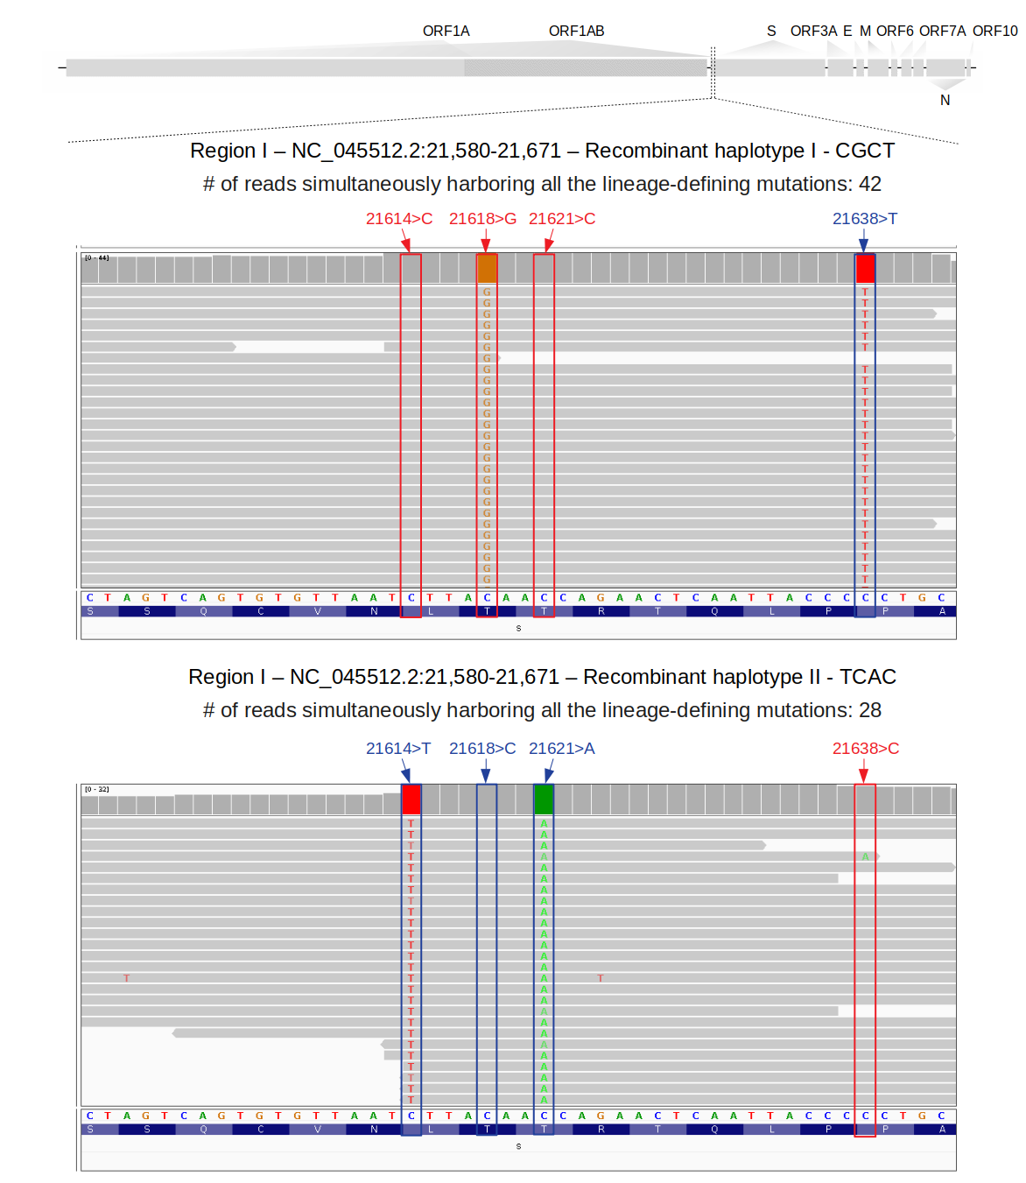
Figure S1. Visualization of sequenced reads covering recombinant haplotypes found in region I. Screenshot of some mosaic reads found in region I as proof of within-host recombination. Blue and red rectangles represent lineage-defining sites where an alternative allele characteristic of Gamma and Delta variants was found, respectively.
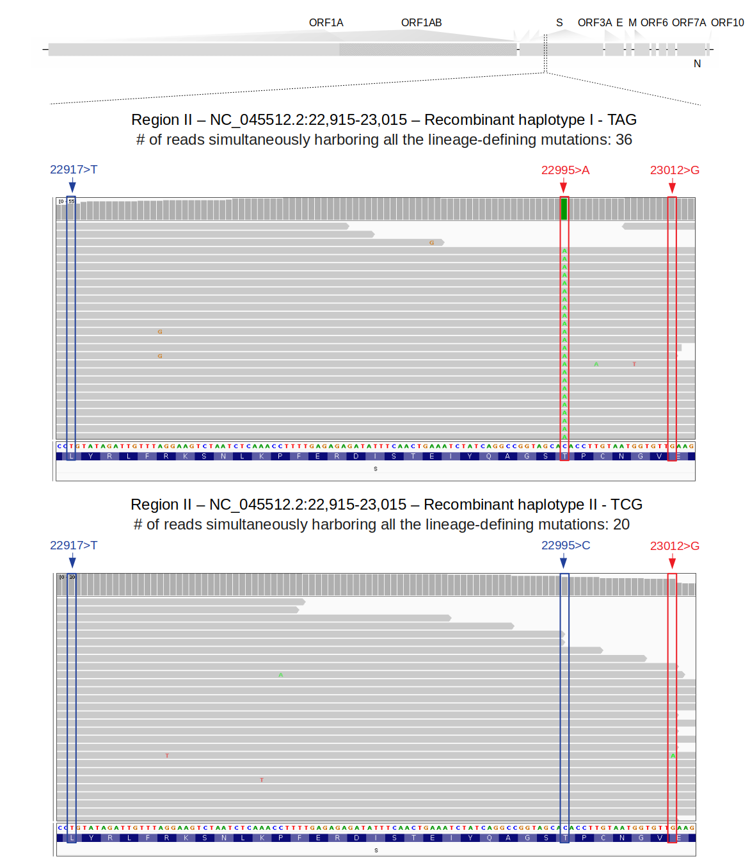
Figure S2. Visualization of sequenced reads covering recombinant haplotypes found in region II. Screenshot of some mosaic reads found in region II as proof of within-host recombination. Blue and red rectangles represent lineage-defining sites where an alternative allele characteristic of Gamma and Delta variants was found, respectively.

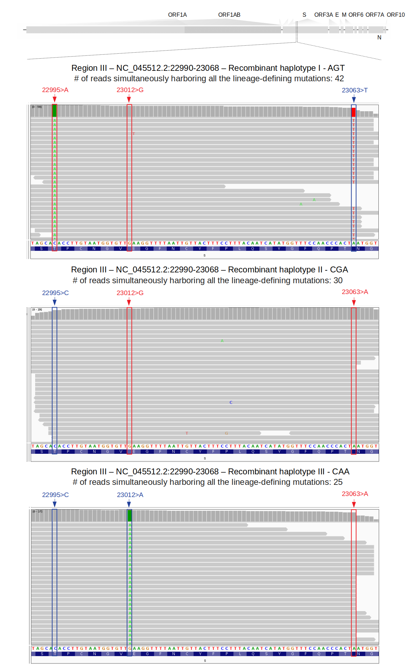
Figure S3. Visualization of sequenced reads covering recombinant haplotypes found in region III. Screenshot of some mosaic reads found in region III as proof of within-host recombination. Blue and red rectangles represent lineage-defining sites where an alternative allele characteristic of Gamma and Delta variants was found, respectively.
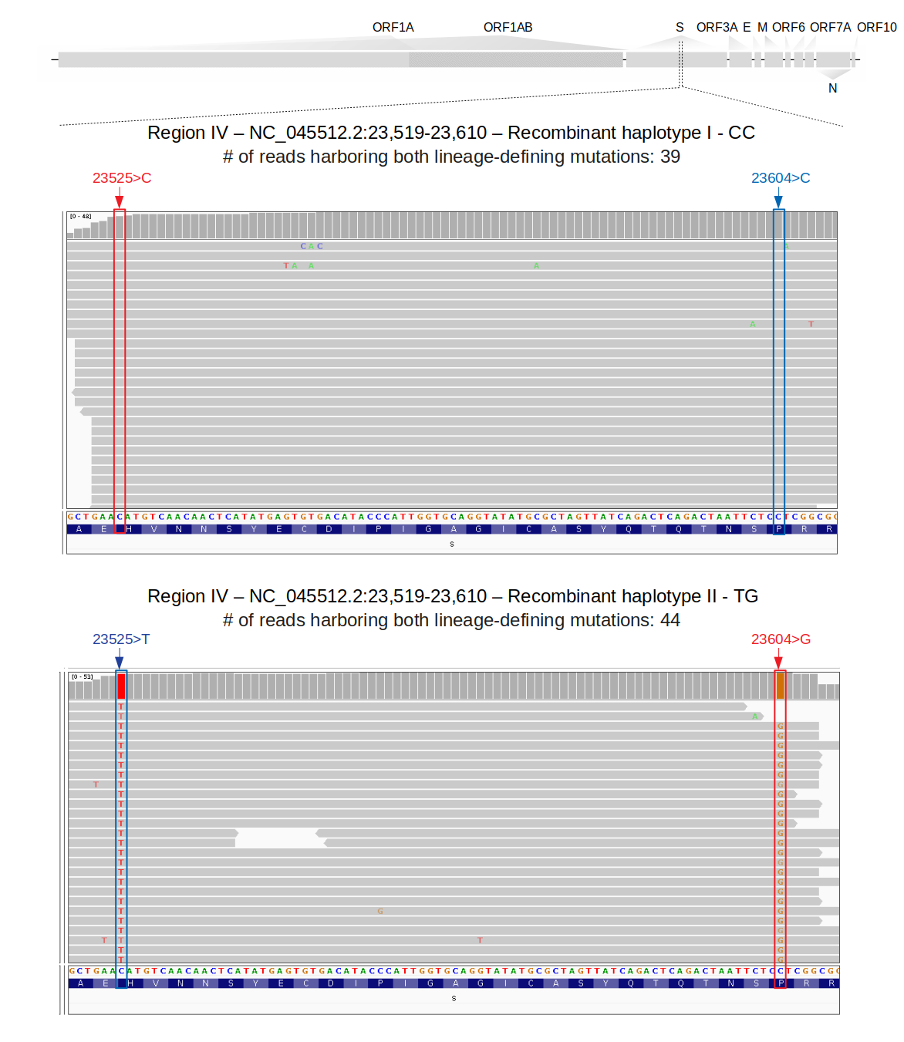
Figure S4. Visualization of sequenced reads covering recombinant haplotypes found in region IV. Screenshot of some mosaic reads found in region IV as proof of within-host recombination. Blue and red rectangles represent lineage-defining sites where an alternative allele characteristic of Gamma and Delta variants was found, respectively.

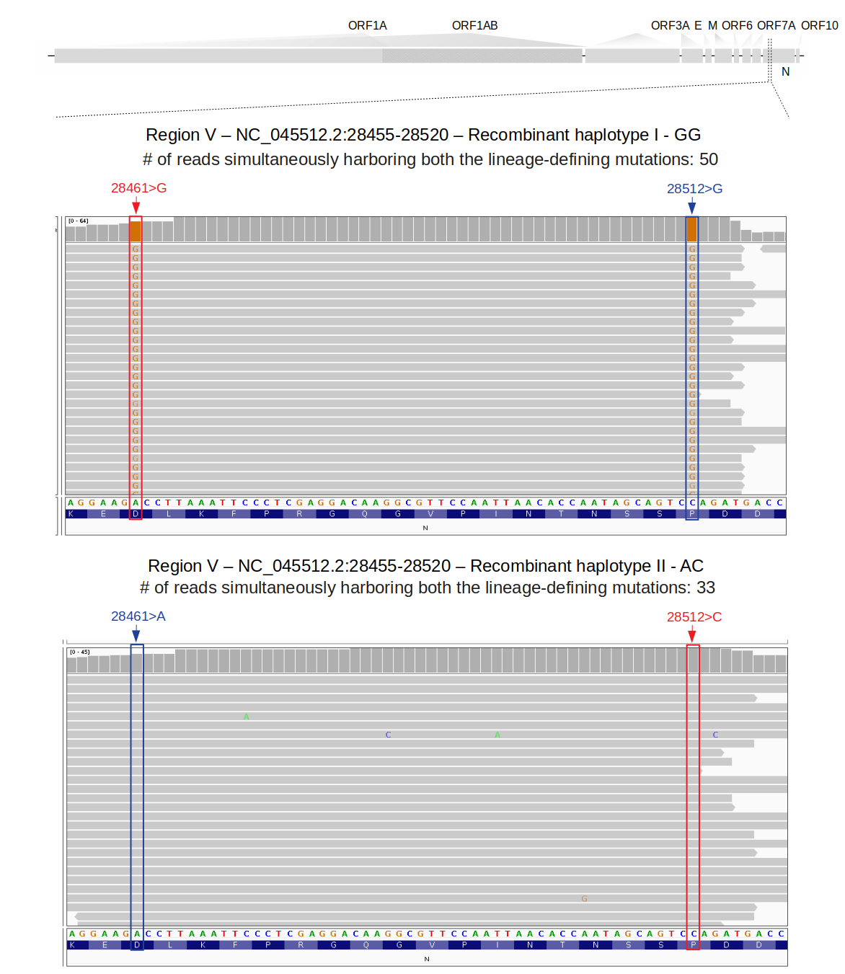
Figure S5. Visualization of sequenced reads covering recombinant haplotypes found in region V. Screenshot of some mosaic reads found in region V as proof of within-host recombination. Blue and red rectangles represent lineage-defining sites where an alternative allele characteristic of Gamma and Delta variants was found, respectively.

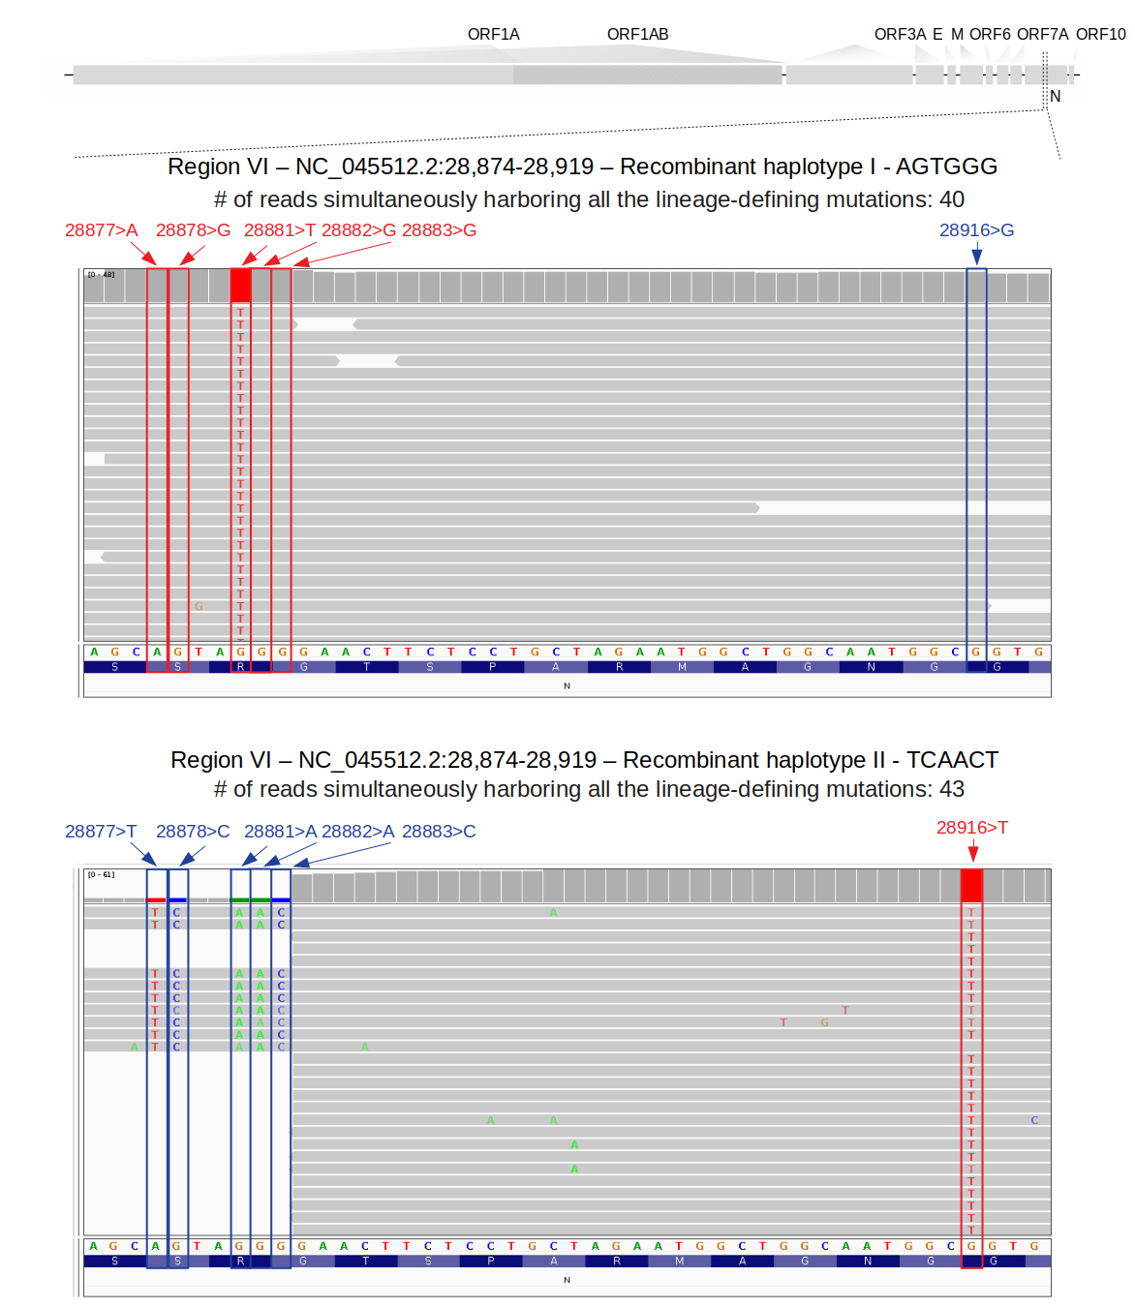
Figure S6. Visualization of sequenced reads covering recombinant haplotypes found in region VI. Screenshot of some mosaic reads found in region VI as proof of within-host recombination. Blue and red rectangles represent lineage-defining sites where an alternative allele characteristic of Gamma and Delta variants was found, respectively. Despite the limited number of reads shown, more fragments were found in each region.
References
1 Martin M. Cutadapt removes adapter sequences from high-throughput sequencing reads. EMBnet J 2011; 17: 10.
2 Langmead B, Salzberg SL. Fast gapped-read alignment with Bowtie 2. Nat Methods 2012; 9: 357–9.
3 Li H, Durbin R. Fast and accurate short read alignment with Burrows-Wheeler transform. Bioinformatics 2009; 25: 1754–60.
4 Li H, Handsaker B, Wysoker A, et al. The Sequence Alignment/Map format and SAMtools. Bioinformatics. 2009; 25: 2078–9.
5 DePristo MA, Banks E, Poplin R, et al. A framework for variation discovery and genotyping using next-generation DNA sequencing data. Nature Genetics. 2011; 43: 491–8.
6 Wilm A, Aw PPK, Bertrand D, et al. LoFreq: a sequence-quality aware, ultra-sensitive variant caller for uncovering cell-population heterogeneity from high-throughput sequencing datasets. Nucleic Acids Research. 2012; 40: 11189–201.
7 Cingolani P, Platts A, Wang LL, et al. A program for annotating and predicting the effects of single nucleotide polymorphisms, SnpEff. Fly. 2012; 6: 80–92.
8 Leviyang S, Griva I, Ita S, Johnson WE. A penalized regression approach to haplotype reconstruction of viral populations arising in early HIV/SIV infection. Bioinformatics 2017; 33: 2455–63.
9 Lindenbaum P. JVarkit: java-based utilities for Bioinformatics. 2015; published online May 26. DOI:10.6084/m9.figshare.1425030.v1.
10 Samoilov AE, Kaptelova VV, Bukharina AY, et al. Case report: change of dominant strain during dual SARS-CoV-2 infection. BMC Infect Dis 2021; 21: 959.
11 Hashim HO, Mohammed MK, Mousa MJ, et al. Unexpected Co-infection with Different Strains of SARS-CoV-2 in Patients with COVID-19. DOI:10.20944/preprints202009.0375.v1.
12 Tonkin-Hill G, Martincorena I, Amato R, et al. Patterns of within-host genetic diversity in SARS-CoV-2. Elife 2021; 10. DOI:10.7554/eLife.66857.
13 Lythgoe KA, Hall M, Ferretti L, et al. SARS-CoV-2 within-host diversity and transmission. Science 2021; 372. DOI:10.1126/science.abg0821.
14 Dezordi FZ, Resende PC, Naveca FG, et al. Unusual SARS-CoV-2 intra-host diversity reveals lineages superinfection. medRxiv 2021; : 2021.09.18.21263755.
15 Zhou H-Y, Cheng Y-X, Xu L, et al. Genomic evidence for divergent co-infections of SARS-CoV-2 lineages. bioRxiv. 2021; : 2021.09.03.458951.
16 Francisco R da S Jr, Benites LF, Lamarca AP, et al. Pervasive transmission of E484K and emergence of VUI-NP13L with evidence of SARS-CoV-2 co-infection events by two different lineages in Rio Grande do Sul, Brazil. Virus Res 2021; 296: 198345.
17 Keck JG, Matsushima GK, Makino S, et al. In vivo RNA-RNA recombination of coronavirus in mouse brain. Journal of Virology. 1988; 62: 1810–3.
18 Dudas G, Rambaut A. MERS-CoV recombination: implications about the reservoir and potential for adaptation. Virus Evol 2016; 2: vev023.
19 Hon C-C, Lam T-Y, Shi Z-L, et al. Evidence of the Recombinant Origin of a Bat Severe Acute Respiratory Syndrome (SARS)-Like Coronavirus and Its Implications on the Direct Ancestor of SARS Coronavirus. Journal of Virology. 2008; 82: 1819–26.
20 Francisco Junior R da S, Lamarca AP, de Almeida LGP, et al. Turnover of SARS-CoV-2 Lineages Shaped the Pandemic and Enabled the Emergence of New Variants in the State of Rio de Janeiro, Brazil. Viruses 2021; 13: 2013.
21 Cooper PD, Steiner-Pryor A, Scotti PD, Delong D. On the Nature of Poliovirus Genetic Recombinants. Journal of General Virology. 1974; 23: 41–9.
22 Worobey M, Holmes EC. Evolutionary aspects of recombination in RNA viruses. J Gen Virol 1999; 80 ( Pt 10): 2535–43.
23 Voloch CM, da Silva Francisco R Jr, de Almeida LGP, et al. Intra-host evolution during SARS-CoV-2 prolonged infection. Virus Evol 2021; 7: veab078.

