Supplements

MRSinMRS table¹:

MRSinMRS | Values
Field strength [T] | 6.98
Manufacturer | Siemens
Model available) | MAGNETOM Terra.X
Software version (if available) | syngo MR XA60
nuclei | 1H
transmit/receive
number of channels | 32
type
body part | Brain
Additional hardware
Pulse sequence | semi-adiabatic spin-echo full-intensity-acquired localization (sSPECIAL)
Volume of Interest (VOI) locations : dmACC
AP Size | 20
LR Size | 20
CC Size | 25
Nominal VOI size [cm3, mm3] | 20 × 20 × 25 mm³
Repetition Time (TR) | 4.00
Echo Time (TE) [ms] | 16.00
If STEAM:, mixing time (TM)
2D of 3D
FOV in all directions
matrix size
acceleration factors
sampling method
Total number of Excitations or acquisitions per spectrum, In time series for kinetic studies: 128
Number of averaged spectra (NA) per time point | 2
spectral width in Hz | 8000
number of spectral points | 2048 per NA (4096)

Supplementary Methods

MRS data exclusions

On the basis of visual inspection of spectral quality, the analysis script excluded participants 2, 5, 9, 22 and 37 from glutamate analyses, and additionally participants 29, 33 and 35 from lactate analyses. Concentrations exceeding two within-participant standard deviations from the participant mean were omitted.

LCModel quantification and basis set
The basis file contained alanine (Ala), aspartate (Asp), phosphocholine (PCho), creatine (Cr), phosphocreatine (PCr), GABA, glutamine (Gln), glutamate (Glu), glutathione (GSH), glycine (Gly), myo-inositol (Ins), lactate (Lac), N-acetylaspartate (NAA), scyllo-inositol (Scyllo), taurine (Tau), ascorbate (Asc), glucose (Glc), N-acetylaspartylglutamate (NAAG), glycerophosphocholine (GPC), phosphoethanolamine (PE) and serine (Ser), together with a macromolecular component labelled Mac (ID: 7T_mac_KR75). The basis header specifies 4096 points, HZPPPM = 295.091003 and BADELT = 0.000166669997 s. The sequence identifier is SE; ECHOT and FWHMBA are set to −1 in the basis header. These header entries are reported as stored; the basis filename identifies the intended sSPECIAL acquisition at TE = 16 ms.
The control file specifies HZPPPM = 297.21, DELTAT = 0.000125 s, ECHOT = 16 ms and a fitting range of 0.20–4.20 ppm. Baseline knot spacing is specified by DKNTMN = 0.15. Water scaling is enabled (DOWS = T), with WCONC = 44444 and ATTH2O = 1; eddy-current correction within LCModel is disabled (DOECC = F), consistent with correction during preprocessing. Combined outputs include Glu+Gln, Cr+PCr, NAA+NAAG, GPC+PCho and Gly+Ins.

LCModel control file
The supplied control file is reproduced below with exact numerical precision retained for reproducibility. The licence KEY field is omitted. Average_1 filenames are the spectrum-specific input and output names in the supplied example.

$LCMODL
OWNER=''
TITLE= ''
FILBAS= '7T_sSPECIAL_TE16ms.BASIS'
FILRAW= 'Average_1.RAW'
FILH2O= 'Average_1.h2o'
FILPS= 'Average_1.ps'
FILCOO= 'Average_1.COORD'
FILPRI= 'Average_1.print'
FILTAB= 'Average_1.table'
LCOORD= 9
LPRINT= 6
LTABLE= 7
DELTAT= 0.000125
HZPPPM= 297.21
NUNFIL= 4096
PPMEND= 0.2
PPMST= 4.2
NEACH= 999
LPS= 8
NSIMUL= 0
ECHOT= 16
DKNTMN= 0.15
PPMSHF= 0
NUSE1= 4
CHUSE1(1)= 'NAA'
CHUSE1(2)= 'Cr'
CHUSE1(3)= 'Glu'
CHUSE1(4)= 'Ins'
NCOMBI= 5
CHCOMB(1)= 'Glu+Gln'
CHCOMB(2)= 'Cr+PCr'
CHCOMB(3)= 'NAA+NAAG'
CHCOMB(4)= 'GPC+PCho'
CHCOMB(5)= 'Gly+Ins'
VITRO = F
ATTH2O= 1
WCONC= 44444
DOECC = F
DOWS = T
FWHMBA = 0.0033646
RFWHM = 3.0
SHIFMN = -0.2,-0.1
SHIFMX = 0.3,0.3
$END

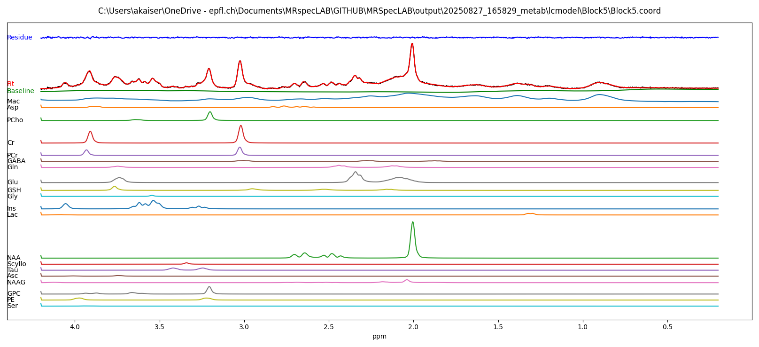
Exemplary spectral fit for one block of one participant.

Supplementary Table 1: Behavioral variables. Mean and confidence intervals, and statistics per behavioral variable.

Measure | Young (mean ± 95% CI) | Old (mean ± 95% CI) | Main effects | Interaction | Post hoc
RT (control) | 0.89 [0.88, 0.90] | 1.60 [1.58, 1.62] | Age:  F(1,30) = 75.97, p < 0.01 | Task × Age:  F(1,3587) = 474.95, p < 0.01 | Young < Old: t = −10.69, p < 0.01
RT (stim) | 1.37 [1.35, 1.38] | 1.80 [1.78, 1.82] | Task:  F(1,3587) = 2824.69, p < 0.01 | Task × Age:  F(1,3587) = 474.95, p < 0.01 | Young < Old: t = −6.67, p < 0.01
RT (stimulation − control) | 0.47 [0.46, 0.48] | 0.19 [0.17, 0.22] | — | — | Young: t = 81.16, p < 0.01;  Old: t = 17.67, p < 0.01
Accuracy (%) | 95.06 [92.14, 97.98] | 70.13 [48.21, 92.04] | Age: t(6.30) = 2.75, p = 0.03 | — | —

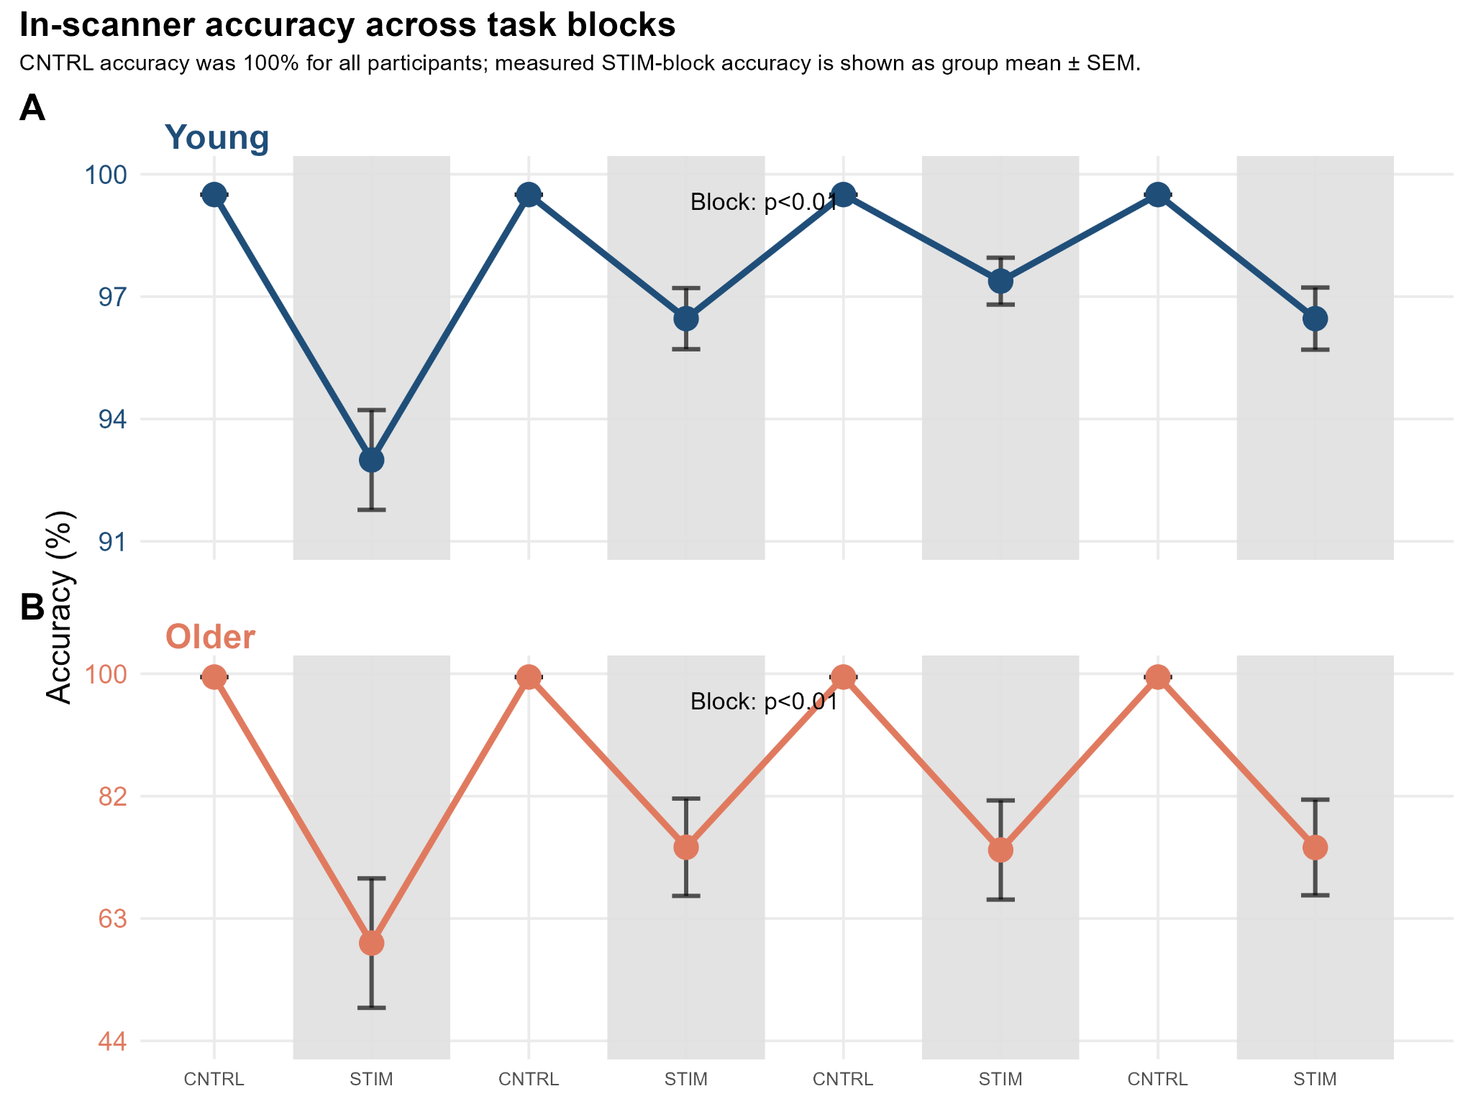
Supplementary Figure 1 | In-scanner accuracy across control and stimulation blocks. Accuracy is shown separately for younger and older participants across eight alternating 128-s blocks. Points and error bars show means ± SEM; shaded periods indicate stimulation. CNTRL accuracy was 100% for all participants. STIM accuracy was calculated from verified verbal responses.

Supplementary Results: Metabolite–behavior associations

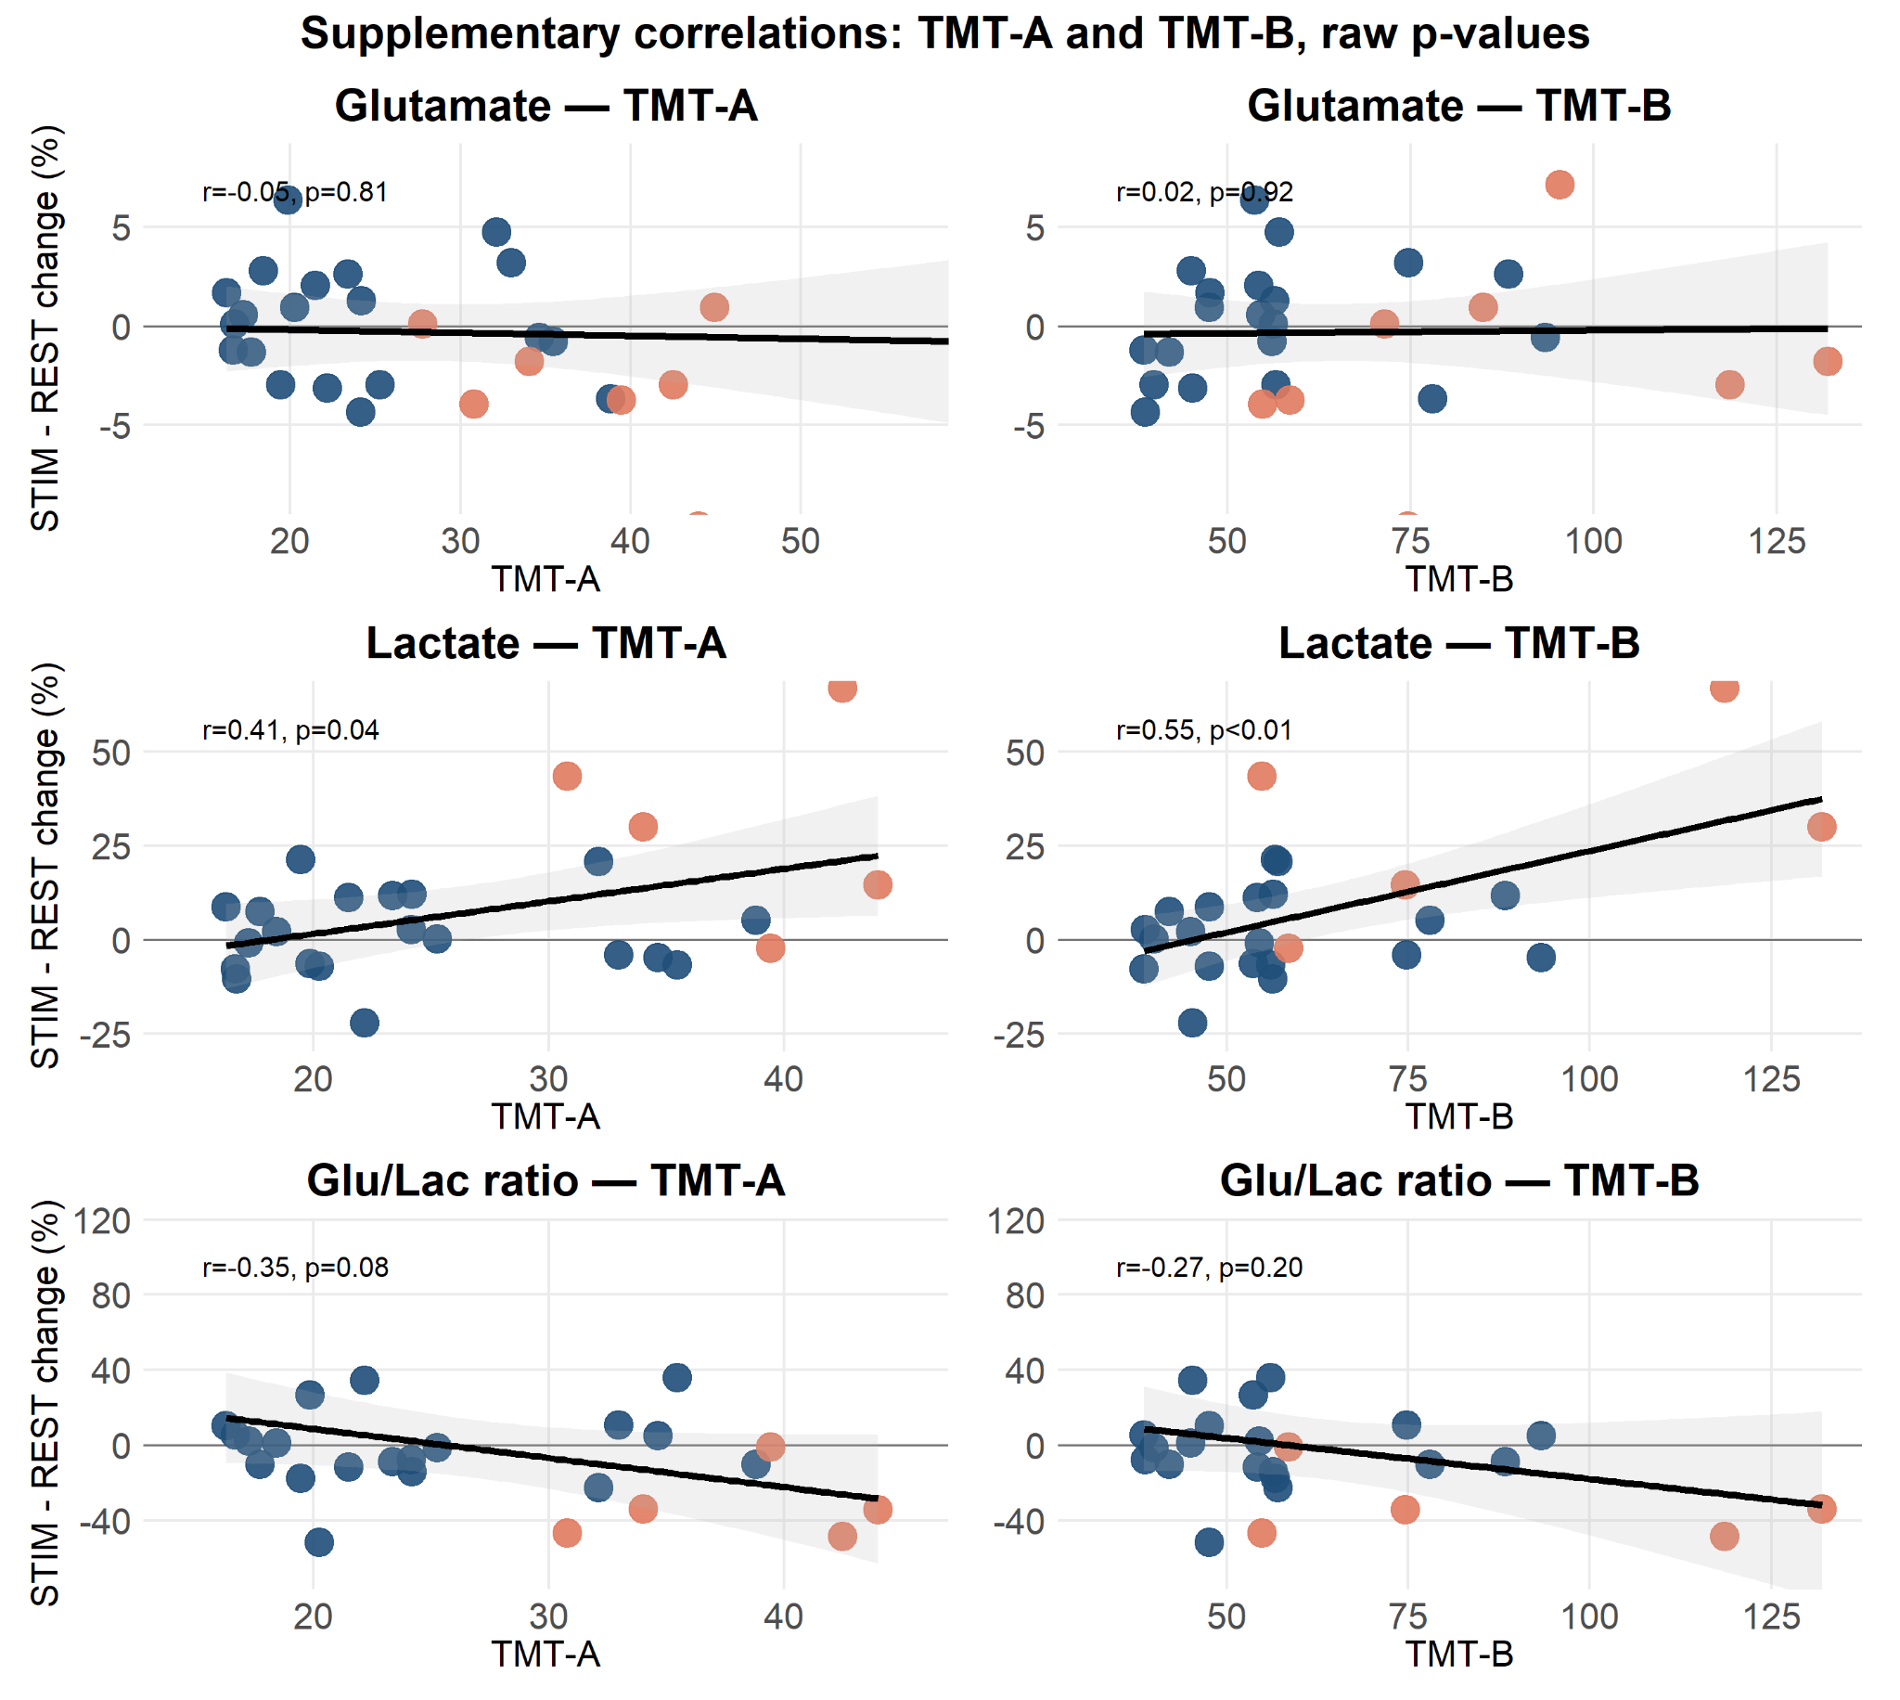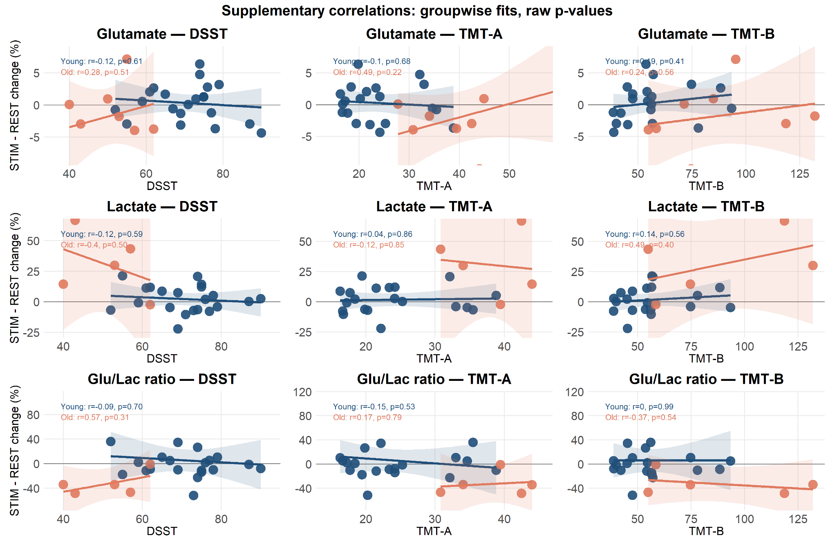
Supplementary Figure 2 | Exploratory associations between metabolite responses and cognitive performance. Original, unadjusted condition-averaged metabolite responses are plotted against behavioral measures across the combined sample and within age groups. Higher DSST scores indicate better performance; longer TMT-A and TMT-B completion times indicate poorer performance. Correlations are exploratory and p values are unadjusted.
The supplementary TMT and within-age correlations shown here use the original, unadjusted metabolite responses. Updated pooled DSST results from detrended responses are reported below and in Supplementary Table 2; these differ from the original supplementary plots.

Glutamate
For the primary analysis, detrended glutamate percentage change was not associated with DSST (r = 0.16, p = 0.40, FDR-adjusted p = 0.40; n = 29). The supplementary within-age analyses used the original, unadjusted responses and were also non-significant (young: r = −0.12, p = 0.61; old: r = 0.28, p = 0.51).
Similarly, no significant associations were found with Trail Making performance. For TMT-A, correlations were not significant in either group (young: r = −0.10, p = 0.68; old: r = 0.49, p = 0.22) or across participants (r = −0.05, p = 0.81). For TMT-B, no significant associations were observed (young: r = 0.19, p = 0.41; old: r = 0.24, p = 0.56; overall: r = 0.02, p = 0.92).
These analyses provided no significant evidence of an association between condition-averaged glutamate change and these behavioral measures; they did not test response latency or recovery.

Lactate
For the primary analysis, larger detrended lactate percentage changes were associated with lower DSST scores (r = −0.56, p < 0.01, FDR-adjusted p < 0.01; n = 26). The supplementary within-age analyses used the original, unadjusted responses and did not reach significance (young: r = −0.12, p = 0.59; old: r = −0.40, p = 0.50).
Additional analyses revealed significant associations with Trail Making performance. Lactate change correlated positively with TMT-A (r = 0.41, p = 0.04) and TMT-B (r = 0.55, p < 0.01), indicating that larger lactate responses were associated with slower performance.
Importantly, these behavioral measures capture partially distinct cognitive components. DSST and TMT-A are primarily driven by processing speed and visuomotor efficiency, whereas TMT-B additionally requires cognitive flexibility and set-shifting. Across these measures, larger lactate responses were associated with poorer performance. These associations do not establish a shared cognitive factor or differences in association strength between tasks.
Within-group analyses showed similar trends but did not reach significance, likely due to reduced sample size.

Glu/Lac ratios
Detrended Glu/Lac percentage change was not significantly associated with DSST (r = 0.29, p = 0.15, FDR-adjusted p = 0.21; n = 26). The supplementary TMT analyses used the original, unadjusted responses: TMT-A, r = −0.35, p = 0.08; TMT-B, r = −0.27, p = 0.20. Neither association was significant.
Within-group analyses likewise did not reach significance. In younger participants, the Glu/Lac ratio was not associated with DSST (r = -0.09, p = 0.70), TMT-A (r = -0.15, p = 0.53), or TMT-B (r = 0.00, p = 0.99). In older participants, effect sizes were somewhat larger but remained non-significant, including positive associations with DSST (r = 0.57, p = 0.31) and TMT-A (r = 0.17, p = 0.79), and a negative association with TMT-B (r = -0.37, p = 0.54).
These exploratory analyses did not provide significant evidence that condition-averaged Glu/Lac changes were associated with cognitive performance.
Supplementary Table 2: Mean and confidence intervals and statistics per metabolite.

Metabolite | Young CTRL(mean [95% CI]) | Young STIM (mean [95% CI]) | Old CTRL(mean [95% CI]) | Old STIM (mean [95% CI]) | Main effects | Interaction | Key associations
Glu | 10.46 [9.99, 10.94] | 10.53 [10.06, 11.00] | 10.26 [9.57, 10.94] | 10.08 [9.40, 10.76] | Age: F(1,31.15)=0.69, p=0.41  Condition: F(1,381.08)=0.65, p=0.42  Time: F(1,381.06)=0.75, p=0.39 | Age×Condition: F(1,381.08)=3.36, p=0.07, FDRp=0.17  Age×Time: p=0.75 | DSST: r=0.16, p=0.40, FDRp=0.40; n=29
Lac | 0.95 [0.59, 1.31] | 0.99 [0.64, 1.35] | 2.09 [1.47, 2.71] | 2.44 [1.82, 3.06] | Age: F(1,28.07)=15.14, p<0.01  Condition: F(1,339.02)=19.24, p<0.01  Time: F(1,339.26)=14.90, p<0.01 | Age×Condition: F(1,339.02)=11.33, p<0.01, FDRp<0.01  Age×Time: p=0.24 | Detrended DSST: r=−0.56, p<0.01, FDRp<0.01; n=26
Glu/Lac ratio | 13.16 [9.81, 16.51] | 13.71 [10.41, 17.01] | 9.49 [3.70, 15.27] | 6.10 [0.35, 11.85] | Age: F(1,27.29)=2.91, p=0.09  Condition: F(1,317.28)=3.49, p=0.06  Time: F(1,317.69)=3.95, p=0.05 | Age×Condition: F(1,317.28)=6.71, p=0.01, FDRp=0.03  Age×Time: p=0.01 | Detrended DSST: r=0.29, p=0.15, FDRp=0.21; n=26

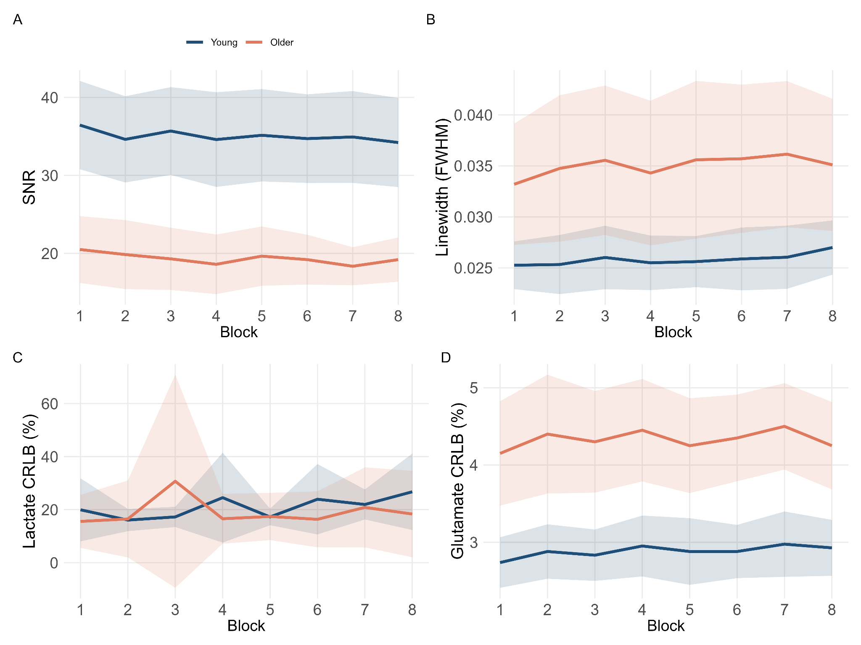
Supplementary Figure 3 | Block-wise spectroscopy quality measures. Signal-to-noise ratio, linewidth (FWHM, ppm) and LCModel percentage fitting uncertainty for lactate and glutamate are shown across eight blocks for younger and older participants. Lines and colored bands show group means and 95% confidence intervals. Values coded as 999 are omitted from the QC display. The fitted spectral linewidth shown here differs from the water-reference linewidth reported in Hz in Table 1.
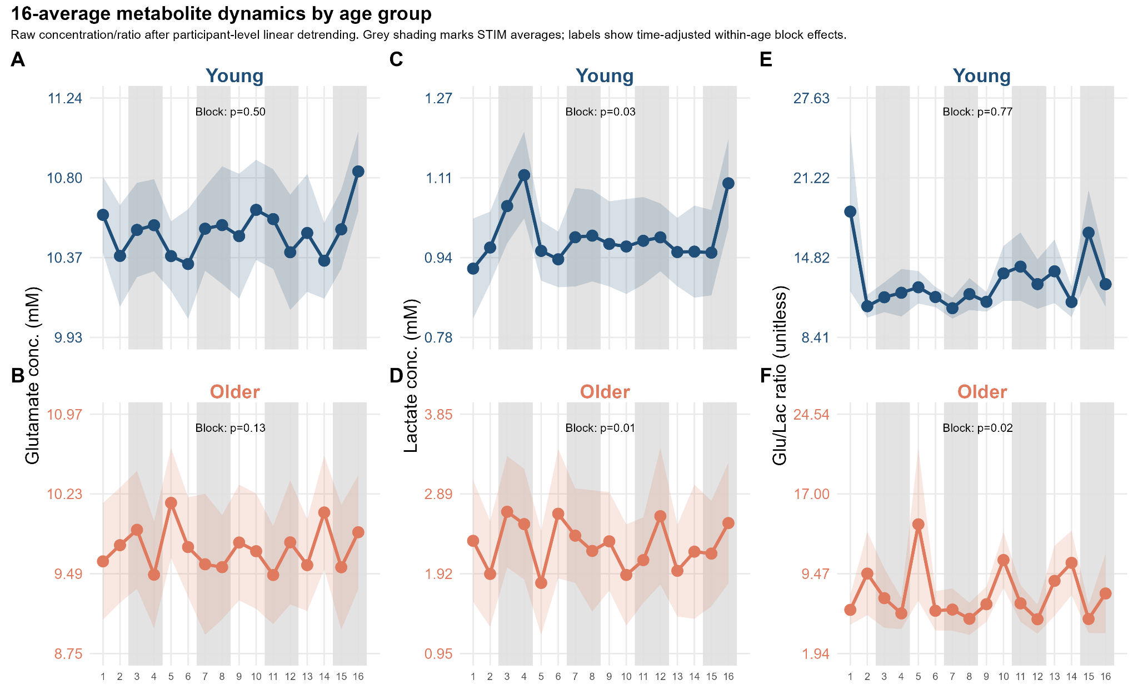
Supplementary Figure 4 | Metabolite dynamics at finer temporal resolution. Glutamate, lactate and Glu/Lac are shown using two spectral averages per 128-s block, yielding 16 time points across the acquisition. Concentrations and ratios are displayed after subtraction of the fitted participant-specific linear time component. Points and colored bands show means ± SEM; gray shaded periods indicate stimulation. Blue and orange indicate younger and older adults, respectively.
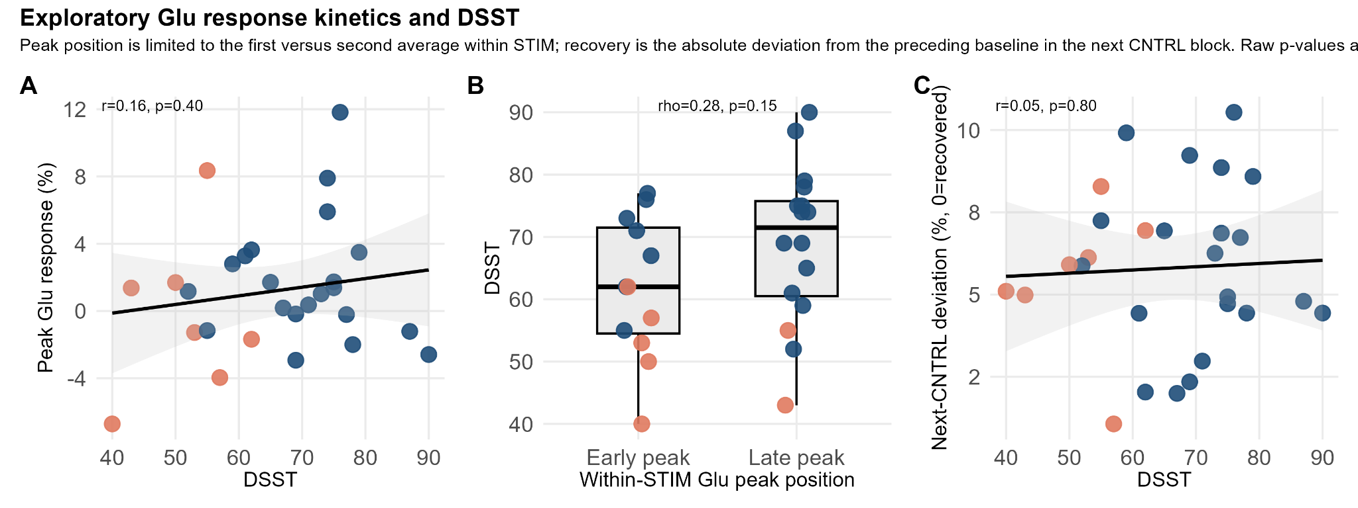
Supplementary Figure 5 | Exploratory associations between glutamate response kinetics and processing speed. (A) Peak task-related glutamate (Glu) change relative to baseline and Digit Symbol Substitution Test (DSST) performance (Pearson’s r = 0.16, p = 0.40). (B) DSST scores by within-stimulation peak position, classified as early or late according to whether the maximum Glu response occurred in the first or second spectral average of the stimulation block (Spearman’s ρ = 0.28, p = 0.15). (C) Absolute Glu deviation from the preceding baseline in the subsequent control block, with zero indicating a return to baseline, and DSST performance (Pearson’s r = 0.05, p = 0.80). Points represent individual participants; blue and orange indicate younger and older adults, respectively. Black lines and shaded bands in A and C show linear fits and confidence intervals. Higher DSST scores indicate better processing speed. All analyses were exploratory, with unadjusted two-sided p values; none reached statistical significance.
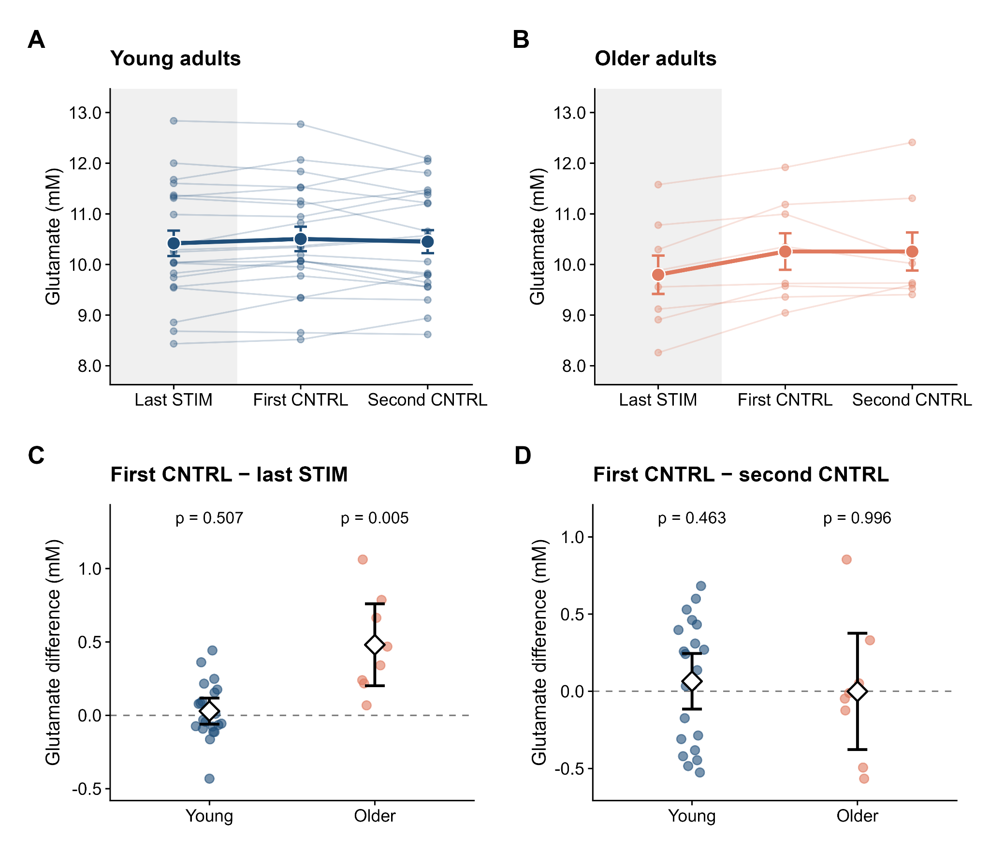
Supplementary Figure 6 | Exploratory post-stimulation glutamate dynamics. A–B, Detrended glutamate concentrations in the last stimulation (STIM) average and the first and second subsequent digit-reading control (CNTRL) averages in younger (A, blue) and older adults (B, orange). Thin lines show individual participant profiles averaged across complete three-position transitions; thick lines, points and error bars show group means ± SEM. Gray shading denotes STIM. Each spectral average spans 64 s. C–D, First CNTRL minus last STIM (C) and first CNTRL minus second CNTRL (D). Colored points represent participant mean contrasts across available paired transitions; white diamonds and black bars show group means and 95% confidence intervals. Dashed lines indicate zero. Labels report unadjusted p values from two-sided one-sample t tests against zero, separately within each age group. No multiple-comparison correction was applied. Transitions following the first three STIM blocks were included; the final STIM block had no subsequent CNTRL period. Missing pairs were omitted without imputation. Profiles require complete three-position transitions, whereas contrasts use available pairs. Glutamate increased after STIM in older adults (p = 0.005), with no significant first-to-second CNTRL difference (p = 0.996). These exploratory tests do not estimate precise response latency or test between-group differences.
Supplementary Table 3: Mean and confidence intervals and statistics for all resting state fMRI measures.

Measure | dmACC ReHo (mean [95% CI]) | Executive network ReHo (mean [95% CI]) | Attention network ReHo (mean [95% CI]) | Main statistics | Key interpretation
Young | 0.60 [0.57, 0.63] | 0.57 [0.55, 0.60] | 0.59 [0.56, 0.61] | — | —
Old | 0.51 [0.46, 0.55] | 0.47 [0.44, 0.49] | 0.48 [0.45, 0.52] | — | —
Group difference (Young − Old) | — | — | — | dmACC: t(17.60) = 4.17, p < 0.01  Exec: t(24.70)=6.34, p<0.01  Attn: t(21)=5.51, p<0.01 | Reduced intrinsic coherence with age
ReHo ↔ DSST | r = 0.44 [0.10, 0.69], p = 0.01, n = 30 | r=0.50 [0.17, 0.73], p<0.01, n=30 | r=0.50 [0.17, 0.73], p<0.01, n=30 | — | Higher coherence → better performance
ReHo ↔ ΔGlu | r = 0.10 [-0.29, 0.46], p = 0.63, n = 27 | r=0.14 [−0.25, 0.50], p=0.47, n=27 | r=0.19 [−0.20, 0.53], p=0.33, n=27 | — | No significant associations
ReHo ↔ ΔLac | r = -0.43 [-0.71, -0.03], p = 0.04, n = 24 | r=−0.49 [−0.75, −0.11], p=0.02, n=24 | r=−0.43 [−0.71, −0.03], p=0.04, n=24 | — | Lower coherence → higher metabolic recruitment

Supplementary Methods - Boilerplate text from fmriprep and xcp-d pipelines
MRI preprocessing
Structural and functional MRI data were preprocessed using fMRIPrep version 25.1.4 (RRID:SCR_016216) [1,2], followed by post-processing with the eXtensible Connectivity Pipeline (XCP-D) [3–5]. Both pipelines were implemented using Nipype version 1.10.0 (RRID:SCR_002502) [6].
Anatomical preprocessing
One high-resolution T1-weighted (T1w) image was acquired for each participant. Intensity non-uniformity was corrected using N4BiasFieldCorrection implemented in ANTs (v2.3.4) [7,8]. Skull stripping was performed using the ANTs-based antsBrainExtraction.sh workflow with the OASIS30ANTs template.
Brain tissue segmentation into gray matter (GM), white matter (WM), and cerebrospinal fluid (CSF) was performed using FAST from FSL (v6.0.7.18) [9]. Cortical surfaces were reconstructed with FreeSurfer (recon-all, v7.3.2) [10], and cortical segmentations were refined by reconciling ANTs- and FreeSurfer-derived gray matter boundaries using the Mindboggle approach [11].
Spatial normalization to the MNI152NLin2009cAsym and MNI152NLin6Asym standard spaces was performed using nonlinear registration with antsRegistration (ANTs v2.3.4). Templates were obtained through TemplateFlow version 24.2.2 [12]. Grayordinate (91k) representations were additionally generated by resampling cortical surfaces to the fsLR standard surface using Connectome Workbench [13].
Functional preprocessing
For each participant, one resting-state BOLD fMRI run was preprocessed.
When available, susceptibility-induced distortions were corrected using paired anterior-posterior EPI field maps with TOPUP (FSL v6.0.7.18) [14]. A reference BOLD volume was generated using the standard fMRIPrep workflow and used for subsequent motion correction. Head motion parameters (three translations and three rotations) were estimated using MCFLIRT (FSL) [15] before any temporal filtering. The BOLD reference image was coregistered to the participant's T1-weighted image using boundary-based registration (bbregister, FreeSurfer) with six degrees of freedom [16].
Functional images were resampled to native anatomical space, standard volumetric space, and fsLR grayordinates through a single interpolation step combining motion correction, susceptibility distortion correction, and spatial normalization transforms. Volumetric resampling employed cubic B-spline interpolation using NiTransforms, while surface resampling was performed using FreeSurfer's mri_vol2surf.
Several confounding time series were estimated during preprocessing, including framewise displacement (FD), DVARS, and global signals extracted from CSF, WM, and whole-brain masks. Both temporal (tCompCor) and anatomical (aCompCor) principal components were computed following the CompCor framework [17]. Motion parameters and tissue signals were expanded with temporal derivatives and quadratic terms [5]. Volumes exceeding 0.50 mm framewise displacement or 1.50 standardized DVARS were flagged as motion outliers. Additional edge-based nuisance regressors ("crown" components) were estimated following Patriat et al. [18].
XCP-D post-processing
The preprocessed outputs from fMRIPrep were further processed using XCP-D version 0.11.2.dev2+g402269a in LINC mode.
The 36-parameter nuisance regression strategy (36P) was applied [5,19]. This nuisance model included:
• Six rigid-body motion parameters
• Mean global signal
• Mean white matter signal
• Mean cerebrospinal fluid signal
• Temporal derivatives of all nuisance regressors
• Quadratic expansion of motion parameters, tissue signals, and their derivatives
The BOLD data were temporarily converted to NIfTI format, despiked using AFNI's 3dDespike, and converted back to CIFTI format.
Temporal filtering was performed using a second-order Butterworth band-pass filter retaining frequencies between 0.01 and 0.08 Hz. The identical filter was applied to both the BOLD time series and nuisance regressors prior to nuisance regression using the denoising approach implemented in Nilearn [20]. The denoised BOLD images were subsequently smoothed using Connectome Workbench with a Gaussian kernel (6 mm FWHM).
Regional homogeneity (ReHo)
Regional homogeneity (ReHo) [21] was computed on the temporally filtered, denoised, unsmoothed functional data. ReHo values were retained as native Kendall’s coefficients of concordance without whole-brain normalization, and the ReHo maps were not spatially smoothed.
For cortical surfaces, ReHo was estimated using the surface-based implementation 2dReHo [22]. Kendall's coefficient of concordance (KCC) was calculated for each surface vertex and its nearest neighboring vertices.
For subcortical volumetric regions, ReHo was computed using AFNI's 3dReHo [23], calculating KCC across neighboring voxels.
Amplitude of low-frequency fluctuations (ALFF)
Amplitude of low-frequency fluctuations (ALFF) [24] was calculated from the denoised BOLD time series. The mean-centered, variance-normalized time series were transformed to the frequency domain, and the power spectrum within the 0.01–0.08 Hz frequency band was calculated. ALFF was defined as the mean square root of the power spectrum within this frequency range and subsequently rescaled by multiplying with the standard deviation of the denoised BOLD signal to preserve the original signal scaling. The resulting ALFF maps were smoothed using Connectome Workbench with a Gaussian kernel (6 mm FWHM).
Functional connectivity
Residual denoised BOLD time series were extracted using Connectome Workbench for multiple cortical and subcortical atlases. The workflow included the following atlases:
• Glasser atlas [25]
• Gordon atlas [26]
• Tian subcortical atlas [27]
• HCP CIFTI subcortical atlas [13]
• MIDB precision brain atlas (75% probability threshold) [28]
• Myers-Labonte infant atlas (50% probability threshold) [29]
Pairwise functional connectivity matrices were generated by computing Pearson correlation coefficients between all parcel time series using the unsmoothed residual BOLD signals. In regions with incomplete surface coverage, uncovered vertices containing zeros or NaNs were ignored when parcel coverage exceeded 50%; otherwise, missing vertices were set to zero according to the default XCP-D implementation.
Software
In addition to fMRIPrep and XCP-D, the preprocessing workflow employed AFNI [30,31], Connectome Workbench [32], ANTs [33], TemplateFlow version 24.2.2 [12], Nilearn version 0.12.0 [20], Nibabel version 5.3.2 [34], NumPy version 2.2.4 [35], SciPy version 1.15.2 [36], PyBIDS version 0.19.0 [37], and Matplotlib version 3.10.5 [38].
References:

- Esteban, O. et al. fMRIPrep: a robust preprocessing pipeline for functional MRI. Nat. Methods 16, 111–116 (2019).
- Esteban, O. et al. Analysis of task-based functional MRI data preprocessed with fMRIPrep. Nat. Protoc. 15, 2186–2202 (2020).
- Mehta, K. et al. XCP-D: a robust pipeline for the post-processing of fMRI data. Imaging Neurosci. 2, 1–26 (2024).
- Ciric, R. et al. Mitigating head motion artifact in functional connectivity MRI. Nat. Protoc. 13, 2801–2826 (2018).
- Satterthwaite, T. D. et al. An improved framework for confound regression and filtering for control of motion artifact in the preprocessing of resting-state functional connectivity data. NeuroImage 64, 240–256 (2013).
- Gorgolewski, K. et al. Nipype: a flexible, lightweight and extensible neuroimaging data processing framework in Python. Front. Neuroinform. 5, 13 (2011).
- Tustison, N. J. et al. N4ITK: improved N3 bias correction. IEEE Trans. Med. Imaging 29, 1310–1320 (2010).
- Avants, B. B. et al. A reproducible evaluation of ANTs similarity metric performance in brain image registration. NeuroImage 54, 2033–2044 (2011).
- Zhang, Y., Brady, M. & Smith, S. Segmentation of brain MR images through a hidden Markov random field model and the expectation-maximization algorithm. IEEE Trans. Med. Imaging 20, 45–57 (2001).
- Fischl, B. FreeSurfer. NeuroImage 62, 774–781 (2012).
- Klein, A. et al. Mindboggling morphometry of human brains. PLoS Comput. Biol. 13, e1005350 (2017).
- Ciric, R. et al. TemplateFlow: FAIR-sharing of multi-scale, multi-species brain models. Nat. Methods 19, 1568–1571 (2022).
- Glasser, M. F. et al. The minimal preprocessing pipelines for the Human Connectome Project. NeuroImage 80, 105–124 (2013).
- Andersson, J. L. R., Skare, S. & Ashburner, J. How to correct susceptibility distortions in spin-echo echo-planar images: application to diffusion tensor imaging. NeuroImage 20, 870–888 (2003).
- Jenkinson, M., Bannister, P., Brady, M. & Smith, S. Improved optimization for the robust and accurate linear registration and motion correction of brain images. NeuroImage 17, 825–841 (2002).
- Greve, D. N. & Fischl, B. Accurate and robust brain image alignment using boundary-based registration. NeuroImage 48, 63–72 (2009).
- Behzadi, Y., Restom, K., Liau, J. & Liu, T. T. A component-based noise correction method (CompCor) for BOLD and perfusion-based fMRI. NeuroImage 37, 90–101 (2007).
- Patriat, R., Molloy, E. K., Birn, R. M., Guitchev, T. & Popov, A. Using edge voxel information to improve motion regression for resting-state fMRI connectivity studies. Brain Connect. 5, 582–595 (2015).
- Ciric, R. et al. Benchmarking of participant-level confound regression strategies for the control of motion artifact in studies of functional connectivity. NeuroImage 154, 174–187 (2017).
- Abraham, A. et al. Machine learning for neuroimaging with scikit-learn. Front. Neuroinform. 8, 14 (2014).
- Jiang, L. & Zuo, X.-N. Regional homogeneity: a multimodal, multiscale neuroimaging marker of the human connectome. Neuroscientist 22, 486–505 (2016).
- Zuo, X.-N. et al. Toward reliable characterization of functional homogeneity in the human brain: preprocessing, scan duration, imaging resolution and computational space. NeuroImage 65, 374–386 (2013).
- Taylor, P. A. & Saad, Z. S. FATCAT: an efficient functional and tractographic connectivity analysis toolbox. Brain Connect. 3, 523–535 (2013).
- Zang, Y.-F. et al. Altered baseline brain activity in children with ADHD revealed by resting-state functional MRI. Brain Dev. 29, 83–91 (2007).
- Glasser, M. F. et al. A multi-modal parcellation of human cerebral cortex. Nature 536, 171–178 (2016).
- Gordon, E. M. et al. Generation and evaluation of a cortical area parcellation from resting-state correlations. Cereb. Cortex 26, 288–303 (2016).
- Tian, Y., Margulies, D. S., Breakspear, M. & Zalesky, A. Topographic organization of the human subcortex unveiled with functional connectivity gradients. Nat. Neurosci. 23, 1421–1432 (2020).
- Hermosillo, R. J. M. et al. A precision functional atlas of personalized network topography and probabilities. Nat. Neurosci. 27, 1000–1013 (2024).
- Myers, M. J. et al. Functional parcellation of the neonatal cortical surface. Cereb. Cortex 34, bhae047 (2024).
- Cox, R. W. AFNI: software for analysis and visualization of functional magnetic resonance neuroimages. Comput. Biomed. Res. 29, 162–173 (1996).
- Cox, R. W. & Hyde, J. S. Software tools for analysis and visualization of fMRI data. NMR Biomed. 10, 171–178 (1997).
- Marcus, D. S. et al. Informatics and data mining tools and strategies for the Human Connectome Project. Front. Neuroinform. 5, 4 (2011).
- Avants, B. B., Tustison, N. J. & Song, G. Advanced normalization tools (ANTS). Insight J. 2, 1–35 (2009).
- Brett, M. et al. nipy/nibabel: version 4.0.0. Zenodo https://doi.org/10.5281/zenodo.6658382 (2022).
- Harris, C. R. et al. Array programming with NumPy. Nature 585, 357–362 (2020).
- Virtanen, P. et al. SciPy 1.0: fundamental algorithms for scientific computing in Python. Nat. Methods 17, 261–272 (2020).
- Yarkoni, T. et al. PyBIDS: Python tools for BIDS datasets. J. Open Source Softw. 4, 1294 (2019).
- Hunter, J. D. Matplotlib: a 2D graphics environment. Comput. Sci. Eng. 9, 90–95 (2007).

