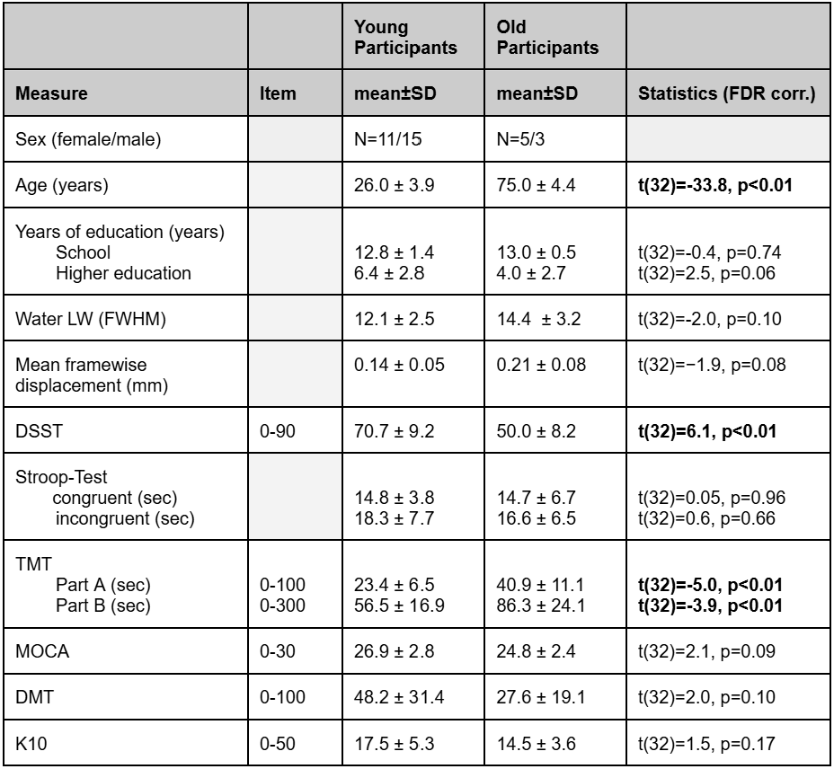Table 1 | Participant characteristics, data-quality measures, and cognitive performance.
Demographic characteristics, spectroscopy quality measures and cognitive performance are reported for younger and older participants. Values are mean ± SD unless otherwise indicated. DSST, Digit Symbol Substitution Test; TMT, Trail Making Test; MoCA, Montreal Cognitive Assessment; DMT, Digit Memory Test; K10, Kessler Psychological Distress Scale; FWHM, full width at half maximum. Higher DSST scores indicate better performance, whereas longer TMT completion times indicate poorer performance. Statistical comparisons and multiple-testing procedures are described in Methods.

