Additional file 1 for Molecular Neurobiology

Syntaxin-1a and SNAP-25 expression level is increased in the blood samples of ischemic stroke patients.
Pamela Cappelletti¹, Melania Filareti¹, Laura Masuelli², Roberto Bei³, Kambiz Hassanzadeh^{4,#}, Massimo Corbo¹, Marco Feligioni^{1,4*}

¹ Department of Neuro-rehabilitation Sciences, Casa Cura Policlinico, Milan, Italy;
²Department of Experimental Medicine, University of Rome “Sapienza”, Rome, Italy
³Department of Clinical Sciences and Translational Medicine, University of Rome “Tor Vergata”, Rome; Italy
⁴EBRI Rita Levi-Montalcini Foundation, Rome

#current address: Fondazione Pisana per la Scienza (FPS), Pisa
*Corresponding author: Marco Feligioni, PhD

Correspondence:
Marco Feligioni, PhD
European Brain Research Institute (EBRI) Rita Levi Montalcini Foundation,
Viale Regina Elena 295, 00161 Rome, Italy
Phone: +39 06 49 255 255
Fax: +39 06 49 255 255
e-mail: m.feligioni@ebri.it

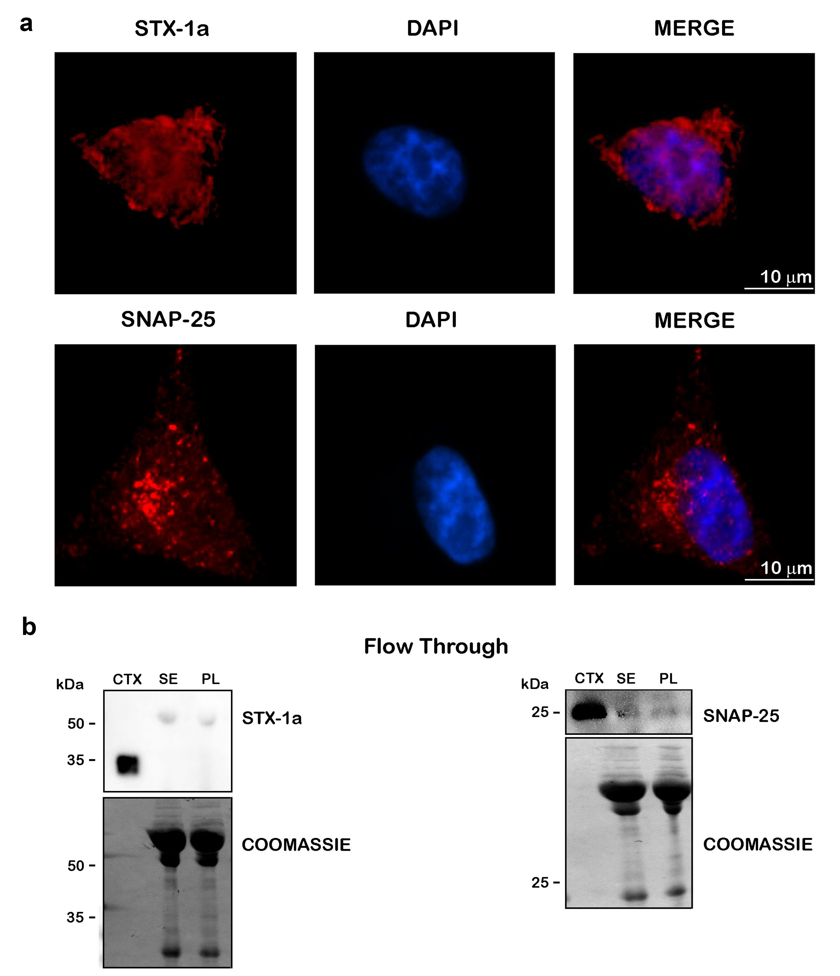

Fig. SI 1 Analysis of STX-1a and SNAP-25 in peripheral blood of healthy donors. a) IF analysis of STX-1a and SNAP-25 in SH-SY5Y cells line. Immunostaining of SH-SY5Y cells, for both synaptic proteins (red channels), has been performed as positive control. Cells have been immunostained with the nuclear marker DAPI (blue channel). Original magnification: 60X. Bars corresponds to 10 µm. b) WB analysis of STX-1a and SNAP-25 in the flow through of serum and plasma depleted from IgG and albumin. After the stripping of IgG and albumin from serum and plasma no specific signal is detected in the flow through for both STX-1a and SNAP-25.
For WB analysis 0.5 µg of mouse brain cortex lysate and 10 µL of flow through has been loaded in each lane

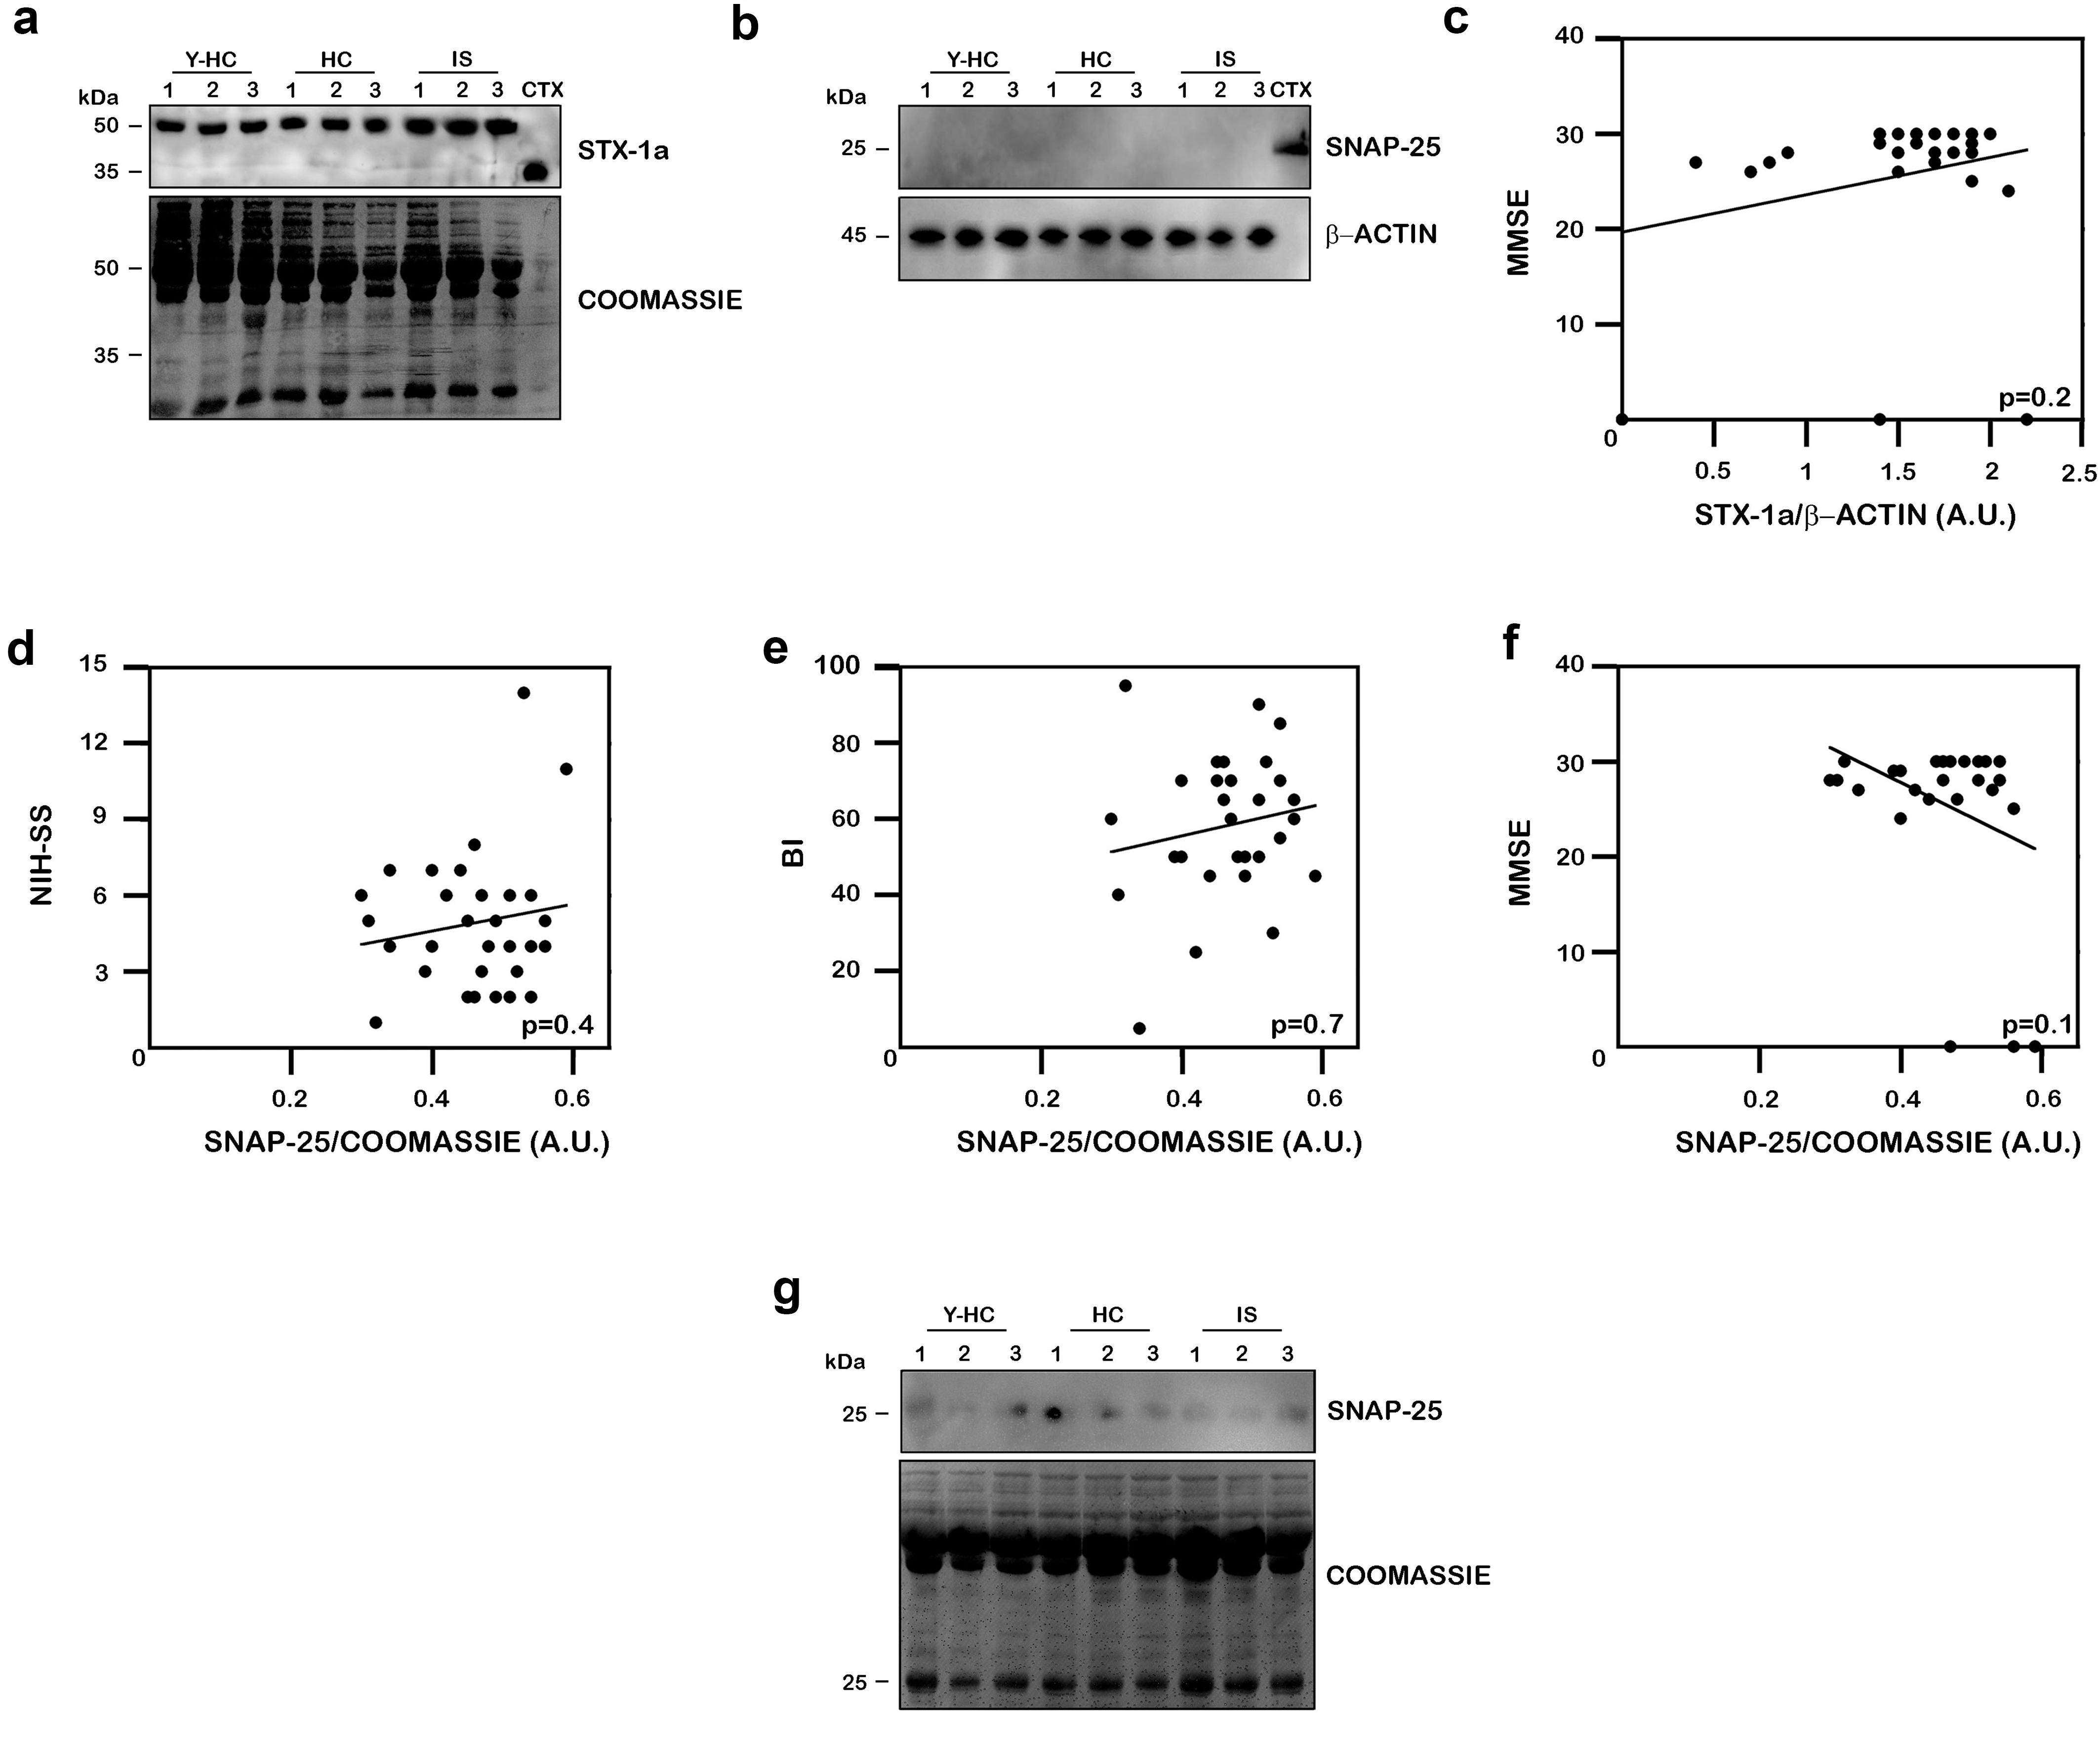

Fig. SI 2 Expression levels of STX-1a and SNAP-25 in blood of IS patients, HC and Y-HC subjects. a) Representative WB analysis of STX-1a in sera of IS patients and healthy controls. STX-1a is shifted at higher M.W. in all population analyzed. b) Representative WB analysis of SNAP-25 in PBMCs of IS patients and healthy controls. SNAP-25 is not expressed in PBMCs in any population analyzed. c) Pearson’s correlation analysis between expression of STX-1a in PBMCs and MMSE. STX-1a normalized expression levels in PBMCs of IS patients present a weak, positive but not statistically significant (p=0.2) correlation with MMSE (0.227). d, e, f) Pearson’s correlation analysis between expression of SNAP-25 in sera and the three clinical scales: NIH-SS (d), BI (e) and MMSE (f). SNAP-25 normalized expression levels in sera of IS patients present a very weak positive correlation with NIH-SS (0.154) (d) and BI (0.071) (e) and a weak negative correlation with MMSE (-0.326) (f). All the correlations are not statistically significant (p=0.4, 0.7 and 0.1 respectively for NIH-SS, BI and MMSE). g) Representative WB analysis of SNAP-25 in the flow through of sera of IS patients and HC subjets depleted from IgG and albumin. After the stripping of IgG and albumin from sera no specific signal for SNAP-25 is detected in any population analyzed.
For WB analysis 100 µg of sera or PBMC, 0.5 µg of mouse brain cortex lysate and 10 µL of flow through has been loaded in each lane

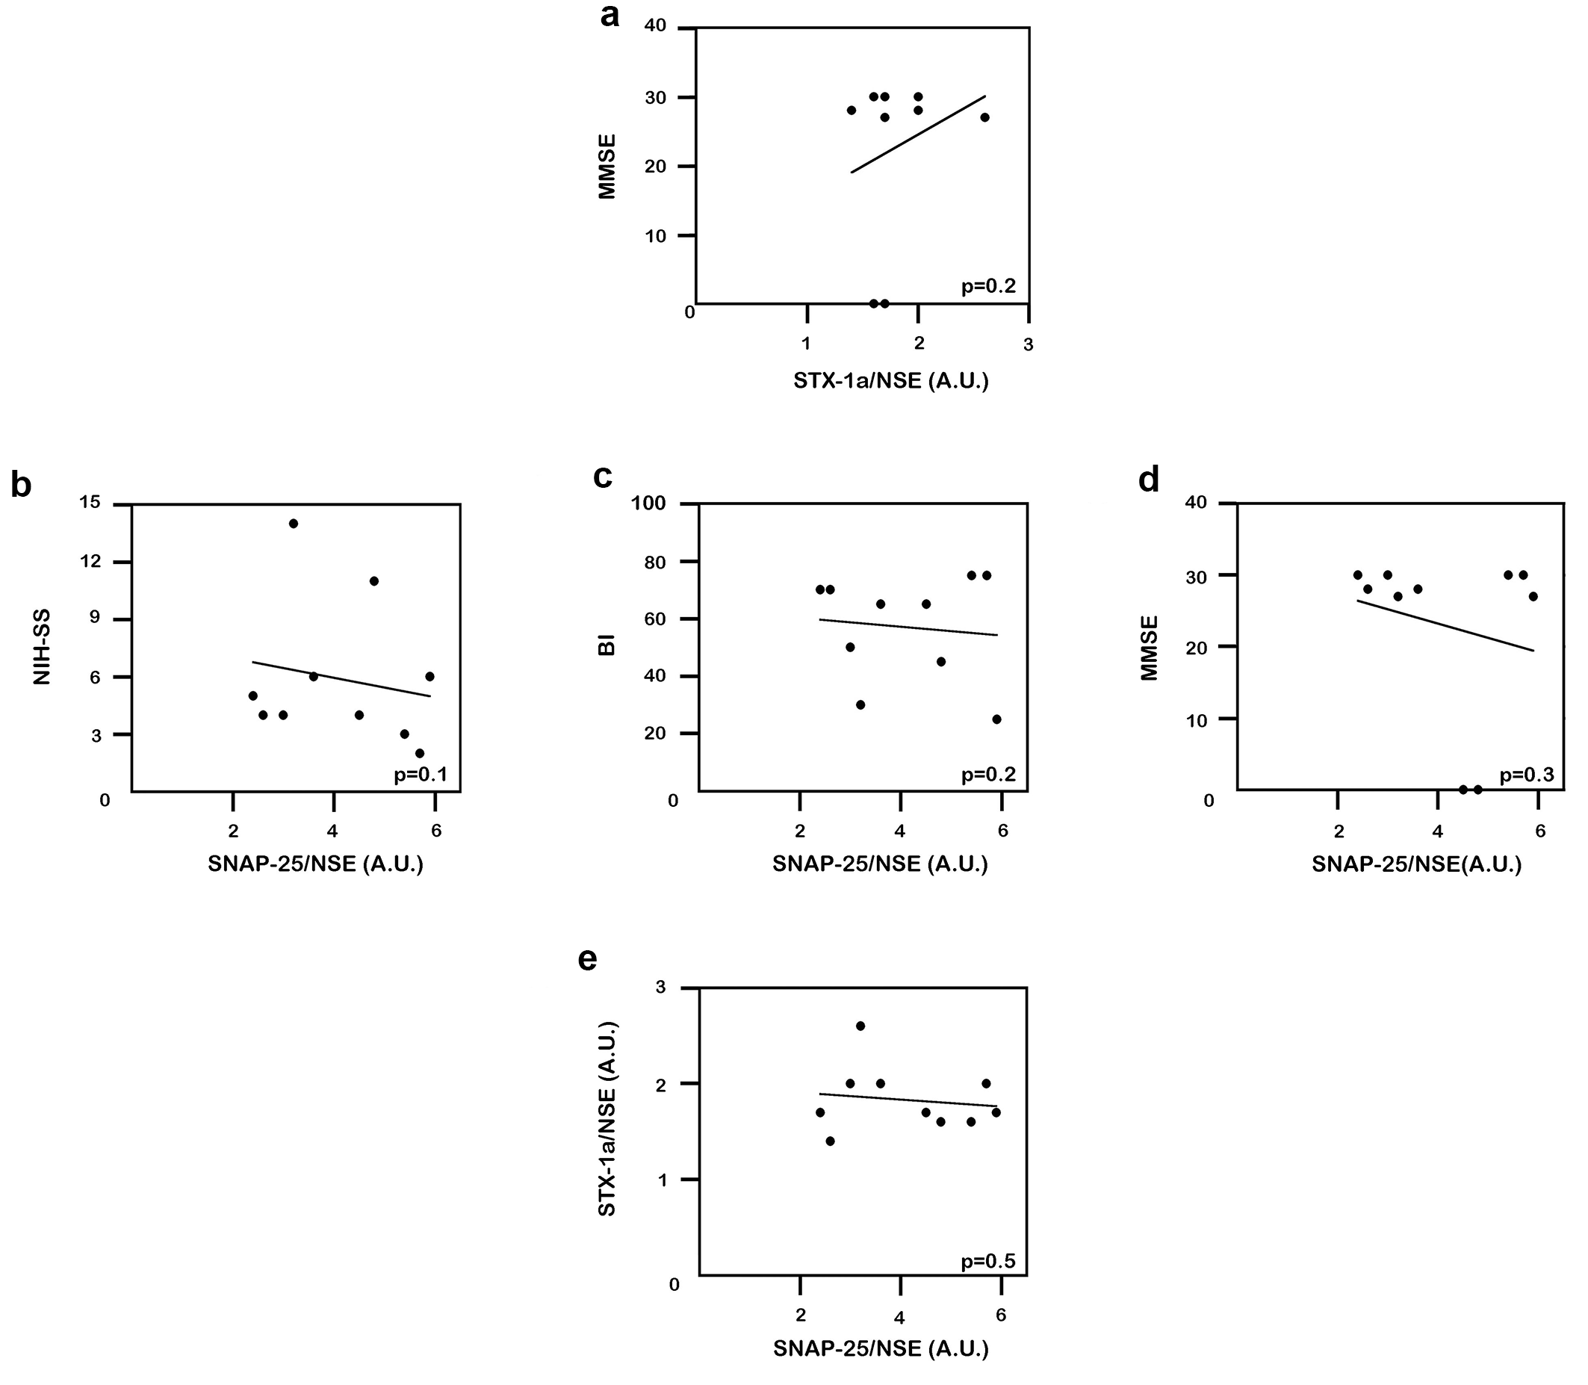

Fig. SI 3 Pearson’s correlation analysis between of STX-1a and SNAP-25 in NDEs and NIH-SS, BI and MMSE. a) Pearson’s correlation analysis between expression of STX-1a in NDEs and MMSE. STX-1a normalized expression levels of IS patients present a weak, positive and not statistically significant (p=0.2) correlation with MMSE (0.255). b, c, d) Pearson’s correlation analysis between expression of SNAP-25 in NDEs and the three clinical scales: NIH-SS (b), BI (c) and MMSE (d). SNAP-25 normalized expression levels of IS patients present a very weak negative correlation with NIH-SS (-0.178) (b) and BI (-0.111) (c) and a weak negative correlation with MMSE (-0.215) (d). All the correlations are not statistically significant (p=0.1, 0.2 and 0.3 respectively for NIH-SS, BI and MMSE). e) Pearson’s correlation analysis between expression of STX-1a and SNAP-25 in NDEs. STX-1a and SNAP-25 normalized expression levels of IS patients are weak negative correlate (-0.144, p=0.5).

