Figure S1 Schematic description of crucial steps in Splentis implantation technique
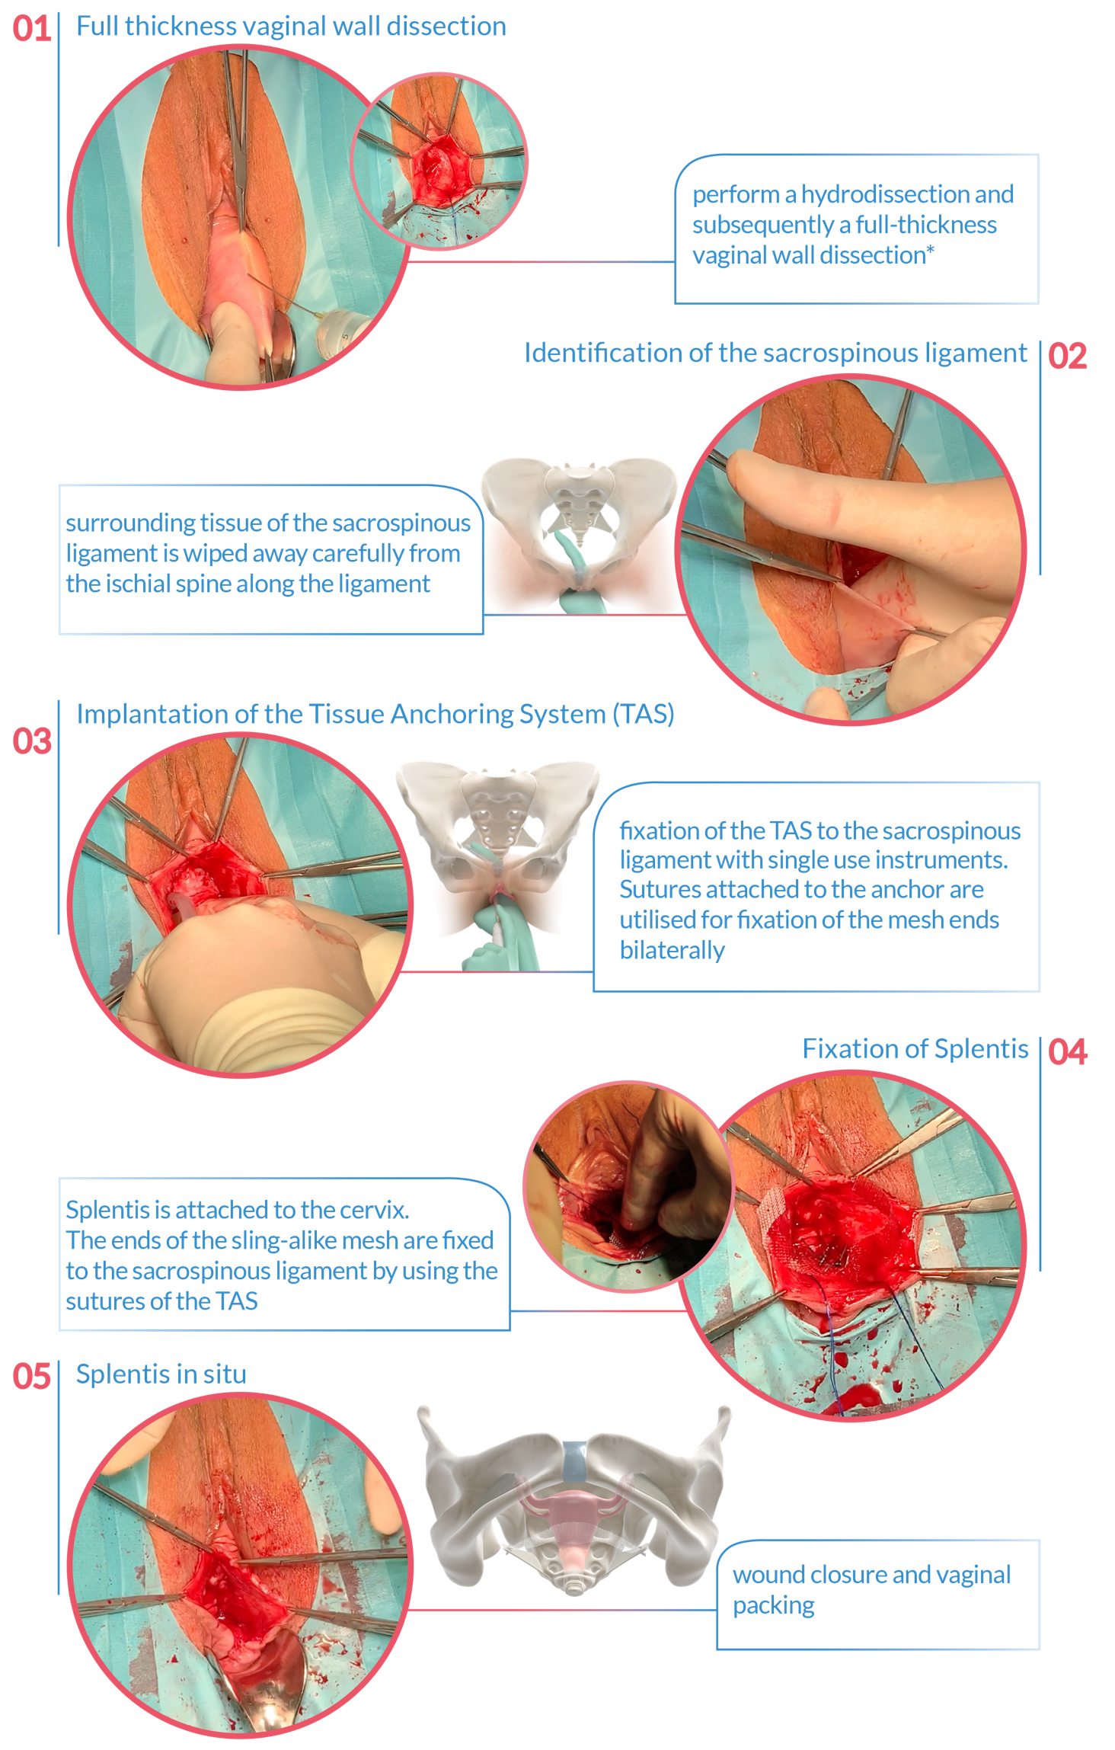

A detailed description of the surgical technique can be found in the Surgical Technique Brochure of Splentis, available at http://www.promedon-urologypf.com or by direct contact to Promedon (Cordoba, Argentina)

