Supplementary Material
Does the El Niño-Southern Oscillation Impact on the Indian Summer Monsoon 1-Dimensional?
Quantifying the Role of Antecedent Southwestern Indian Ocean Capacitance on the Variability of Summer Monsoon Rainfall over Homogeneous Regions of India
Venugopal Thandlam^{*1,2,3}, Hasibur Rahaman⁴, Anna Rutgersson^{1,5}, Erik Sahlee¹, M Ravichandran⁶ and S.S.V.S Ramakrishna²

- Department of Earth Sciences, Uppsala University, Uppsala, Sweden.
- Department of Meteorology and Oceanography, Andhra University, Visakhapatnam, India.
- The Center for Environment and Development Studies Research Forum, Uppsala University, Uppsala, Sweden.
- Indian National Centre for Ocean Information Services, Ministry of Earth Sciences, Hyderabad, India.
- Centre of Natural Hazards and Disaster Science, Uppsala University, Uppsala, Sweden.
- Ministry of Earth Sciences, New Delhi, India.

*Corresponding author’s email: venu.thandlam@geo.uu.se
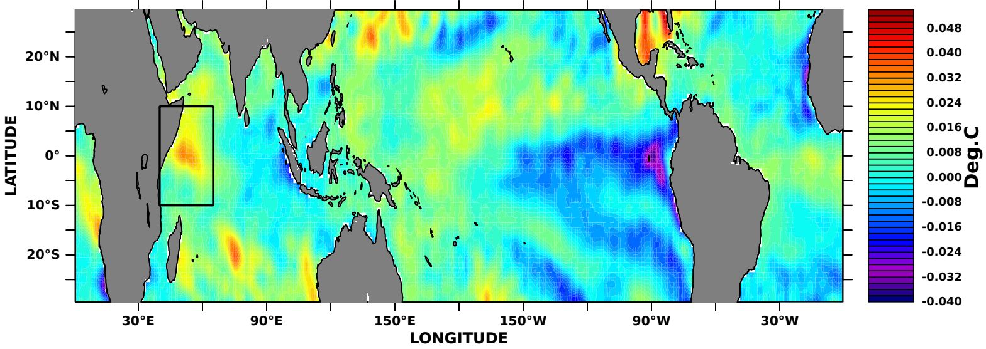
(a)
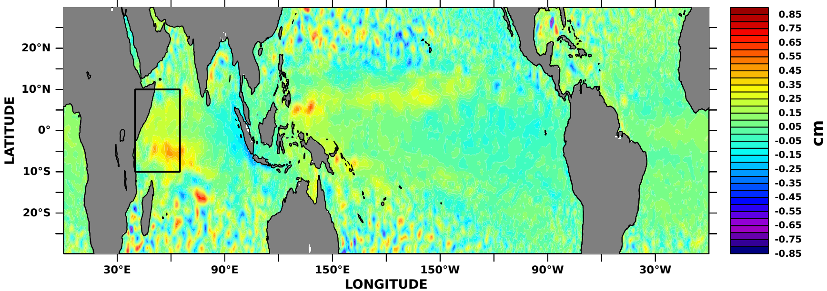
(b)
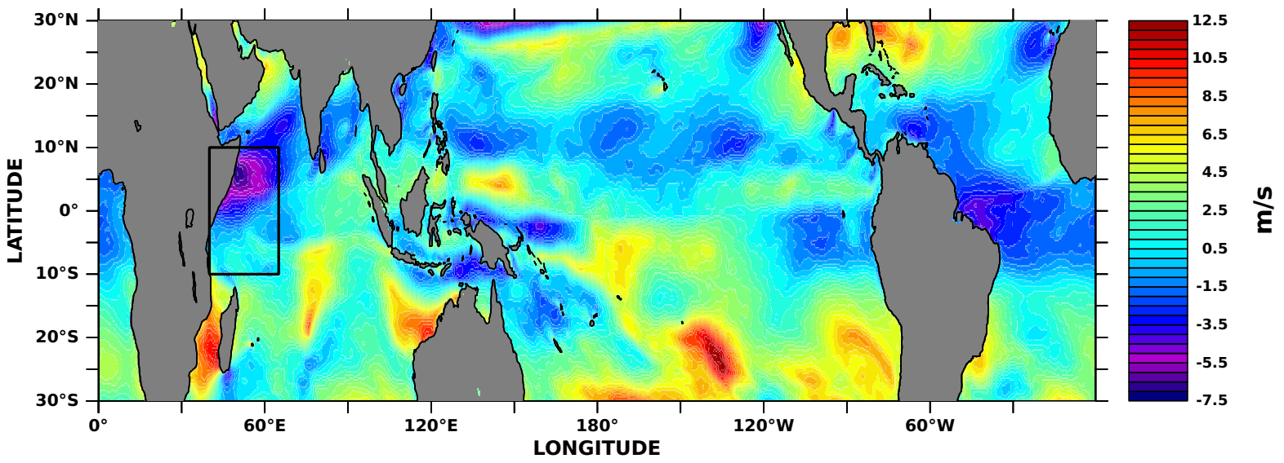
(c)
Figure S1: Difference between summer half-year (AMJJAS) and winter half-year (ONDJFM) (a) SSTA (b) MSLA and (c) wind speed anomalies over the global tropical ocean during 1993-2019.

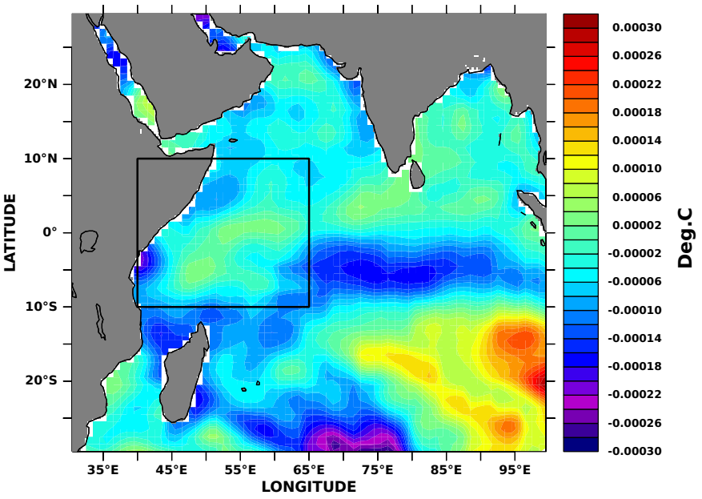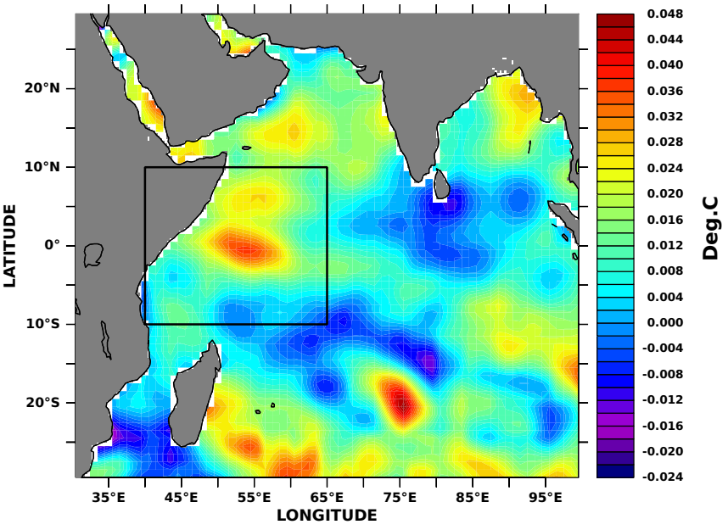
(a) (b)
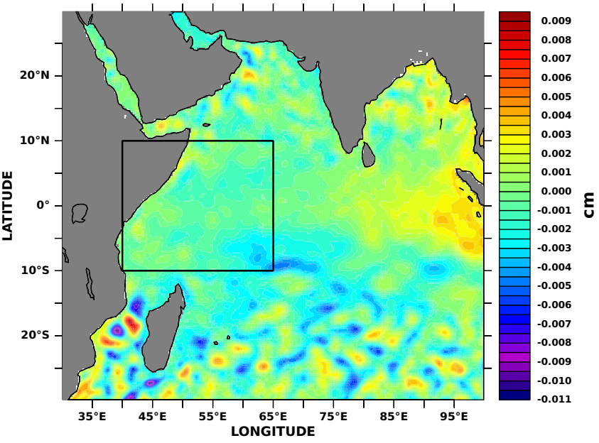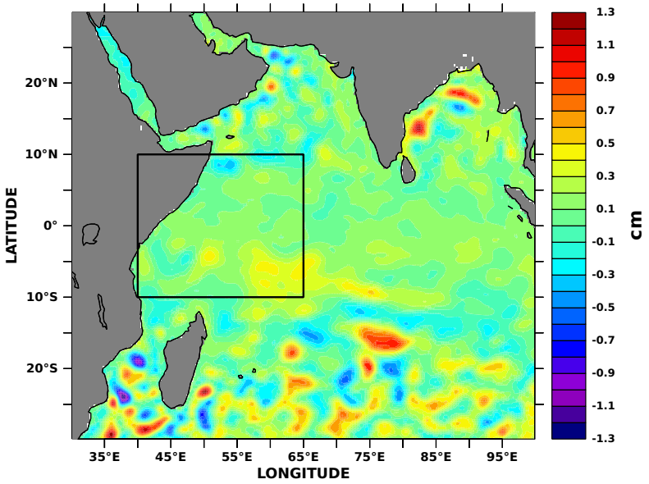
(c) (d)

Figure S2: SSTA and MSLA mean in the Indian Ocean. SSTA mean during (a) winter half-year (ONDJFM) and (b) April-May. MSLA mean during (c) winter-half year (ONDJFM) and (d) April-May.

