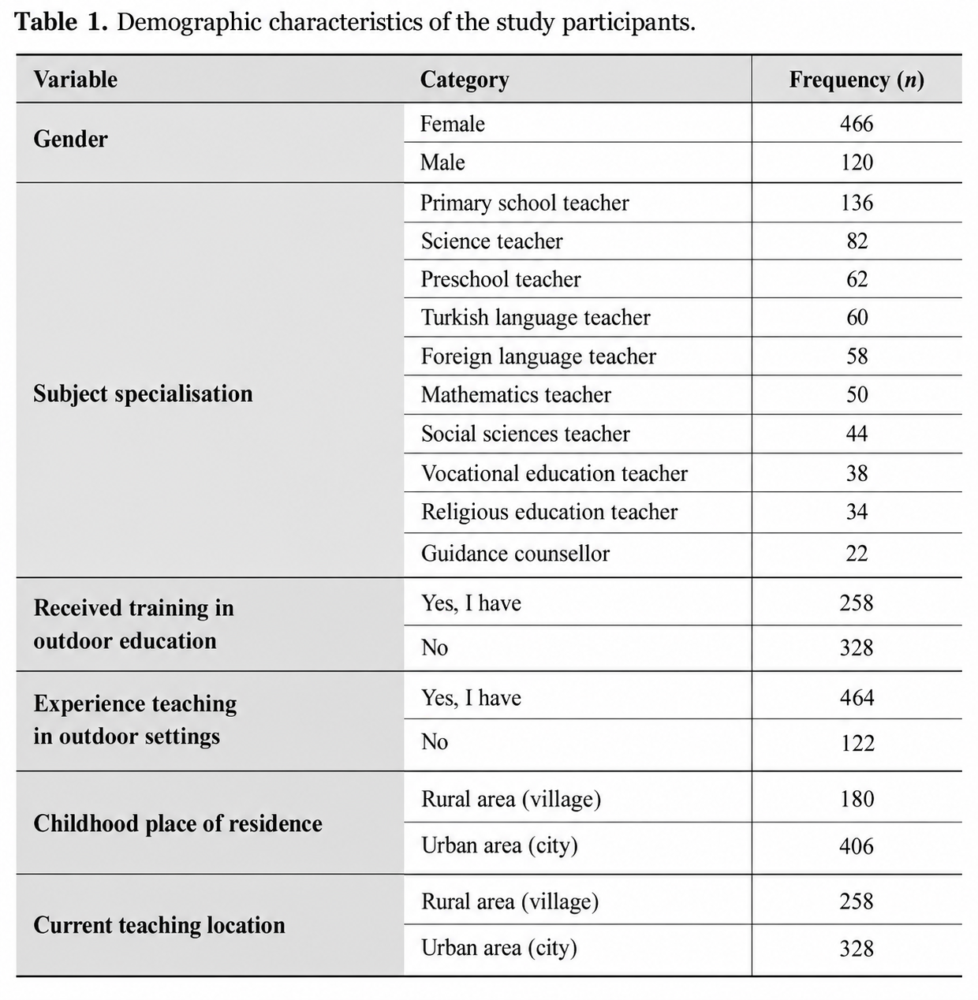
Table 1. Demographic characteristics of the study participants.
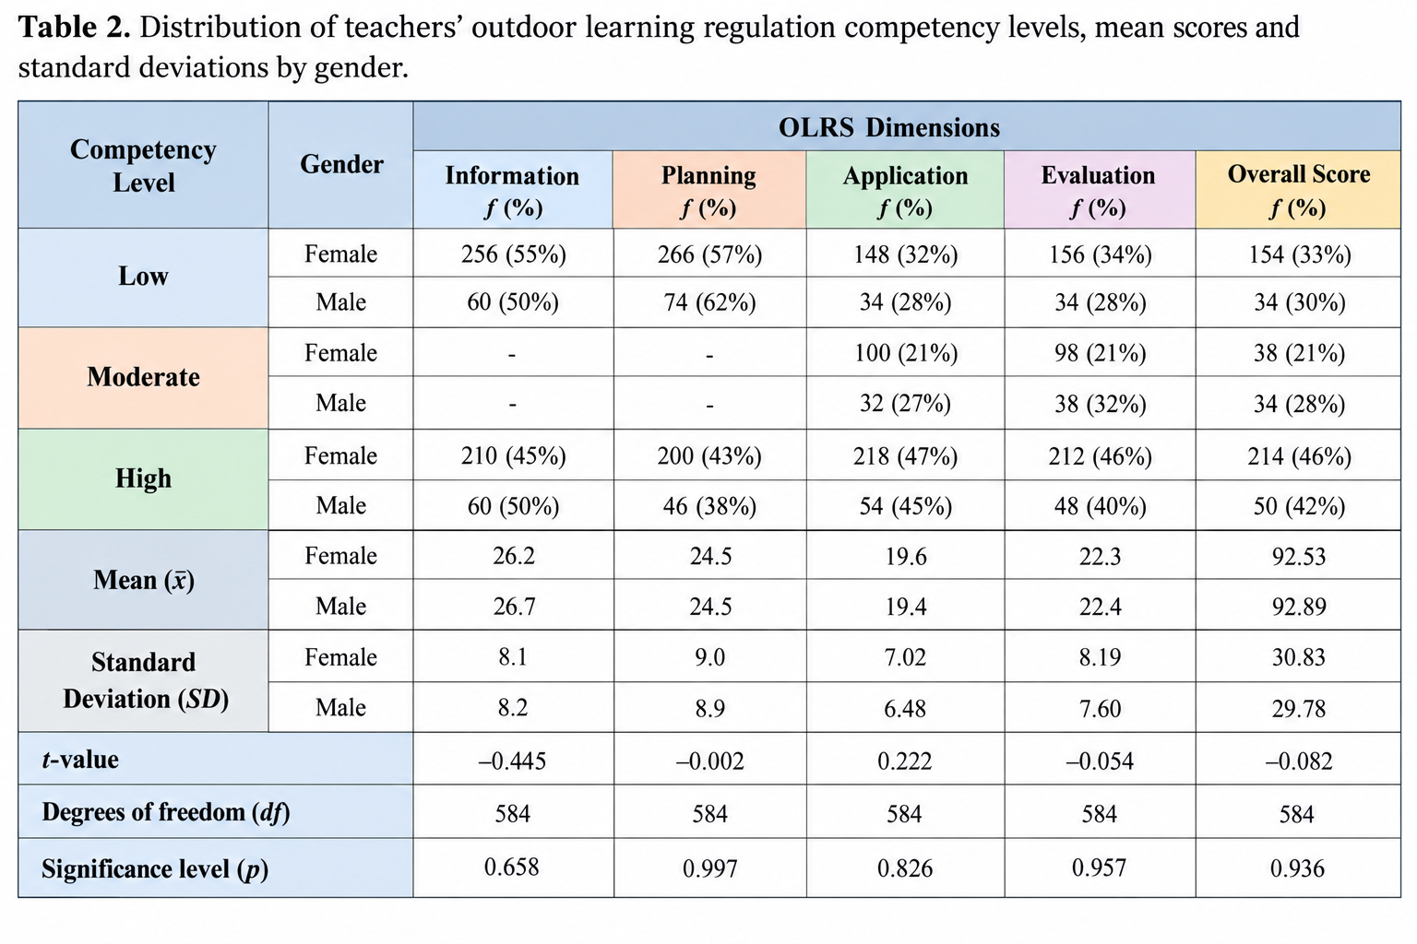
Table 2. Gender-related differences in participants’ competency levels and corresponding t-test findings across the OLRS dimensions.

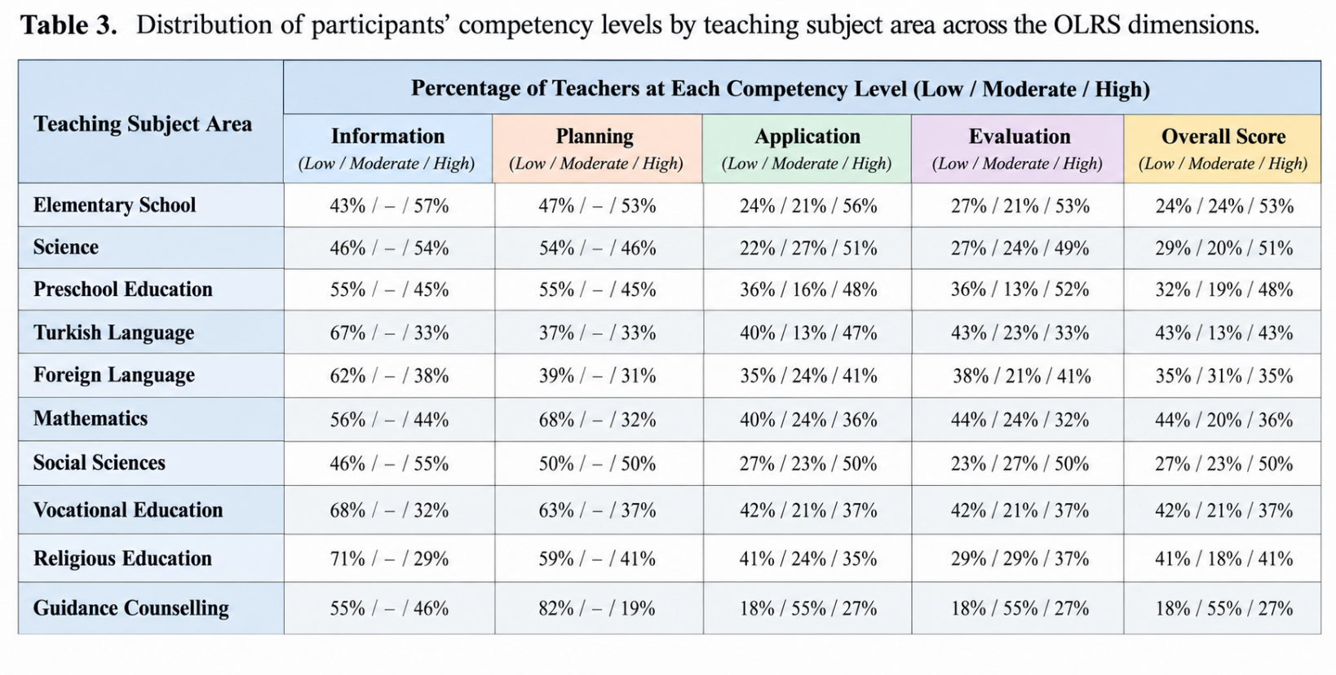
Table 3. Distribution of participants’ competency levels across teaching specialisations and OLRS dimensions.

Note: Percentages may differ slightly from 100% because of rounding. The symbol “-” denotes the absence of reported data for the moderate competency category within the corresponding factor. ANOVA statistics (F, p, η²) are provided for each dimension, with no statistically significant differences identified (all p > 0.05).
ANOVA findings: Information: F(18, 566) = 1.29, p = 0.238, η² = 0.039; Planning: F(18, 566) = 0.94, p = 0.492, η² = 0.029; Application: F(18, 566) = 0.79, p = 0.632, η² = 0.024; Evaluation: F(18, 566) = 0.55, p = 0.838, η² = 0.018.

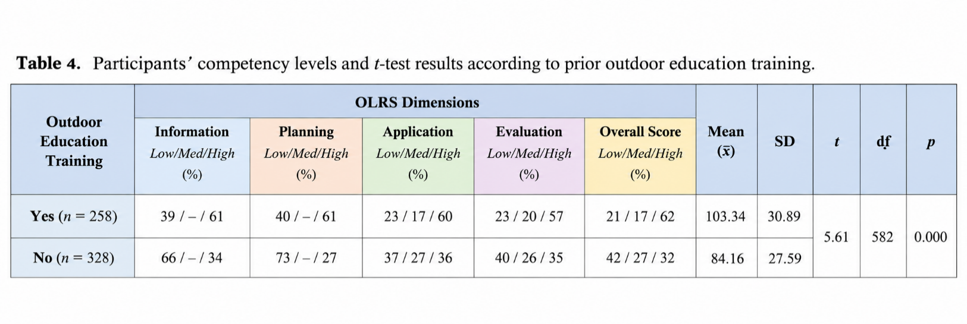
Table 4. Participants’ competency levels and corresponding t-test findings according to prior outdoor education training.
Note: Percentages indicate the proportion of participants classified into low, moderate, and high competency categories within each OLRS dimension. Independent-samples t-test findings revealed statistically significant differences across all OLRS dimensions, with higher competency scores observed among teachers who had received prior training (all p < 0.001).

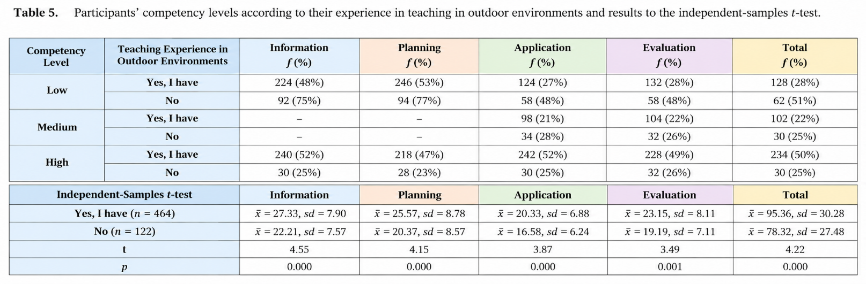
Table 5. Participants’ levels based on their teaching experience in outdoor environments and outcomes of the independent samples t-test.

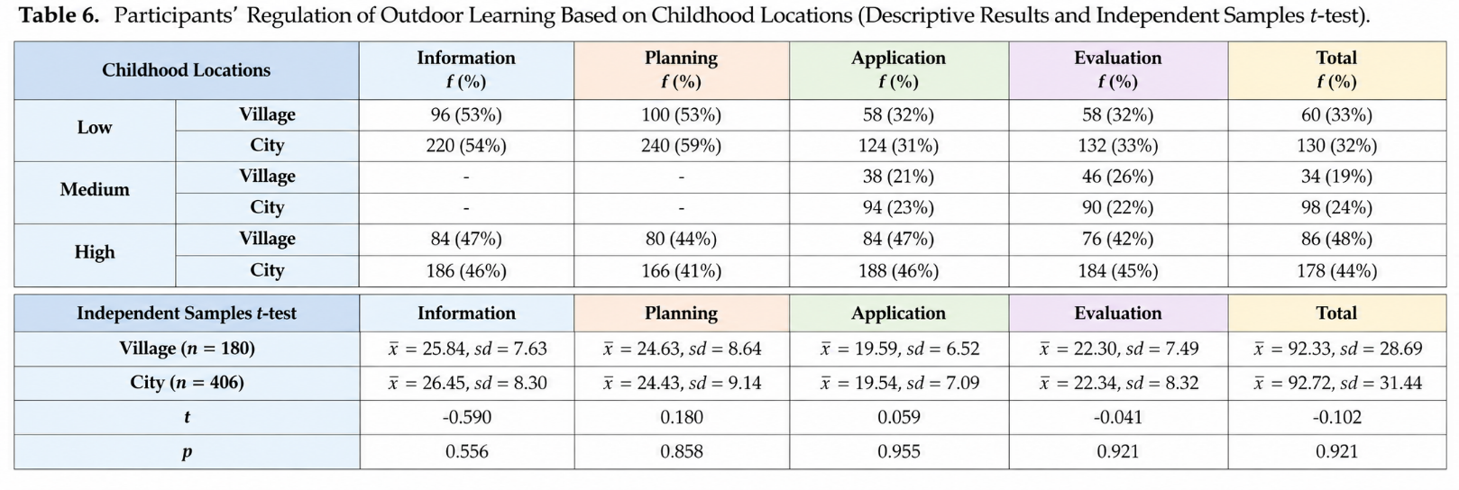
Table 6. Participants’ outdoor learning regulation competencies according to childhood residence: Descriptive statistics and independent-samples t-test results.

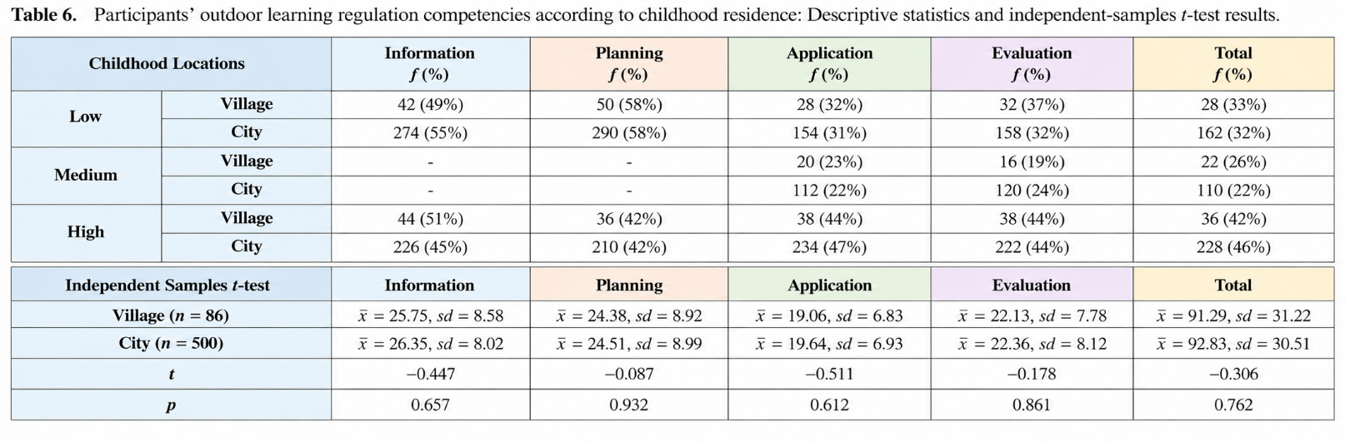
Table 6. Participants’ competencies in regulating outdoor learning by childhood location: Descriptive findings and independent-samples t-test analysis.

