From theory to experiment: transformer-based generation enables rapid discovery of novel reactions
Xinqiao Wang^{1†}, Chuansheng Yao^{2, 3†}, Yun Zhang^{1†}, Jiahui Yu¹, Haoran Qiao⁴, Chengyun Zhang¹, Yejian Wu¹, Renren Bai^{2,} ^{3*} & Hongliang Duan^{1*}
¹Artificial Intelligence Aided Drug Discovery Institute, College of Pharmaceutical Sciences, Zhejiang University of Technology, Hangzhou 310014, P. R. China
²College of Pharmacy, School of Medicine, Hangzhou Normal University, Hangzhou, PR China
³Key Laboratory of Elemene Class Anti-Cancer Chinese Medicines, Engineering Laboratory of Development and Application of Traditional Chinese Medicines, Collaborative Innovation Center of Traditional Chinese Medicines of Zhejiang Province, Hangzhou Normal University, Hangzhou, PR China
⁴College of Mathematics and Physics, Shanghai University of Electric Power, Shanghai, 201203 (P. R. China)
†Xinqiao Wang, Chuansheng Yao and Yun Zhang contributed equally to this work
*Corresponding Author: Hongliang Duan
Email: hduan@zjut.edu.cn
Renren Bai
Email: renrenbai@hznu.edu.cn

Table of content
Section S1 General mechanism of Heck reaction 3
Section S2 Experiment section 3
S2.1 General information 3
S2.2 General procedure for the preparation of compounds 1-8 4
S2.3 Spectra of compounds 1-8 4
Section S3 References 13

Section S1 General mechanism of Heck reaction
We summarized the general mechanism of the Heck reaction in Fig. S1. The precursor of Pd(II) is first activated to form a low coordination number Pd(0) before the oxidative addition of palladium and halogenated hydrocarbon, and palladium is subsequently inserted into the halogen-carbon bond in this process [1-3]. The palladium atoms then interact with the alkene to produce π complexes, and the coordinated alkene is inserted migration into the palladium-carbon bond. Then β-H is eliminated after rotational isomerization into trans isomers with lower torsional tension, and a new intermediate with coordination between palladium and alkene is obtained. The alkenes and the Pd(II) species are also produced in the following process, and the Pd(II) was converted to Pd(0) by reduction and elimination under the effect of the base. Numerous chemists have devoted to Heck reaction research because of its influence, demonstrating that the Heck reaction quantities is sufficient to train the model [4].

Fig. S1 General mechanism of Heck coupling reaction.

Section S2 Experiment section

S2.1 General information
All the starting materials were obtained from commercial sources and used without further purification. All the reactions were carried out under a dry nitrogen atmosphere. The 1H NMR and 13C NMR spectra were recorded on Bruker and Varian instruments at 500, 400 and 125, 100 MHz, respectively, where CDCl₃ or DMSO-d₆ was used as the solvent. J (coupling constants) is expressed in Hertz (Hz).

S2.2 General procedure for the preparation of compounds 1-8
To a solution of halobenzene or substituted halobenzene (1 mmol) in DMF (6 mL) under an atmosphere of dry nitrogen, Pd(OAc)₂ (2 mol%), (O-tolyl)₃P (4 mol%), substituted olefin (1.2 equiv), and DIPEA (2 equiv) were added. The reaction solution was deoxidized by nitrogen displacement three times and then heated to 120 ºC for 12 h. The mixture was then naturally cooled to room temperature. 15 mL of water was added and the mixture was extracted three times with EtOAc (3 × 15 mL). The combined organic layer was washed three times with saturated brine (3 × 15 mL), dried over anhydrous Na₂SO₄. The organic solvent was then removed under reduced pressure and separated by thin-layer silica gel (Fig. S2).
Fig. S2 The conditions of preparation of compounds 1-8.

S2.3 Spectra of compounds 1-8
Methyl cinnamate (1)
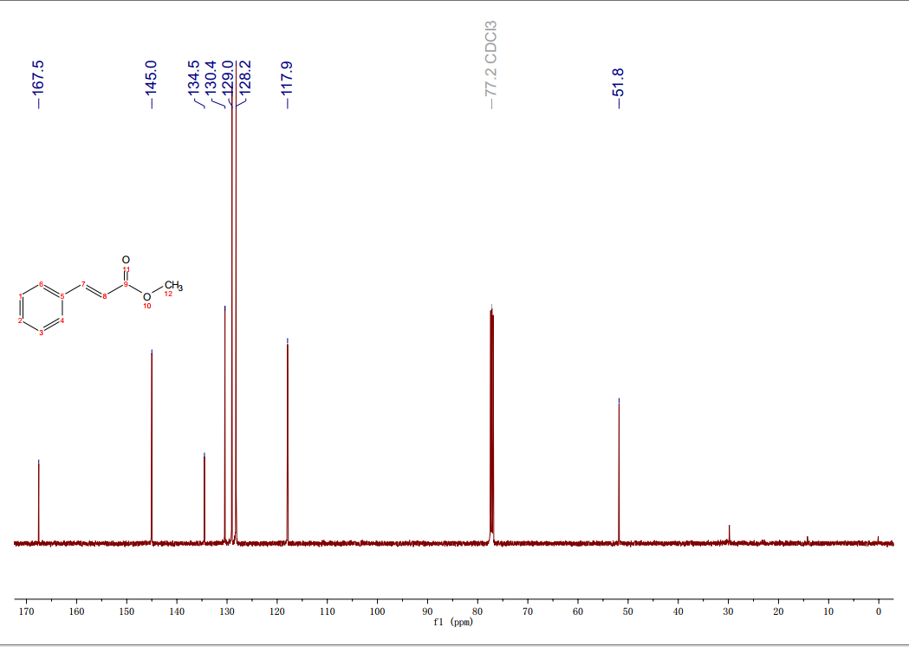
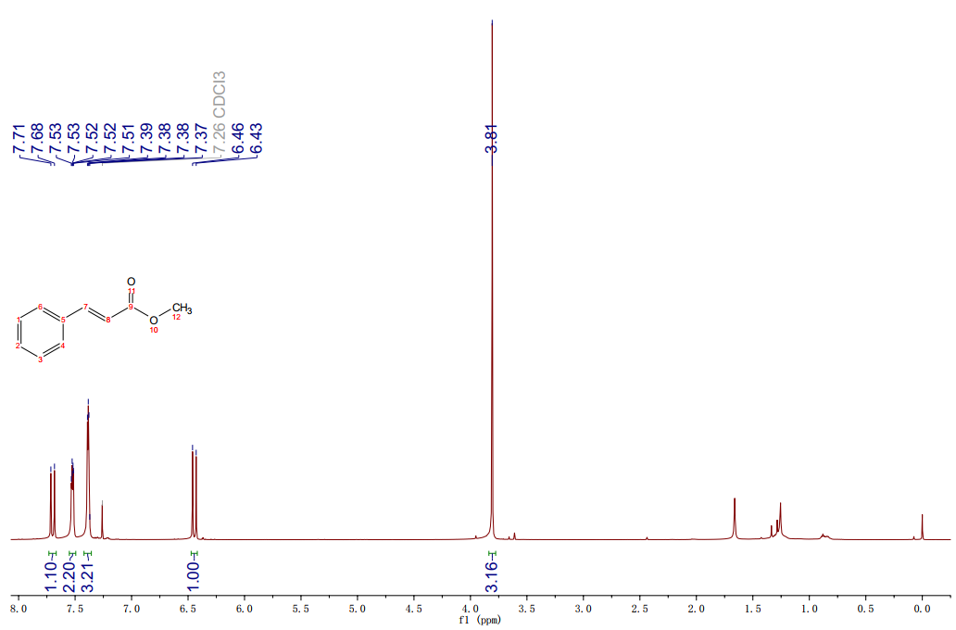
Yellowish solid, yield 61.7%; ¹H NMR (500 MHz, CDCl₃) δ 7.70 (d, J = 15.0 Hz, 1H), 7.53 - 7.51 (m, 2H), 7.39 - 7.37 (m, 3H), 6.44 (d, J = 15.0 Hz, 1H), 3.81 (s, 3H); ¹³C NMR (125 MHz, CDCl3) δ 167.5, 145.0, 134.5, 130.4, 129.0, 128.2, 117.9, 51.8. ¹H NMR and ¹³C NMR spectra of methyl cinnamate were shown in Fig. S3.
Fig. S3 ¹H NMR and ¹³C NMR spectra of methyl cinnamate (1).
(E)-3-(m-tolyl)acrylonitrile (2)
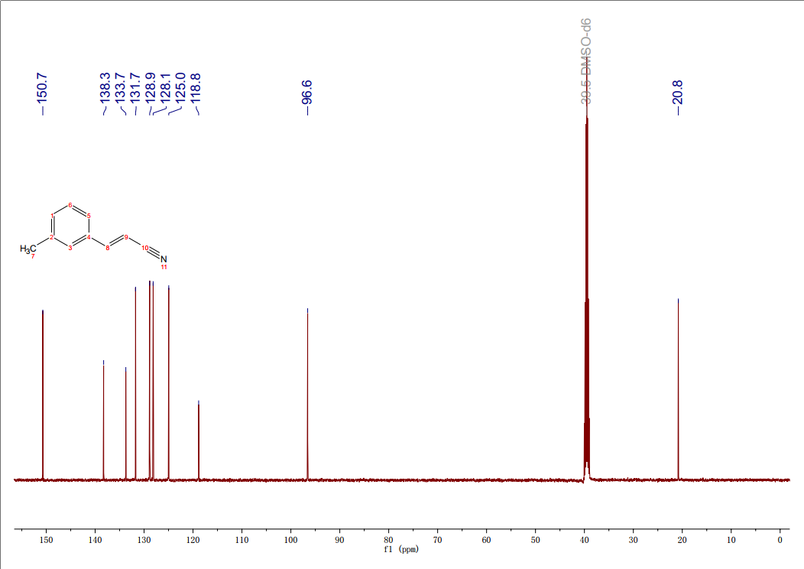
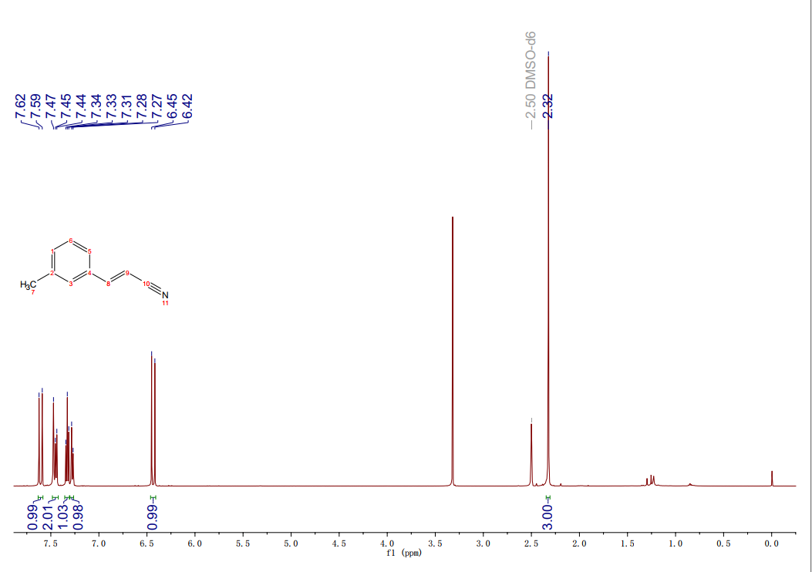
Colorless oil, yield 41.2%; ¹H NMR (500 MHz, DMSO-d₆) δ 7.61 (d, J = 15.0 Hz, 1H), 7.47 - 7.44 (m, 2H), 7.33 (t, J = 7.6 Hz, 1H), 7.28 (d, J = 5.0 Hz, 1H), 6.43 (d, J = 15.0 Hz, 1H), 2.32 (s, 3H); ¹³C NMR (125 MHz, DMSO-d₆) δ 150.7, 138.3, 133.7, 131.7, 128.9, 128.1, 125.0, 118.8, 96.6, 20.8. ¹H NMR and ¹³C NMR spectra of (E)-3-(m-tolyl)acrylonitrile were shown in Fig. S4.
Fig. S4 ¹H NMR and ¹³C NMR spectra of (E)-3-(m-tolyl)acrylonitrile (2).

Methyl (E)-3-(4-(methylthio)phenyl)acrylate (3)
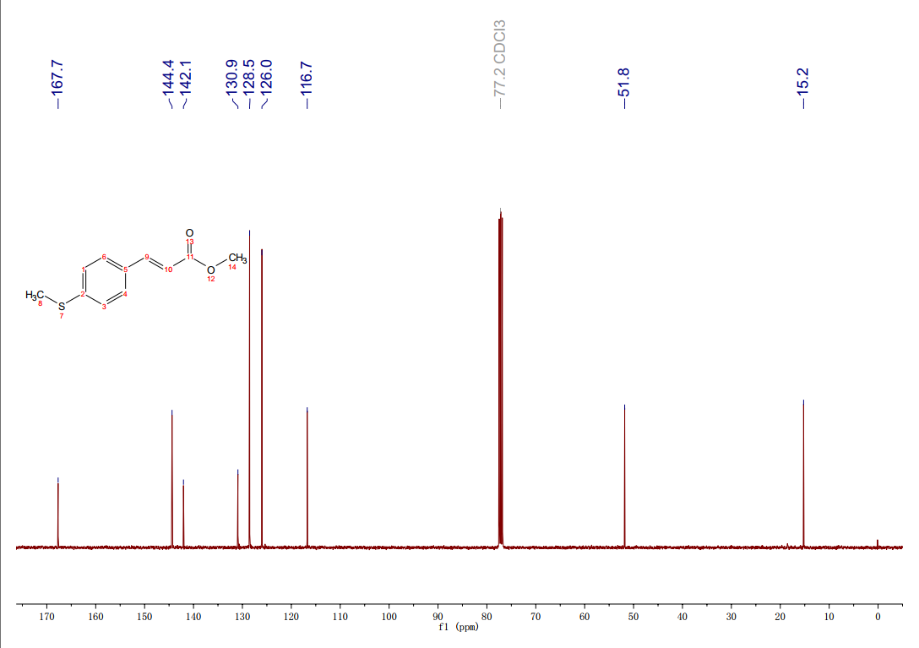
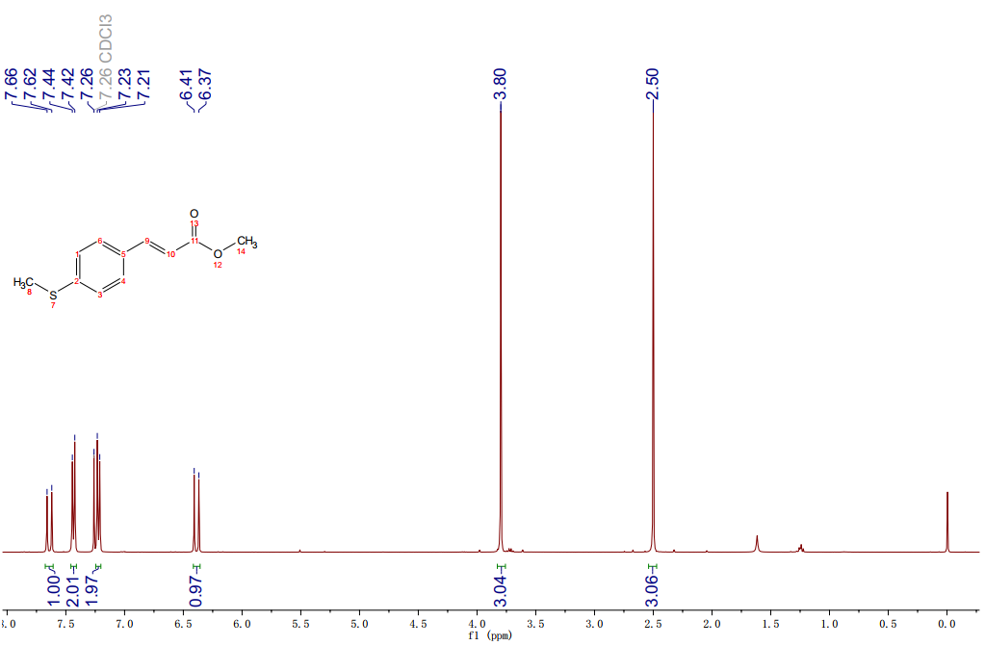
White solid, yield 54.8%; ¹H NMR (400 MHz, CDCl₃) δ 7.64 (d, J = 16.0 Hz, 1H), 7.43 (d, J = 8.0 Hz, 2H), 7.22 (d, J = 8.0 Hz, 2H), 6.39 (d, J = 16.0 Hz, 1H), 3.80 (s, 3H), 2.50 (s, 3H); ¹³C NMR (100 MHz, CDCl₃) δ 167.7, 144.4, 142.1, 130.9, 128.5, 126.0, 116.7, 51.8, 15.2. ¹H NMR and ¹³C NMR spectra of methyl (E)-3-(4-(methylthio)phenyl)acrylate were shown in Fig. S5.
Fig. S5 ¹H NMR and ¹³C NMR spectra of methyl (E)-3-(4-(methylthio)phenyl)acrylate (3).
Methyl (E)-3-(4-ethylphenyl)acrylate (4)
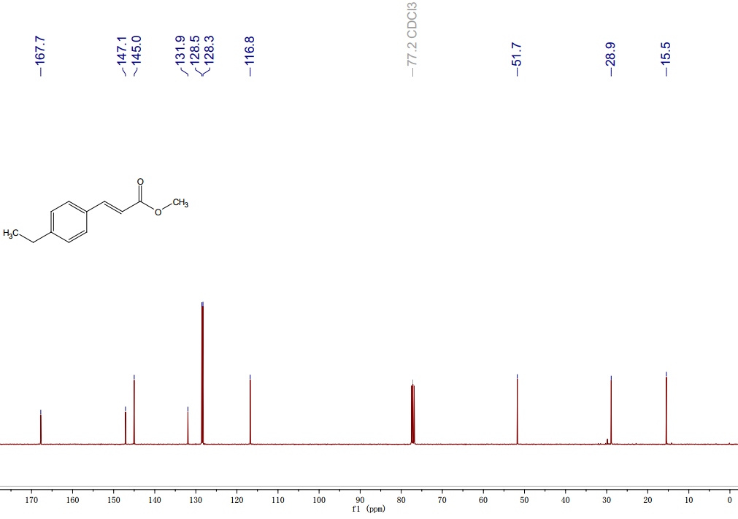
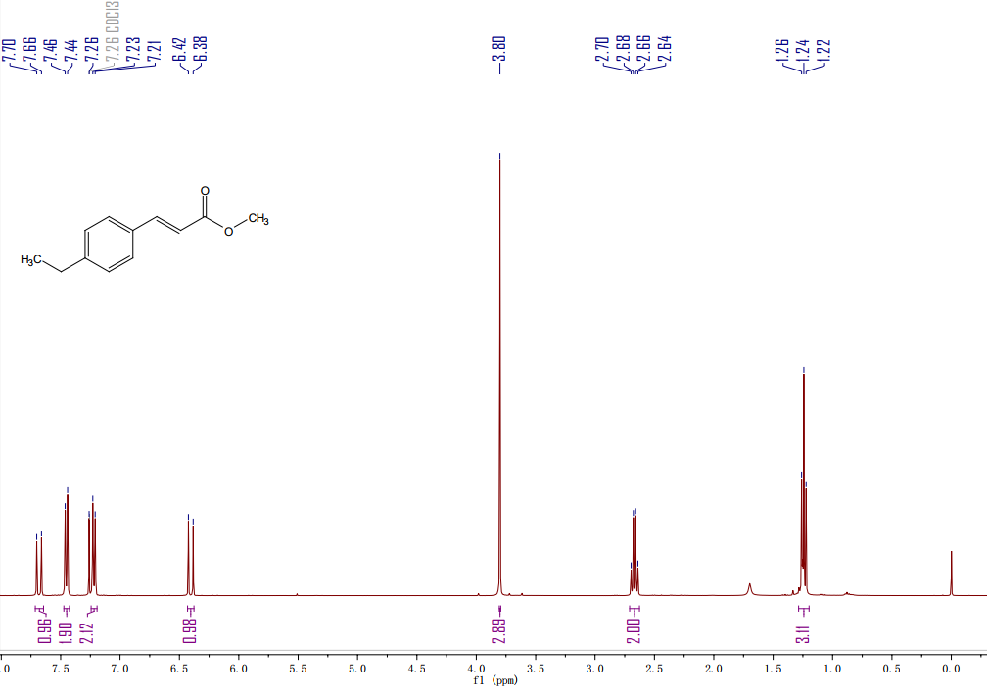
Colorless oil, yield 51.5%; ¹H NMR (400 MHz, CDCl₃) δ 7.68 (d, J = 16.0 Hz, 1H), 7.45 (d, J = 8.0 Hz, 2H), 7.22 (d, J = 8.0 Hz, 2H), 6.40 (d, J = 16.0 Hz, 1H), 3.80 (s, 3H), 2.67 (q, J = 7.6 Hz, 2H), 1.24 (t, J = 7.6 Hz, 3H); ¹³C NMR (100 MHz, CDCl₃) δ 167.7, 147.1, 145.0, 131.9, 128.5, 128.3, 116.8, 51.7, 28.9, 15.5. ¹H NMR and ¹³C NMR spectra of methyl (E)-3-(4-ethylphenyl)acrylate were shown in Fig. S6.
Fig. S6 ¹H NMR and ¹³C NMR spectra of methyl (E)-3-(4-ethylphenyl)acrylate (4).

Ethyl (E)-3-(3-ethoxy-3-oxoprop-1-en-1-yl)benzoate (5)
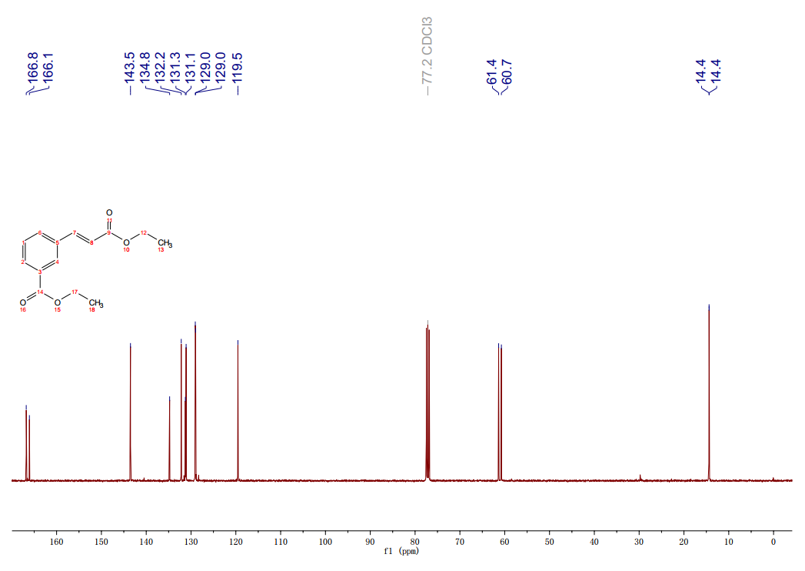
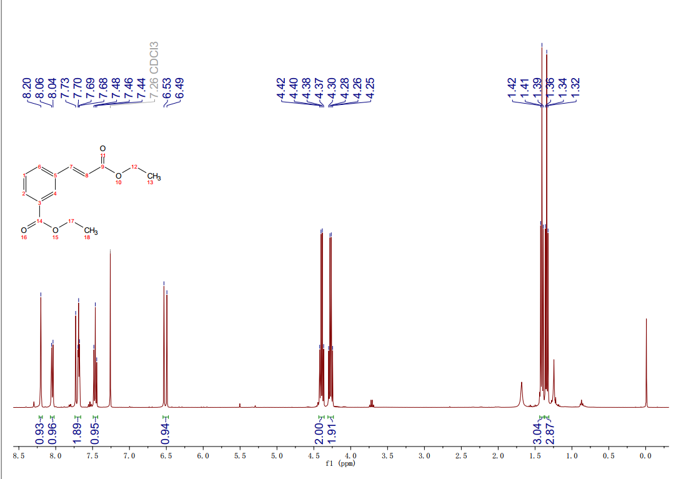
Colorless oil, yield 47.5%; ¹H NMR (400 MHz, CDCl₃) δ 8.20 (d, J = 1.7 Hz, 1H), 8.05 (d, J = 7.8, 1.4 Hz, 1H), 7.73 - 7.68 (m, 2H), 7.46 (t, J = 7.8 Hz, 1H), 6.51 (d, J = 16.0 Hz, 1H), 4.39 (q, J = 7.1 Hz, 2H), 4.27 (q, J = 7.1 Hz, 2H), 1.41 (t, J = 7.1 Hz, 3H), 1.34 (t, J = 7.1 Hz, 3H); ¹³C NMR (100 MHz, CDCl₃) δ 166.8, 166.1, 143.5, 134.8, 132.2, 131.3, 131.1, 129.0, 129.0, 119.5, 61.4, 60.7, 14.4, 14.4. ¹H NMR and ¹³C NMR spectra of ethyl (E)-3-(3-ethoxy-3-oxoprop-1-en-1-yl)benzoate were shown in Fig. S7.
Fig. S7 ¹H NMR and ¹³C NMR spectra of ethyl (E)-3-(3-ethoxy-3-oxoprop-1-en-1-yl)benzoate (5).
(E)-N,N-dimethyl-4-styrylaniline (6)
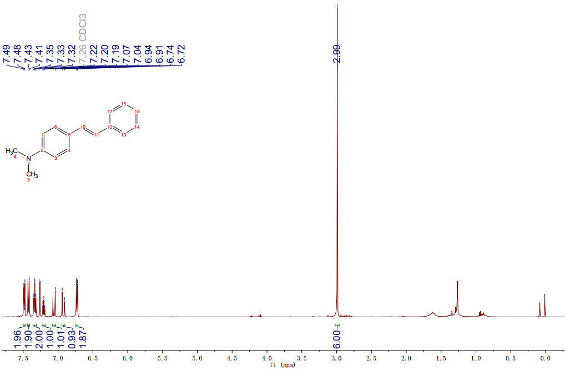
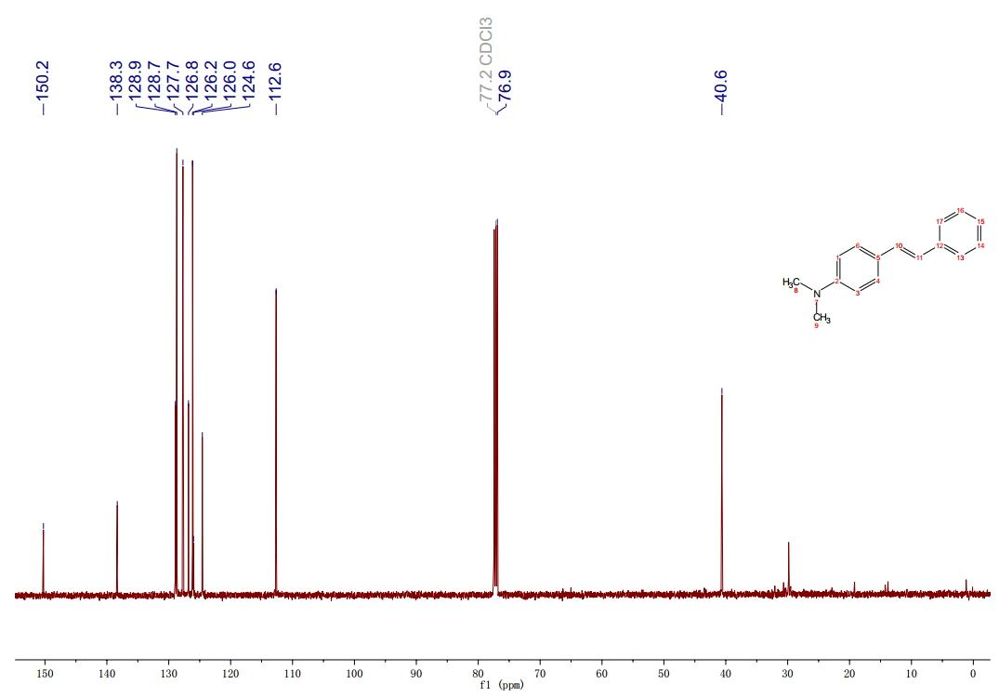
Yellowish solid, yield 15.7%; 1H NMR (500 MHz, CDCl₃) δ 7.48 (d, J = 7.9 Hz, 2H), 7.42 (d, J = 8.7 Hz, 2H), 7.33 (t, J = 7.8 Hz, 2H), 7.22 - 7.19 (m, 1H), 7.06 (d, J = 15.0 Hz, 1H), 6.92 (d, J = 15.0 Hz, 1H), 6.73 (d, J = 8.7 Hz, 2H), 2.99 (s, 6H). ¹³C NMR (125 MHz, CDCl₃) δ 150.2, 138.3, 128.9, 128.7, 127.7, 126.8, 126.2, 126.0, 124.6, 112.6, 40.6. ¹H NMR and ¹³C NMR spectra of (E)-N,N-dimethyl-4-styrylaniline were shown in Fig. S8.
Fig. S8 ¹H NMR and ¹³C NMR spectra of (E)-N,N-dimethyl-4-styrylaniline (6).

(E)-3-([1,1'-biphenyl]-2-yl)allyl acetate (7)
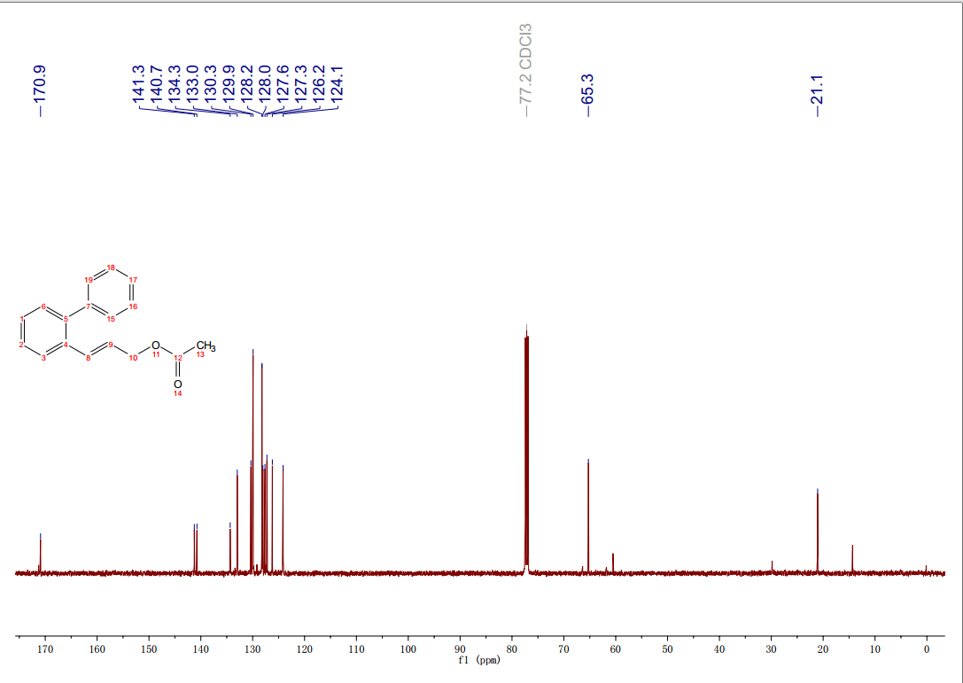
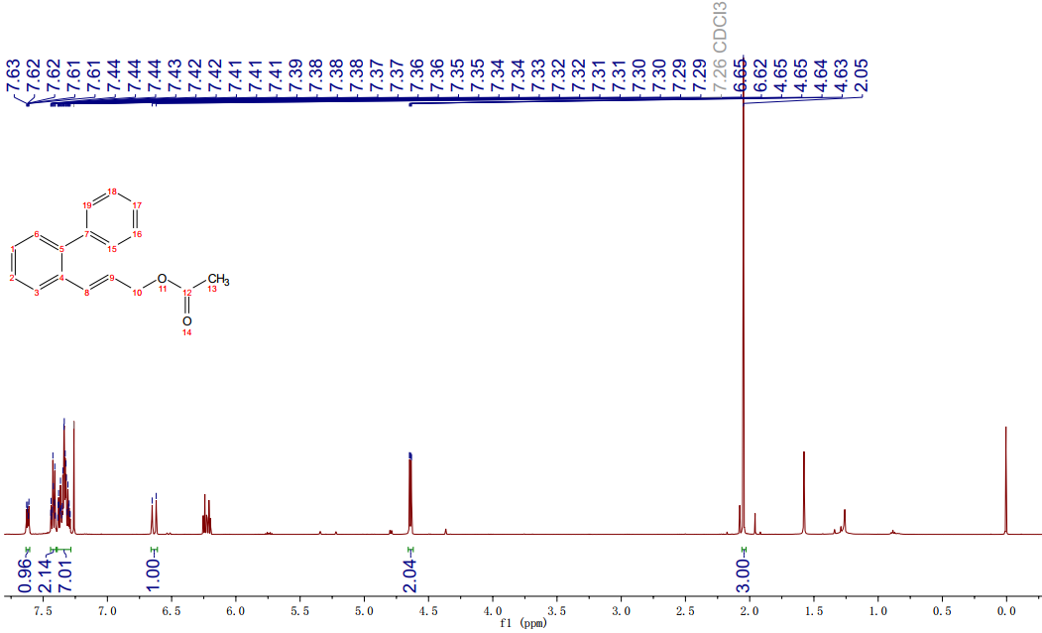
Yellowish oil, yield 13.1%; ¹H NMR (500 MHz, CDCl₃) δ 7.64 – 7.61 (m, 1H), 7.44 – 7.39 (m, 2H), 7.38 - 7.29 (m, 7H), 6.64 (d, J = 15.0 Hz, 1H), 4.64 (dd, J = 6.4, 1.4 Hz, 2H), 2.05 (s, 3H). 13C NMR (125 MHz, CDCl₃) δ 170.9, 141.3, 140.7, 134.3, 133.0, 130.3, 129.9, 128.2, 128.0, 127.6, 127.3, 126.2, 124.1, 65.3, 21.1. ¹H NMR and ¹³C NMR spectra of (E)-3-([1,1'-biphenyl]-2-yl)allyl acetate were shown in Fig. S9.
Fig. S9 ¹H NMR and ¹³C NMR spectra of (E)-3-([1,1'-biphenyl]-2-yl)allyl acetate (7).

Cyclohexyl (E)-3-(4-(tert-butyl)phenyl)acrylate (8)
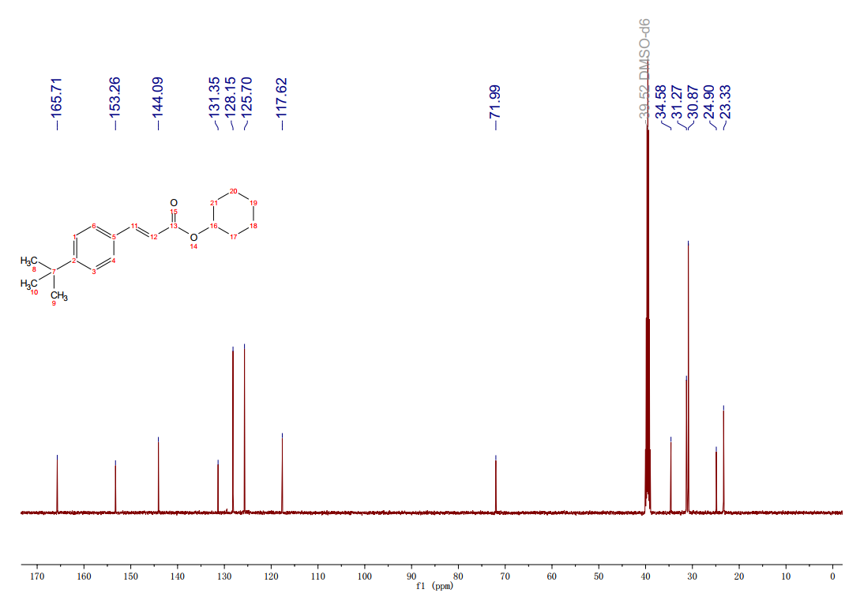
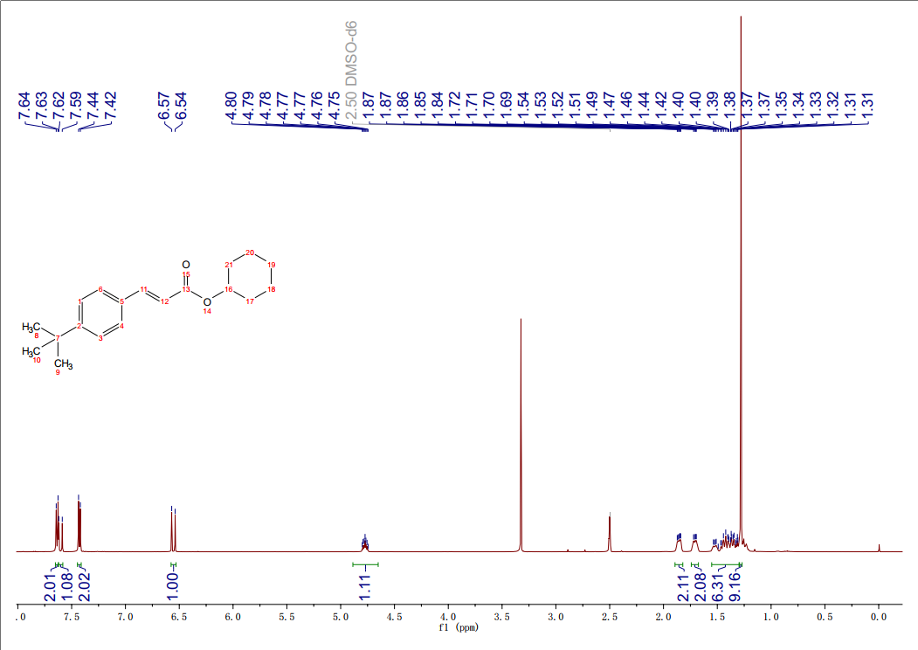
Colorless oil, yield 57.3%; ¹H NMR (500 MHz, DMSO-d₆) δ 7.64 (d, J = 8.4 Hz, 2H), 7.60 (d, J = 15.0 Hz, 1H), 7.43 (d, J = 8.4 Hz, 2H), 6.55 (d, J = 15.0 Hz, 1H), 4.80 - 4.75 (m, 1H), 1.87 - 1.84 (m, 2H), 1.72 - 1.69 (m, 2H), 1.54 - 1.31 (m, 6H), 1.28 (s, 9H); ¹³C NMR (125 MHz, DMSO-d₆) δ 165.7, 153.3, 144.1, 131.3, 128.2, 125.7, 117.6, 72.0, 34.6, 31.3, 30.9, 24.9, 23.3. ¹H NMR and ¹³C NMR spectra of cyclohexyl (E)-3-(4-(tert-butyl)phenyl)acrylate were shown in Fig. S10.
Fig. S10 ¹H NMR and ¹³C NMR spectra of cyclohexyl (E)-3-(4-(tert-butyl)phenyl)acrylate (8).

Section S3 References
1. Amatore C, Carre E, Jutand, A and M'Barki MA (1995) Rates and mechanism of the formation of zerovalent palladium complexes from mixtures of Pd (OAc) 2 and tertiary phosphines and their reactivity in oxidative additions. Organometallics, 14: 1818-1826.
2. Jutand A and Mosleh A (1995) Rate and Mechanism of Oxidative Addition of Aryl Triflates to Zerovalent Palladium Complexes. Evidence for the Formation of Cationic (. sigma.-Aryl) palladium Complexes, Organometallics. 14: 1810-1817.
3. Thorn DL and Hoffmann R (1978) The olefin insertion reaction. J Am Chem Soc 100: 2079-2090.
4. Crisp GT (1998) Variations on a theme-recent developments on the mechanism of the Heck reaction and their implications for synthesis. Chem Soc Rev 27: 427-436.

