Supporting Information

Long-range transport of sulfur dioxide emissions from external sources to Tehran

Reza Bashiri Khuzestani ª, Ahmad Taheri ^{b}, Bijan Yeganeh ^{a, c*}

ª Faculty of Civil, Water and Environmental Engineering, Shahid Beheshti University, Tehran, Iran
^{b} Tehran Air Quality Control Company, Tehran Municipality, Tehran, Iran
^{c} Centre for Air pollution, Energy and Health Research (CAR), Glebe, New South Wales, 2037, Australia

* Corresponding author: Bijan Yeganeh, PhD
email: b_yeganeh@sbu.ac.ir

Figure S1: Timeseries and monthly averaged meteorological parameters including temperature, wind speed and humidity during 2018-2020 in Tehran

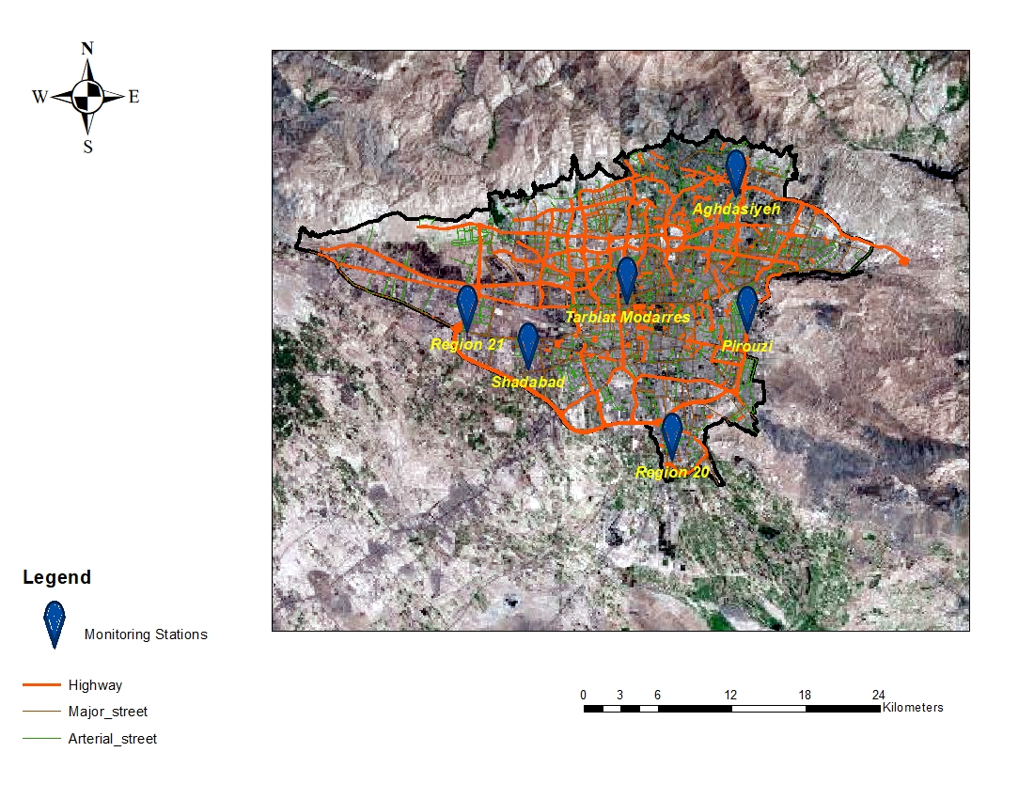
Fig S2. The geographical location of our monitoring sites in Tehran. Monitoring stations covered different types of environments in Tehran and classified as urban-residential (Tarbiat Modarres), traffic hotspots (Shadabad and Region 21 areas), industrial (Region 20 area), and residential (Aghdasiyeh and Pirouzi areas).

Table S1. Characteristics of our SO₂ monitoring stations, including name, geographical locations and the types of the analyzers used in each monitor.

Station Name (Code) | Location | Species Monitored | Analyzer models | Characteristics
Aghdasiyeh  (AGD) | 51.48414, 35.79587 | O₃ | Environnement S.A | Traffic-residential (north)
Aghdasiyeh  (AGD) | 51.48414, 35.79587 | CO | Environnement S.A | Traffic-residential (north)
Aghdasiyeh  (AGD) | 51.48414, 35.79587 | SO₂ | Environnement S.A | Traffic-residential (north)
Aghdasiyeh  (AGD) | 51.48414, 35.79587 | NO, NO₂, NO_{X} | Environnement S.A | Traffic-residential (north)
Aghdasiyeh  (AGD) | 51.48414, 35.79587 | PM_{2.5} | Environnement S.A | Traffic-residential (north)
Aghdasiyeh  (AGD) | 51.48414, 35.79587 | PM₁₀ | Environnement S.A | Traffic-residential (north)
Pirouzi  (PIR) | 51.49376, 35.69599 | O₃ | Ecotech | Traffic-residential (east)
Pirouzi  (PIR) | 51.49376, 35.69599 | CO | Ecotech | Traffic-residential (east)
Pirouzi  (PIR) | 51.49376, 35.69599 | SO₂ | Ecotech | Traffic-residential (east)
Pirouzi  (PIR) | 51.49376, 35.69599 | NO, NO₂, NO_{X} | Ecotech | Traffic-residential (east)
Pirouzi  (PIR) | 51.49376, 35.69599 | PM_{2.5} | Met-One | Traffic-residential (east)
Pirouzi  (PIR) | 51.49376, 35.69599 | PM₁₀ | Met-One | Traffic-residential (east)
Region 20  (R20) | 51.42571, 35.60363 | O₃ | Environnement S.A | Industrial-Traffic (south)
Region 20  (R20) | 51.42571, 35.60363 | CO | Environnement S.A | Industrial-Traffic (south)
Region 20  (R20) | 51.42571, 35.60363 | SO₂ | Environnement S.A | Industrial-Traffic (south)
Region 20  (R20) | 51.42571, 35.60363 | NO, NO₂, NO_{X} | Environnement S.A | Industrial-Traffic (south)
Region 20  (R20) | 51.42571, 35.60363 | PM_{2.5} | Environnement S.A | Industrial-Traffic (south)
Region 20  (R20) | 51.42571, 35.60363 | PM₁₀ | Environnement S.A | Industrial-Traffic (south)
Region 21  (R21) | 51.24311, 35.697773 | O₃ | Ecotech | Traffic-Upwind (west)
Region 21  (R21) | 51.24311, 35.697773 | CO | Ecotech | Traffic-Upwind (west)
Region 21  (R21) | 51.24311, 35.697773 | SO₂ | Ecotech | Traffic-Upwind (west)
Region 21  (R21) | 51.24311, 35.697773 | NO, NO₂, NO_{X} | Ecotech | Traffic-Upwind (west)
Region 21  (R21) | 51.24311, 35.697773 | PM_{2.5} | Met-One | Traffic-Upwind (west)
Region 21  (R21) | 51.24311, 35.697773 | PM₁₀ | Met-One | Traffic-Upwind (west)
Shadabad  (SHAD) | 51.29735, 35.67005 | O₃ | Ecotech | Traffic-Upwind (west)
Shadabad  (SHAD) | 51.29735, 35.67005 | CO | Ecotech | Traffic-Upwind (west)
Shadabad  (SHAD) | 51.29735, 35.67005 | SO₂ | Ecotech | Traffic-Upwind (west)
Shadabad  (SHAD) | 51.29735, 35.67005 | NO, NO₂, NO_{X} | Ecotech | Traffic-Upwind (west)
Shadabad  (SHAD) | 51.29735, 35.67005 | PM_{2.5} | Met-One | Traffic-Upwind (west)
Shadabad  (SHAD) | 51.29735, 35.67005 | PM₁₀ | Met-One | Traffic-Upwind (west)
Tarbiat Modarres  (TARB) | 51.385909, 35.71751 | O₃ | Ecotech | Residential-Urban (center)
Tarbiat Modarres  (TARB) | 51.385909, 35.71751 | CO | Ecotech | Residential-Urban (center)
Tarbiat Modarres  (TARB) | 51.385909, 35.71751 | SO₂ | Ecotech | Residential-Urban (center)
Tarbiat Modarres  (TARB) | 51.385909, 35.71751 | NO, NO₂, NO_{X} | Ecotech | Residential-Urban (center)
Tarbiat Modarres  (TARB) | 51.385909, 35.71751 | PM_{2.5} | Met-One | Residential-Urban (center)
Tarbiat Modarres  (TARB) | 51.385909, 35.71751 | PM₁₀ | Met-One | Residential-Urban (center)

Table S2: overall data quality, including the percentage of data coverage over the year as well as the percentage of the missing data for the study period in all of our monitoring areas
 | data coverage in each site (%)
Month | AGD | PIR | R20 | R21 | SHAD
January | 97.04 | 96.91 | 91.30 | 96.95 | 88.69
February | 98.92 | 75.98 | 98.89 | 99.99 | 99.94
March | 93.38 | 93.22 | 93.27 | 93.27 | 93.04
April | 99.69 | 98.85 | 76.40 | 99.91 | 99.71
May | 100.00 | 100.00 | 100.00 | 100.00 | 69.02
June | 99.73 | 99.83 | 99.87 | 100.00 | 71.18
July | 100.00 | 95.65 | 100.00 | 100.00 | 100.00
August | 99.89 | 99.34 | 99.90 | 99.81 | 99.91
September | 98.40 | 99.40 | 100.00 | 99.90 | 97.38
October | 96.89 | 96.77 | 96.62 | 96.79 | 96.80
November | 96.81 | 96.68 | 96.64 | 90.09 | 96.70
December | 99.91 | 99.87 | 93.74 | 99.87 | 80.65
Total | 105504 | 102855 | 102555 | 105120 | 96861
Missing data (%) | 2.09 | 3.10 | 3.47 | 3.88 | 4.30

Fig. S3. Hexbin map of the frequencies of all the back-trajectories arriving in Tehran from January 2020 to December 2020.

Fig.S4. Nonparametric Wind Regression (NWR) analysis of SO₂ in each monitoring area in Tehran. a) AGD, b) TARB, c) PIR, d) R20, e) R21, and f) SHAD.

Fig. S5. k-mean cluster analysis of the general SO₂ emission data in Tehran for 2-10 cluster numbers

Fig. S6. Diurnal variation patterns of cluster-averaged SO₂ concentration in each monitoring site in Tehran.

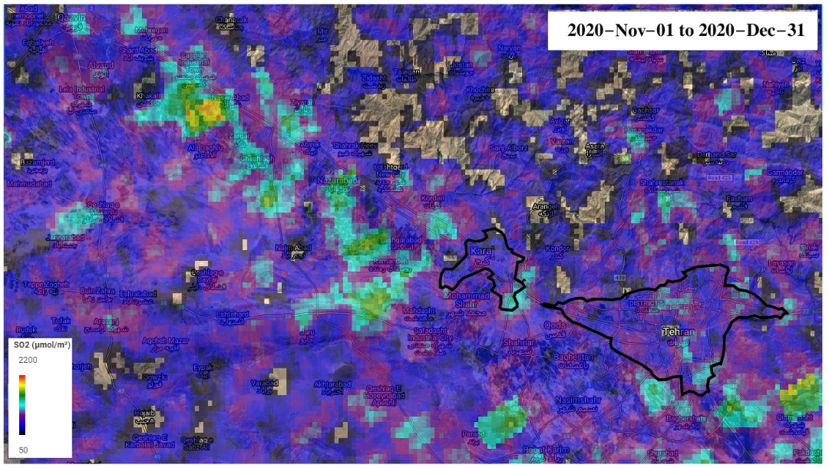
Fig. S7. Existence of large SO₂ plumes from power plants and oil/gas industries in external location from the western areas in Tehran.

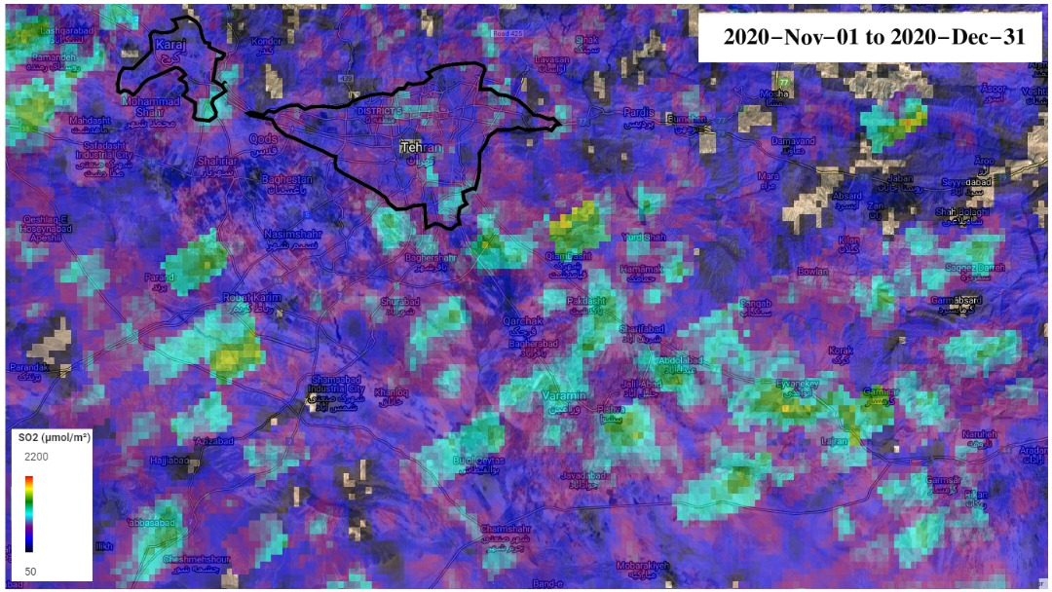
Fig. S8. Existence of large SO₂ plumes from power plants and oil/gas industries in the external location from the southern areas in Tehran.

Table S3. Pairwise regression analysis including slope and intercept between each pair
Pairs | Slope | Slope uncertainty | Remark | Intercept | Intercept uncertainty | R2 | remark
AGD-TARB | 0.98 | 0.017 | R | 1.37 | 0.08 | 0.31 | L
AGD-R21 | 0.56 | 0.025 | L | 5.08 | 0.12 | 0.056 | L
AGD-SHAD | 0.79 | 0.032 | L | 4.72 | 0.16 | 0.08 | L
AGD-R20 | 0.89 | 0.13 | R | 2.7 | 0.11 | 0.28 | L
TARB-R21 | 0.58 | 0.014 | L | 4.29 | 0.10 | 0.20 | L
TARB-SHAD | 0.76 | 0.017 | L | 3.95 | 0.12 | 0.25 | L
TARB-R20 | 0.6 | 0.013 | L | 3.43 | 0.09 | 0.20 | L
R21-SHAD | 0.78 | 0.112 | R | 2.52 | 0.11 | 0.38 | L
R21-R20 | 0.21 | 0.011 | L | 5.17 | 0.10 | 0.048 | L
R20-SHAD | 0.35 | 0.014 | L | 5.78 | 0.13 | 0.078 | L
L: local emission
R: regional

