Supporting Information

Wax-coated jute bags preserve seed moisture content and viability over nine months of storage under contrasting humidity and temperature condition

Muhammad Subkhi Sadullah^{1,2,3‡}, Kennedy Odokonyero^{1,2, ‡}, Wafa M. Taef⁴,
and Himanshu Mishra^{1,2,3,*}
¹Environmental Science and Engineering (EnSE) Program, Biological and Environmental Science and Engineering (BESE) Division, King Abdullah University of Science and Technology (KAUST), Thuwal, 23955-6900, Saudi Arabia.
²Center of Excellence for Sustainable Food Security, King Abdullah University of Science and Technology (KAUST), Thuwal 23955-6900, Kingdom of Saudi Arabia
³Water Desalination and Reuse Platform (WDRP), King Abdullah University of Science and Technology (KAUST), Thuwal 23955-6900, Kingdom of Saudi Arabia
⁴Energy and Bio-products Research Institute (EBRI), Aston University, Birmingham, UK

*Correspondence: Himanshu.mishra@kaust.edu.sa
‡Equal authors contributions

This Supporting Information document provides experimental data and visual evaluations to support the primary manuscript. As noted in the main text, moisture uptake in control jute bags (CJBs) exhibited a strong positive dependence on temperature at fixed relative humidity, a behavior inconsistent with pure water vapor sorption phenomena, where equilibrium moisture content (EMC) decreases slightly with increasing temperature. This anomalous moisture accumulation was driven by capillary wicking due to direct contact with liquid water. The visual evaluations of the grain and packaging materials (Figure S1) directly corroborate the final seed moisture content (SMC) measurements, highlighting severe dampness, discoloration, and fungal deterioration in CJBs at elevated temperatures and humidities. Conversely, wax-coated jute bags (WCJBs) effectively suppressed liquid moisture ingress via surface hydrophobicity. The consequences of the use of wax coating of the jute bags on seed viability and crop vigor were quantified via germination potential assessments (Figure S2). In addition, Figure 3
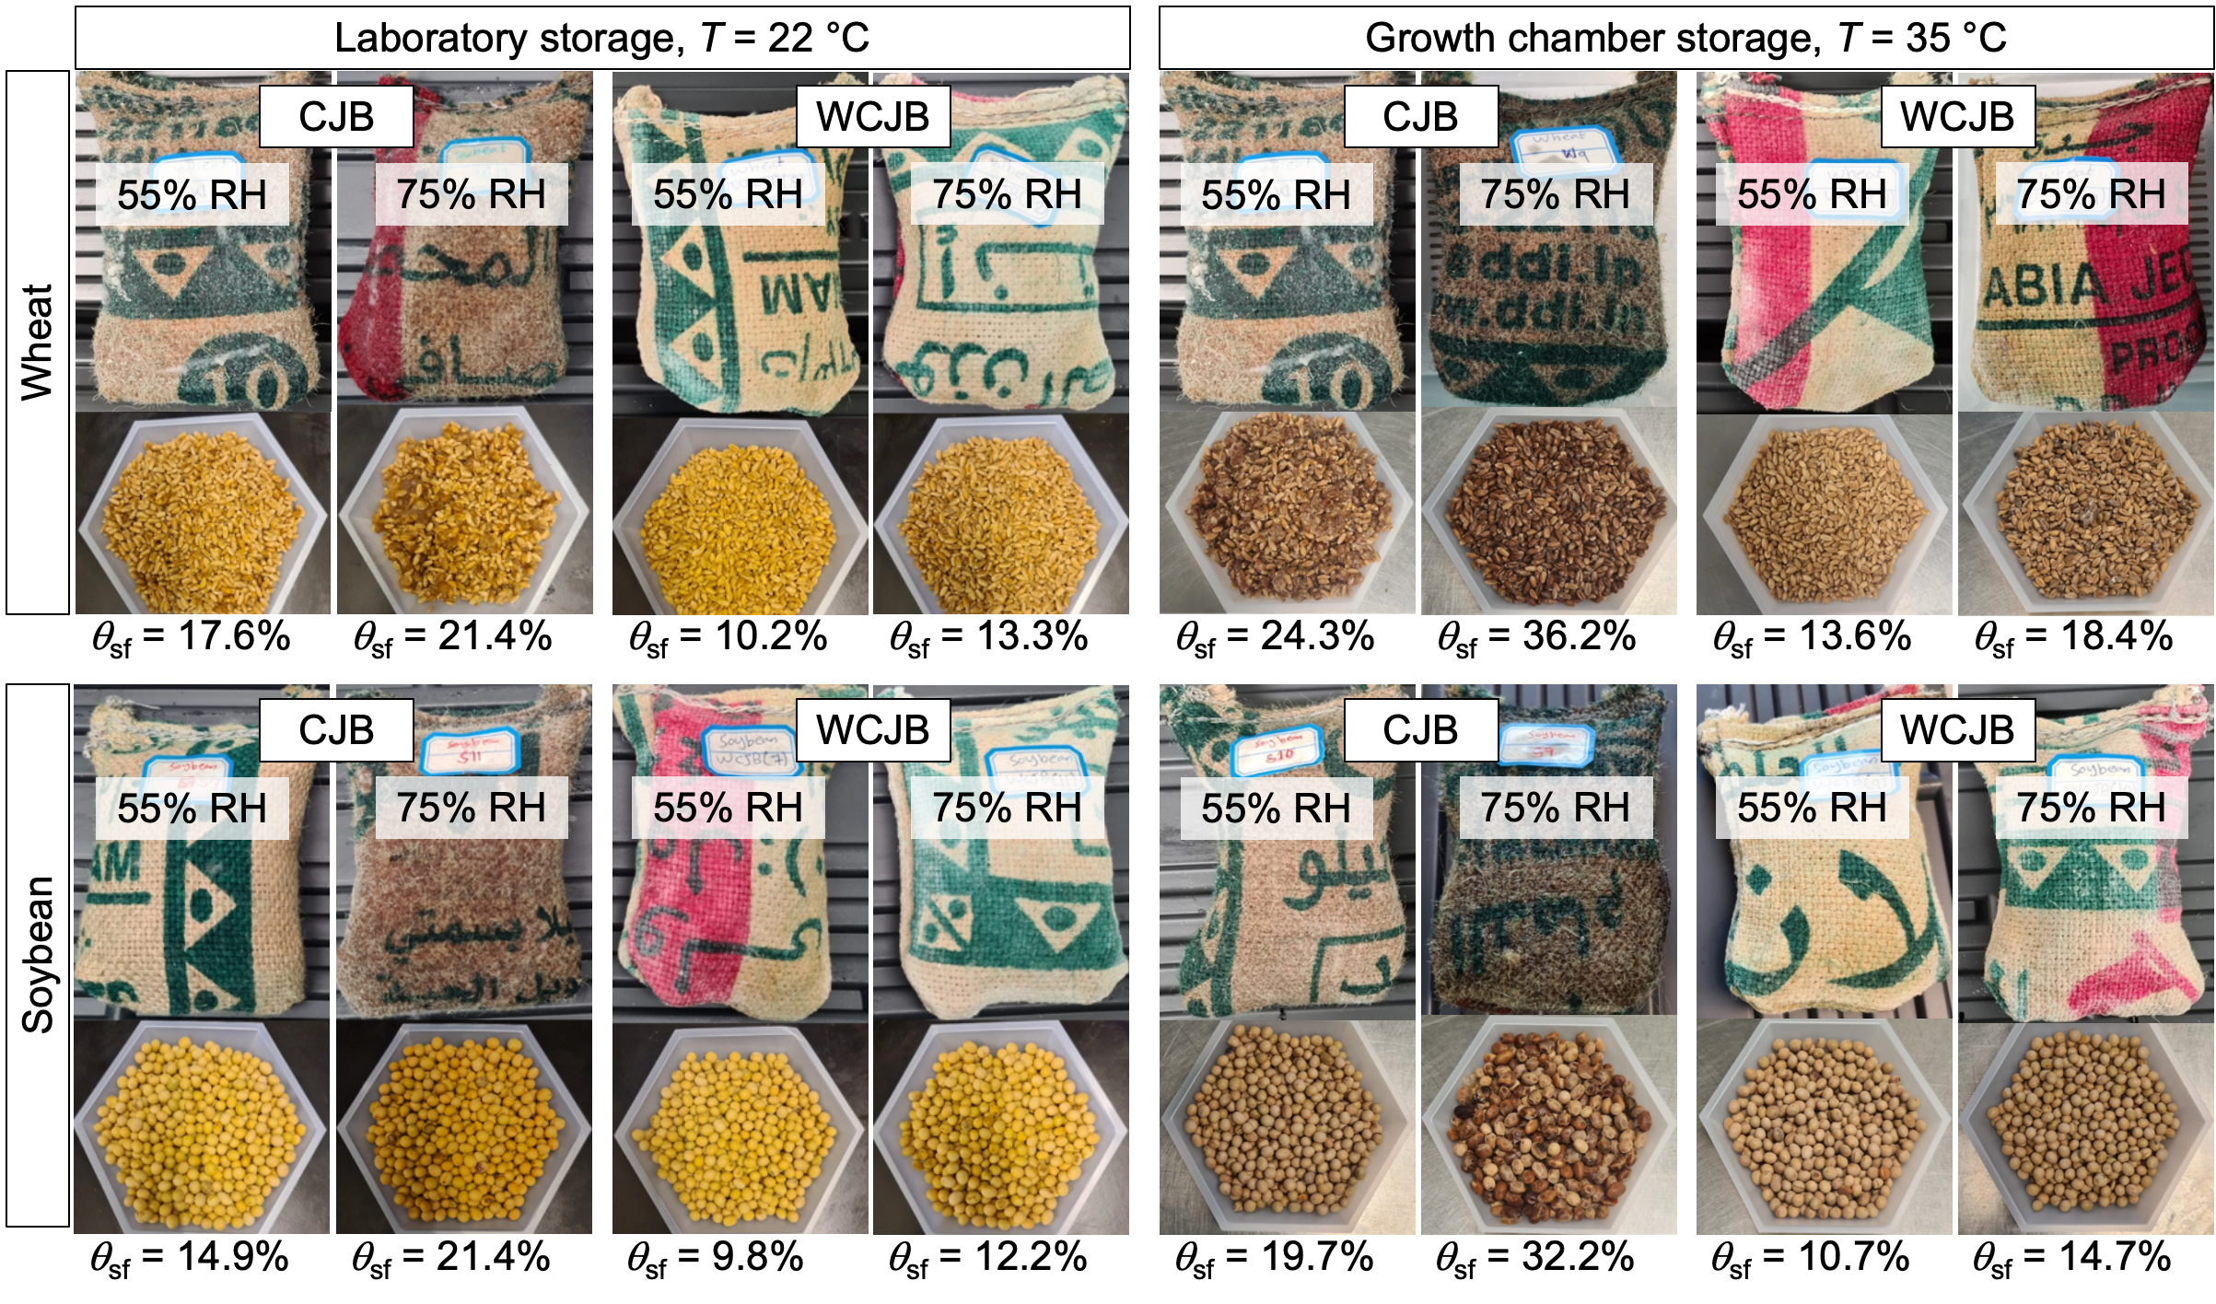
Figure S1. Visual appearance. Representative photographs of wheat (top panels) and soybean (bottom panels) seeds and the jute bags after nine months of storage. CJBs stored at 35 °C and 75% RH exhibit severe structural damping, fabric discoloration due to surface mold, especially at 75% RH. In contrast, WCJBs and their enclosed seeds remain visibly dry and structurally intact across all conditions.
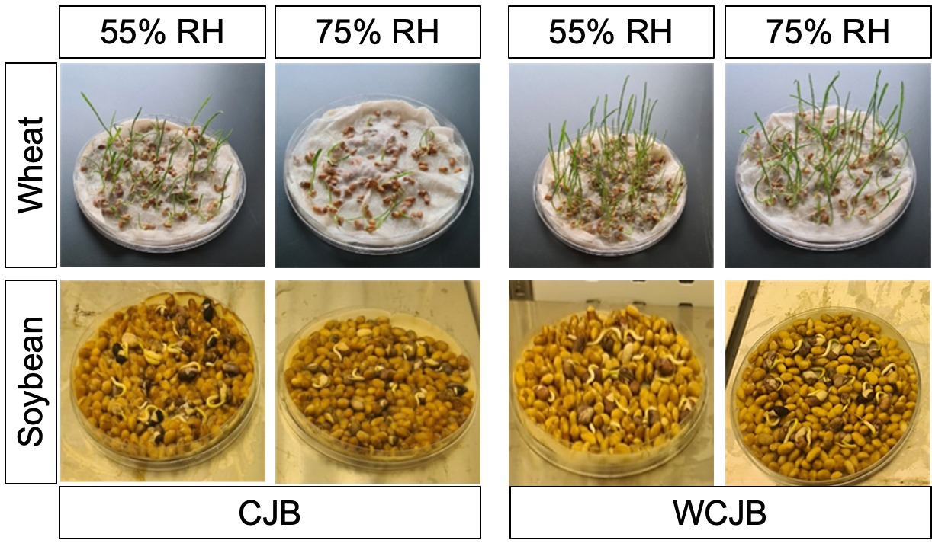
Figure S2. Post-storage seed germination potential and seedling vigor assessment. Experimental setup and representative seedling appearances for wheat (top panels) and soybean (bottom panels) after nine months of storage in CJBs and WCJBs. Seedlings from WCJB storage maintained high germination percentages (>75%) across all RH and temperature combinations, reflecting final seed moisture contents held close to target equilibrium levels. Conversely, seeds retrieved from CJBs under exhibited complete germinative collapse especially when stored under high RH.

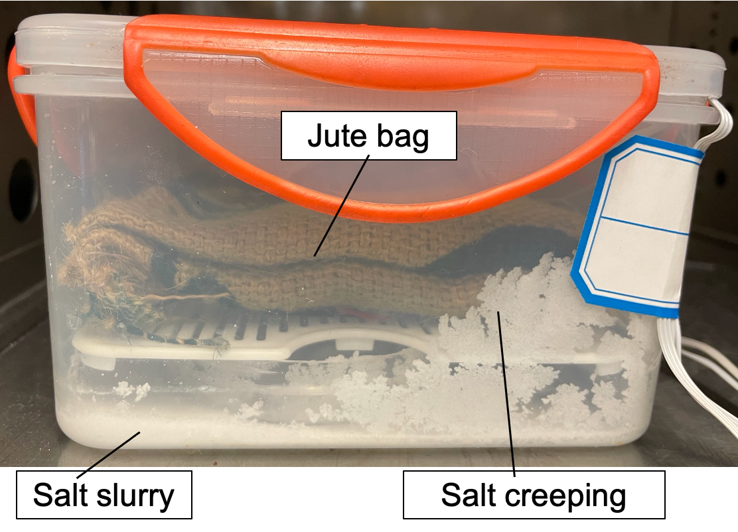
Figure S3. Salt creep along the support structure. Salt crystals from the saturated slurry migrated several millimeters above the drainage tray, presenting a potential pathway for salt contamination and moisture uptake to the jute bags during the storage experiment.

