Small extracellular vesicles released from bioglass/hydrogel scaffold promote vascularized bone regeneration by transferring miR-23a-3p
Hongxing Hu^{1, a}, Hang Zhang^{1, c}, Ziheng Bu^{b}, Mingmang Pan^{e}, Fang Lv^{d,e*}, Zhongtang Liu^{b*}, Liming Cheng^{a*}
- Department of Orthopedics, Tongji Hospital Affiliated to Tongji University, Tongji University School of Medicine, 389 Xincun Road Shanghai,200065, China
- Department of Orthopedics Changhai Hospital Affiliated to the Second Military Medical University, 168 Changhai Road, Shanghai 200233, China
- School of Mechanical Engineering, Shanghai Jiao Tong University, 800 Dongchuan Road, Shanghai 200240, China
- Shanghai Key Laboratory of Regulatory Biology, Institute of Biomedical Science and School of Life Science, East China Normal University, 500 Dongchuan Road, Shanghai 200241, China
- Department of orthopedics, Southern Medical University Affiliated Fengxian Hospital,.6600 Nanfeng Road, Shanghai, 201499, China
Co-authers:
Hongxing Hu: huhongxing0422@163.com
Hang Zhang: hangzhang@sjtu.edu.cn
*Corresponding authors:
Dr. Fang Lv: Email: dafang_lucky@163.com
Dr. Zhongtang Liu: Email: surgeon_liu@163.com
Dr. Liming Cheng: Email: limingcheng@tongji.edu.cn
Supplementary Figures
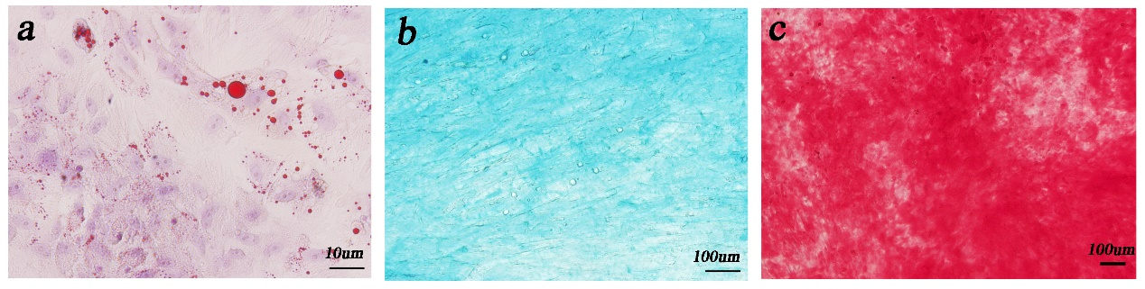
Supplementary Figure 1. hUC-MSCs showed muti-lineage differentiation of adipogenesis (a), chondrogenesis (b) and osteogenesis (c).

Supplementary Figure 2. HUVECs were cultured with sEVs for 24h, then qPCR was used to measure miR-23a-3p expression level in cells. Three independent replicates have been statistical analysis. *p < 0.05.
Supplementary Figure 3. Western blot was implemented to evaluate the expression levels of AKT, P-AKT, PTEN in HUVECs.
Supplementary Figure 4. (b) CCK-8 assay of BMSCs cultured on BG and BG-gel scaffolds.

Supplementary table 1: The sequence of the primers.
Gene | Sequences
OCN | F-5’-CTCACAGATGCCAAGCCCA-3’
OCN | R-5’-CAAGGTAGCGCCGGAGTCT-3’
ALP | F-5’-TCCTGACCAAAAACCTCAAAGG-3’
ALP | R-5’-TGCTTCATGCAGAGCCTGC-3’
BMP-2 | F-5’-ACTACCAGAAACGAGTGGGAA-3’
BMP-2 | R-5’-GCATCTGTTCTCGGAAAACCT-3’

Supplementary table 2: The sequence of antagomir-23a-3p and scramblemir.
Name | Sequences
Antagomir-23a-3p | 5’-GGAAAUCCCGGCAAUGUGAU-3’
Scramblemir | 5’-CAGUACUUUUGUGUAGUACAA-3’

