Fig.S1 a. Scanning electron micrograph of strain R-1-5s-1^{T} grown at 37°C on LB agar medium. Bar 5µm. b. Transmission electron micrograph of strain R-1-5s-1^{T} grown at 37°C on LB agar medium. Bar 0.5µm.

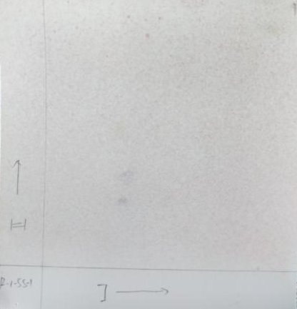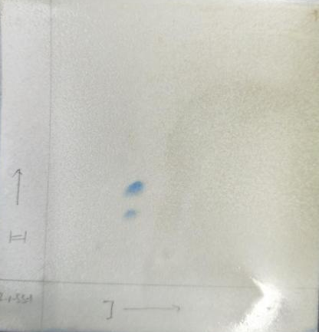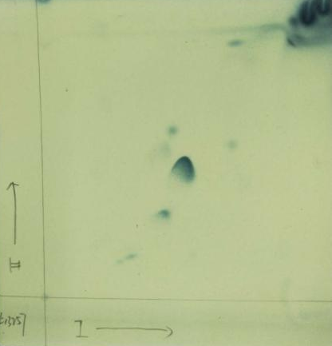
DPG
PG
UL1
UL3
UL2
c.
b.
a.
DPG
PG
DPG
PG

Fig.S2 a. Molybdenum blue colored two dimensional thin-layer chromatogram of total polar lipids of strain R-1-5s-1^{T}, phosphatidylglycerol (PG) and diphosphatidylglycerol (DPG); b. Ninhydrin colored two dimensional thin-layer chromatogram of phospholipid of strain R-1-5s-1^{T}, DPG and PG; c. α-Naphthol colored two dimensional thin-layer chromatogram of total polar lipids of strain J. salarius ASL-1^{T}, DPG, PG, UL1, UL2 and UL3.

