Supplementary Material
The following supplementary figures and tables provide additional descriptive, diagnostic, and robustness detail supporting the Results and Discussion sections. They are cited selectively from the main text and are not required to follow the core argument.

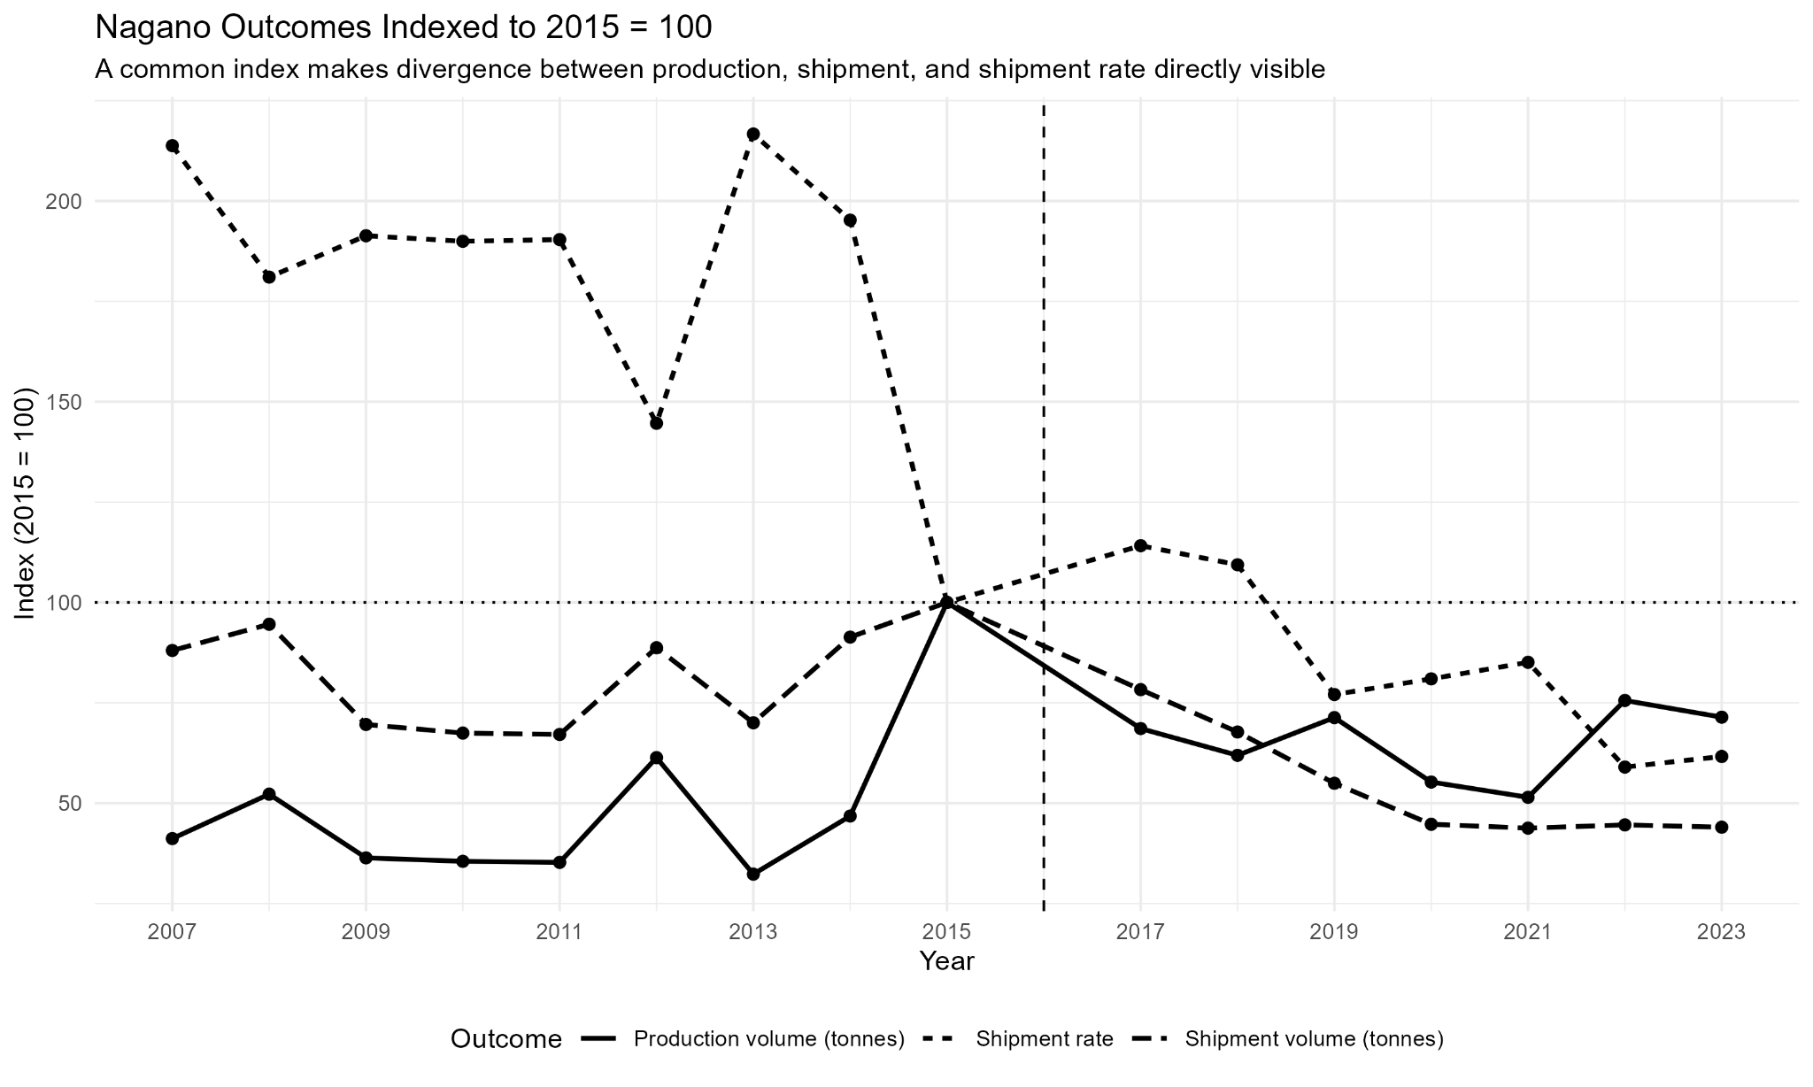
Figure S1 Nagano outcomes indexed to 2015 = 100. The common index facilitates comparison of the direction and magnitude of changes in production volume, shipment volume, and shipment rate.
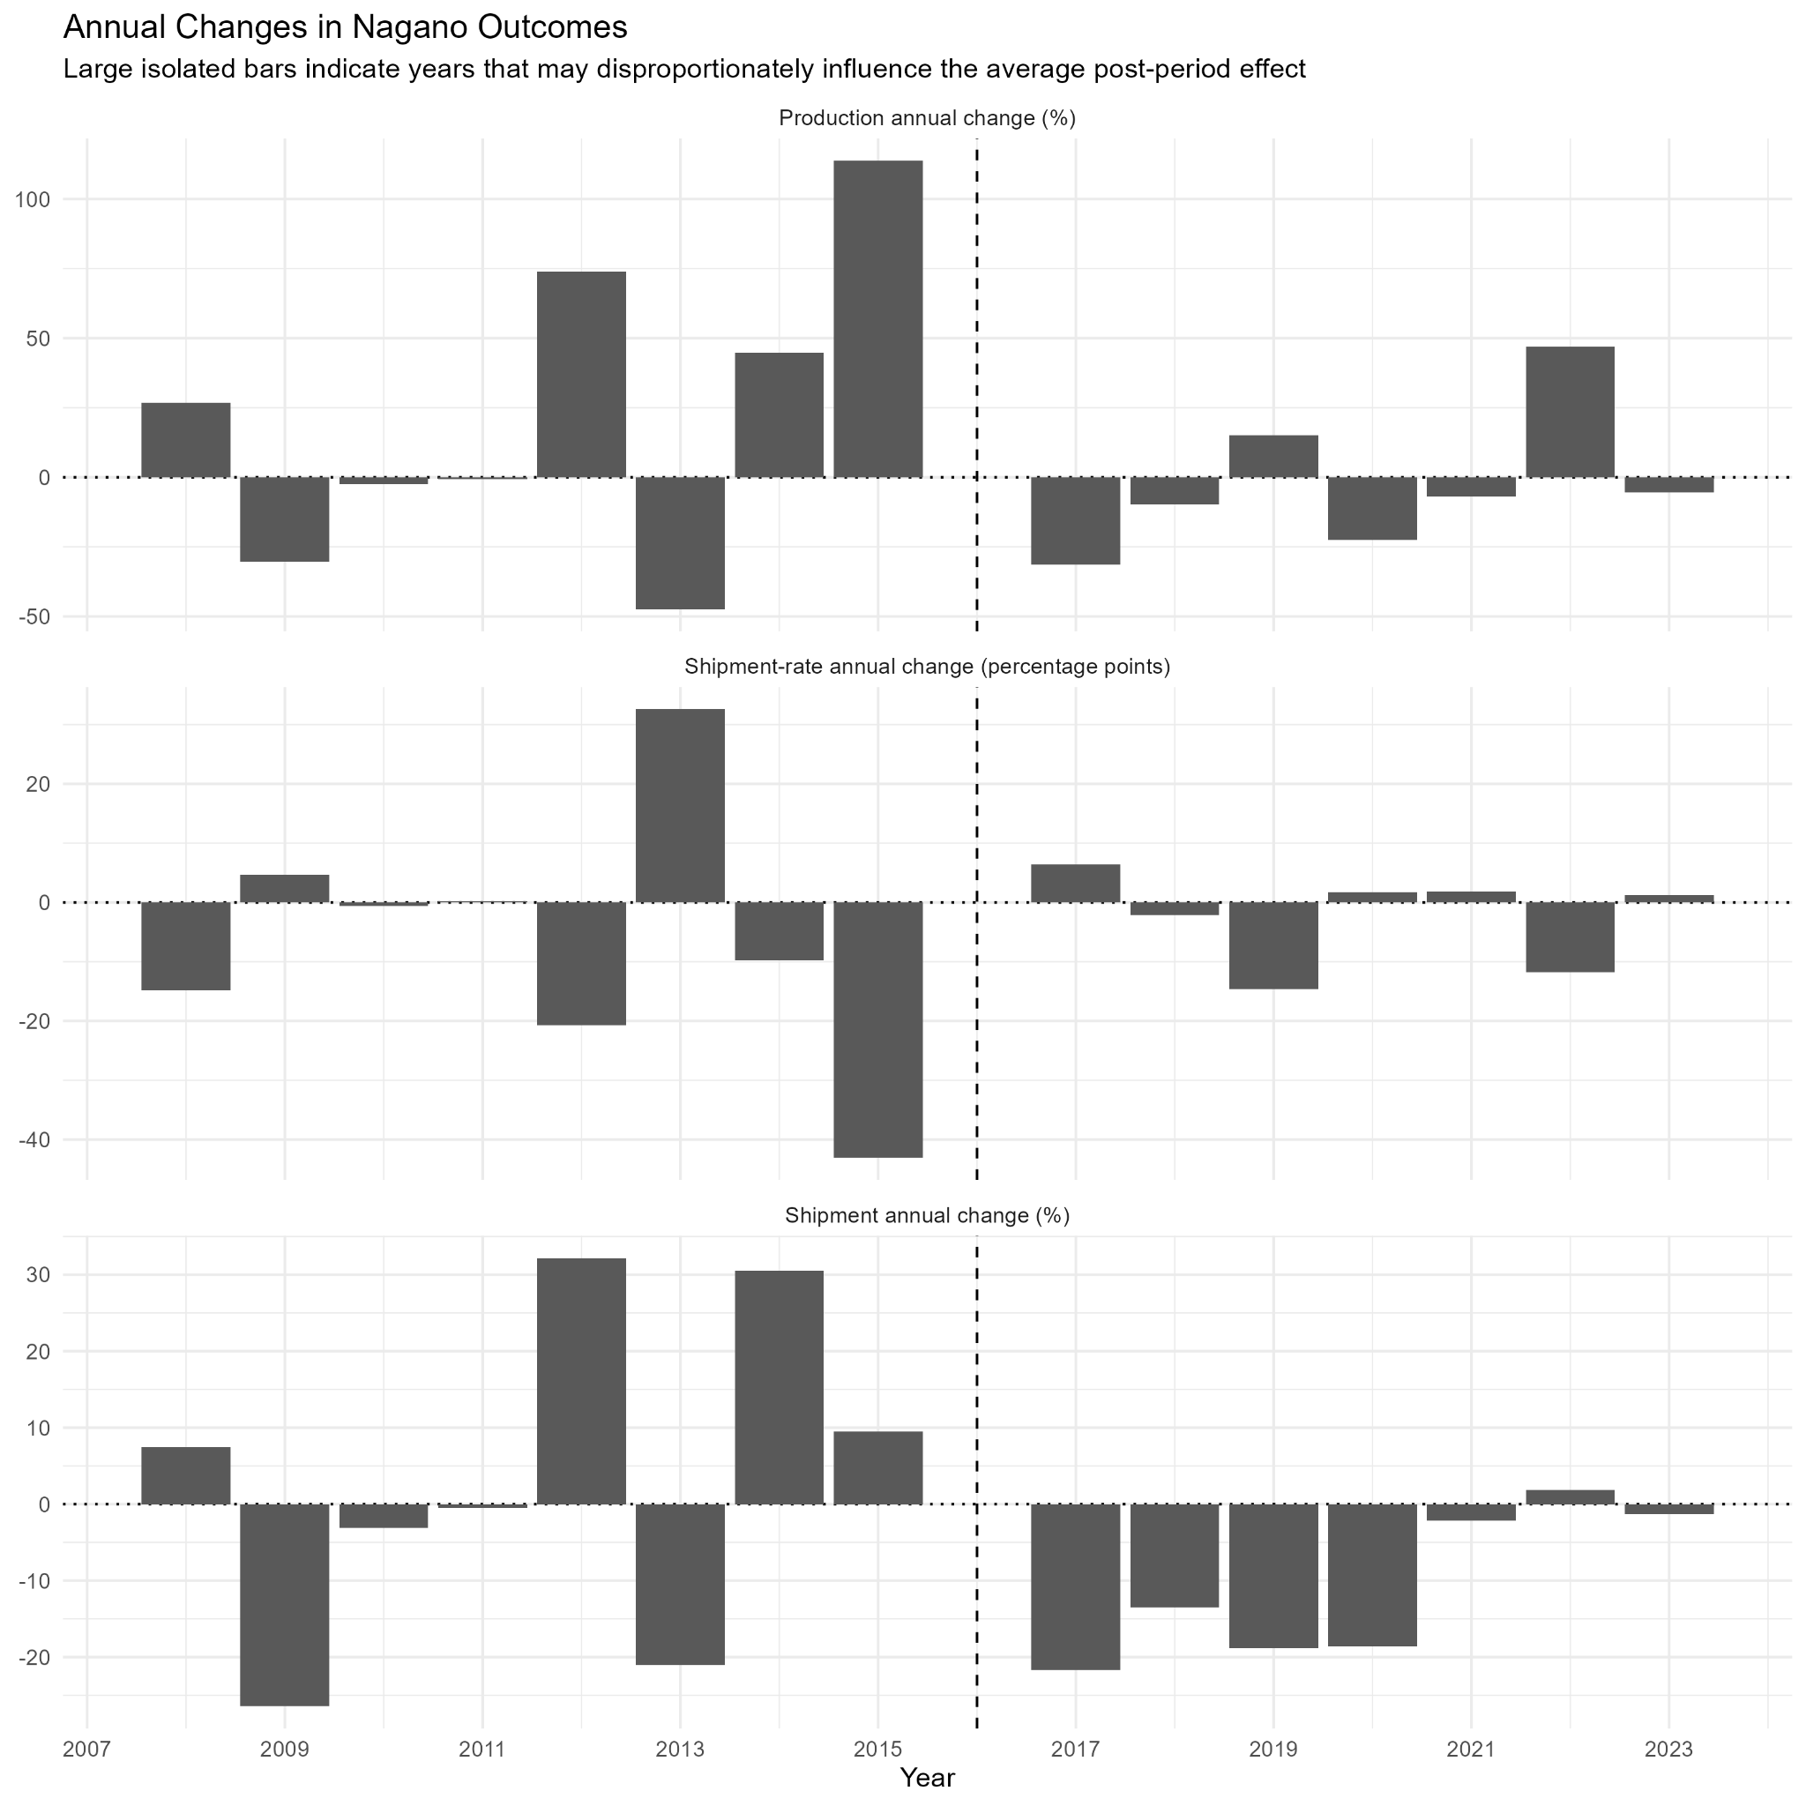
Figure S2 Annual changes in Nagano production volume, shipment rate, and shipment volume. The figure is used to identify isolated annual shocks that could disproportionately influence average post-GI comparisons.

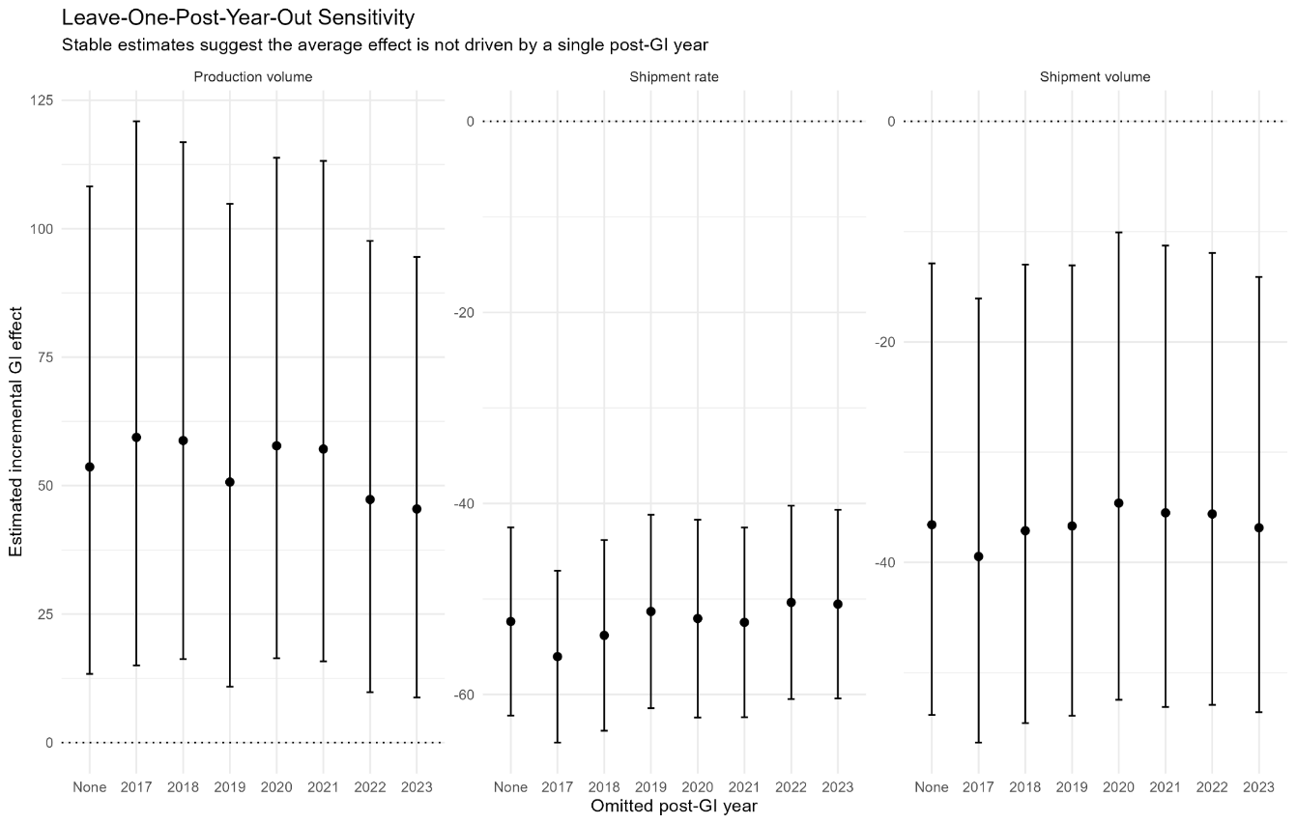
Figure S3 Leave-one-post-year-out sensitivity analysis. Each estimate is obtained after omitting one year from the 2017-2023 post-GI period; 'None' denotes the estimate using all post-GI years.

Table S1 Annual percentage (or percentage-point) changes in Nagano outcomes, 2007-2023 (2016 excluded).
Year | Production change (%) | Shipment change (%) | Shipment-rate change (pp)
2007 | - | - | -
2008 | 26.9 | 7.4 | -14.8
2009 | -30.4 | -26.4 | 4.7
2010 | -2.4 | -3.1 | -0.6
2011 | -0.7 | -0.5 | 0.2
2012 | 74.0 | 32.2 | -20.7
2013 | -47.3 | -21.1 | 32.6
2014 | 44.8 | 30.5 | -9.7
2015 | 113.7 | 9.5 | -43.0
2017 | -31.4 | -21.7 | 6.4
2018 | -9.7 | -13.5 | -2.1
2019 | 15.2 | -18.9 | -14.6
2020 | -22.5 | -18.6 | 1.8
2021 | -6.9 | -2.1 | 1.9
2022 | 46.9 | 1.8 | -11.8
2023 | -5.5 | -1.3 | 1.2

Table S2 Interpreted (percent / percentage-point) annual event-study effects, relative to 2015.
Outcome | Year | Phase | Effect | 95% CI (effect) | Unit | CI excludes 0
Production volume | 2007 | Pre-GI lead | -63.5 | [-77.5, -40.7] | percent | Yes
Production volume | 2008 | Pre-GI lead | -57.0 | [-74.4, -27.5] | percent | Yes
Production volume | 2009 | Pre-GI lead | -64.6 | [-79.1, -40.2] | percent | Yes
Production volume | 2010 | Pre-GI lead | -51.0 | [-68.8, -23.1] | percent | Yes
Production volume | 2011 | Pre-GI lead | -39.7 | [-70.1, 21.4] | percent | No
Production volume | 2012 | Pre-GI lead | 2.5 | [-50.6, 112.3] | percent | No
Production volume | 2013 | Pre-GI lead | -43.6 | [-62.9, -14.2] | percent | Yes
Production volume | 2014 | Pre-GI lead | -36.0 | [-52.4, -13.9] | percent | Yes
Production volume | 2017 | Early post-GI | -29.9 | [-51.4, 1.1] | percent | No
Production volume | 2018 | Early post-GI | -28.3 | [-50.7, 4.2] | percent | No
Production volume | 2019 | Middle post-GI | -2.0 | [-32.7, 42.8] | percent | No
Production volume | 2020 | Middle post-GI | -25.5 | [-48.9, 8.5] | percent | No
Production volume | 2021 | Late post-GI | -23.7 | [-48.3, 12.6] | percent | No
Production volume | 2022 | Late post-GI | 12.6 | [-28.9, 78.4] | percent | No
Production volume | 2023 | Late post-GI | 21.4 | [-23.7, 93.1] | percent | No
Shipment volume | 2007 | Pre-GI lead | -20.3 | [-48.3, 22.8] | percent | No
Shipment volume | 2008 | Pre-GI lead | -13.7 | [-44.3, 33.7] | percent | No
Shipment volume | 2009 | Pre-GI lead | -28.6 | [-52.1, 6.5] | percent | No
Shipment volume | 2010 | Pre-GI lead | -9.5 | [-41.4, 39.9] | percent | No
Shipment volume | 2011 | Pre-GI lead | 17.7 | [-45.9, 156.1] | percent | No
Shipment volume | 2012 | Pre-GI lead | 49.4 | [-31.5, 225.7] | percent | No
Shipment volume | 2013 | Pre-GI lead | 14.9 | [-23.4, 72.5] | percent | No
Shipment volume | 2014 | Pre-GI lead | 12.1 | [-12.9, 44.2] | percent | No
Shipment volume | 2017 | Early post-GI | -16.1 | [-33.4, 5.7] | percent | No
Shipment volume | 2018 | Early post-GI | -33.1 | [-49.8, -10.7] | percent | Yes
Shipment volume | 2019 | Middle post-GI | -35.8 | [-53.4, -11.5] | percent | Yes
Shipment volume | 2020 | Middle post-GI | -47.1 | [-61.6, -27.1] | percent | Yes
Shipment volume | 2021 | Late post-GI | -42.6 | [-58.8, -20.0] | percent | Yes
Shipment volume | 2022 | Late post-GI | -41.9 | [-61.2, -13.0] | percent | Yes
Shipment volume | 2023 | Late post-GI | -34.7 | [-56.9, -1.2] | percent | Yes
Shipment rate | 2007 | Pre-GI lead | 57.6 | [36.6, 78.7] | percentage points | Yes
Shipment rate | 2008 | Pre-GI lead | 47.2 | [25.1, 69.4] | percentage points | Yes
Shipment rate | 2009 | Pre-GI lead | 47.2 | [25.2, 69.1] | percentage points | Yes
Shipment rate | 2010 | Pre-GI lead | 41.4 | [22.5, 60.2] | percentage points | Yes
Shipment rate | 2011 | Pre-GI lead | 43.7 | [22.0, 65.5] | percentage points | Yes
Shipment rate | 2012 | Pre-GI lead | 23.1 | [2.4, 43.9] | percentage points | Yes
Shipment rate | 2013 | Pre-GI lead | 51.2 | [32.7, 69.7] | percentage points | Yes
Shipment rate | 2014 | Pre-GI lead | 38.1 | [20.7, 55.5] | percentage points | Yes
Shipment rate | 2017 | Early post-GI | 8.5 | [-7.7, 24.6] | percentage points | No
Shipment rate | 2018 | Early post-GI | -4.8 | [-20.0, 10.3] | percentage points | No
Shipment rate | 2019 | Middle post-GI | -19.9 | [-36.1, -3.6] | percentage points | Yes
Shipment rate | 2020 | Middle post-GI | -15.4 | [-31.4, 0.6] | percentage points | No
Shipment rate | 2021 | Late post-GI | -13.0 | [-31.7, 5.6] | percentage points | No
Shipment rate | 2022 | Late post-GI | -25.6 | [-43.3, -7.8] | percentage points | Yes
Shipment rate | 2023 | Late post-GI | -24.5 | [-40.6, -8.4] | percentage points | Yes
Note: For production volume and shipment volume, effect = 100x(exp(coefficient)-1). For shipment rate, effect is in percentage points.

Table S3 Summary of the timing and persistence of the estimated post-GI effects.
Outcome | Post years | Significant post years | First sig. year | Last sig. year | Consecutive sig. years | Mean early effect | Mean middle effect | Mean late effect | Timing pattern
Production volume | 7 | 0 | NA | NA | 0 | -29.1 | -13.7 | 3.4 | No individually clear post-GI year
Shipment volume | 7 | 6 | 2018 | 2023 | 6 | -24.6 | -41.4 | -39.7 | Persistent multi-year change
Shipment rate | 7 | 3 | 2019 | 2023 | 2 | 1.8 | -17.6 | -21.0 | Intermittent post-GI change
Table S4 reports the leave-one-post-year-out robustness analysis. Each model re-estimates the baseline TWFE specification reported in Table 3 of the main text after omitting one post-registration year (2017–2023).
Table S4 Leave-one-post-year-out robustness analysis of the TWFE estimates
Outcome | Omitted year | Coefficient | SE | p | Implied effect
Production volume | 2017 | 0.466 | 0.150 | 0.009 | 59.4%
Production volume | 2018 | 0.462 | 0.143 | 0.007 | 58.8%
Production volume | 2019 | 0.410 | 0.141 | 0.013 | 50.7%
Production volume | 2020 | 0.456 | 0.139 | 0.007 | 57.7%
Production volume | 2021 | 0.452 | 0.140 | 0.007 | 57.1%
Production volume | 2022 | 0.387 | 0.135 | 0.014 | 47.3%
Production volume | 2023 | 0.375 | 0.133 | 0.016 | 45.5%
Shipment volume | 2017 | −0.502 | 0.150 | 0.006 | −39.5%
Shipment volume | 2018 | −0.464 | 0.149 | 0.009 | −37.1%
Shipment volume | 2019 | −0.457 | 0.146 | 0.009 | −36.7%
Shipment volume | 2020 | −0.425 | 0.146 | 0.013 | −34.6%
Shipment volume | 2021 | −0.439 | 0.146 | 0.011 | −35.5%
Shipment volume | 2022 | −0.440 | 0.144 | 0.010 | −35.6%
Shipment volume | 2023 | −0.460 | 0.141 | 0.007 | −36.9%
Shipment rate | 2017 | −0.560 | 0.041 | <0.001 | −56.0 pp
Shipment rate | 2018 | −0.538 | 0.046 | <0.001 | −53.8 pp
Shipment rate | 2019 | −0.513 | 0.046 | <0.001 | −51.3 pp
Shipment rate | 2020 | −0.520 | 0.048 | <0.001 | −52.0 pp
Shipment rate | 2021 | −0.524 | 0.046 | <0.001 | −52.4 pp
Shipment rate | 2022 | −0.504 | 0.046 | <0.001 | −50.4 pp
Shipment rate | 2023 | −0.505 | 0.045 | <0.001 | −50.5 pp

Notes. Each model re-estimates the baseline two-way fixed-effects specification after omitting one post-treatment year (2017–2023). The baseline TWFE estimates are reported in Table 3 of the main text. Implied effects are calculated as exp(β) − 1 for log-transformed outcomes and are expressed as percentage-point changes for shipment rate.

Table S5 Sensitivity analysis excluding the pre-treatment reference year (2015)
Outcome | Full sample | Excluding 2015 | Interpretation
Production | +53.6% | +65.0% | Positive effect remains
Shipment | −36.6% | −36.6% | Negative effect remains
Shipment rate | −52.4 pp | −57.2 pp | Negative effect remains

Note. The table compares the baseline TWFE estimates with estimates obtained after excluding the pre-treatment reference year (2015). The similarity of the estimates indicates that the principal findings are not driven by this potentially influential observation.

Table S6 Spatial heterogeneity diagnostic based on geographical proximity to Nagano
Outcome | Coefficient | SE | t | p | 95% CI | Effect per 1-SD closer | Interpretation
Production volume | -0.327 | 0.085 | -3.84 | 0.003 | [-0.515, -0.140] | -27.9% | Consistent with stronger negative post-GI change among closer prefectures
Shipment volume | -0.316 | 0.081 | -3.91 | 0.002 | [-0.494, -0.138] | -27.1% | Consistent with stronger negative post-GI change among closer prefectures
Shipment rate | 0.008 | 0.035 | 0.22 | 0.830 | [-0.068, 0.084] | 0.8 pp | No statistically clear distance-dependent post-GI pattern
Note: Closeness is a standardised measure of geographical proximity based on the negative distance from Nagano Prefecture, with higher values indicating greater proximity.

Table S7 Annual dried persimmon outcomes in Nagano Prefecture, 2007-2023 (2016 excluded)
Year | Production (tonnes) | Shipment (tonnes) | Shipment rate | Period
2007 | 2,383 | 2,302 | 0.966 | RCT-only
2008 | 3,023 | 2,473 | 0.818 | RCT-only
2009 | 2,105 | 1,820 | 0.865 | RCT-only
2010 | 2,055 | 1,764 | 0.858 | RCT-only
2011 | 2,040 | 1,755 | 0.860 | RCT-only
2012 | 3,550 | 2,320 | 0.654 | RCT-only
2013 | 1,870 | 1,831 | 0.979 | RCT-only
2014 | 2,708 | 2,389 | 0.882 | RCT-only
2015 | 5,787 | 2,615 | 0.452 | RCT-only
2017 | 3,969 | 2,047 | 0.516 | Combined RCT-plus-GI
2018 | 3,583 | 1,771 | 0.494 | Combined RCT-plus-GI
2019 | 4,127 | 1,437 | 0.348 | Combined RCT-plus-GI
2020 | 3,198 | 1,170 | 0.366 | Combined RCT-plus-GI
2021 | 2,978 | 1,145 | 0.384 | Combined RCT-plus-GI
2022 | 4,374 | 1,166 | 0.267 | Combined RCT-plus-GI
2023 | 4,133 | 1,151 | 0.278 | Combined RCT-plus-GI
Note: The year 2016 is omitted because it represents the transition year during which GI registration was implemented. Shipment rate is calculated as shipment volume divided by production volume.

Table S8 Annual event-study coefficients for production volume, shipment volume, and shipment rate relative to 2015.
Outcome | Year | Phase | Coefficient | SE | t | p | 95% CI
Production volume | 2007 | Pre-GI lead | -1.007 | 0.222 | -4.53 | <0.001 | [-1.492, -0.523]
Production volume | 2008 | Pre-GI lead | -0.843 | 0.239 | -3.52 | 0.004 | [-1.364, -0.322]
Production volume | 2009 | Pre-GI lead | -1.039 | 0.241 | -4.31 | 0.001 | [-1.564, -0.514]
Production volume | 2010 | Pre-GI lead | -0.714 | 0.207 | -3.45 | 0.005 | [-1.165, -0.263]
Production volume | 2011 | Pre-GI lead | -0.506 | 0.321 | -1.58 | 0.141 | [-1.206, 0.194]
Production volume | 2012 | Pre-GI lead | 0.024 | 0.334 | 0.07 | 0.943 | [-0.704, 0.753]
Production volume | 2013 | Pre-GI lead | -0.572 | 0.192 | -2.97 | 0.012 | [-0.991, -0.153]
Production volume | 2014 | Pre-GI lead | -0.446 | 0.136 | -3.28 | 0.007 | [-0.743, -0.149]
Production volume | 2017 | Early post-GI | -0.356 | 0.168 | -2.11 | 0.056 | [-0.723, 0.011]
Production volume | 2018 | Early post-GI | -0.333 | 0.172 | -1.94 | 0.077 | [-0.707, 0.042]
Production volume | 2019 | Middle post-GI | -0.020 | 0.172 | -0.11 | 0.911 | [-0.395, 0.356]
Production volume | 2020 | Middle post-GI | -0.294 | 0.173 | -1.71 | 0.114 | [-0.670, 0.082]
Production volume | 2021 | Late post-GI | -0.270 | 0.179 | -1.51 | 0.156 | [-0.660, 0.119]
Production volume | 2022 | Late post-GI | 0.119 | 0.211 | 0.56 | 0.583 | [-0.341, 0.579]
Production volume | 2023 | Late post-GI | 0.194 | 0.213 | 0.91 | 0.381 | [-0.270, 0.658]
Shipment volume | 2007 | Pre-GI lead | -0.227 | 0.198 | -1.14 | 0.275 | [-0.660, 0.205]
Shipment volume | 2008 | Pre-GI lead | -0.147 | 0.201 | -0.73 | 0.477 | [-0.585, 0.290]
Shipment volume | 2009 | Pre-GI lead | -0.336 | 0.183 | -1.84 | 0.091 | [-0.735, 0.063]
Shipment volume | 2010 | Pre-GI lead | -0.100 | 0.200 | -0.50 | 0.627 | [-0.535, 0.336]
Shipment volume | 2011 | Pre-GI lead | 0.163 | 0.357 | 0.46 | 0.656 | [-0.614, 0.940]
Shipment volume | 2012 | Pre-GI lead | 0.401 | 0.358 | 1.12 | 0.284 | [-0.378, 1.181]
Shipment volume | 2013 | Pre-GI lead | 0.139 | 0.186 | 0.75 | 0.469 | [-0.267, 0.545]
Shipment volume | 2014 | Pre-GI lead | 0.114 | 0.116 | 0.99 | 0.343 | [-0.138, 0.366]
Shipment volume | 2017 | Early post-GI | -0.175 | 0.106 | -1.65 | 0.124 | [-0.406, 0.056]
Shipment volume | 2018 | Early post-GI | -0.401 | 0.132 | -3.03 | 0.010 | [-0.690, -0.113]
Shipment volume | 2019 | Middle post-GI | -0.443 | 0.147 | -3.01 | 0.011 | [-0.764, -0.122]
Shipment volume | 2020 | Middle post-GI | -0.637 | 0.148 | -4.32 | 0.001 | [-0.958, -0.315]
Shipment volume | 2021 | Late post-GI | -0.555 | 0.152 | -3.65 | 0.003 | [-0.887, -0.224]
Shipment volume | 2022 | Late post-GI | -0.543 | 0.186 | -2.93 | 0.013 | [-0.947, -0.139]
Shipment volume | 2023 | Late post-GI | -0.426 | 0.190 | -2.24 | 0.045 | [-0.841, -0.012]
Shipment rate | 2007 | Pre-GI lead | 0.576 | 0.097 | 5.96 | <0.001 | [0.366, 0.787]
Shipment rate | 2008 | Pre-GI lead | 0.472 | 0.102 | 4.64 | <0.001 | [0.251, 0.694]
Shipment rate | 2009 | Pre-GI lead | 0.472 | 0.101 | 4.68 | <0.001 | [0.252, 0.691]
Shipment rate | 2010 | Pre-GI lead | 0.414 | 0.087 | 4.78 | <0.001 | [0.225, 0.602]
Shipment rate | 2011 | Pre-GI lead | 0.437 | 0.100 | 4.38 | <0.001 | [0.220, 0.655]
Shipment rate | 2012 | Pre-GI lead | 0.231 | 0.095 | 2.43 | 0.032 | [0.024, 0.439]
Shipment rate | 2013 | Pre-GI lead | 0.512 | 0.085 | 6.03 | <0.001 | [0.327, 0.697]
Shipment rate | 2014 | Pre-GI lead | 0.381 | 0.080 | 4.77 | <0.001 | [0.207, 0.555]
Shipment rate | 2017 | Early post-GI | 0.085 | 0.074 | 1.14 | 0.275 | [-0.077, 0.246]
Shipment rate | 2018 | Early post-GI | -0.048 | 0.069 | -0.70 | 0.499 | [-0.200, 0.103]
Shipment rate | 2019 | Middle post-GI | -0.199 | 0.075 | -2.66 | 0.021 | [-0.361, -0.036]
Shipment rate | 2020 | Middle post-GI | -0.154 | 0.073 | -2.10 | 0.057 | [-0.314, 0.006]
Shipment rate | 2021 | Late post-GI | -0.130 | 0.086 | -1.52 | 0.154 | [-0.317, 0.056]
Shipment rate | 2022 | Late post-GI | -0.256 | 0.081 | -3.14 | 0.009 | [-0.433, -0.078]
Shipment rate | 2023 | Late post-GI | -0.245 | 0.074 | -3.31 | 0.006 | [-0.406, -0.084]
Note: Coefficients for production volume and shipment volume are expressed on the logarithmic scale, whereas shipment-rate coefficients are expressed in levels. Standard errors are clustered at the prefecture level. The transition year 2016 is excluded.

Synthetic control robustness analysis
To further assess the robustness of the estimated treatment effects, we conducted supplementary synthetic control analyses for production volume, shipment volume, and shipment rate. The transition year (2016) was excluded from estimation. Candidate predictor specifications were prespecified, and the specification with the smallest pre-treatment RMSPE was selected for each outcome. Table S9 summarises pre-treatment fit diagnostics, while Figures S4–S6 compare the observed and synthetic trajectories.

Table S9 Summary of synthetic control results
Outcome | Pre-treatment fit | Main post-treatment finding | Relationship to TWFE findings
Production volume | The synthetic control did not closely reproduce the pre-treatment trajectory. | Observed production remained generally above the synthetic control after GI registration. | Qualitatively similar to the positive TWFE estimate, but interpretation should be cautious because of the limited pre-treatment fit.
Shipment volume | The synthetic control did not closely reproduce the pre-treatment trajectory. | Observed shipment remained persistently below the synthetic control after GI registration. | Consistent with the negative TWFE estimate and the persistent post-treatment decline.
Shipment rate | The synthetic control closely reproduced the pre-treatment trajectory. | Observed shipment rate remained below the synthetic control after GI registration. | Consistent with the negative TWFE estimate.
Note. The synthetic control analyses compare observed outcomes in Nagano Prefecture with synthetic control trajectories constructed from donor prefectures. Pre-treatment fit refers to the similarity between observed and synthetic trajectories before GI registration (2007–2015). Post-treatment comparisons begin in 2017, with the transition year (2016) excluded.
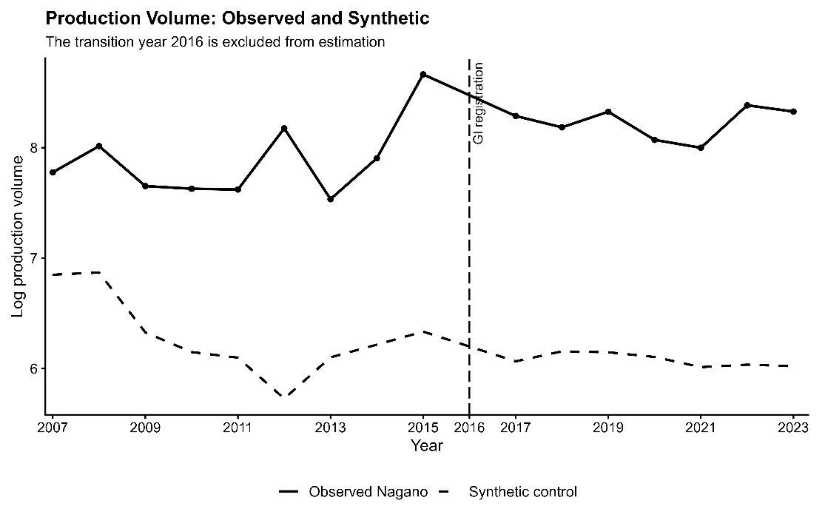
Figure S4 Synthetic control analysis for production volume. Observed and synthetic trajectories for log production volume in Nagano Prefecture. The transition year (2016) is excluded from estimation. The predictor specification was selected from prespecified candidate models using the smallest pre-treatment RMSPE. Because the pre-treatment fit is relatively poor, this result is interpreted as a supplementary sensitivity analysis rather than definitive causal evidence.

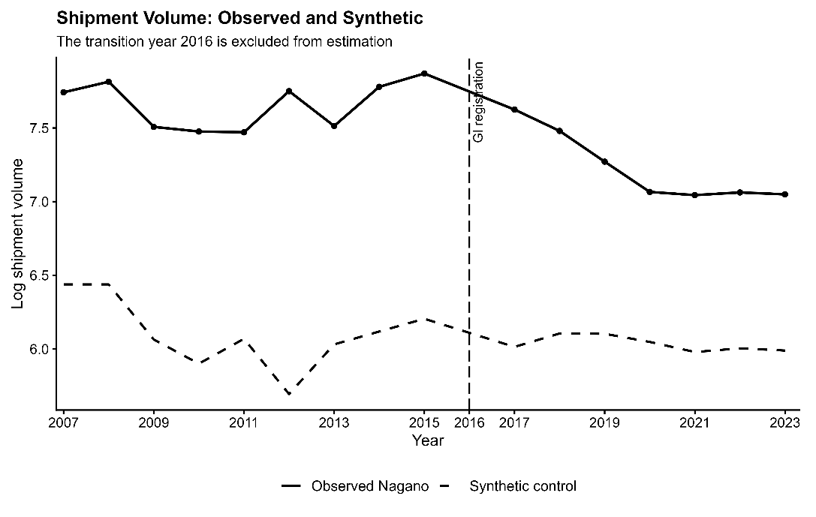
Fig. S5. Synthetic control analysis for shipment volume. Observed and synthetic trajectories for log shipment volume. The transition year (2016) is excluded from estimation. The selected specification minimized pre-treatment RMSPE among the candidate models. Because pre-treatment fit remains limited, this analysis is presented as supporting robustness information.

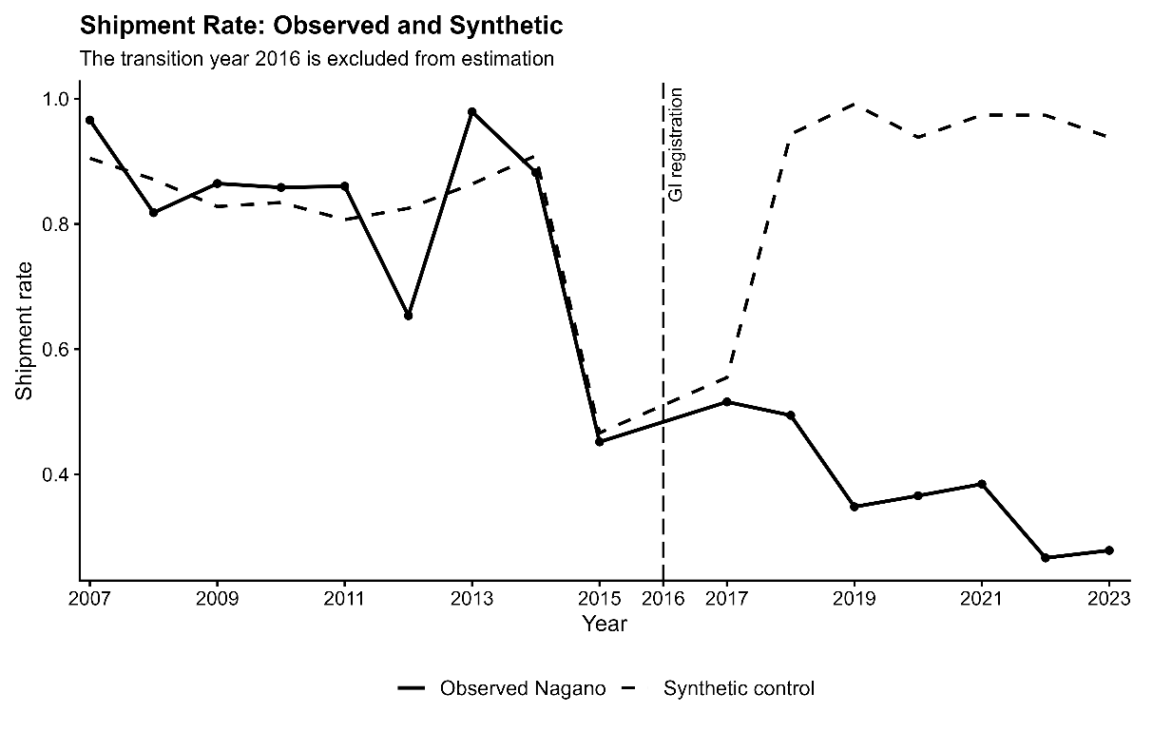
Figure S6 Synthetic control analysis for shipment rate. Observed and synthetic trajectories for shipment rate. The transition year (2016) is excluded from estimation. Compared with production and shipment volume, the shipment-rate model achieves a substantially closer pre-treatment fit and shows a pronounced negative post-registration divergence.

