Supporting information
Green Synthesis and Defect-State Investigation of Cerium Oxide Nanoparticles via Anogeissus latifolia Bark Extract: Insights into Photocatalytic and Antimicrobial Study

Index
Sr. No | Content | Page No.
1 | Fig. S1: - Illustration of preparation of bark extract | 3
2 | Fig.S2: - Schematic representation of biosynthesis of D-CeO₂-NPs | 3
3 | Fig. S3: - The observation of different test of phytochemical | 3
4 | Fig. S4: - XRD spectra of D-CeO₂ NPs | 4
5 | Fig. S5: - (a) Rietveld refinement graph; (b) electron density mapping in 2D counter form; (c) electron density mapping in 3D form; (d) crystal structure of D-CeO₂ NPs in the single unit cell; (e) crystal structure of D-CeO₂ NPs in a single layer; and (f) crystal structure in a polyhedral structure. | 4
6 | Fig. S6: - UV–Vis-NIR spectra: (a) D-CeO₂ NPs, (b) Bark extracts | 6
7 | Fig. S7: - Tauc plot spectra: (a) D-CeO₂ NPs, (b) Bark extracts | 6
8 | Fig. S8: - FT-IR spectra of D-CeO₂ NPs. | 7
9 | Fig.S9: - SEM image of (a-e) biosynthesized D-CeO₂ NPs | 7
10 | Fig.S10: - EDX spectrum of biosynthesized D-CeO₂ NPs | 8
11 | Fig.S11: - TG graph of biosynthesized D-CeO₂ NPs | 8
12 | Fig.S12: - Optical and photoluminescent properties of D-CeO₂: (a) PLE spectrum measured at 469 nm, (b) PL emission spectrum at 245 nm, and (c) CIE color co-ordinates | 9
13 | Fig. S13: - HRTEM and SAED image (a-f) of D-CeO₂ NPs | 10
14 | Fig.S14: - Photocatalytic activity: (a)Degradation of RhB dye by D-CeO₂-NPs under UV irradiation (b) Rate constant calculated for the dye degradation reaction following a pseudo-first order (c) Percentage dye degradation rate | 12
15 | Fig. S15: - (a) Concentration-dependent (Sigmoidal dose-response) curve of the D-CeO₂ NPs against E. coli | 13
16 | Fig. S15: - (b) Concentration-dependent (Sigmoidal dose-response) curve of the D-CeO₂ NPs against S. aureus | 13
17 | Fig. S16: - Antifungal activity of D-CeO₂ NPs displaying zones of inhibition in concentration dependant manner against (a) A. niger (AS14) and (b) C. albicans (CA10) along with negative control (DMSO) and positive control (Itraconazole) | 14

Bark Extract Preparation
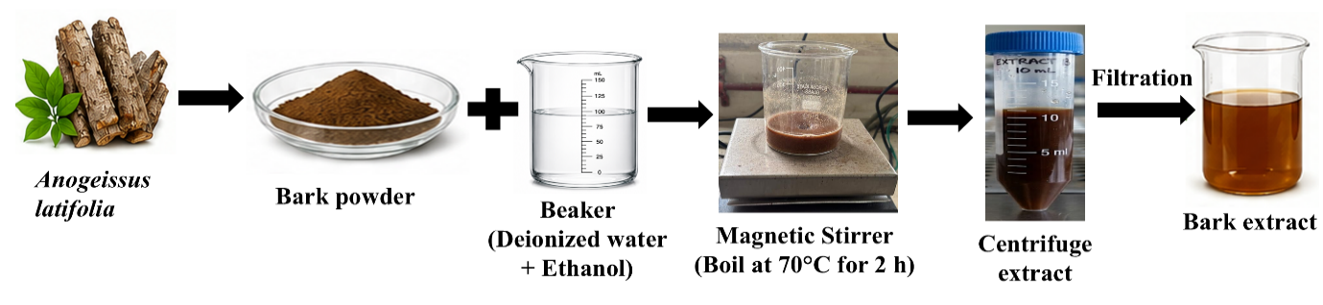
Fig. S1. Illustration of preparation of bark extract.

Biosynthesis of D-CeO₂ NPs
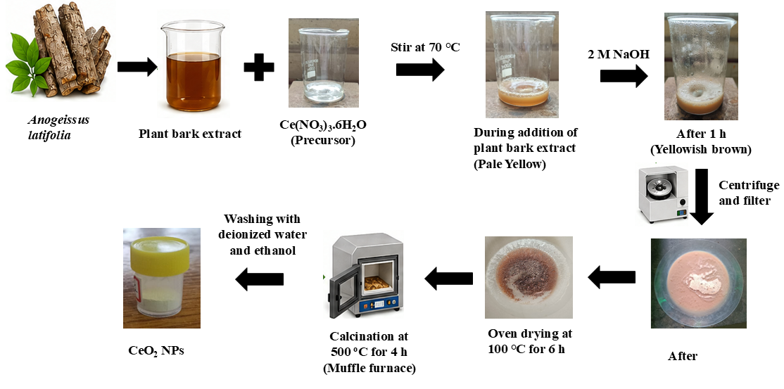
Fig. S2. Schematic representation of biosynthesis of D-CeO₂-NPs

Phytochemical Screening of the Plant Bark Extracts
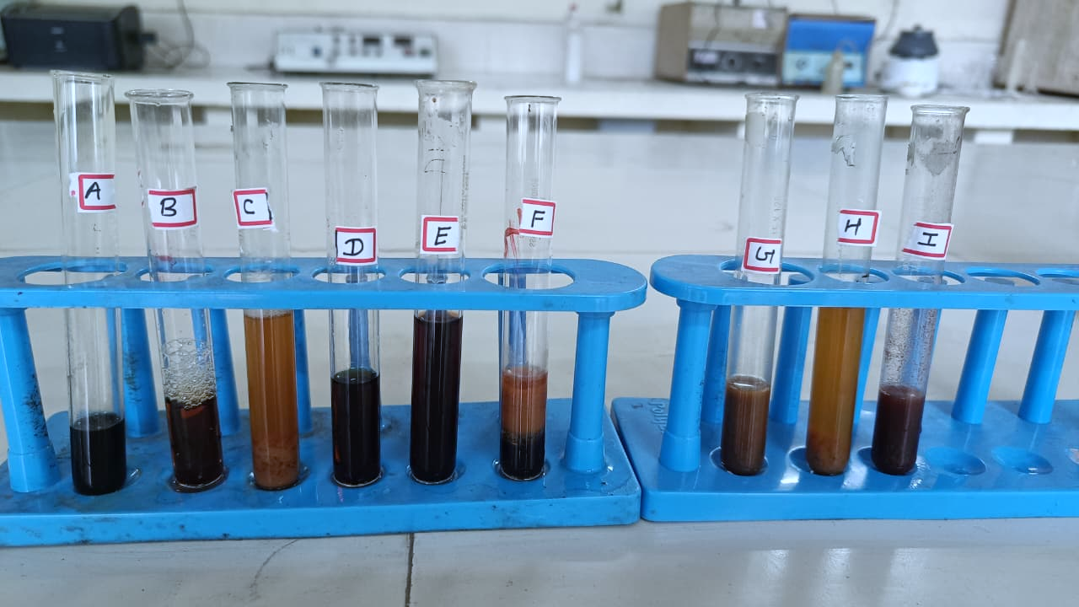
Fig. S3. The observation of different test of phytochemical.

X-ray Diffraction analysis
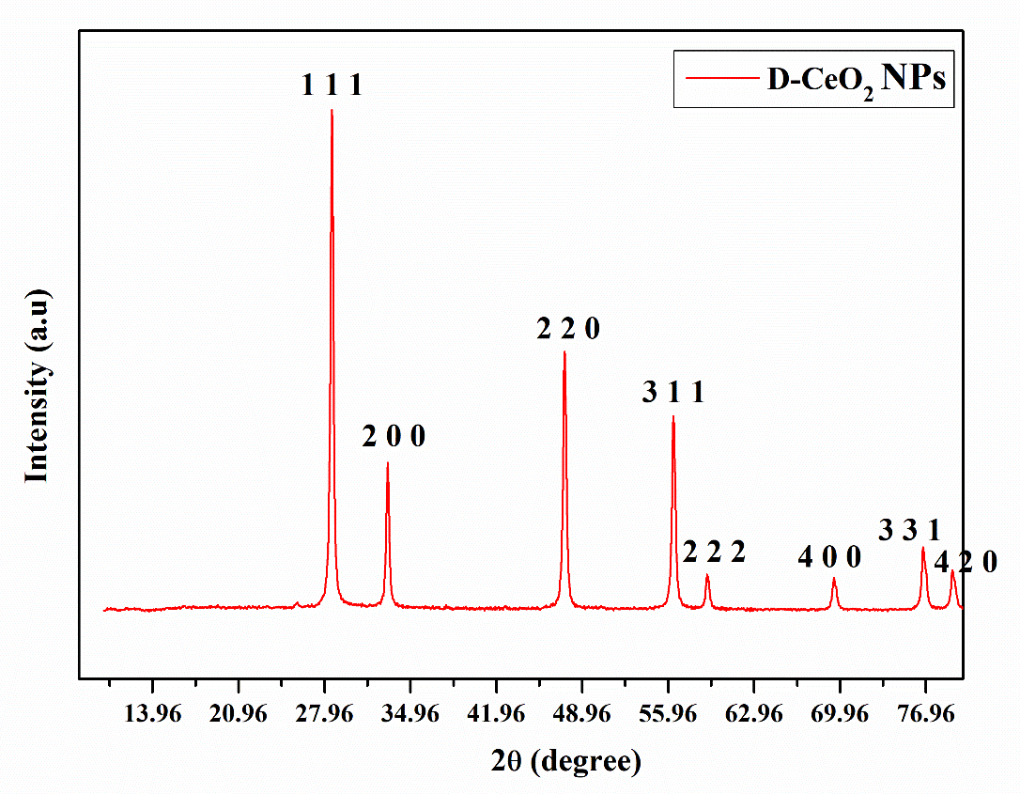
Fig. S4. XRD spectra of D-CeO₂ NPs

Rietveld Refinement

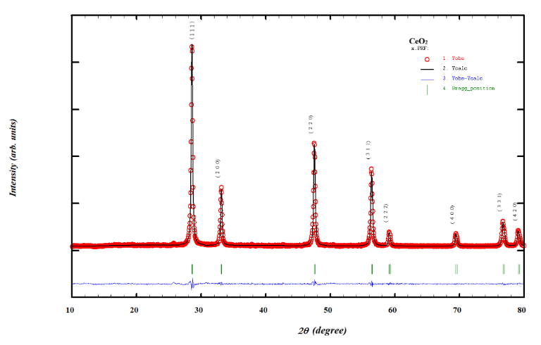

(a)

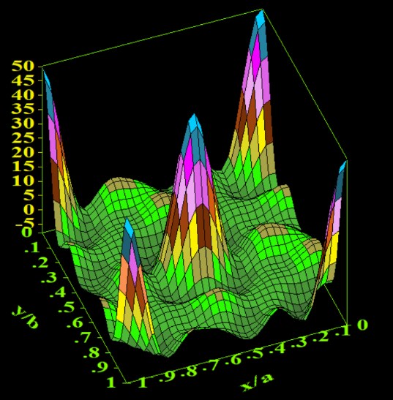
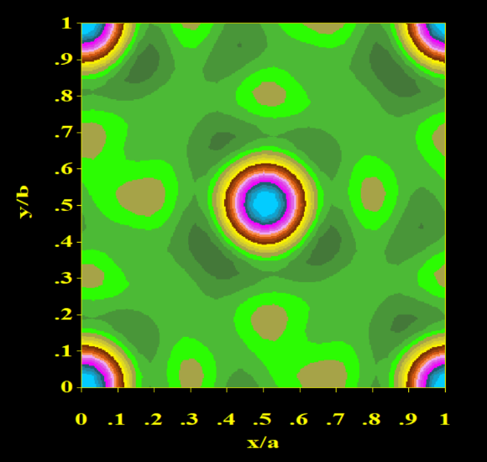

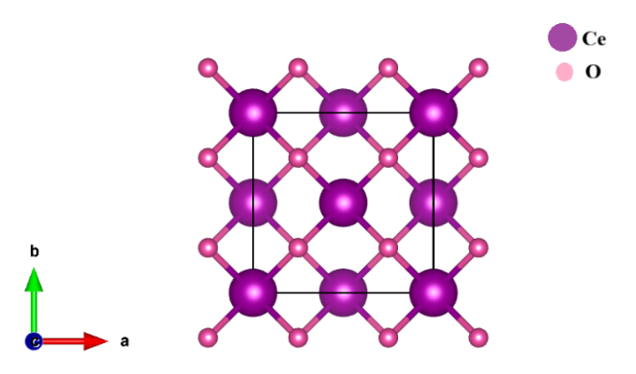
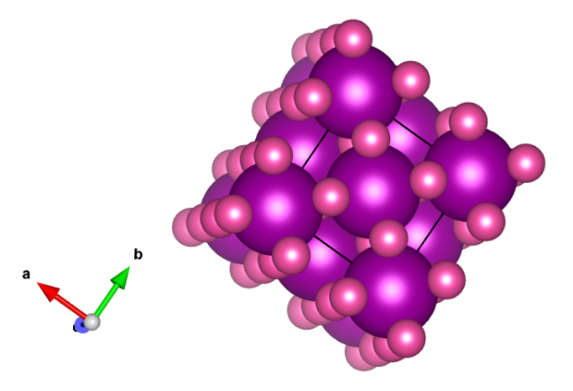
(b) (c)

(d) (e)
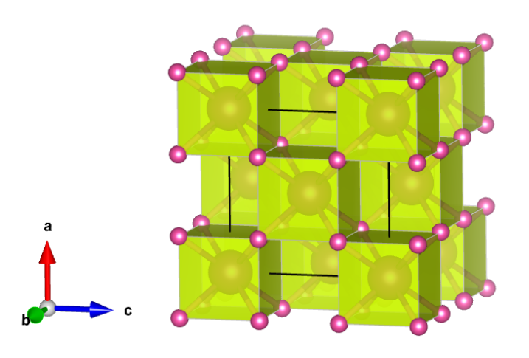
(f)
Fig. S5. (a) Rietveld refinement graph; (b) electron density mapping in 2D counter form; (c) electron density mapping in 3D form; (d) crystal structure of D-CeO₂ NPs in the single unit cell; (e) crystal structure of D-CeO₂ NPs in a single layer; and (f) crystal structure in a polyhedral structure.

Ultraviolet-Visible-NIR Spectroscopy
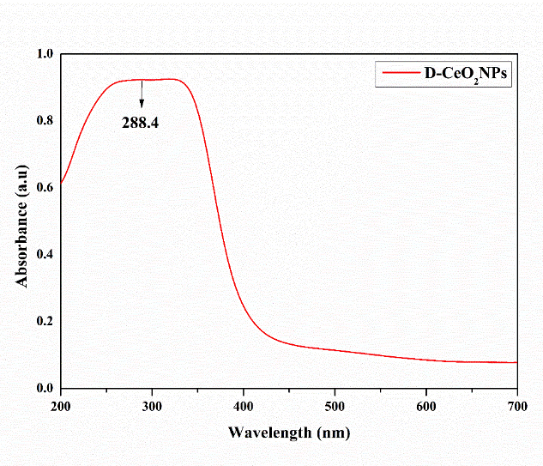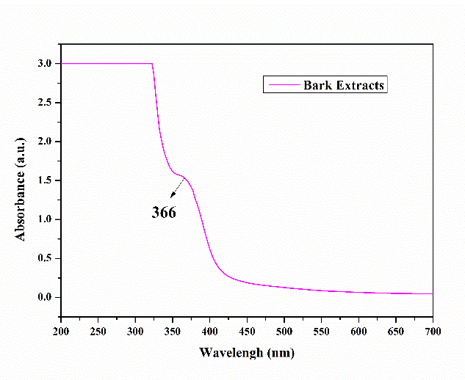
- (b)
Fig. 6. UV–Vis-NIR spectra: (a) D-CeO₂ NPs, (b) Bark extracts.
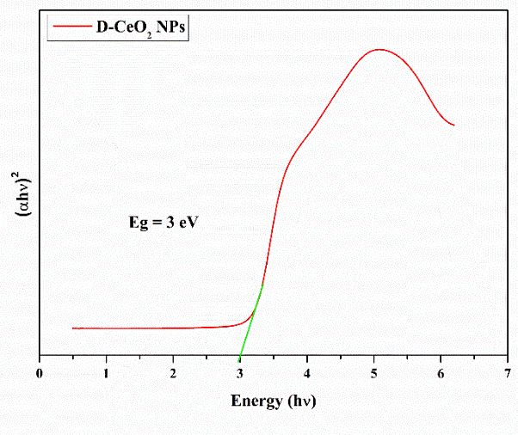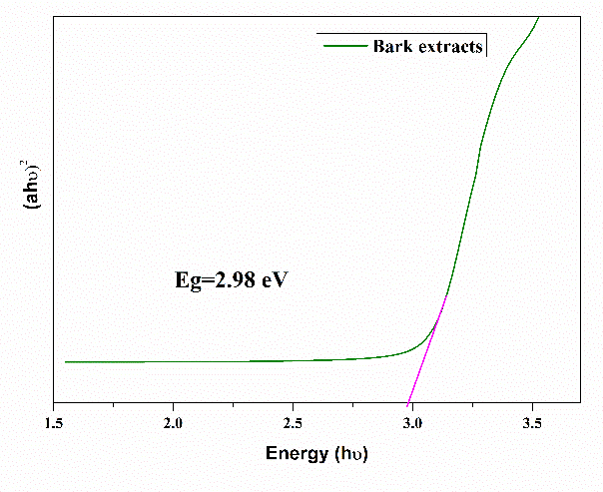
- (b)
Fig. S7. Tauc plot spectra: (a) D-CeO₂ NPs, (b) Bark extracts

FT-IR Spectroscopy
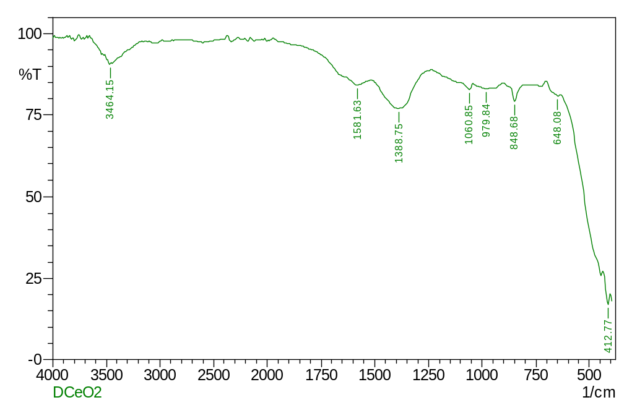
Fig. S8. FT-IR spectra of D-CeO₂ NPs.

Scanning Electron Microscopy with Energy-Dispersive X-ray Spectroscopy Analysis
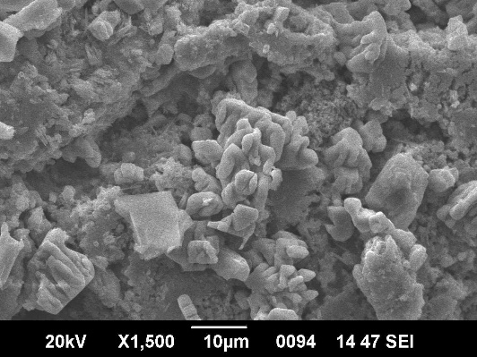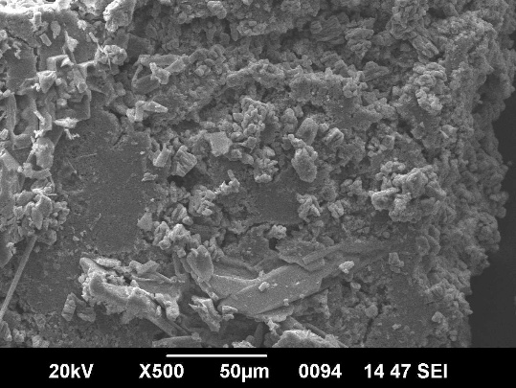
(a) (b)
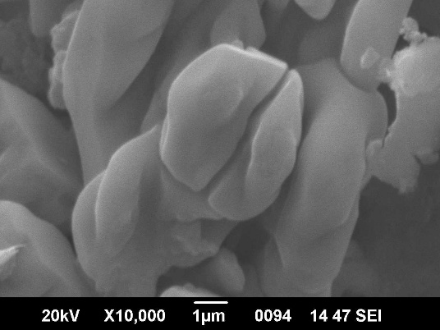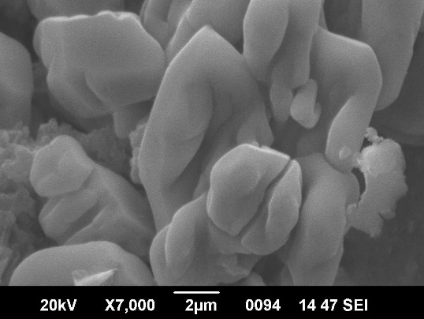
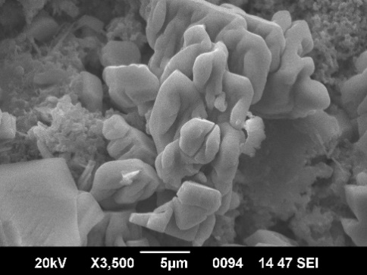
(c) (d)

(e)
Fig. S9. SEM image of (a-e) biosynthesized D-CeO₂ NPs.
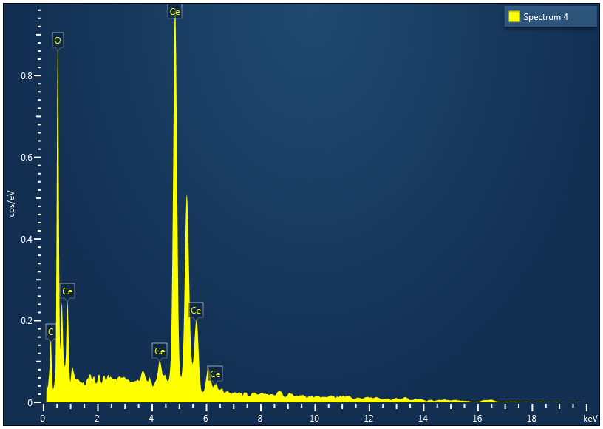
Fig. S10. EDX spectrum of biosynthesized D-CeO₂ NPs.
Thermal Studies
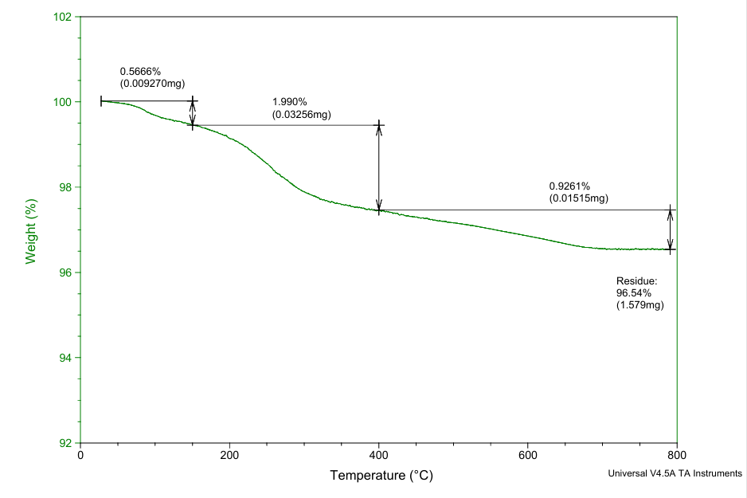
Fig. S11. TG graph of biosynthesized D-CeO₂ NPs
Photoluminescence (PL) Spectroscopy
(a) (b)
(c)

Fig. S12. Optical and photoluminescent properties of D-CeO₂: (a) PLE spectrum measured at 469 nm, (b) PL emission spectrum at 245 nm, and (c) CIE color co-ordinates.

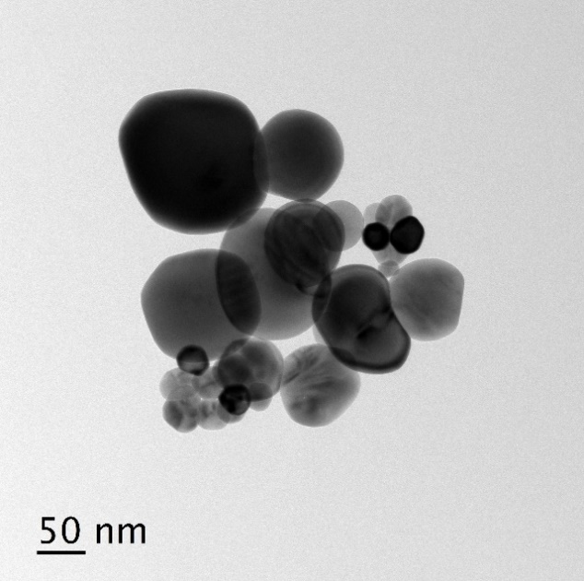
Microstructural and Crystallographic Analysis
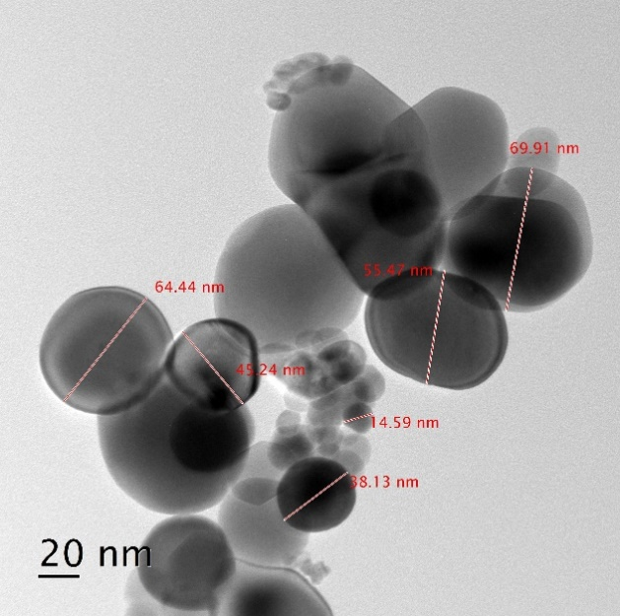
(a) (b)
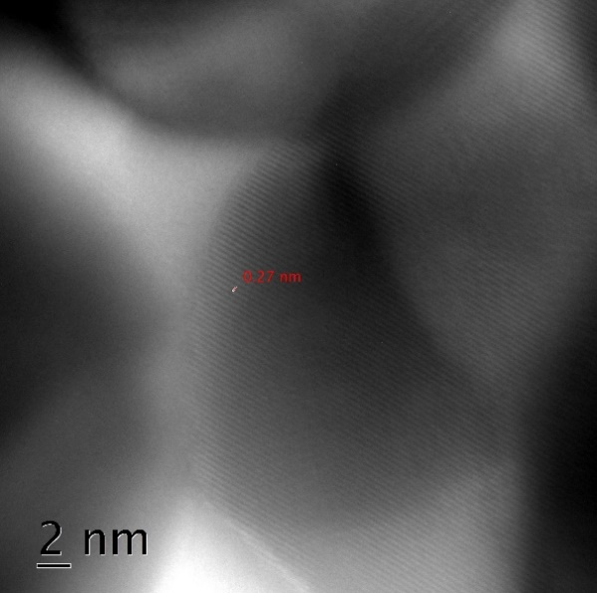
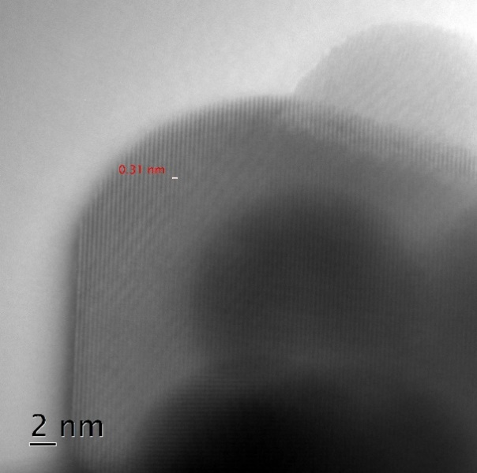
(c) (d)
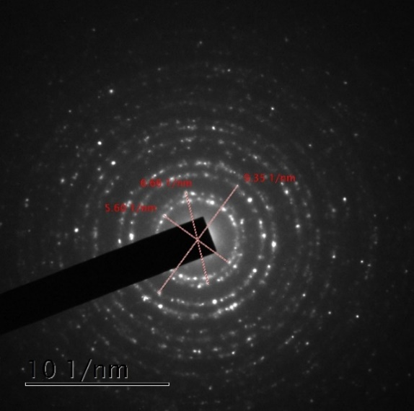

(e) (f)

Fig. S13. HRTEM and SAED image (a-f) of D-CeO₂ NPs.

Photocatalytic Activity
(a) (b)
(c)

Fig. S14. Photocatalytic activity: (a)Degradation of RhB by D-CeO₂-NPs under UV irradiation (b) Rate constant calculated for the dye degradation reaction following a pseudo-first order (c) Percentage dye degradation rate.

Antimicrobial Assay of CeO₂ NPs

Antibacterial Activity
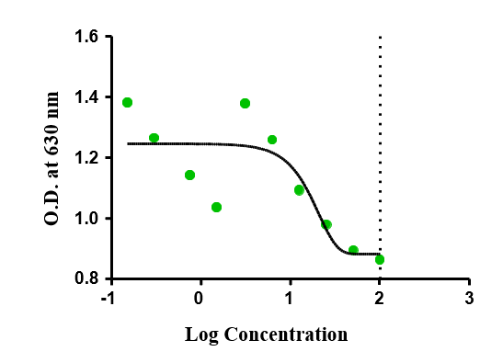
Fig. S15(a). Concentration-dependent (Sigmoidal dose-response) curve of the D-CeO₂ NPs against E. coli

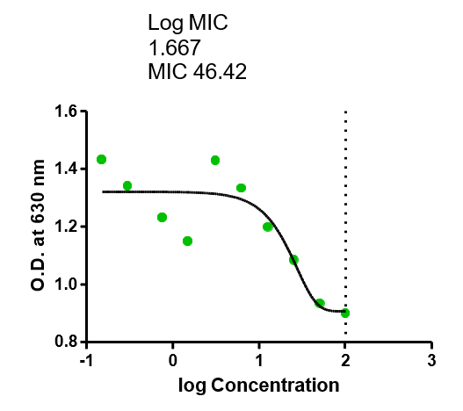
Fig. S15(b). Concentration-dependent (Sigmoidal dose-response) curve of the D-CeO₂ NPs against S. aureus.

Antifungal Activity

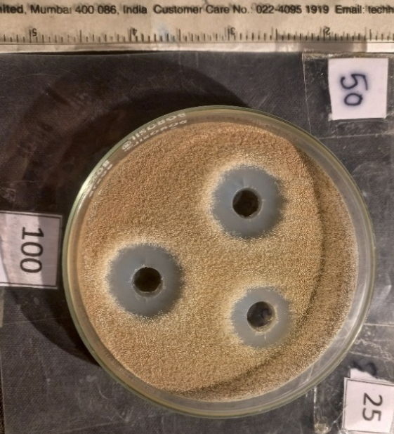 | 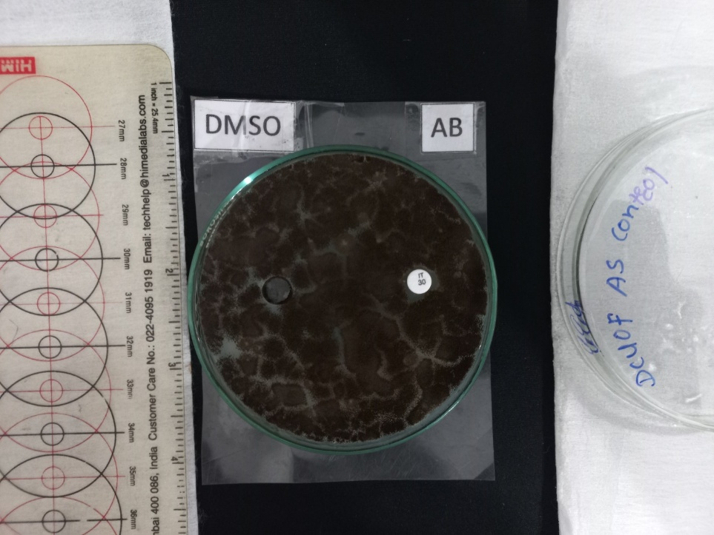
AS14-D-CeO₂-B  D-CeO₂ NPs against Aspergillus niger | Control against Aspergillus niger
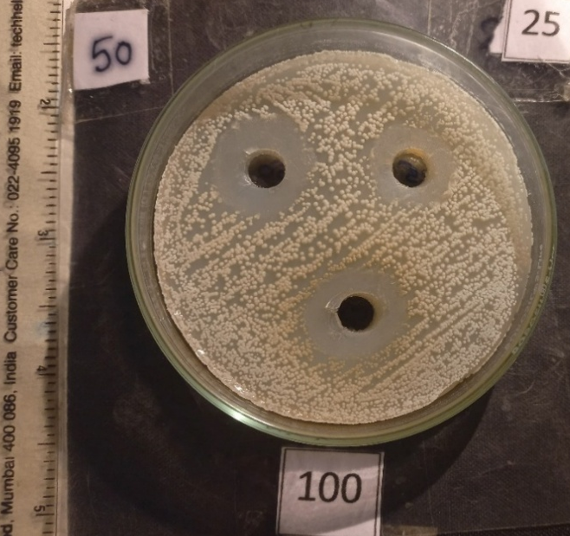 | 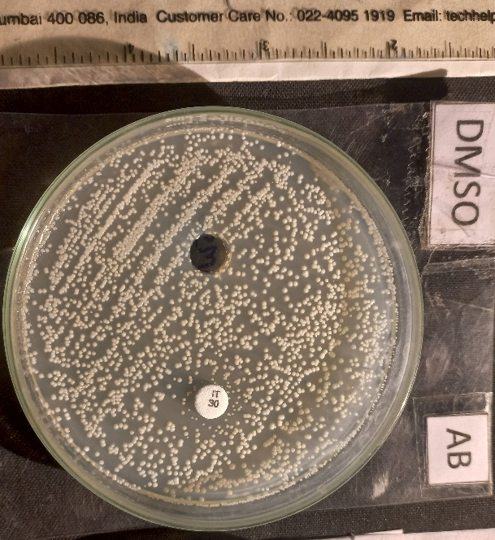
CA10-D-CeO₂-B  D-CeO₂ NPs against C. albicans | Control against C. albicans

Fig. S16. Antifungal activity of D-CeO₂ NPs displaying zones of inhibition in concentration dependant manner against (a) A. niger (AS14) and (b) C. albicans (CA10) along with negative control (DMSO) and positive control (Itraconazole).

