Supplementary Information (SI)
Production and characterization of high solid content cellulose nanofibrils from pretreated fluff pulp
Prabaharan Graceraj Ponnusamyª, Suraj Sharma^{b} and Sudhagar Mani^{a*}
ª College of Engineering, University of Georgia, Athens, Georgia 30602, United States.
^{b} Department of Textiles, Merchandising, and Interiors, University of Georgia, Athens, Georgia 30602, United States.
*Corresponding author, E-mail: smani@uga.edu, Tel: +1-706-542-2358.
Statistical analysis
The one-way ANOVA test was performed to study the effect of the pretreatment process on feedstock cellulose fiber dimension (width and length) reduction, CNF solid content percentage, zeta potential, crystallinity, and fibril width. The data for statistical tests were obtained from optical microscope images, moisture tests, zeta potential measurements, XRD tests, and SEM images. The hypotheses of the statistical tests were defined and tests were performed in MATLAB software. The anova1() function was used to return the ‘p-value and ANOVA table. The variation between samples and within samples (Error) was listed in the ANOVA table. The significant difference across the mean value of samples was determined from returned ‘p-value and conclusions about the null hypothesis were reported. The multcompare () function was used to make a pairwise comparison of sample means and to study pretreatment effects on CNF samples manufactured. Tukey’s honestly significant difference procedure was used to test the hypothesis.
Effect of pretreatment process on feedstock cellulose fiber width
The following hypothesizes were tested to investigate the effect of the pretreatment process on the width of feedstock cellulose fibers.
Null hypothesis: The mean width of cellulose fibers produced by different pretreatment methods are the same.
Alternate hypothesis: The mean width of cellulose fibers produced by different pretreatment methods are not the same.
Inference: The ‘p-value is less than 0.05. Hence, the null hypothesis was rejected. The multiple comparison test indicated that pretreated sample means were different from the control sample
Table S1. One-way ANOVA significance test table of fiber width
Source | Sum of squares | Degrees of freedom | Mean square | F value | Prob > F
Variation between CNF samples | 32881 | 6 | 5480 | 302 | 9x10⁻¹¹⁵
Error | 4780 | 263 | 18.17
Total | 37660 | 269

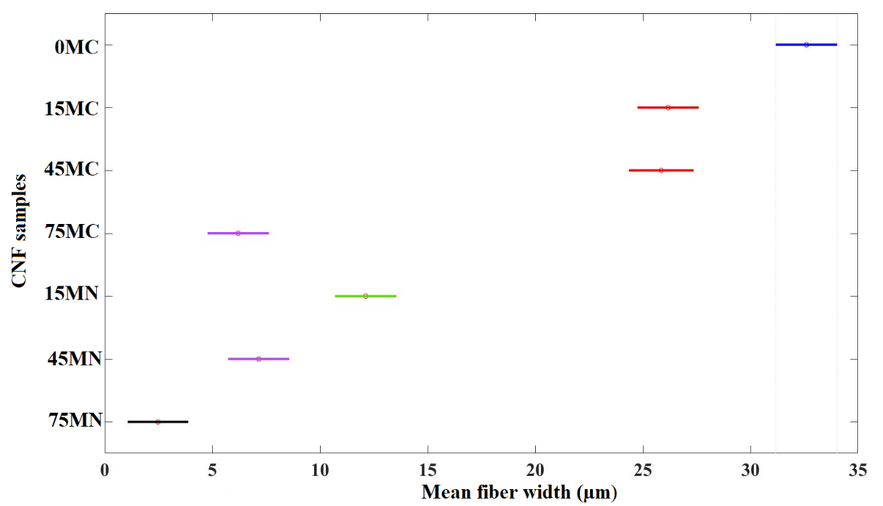
Fig. S1. One-way ANOVA multiple comparison test of pretreated cellulose fiber width
Effect of pretreatment process on feedstock cellulose fiber length
The following hypothesizes were defined to investigate the effect of pretreatment on the length of feedstock cellulose fiber.
Null hypothesis: The mean length of cellulose fibers produced by different pretreatment methods are the same.
Alternate hypothesis: The mean length of cellulose fibers produced by different treatment methods are not the same.
Inference: The ‘p-value in the ANOVA table is less than 0.05. Hence, the null hypothesis was rejected. The pairwise multiple comparison test results are presented in Fig. S2. The effect of all pretreatments on fiber length reduction was significantly different from the control sample.
Table S2. One-way ANOVA significance test table of fiber length
Source | Sum of squares | Degrees of freedom | Mean square | F value | Prob > F
Variation between CNF samples | 5x10⁶ | 6 | 756714 | 69 | 5x10⁻⁵¹
Error | 3x10⁶ | 262 | 11010
Total | 7x10⁶ | 268

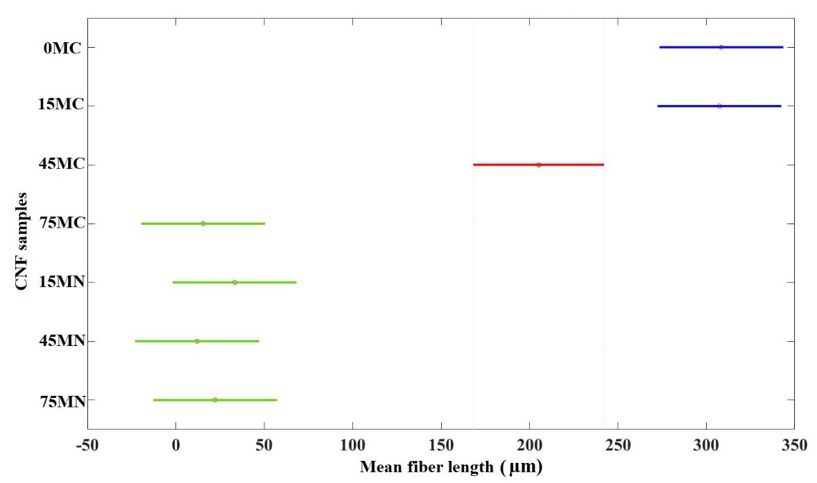
Fig. S2. One-way ANOVA multiple comparison test of pretreated cellulose fiber length

Effect of pretreatment process on CNF hydrogel solid content
The following hypothesizes were tested to investigate the effect of pretreatment on solid content percentage in CNF hydrogel.
Null hypothesis: The mean solid content of CNF hydrogel produced by different pretreatment methods are the same.
Alternate hypothesis: The mean solid content of CNF hydrogel produced by different treatment methods are not the same.
Inference: The ‘p-value in the ANOVA table is less than 0.05. Hence, the null hypothesis was rejected. The means values of CNF samples such as 0MC, 15MC, and 45MC are different from other samples.
Table S3. One-way ANOVA significance test table of solid content percentage in CNF hydrogel
Source | Sum of squares | Degrees of freedom | Mean square | F value | Prob > F
Variation between CNF samples | 0.0032 | 6 | 0.00053 | 21.59 | 5.89984x10⁻³⁵
Error | 0.00138 | 56 | 0.00002
Total | 0.00459 | 62

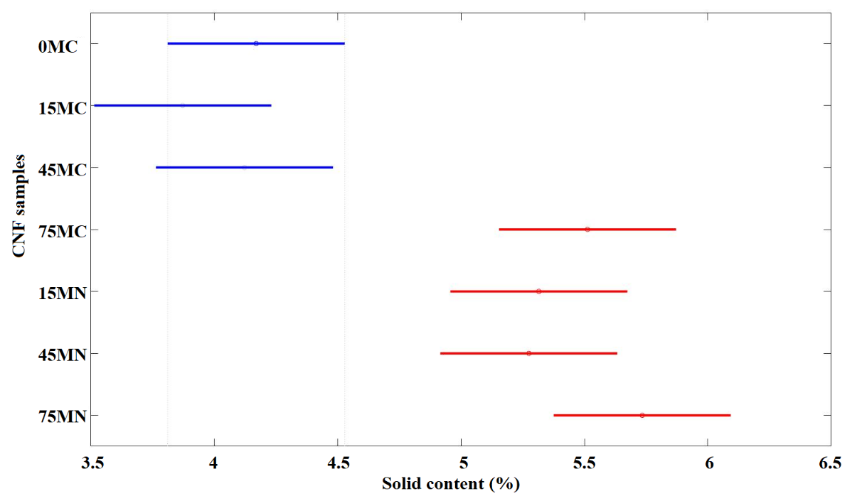
Fig. S3. One-way ANOVA multiple comparison test of CNF hydrogel solid content percentage
Effect of pretreatment process on zeta potential
The null and alternate hypotheses of zeta potential parameters were defined for the one-way ANOVA test.
Null hypothesis: The mean zeta potential of CNF hydrogel produced by different pretreatment methods is the same.
Alternate hypothesis: The mean zeta potential of CNF hydrogel produced by different treatment methods is not the same.
Inference: The ‘p-value in the ANOVA table is less than 0.05. Hence, the null hypothesis was rejected. The mean values of Ref. CNF samples are different from other samples.
Table S4. One-way ANOVA significance test table of zeta potential
Source | Sum of squares | Degrees of freedom | Mean square | F value | Prob > F
Variation between CNF samples | 2774 | 7 | 396 | 10 | 7x10-¹⁰
Error | 6980 | 167 | 42
Total | 9765 | 174
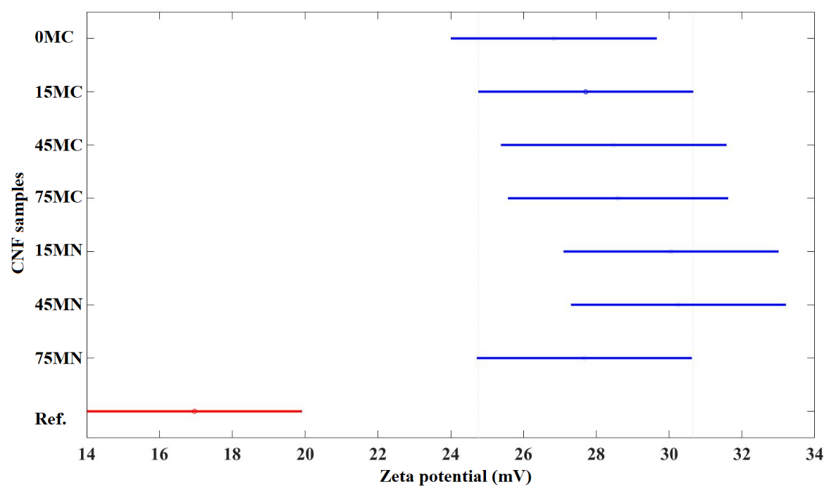
Fig. S4. One-way ANOVA multiple comparison test of zeta potential
Effect of pretreatment process on crystallinity
The null and alternate hypotheses of the crystallinity index parameter were defined for the one-way ANOVA test.
Null hypothesis: The mean crystallinity index of CNF hydrogel produced by different pretreatment methods are the same.
Alternate hypothesis: The mean crystallinity index of CNF hydrogel produced by different treatment methods are not the same.
Inference: The ‘p-value in the ANOVA table was greater than 0.05. Hence, the null hypothesis was accepted. The mean values of the crystallinity index were the same for all samples.
Table S5. One-way ANOVA significance test table of crystallinity index
Source | Sum of squares | Degrees of freedom | Mean square | F value | Prob > F
Variation between CNF samples | 195 | 7 | 28 | 1 | 0.4
Error | 384 | 16 | 24
Total | 580 | 23
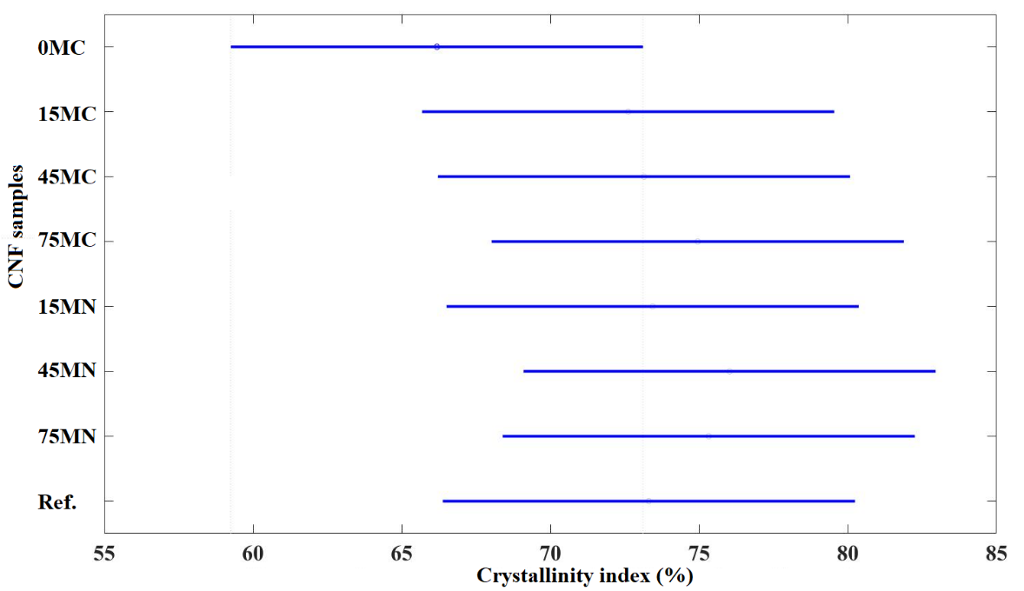
Fig. S5. One-way ANOVA multiple comparison test of crystallinity index
Effect of pretreatment process on CNF width
The following hypothesizes were tested to investigate the effect of pretreatment on CNF hydrogel fibril width.
Null hypothesis: The mean fibril width of CNF hydrogel produced by different pretreatment methods are the same.
Alternate hypothesis: The mean fibril width of CNF hydrogel produced by different treatment methods are not the same.
Inference: As the p<0.05, the null hypothesis was rejected. The mean width of control and Ref. samples were different from pretreated samples.
Table S6. One-way ANOVA significance test table of CNF width
Source | Sum of squares | Degrees of freedom | Mean square | F value | Prob > F
Variation between CNF samples | 71504 | 7 | 10215 | 99 | 2x10⁻¹⁰³
Error | 81169 | 787 | 103
Total | 152672 | 794
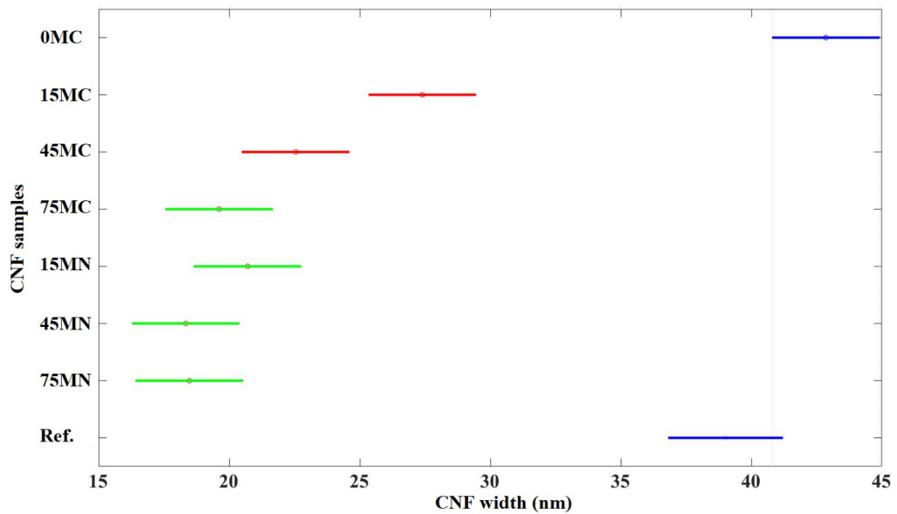
Fig. S6. One-way ANOVA multiple comparison test of CNF width

