Supporting Information for
Growing Pacific linkage with western North Atlantic explosive cyclogenesis

Jacob Stuivenvolt-Allen^{1,2}, Simon S.-Y. Wang^{1,3}, Yoshimitsu Chikamoto¹, Jonathan D.D. Meyer^{1,3}, Zachary F. Johnson^{1,3}, Liping Deng⁴

¹Department of Plants, Soils, and Climate, Utah State University, Logan UT, United States
²Department of Earth and Planetary Sciences, Yale University, New Haven CT, United States
³Utah Climate Center, Utah State University, Logan UT, United States
⁴Department of Earth and Atmospheric Sciences, Central Michigan University, Mt. Pleasant MI, United States
⁵College of Ocean and Meteorology, Guangdong Ocean University, Zhanjiang 524088, Guangdong, China

Corresponding author: Jacob Stuivenvolt-Allen (jacob.stuivenvolt-allen@yale.edu)

Contents of this file

Figures S1-S6
Text S1

Text S1: Explosive cyclogenesis tracking evaluation and uncertainties

Other work evaluating cyclone detection and tracking methods has shown that differences in results do come from differences in methodology. The source of heterogeneity in the results of different tracking methods comes from data products and resolution differences (Hodges et al., 2003, 2011; Jung et al., 2006; Wang et al., 2016), differences in the criteria of extratropical cyclones (Allen et al., 2010; Hoskins & Hodges, 2002; Walker et al., 2020), and difference in analysis domains (i.e developing a tracking scheme for global versus regional domains) (Reale et al., 2019). While tracking using minima of mean sea level pressure or surface pressure has been successfully carried out in many studies (Benestad & Chen, 2006; Blender et al., 1997; Hanley & Caballero, 2012; Rudeva & Gulev, 2011; Trigo, 2006), there are documented uncertainties in this approach. Many of these uncertainties are associated with weak low-pressure systems (Neu et al., 2012) or storms with a more complex structure (Hanley & Caballero, 2012). Due to these complicating factors in the development of a storm and to differences in data used for tracking, the exact frequency of cyclones per year remains one of the largest uncertainties (see Neu et al., 2012 for a review).

Despite these caveats, research has also shown that tracking is often most reliable for deep and extreme cyclones where low-pressure centers are prominent (Neu et al., 2012). This has been shown in mid-century reanalysis data and particularly for tracking methods in the northern hemisphere where observed data has had a longer, denser, and more reliable record than the southern hemisphere. While the exact frequency of extratropical cyclones is a source of disagreement between different datasets and methods, there is much stronger coherence in the interannual variability of cyclones detected by tracking methods (Neu et al., 2012). Additionally, the spatial distribution of cyclogenesis and cyclone tracks is well captured by several diverse methods and datasets (Allen et al., 2010; Raible et al., 2008; Walker et al., 2020). These findings motivated the tracking methods used in this study, which are intentionally focused on the interannual variability of deep cyclones (ECs) with a clear definition and threshold criteria. We expect the greatest uncertainty in our methods to come from the data used in the study –motivating our use of four reanalysis datasets and their own records of ECs.
For a glimpse into the efficacy of our tracking methods, Figure S1 shows four consecutive time steps of MSLP for three randomly selected explosive cyclones. The black plus sign intersects the minimum MSLP value for that timestep. For each cyclone, our approach effectively follows the trajectory of the low-pressure center and does not jump to other adjacent centers of MSLP. We have manually evaluated each storm tracked by these methods by plotting the MSLP field along with our point detection scheme and the algorithm performs very well at capturing the evolution of explosive cyclones. Please see Methods Section 2.1 for a full description our tracking methods.
Even if our tracking methods were flawless, uncertainties exist due to the nature of reanalysis data. This concern has been documented by other studies and are not a focal part of the analysis here (Benestad & Chen, 2006; Hodges et al., 2011; Raible et al., 2008). All of the mid-century reanalysis datasets used in this study assimilate an inconsistent number of observations in time (i.e. more observations assimilated in the recent period) (Ebita et al., 2011; Hersbach et al., 2020; Kalnay et al., 1996). Notably, the amount of upper-air observations assimilated into reanalysis has seen a precipitous increase from the mid-20th century until now (Hwang et al., 2010; Kobayashi et al., 2014). To provide some context into the role of data assimilation in impacting our results, we have repeated the EC tracking in ERA 20th century reanalysis (ERA20c) (Poli et al., 2016). This reanalysis still has an increasing number of assimilated observations in time, but the observations come from the surface only and will not demonstrate the same upper-atmosphere shifts noted from data assimilation changes in mid-century reanalysis. Figure S2 shows that the coastal ECs from ERA20c also exhibit a growing relationship with the north Pacific wave-train of atmospheric pressure anomalies. While the exact impact of the frequency of assimilated observations is unknown, this ability of all four reanalysis datasets (despite differences in data assimilation) to capture this growing relationship instill confidence in our tracking results and the conclusions that follow.

Figure S1. Three evolutions of explosive cyclones chosen at random. Each row represents four 6-hour time steps leading up to the explosive cyclogenesis threshold. The contour fill represents MSLP, and the black plus sign intersects the point of minimum MSLP detected by our tracking methods. The pressure at this grid point can be found in the bottom left corner each subplot while the date is in the top left corner.

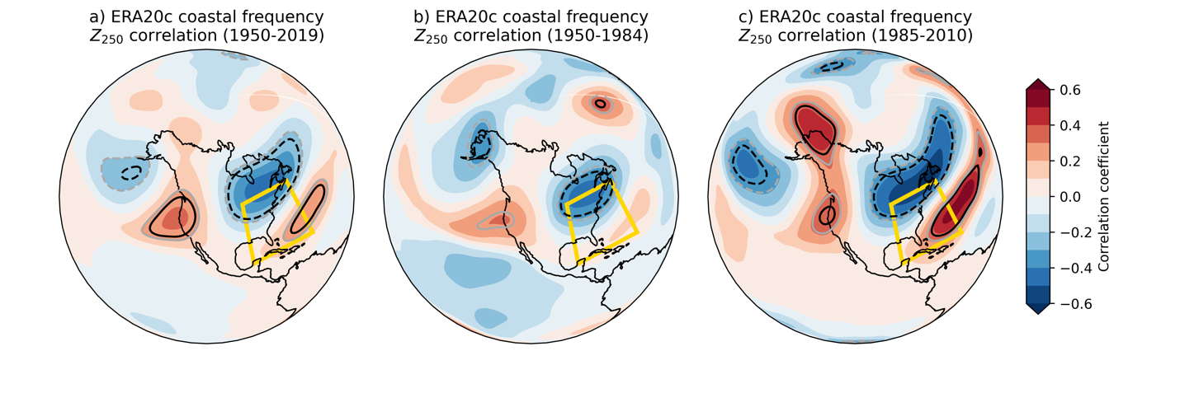 Figure S2. Correlation of coastal EC frequency in ERA20c with Z₂₅₀ from November through March for the entire analysis period (a), 1950 through 1984 (b) and the recent period, 1985 through 2020 (c). The black contour lines indicate the 95% confidence threshold for the correlation coefficient with the degrees of freedom equaling the number of the years in each correlation minus two.

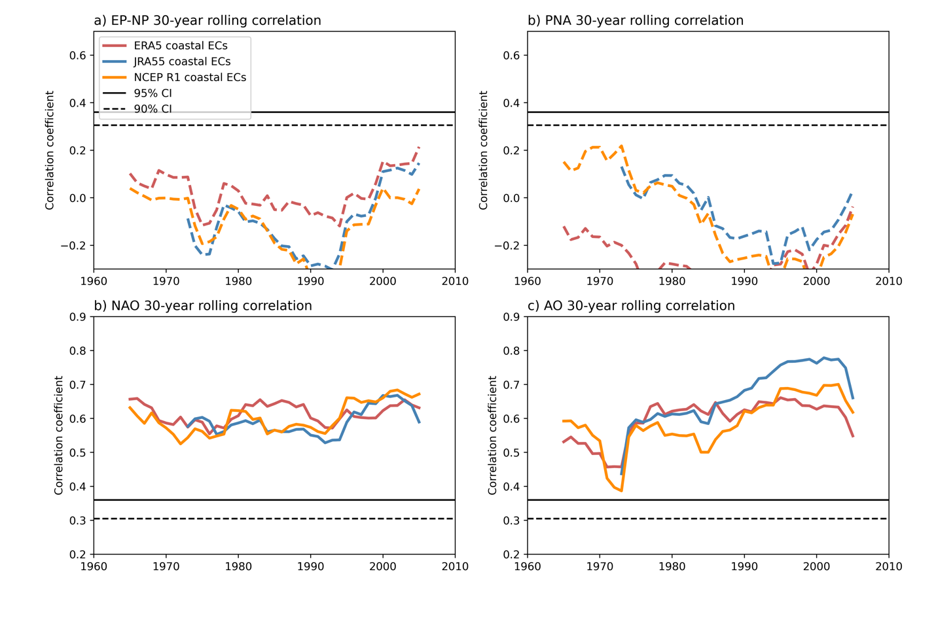

Figure S3. A 30-year rolling correlation between the November through March frequency of high-latitude ECs tracked in ERA5 (red line), JRA55 (blue line) and NCEP R1 (orange line) with the EP-NP (a), PNA (b), NAO (c), and AO teleconnection indices (d). The horizontal dotted line and solid line indicate the significance thresholds for 28 degrees of freedom for the 90% and 95% confidence interval respectively. Gray shading highlights the insignificant areas.

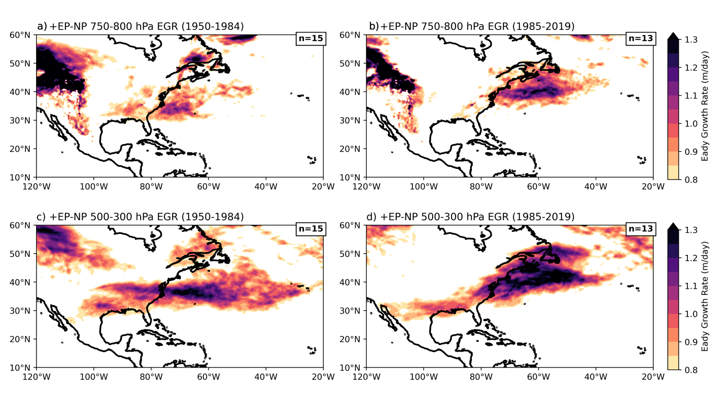
Figure S4. Positive EP-NP case composites of (a,b) 700-850 hPa EGR and (c,d) 500-300 hPa EGR.

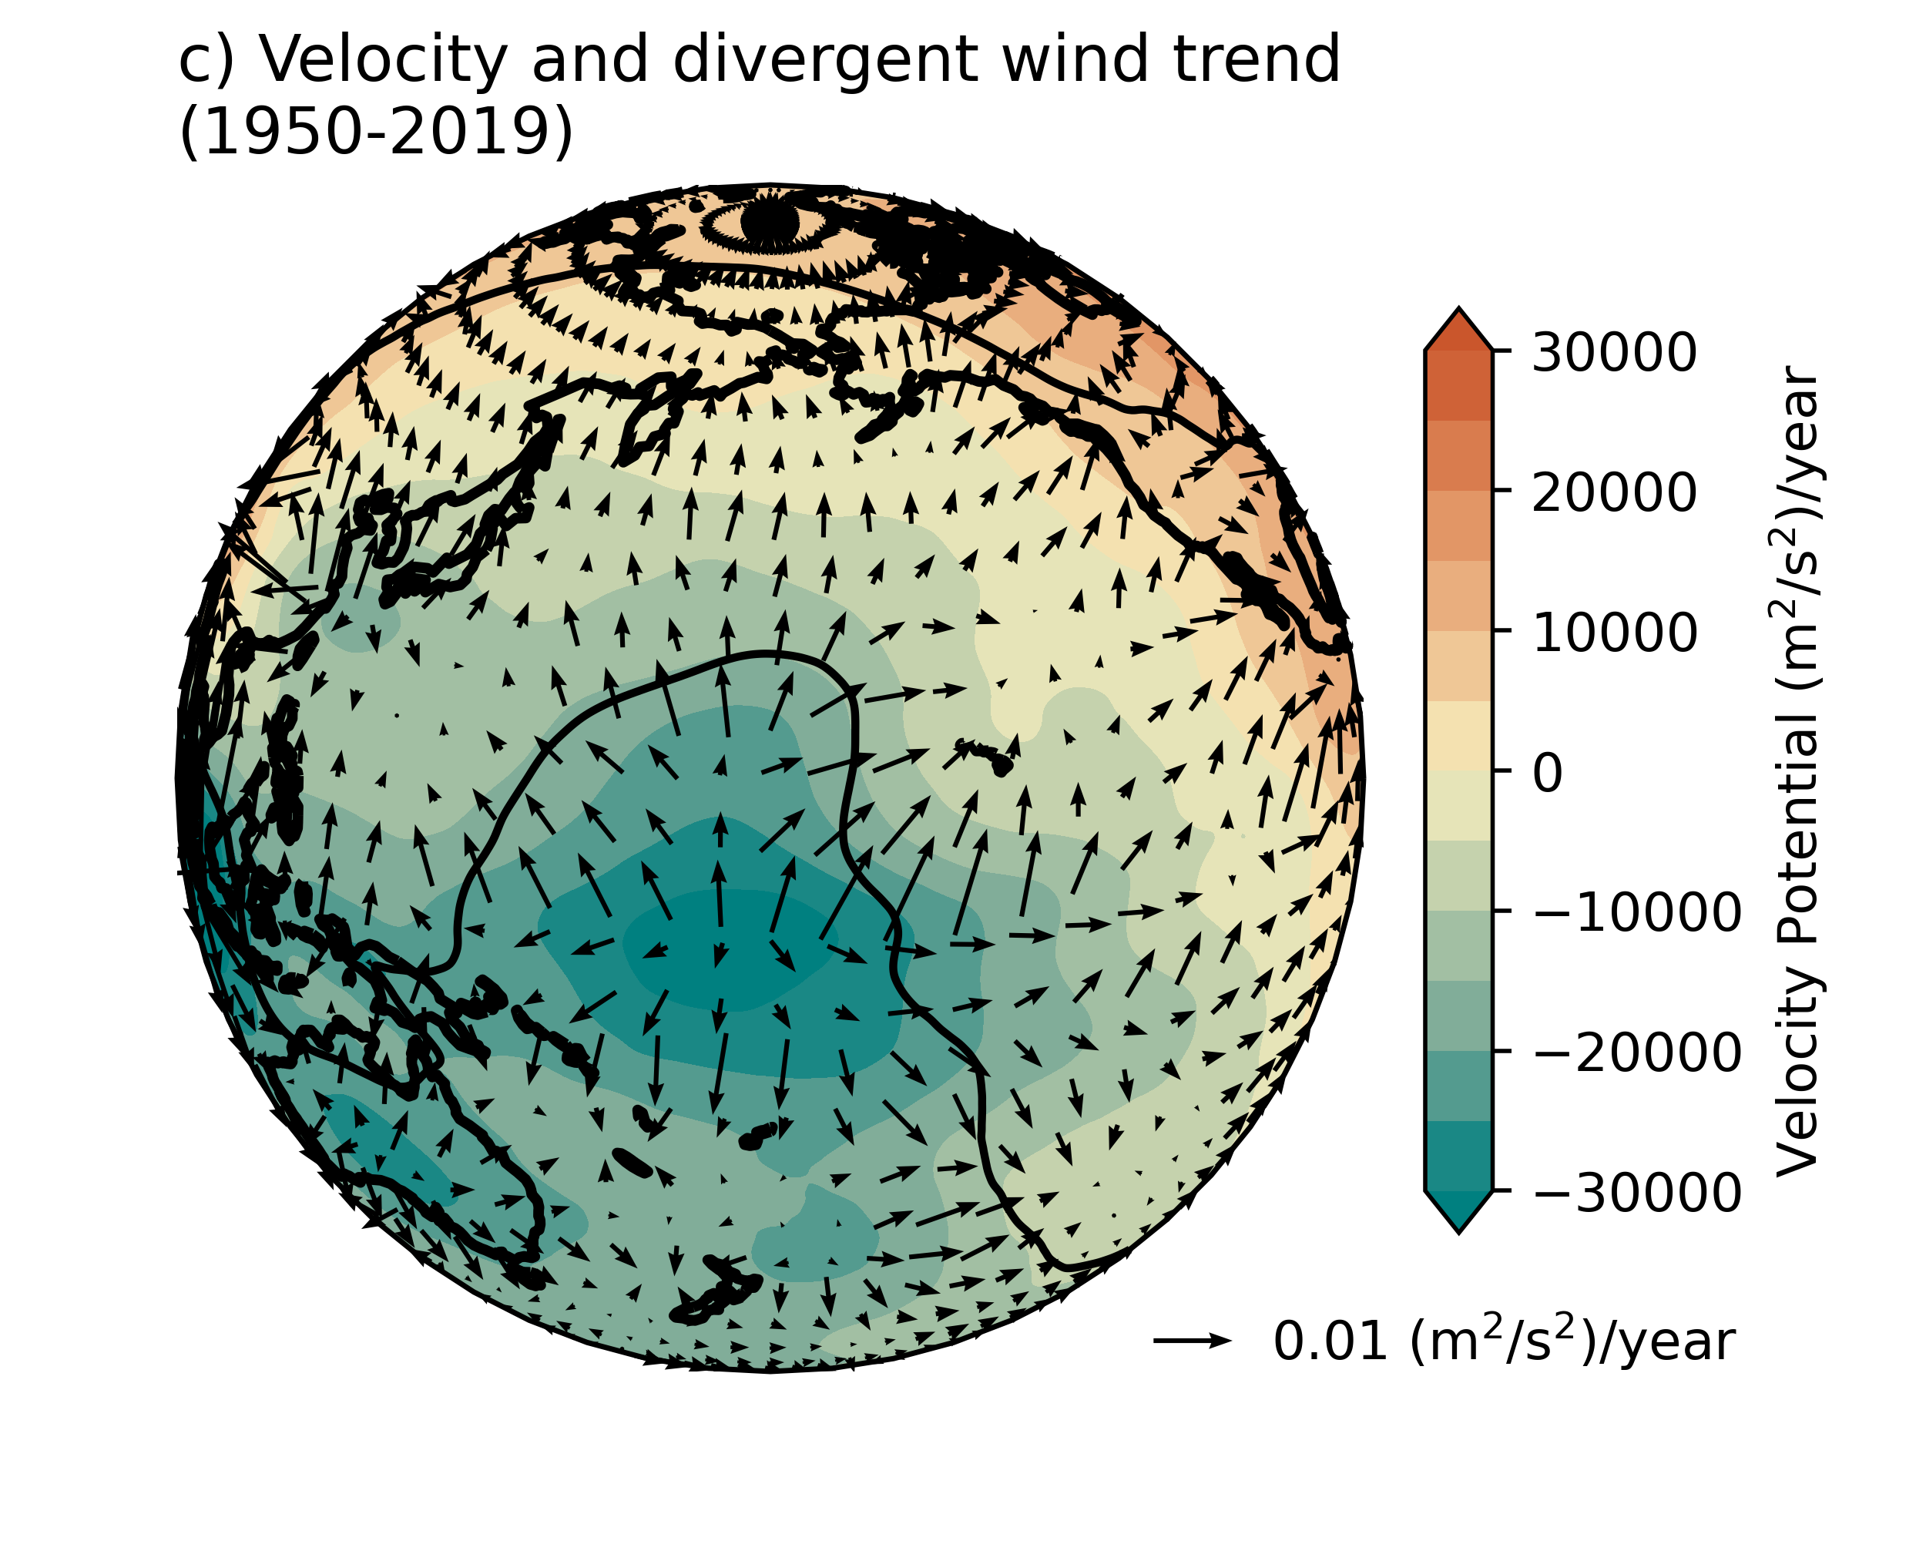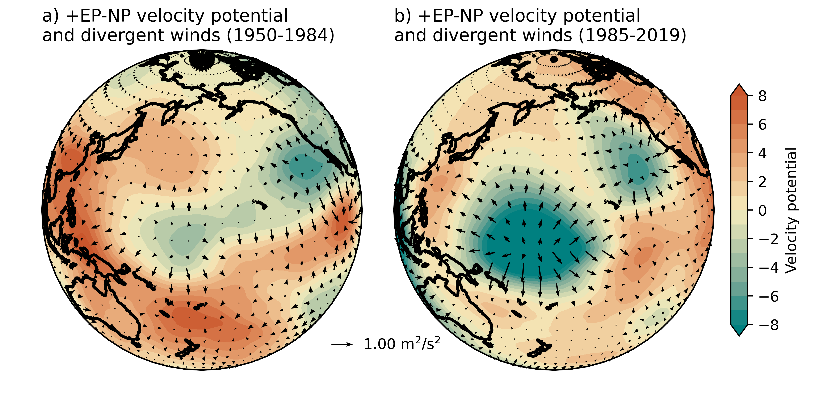
Figure S5. Velocity potential and irrotational winds at 250 hPa for the positive EP-NP from 1950 to 1985 (a) and 1985 to 2020 (b). Figure 8c shows the linear trend of velocity potential and irrotational winds. These plots are centered on 180° W, showing the north Pacific Ocean.

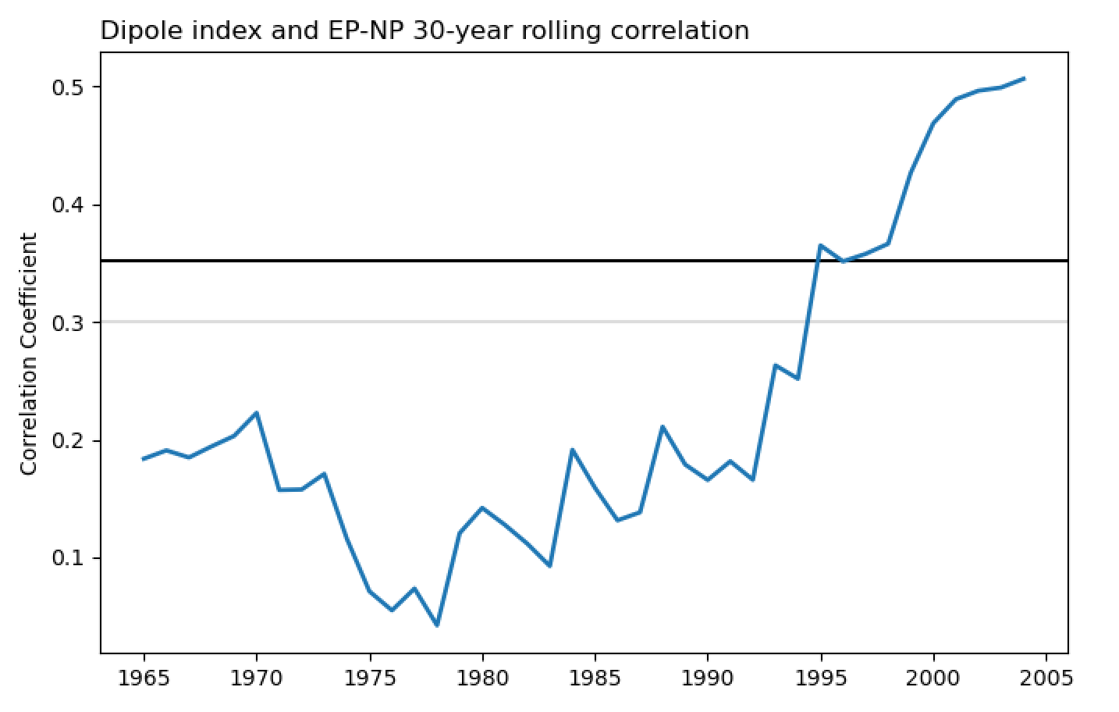
Figure S6. November through March “dipole-index” 30-year rolling correlation with the EP-NP index. The dipole index is calculated following Wang et al. (2015) by subtracting the monthly Z300 values between the ridge center (232.5-237.5°E & 47.5-52.5°N) from the trough center (282.5-287.5°E and 57.5-62.5°N) in NCEP R1. The horizontal black and gray lines indicate the 95% and 90% confidence intervals for 28 degrees of freedom.

References:

Allen, J. T., Pezza, A. B., & Black, M. T. (2010). Explosive Cyclogenesis: A Global Climatology Comparing Multiple Reanalyses. Journal of Climate, 23(24), 6468–6484. https://doi.org/10.1175/2010JCLI3437.1
Benestad, R. E., & Chen, D. (2006). The use of a calculus-based cyclone identification method for generating storm statistics. Tellus A, 58(4), 473–486. https://doi.org/10.1111/j.1600-0870.2006.00191.x
Blender, R., Fraedrich, K., & Lunkeit, F. (1997). Identification of cyclone-track regimes in the North Atlantic. Quarterly Journal of the Royal Meteorological Society, 123(539), 727–741. https://doi.org/10.1002/qj.49712353910
Ebita, A., Kobayashi, S., Ota, Y., Moriya, M., Kumabe, R., Onogi, K., Harada, Y., Yasui, S., Miyaoka, K., Takahashi, K., Kamahori, H., Kobayashi, C., Endo, H., Soma, M., Oikawa, Y., & Ishimizu, T. (2011). The Japanese 55-year Reanalysis “JRA-55”: An Interim Report. Sola, 7, 149–152. https://doi.org/10.2151/sola.2011-038
Hanley, J., & Caballero, R. (2012). Objective identification and tracking of multicentre cyclones in the ERA-Interim reanalysis dataset. Quarterly Journal of the Royal Meteorological Society, 138(664), 612–625. https://doi.org/10.1002/qj.948
Hersbach, H., Bell, B., Berrisford, P., Hirahara, S., Horányi, A., Muñoz‐Sabater, J., Nicolas, J., Peubey, C., Radu, R., Schepers, D., Simmons, A., Soci, C., Abdalla, S., Abellan, X., Balsamo, G., Bechtold, P., Biavati, G., Bidlot, J., Bonavita, M., … Thépaut, J.-N. (2020). The ERA5 global reanalysis. Quarterly Journal of the Royal Meteorological Society, 146(730), 1999–2049. https://doi.org/10.1002/qj.3803
Hodges, K. I., Hoskins, B. J., Boyle, J., & Thorncroft, C. (2003). A Comparison of Recent Reanalysis Datasets Using Objective Feature Tracking: Storm Tracks and Tropical Easterly Waves. Monthly Weather Review, 131(9), 2012–2037. https://doi.org/10.1175/1520-0493(2003)131<2012:ACORRD>2.0.CO;2
Hodges, K. I., Lee, R. W., & Bengtsson, L. (2011). A Comparison of Extratropical Cyclones in Recent Reanalyses ERA-Interim, NASA MERRA, NCEP CFSR, and JRA-25. Journal of Climate, 24(18), 4888–4906. https://doi.org/10.1175/2011JCLI4097.1
Hoskins, B. J., & Hodges, K. I. (2002). New Perspectives on the Northern Hemisphere Winter Storm Tracks. Journal of the Atmospheric Sciences, 59(6), 1041–1061. https://doi.org/10.1175/1520-0469(2002)059<1041:NPOTNH>2.0.CO;2
Hwang, S.-O., Hong, S.-Y., & Kanamitsu, M. (2010). Impacts of assimilated data on reanalysis climatology. Asia-Pacific Journal of Atmospheric Sciences, 46(2), 185–197. https://doi.org/10.1007/s13143-010-0017-0
Jung, T., Gulev, S. K., Rudeva, I., & Soloviov, V. (2006). Sensitivity of extratropical cyclone characteristics to horizontal resolution in the ECMWF model. Quarterly Journal of the Royal Meteorological Society, 132(619), 1839–1857. https://doi.org/10.1256/qj.05.212
Kalnay, E., Kanamitsu, M., Kistler, R., Collins, W., Deaven, D., Gandin, L., Iredell, M., Saha, S., White, G., Woollen, J., Zhu, Y., Chelliah, M., Ebisuzaki, W., Higgins, W., Janowiak, J., Mo, K. C., Ropelewski, C., Wang, J., Leetmaa, A., … Joseph, D. (1996). The NCEP/NCAR 40-Year Reanalysis Project. Bulletin of the American Meteorological Society, 77(3), 437–472. https://doi.org/10.1175/1520-0477(1996)077<0437:TNYRP>2.0.CO;2
Kobayashi, C., Endo, H., Ota, Y., Kobayashi, S., Onoda, H., Harada, Y., Onogi, K., & Kamahori, H. (2014). Preliminary Results of the JRA-55C, an Atmospheric Reanalysis Assimilating Conventional Observations Only. SOLA, 10, 78–82. https://doi.org/10.2151/sola.2014-016
Neu, U., Akperov, M. G., Bellenbaum, N., Benestad, R., Blender, R., Caballero, R., Cocozza, A., Dacre, H. F., Feng, Y., Fraedrich, K., Grieger, J., Gulev, S., Hanley, J., Hewson, T., Inatsu, M., Keay, K., Kew, S. F., Kindem, I., Leckebusch, G. C., … Wernli, H. (2012). IMILAST: A Community Effort to Intercompare Extratropical Cyclone Detection and Tracking Algorithms. Bulletin of the American Meteorological Society, 94(4), 529–547. https://doi.org/10.1175/BAMS-D-11-00154.1
Poli, P., Hersbach, H., Dee, D. P., Berrisford, P., Simmons, A. J., Vitart, F., Laloyaux, P., Tan, D. G. H., Peubey, C., Thépaut, J.-N., Trémolet, Y., Hólm, E. V., Bonavita, M., Isaksen, L., & Fisher, M. (2016). ERA-20C: An Atmospheric Reanalysis of the Twentieth Century. Journal of Climate, 29(11), 4083–4097. https://doi.org/10.1175/JCLI-D-15-0556.1
Raible, C. C., Della-Marta, P. M., Schwierz, C., Wernli, H., & Blender, R. (2008). Northern Hemisphere Extratropical Cyclones: A Comparison of Detection and Tracking Methods and Different Reanalyses. Monthly Weather Review, 136(3), 880–897. https://doi.org/10.1175/2007MWR2143.1
Reale, M., Liberato, M. L. R., Lionello, P., Pinto, J. G., Salon, S., & Ulbrich, S. (2019). A Global Climatology of Explosive Cyclones using a Multi-Tracking Approach. Tellus A: Dynamic Meteorology and Oceanography, 71(1), 1611340. https://doi.org/10.1080/16000870.2019.1611340
Rudeva, I., & Gulev, S. K. (2011). Composite Analysis of North Atlantic Extratropical Cyclones in NCEP–NCAR Reanalysis Data. Monthly Weather Review, 139(5), 1419–1446. https://doi.org/10.1175/2010MWR3294.1
Trigo, I. F. (2006). Climatology and interannual variability of storm-tracks in the Euro-Atlantic sector: A comparison between ERA-40 and NCEP/NCAR reanalyses. Climate Dynamics, 26(2), 127–143.
Walker, E., Mitchell, D., & Seviour, W. (2020). The numerous approaches to tracking extratropical cyclones and the challenges they present. Weather, 75(11), 336–341. https://doi.org/10.1002/wea.3861
Wang, X. L., Feng, Y., Chan, R., & Isaac, V. (2016). Inter-comparison of extra-tropical cyclone activity in nine reanalysis datasets. Atmospheric Research, 181, 133–153. https://doi.org/10.1016/j.atmosres.2016.06.010

