Polygenic contribution to cannabis use disorder shared with and independent of ADHD: a GWAS-by-subtraction approach

Judit Cabana-Domínguez^{1,2,3,4,&}, Natalia Llonga^{1,2,3,4,&}, Silvia Alemany^{1,2,3}, Triinu Varvas⁵, Laura Vilar-Ribó⁶, Uxue Zubizarreta-Arruti^{1,2,3,4}, Pau Carabí-Gassol^{1,2,3,4}, Manuel Donato Rodríguez-Romero^{1,2,3,4}, Valeria Macias-Chimborazo^{1,2,3}, Christian Fadeuilhe^{1,2,3,7}, Montse Corrales^{1,2,3,7}, Vanesa Richarte^{1,2,3,7}, Silvia Amoretti^{1,2,3}, Lara Grau-López^{2,3,8}, Constanza Daigre^{2,3,8}, Elena Ros-Cucurull^{2,8}, Raúl Felipe Palma-Alvarez^{2,3,8}, Àlex Gozález-Segura^{1,2,3}, Matea Skojo^{1,2,3}, Bru Cormand^{4, 9,10,11}, Noèlia Fernàndez-Castillo^{4,9,10,11}, Kadri Kõiv⁵, Kelli Lehto⁵, Estonian Biobank Research Team⁵, Josep Antoni Ramos-Quiroga^{1,2,3,7}, María Soler Artigas^{1,2,3,4,*}, Marta Ribasés^{1,2,3,4,*}

Supplementary figures
Supplementary Figure 1. Overview of the study design. 2
Supplementary Figure 2. MiXeR results 3
Supplementary Figure 3. GWAS-by-subtraction GenomicSEM model. 4
Supplementary Figure 4. Quantile-quantile plot 5
Supplementary Figure 5. 6
Supplementary Figure 6. Functional annotation of significant variants 7

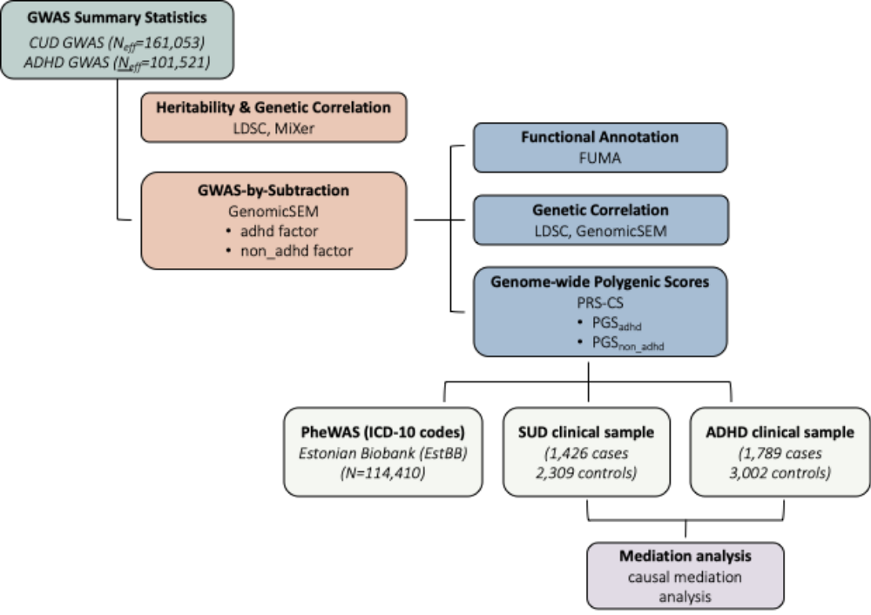

Supplementary Figure 1. Overview of the study design. GWAS summary statistics for cannabis use disorder (CUD; N effective = 161,053) and ADHD (N effective = 101,521) were used to estimate SNP-based heritability and genetic correlation. GWAS-by-subtraction was applied to derive ADHD-related and non-ADHD-related genetic components, which were used for functional annotation, genetic correlation analyses, and construction of genome-wide polygenic scores. These risk scores were tested for association with 1,902 ICD-10 codes in a PheWAS in the Estonian Biobank (N = 114,410) and with substance use disorder (SUD; 1,426 cases and 2,309 controls) and ADHD (1,789 cases and 3,002 controls) in two independent clinical datasets. Finally, mediation analysis in the clinical datasets was conducted to evaluate whether the association between polygenic scores and SUD was mediated by ADHD diagnosis.

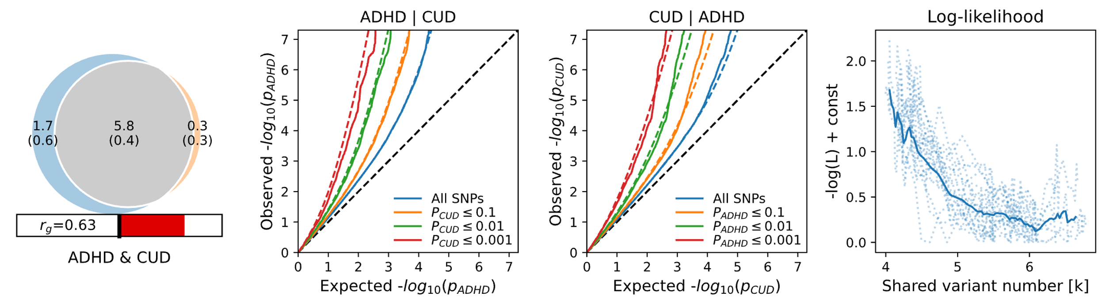
ADHD | CUD
(a)
(b)
(c)
(d)
CUD | ADHD

Observed -log₁₀ (p_{CUD})
Observed -log₁₀ (p_{ADHD})

All SNPs
P_{ADHD} ≤ 0.1
P_{ADHD} ≤ 0.01
P_{ADHD} ≤ 0.001
All SNPs
P_{CUD} ≤ 0.1
P_{CUD} ≤ 0.01
P_{CUD} ≤ 0.001
ADHD & CUD

Expected -log₁₀ (p_{addiction})
Expected -log₁₀ (p_{ADHD})

Supplementary Figure 2. MiXeR results. (a) Venn diagram showing the estimated number of variants shared between ADHD and CUD (gray). Variants unique to ADHD are depicted in blue and variants unique to addiction in orange. The number of variants (and standard deviation) is shown in thousands. The size of the circles reflects the polygenicity of each phenotype, with larger circles corresponding to greater polygenicity. The estimated genetic correlation (rg) between ADHD and CUD is shown below the Venn diagram, with red color indicating positive genetic correlation. b) and c) depict conditional Q–Q plots of observed versus expected −log10 p-values in the primary phenotype as a function of significance of association with a secondary phenotype at different levels of p -values. Colored dotted lines indicate model predictions for each stratum and the black dotted diagonal is the expected Q–Q plot under null (no SNPs associated with the phenotype). d) Log-likelihood curves highlighting the goodness of model fit. The minimum point indicates the best-fitting model estimate of the number of influencing variants shared between both phenotypes.

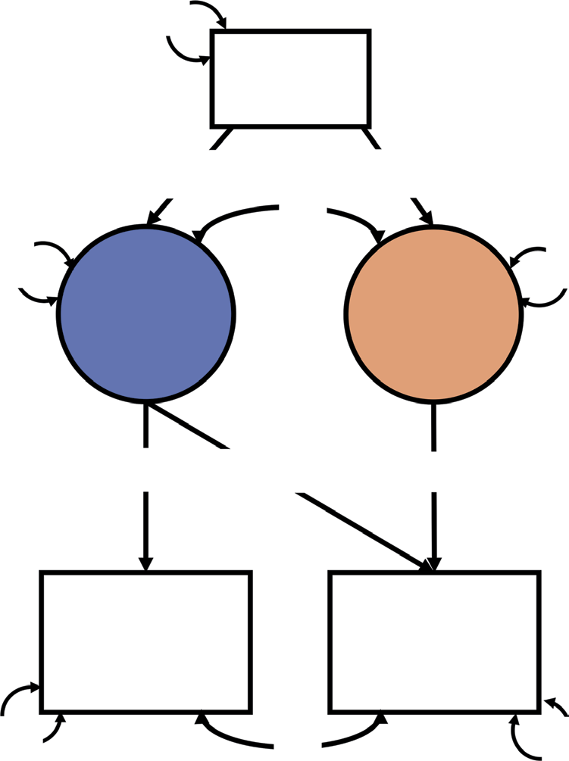
1
1
non_adhd
adhd
0
2pq
ßnon_adhd
ßadhd
SNP

λnon_adhd-CUD
adhd
λadhd-CUD
adhd
λadhd-ADHD
adhd

CUD
ADHD
adhd

0
0
0

Supplementary Figure 3. GWAS-by-subtraction GenomicSEM model. The model allows for two paths from the SNP to cannabis use disorder (CUD). The first path corresponds to the SNP’s effect on CUD via a latent variable (adhd). The latent variable adhd loads on both ADHD as well as CUD: it reflects the adhd genetic effect on CUD. The second path from SNP to CUD reflects genetic effects on CUD, that are not correlated with ADHD (non_adhd). The observed variables ADHD and CUD were regressed on the latent variables (adhd and non_adhd), resulting in the estimates for the path loadings: λ_{adhd-ADHD}=0.42, λ_{adhd-CUD}=0.17 and λ_{non_adhd-CUD}=0.22.

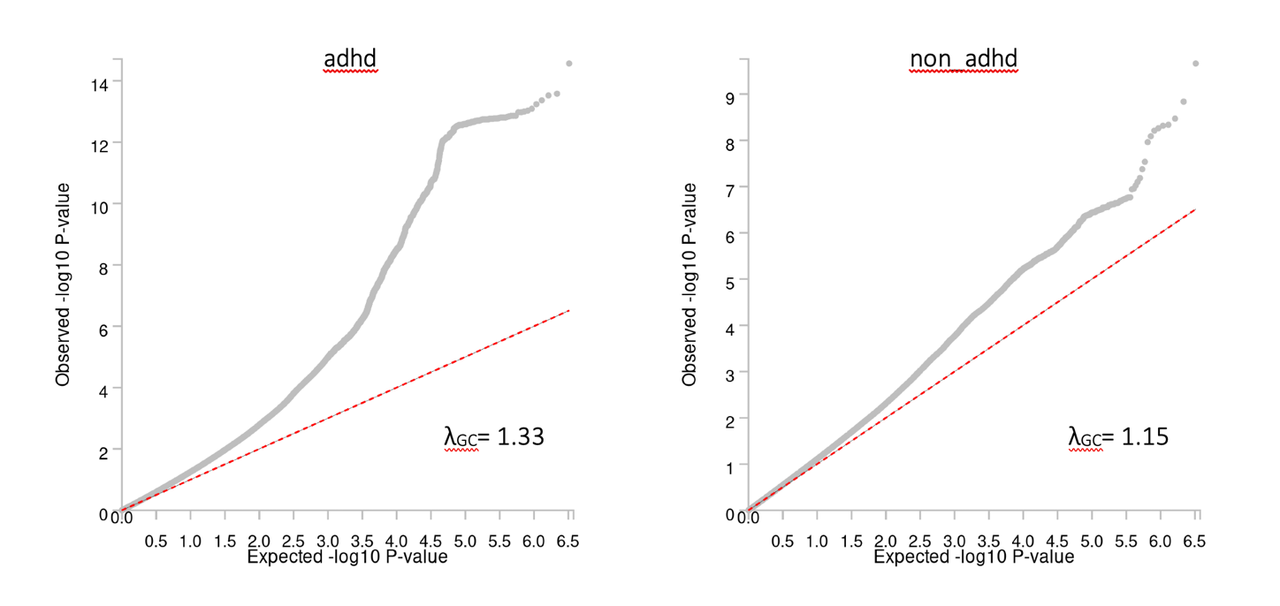

Supplementary Figure 4. Quantile-quantile plot of the -log10 P-values from the adhd and non_adhd factors against expected -log10 P-values. The red dashed line indicates the distribution of P-values under the null hypothesis.

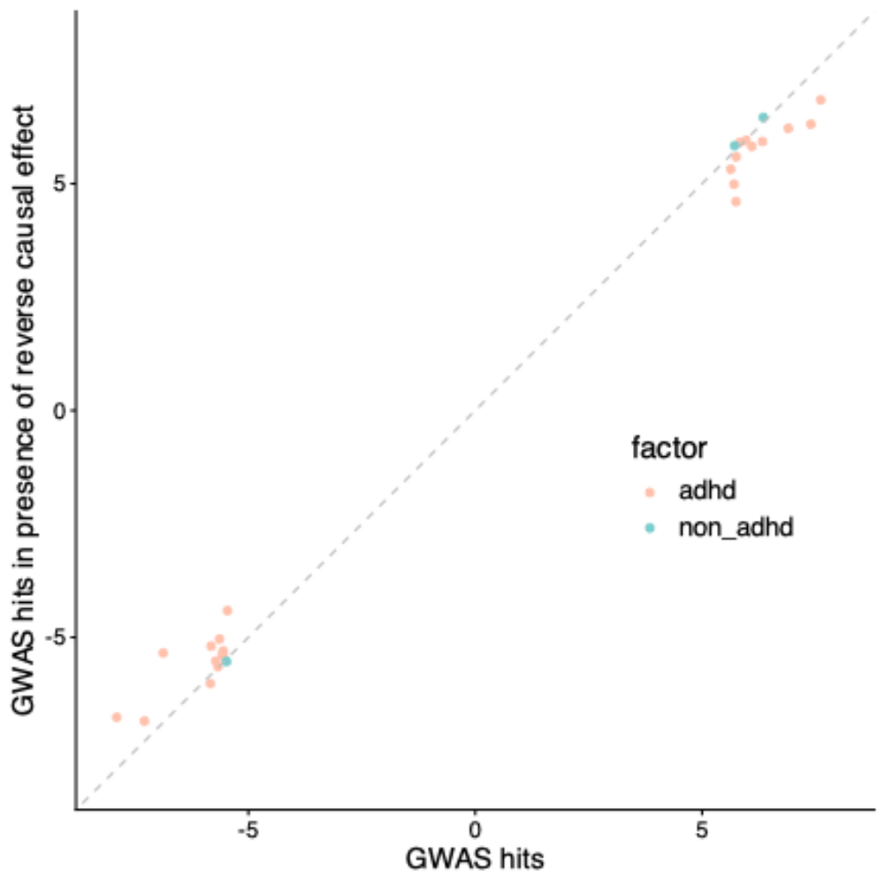

Supplementary Figure 5. Scatter plot of Z-statistics for independent genome-wide significant hits for adhd (in orange) and non_adhd (in green) estimated with the GWAS-by-subtraction model (x-axis) versus estimated with a model allowing for a reverse causal effect of CUD on ADHD (y-axis). Z-statistics of independent hits estimated with the two models were significantly correlated (r=0.93, P-value=5.4e-12).

(a)

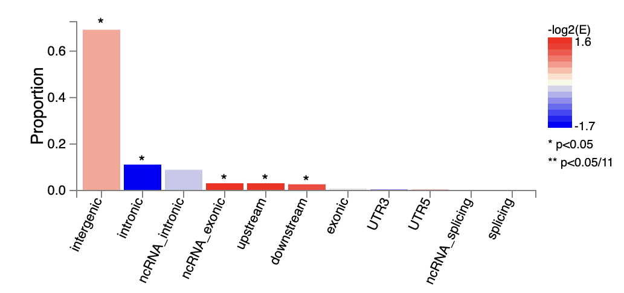

(b)
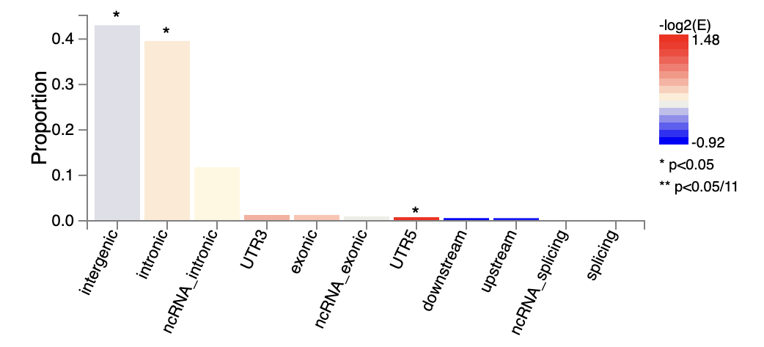

Supplementary Figure 6. Functional annotation of significant variants (P<5e-05) associated with (a) the adhd factor and (b) the non_adhd factor.

