Supplementary information

Aminolytic Depolymerization of Polyethylene Terephthalate Wastes Using Sn-Doped ZnO Nanoparticles
Viswanathan Vinitha¹, Mani Preeyanghaa², Ravikumar Dhanalakshmi¹, Murugan Anbarasu¹, Bernaurdshaw Neppolian²* and Vajiravelu Sivamurugan¹*
¹PG and Research Department of Chemistry, Pachaiyappa’s College, Chennai-600 030.
²Departments of Physics and Nanotechnology & SRM Research Institute, SRM Institute of Science and Technology, Kattankulathur, Chennai, 603203, India

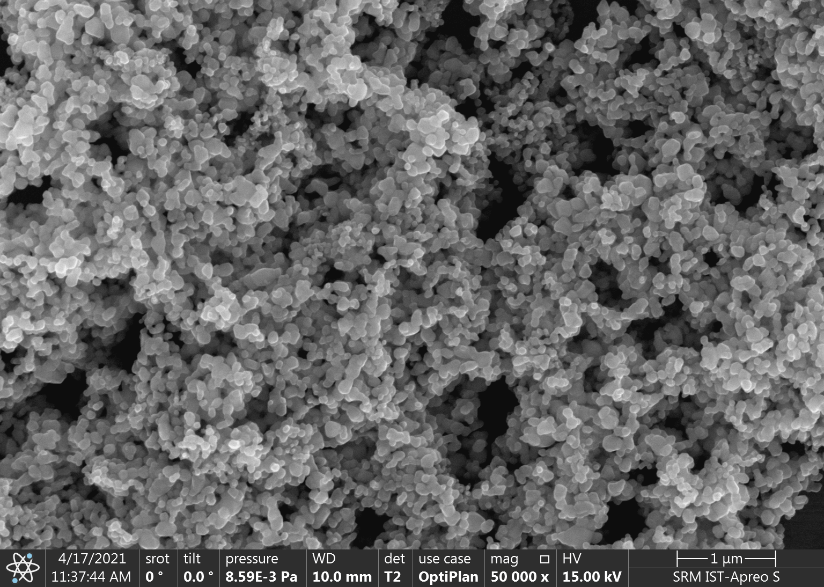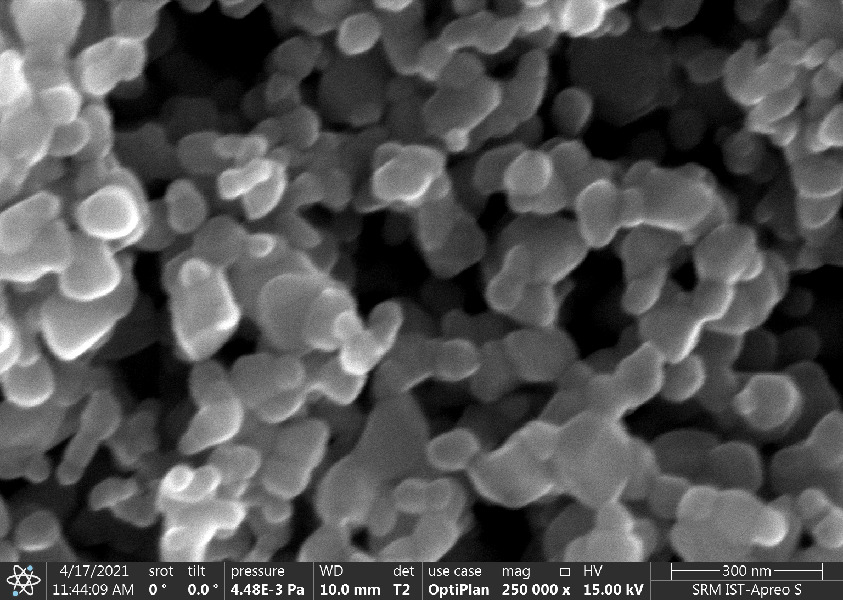
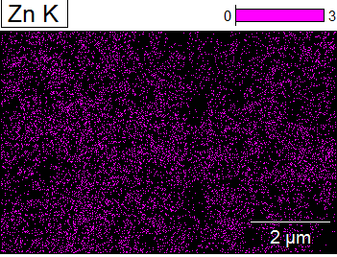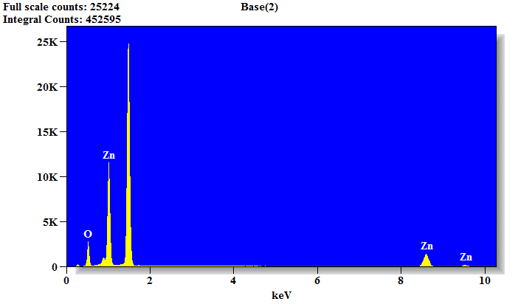
Figure S1. HR SEM, elemental mapping and EDAX spectra of pure ZnO

Table S1. Elemental composition of pure ZnO
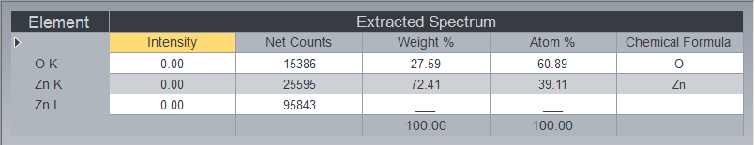

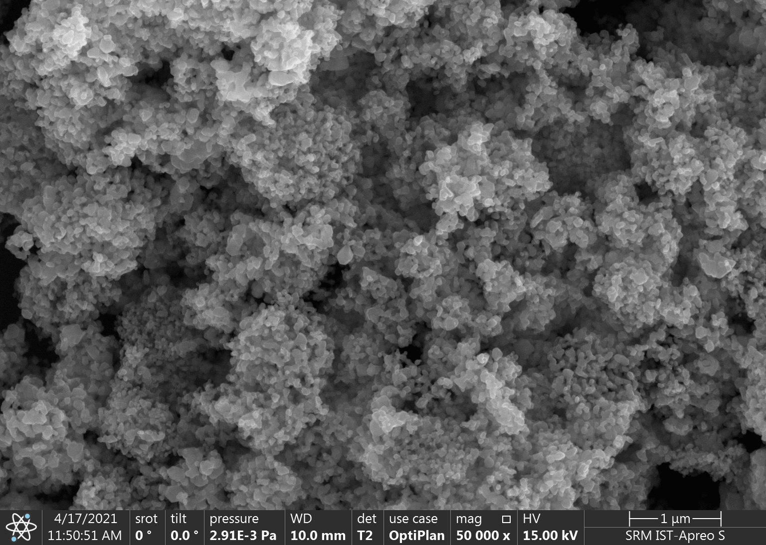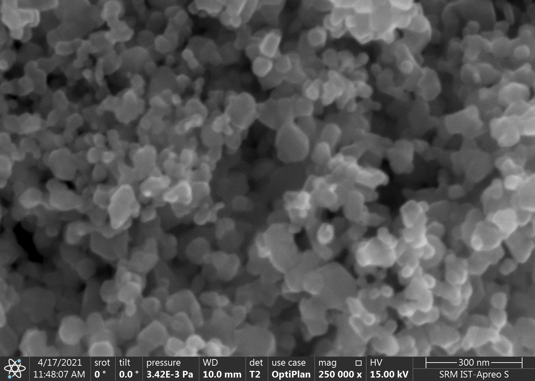
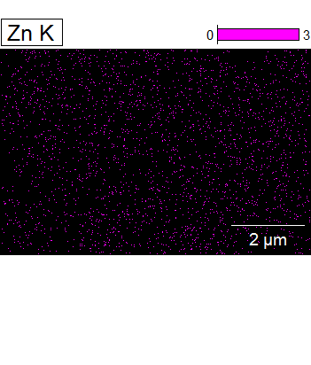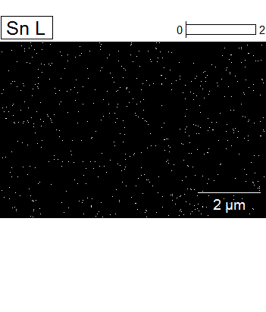
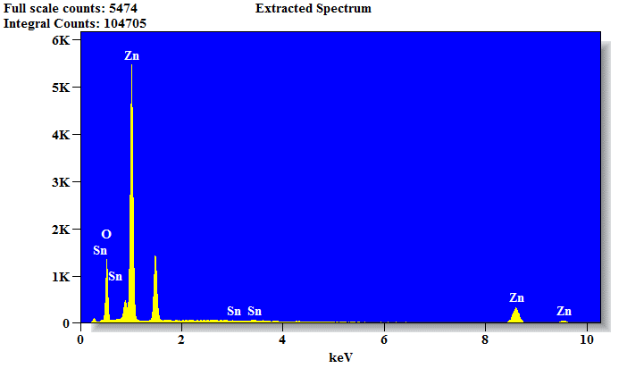
Figure S2. HR SEM, elemental mapping and EDAX spectra of 1 mol% Sn doped ZnO

Table S2. Elemental composition of 1 mol% Sn(II) doped ZnO
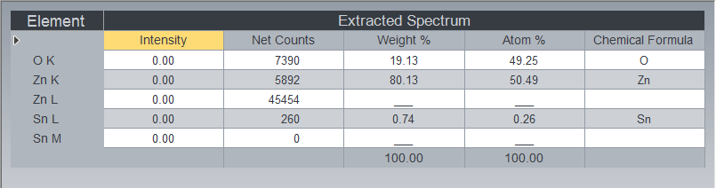

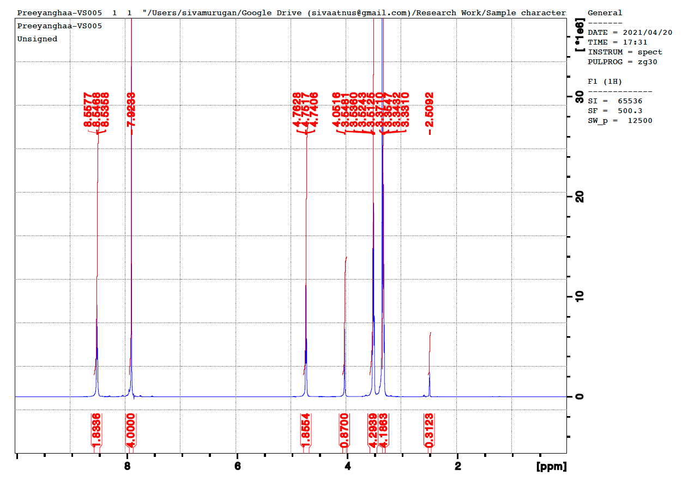
Figure S3. ¹H NMR Spectra of depolymerised product, BHETA

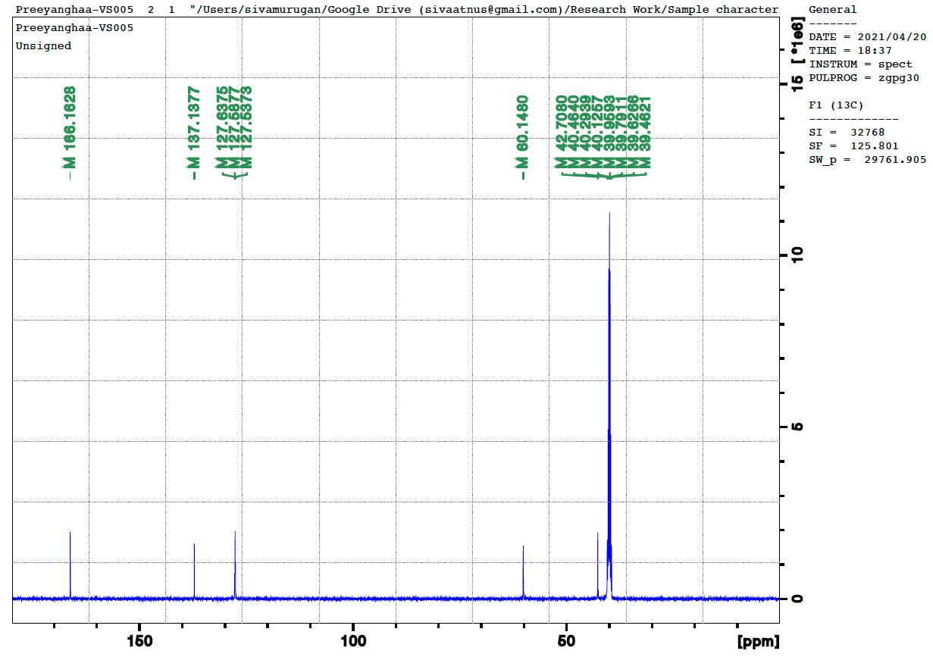
Figure S4. ¹³C NMR Spectra of depolymerised product
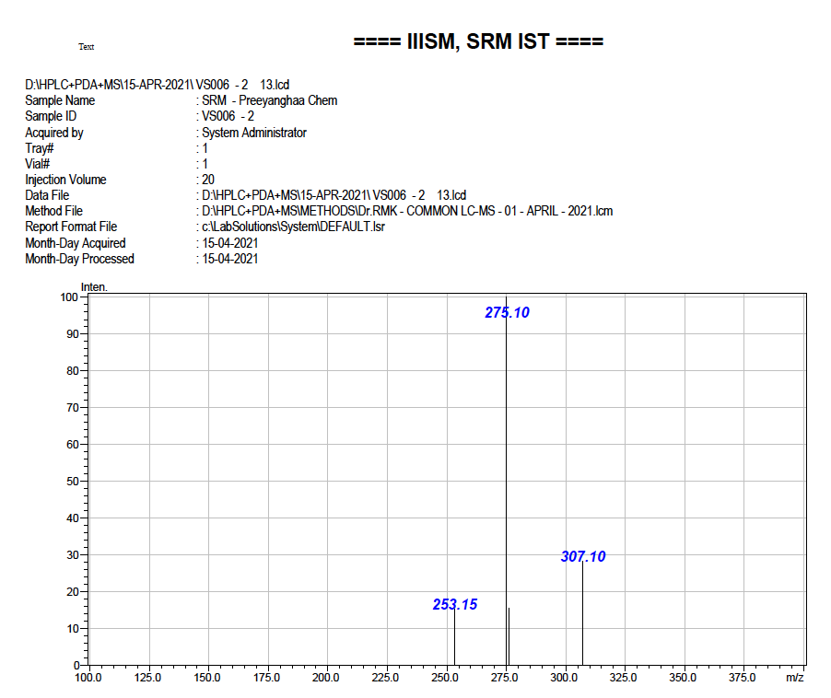
Figure S5. Mass spectrum of depolymerised product
Figure S6. FT-IR spectra of bis(hydroxy ethyl)terephthalimide, BHETA

