Appendix A
Comprehensive List of PAC Members
Member  Dr. Nicholas Muraguri  Dr. Izaq Odongo  Dr. Hannah Wamae  Mr. Joseph Mirereh  Dr. Santau Migiro  Dr. Pacifica Onyancha  Dr. Rachel Nyamai  Dr. Martin Sirengo  Dr. Irene Mukui  Dr. Peter Kimuu  Dr. Jackson Kioko  Professor Issaac Kibwage  Mr. David Njoroge  Dr. Andrew Mulwa  Dr Jack Magara  Mrs. Agnes Waudo  Mr. Sylvester Kimaiyo  Mr. Meshack Ndolo  Dr. Janet Muriuki  Mr. Mathew Thuku  Mr, Mark Hawken  Mrs. Susan Otieno  Mr. Andre Verani  Mr. James Kwach  Dr. Abraham Katana  Dr. Elly Odongo  Mr. Peter Waithaka  Mrs. Edna Tallam Kimaiyo  Mr. Micah Kisoo  Mr. Daniel Yumbya  Dr. Samuel Mwenda  Ms. Jacinta Mutegi  Ms. Firdaus Omar  Mr. Peter Tum  Dr. Jane Karonjo  Professor Barasa Otsyula  Mrs. Jessica Gross  Custodia Mandlhate  Dr. Nduku Kilonzo  Dr. Celestine Mugambi  Prof. Sylvia Ojoo | Institution of Affiliation  MOH  MOH  MOH  MOH  MOH  MOH  MOH  NASCOP  NASCOP  MOH  MOH  University of Nairobi  MOH  County Executives Committee (CEC) for Health  County Directors of Health Services (CDHS)  Emory Kenya Health Workforce Project  AMPATH  IntraHealth International  IntraHealth International  IntraHealth International  ICAP  MOH  CDC Atlanta  CDC Kenya  CDC Kenya  CDC Kenya  USAID Kenya  NCK  COC  KMPDB  CHAK  KCCB  SUPKEM  KMTC  Mt. Kenya University  Kenya Methodist University  Emory University/ CDC Atlanta  WHO Kenya  NACC  NACC  University of Maryland
Appendix B
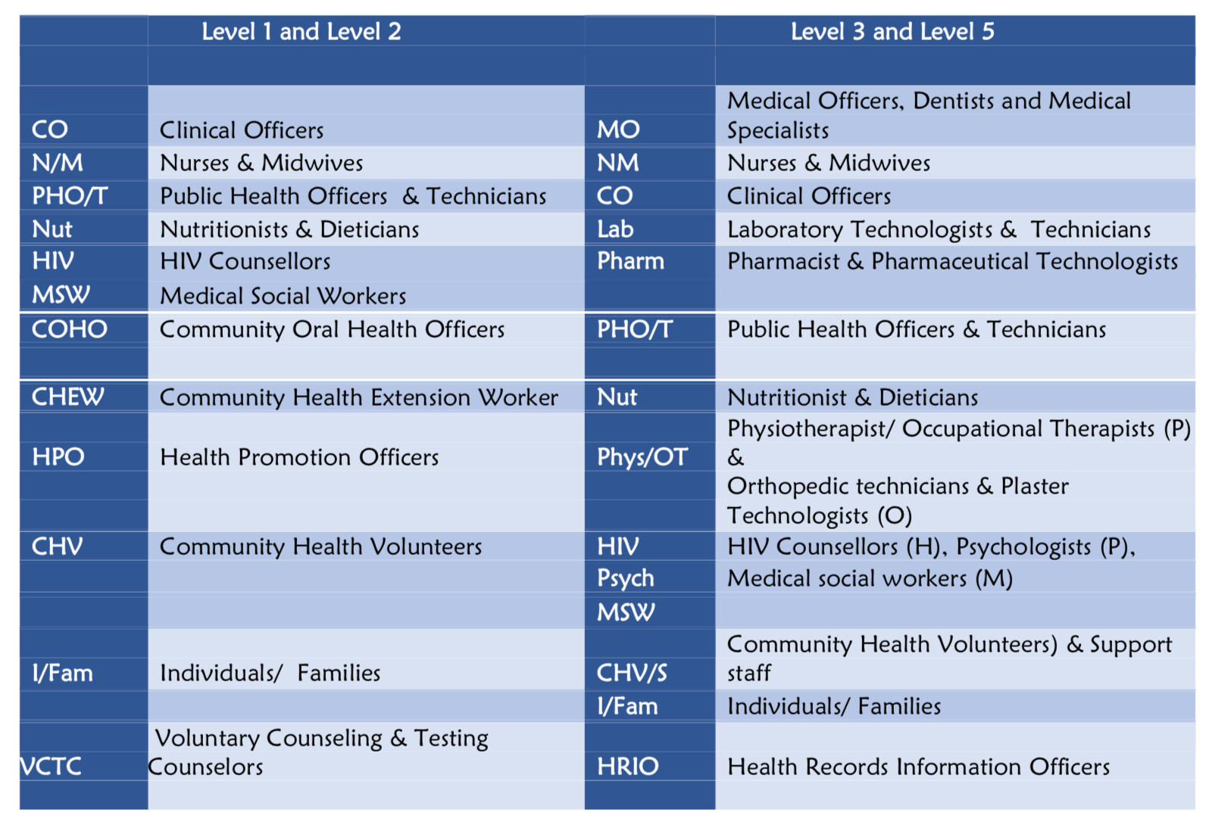
Figure 1: Cadre Abbreviations. Reprinted from Task Sharing Policy Guidelines 2017-2030 (p. 53) by Kenya Ministry of Health, Nairobi, Kenya. Copyright 2017 by the Principal Secretary, Ministry of Health, Kenya. Reprinted with permission.

Appendix C
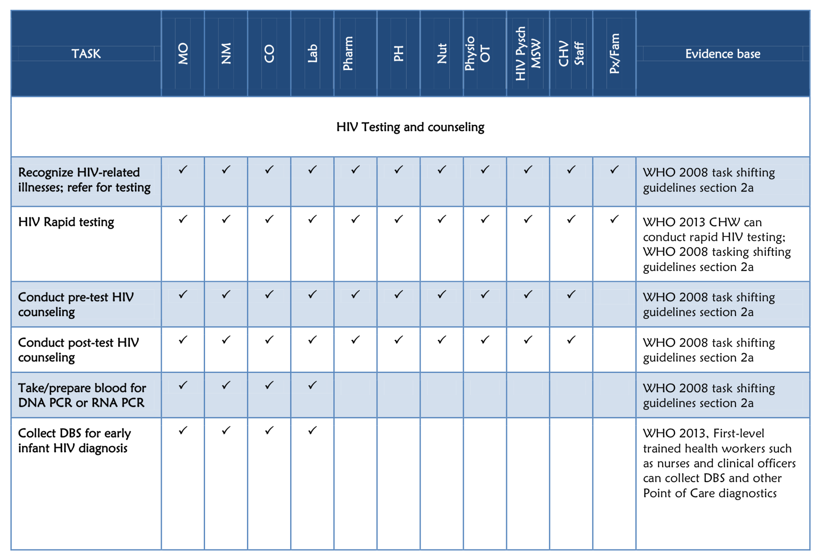
Figure 2: HIV testing and counseling tasks that may conducted with adequate training and supervision. Reprinted from Task Sharing Policy Guidelines 2017-2030 (p. 85) by Kenya Ministry of Health, Nairobi, Kenya. Copyright 2017 by the Principal Secretary, Ministry of Health, Kenya. Reprinted with permission.

