Supplementary Methods
Cohort-specific inclusion/exclusion criteria
The SILCODE cohort: Data were obtained from the ongoing Sino Longitudinal Study on Cognitive Decline (SILCODE; ClinicalTrials.gov identifier: NCT03370744 from December 2015 to May 2021)¹. Participants included were classified Cognitively Normal (CN, without subjective or informant-reported cognitive decline) or as having Subjective Cognitive Decline (SCD, with subjective memory concerns but normal memory function) at their initial visit. All participants underwent standardized neuropsychological assessment and received MRI (T1-weighted structural, rs-fMRI, and DTI images), amyloid PET imaging, and apolipoprotein E (ApoE) genotype assessments, and in this study, 85 subjects were included. The study was approved by relevant ethics committees and radiation protection authorities. All participants provided written informed consent².
The HABS cohort: Data were sourced from Harvard Aging Brain Study³ Public Dataset https://www.synapse.org/Synapse:syn65670172 . Participants included were classified as CN. For the present study, eligibility criteria mandated complete APOE genotyping, comprehensive cognitive testing tracking, and [¹¹C]-PiB amyloid PET imaging at baseline and across a long-term longitudinal tracking horizon extending up to 8 years. A total of 157 gAβ- participants at baseline with 3-years and among them, 72 with 8-year follow-up were included for longitudinal validation analyses. The HABS study was approved by the Partners Healthcare Institutional Review Board, and all participants provided written informed consent.
Cohort-specific cognitive Assessment and PACC construction
In SILCODE¹, general cognitive performance was obtained from the Chinese-Mini-Mental State Examination (MMSE), episodic memory was obtained from the Auditory Verbal Learning Test (AVLT), language test was obtained from Animal Fluency Test (AFT), speed/executive function was obtained from Shape Trail Test Parts A and B (STTA-B). And a composite score calculated as the sum of normalized these scores. The cohort-specific composite score was computed as the average of the standardized z-scores of these components, calibrated against the global amyloid-negative reference group.
In HABS, we examined cognitive decline using the Preclinical Alzheimer Cognitive Composite score with MMSE, Logical Memory Delayed Recall and the Free and Cued Selective Reminding Test, and Categories (Animals/Vegetables/Fruit). All sub-scores were standardized into z-scores based on the global amyloid-negative HABS baseline sample and averaged to form the composite.
PET Acquisition and Preprocessing
The SILCODE cohort^{2,4}: two different scanning protocols were applied using a GE Signa and GE Discovery PET/CT Elite scanner. For the GE Signa PET scanner, the tracer activity was between 259-370 MBq (5.55-7.4 MBq/kg), and the emission scan started after 40 minutes' post-injection. For the GE Discovery PET/CT Elite scanner, the tracer activity ranged from 259-370 MBq (5.55-7.4 MBq/kg), with the emission scan starting between 50–70 minutes' post-injection. PET preprocessing was performed in SPM12 using PETPVE12: images were realigned to structural T1, normalized to MNI space using DARTEL, and partial volume effects were corrected using the Müller-Gärtner method. PET signal intensity was normalized to cerebellar gray matter (masked at 50% GM probability). Global amyloid burden was calculated as the mean SUVR across the cortex. Regional amyloid burden was extracted from 50 bilateral automated anatomical atlas (AAL) regions and further summarized into six cortical meta-regions (frontal, temporal, parietal, anterior cingulate, posterior cingulate, precuneus). A cutoff of mean SUVR >1.2 was used to define amyloid positivity.
The HABS cohort³: [¹¹C]-PiB PET scans were acquired using a 60-minute dynamic protocol following tracer injection on an ECAT EXACT HR+ scanner. Images were co-registered to T1 MRI using FreeSurfer-derived regions of interest (version 6.0) and mapped into native PET space with SPM12. Neocortical amyloid burden was calculated as SUVR across frontal, temporal, parietal, precuneus, anterior cingulate and posterior cingulate, using cerebellar gray as the reference. A cutoff of mean SUVR >1.28 was used to define amyloid positivity.
MRI Acquisition, Preprocessing, and Network Construction (SILCODE)
Resting-state fMRI (rs-fMRI) preprocessing: rs-fMRI was acquired using an echo-planar imaging (EPI) sequence on a 3T GE Signa PET/MR scanner (FOV = 224 × 224 mm², slice thickness = 4 mm with 1 mm gap, 28 slices, 240 volumes, TR = 2000 ms, TE = 30 ms, FA = 90°, voxel size = 3.5 × 3.5 × 5 mm³). The first five volumes were discarded. The remaining images were motion- and slice-time–corrected, coregistered to T1 images, normalized using the Diffeomorphic Anatomical Registration Through Exponentiated Lie Algebra (DARTEL) algorithm⁵, linearly detrended, smoothed with an 8-mm FWHM Gaussian filter, corrected for 24 motion parameters and physiological noise simulated by WM and CSF signals^{6–8}, and temporally band-pass filtered (0.01–0.1 Hz).
Diffusion tensor imaging (DTI) processing⁴: DTI images were acquired using a single-shot spin-echo diffusion-weighted EPI sequence (FOV = 224 × 224 mm², matrix = 112 × 112, slice thickness = 2 mm, 70 interleaved slices, TR = 16,500 ms, TE = 95.6 ms, 30 directions, 5 b0 images, b = 1000 s/mm², voxel size = 2 × 2 × 2 mm³). Preprocessing was performed with FSL6.0 (fsl.fmrib.ox.ac.uk/fsl/), including motion and eddy current correction using affine registration to the first b0 volume⁹. Diffusion tensors were estimated voxel-wise, and eigen decomposition was performed to yield eigenvalues and eigenvectors¹⁰. T1 images were linearly coregistered to the b0 image and nonlinearly normalized to the ICBM152 MNI template. The inverse transformation was applied to warp the AAL atlas into each subject’s native DTI space¹¹.
Network construction and topological properties: Brain networks were constructed with nodes representing brain regions and weighted edges depicting inter-regional connectivity. Nodes were defined by parcellating the cortex into 90 AAL atlas-based regions of interest (ROIs).
For the functional network, the mean time series of the all ROIs were extracted and intercorrelated, resulting in a correlation matrix for each participant. The weighted edge of a node pair was defined as significant after a threshold. To ensure robustness across a range of network densities, four correlation thresholds were additionally examined (r = 0.13, 0.23, 0.33, 0.43; interval = 0.10). In the main analyses, we report results based on r = 0.23.
For the structural network, parcellation of DTI images was performed in individual native spaces based on inversely warped AAL maps (see section MRI data preprocessing), resulting in 90 ROIs for each participant. Voxel-based fiber tracking of the entire cortex was performed using PANDA¹² (nitrc.org/projects/panda), with a fractional anisotropy (FA) threshold of 0.2 and a tracking turning angular threshold of 45° between two connections. Fiber connections were defined if at least three fiber bundles passed through or terminated in cortical ROIs^{13,14}. The weighted edge of a node pair was obtained by the number of fiber bundles connecting a node pair, resulting in a matrix for each participant^{11,15}. To evaluate threshold robustness, four fiber‑count thresholds were tested (3, 8, 13, 18; interval = 5). The primary analyses used 23 streamlines as the main threshold.
Nodal (Regional) degree centrality characterizes the importance of a given node within a network^{16,17}. Nodal degree $D_{reg}\left(i\right)$represents number of edges connected to the node as follows:
$D_{reg}\left(i\right)=\sum_{i≠j∈G}{d_{ij}}$
Nodal (Regional) betweenness characterize the effectiveness of communication of a given node within a network. The betweenness of a given node $B_{reg}\left(i\right)$measures the proportion of shortest paths between any node pair (j, k) in the network G passing through a given node i ($d_{jik}$), among all other shortest paths between the node pair ($d_{jk}$):
$$B_{reg}\left(i\right)=\sum_{j,k}{\frac{d_{jik}}{d_{jk}}}$$
Nodes with higher betweenness are also named hubs, indicating a more critical role for efficient communication within a network, bridging nodes that connect disparate parts of the network.
Nodal (Regional) shortest path length quantifies the average minimum distance from a given node to all other nodes in the network, reflecting the efficiency of information transfer from that node to the rest of the system. A shorter path length indicates a more central position for efficient communication. For a given node $i$, the nodal shortest path length $L_{reg}\left(i\right)$ is defined as:
$$L_{reg}\left(i\right)=\frac{1}{N-1}\sum_{i≠j}{d_{ij}}$$

where $d_{ij}$ denotes the shortest path length between node$i$ and node$j$, and $N$ is the total number of nodes in the network $G$.
Network hubs were defined as regions exhibiting either degree centrality or betweenness centrality greater than one standard deviation above the network mean¹⁸.
Supplementary Results
SILCODE: Robustness and Topological Characterization
Robustness of the regional Aβ–PACC association in PCUN - To evaluate the robustness of the amyloid-centered region’s (PCUN) main effect reported above, we conducted three additional analyses using the SILCODE baseline data. First, considering the high and positive associations between regional Aβ in PCUN and global SUVR (r = 0.597, p < 0.001), replacing regional Aβ in PCUN with its residual after regressing out global SUVR yielded a virtually identical coefficient (β = 1.688, p = 0.007), indicating that the association was not attributable to collinearity between regional and global amyloid burden. Second, the partial correlation between regional Aβ in PCUN and PACC, adjusting for global SUVR and all covariates, remained positive and significant (r = 0.306, p = 0.008). Notably, global SUVR itself was not significantly associated with PACC in this sample (r = 0.024, p = 0.842), underscoring that this regional-level association was not evident at the global level. Third, to determine whether the positive association reflected an idiosyncrasy of the PACC composite, we re-ran Model 1 substituting PACC with its constituent subtests. MMSE and RAVLT subtests showed positive associations with regional Aβ in PCUN in the same direction as PACC, albeit with attenuated statistical significance (MMSE: β = 3.009, p = 0.012; RAVLT: β = 2.801, p = 0.017; Figure 1B), supporting that this association reflects a genuine, domain-general relationship rather than an artifact of composite scoring.
Regional Aβ Load Preferentially Aligns with Structural Network Centrality - To assess the correspondence between baseline pathology and intrinsic connectome architecture, we computed region-wise Pearson correlations between cohort-averaged regional Aβ and group-mean nodal centrality in the functional and structural networks (Supplementary Table S2). Regional Aβ correlated only with functional betweenness centrality (r = 0.37–0.39, all p < 0.05; Supplementary Figure S1A-B), but not with functional degree centrality or shortest path length. In the structural network, regional Aβ correlated positively with both degree centrality (r = 0.47–0.50, all p < 0.01; Supplementary Figure S1C-D), but not with betweenness centrality or shortest path length.
References
1. Li, X., Wang, X., Su, L., Hu, X. & Han, Y. Sino Longitudinal Study on Cognitive Decline (SILCODE): protocol for a Chinese longitudinal observational study to develop risk prediction models of conversion to mild cognitive impairment in individuals with subjective cognitive decline. BMJ Open 9, e028188 (2019).
2. Jiang, X. et al. Altered limbic functional connectivity in individuals with subjective cognitive decline: Converging and diverging findings across Chinese and German cohorts. Alzheimers Dement. 19, 4922–4934 (2023).
3. Dagley, A. et al. Harvard Aging Brain Study: dataset and accessibility. NeuroImage 144, 255–258 (2017).
4. Jiang, X. et al. Brain Topological Changes in Subjective Cognitive Decline and Associations with Amyloid Stages. Preprint at https://doi.org/10.21203/rs.3.rs-4459273/v1 (2025).
5. Ashburner, J. A fast diffeomorphic image registration algorithm. NeuroImage 38, 95–113 (2007).
6. Dagli, M. S., Ingeholm, J. E. & Haxby, J. V. Localization of Cardiac-Induced Signal Change in fMRI. NeuroImage 9, 407–415 (1999).
7. Friston, K. J., Williams, S., Howard, R., Frackowiak, R. S. J. & Turner, R. Movement‐Related effects in fMRI time‐series. Magn. Reson. Med. 35, 346–355 (1996).
8. Windischberger, C. et al. On the origin of respiratory artifacts in BOLD-EPI of the human brain. Magn. Reson. Imaging 20, 575–582 (2002).
9. Smith, S. M. Fast robust automated brain extraction. Hum. Brain Mapp. 17, 143–155 (2002).
10. Mori, S., Crain, B. J., Chacko, V. P. & van Zijl, P. C. Three-dimensional tracking of axonal projections in the brain by magnetic resonance imaging. Ann. Neurol. 45, 265–269 (1999).
11. Gong, G. et al. Mapping Anatomical Connectivity Patterns of Human Cerebral Cortex Using In Vivo Diffusion Tensor Imaging Tractography. Cereb. Cortex 19, 524–536 (2009).
12. Cui, Z., Zhong, S., Xu, P., He, Y. & Gong, G. PANDA: a pipeline toolbox for analyzing brain diffusion images. Front. Hum. Neurosci. 7, (2013).
13. Li, Y. et al. Brain Anatomical Network and Intelligence. PLOS Comput. Biol. 5, e1000395 (2009).
14. Shu, N. et al. Altered Anatomical Network in Early Blindness Revealed by Diffusion Tensor Tractography. PLoS ONE 4, e7228 (2009).
15. Lo, C.-Y. et al. Diffusion Tensor Tractography Reveals Abnormal Topological Organization in Structural Cortical Networks in Alzheimer’s Disease. J. Neurosci. 30, 16876–16885 (2010).
16. Buckner, R. L. et al. Cortical Hubs Revealed by Intrinsic Functional Connectivity: Mapping, Assessment of Stability, and Relation to Alzheimer’s Disease. J. Neurosci. 29, 1860–1873 (2009).
17. Bullmore, E. & Sporns, O. Complex brain networks: graph theoretical analysis of structural and functional systems. Nat. Rev. Neurosci. 10, 186–198 (2009).
18. He, Y., Chen, Z. & Evans, A. Structural Insights into Aberrant Topological Patterns of Large-Scale Cortical Networks in Alzheimer’s Disease. J. Neurosci. 28, 4756–4766 (2008).

Supplementary Table 1. Regions of interest based on automated anatomical labeling (AAL) and Desikan–Killiany (DK) atlas.
Cortex | Regions in AAL | Regions in DK | Cortex | Regions in AAL | Regions in DK
Frontal | Precentral gyrus | precentral | Temporal | Superior temporal gyrus | superior temporal
Frontal | Superior frontal gyrus, dorsolateral | superior frontal | Temporal | / | bankssts
Frontal | Superior frontal gyrus, orbital part | lateral orbitofrontal | Temporal | Middle temporal gyrus | middle temporal
Frontal | Inferior frontal gyrus, orbital part | pars orbitalis | Temporal | Inferior temporal gyrus | inferior temporal
Frontal | Middle frontal gyrus | rostral middle frontal | Temporal | Heschl gyrus | Transverse temporal
Frontal | Middle frontal gyrus, orbital part | medial orbitofrontal | Temporal | Para-hippocampus | para-hippocampus
Frontal | Inferior frontal gyrus, opercular part | pars opercularis | Temporal | Fusiform | fusiform
Frontal | Inferior frontal gyrus, triangular part | pars triangularis | Temporal | Temporal pole: superior temporal gyrus | /
Frontal | Supplementary motor area | caudal middle frontal | Temporal | Temporal pole: middle temporal gyrus | /
Frontal | Olfactory cortex | / | Parietal | Postcentral gyrus | postcentral
Frontal | Gyrus rectus | / | Parietal | Superior parietal gyrus | superior parietal
Frontal | Superior frontal gyrus, medial | / | Parietal | Inferior parietal gyrus | inferior parietal
Frontal | Superior frontal gyrus, medial orbital | / | Parietal | Supramarginal gyrus | supramarginal
Anterior cingulate | Anterior cingulate and paracingulate gyri | caudal anterior cingulate | Parietal | Angular gyrus | /
Anterior cingulate | Anterior cingulate and paracingulate gyri | rostral anterior cingulate | Parietal | Paracentral lobule | paracentral
Posterior cingulate | Posterior cingulate gyrus | isthmus cingulate | Precuneus | Precuneus | Precuneus
Posterior cingulate | Posterior cingulate gyrus | posterior cingulate | Precuneus | Precuneus | Precuneus

Supplementary Table 2. Significant effects (FDR corrected) of regional Aβ burden and its interaction effects with functional nodal centralities on cognition in SILCODE across different functional network thresholds.
 |  |  | Threshold = 0.13 |  |  | Threshold = 0.23 |  |  | Threshold = 0.33 |  |  | Threshold = 0.43
Models | Effects | Regions | β | SE | T | β | SE | T | β | SE | T | β | SE | T
Model 1 | Aβ main effect | PCUN | 1.688 | 0.609 | 2.774* | 1.688 | 0.609 | 2.774 | 1.688 | 0.609 | 2.774 | 1.688 | 0.609 | 2.774
Model 2 | Aβ main effect  (Adjusted $Dreg$) | PCUN | 1.755 | 0.618 | 2.838* | 1.781 | 0.621 | 2.866* | 1.747 | 0.622 | 2.807* | 1.747 | 0.623 | 2.806*
Model 2 | Aβ main effect  (Adjusted $Breg$) | PCUN | / | / | / | / | / | / | 1.673 | 0.610 | 2.745* | 1.679 | 0.614 | 2.737*
Model 2 | Aβ main effect  (Adjusted $Lreg$) | PCUN | 1.773 | 0.627 | 2.828* | 1.777 | 0.627 | 2.833* | 1.806 | 0.628 | 2.877* | / | / | /
Note: Values represent the regression coefficients (β), standard errors (SE), and t‑values. Significance * represents FDR-corrected p < 0.05. PCUN, Precuneus; FFA, fusiform; PCL, paracentral lobule; ORBinf, Inferior frontal gyrus, orbital part; $Dreg$, regional degree centrality;$Breg$, regional betweenness centrality; $Lreg$, regional shortest path length.
Supplementary Table 3. Significant effects (FDR corrected) of regional Aβ burden and its interaction effects with structural nodal centralities on cognition in SILCODE across different structural network thresholds.
 |  |  | Threshold = 3 |  |  | Threshold = 8 |  |  | Threshold = 13 |  |  | Threshold = 18
Models | Effects | Regions | β | SE | T | β | SE | T | β | SE | T | β | SE | T
Model 1 | Aβ main effect | PCUN | 1.688 | 0.609 | 2.774* | 1.688 | 0.609 | 2.774 | 1.688 | 0.609 | 2.774 | 1.688 | 0.609 | 2.774
Model 2 | Aβ main effect  (Adjusted $Dreg$) | PCUN | 1.725 | 0.615 | 2.806* | 1.723 | 0.615 | 2.804* | 1.722 | 0.615 | 2.802* | 1.722 | 0.615 | 2.802*
Model 2 | Aβ main effect  (Adjusted $Breg$) | PCUN | 1.711 | 0.618 | 2.767* | 1.716 | 0.618 | 2.778* | 1.715 | 0.617 | 2.781* | 1.754 | 0.616 | 2.873*
Model 2 | Aβ main effect  (Adjusted $Lreg$) | PCUN | 1.713 | 0.613 | 2.794* | 1.711 | 0.613 | 2.791* | 1.711 | 0.613 | 2.792* | 1.712 | 0.613 | 2.796*
Model 3 | Aβ $×Dreg$  interaction effect | IFGtriang | -0.007 | 0.002 | -2.991* | -0.007 | 0.002 | -2.976* | -0.007 | 0.002 | -2.926* | -0.006 | 0.002 | -2.858*
Model 3 | Aβ $×Dreg$  interaction effect | ACG | -0.007 | 0.003 | -2.843* | -0.007 | 0.003 | -2.861* | -0.007 | 0.003 | -2.781* | -0.007 | 0.003 | -2.796*
Model 3 | Aβ $×Dreg$  interaction effect | PHG | -0.009 | 0.003 | -3.084* | -0.009 | 0.003 | -3.142* | -0.010 | 0.003 | -3.258* | -0.010 | 0.003 | -3.263*
Model 3 | Aβ $×Dreg$  interaction effect | PoCG | -0.008 | 0.002 | -2.960* | -0.007 | 0.002 | -2.980* | -0.007 | 0.002 | -2.947* | -0.007 | 0.002 | -2.883*
Model 3 | Aβ $×Dreg$  interaction effect | IPL | -0.005 | 0.002 | -2.658* | / | / | / | / | / | / | / | / | /
Model 3 | Aβ $×Dreg$  interaction effect | SMG | -0.005 | 0.002 | -2.870* | -0.005 | 0.002 | -2.895* | -0.005 | 0.002 | -2.885* | -0.004 | 0.002 | -2.761*
Model 3 | Aβ $×Dreg$  interaction effect | STG | -0.003 | <0.001 | -3.405* | -0.003 | <0.001 | -3.415* | -0.003 | <0.001 | -3.394* | -0.003 | <0.001 | -3.376*
Model 3 | Aβ $×Dreg$  interaction effect | MTG | -0.003 | <0.001 | -3.517* | -0.003 | <0.001 | -3.520* | -0.003 | <0.001 | -3.530* | -0.003 | <0.001 | -3.565*
Model 3 | Aβ $×Lreg$  interaction effect | PoCG | 66.49 | 20.20 | 3.292* | 62.67 | 19.51 | 3.212* | 55.40 | 17.48 | 3.170* | / | / | /
Model 3 | Aβ $×Lreg$  interaction effect | IPL | 38.06 | 11.91 | 3.197* | 37.10 | 11.52 | 3.221* | / | / | / | / | / | /
Model 3 | Aβ $×Lreg$  interaction effect | STG | 48.33 | 14.49 | 3.336* | 46.78 | 14.19 | 3.298* | 41.96 | 13.11 | 3.200* | 35.27 | 11.14 | 3.166*
Model 3 | Aβ $×Lreg$  interaction effect | MTG | 38.71 | 12.01 | 3.223* | 37.66 | 11.74 | 3.208* | 33.05 | 10.88 | 3.039* | 27.64 | 9.224 | 2.997*
Note: Values represent the regression coefficients (β), standard errors (SE), and t‑values. Significance * represents FDR-corrected p < 0.05. PCUN, Precuneus; IFGtriang, Inferior frontal gyrus, triangle part; ACG, Anterior cingulate and paracingulate gyri; PHG, Para-hippocampal gyrus; PoCG, postcentral gyrus; IPL, inferior parietal lobule; SMG, Supramarginal gyrus; STG, Superior temporal gyrus; MTG, Middle temporal gyrus; OLF, Olfactory cortex; PCG, Posterior cingulate gyrus; $Dreg$, regional degree centrality;$Breg$, regional betweenness centrality; $Lreg$, regional shortest path length.

Supplementary Table 4. Baseline association between regional Aβ load and regional topology in SILCODE
 | $$Dreg$$ |  | $$Breg$$ |  | $$Lreg$$
 | r | p | r | p | r | p
Threshold = 0.13 in FN | 0.110 | 0.564 | 0.381 | 0.038* | -0.169 | 0.371
Threshold = 0.23 in FN | 0.121 | 0.524 | 0.383 | 0.037* | -0.176 | 0.352
Threshold = 0.33 in FN | 0.125 | 0.510 | 0.388 | 0.034* | -0.174 | 0.357
Threshold = 0.43 in FN | 0.134 | 0.482 | 0.369 | 0.045* | -0.063 | 0.740
Threshold = 3 in SN | 0.469 | 0.009** | 0.236 | 0.209 | -0.334 | 0.071
Threshold = 8 in SN | 0.473 | 0.008** | 0.227 | 0.227 | -0.251 | 0.181
Threshold = 13 in SN | 0.478 | 0.006** | 0.219 | 0.245 | -0.146 | 0.440
Threshold = 18 in SN | 0.484 | 0.007** | 0.250 | 0.183 | -0.116 | 0.541
Note: Correlation were calculated between regional Aβ and regional topology at group level. Significance * represents p < 0.05, ** represents p < 0.01. FN, functional network; SN, structural network; $Dreg$, regional degree centrality;$Breg$, regional betweenness centrality; $Lreg$, regional shortest path length.

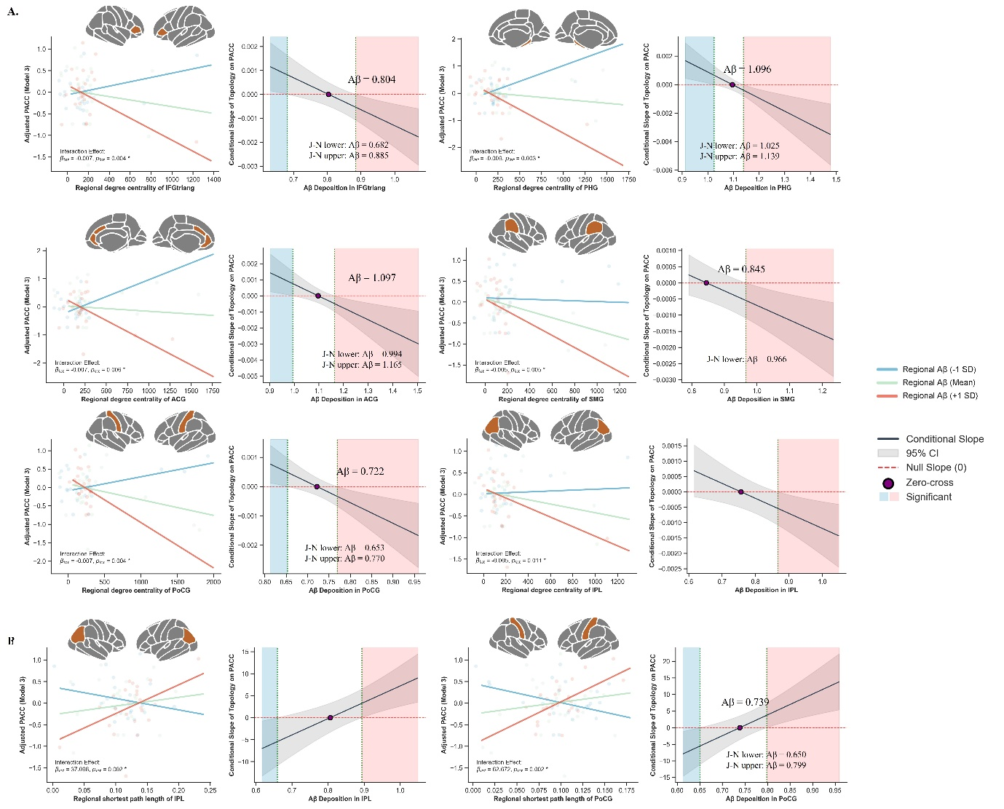
Supplementary figure S1. Regional topology moderates the association between regional Aβ burden and cognition.

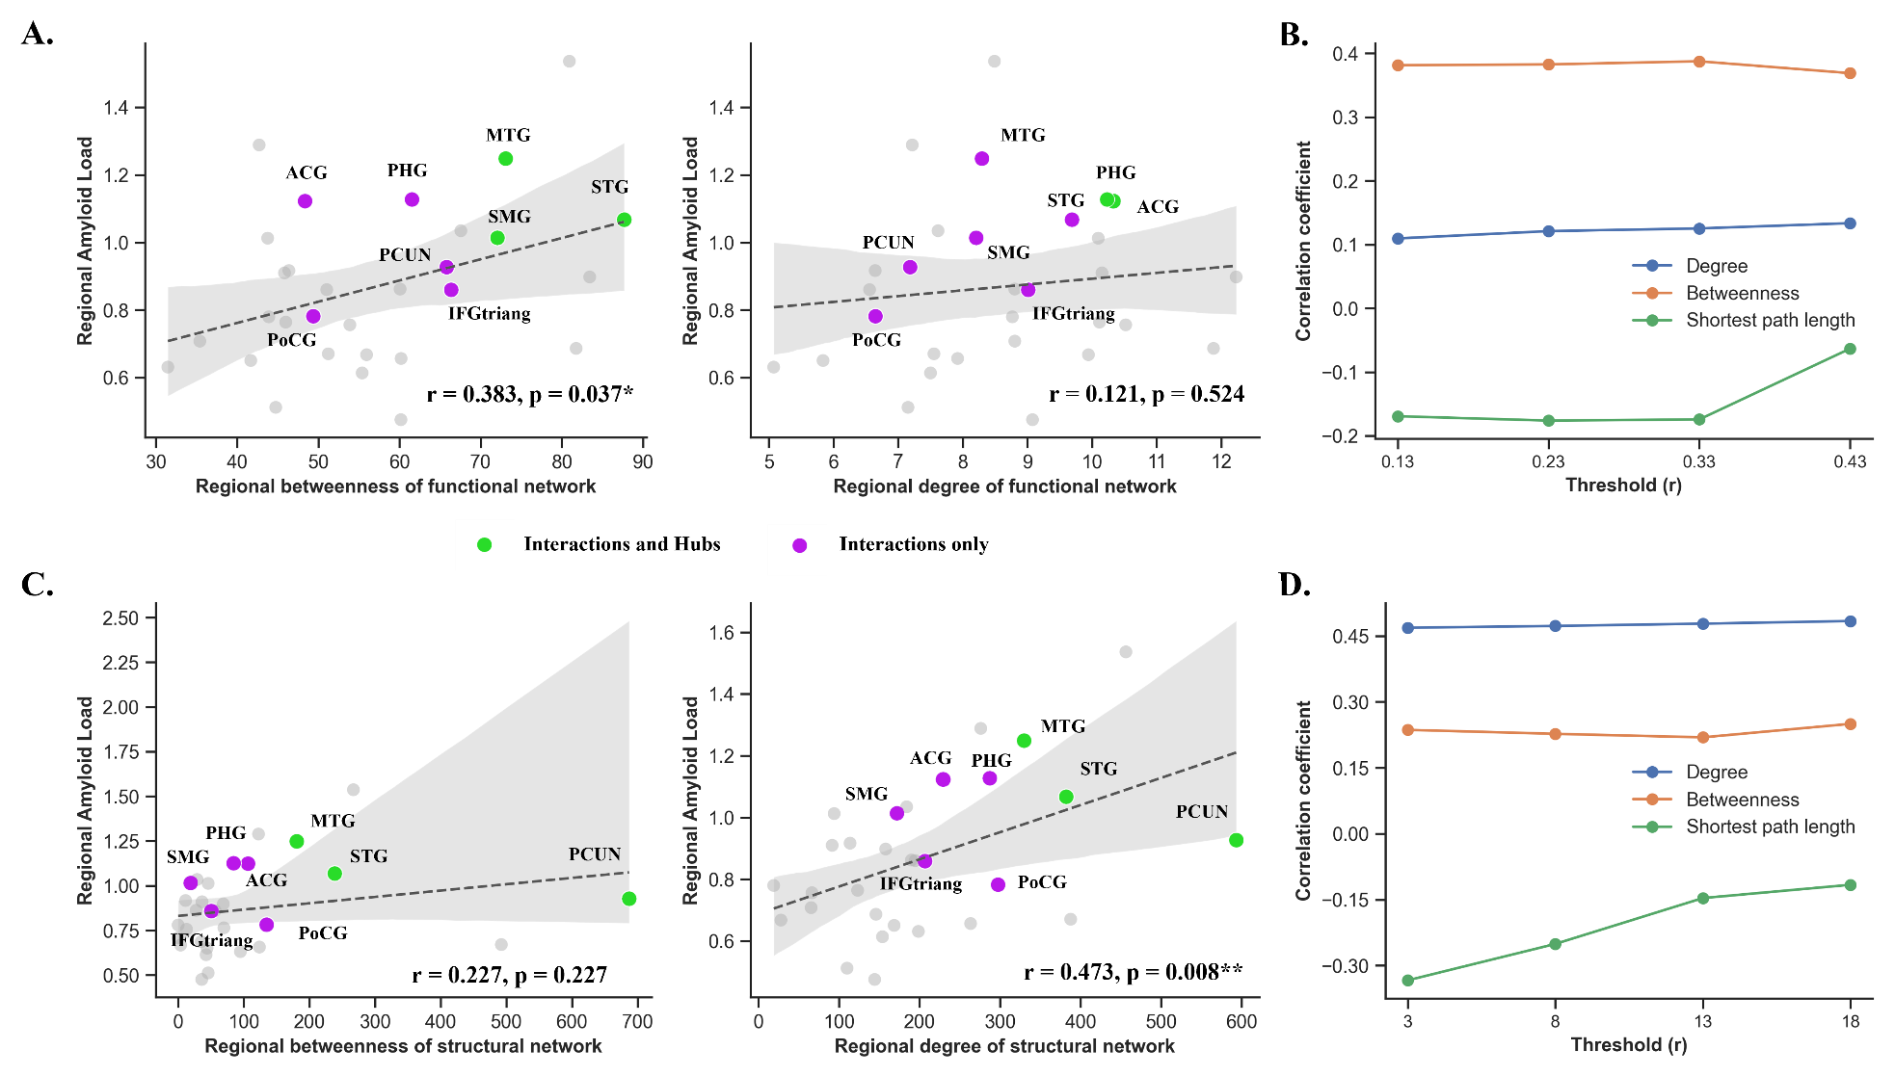
Supplementary figure S2. Spatial correspondence between Aβ-related regions and network hub architecture. A) Associations between regional Aβ burden and network centrality, including betweenness centrality and degree centrality of A) the functional network C) across four thresholds and B) the structural network D) across four thresholds.

