Supplementary Materials

Figure S1: Violin plot of the distribution of correlations between grand-mean grey matter volume (GMV) template and GMV samples in each dataset

Figure S2: The distribution of 100,000 accuracy differences between randomly permutated pseudo 3T samples and pseudo 1.5T samples
The actual accuracy difference between 3T samples and 1.5T samples was labeled as red dash line.

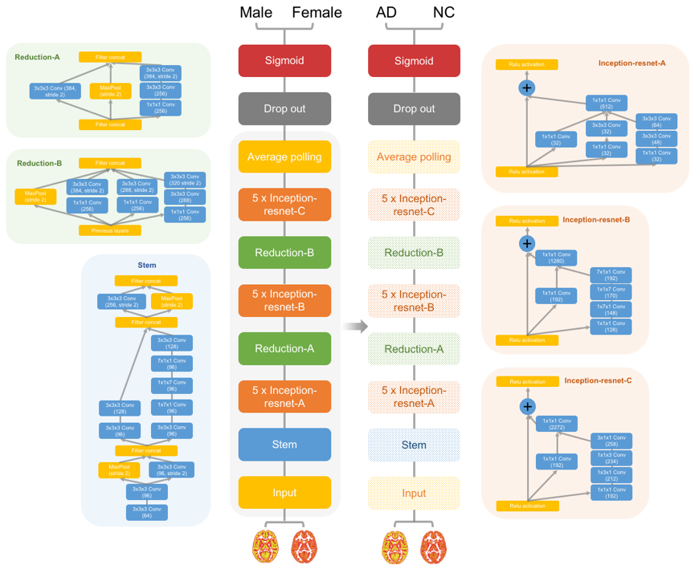
Figure S3: Flow diagram for the Alzheimer disease transfer learning framework without optimization
Schema for 3D Inception-ResNet-V2 model and the Alzheimer disease classifier without model structure optimizing before transfer learning.
Figure S4: Performance of the Alzheimer's disease (AD) classifier without optimization
(A) The receiver operating characteristic curve of the AD classifier. (B) The tensorboard monitor panel of the AD classifier in the training sample. (C) The tensorboard monitor panel of the AD classifier in the validation sample.
Figure S5: Receiver operating characteristic curves of the Alzheimer disease (AD) classifier without optimization when tested on independent AD samples and a mild cognitive impairment sample
(A) The ROC curve of AD classifier tested on the AIBL sample. (B) The ROC curve of AD classifier tested on the OASIS sample. (C) The ROC curve of AD classifier tested on MCI sample in ADNI. The images of MCI subjects with future conversion to AD were labeled as “AD”, and the images of MCI subjects which hadn’t shown conversion to AD were labeled as “NC”.
Figure S6: Interpretation of the AD classifiers without optimization by occlusion maps
Classifier performance dropped considerably when the brain areas rendered in red were masked out of the model input.
Figure S7: Correlations between the output of the Alzheimer's disease (AD) classifier without optimization and the severity of illness
The predicted scores from the AD classifier showed significant negative correlations with the mini-mental state examination (MMSE) scores of AD, normal control (NC) and mild cognitive impairment (MCI) samples. (A) Correlation between the predicted scores from AD classifier and the MMSE scores of AD samples. (B) Correlation between the predicted scores from the AD classifier and the MMSE scores of MCI samples. (C) Correlation between the predicted scores from AD classifier and the MMSE scores of NC samples. (D) Correlation between the predicted scores from AD classifier and the MMSE scores of AD, NC, and MCI samples.

Figure S8: Violin plot of the output (predicted scores) of AD classifier and the mini-mental state examination (MMSE) scores of pMCI and sMCI participants in the first visit, age and sex were regressed out as covariates
(A) The results of AD classifier with optimization. (B) The results of AD classifier without optimization.

