Reduction of the pyruvate decarboxylase activity improves isobutanol production by Klebsiella pneumoniae
Lin Shu^{1,4}#, Jinjie Gu^{1,3,4}#, Qinghui Wang¹, Shaoqi Sun¹, Youtian Cui³, Jason Fell³, Wai Shun Mak³, Justin B. Siegel³, Jiping Shi¹, Gary J. Lye², Frank Baganz²*, Jian Hao^{1,2,4}*
1. Lab of Biorefinery, Shanghai Advanced Research Institute, Chinese Academy of Sciences, No. 99 Haike Road, Pudong, Shanghai, 201210, PR China
2. Department of Biochemical Engineering, University College London, Gordon Street, London WC1H 0AH, UK
3. Department of Chemistry, Biochemistry & Molecular Medicine, and the Genome Center, University of California, Davis, One Shields Avenue, Davis, California 95616, USA
4. University of Chinese Academy of Sciences, Beijing, 100049, PR China
# Both authors contributed equally to this work
*Corresponding author.
Email: haoj@sari.ac.cn
f.baganz@ucl.ac.uk
Tel.: +86 21 20325163

Table S1 Oligonucleotides used for PCR
Primers | Nucleotide sequence(5’-3’)
ipdC-s | AGCTAGAATTCATGCAACCGACCTACACTATTGGGG
ipdC-a | AGCTAGGATCCCTAAACGCGGCTGTTTCGTTCCT
kivD-s | AGCTAGGTACCATGTATACAGTAGGAGATTACCTATTAGACCG
kivD-a | AGCTAGGATCCTTATGATTTATTTTGTTCAGCAAATAGTTTGCCCATTTTTTTC
D289L-s | GGCACGCGCTTCACCCTCACCATCACCGCGGG
D289L-a | CCCGCGGTGATGGTGAGGGTGAAGCGCGTGCC
T290L-s | CGCGCTTCACCGACCTCATCACCGCGGGATTC
T290L-a | GAATCCCGCGGTGATGAGGTCGGTGAAGCGCG
Q383M-s | CGATATTATTCTCGCCGACATGGGGACGGCCG
Q383M-a | CGGCCGTCCCCATGTCGGCGAGAATAATATCG
A387I-s | CCAGGGGACGGCCATCTTCGGCATTGCCGCGC
A387I-a | GCGCGGCAATGCCGAAGATGGCCGTCCCCTGG
D289L+T290L-s | GCACGCGCTTCACCCTCCTCATCACCGCGGGATTC
D289L+T290L-a | GAATCCCGCGGTGATGAGGAGGGTGAAGCGCGTGC
F388W-s | CCAGGGGACGGCCGCCTGGGGCATTGCCGCGC
F388W-a | GCGCGGCAATGCCCCAGGCGGCCGTCCCCTGG
A387L-s | CCAGGGGACGGCCCTCTTCGGCATTGCCGCGC
A387L-a | GCGCGGCAATGCCGAAGAGGGCCGTCCCCTGG
V542I-s | CCGATTTCCTGCGCGCGATCACGCAGGCGCTGGAGG
V542I-a | CCTCCAGCGCCTGCGTGATCGCGCGCAGGAAATCGG
L546W-s | GGTGACGCAGGCGTGGGAGGAACGAAACAGCCG
L546W-a | CGGCTGTTTCGTTCCTCCCACGCCTGCGTCACC
A387I+F388W-s | CCGACCAGGGGACGGCCATCTGGGGCATTGCCGCGC
A387I+F388W-a | GCGCGGCAATGCCCCAGATGGCCGTCCCCTGGTCGG

Fig S1. IpdC kinetic parameters detection

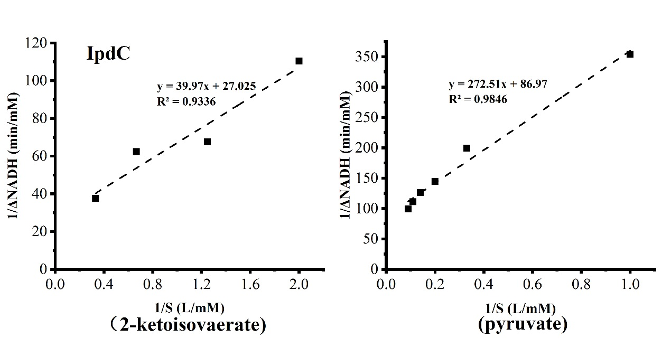

Fig S2. KivD kinetic parameters detection
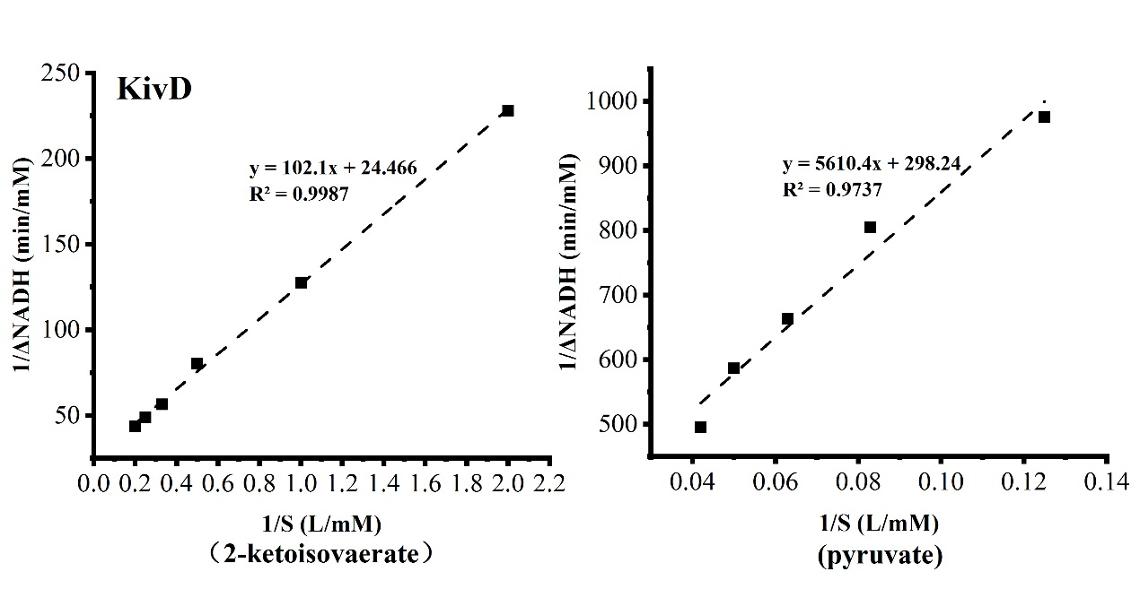

Fig S3. A378L kinetic parameters detection
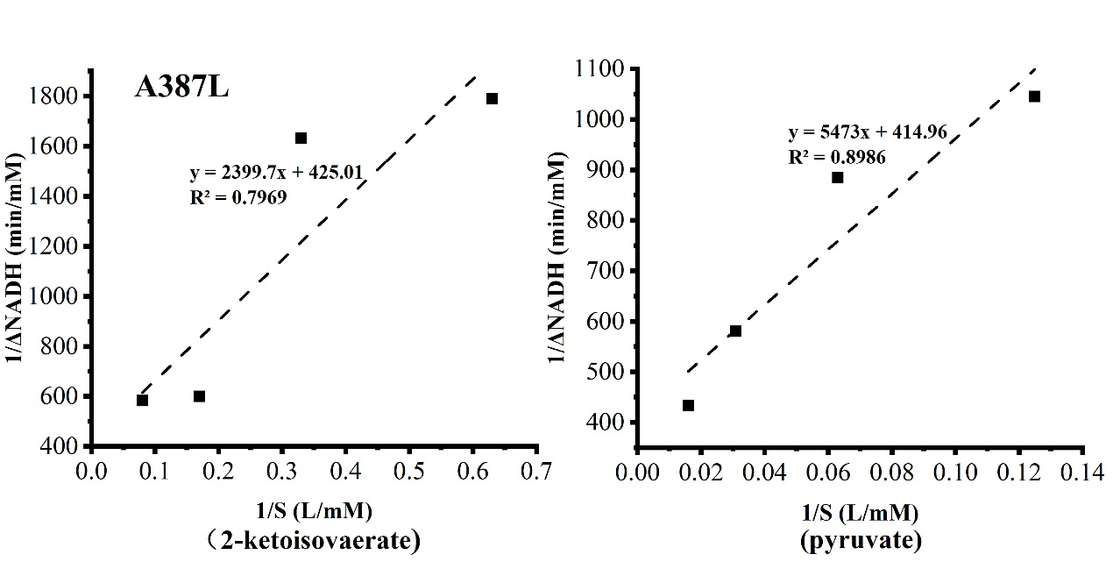

Fig S4. F388W kinetic parameters detection
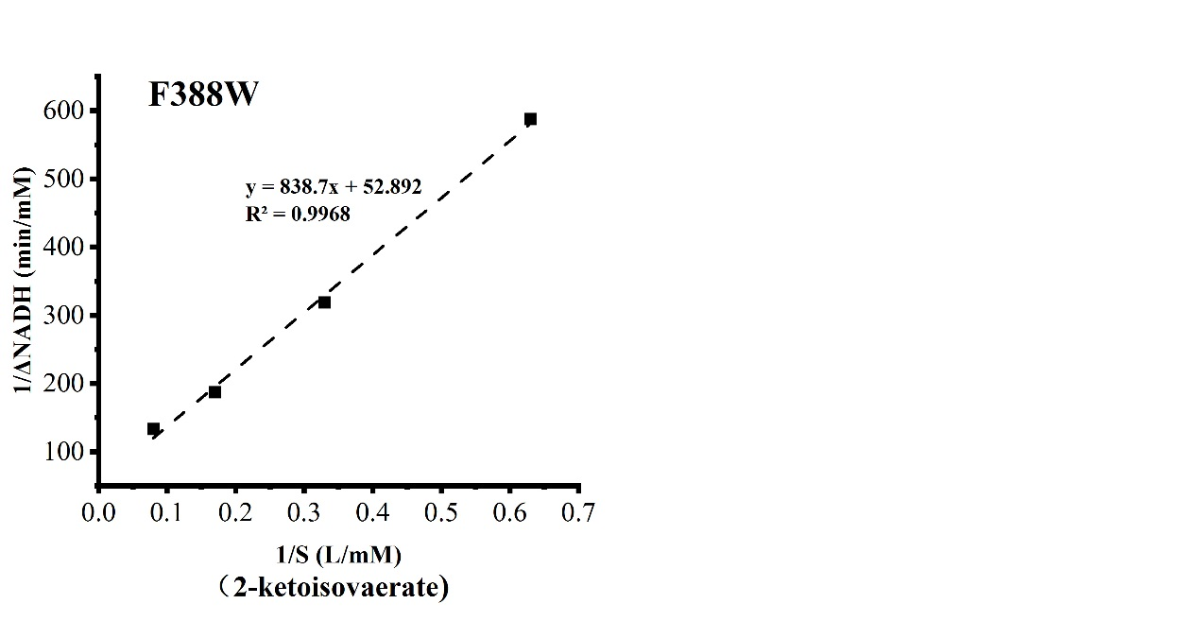

Fig S5. V541I kinetic parameters detection
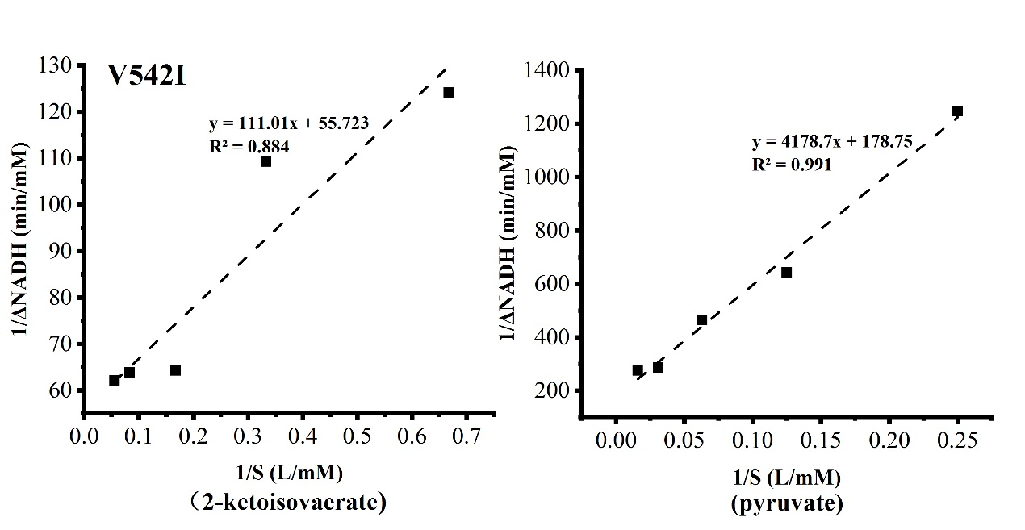

Fig S6. L546W kinetic parameters detection
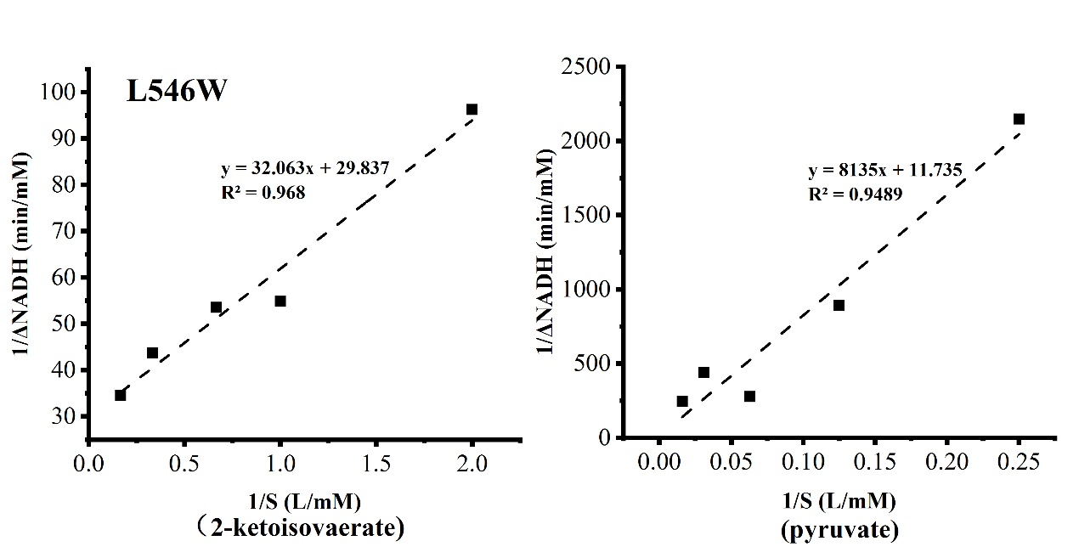

Fig S7. A387I +F388W kinetic parameters detection
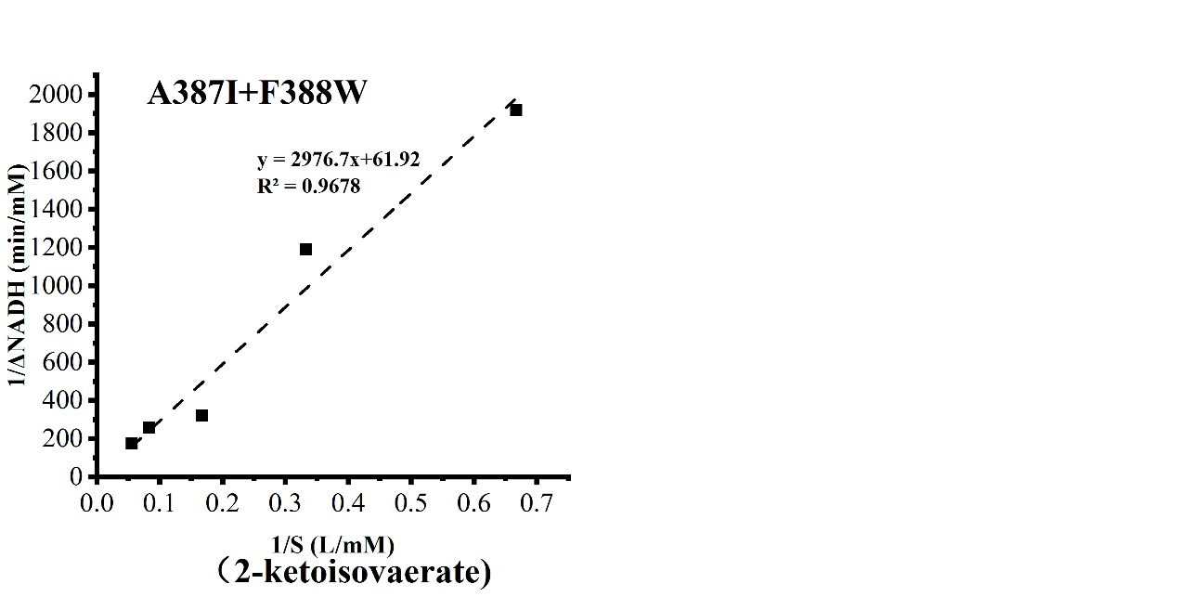

Fig S8. T290L kinetic parameters detection
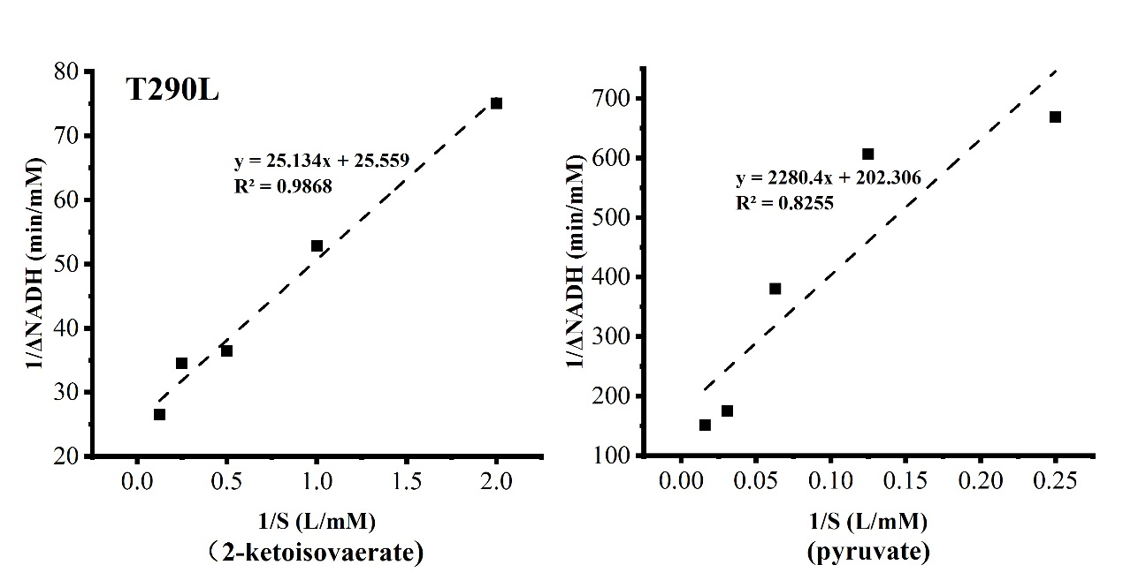

Fig S9. Q383M kinetic parameters detection
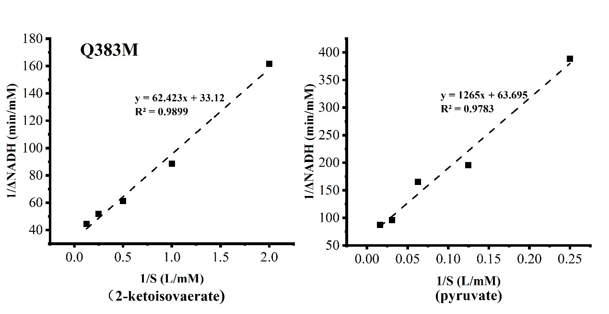

Fig S10. A387I kinetic parameters detection
