Supporting information
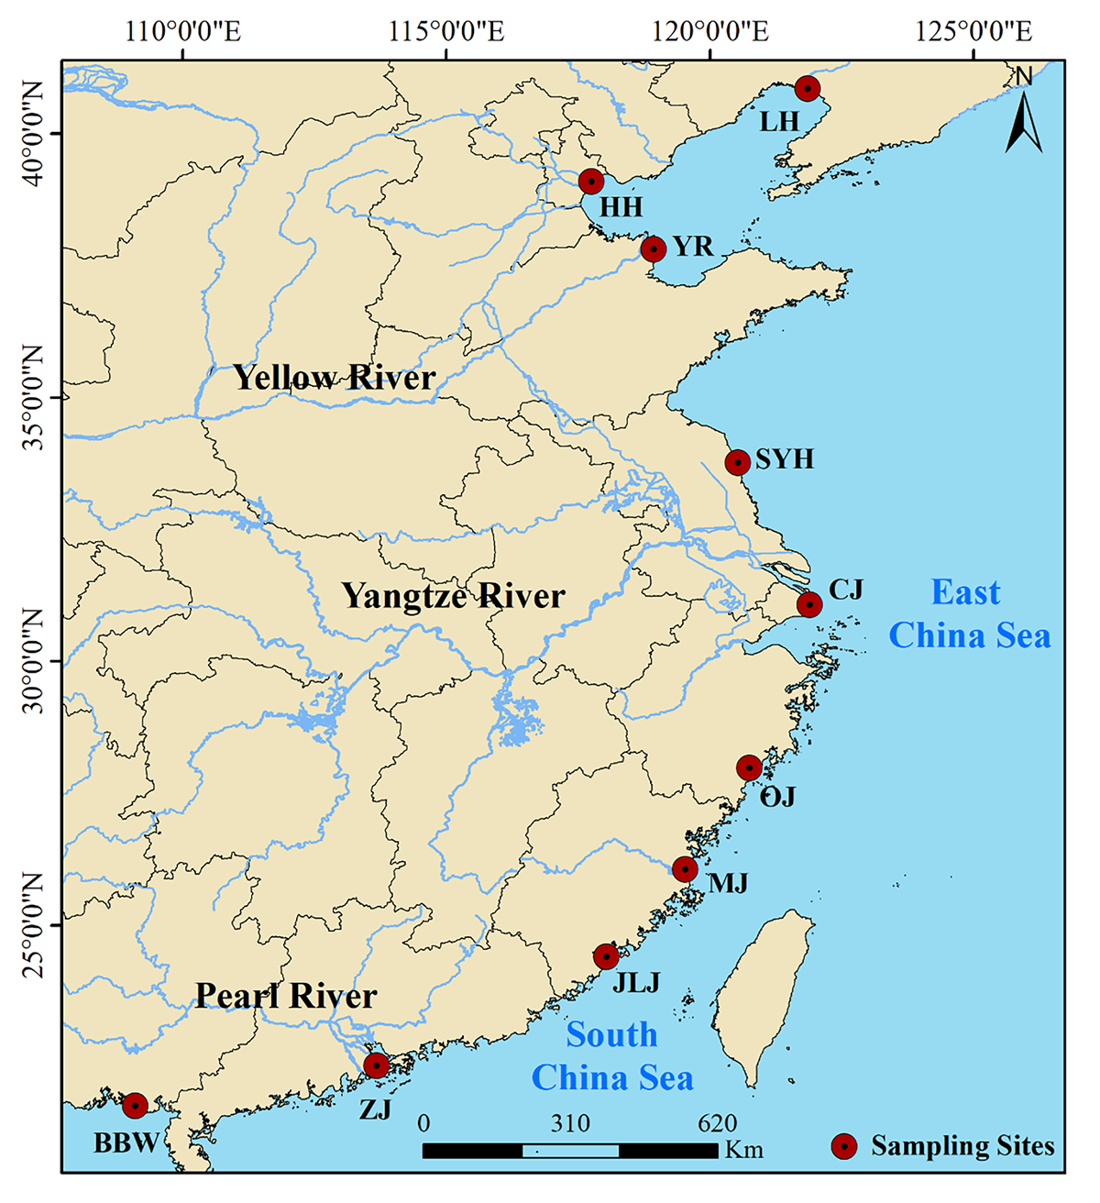
Figure S1 Sampling sites along China’s estuarine intertidal wetlands. BBW, Beibuwan Gulf; ZJ, Zhujiang River; JLJ, Jiulongjiang River; MJ, Minjiang River; OJ, Oujiang River; CJ, Changjiang River; SYH, Sheyanghe River; YR, Yellow River; HH, Haihe River; LH, Liaohe River.

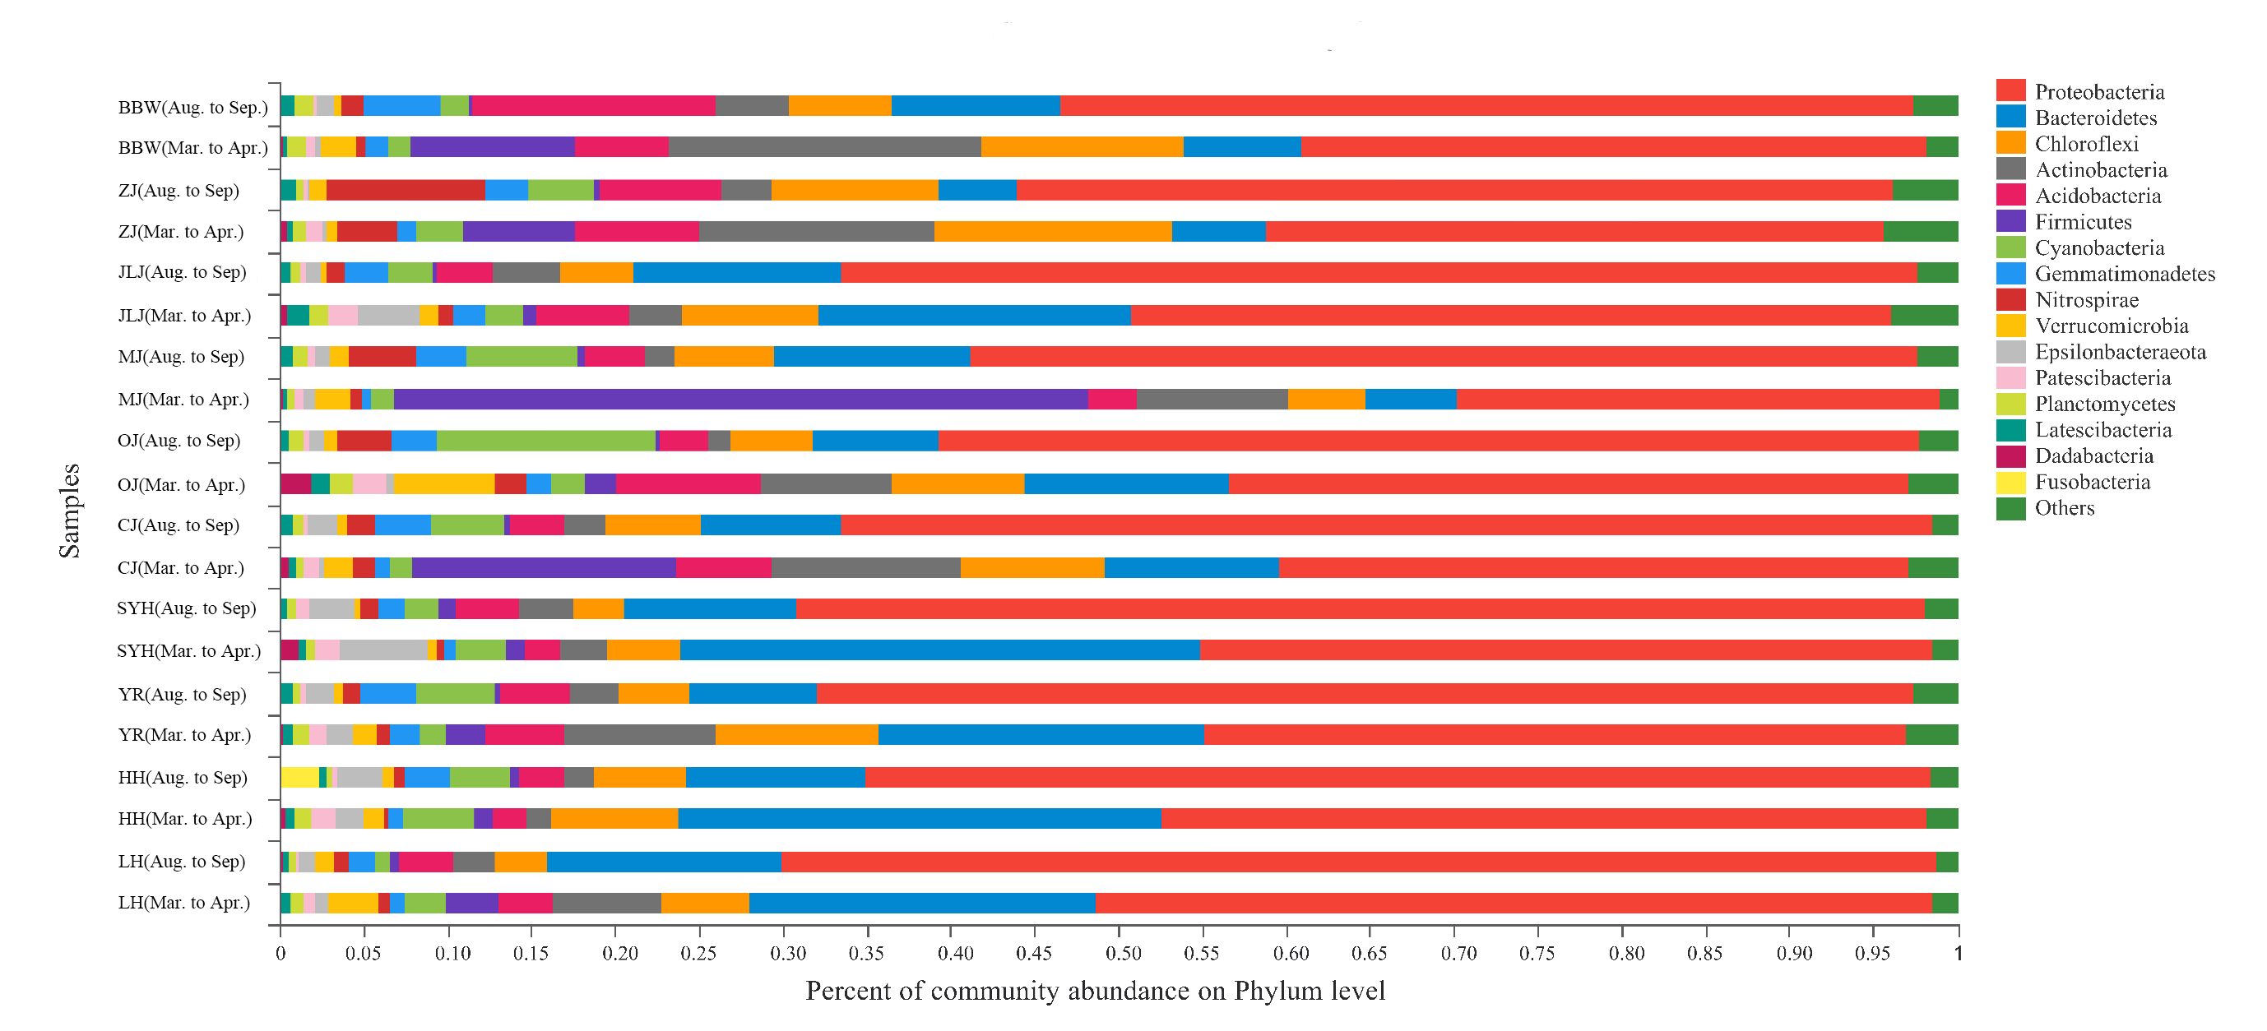
Figure S2 Distribution of the relative abundance of the most abundant phyla (other < 0.01) in each area.

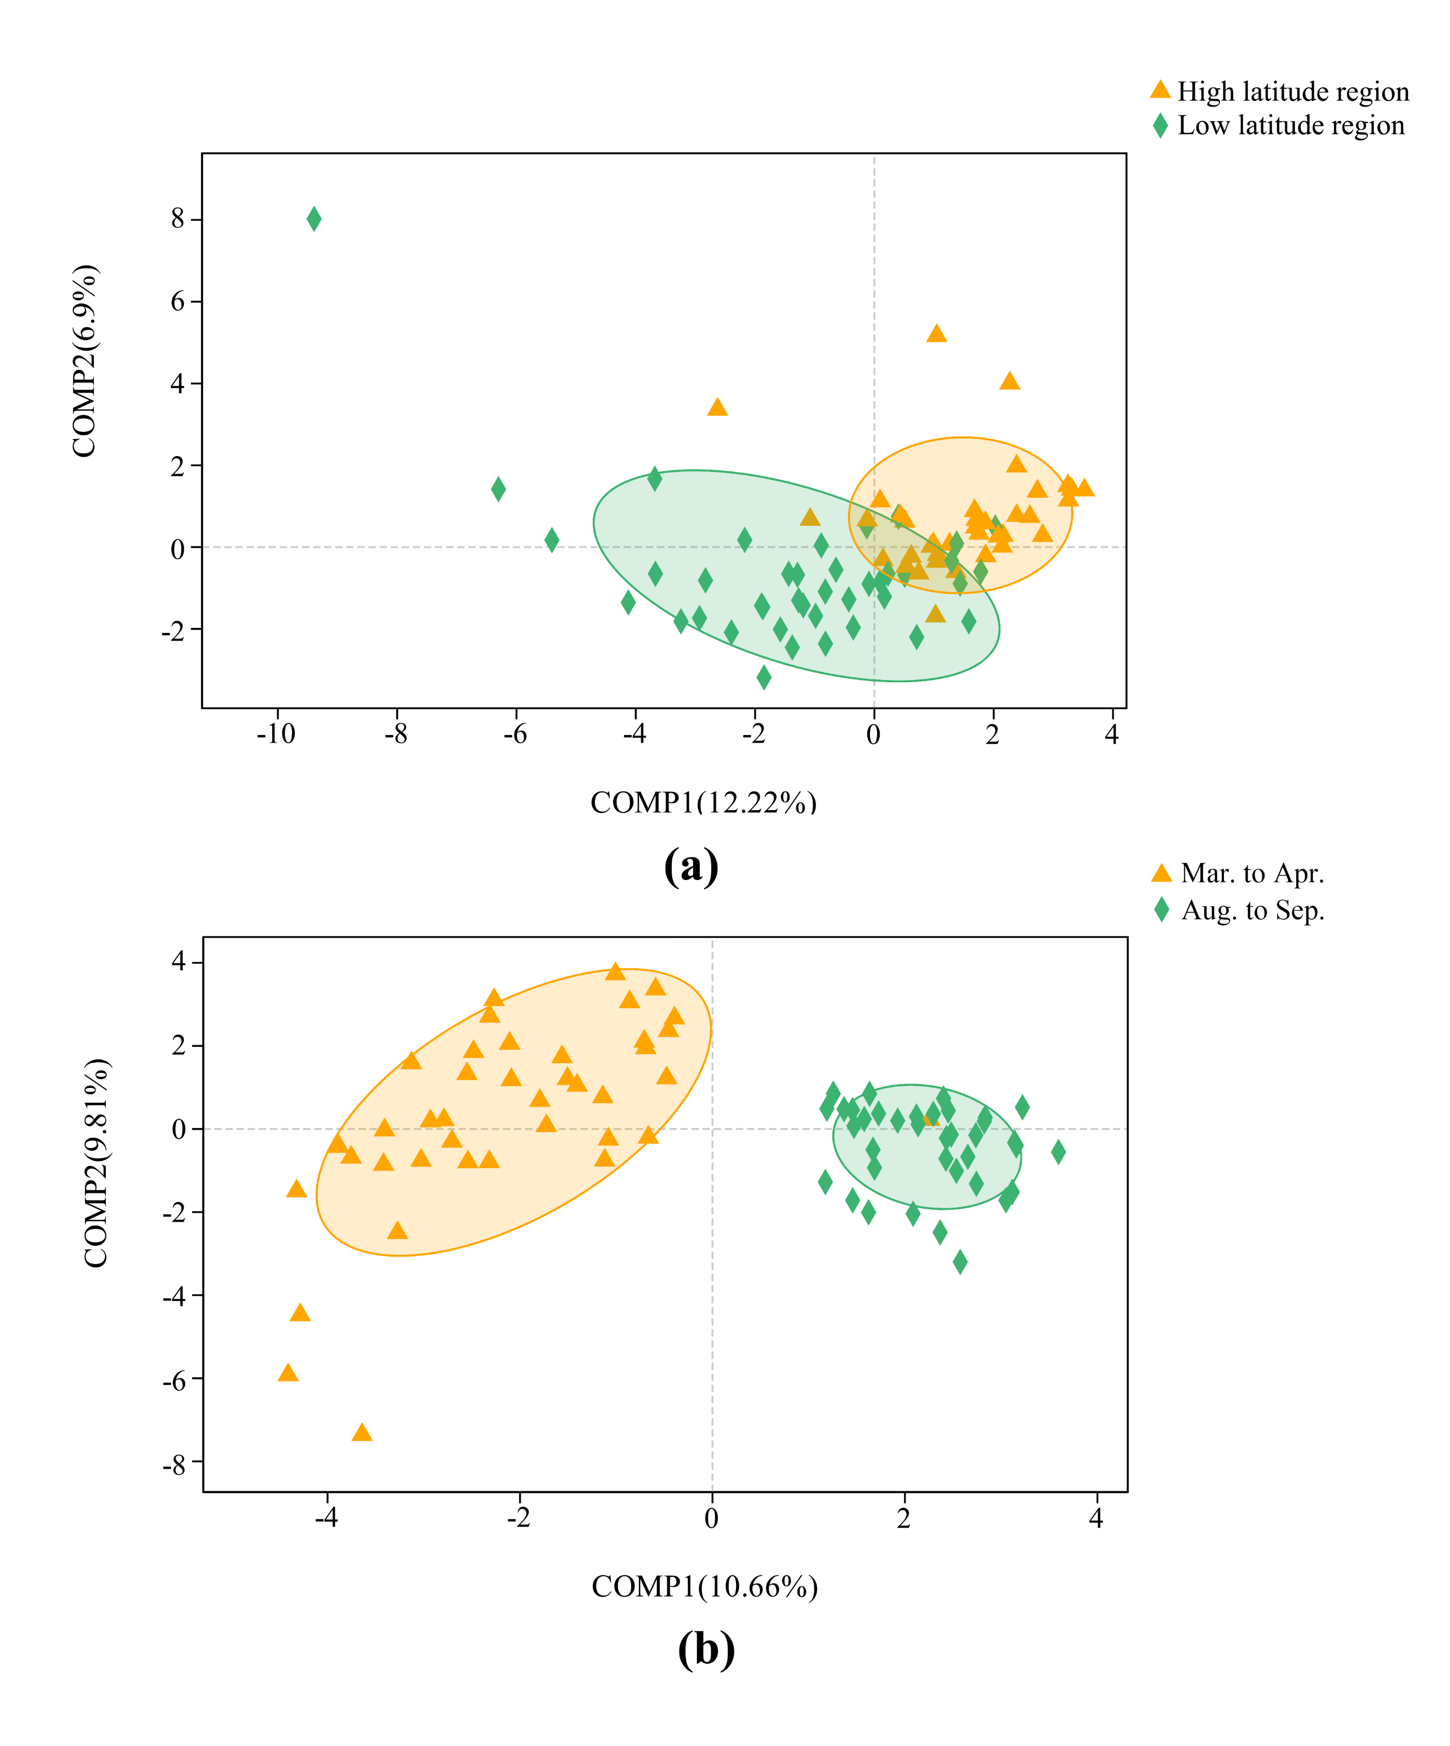
Figure S3 Partial least squares discriminant analysis (PLS-DA) score plots based on 16S rRNA gene sequences distinguishing between the bacterial community spatially (high latitude and low latitude samples, a) and seasonally (March to April and August to September, b).

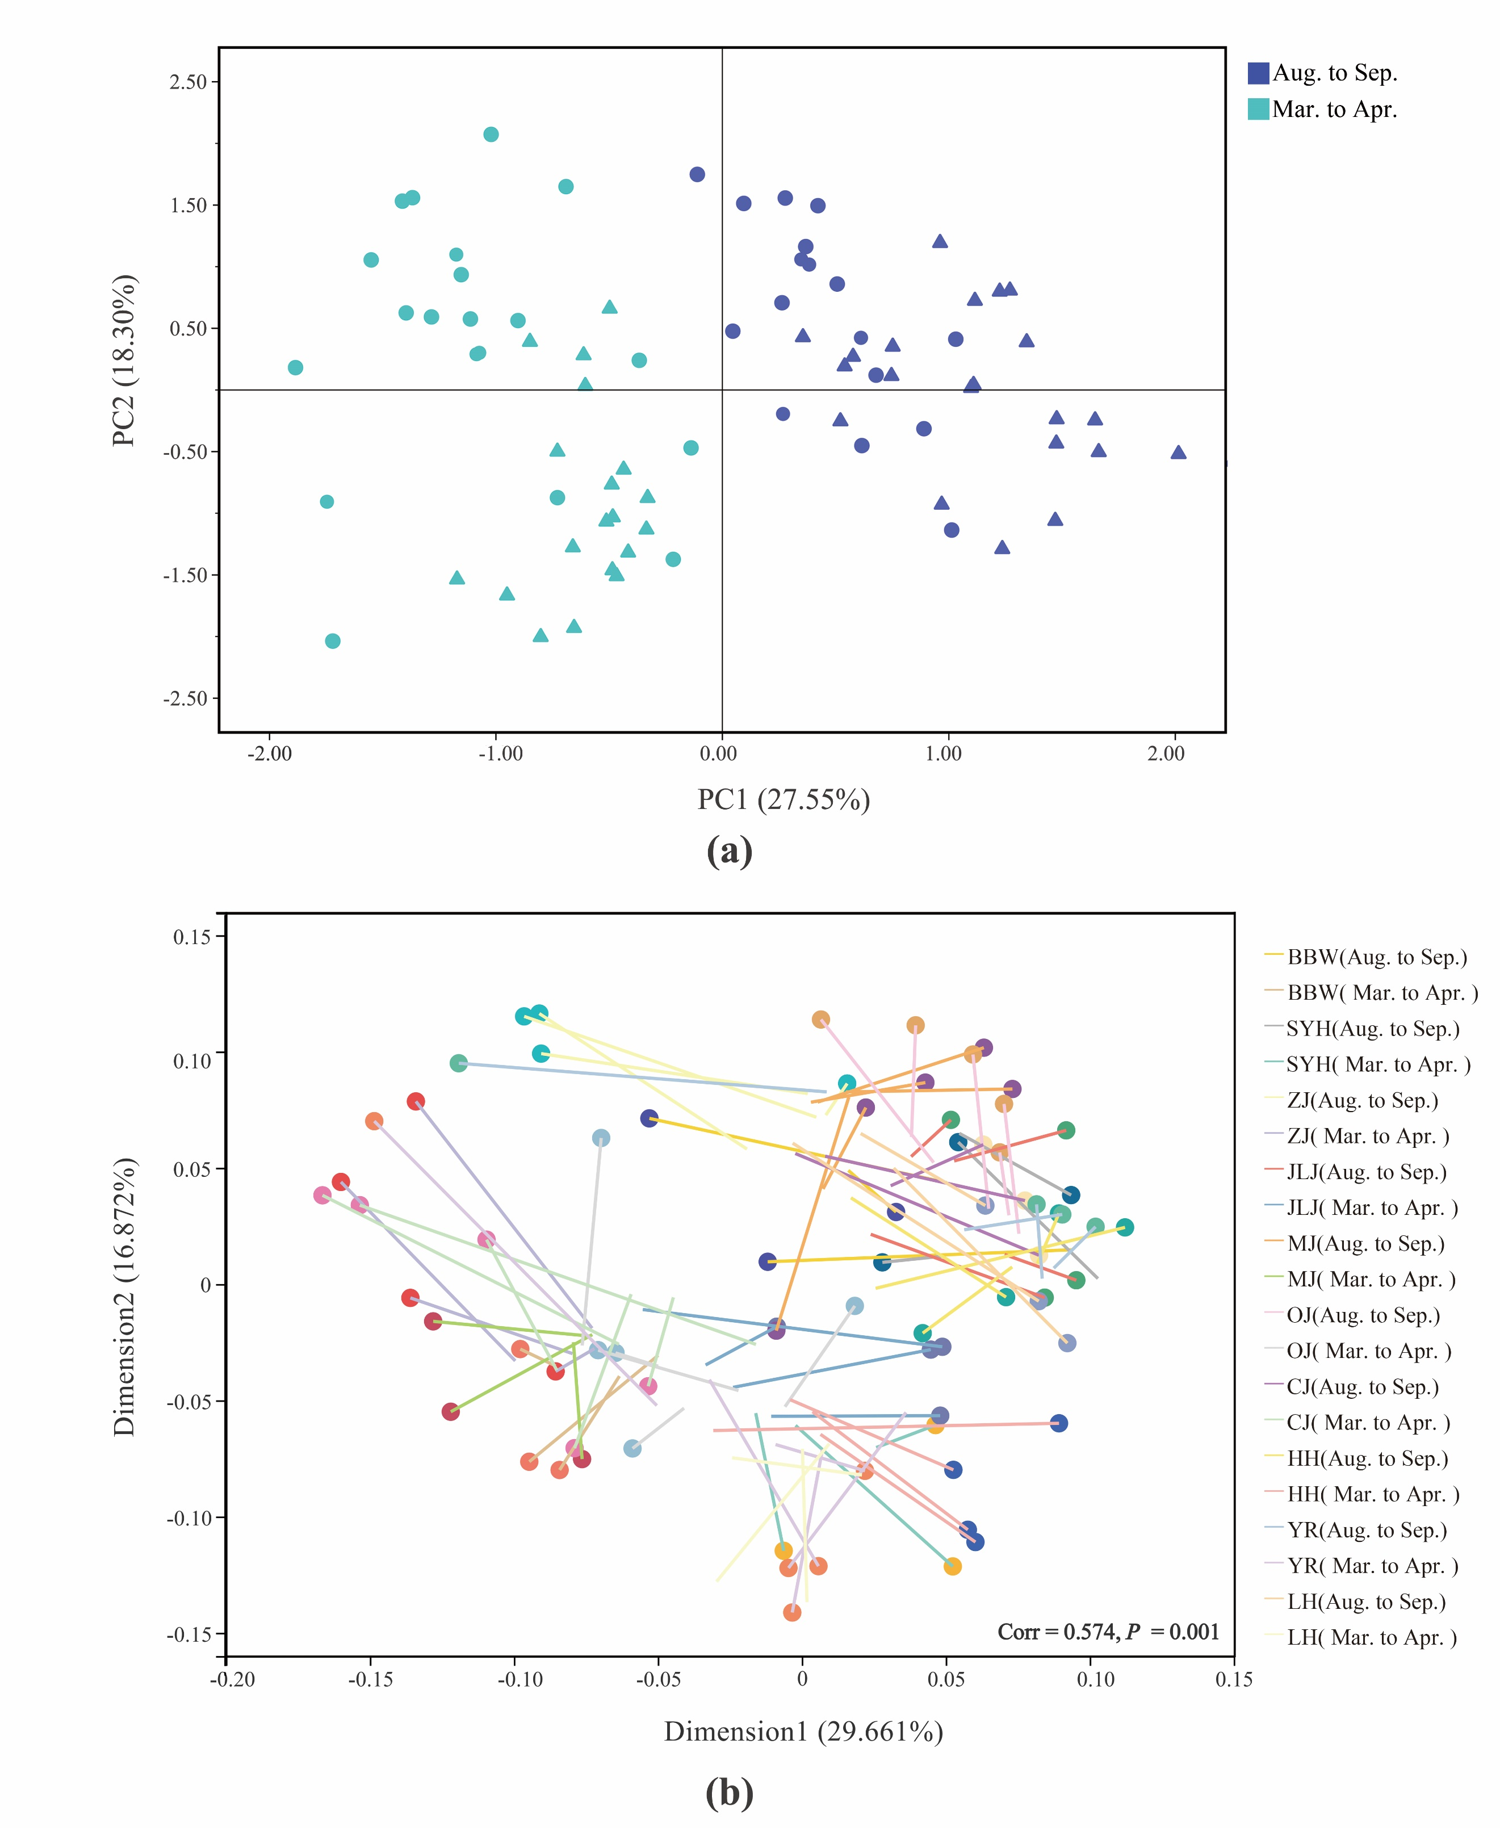
Figure S4 Principal component analysis (PCA) ordination plots of sediment physicochemical parameters (a). Procrustes analysis comparing ordinations of bacterial community structure and physicochemical parameters (b). The symbols represent the rotated configuration (sediment physicochemical parameters in PCA plots) and the lines represent the target configuration of bacterial community structure in PCoA plots.

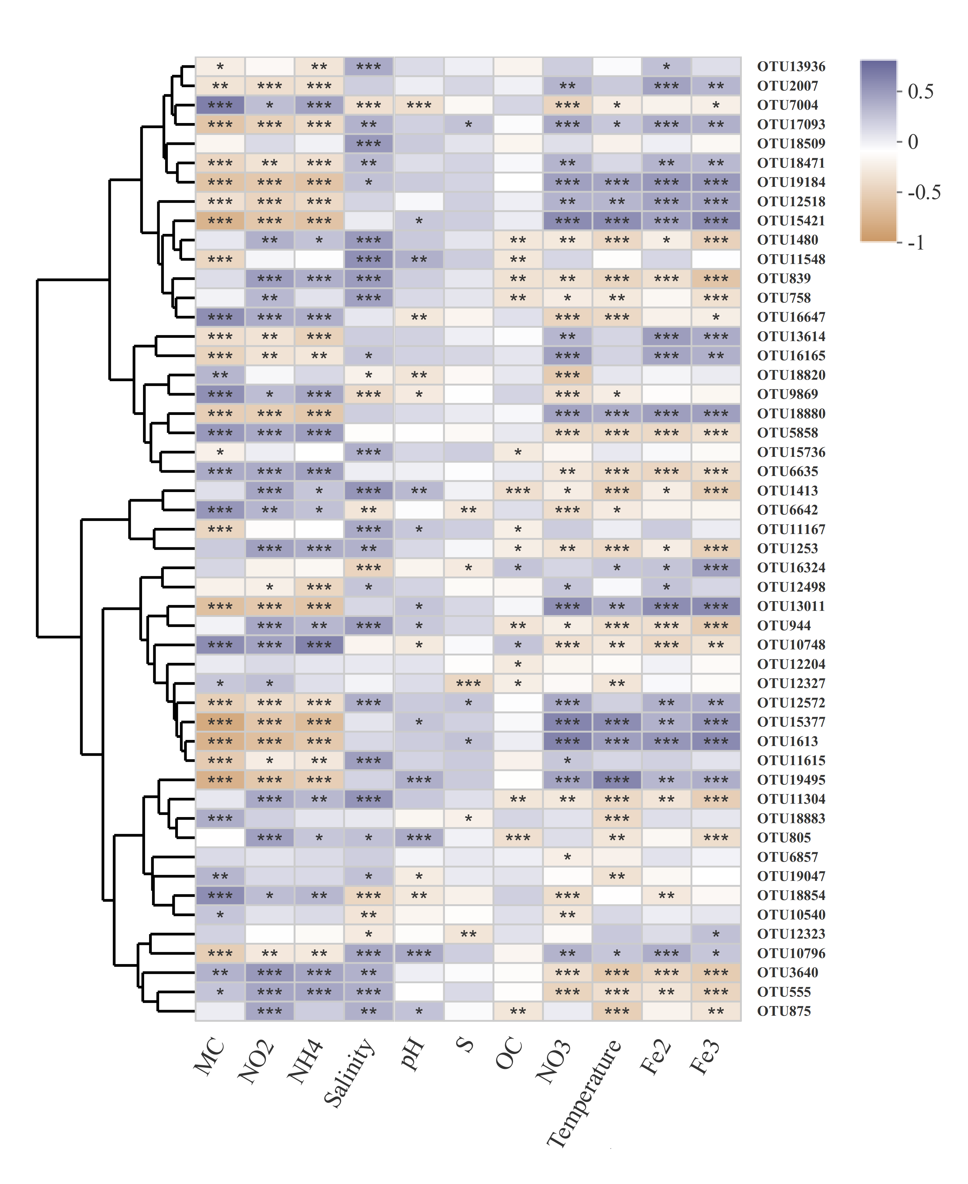
Figure S5 Correlations between the top 100 most abundant OTUs and environmental variables on the basis of Pearson’s correlation. Clustering based on Bray-Curtis distance. Colors indicate the positive and negative Pearson’s correlation coefficients, as shown in the color key. The significant differences are shown as follows: ** P < 0.01 and * P < 0.05. MC, moisture content; NO2, nitrite; NH4, ammonium; S, sulfide; OC, organic carbon; NO3, nitrate; Fe2, ferrous iron; Fe3, ferric iron.

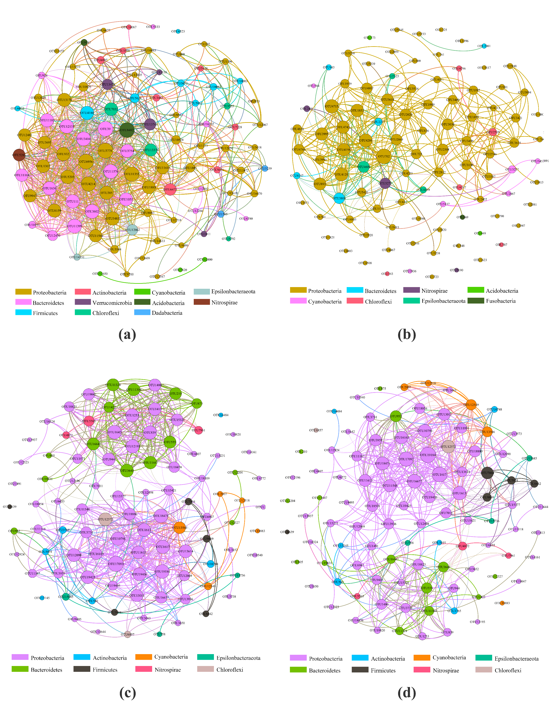
Figure S6 Network of cooccurring bacterial OTUs (top 100) in March to April (a) and August to September (b), as well as in high-latitude (c) and low-latitude (d) samples based on correlation analysis. Nodes in the cooccurring network are colored by phylum.

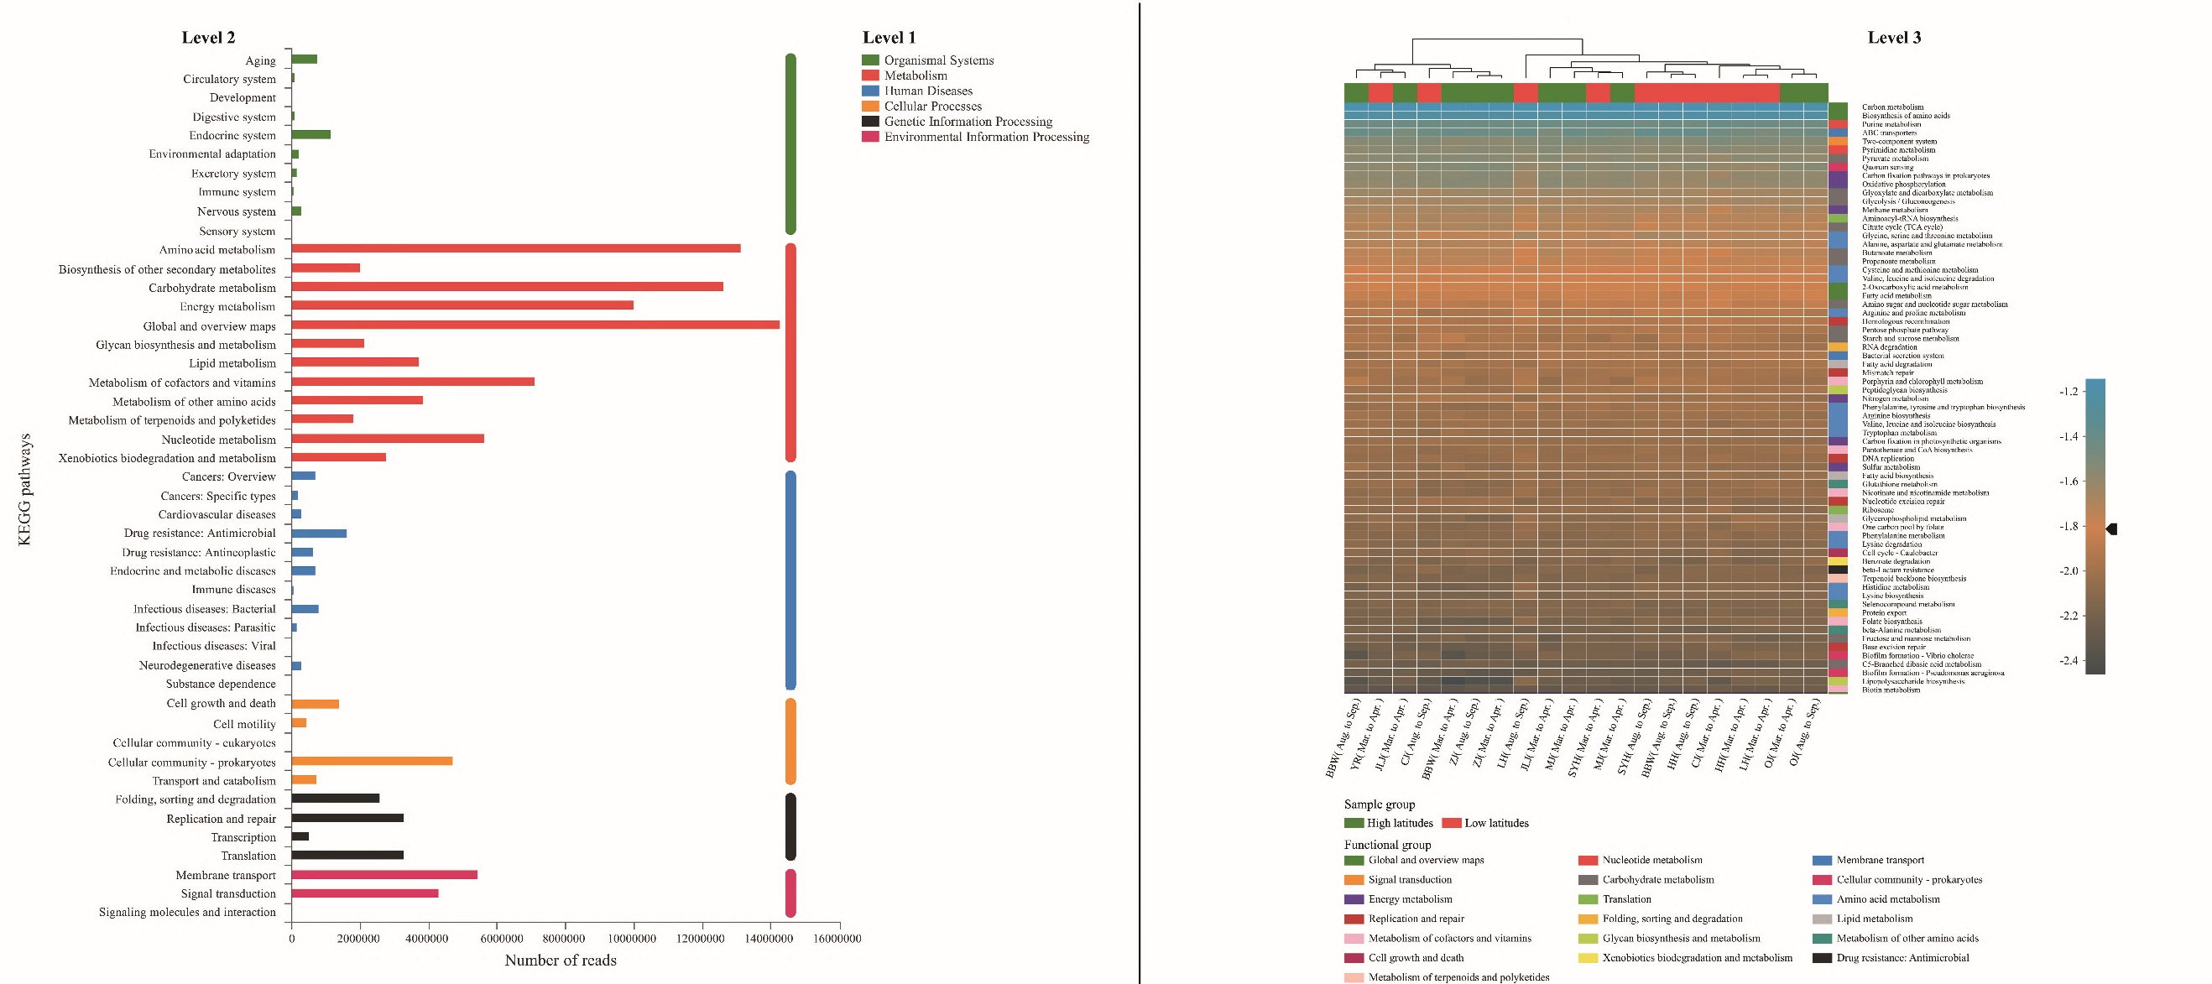
Figure S7 KEGG functional categories (KEGG level 2) in sediment samples. The horizontal axis indicates average reads based on the number of sequences (left). Clustering of the most abundant (top 70) functional KEGG level 3. Group names are defined by sampling area and season (right). Functions in the same taxon (KEGG level 2) are marked with the same colors. The heatmap shows the abundance of the top functions by a color gradient after log10 transformation.
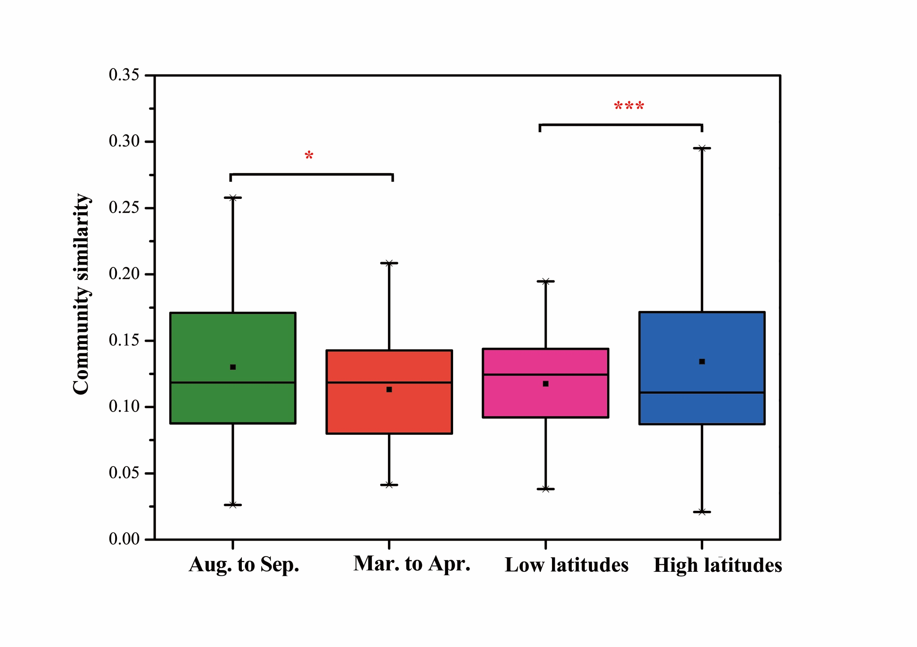
Figure S8 Bacterial taxonomic similarity between spatial (high latitudes and low latitudes) and seasonal (Mar. to Apr. and Aug. to Sep.) conditions based on Bray-Curtis distances. **P < 0.01; *P < 0.05.

Figure S9 Distance-decay curves of functional (KEGG level 3) similarity for bacteria along latitudinal gradients.

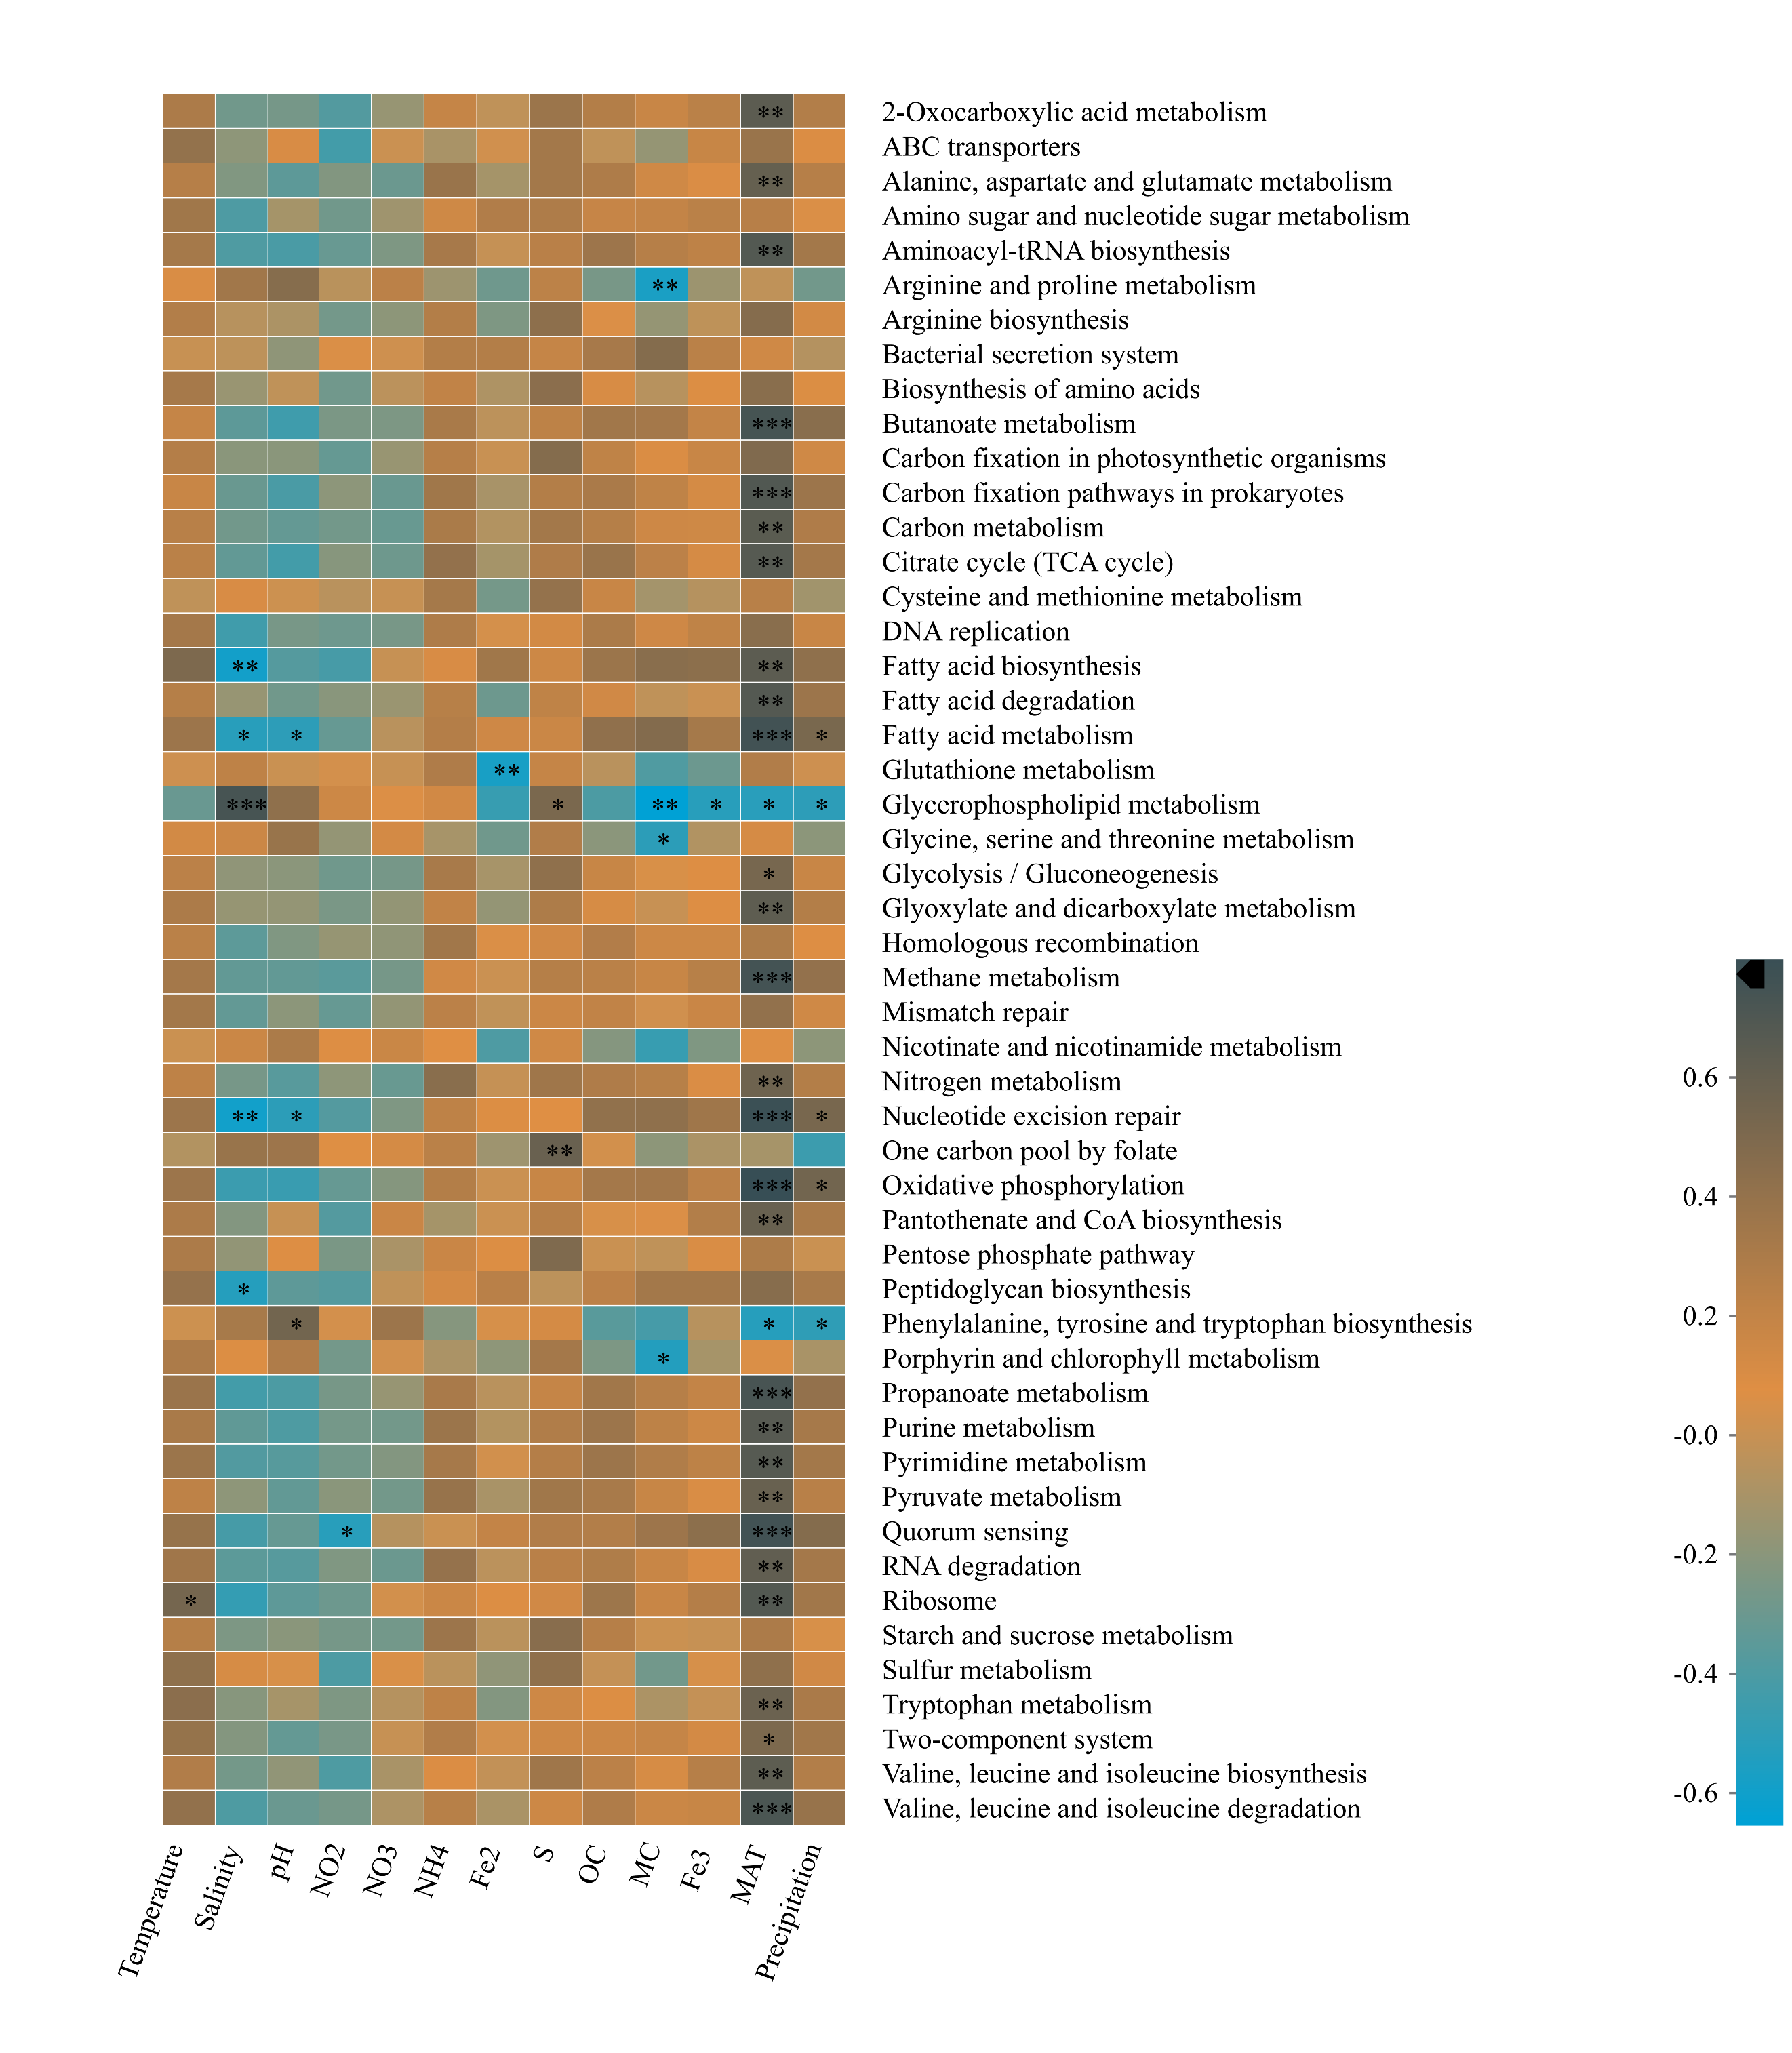
Figure S10 Correlations between the top 50 most abundant functions of KEGG level 2 and environmental variables and climate factors on the basis of Pearson’s correlation.

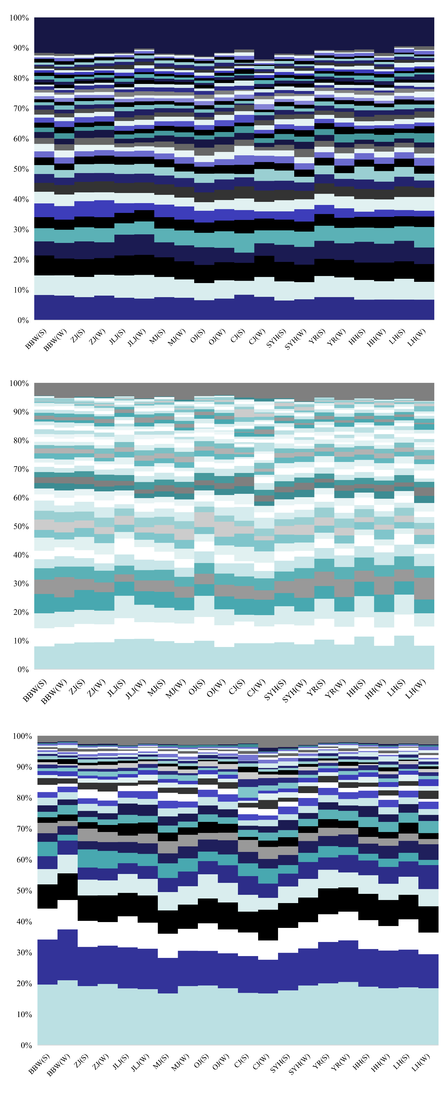
Figure S11 Relative abundances of genes (KO level) in metagenomic sequences of methane (upper), nitrogen (lower), and sulfur (middle) metabolisms (genes are grouped by function with one color per gene group and one column per sample). The top colors are the sum of the taxa whose relative abundance is less than 1%.

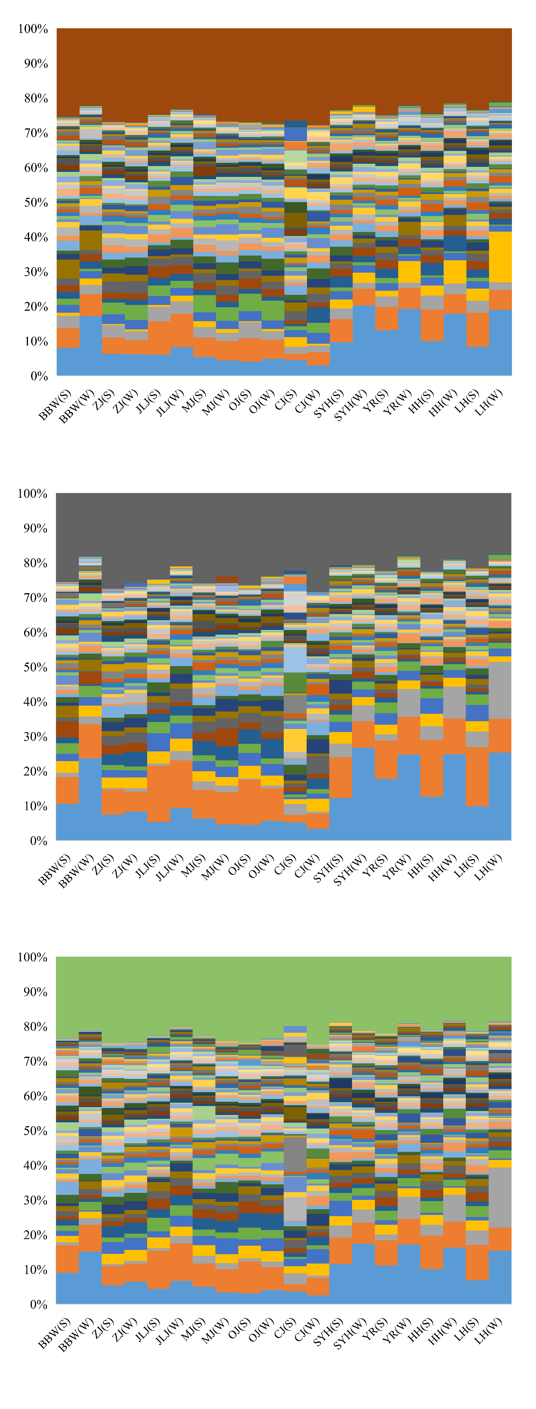
Figure S12 Relative abundances of bacterial families involved in methane (upper), nitrogen (lower), and sulfur (middle) metabolisms (one column per sample, one color per taxon). The top colors are the sum of the taxa whose relative abundance is less than 1%.

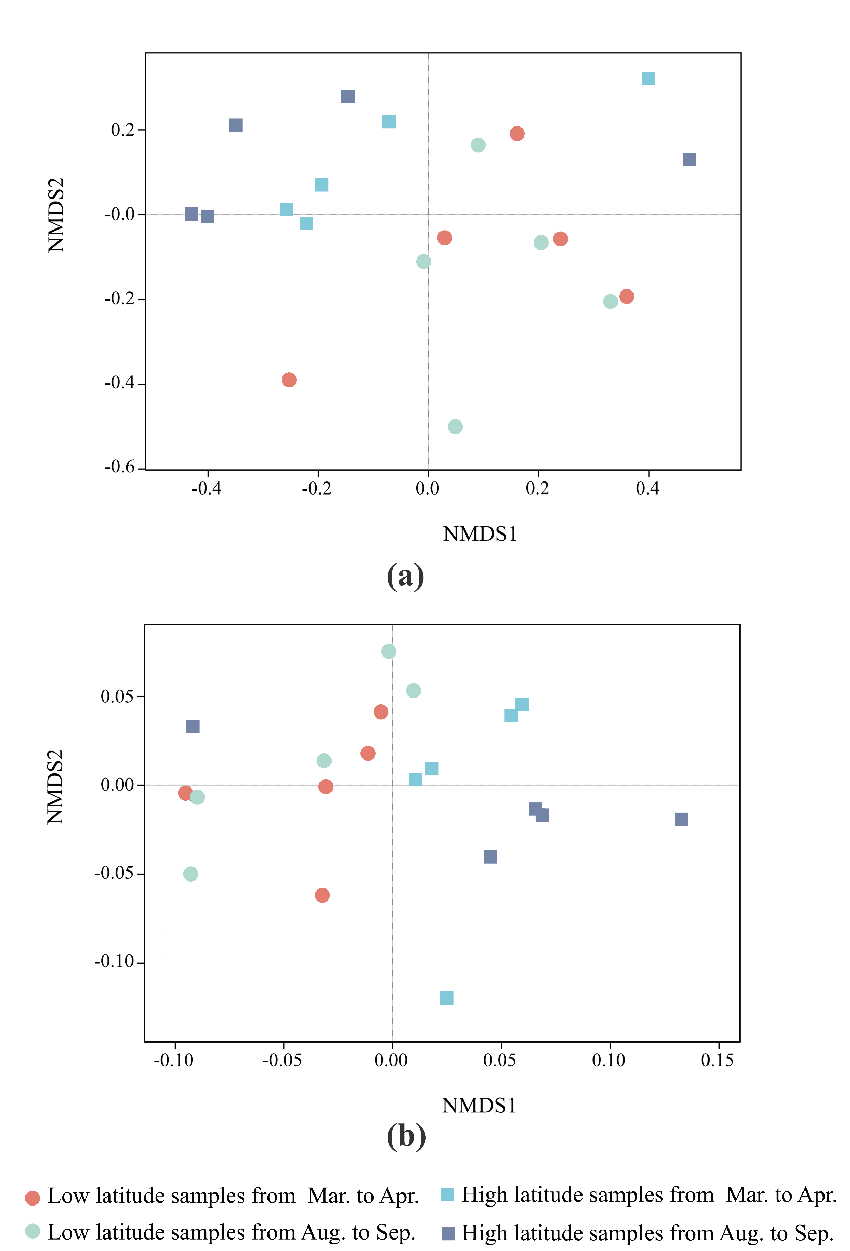
Figure S13 Nonmetric multidimensional scaling analysis (NMDS) based on all reads (a) and annotated orthologous genes (b).

Table S1 Environmental characterization of soil samples in China’s estuarine intertidal wetlands
Sampling seasons and site | Temperature | Salinity | pH | NO₂⁻-N | NO₃⁻-N | NH₄⁺-N | Fe²⁺ | Fe³⁺ | Sulfide | TOC | MC | Latitude | Longitude
Sampling seasons and site | (°C) | (ppt) | pH | (μg/g) | (μg/g) | (μg/g) | (mg/g) | (mg/g) | (μg/g) | (mg/g) | (%) | (°N) | (°E)
Mar. to Apr.
LH-1 | 14.30 | 27.00 | 8.15 | 0.52 | 11.47 | 49.40 | 0.69 | 0.20 | 0.03 | 9.53 | 28.00 | 40°47'N | 121°56'E
LH-2 | 12.00 | 26.80 | 7.93 | 0.61 | 9.71 | 53.77 | 1.05 | 0.35 | 0.11 | 16.26 | 40.59 | 40°51'N | 121°56'E
LH-3 | 11.00 | 23.10 | 8.31 | 0.46 | 8.87 | 20.54 | 0.63 | 0.39 | 0.29 | 8.69 | 27.03 | 40°54'N | 121°49'E
HH-1 | 15.40 | 28.20 | 7.42 | 0.74 | 11.49 | 44.74 | 0.99 | 0.26 | 0.04 | 17.11 | 51.59 | 39°50'N | 117°50'E
HH-2 | 22.20 | 26.00 | 7.73 | 0.53 | 8.43 | 42.63 | 0.60 | 0.26 | 0.12 | 7.14 | 26.00 | 39°05'N | 117°44'E
HH-3 | 14.70 | 25.60 | 8.16 | 0.48 | 7.27 | 23.52 | 1.30 | 0.39 | 1.70 | 13.36 | 28.61 | 38°58'N | 117°42'E
HH-4 | 16.20 | 25.60 | 8.07 | 0.38 | 7.49 | 31.93 | 0.42 | 0.61 | 0.01 | 8.66 | 25.06 | 38°46'N | 117°34'E
YR-1 | 11.10 | 27.40 | 7.76 | 0.41 | 8.15 | 26.29 | 0.35 | 0.41 | 0.13 | 7.14 | 27.59 | 38°14'N | 118°58'E
YR-2 | 13.30 | 24.30 | 7.82 | 0.34 | 8.05 | 33.95 | 0.67 | 0.27 | 1.50 | 12.24 | 30.99 | 37°51'N | 119°05'E
YR-3 | 15.10 | 0.56 | 8.63 | 0.44 | 9.78 | 30.10 | 0.33 | 0.45 | 0.06 | 6.33 | 31.81 | 37°45'N | 119°10'E
YR-4 | 16.50 | 29.00 | 8.44 | 0.24 | 7.99 | 11.45 | 0.06 | 0.36 | 0.07 | 3.49 | 21.82 | 37°34'N | 118°56'E
YR-5 | 14.20 | 7.18 | 8.67 | 0.47 | 7.82 | 31.81 | 0.36 | 0.27 | 0.04 | 5.97 | 25.24 | 37°41'N | 119°01'E
SYH-1 | 16.00 | 22.90 | 7.99 | 0.46 | 7.14 | 24.32 | 0.69 | 0.31 | 0.05 | 6.77 | 30.27 | 33°53'N | 120°26'E
SYH-2 | 16.70 | 16.60 | 8.04 | 0.31 | 8.52 | 22.27 | 0.55 | 0.48 | 0.19 | 5.19 | 37.19 | 33°48'N | 120°28'E
SYH-3 | 16.90 | 22.60 | 7.99 | 0.20 | 7.69 | 11.12 | 0.51 | 0.46 | 0.04 | 3.83 | 26.81 | 33°46'N | 120°31'E
CJ-1 | 23.80 | 0.16 | 7.66 | 0.37 | 8.81 | 42.62 | 1.34 | 0.33 | 0.12 | 10.81 | 39.42 | 30°06'N | 121°56'E
CJ-2 | 21.20 | 0.22 | 7.01 | 0.51 | 9.04 | 112.05 | 1.52 | 0.19 | 0.13 | 11.81 | 40.95 | 30°24'N | 121°35'E
CJ-3 | 26.50 | 2.42 | 7.94 | 0.24 | 8.85 | 14.42 | 1.13 | 0.68 | 0.06 | 12.00 | 39.13 | 30°28'N | 121°30'E
CJ-4 | 26.50 | 2.42 | 7.94 | 0.28 | 7.54 | 14.60 | 1.11 | 0.80 | 0.07 | 22.41 | 49.41 | 31°56'N | 121°09'E
CJ-5 | 25.10 | 10.95 | 7.92 | 0.26 | 8.12 | 12.54 | 0.81 | 0.64 | 0.07 | 7.15 | 37.48 | 31°42'N | 121°18'E
OJ-1 | 14.10 | 7.64 | 7.91 | 0.19 | 2.24 | 12.49 | 2.10 | 0.84 | 0.21 | 6.74 | 40.74 | 27°56'N | 120°52'E
OJ-2 | 18.70 | 1.75 | 8.60 | 0.15 | 3.07 | 6.94 | 2.05 | 0.82 | 0.10 | 8.33 | 45.33 | 27°59'N | 120°44'E
OJ-3 | 14.30 | 2.16 | 7.52 | 0.20 | 3.52 | 11.09 | 1.92 | 1.03 | 0.03 | 12.10 | 40.89 | 28°01'N | 120°45'E
OJ-4 | 16.90 | 13.20 | 7.63 | 0.17 | 4.07 | 7.62 | 1.98 | 1.21 | 0.01 | 10.11 | 42.96 | 27°59'N | 120°51'E
OJ-5 | 19.50 | 17.50 | 7.63 | 0.17 | 1.97 | 9.75 | 1.49 | 0.81 | 0.00 | 8.13 | 36.04 | 28°00'N | 120°58'E
MJ-1 | 16.90 | 3.46 | 7.22 | 0.14 | 1.72 | 14.58 | 0.64 | 2.02 | 0.11 | 16.10 | 43.53 | 26°03'N | 119°36'E
MJ-2 | 16.30 | 0.50 | 7.45 | 0.23 | 3.68 | 17.54 | 0.90 | 1.64 | 0.02 | 15.22 | 47.44 | 26°33'N | 119°31'E
MJ-3 | 17.80 | 4.07 | 7.19 | 0.14 | 3.44 | 16.29 | 1.32 | 1.56 | 0.02 | 14.25 | 49.22 | 26°08'N | 119°35'E
JLJ-1 | 19.40 | 19.10 | 7.12 | 0.23 | 2.88 | 25.22 | 0.73 | 0.22 | 0.05 | 7.09 | 26.39 | 24°24'N | 118°01'E
JLJ-2 | 22.20 | 14.90 | 7.38 | 0.25 | 2.59 | 8.45 | 0.74 | 1.40 | 0.01 | 13.24 | 49.35 | 24°23'N | 117°56'E
JLJ-3 | 25.30 | 19.50 | 7.57 | 0.24 | 2.29 | 13.21 | 0.68 | 1.30 | 0.01 | 11.12 | 48.42 | 24°28'N | 117°56'E
JLJ-4 | 25.10 | 6.14 | 7.82 | 0.27 | 1.38 | 16.05 | 1.46 | 0.23 | 0.04 | 18.38 | 36.29 | 24°27'N | 118°02'E
ZJ-1 | 19.50 | 3.16 | 7.57 | 0.20 | 4.28 | 20.35 | 0.47 | 1.70 | 0.90 | 16.21 | 42.05 | 22°08'N | 113°02'E
ZJ-2 | 17.80 | 1.16 | 7.42 | 0.26 | 4.02 | 34.18 | 1.14 | 0.76 | 0.50 | 19.20 | 49.93 | 22°09'N | 113°26'E
ZJ-3 | 18.80 | 5.47 | 7.08 | 0.23 | 4.78 | 26.90 | 1.30 | 1.34 | 0.06 | 16.28 | 53.54 | 22°24'N | 113°36'E
ZJ-4 | 18.30 | 0.49 | 7.67 | 0.22 | 3.37 | 20.52 | 2.69 | 1.05 | 0.04 | 9.52 | 34.63 | 22°35'N | 113°26'E
BBW-1 | 21.70 | 1.75 | 7.76 | 0.09 | 0.44 | 101.56 | 0.64 | 0.32 | 0.49 | 15.88 | 31.21 | 21°35'N | 108°18'E
BBW-2 | 22.70 | 8.44 | 6.91 | 0.33 | 1.24 | 44.93 | 0.34 | 0.20 | 0.49 | 12.47 | 32.39 | 21°36'N | 109°04'E
BBW-3 | 24.60 | 8.54 | 7.57 | 0.08 | 1.36 | 28.76 | 0.12 | 0.70 | 0.21 | 13.00 | 38.09 | 21°37'N | 109°02'E
Aug. to Sep.
LH-1 | 22.30 | 8.47 | 8.06 | 0.68 | 16.44 | 9.43 | 2.68 | 1.44 | 0.02 | 7.87 | 39.99 | 40°48'N | 121°49'E
LH-2 | 19.40 | 1.73 | 7.98 | 0.11 | 9.24 | 5.54 | 2.68 | 1.03 | 0.05 | 7.52 | 29.42 | 40°50'N | 121°56'E
LH-3 | 21.30 | 1.81 | 8.37 | 0.12 | 9.04 | 11.85 | 0.76 | 0.86 | 0.07 | 25.03 | 20.76 | 40°54'N | 121°49'E
HH-1 | 21.40 | 34.30 | 7.92 | 0.15 | 5.06 | 32.61 | 4.60 | 0.86 | 1.86 | 14.38 | 50.59 | 39°50'N | 117°50'E
HH-2 | 23.50 | 29.10 | 8.05 | 0.15 | 7.67 | 7.97 | 1.92 | 1.22 | 0.02 | 5.36 | 30.18 | 39°05'N | 117°44'E
HH-3 | 23.20 | 8.04 | 8.77 | 0.10 | 6.41 | 13.43 | 4.63 | 0.45 | 1.70 | 10.83 | 34.34 | 38°58'N | 117°42'E
HH-4 | 20.70 | 32.70 | 7.97 | 0.12 | 8.72 | 3.92 | 2.39 | 1.15 | 0.03 | 6.82 | 34.54 | 38°46'N | 117°34'E
YR-1 | 22.90 | 25.40 | 8.19 | 0.08 | 8.91 | 4.67 | 0.96 | 1.06 | 0.16 | 17.02 | 25.13 | 38°10'N | 118°59'E
YR-2 | 22.60 | 0.33 | 8.29 | 0.04 | 9.32 | 2.64 | 0.98 | 1.10 | 0.03 | 15.79 | 26.98 | 38°51'N | 119°15'E
YR-3 | 22.10 | 31.80 | 8.29 | 0.15 | 9.70 | 7.55 | 0.74 | 0.47 | 0.21 | 3.01 | 23.27 | 37°49'N | 118°12'E
YR-4 | 22.30 | 27.30 | 8.23 | 0.09 | 8.56 | 3.05 | 0.63 | 1.16 | 0.03 | 4.54 | 27.04 | 37°54'N | 118°51'E
SYH-1 | 23.70 | 7.18 | 8.15 | 0.15 | 12.72 | 1.70 | 1.09 | 0.73 | 0.04 | 1.77 | 23.04 | 32°01'N | 120°36'E
SYH-2 | 26.40 | 18.80 | 8.56 | 0.13 | 7.94 | 16.17 | 1.58 | 1.44 | 0.03 | 3.98 | 33.17 | 33°28'N | 120°18'E
SYH-3 | 23.60 | 28.60 | 8.18 | 0.34 | 10.09 | 2.01 | 0.82 | 0.41 | 0.05 | 1.12 | 20.40 | 33°16'N | 120°32'E
CJ-1 | 26.50 | 2.42 | 7.94 | 0.06 | 5.63 | 12.66 | 4.89 | 0.75 | 0.00 | 7.60 | 35.24 | 30°16'N | 121°58'E
CJ-2 | 26.50 | 2.42 | 7.94 | 0.07 | 6.26 | 15.27 | 4.33 | 1.40 | 0.52 | 10.89 | 44.98 | 30°48'N | 121°27'E
CJ-3 | 25.10 | 10.95 | 7.92 | 0.03 | 8.37 | 9.42 | 3.28 | 3.25 | 0.02 | 10.87 | 45.29 | 31°22'N | 121°57'E
CJ-4 | 26.80 | 25.50 | 7.84 | 0.04 | 9.94 | 22.81 | 3.13 | 3.18 | 0.01 | 3.79 | 17.75 | 30°58'N | 121°21'E
OJ-1 | 20.80 | 19.60 | 7.98 | 0.04 | 16.65 | 1.86 | 3.08 | 3.37 | 0.17 | 8.14 | 46.07 | 28°13'N | 120°45'E
OJ-2 | 24.10 | 11.70 | 8.04 | 0.15 | 14.78 | 2.04 | 1.50 | 4.98 | 0.01 | 11.98 | 40.81 | 27°59'N | 120°44'E
OJ-3 | 24.30 | 9.73 | 8.09 | 0.03 | 19.05 | 1.91 | 1.64 | 4.05 | 0.14 | 12.99 | 57.52 | 28°01'N | 120°51'E
OJ-4 | 25.20 | 21.10 | 8.00 | 0.04 | 17.69 | 3.51 | 2.71 | 3.41 | 0.14 | 11.03 | 53.23 | 27°49'N | 120°51'E
OJ-5 | 24.10 | 25.60 | 7.79 | 0.04 | 20.50 | 3.52 | 2.21 | 3.88 | 0.09 | 9.92 | 57.89 | 28°10'N | 120°49'E
MJ-1 | 26.80 | 3.02 | 8.13 | 0.44 | 13.20 | 3.86 | 1.38 | 6.29 | 0.05 | 15.11 | 40.65 | 26°03'N | 119°16'E
MJ-2 | 24.90 | 10.08 | 7.98 | 0.06 | 13.34 | 22.80 | 4.68 | 2.88 | 0.05 | 17.32 | 52.23 | 26°47'N | 119°31'E
MJ-3 | 17.80 | 4.07 | 7.19 | 0.03 | 53.79 | 7.89 | 2.52 | 5.40 | 0.02 | 13.52 | 56.83 | 26°46'N | 119°25'E
MJ-4 | 16.30 | 0.50 | 7.45 | 0.08 | 13.27 | 4.80 | 6.35 | 1.59 | 1.02 | 15.10 | 41.85 | 26°23'N | 119°03'E
MJ-5 | 17.80 | 4.07 | 7.19 | 0.05 | 16.20 | 1.85 | 2.04 | 4.54 | 0.06 | 13.70 | 45.48 | 26°55'N | 119°07'E
JLJ-1 | 26.10 | 13.90 | 7.84 | 0.12 | 9.70 | 23.57 | 2.71 | 1.92 | 0.84 | 9.53 | 48.57 | 24°31N | 118°41'E
JLJ-2 | 27.30 | 13.90 | 7.69 | 0.04 | 15.11 | 5.43 | 2.79 | 4.23 | 0.17 | 14.76 | 50.22 | 24°46'N | 117°35'E
JLJ-3 | 27.20 | 22.00 | 7.42 | 0.09 | 19.61 | 4.23 | 1.84 | 5.59 | 0.06 | 26.81 | 49.99 | 24°27'N | 117°56'E
JLJ-4 | 27.40 | 28.90 | 7.94 | 0.07 | 10.40 | 9.43 | 0.95 | 2.11 | 0.10 | 5.93 | 20.64 | 24°27'N | 118°42'E
ZJ-1 | 28.70 | 2.61 | 7.98 | 0.11 | 14.55 | 9.58 | 0.82 | 6.78 | 0.91 | 26.15 | 47.23 | 22°41'N | 113°01'E
ZJ-2 | 29.10 | 4.75 | 7.68 | 0.15 | 10.01 | 10.03 | 5.56 | 3.40 | 0.59 | 25.13 | 48.75 | 22°19'N | 113°00'E
ZJ-3 | 30.70 | 7.52 | 8.21 | 0.05 | 18.18 | 12.43 | 2.45 | 5.96 | 0.31 | 14.76 | 59.38 | 22°44'N | 113°46'E
ZJ-4 | 31.80 | 0.80 | 8.33 | 0.25 | 10.21 | 28.74 | 9.39 | 1.69 | 0.05 | 11.62 | 40.62 | 22°08'N | 113°38'E
BBW-1 | 29.60 | 23.70 | 7.70 | 0.09 | 9.87 | 2.04 | 0.05 | 0.40 | 0.11 | 2.96 | 20.05 | 21°41'N | 108°19'E
BBW-2 | 30.90 | 14.10 | 7.61 | 0.04 | 11.28 | 3.09 | 0.31 | 0.70 | 0.19 | 11.89 | 24.74 | 21°42'N | 109°17'E
BBW-3 | 26.80 | 4.23 | 7.74 | 0.09 | 6.85 | 12.04 | 1.03 | 0.99 | 0.05 | 7.30 | 22.81 | 21°44'N | 109°22'E
YSI Model 30 conductivity meter were used to measure the temperature and salinity of soil samples, and Mettler-Toledo pH meter were used to measure sample pH. Soil exchangeable ammonium (NH₄⁺-N), nitrite (NO₂⁻-N), and nitrate (NO₃⁻-N) were extracted with 2M KCl, then the filtered solution analyzed by spectrophotometry on a continuous-flow nutrient analyzer (SAN Plus, Skalar Analytical B.V., The Netherlands). Ferric oxides (Fe²⁺ and Fe³⁺) in soils were extracted with a mixture of 0.5 M HCl and 0.25 M hydroxylamine hydrochloride and analyzed by colorimetric method based on ferrozine. A Microelectrode (Unisense H₂S-100) connected to a picoampere meter (Unisense Picometer PA2000) were used to analyzed the soil sulfide concentration (S). Total organic carbon (TOC) of soil was measured on a carbon-hydrogen-nitrogen elementary analyzer (VVarioELIII, Elementary, Germany). Moisture content (MC) of soil was measured based on weight loss after drying a known quantity of wet soil at 60°C to constant weight.
Table S2 Number of OTUs, richness (Ace and Chao I) and diversity (Shannon and PD) characteristics, and Good’s coverage among all samples at the 97% similarity level
Area | Sample | OTUs | Ace | Chao I | Shannon | PD | Coverage
 | LH-1(Aug. to Sep.) | 1928 | 5494.32 | 3744.41 | 6.11 | 150.02 | 0.90
 | LH-2(Aug. to Sep.) | 2211 | 5954.11 | 4154.38 | 6.35 | 164.13 | 0.88
LH | LH-3(Aug. to Sep.) | 1831 | 4776.33 | 3441.59 | 5.68 | 143.32 | 0.90
 | LH-1(Mar. to Apr.) | 1524 | 4286.99 | 3094.88 | 5.57 | 138.93 | 0.92
 | LH-2(Mar. to Apr.) | 1953 | 5603.41 | 3905.32 | 6.15 | 159.72 | 0.89
 | LH-3(Mar. to Apr.) | 1472 | 4356.07 | 2866.23 | 5.49 | 129.51 | 0.92
 | HH-1(Aug. to Sep.) | 1622 | 4218.62 | 3108.29 | 5.75 | 129.90 | 0.91
 | HH-2(Aug. to Sep.) | 1964 | 5428.21 | 3781.39 | 6.19 | 157.36 | 0.90
 | HH-3(Aug. to Sep.) | 1764 | 4878.72 | 3451.51 | 5.93 | 141.54 | 0.91
HH | HH-4(Aug. to Sep.) | 1799 | 4166.48 | 3126.77 | 5.94 | 140.55 | 0.91
 | HH-1(Mar. to Apr.) | 1469 | 3464.74 | 2542.11 | 5.70 | 130.36 | 0.93
 | HH-2(Mar. to Apr.) | 1466 | 3543.26 | 2659.21 | 5.89 | 130.96 | 0.93
 | HH-3(Mar. to Apr.) | 1506 | 3362.00 | 2581.72 | 6.00 | 136.80 | 0.93
 | HH-4(Mar. to Apr.) | 1438 | 3317.77 | 2560.32 | 5.74 | 125.71 | 0.93
 | YR-1(Aug. to Sep.) | 2374 | 5782.92 | 4278.12 | 6.61 | 173.51 | 0.88
 | YR-2(Aug. to Sep.) | 1602 | 3587.29 | 2809.80 | 5.52 | 128.96 | 0.92
 | YR-3(Aug. to Sep.) | 1725 | 4353.78 | 3195.65 | 5.91 | 142.99 | 0.91
YR | YR-4(Aug. to Sep.) | 2069 | 5728.28 | 4076.53 | 6.25 | 155.56 | 0.89
 | YR-1(Mar. to Apr.) | 1433 | 3363.77 | 2515.02 | 5.67 | 128.15 | 0.93
 | YR-2(Mar. to Apr.) | 2123 | 5210.34 | 3854.68 | 6.49 | 171.65 | 0.89
 | YR-3(Mar. to Apr.) | 2449 | 3802.46 | 3664.51 | 7.05 | 187.58 | 0.89
 | YR-4(Mar. to Apr.) | 1751 | 5120.19 | 3500.99 | 5.93 | 151.41 | 0.90
 | YR-5(Mar. to Apr.) | 1842 | 4905.88 | 3406.88 | 6.27 | 156.79 | 0.91
 | SYH-1(Aug. to Sep.) | 2041 | 5202.58 | 3891.63 | 6.02 | 159.04 | 0.89
 | SYH-2(Aug. to Sep.) | 2314 | 6166.76 | 4350.54 | 6.64 | 176.02 | 0.88
SYH | SYH-3(Aug. to Sep.) | 1492 | 3676.62 | 2751.39 | 5.61 | 122.79 | 0.92
 | SYH-1(Mar. to Apr.) | 1437 | 3470.54 | 2594.25 | 5.56 | 127.09 | 0.93
 | SYH-2(Mar. to Apr.) | 1399 | 3321.34 | 2485.09 | 4.96 | 142.17 | 0.93
 | SYH-3(Mar. to Apr.) | 2165 | 5099.64 | 3817.78 | 6.28 | 176.50 | 0.89
 | CJ-1(Aug. to Sep.) | 2042 | 5616.23 | 3953.17 | 6.33 | 158.48 | 0.89
 | CJ-2(Aug. to Sep.) | 1902 | 4424.02 | 3431.92 | 6.33 | 148.30 | 0.91
 | CJ-3(Aug. to Sep.) | 1521 | 4483.25 | 3080.90 | 5.30 | 120.35 | 0.91
CJ | CJ-4(Aug. to Sep.) | 1952 | 5040.38 | 3624.94 | 6.20 | 161.48 | 0.90
 | CJ-1(Mar. to Apr.) | 1942 | 4108.35 | 3214.68 | 6.49 | 165.33 | 0.91
 | CJ-2(Mar. to Apr.) | 2115 | 4862.80 | 3770.75 | 6.43 | 178.99 | 0.89
 | CJ-3(Mar. to Apr.) | 1956 | 5642.34 | 3954.02 | 6.24 | 167.72 | 0.89
 | CJ-4(Mar. to Apr.) | 1100 | 2512.31 | 1845.17 | 4.34 | 109.16 | 0.95
 | CJ-5(Mar. to Apr.) | 1904 | 3916.45 | 3230.02 | 6.49 | 165.95 | 0.91
 | OJ-1(Aug. to Sep.) | 1651 | 4733.14 | 3317.92 | 4.88 | 134.59 | 0.91
 | OJ-2(Aug. to Sep.) | 2067 | 5160.78 | 3774.17 | 6.01 | 169.49 | 0.89
 | OJ-3(Aug. to Sep.) | 2092 | 5127.30 | 3838.25 | 6.35 | 171.43 | 0.89
 | OJ-4(Aug. to Sep.) | 1776 | 4966.71 | 3510.30 | 5.56 | 145.94 | 0.90
OJ | OJ-5(Aug. to Sep.) | 2407 | 5305.89 | 4013.79 | 6.82 | 173.95 | 0.88
 | OJ-1(Mar. to Apr.) | 1692 | 4590.14 | 3191.77 | 6.10 | 151.58 | 0.91
 | OJ-2(Mar. to Apr.) | 1667 | 3943.73 | 2814.10 | 5.87 | 154.97 | 0.92
 | OJ-3(Mar. to Apr.) | 2261 | 5380.60 | 3984.53 | 6.67 | 215.22 | 0.89
 | OJ-4(Mar. to Apr.) | 1937 | 5044.29 | 3533.52 | 6.15 | 168.82 | 0.90
 | OJ-5(Mar. to Apr.) | 2540 | 6602.03 | 4634.38 | 6.75 | 200.98 | 0.86
 | MJ-1(Aug. to Sep.) | 1818 | 4406.26 | 3422.03 | 6.25 | 147.63 | 0.91
 | MJ-2(Aug. to Sep.) | 2084 | 5517.77 | 3910.10 | 6.39 | 173.47 | 0.89
 | MJ-3(Aug. to Sep.) | 2351 | 5859.87 | 4490.28 | 6.64 | 184.49 | 0.88
MJ | MJ-4(Aug. to Sep.) | 2130 | 5365.53 | 3760.85 | 6.14 | 167.57 | 0.89
 | MJ-5(Aug. to Sep.) | 2259 | 5310.00 | 3999.05 | 6.55 | 171.72 | 0.89
 | MJ-1(Mar. to Apr.) | 958 | 2732.99 | 1919.56 | 3.82 | 86.42 | 0.95
 | MJ-2(Mar. to Apr.) | 1437 | 3978.57 | 2861.63 | 4.57 | 144.05 | 0.92
 | MJ-3(Mar. to Apr.) | 1977 | 5742.21 | 3846.57 | 5.41 | 169.32 | 0.89
 | JLJ-1(Aug. to Sep.) | 2051 | 5124.90 | 3852.70 | 6.32 | 157.22 | 0.89
 | JLJ-2(Aug. to Sep.) | 2315 | 5461.25 | 4056.84 | 6.66 | 173.36 | 0.88
 | JLJ-3(Aug. to Sep.) | 2053 | 5230.35 | 3668.58 | 6.16 | 156.35 | 0.89
JLJ | JLJ-4(Aug. to Sep.) | 1853 | 4598.43 | 3524.30 | 6.15 | 141.43 | 0.91
 | JLJ-1(Mar. to Apr.) | 2163 | 5784.11 | 4117.09 | 6.38 | 183.71 | 0.88
 | JLJ-2(Mar. to Apr.) | 2686 | 7405.61 | 5026.44 | 6.63 | 213.48 | 0.85
 | JLJ-3(Mar. to Apr.) | 2520 | 6733.06 | 4651.28 | 6.73 | 198.62 | 0.87
 | JLJ-4(Mar. to Apr.) | 2450 | 5180.93 | 4015.21 | 6.81 | 201.52 | 0.88
 | ZJ-1(Aug. to Sep.) | 2051 | 4225.23 | 3443.29 | 6.62 | 155.14 | 0.91
 | ZJ-2(Aug. to Sep.) | 2468 | 5602.69 | 4381.73 | 6.84 | 189.29 | 0.88
 | ZJ-3(Aug. to Sep.) | 1907 | 4801.44 | 3566.57 | 6.19 | 150.34 | 0.90
ZJ | ZJ-4(Aug. to Sep.) | 2147 | 4791.78 | 3643.63 | 6.36 | 171.51 | 0.89
 | ZJ-1(Mar. to Apr.) | 2294 | 4570.50 | 3653.85 | 6.80 | 204.17 | 0.89
 | ZJ-2(Mar. to Apr.) | 2077 | 3902.82 | 3173.16 | 6.79 | 167.27 | 0.91
 | ZJ-3(Mar. to Apr.) | 1973 | 4463.23 | 3342.22 | 6.57 | 166.94 | 0.91
 | ZJ-4(Mar. to Apr.) | 2001 | 5333.27 | 3708.21 | 6.18 | 163.46 | 0.89
 | BBW-1(Aug. to Sep.) | 1413 | 3756.25 | 2638.03 | 5.97 | 123.88 | 0.93
 | BBW-2(Aug. to Sep.) | 1445 | 4697.65 | 3018.64 | 5.23 | 125.77 | 0.92
BBW | BBW-3(Aug. to Sep.) | 1759 | 4515.79 | 3505.86 | 6.12 | 144.22 | 0.91
 | BBW-1(Mar. to Apr.) | 1920 | 4067.24 | 3291.22 | 6.44 | 151.31 | 0.91
 | BBW-2(Mar. to Apr.) | 1647 | 3253.89 | 2585.03 | 6.18 | 138.41 | 0.93
 | BBW-3(Mar. to Apr.) | 1696 | 4123.23 | 3136.74 | 6.16 | 140.02 | 0.92

Table S3 Topological properties of cooccurring networks at the KO level (CH4, N and S metabolisms).
 | Average path length (APL) | Graph density  (GD) | Average degree (AD) | Network diameter (ND) | Clustering coefﬁcient (CC)
Whole network | 2.865 | 0.115 | 13.326 | 9 | 0.615
Random network | 2.095 | 0.057 | 13.316 | 3 | 0.113

A random network is an identically sized random network generated based on the Erd$\ddot{o}$s-R$\acute{e}$nyi model, whose topological properties are calculated as the average value from 10,000 Erd$\ddot{o}$s-R$\acute{e}$nyi random networks.

