Preliminary investigation into how environmental factors are associated with stress and disease in koalas on the mid-north coast of NSW

Aim
To explore if any fine-scale environmental variables could explain the spatial patterns of FGM levels, KoRV load, Chlamydia score, body condition, PcGHV-1 or PcGHV-2 in koalas on the mid-north coast of NSW.

Methods
All samples and laboratory results used in this analysis are detailed in the main paper. Regression models were constructed in R for each of the disease measures, FGM levels and body condition. Ordered logistic regression was used to assess body condition and Chlamydia score, while generalised linear models with Logit link functions were used to assess PcGHV-1 and PcGHV-2 and linear models were used to assess the FGMs and KoRV load. For each response variable, fine-scale environmental variables including tree cover, leaf moisture, elevation, slope, soil properties, fire history, distance to habitation and roads as well as human population density (Table S1), along with latitude and longitude, were fitted as predictors in separate models. Due to the limited sample size only univariate models were considered, except for the modelling of faecal tetrahydrocortisol concentrations where sex was included as a covariate in all models. The different models were then ranked by Akaike information criterion to establish the best predictors. Only models with a delta AIC of > 2 when compared to the intercept model were considered.

Table S1: Fine-scale environmental factors modelled as potential explanatory variables of koala FGM levels and disease
Short name | Predictor Description | Creator
b_denallrd | Kernel density for sealed and unsealed roads (but not walking tracks) | DCCEEW - Allen Mcilwee
b_denselrd | Kernel density for sealed roads (no unsealed or walking tracks) | DCCEEW - Allen Mcilwee
b_disallrd | Distance to sealed and unsealed roads (but not walking tracks) | DCCEEW - Allen Mcilwee
b_disbuild | Distance to buildings. Uses the June 2024 Geoscape Building Footprints. | DCCEEW - Allen Mcilwee
b_disclasrd | Distance to classified roads. This includes all major roads and highways as classified by the Roads and Maritime Services. | DCCEEW - Allen Mcilwee
b_dismintn | Distance to all major and minor population centres. This uses the existing corporate towns layer on P drive. | DCCEEW - Allen Mcilwee
b_disselrd | Distance to sealed roads (no unsealed or walking tracks) | DCCEEW - Allen Mcilwee
b_mbpopden | Population density (individuals per km2) from 2021 census data attributed to Mesh Blocks. Blocks with >100 individuals per km2 were capped (given a value of 100). The data were converted to raster and the mean value calculated for each input cell over a 90m circular neighbourhood radius. | DCCEEW - Allen Mcilwee
ct_tmpmtc | Min Temperature of Coldest Period (bio6). DCCEEW BIOCLIM 30m layer. | DCCEEW - Jill Thonell
ct_tmpmtw | Max Temperature of Warmest Period (bio5). DCCEEW BIOCLIM 30m layer. | DCCEEW - Jill Thonell
cw_precipa | Annual Precipitation (bio12). DCCEEW BIOCLIM 30m layer. | DCCEEW - Jill Thonell
cw_precipd | Precipitation of Driest Period (bio14). DCCEEW BIOCLIM 30m layer. | DCCEEW - Jill Thonell
dl_strmd2 | Euclidean distance to 2nd order streams and above. Uses Strahler Stream Order layer on P drive: | DCCEEW - Jill Thonell
fesm_maxse | Fire Extent and Severity Mapping (FESM). Maximum serverity (per pixel) between 2016 and 2023. 0= not burnt, 1= burnt low severity, 2, mod, 3 high and 4 extreme. | DCCEEW - Allen Mcilwee
firetfre70 | Number of times burnt. Calculated from FireTools dataset for the period 1970 to 2023. Values range from 0 to 14. | DCCEEW - Allen Mcilwee
fmc_5th | University of Western Sydney Leaf Moisture Index. 5th Percentile for foliar moisture index based on random forest model. Uses radiative transfer model emulator | Ivan Kotzur - University of Western Sydney
fmc_mean | University of Western Sydney Leaf Moisture Index. Mean through timeseries. Foliar moisture based on random forest model. Uses radiative transfer model emulator. | Ivan Kotzur - University of Western Sydney
khsm30 | Existing DCCEEW Koala Habitat Suitability Model (KHSM) published under the Koala Habitat Information Base. Floating point values (0-1) have been converted to integers with a range from 0-10,000. | DCCEEW - KHIIB Existing Product
lf_dem1nnv | Digital Elevation Model (DEM). Source is the 1 Second Digital Elevation Models (v1.0) from the Shuttle Radar Topographic Mission (SRTM). The DEM used is referred to as the Smoothed DEM (DEM-S). NNV refers to no negative values. These were converted to 0. | Geoscience Australia
lf_slope_d | Slope in degrees. Calculated from lf_dem1nnv. | DCCEEW - Jill Thonell
nve_wb | 30m woody binary layer. Created from a 5m statewide Native Vegetation Extent layer (NVE v1.4). The upscaling process means only one or more 5m woody pixels needs to be present for the 30m cell to be classified as woody. If all 5m pixels are non-woody, the cell is classified as non-woody. | DCCEEW
rs_ndvi_q3 | Seasonal long-term average Normalized Difference Vegetation Index (NDVI) for Quarter 3. Derived from could-free Landsat 8 TOA collection - https://developers.google.com/earth-engine/datasets/catalog/landsat-8 - and processed in Google Earth Engine. | TERN
sp_des1200 | Depth of Soil Profile (A and B horizons) 0 to 200 cm depths. This is Version 2 of the Depth of Regolith product which is part of the TERN Soil and Landscape Grid of Australia. | TERN
sp_snd0100 | Sand content proportionally combined depths from 0 to 100 cm. Part of the TERN Soil and Landscape Grid of Australia. | TERN
TI1C12cell | Tree species index – C1 and C2 species - cell by cell - NVE Tree Cover Mask | DCCEEW - KHIIB Future Product

Results

FGM Levels
For both faecal corticosterone and cortisol metabolites there were four environmental variables that outperformed the intercept model (ΔAIC to intercept model >2; Tables S2 and S3). These models collectively showed that koalas had higher corticosterone and cortisol metabolite levels towards the northern end of the study region and at higher elevations (Figures S2 and 1). Consistent with this, koalas in areas with lower minimum temperatures during the coldest period had higher faecal corticosterone and cortisol metabolite levels. Further, koalas captured from areas with more suitable habitat (as measured by the DCCEEW Koala Habitat Suitability Model)¹ had higher corticosterone and cortisol metabolite levels.

Table S2: Fine-scale environmental variables that outperformed the intercept model (ΔAIC >2) in explaining faecal corticosterone metabolite levels in wild captured koalas
ΔAIC to intercept model | Relationship with Corticosterone | Short code | Brief description
12.22 | negative | ct_tmpmtc | Min Temperature of Coldest Period
11.56 | positive | lf_dem1nnv | Digital Elevation Model
3.59 | positive | Latitude | Latitude
3.31 | positive | khsm30 | Existing DCCEEW Koala Habitat Suitability Model (KHSM)

Table S3: Fine-scale environmental variables that outperformed the intercept model (ΔAIC >2) in explaining faecal cortisol metabolite levels in wild captured koalas
ΔAIC to intercept model | Relationship with Cortisol | Short code | Brief description
12.22 | negative | ct_tmpmtc | Min Temperature of Coldest Period
11.56 | positive | lf_dem1nnv | Digital Elevation Model
3.59 | positive | Latitude | Latitude
3.31 | positive | khsm30 | Existing DCCEEW Koala Habitat Suitability Model
There were three environmental variables that outperformed the intercept model (ΔAIC to intercept model >2; Table S4) for faecal tetrahydrocortisol. Together, these environmental variables suggest that tetrahydrocortisol was higher in koalas with reduced moisture intake, as tetrahydrocorticol concentrations were higher for koalas captured from areas with lower annual precipitation and lower foliar moisture (both 5th percentile and mean foliar moisture index).

Table S4: Fine-scale environmental variables that outperformed the intercept model (ΔAIC >2) in explaining faecal tetrahydrocortisol concentrations in wild captured koalas
ΔAIC to intercept model | Relationship with Tetrahydrocortisol | Short code | Brief description
9.59 | negative | fmc_5thp | 5th Percentile for foliar moisture index
8.52 | negative | fmc_mean | Mean foliar moisture index
3.23 | negative | cw_precipa | Annual Precipitation (bio12)

KoRV Load
In the case of KoRV load, the number of KoRV subtypes a koala carried was included as a covariate in all models to account for potential geographic differences in KoRV subtypes. There were six environmental variables that outperformed the intercept model (ΔAIC to intercept model >2; Table S5). Koalas that were further from population centres, with lower human population densities had higher KoRV loads. Additionally, koalas further from the coast that were at higher elevation, experiencing lower minimum temperatures during the coldest period as well as lower annual rainfall and where there is lower sand content in soil had higher KoRV loads (Figure 2; see maps of environmental variables).

Table S5: Fine-scale environmental variables that outperformed the intercept model (ΔAIC >2) in explaining KoRV load in wild captured koalas
ΔAIC to intercept model | Relationship with KoRv Load | Short code | Brief description
4.50 | Positive | b_dismintn | Distance to all major and minor population centres
3.91 | Positive | sqrt_lf_dem1nnv | Digital Elevation Model
2.88 | Negative | sp_snd0100 | Sand content proportionally combined depths from 0 -100 cm
2.48 | Negative | sqrt_b_mbpopden | Square root of population density (individuals per km2) from 2021 census
2.47 | Negative | ct_tmpmtc | Min Temperature of Coldest Period
2.10 | Negative | cw_precipa | Annual Precipitation

Chlamydia Score
There were six environmental variables that marginally outperformed the intercept model of Chlamydia score (see main paper methods for description of Chlamydia score; ΔAIC to intercept model >2; Table S6). Koalas that were captured from locations that had previously burnt more often or with greater severity had higher Chlamydia scores. Koalas that were sampled in habitats with higher suitability (as measured by the DCCEEW Koala Habitat Suitability Model)¹ also had higher Chlamydia scores. Further, consistent with our finding that koalas in peri-urban areas had lower rates of chlamydiosis, koalas that were further from sealed roads and human population centres or were in more wooded areas had higher Chlamydia scores (Figure 4).

Table S6: Fine-scale environmental variables that outperformed the intercept model (ΔAIC >2) in explaining Chlamydia score in wild captured koalas
ΔAIC to intercept model | Relationship with Chlamydia Score | Short code | Brief description
2.99 | Positive | firetfre70 | Number of times burnt.
2.90 | Positive | khsm30 | Existing DCCEEW Koala Habitat Suitability Model
2.86 | Positive | sqrt_b_disselrd | square root distance to sealed roads
2.55 | Positive | fesm_maxse | Fire Extent and Severity Mapping
2.34 | Positive | b_dismintn | Distance to all major and minor population centres.
2.20 | Positive | nve_wb | 30m woody binary layer.

Phascolartid gammaherpesvirus 1 and 2
There were no environmental variables that outperformed the intercept model (ΔAIC >2) in explaining the prevalence of PcGHV-1 infection. There were seven environmental variables that outperformed the intercept model of PcGHV-2 prevalence (ΔAIC to intercept model >2; Table S7). In contrast to KoRV load, koalas closer to the coast, where there was a higher sand content and deeper soil, with warmer minimum temperatures during the coldest period, at lower elevation on flatter land, to the east of the study area, were more likely to carry PcGHV-2 (Figure S10; maps of environmental variables). Koalas in areas with a history of more severe and extensive fires were also more likely to carry PcGHV-2.

Table S7: Fine-scale environmental variables that outperformed the intercept model (ΔAIC >2) in explaining PcGHV-2 infection in wild captured koalas
ΔAIC to intercept model | Relationship with Chlamydia Score | Short code | Brief description
6.78 | Positive | sp_snd0100 | Sand content proportionally combined depths from 0 to 100 cm.
6.43 | Positive | ct_tmpmtc | Min Temperature of Coldest Period.
4.79 | Negative | sqrt_lf_slope_d | square root slope in degrees.
4.61 | Negative | sqrt_lf_dem1nnv | square root digital Elevation Model
4.26 | Positive | sp_des1200 | Depth of Soil Profile (A and B horizons) 0 to 200 cm depths.
3.19 | Positive | fesm_maxse | Fire Extent and Severity Mapping.
3.17 | Positive | Longitude | Longitude

Body Condition Score

There were no environmental variables that outperformed the intercept model (ΔAIC >2) in explaining body condition score.

Discussion
Many of the fine scale environmental variables that performed better than the intercept model for the FGM or disease measures confirmed our findings assessing these measures against the level of human association (main paper). Although, there were several findings that offer unique insights on how environmental factors influence koala health. For instance, the finding that koalas at higher elevations with colder minimum temperatures during the coldest period had higher corticosterone and cortisol metabolite levels may be attributed to the fact that we sampled koalas during Autumn and Winter. In other regions of New South Wales and Queensland, koala mortality has been associated with prolonged heatwaves², and increasing maximum temperatures and reduced rainfall are thought to be a major environmental stressor for koalas at the edge of their distribution in the semi-arid zone^{3,4}. However, in this study, koalas were sampled in mesic habitats during the colder months of the year when heat stress is unlikely. Instead, minimum temperatures may have been a more relevant stressor during the study period in this region. Moreover, increased glucocorticoid metabolite levels may be seen as an adaptation to cooler temperatures, as the release of cortisol increases blood glucose availability, which is crucial for metabolic heat production, a key mechanism for thermoregulation during cold stress⁵. Given the labile nature of FGMs⁶, it is possible that we would observe a different spatial pattern in higher corticosterone and cortisol metabolite levels during the warmer months.
Interestingly, in contrast to corticosterone and cortisol metabolite levels, faecal tetrahyrocortisol concentrations were not associated with colder minimum temperatures but were instead associated with reduced foliar moisture. Importantly, it should be noted that variation in faecal moisture cannot be responsible for this finding as all FGM assays were conducted on dry faecal weights. Instead, this finding suggests that tetrahyrocortisol responds differently to the koala’s physiological state when compared with the metabolites measured by the cortisol and corticosterone assays, as discussed in detail in the main paper.
There were two findings regarding the patterns of C. pecorum infection that were unexpected. Firstly, koalas in more suitable habitat were found to have higher corticosterone/cortisol metabolite levels and Chlamydia scores. This finding is in agreement with the findings of McAlpine and colleagues⁷ where hospitalised koalas in south-east Queensland from more suitable habitat had a higher incidence of Chlamydia. While these results may appear counterintuitive, the model of habitat suitability used in this study was derived from koala occurrence records and is a likely indicator of population densities in the sampled areas¹. Prevalence of Chlamydia infection is likely to be higher in areas with higher koala density, due to increased interactions among koalas and opportunities for transmission⁸. Further, higher population densities could conceivably lead to higher stress levels through increased competition among individuals and territorial incursions⁹. Secondly, koalas that were captured from locations that had previously burnt more often or with greater severity had higher Chlamydia scores and were more likely to carry PcGHV-2. This was an unexpected finding as sites with recent fire history were avoided in this study. However, Limeburners Creek National Park did have a past fire history adjacent to the area we sampled and a high rate of chlamydiosis was found in that area, which likely led to this finding.

References
1 State Government of NSW and NSW Department of Climate Change, E., the Environment and Water 2019. (NSW Department of Climate Change, Energy, the Environment and Water, 2025).
2 Gordon, G., Brown, A. & Pulsford, T. A koala (Phascolarctos cinereus Goldfuss) population crash during drought and heatwave conditions in south‐western Queensland. Australian Journal of Ecology 13, 451-461 (1988).
3 Mella, V. S. et al. Hot climate, hot koalas: the role of weather, behaviour and disease on thermoregulation. Conservation Physiology 12, coae032 (2024).
4 Davies, N. A. et al. Physiological stress in koala populations near the arid edge of their distribution. PLoS One 8, e79136 (2013).
5 Lenis Sanin, Y., Zuluaga Cabrera, A. M. & Tarazona Morales, A. M. Adaptive responses to thermal stress in mammals. Revista de Medicina Veterinaria, 121-135 (2016).
6 Blyton, M. D. J. et al. Temporal dynamics of koala retrovirus plasma RNA load in relation to faecal glucocorticoid metabolites and Chlamydia infection. Journal of general virology 106, doi:10.1099/jgv.0.002147 (2025).
7 McAlpine, C. et al. Time-delayed influence of urban landscape change on the susceptibility of koalas to chlamydiosis. Landscape Ecology 32, 663-679 (2017).
8 Wedrowicz, F., Mosse, J., Wright, W. & Hogan, F. E. Using non-invasive sampling methods to determine the prevalence and distribution of Chlamydia pecorum and koala retrovirus in a remnant koala population with conservation importance. Wildlife Research 45, 366-380 (2018).
9 Creel, S., Dantzer, B., Goymann, W. & Rubenstein, D. R. The ecology of stress: effects of the social environment. Functional ecology 27, 66-80 (2013).

Supplementary Figures
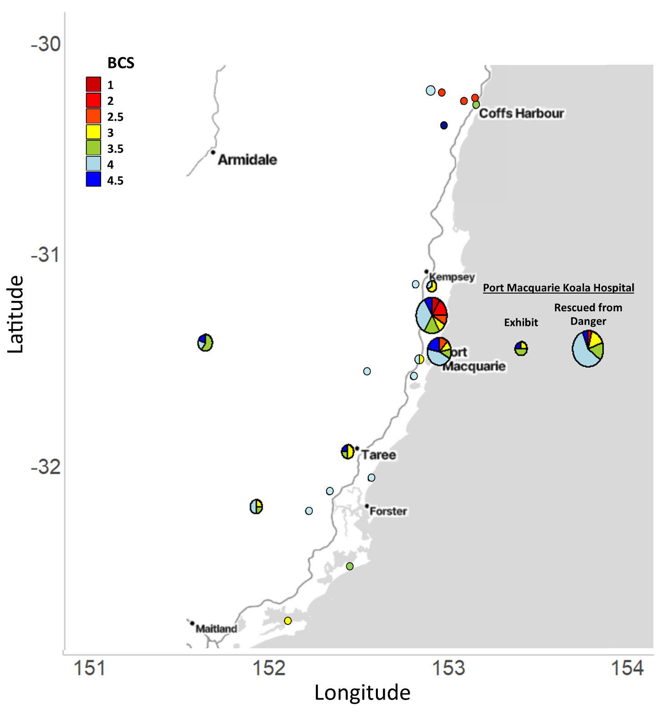
Figure S1: Body condition score across the study region. The size of the pie charts are indicative of the sample size at each study site.

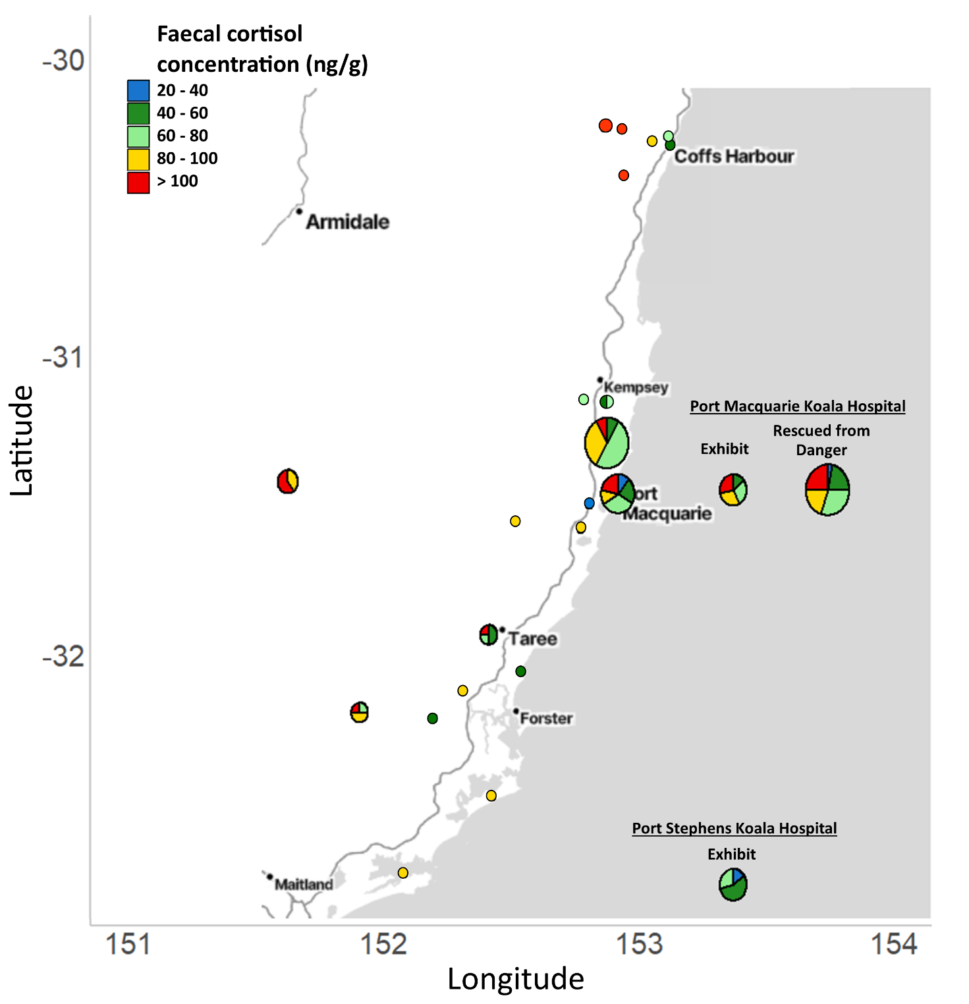
Figure S2: Faecal cortisol concentrations (ng/g) across the study region. The size of the pie charts are indicative of the sample size at each study site.
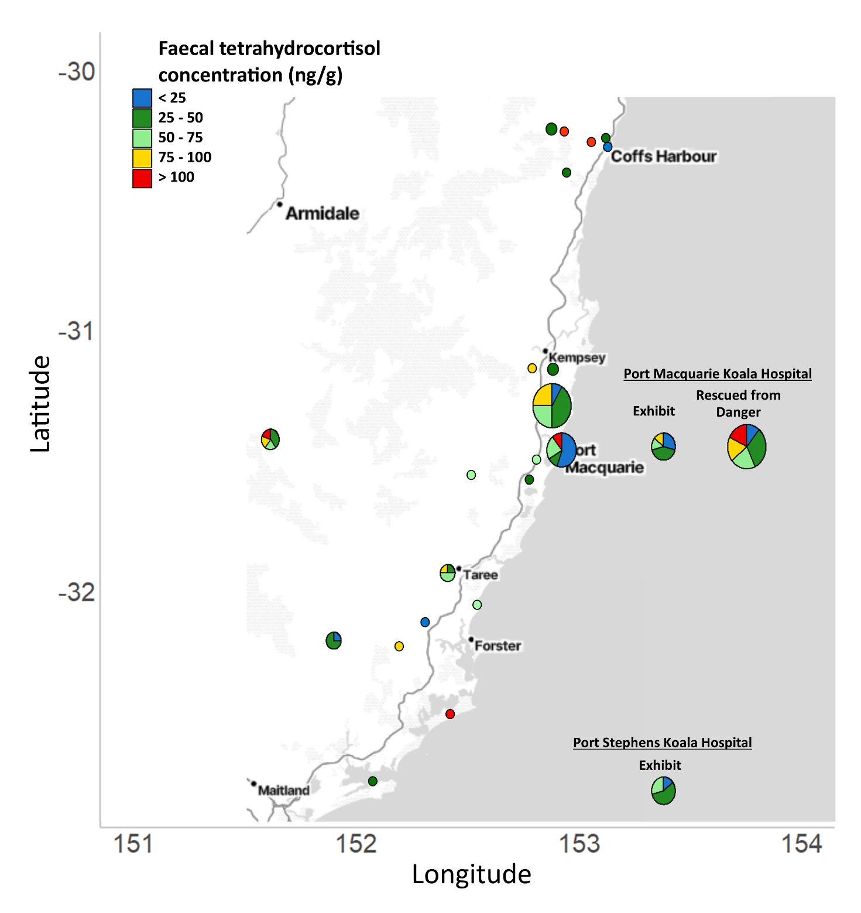
Figure S3: Faecal tetrahydrocortisol concentrations (ng/g) across the study region. The size of the pie charts are indicative of the sample size at each study site.

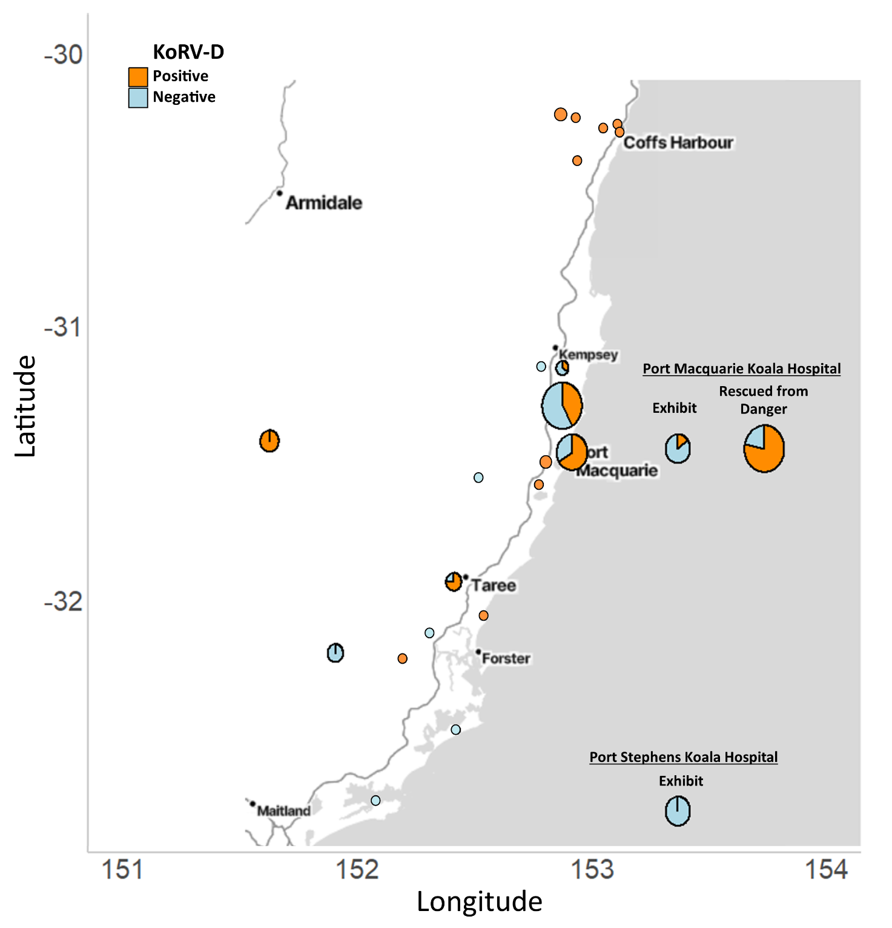
Figure S4: KoRV-D prevalence across the study region. The size of the pie charts are indicative of the sample size at each study site.
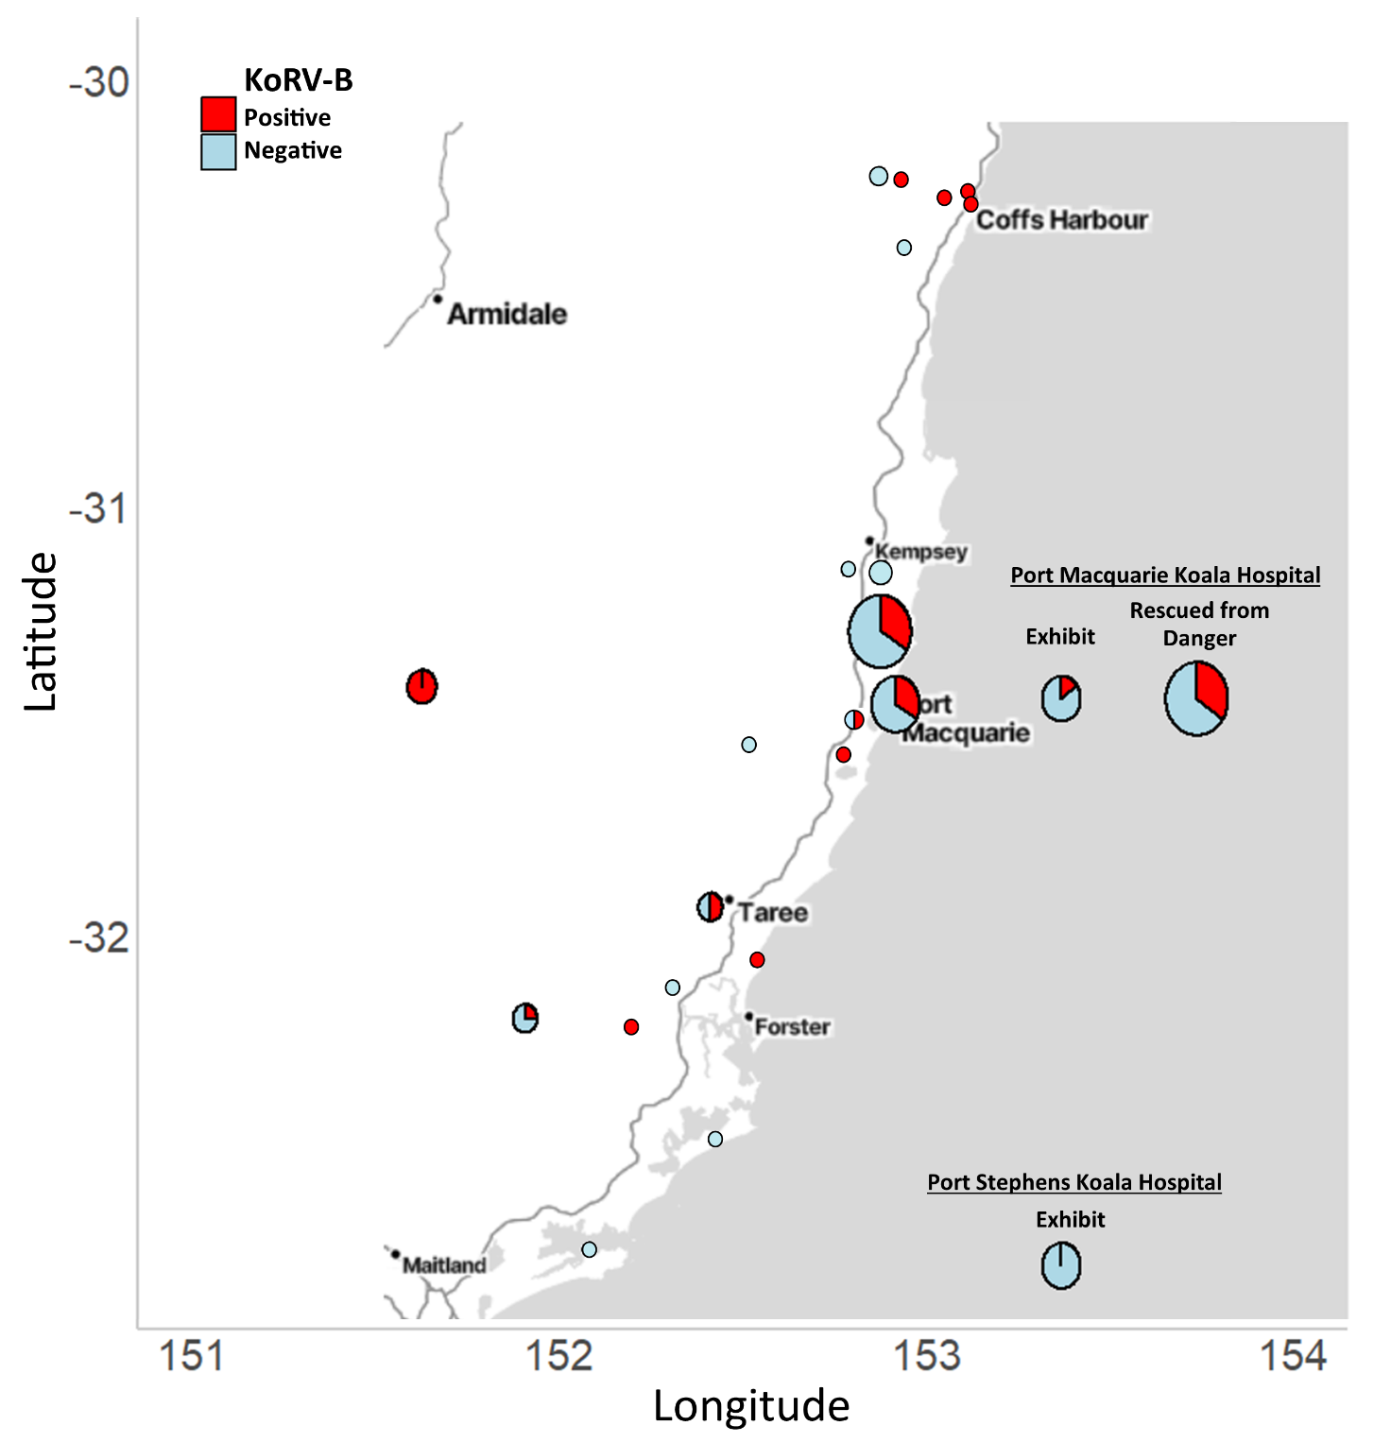
Figure S5: KoRV-B prevalence across the study region. The size of the pie charts are indicative of the sample size at each study site.
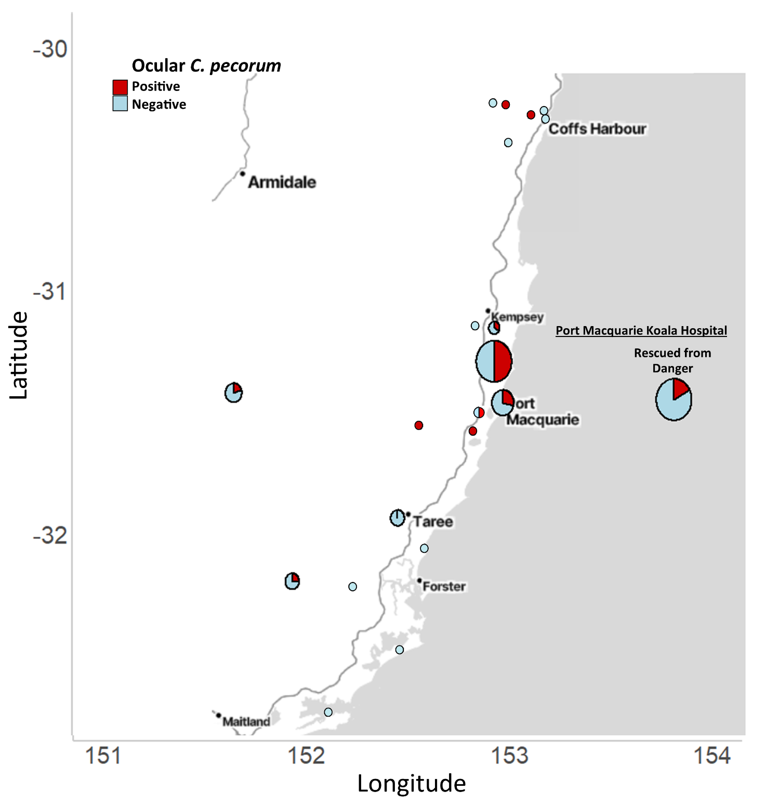
Figure S6: Ocular C. pecorum infection prevalence across the study region. The size of the pie charts are indicative of the sample size at each study site. X-axis show longitude and Y-axis shows latitude.
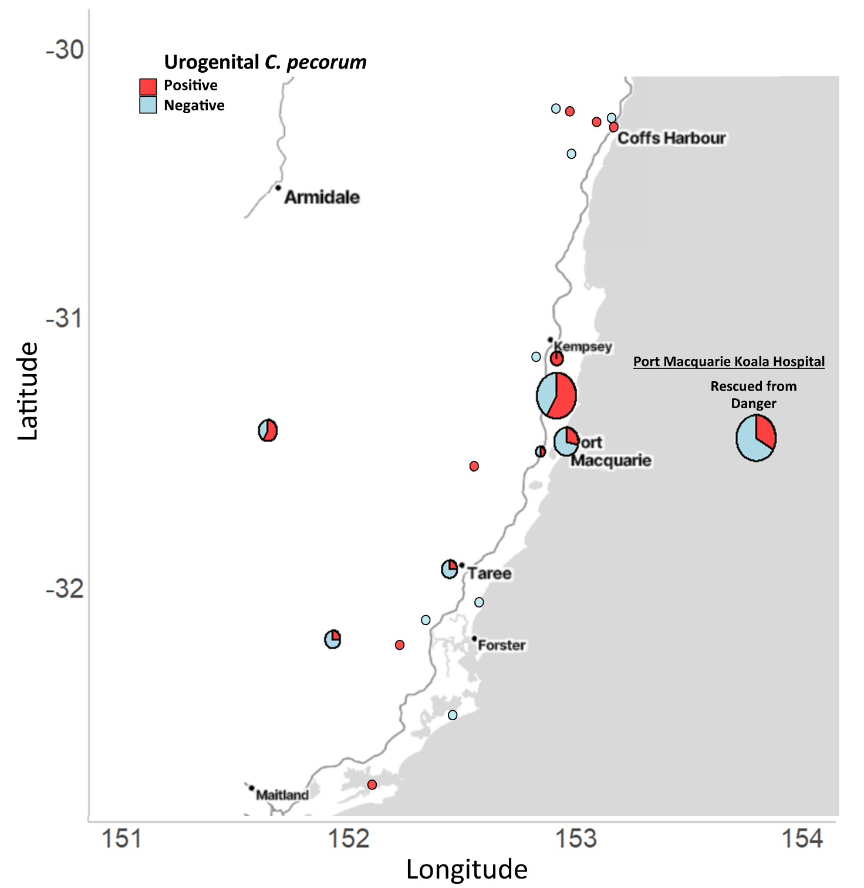
Figure S7: Urogenital C. pecorum infection prevalence across the study region. The size of the pie charts are indicative of the sample size at each study site.
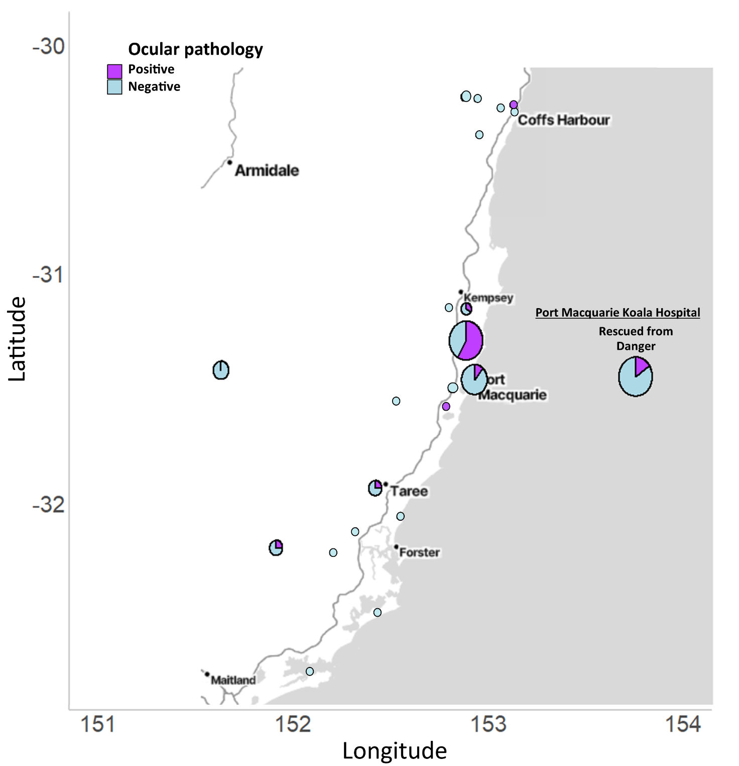
Figure S8: Incidence of ocular pathology across the study region. The size of the pie charts are indicative of the sample size at each study site.
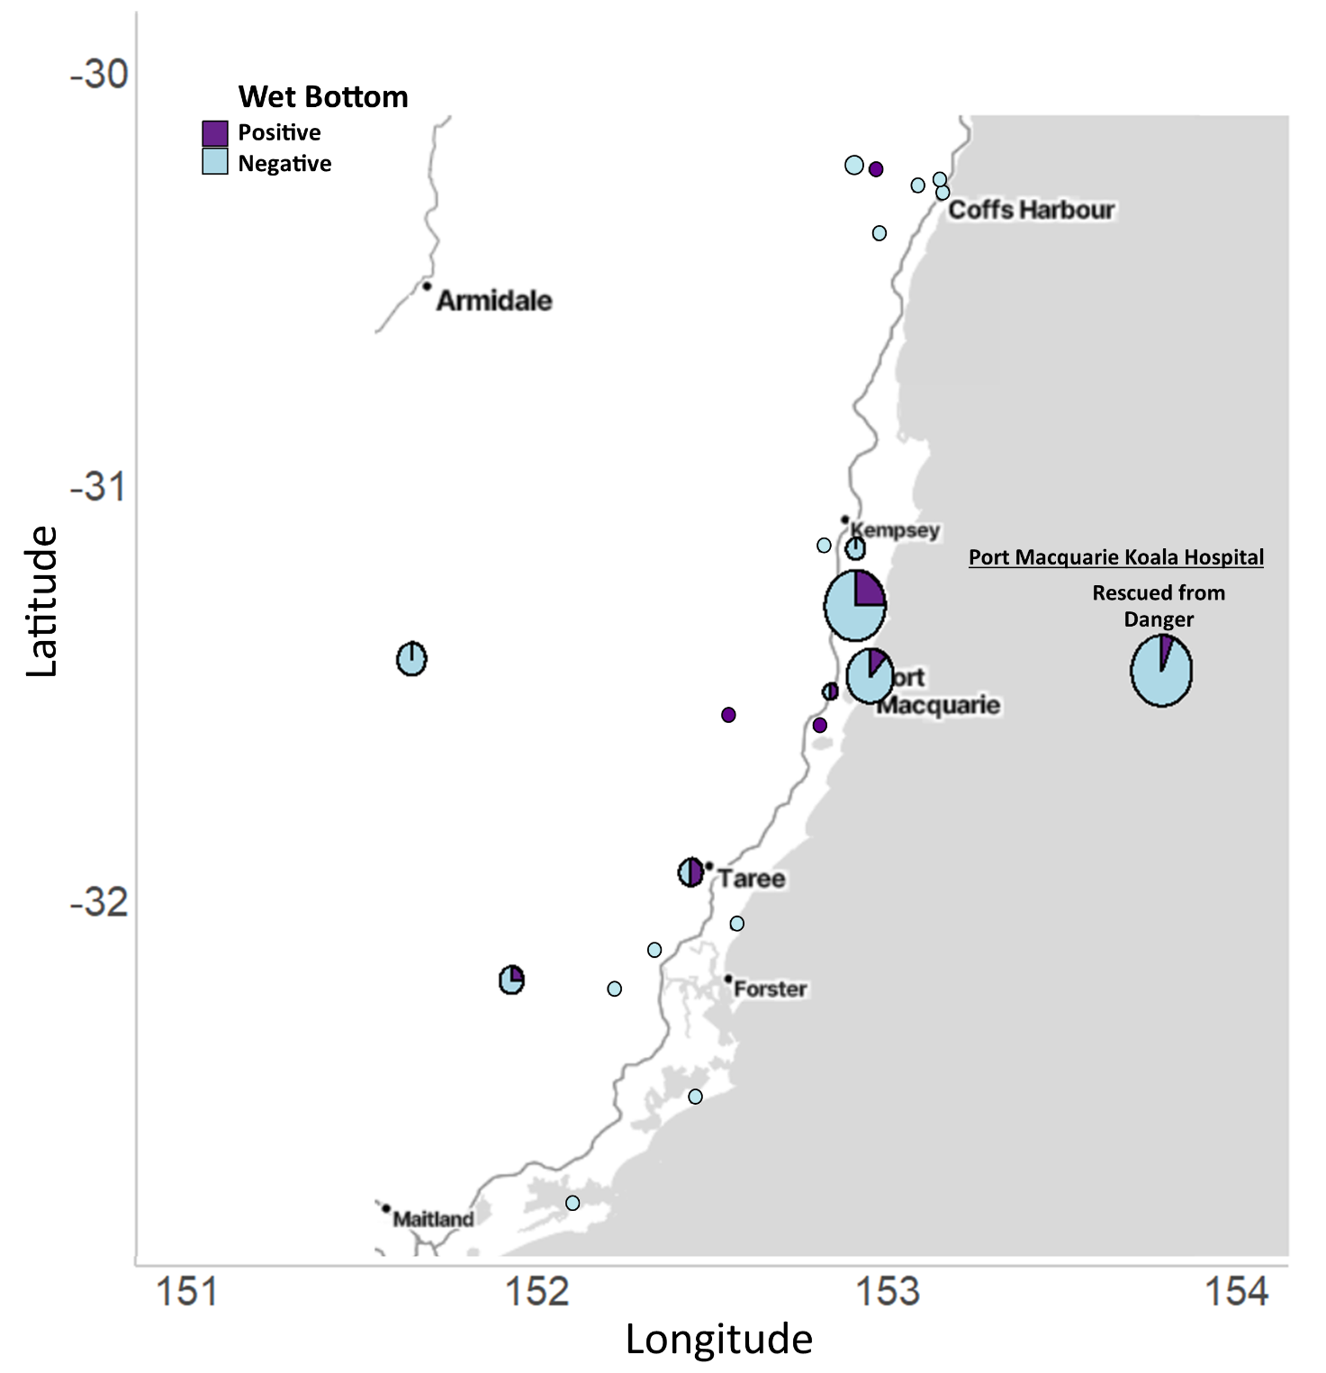
Figure S9: Incidence of wet bottom across the study region. The size of the pie charts are indicative of the sample size at each study site.
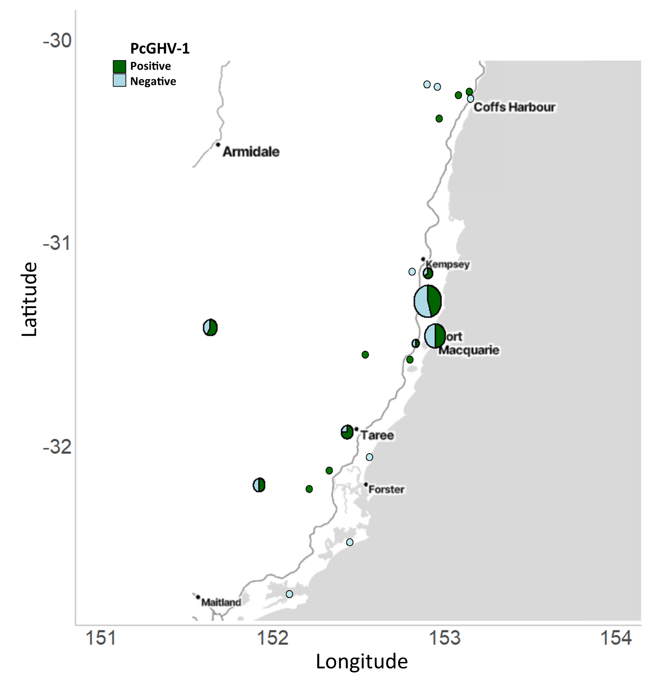
Figure S10: Incidence of PcGHV-1 across the study region. The size of the pie charts are indicative of the sample size at each study site.

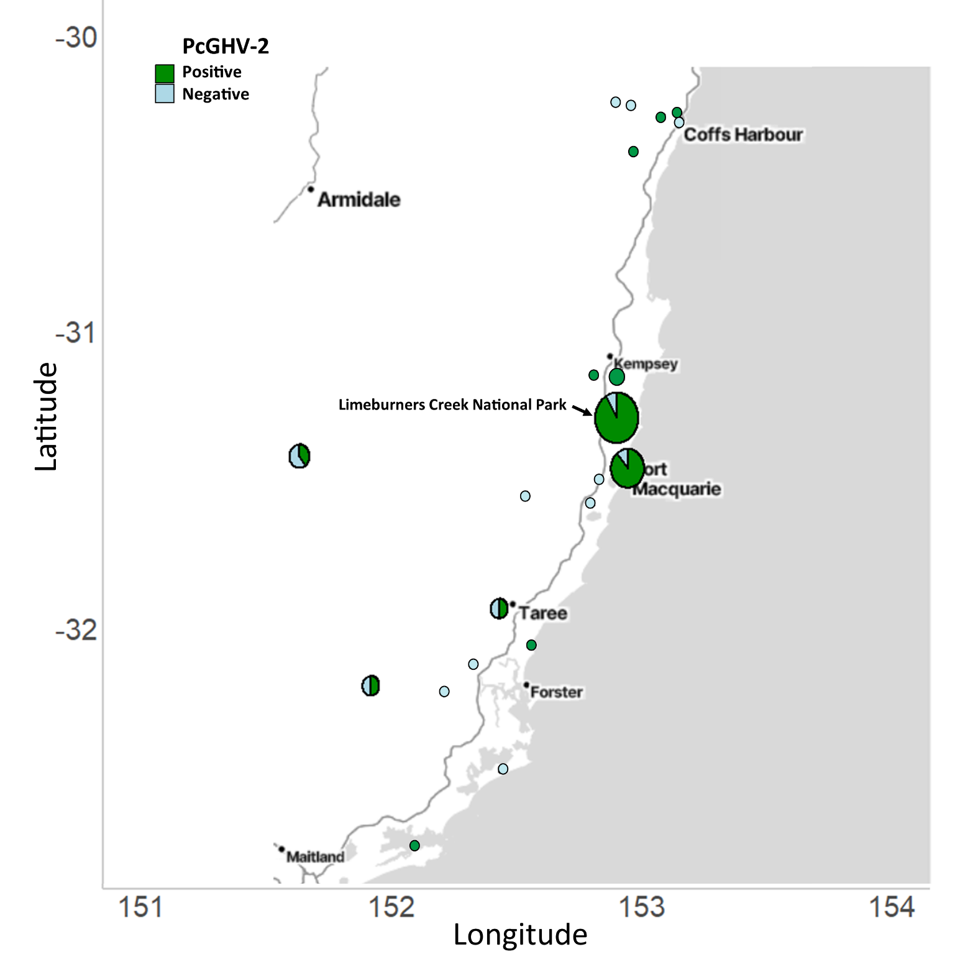
Figure S11: Incidence of PcGHV-2 across the study region. The size of the pie charts is indicative of the sample size at each study site.

Supplementary Tables

Table S8: Additional disease measures by habitat category/ koala cohort
Category | n | Sex  F:M | Average Tooth wear class | Average number of KoRV Subtypes | Proportion KoRV-B positive | Proportion KoRV-D positive | Proportion Ocular  C. pecorum  positive | Proportion Urogenital  C. pecorum  positive | Proportion with ocular pathology | Proportion with urogenital pathology
National Parks | 21 | 14:7 | 3.62 | 2 | 0.29 | 0.43 | 0.45³ | 0.55³ | 0.48 | 0.24
Rural | 17 | 9:8 | 2.97 | 2.35 | 0.53 | 0.76 | 0.31³ | 0.50³ | 0.06 | 0.18
Peri-/Urban | 16 | 12:4 | 4.10 | 2.13 | 0.38 | 0.75 | 0.14¹ | 0.36¹ | 0.13 | 0.19
Rescued from Danger | 8 | 2:6 | 2.75 | 2.13 | 0.25 | 0.88 | 0³ | 0.17³ | 0.13 | 0
Exhibit | 14 | 7:5¹ | 3.93² | 1.36 | 0.07 | 0.07 | N/A | N/A | N/A | N/A
p value |  |  | 0.157 | 0.348 | 0.175⁺ | 0.061*** | 0.149*,⁵ | 0.305 | 0.033 | 0.881⁵

1: value not available for 2 koalas 4. value not available for 10 koalas
2: value not available for 7 koalas 5. “Rescued from Danger” category not included as 0% occurrence
3. value not available for 1 koala p value without site included as random factor: + 0.05-0.1, * <0.05, **<0.01, ***<0.0

Table S9: Provenance of koalas included in the study
Site | Human Association Category | Number of Koalas
Port Macquarie Koala Hospital | Exhibit | 7
Port Stephens Koala Hospital | Exhibit | 7
Bindari National Park | Natural Forest | 1
Kumbatine National Park | Natural Forest | 1
Limeburners Creek National Park | Natural Forest | 12
Maria National Park | Natural Forest | 3
Myall Lakes National Park | Natural Forest | 1
Queens Lake Nature Reserve | Natural Forest | 1
Ulidarra National Park | Natural Forest | 1
Wallamba Nature Reserve | Natural Forest | 1
Coffs Harbour | Peri-urban | 1
Port Macquarie | Peri-urban | 9
Red Head | Peri-urban | 1
Salamander Bay | Peri-urban | 1
Tinonee | Peri-urban | 4
Port Macquarie Koala Hospital | Rescued from Danger | 32
Bayabarra | Rural | 1
Bunya | Rural | 1
Karangi | Rural | 1
Lake Innes | Rural | 2
Nowendoc | Rural | 5
Ulong | Rural | 2
Valery | Rural | 1
Ward River | Rural | 4

