Supporting Information

Direct Measurement of Nonadditive van der Waals Forces From Graphene Nanostacks
Pavlo Gordiichuk, Alberto Ambrosetti, Michael Strano, Alexandre Tkatchenko

METHODS

Chemical vapor deposition (CVD) for growth of Graphene
CVD graphene sheets were produced following the previously reported procedures¹. Briefly, a 2.0 × 2.2 cm Cu foil (Alfa Aesar, 99.8%, 25 μm thick) was used as a substrate. Cu foil was annealed at 30 s.c.c.m. H₂ gas flow (~560 mtorr) for 30 min at 1,000 °C, and then 0.5 s.c.c.m. of CO₂ (for single-layer graphene) was introduced for 15 min, respectively. Next, the furnace was kept at 1,000°C for another 5 min and turned off. The Cu foil was cooled and removed at room temperature.

Polymer assisted fabrication of Multilayered Graphene (MLG) Stacks
To transfer CVD graphene on top of Si/SiO₂ substrate, a PMMA layer with a thickness of 230 nm was spin-coated onto the surface of the graphene/Cu foil using 950 PMMA A4 (MicroChem) at 2,000 r.p.m. for 1 min. We etched the Cu layer (or SiO₂ layer) with ammonium persulfate (APS-100, Transene Co.; or 1 M KOH solution at 80 °C for SiO₂), resulting in graphene/PMMA film which then was rinsed repeatedly (three times) with deionized water. We then picked up the graphene/PMMA film using a Si/SiO₂ substrate inserted below the film floating on water. Samples were fabricated to ensure that only half of the Si/SiO₂ surface was covered with the desired MLG film with homogeneous coverage at the samples’ edge, to allow (i) comparative measurement with and without MLG on the same substrate; and (ii) to assess the reproducibility of force measurements along the edge of the sample.

We checked that force measurements on top of two different samples of 1LG/Si/SiO₂ (one produced by our own CVD growth and another commercially purchased) gave essentially identical results (~4÷5 nN at F_{Contact}).

Experiments on 1LMoS₂ were conducted on the commercially CVD-grown samples on Si/SiO₂ purchased from ACS Materials (Canada). Similarly, half of the sample area was cleaned by soaking half of the Si/SiO₂/1LMoS₂ sample into water for 5 min, followed by drying at ambient conditions. Here, water applied to 1LMoS₂ led to the dissolution of the 1LMoS₂ layer, a result which could be observed by an optical microscope. This was checked by observing a clear optical difference between covered and non-covered areas with 1LMoS₂ layer under 10x microscope zoom; therefore, the same samples were used for the measurements on top of 1LMoS₂ and uncovered Si/SiO₂ areas.

We fabricated MLG samples by sequential polymer-assisted transfer of CVD graphene (or multilayers provided by ACS Materials Canada), followed by F-ds measurements on top of multiple locations across the sample edge, before the next sample of CVD-grown MLG was transferred. A commercially available sample of multilayer stacks of graphene (ACS Materials, Canada) was applied in the fabrication of a thick stack reaching 21LG. The following MLG sequence (0→1→2→4→7→14→21)² was prepared and studied with an angle-dependent experimental strategy described in the main text. In addition, we measured freshly cleaved highly oriented pyrolytic graphite (HOPG) sample. We note that fabricated MLG stacks with the polymer-assisted CVD graphene transfer may still contain an irreversibly absorbed layer of PMMA polymer (even after 10 min soaking in acetone, Ref.³), according to several studies and commensurate with the increase of its roughness.⁴

Calibration of Arrow-TL1-50 tipless cantilevers
The F-ds force measurements were conducted with two brands of AFMs: (i) Bruker Multimode 8 AFM equipped with the Controller V and (ii) Asylum MFP-3D. We selected high aspect ratio Arrow-TL1-50 tipless probes, provided by NanoWorld, having a thickness of 0.7 μm, length 500 μm, and width 100 μm. We determined the spring constant of each cantilever individually (0.15±0.08 N/m) by the thermal tuning method with the hardware and software provided by each AFM setup. In addition, the corresponding vertical sensitivity (150±20 nm/V) was measured on top of the clean HOPG substrate, which had a characteristic F-ds shape with a linear bending regime after establishing a contact with the surface (Fig. S3a). To confirm that the vertical sensitivity is not affected by the contact shape of the tipless cantilever, we conducted the same experiments on the “flipped” SNL-10 probes attached to Si/SiO₂ with the carbon tape (facing with a sharp probe upwards). Such approach allowed us to establish a point contact between the cantilevers and the bottom substrate and reliably measure the cantilever bending. Specifically, the Arrow-TL1-50 probe was approached on the top of the SNL-10 probe’s pyramid facing up until a hard contact between the SNL-10 probe pyramid and the cantilever was achieved. Next, force measurements conducted on top of the SNL-10 pyramid probes showed F-ds curves exhibiting linear bending, which then were used for calculating the vertical sensitivity of tipless cantilevers (145±20 nm/V); these values are in excellent agreement with direct measurements on HOPG.
Realization of angle-dependent F-ds measurements
To measure angle-dependent F-ds on HOPG in situ, the manual goniometer (PT-SD304) stage was introduced into the MFP-3D setup (Fig. S1). During the measurements, all samples were fixed on the goniometer with double-sided tape and tilted from 0˚ to 10˚, which resulted in angles of 11˚ to 1˚ with respect to the cantilever. The angle-dependent experiments on Bruker Multimode 8 AFM were realized on the top of the small Aluminium samples holders having 1-10˚ tilting angles, which were fabricated in a local workshop at MIT. Measurement samples with size 1x1 cm were glued to Aluminum sample holders with the help of a carbon tape. Experiments conducted at different tilting angles with both setups showed that upon decreasing the angle between HOPG substrate and Si cantilever, attraction forces at the contact reach ~14.5 nN at α=1˚, which demonstrates roughly a 100-fold amplification (the ratio: 14.5±0.5nN ÷ 0.13±0.07nN = 111).

Avoiding optical oscillatory noise in F-ds measurements
A typical AFM setup exhibits optical coupling because the feedback laser reflects both from the cantilever and the substrate, leading to a pronounced oscillatory signal, Fig S2. We avoided such optical artifacts by conducting measurements at the edge of each sample (<200 µm from the edge into the sample, Fig. S1b), whereas the reflection feedback laser was focused on the cantilever area withdrawn from the substrate. Such a measurement strategy helped us to measure laser reflection from the cantilever to the photodetector only. We note that due to the high aspect ratio of the cantilever, the placement of the reflecting laser with offset to the cantilever’s measurement area is expected to have a minor effect on the estimation of vertical distances for large cantilever-substrate separations.

Data collection and analysis
Collected F-ds experiments were analyzed with Igor Pro software (for experiments conducted on Asylum MFP-3D AFM) and with NanoScope Analysis software version 1.40 (for experiments recorded on Multimode 8). Statistical analysis and averaging of F-ds curves were conducted in Excel.

Supplementary Notes
Supplementary Note 1
Angle-dependent F-ds measurements on hydrophobic and hydrophilic surfaces
Both MLG and HOPG samples are hydrophobic, hence we expect our measurements to not be influenced by adsorbed water. To assess this hypothesis, we conducted additional experiments on hydrophilic Si/SiO2 and mica surfaces. We observed opposite trends for force measurements between hydrophilic (Si/SiO2 and mica) and hydrophobic (MLG and HOPG) substrates. Namely, angle-dependent experiments demonstrated a steady increase in the attraction forces reaching 2 µm separations and 100-fold enhancement in magnitude upon decreasing the angle from α=11˚ to α=1˚, Fig. S4, for hydrophobic surfaces. In contrast, similar angle-dependent experiments on hydrophilic surfaces show an opposite trend, where no detectable attraction was observed upon decrease of α across the entire range from 11-to-1˚. Instead, a steady increase in retraction forces was observed, which could be associated with water present between the cantilever and the hydrophilic surface. Our results are consistent with pioneering experiments by Prosser and Kitchener⁵ and others⁶.

Supplementary Note 2
Analytical model for vdW F-ds force amplification upon tilting
To model the observed dependence of our force measurements on the cantilever tilting angle, we propose a simple physical model for the system. A flat cantilever is placed at an angle α with respect to the substrate, with its closest edge at distance D_{x} from the substrate, as illustrated in Scheme 1.

We assume that every infinitesimal portion of the cantilever dl provides the following contribution to the total vdW force: dF = dl·C/Z(x)^{p}. In practice, power-law scaling of the form C/Z(x)^{p} (C being a constant factor, derivable from the Hamaker constants of the system) has been introduced for the force acting on any infinitesimal portion of the cantilever, at distance Z(x)=x·tan(α) from the cantilever. If the total length of the cantilever is L, where L=(x_{L} - x_{min}) / cos(α), dl=dx/cos(α) , and x_{min} = D_{x} / tan(α) , the total force can be expressed as:
$F(α)=∫_{x_{min}}^{x_{L}}\frac{dx}{cos(α)}\frac{C}{(x tan(α))^{p}}=\frac{C}{cos(α)tan(α)^{p}}\left(\frac{1}{p-1}\right)\left(\frac{1}{x_{min}^{p-1}}-\frac{1}{x_{L}^{p-1}}\right)$. (1)
Considering the dependence of the above expression on α and assuming the power law p=2 in accordance with the experiment at a short distance, one finds that the ratio between the force measured at α=1˚ and α=11˚ is ~100.
Scheme 1. Geometry of the model adopted to describe the angle-dependence of substrate-cantilever interactions. The blue bar represents the cantilever, oriented at angle α with respect to the (horizontal) substrate. Attraction forces could be amplified by tilting the cantilever towards the substrate, as being exploited in the current research strategy. When the attraction forces relative to an infinitesimal cantilever fragment (red) are governed by a power-law decay with exponent p, the entire cantilever will be subject to the force described by eq.(1).

Supplementary Note 3

Estimation of contact area between tipless cantilever and HOPG
To estimate the contact area of the Si cantilever with the HOPG sample, we calculated the peeling energy of the Si cantilever from HOPG and compared the obtained values to previous literature⁷. By taking the peeling length l=4 µm from the retraction curve and taking the geometrical parameters of the cantilever having an isosceles triangular part (i.e., base 100 µm, height 86.6 µm and angle of β=60˚), we calculated that the contact area of the cantilever with HOPG is equal to 9.28 µm². Upon dividing the binding energy (calculated from integration of the area under the retraction curve (Fig. S5)) by the contact area of 9.28 µm², we obtained a binding energy of 0.11±0.02 N/m between the Si surface and HOPG, which is in a good agreement to other macroscopic force-displacement experiments⁷. We note that Fig. S5d demonstrates that adhesion energy has an abrupt transition at α=1˚, which suggests that the cantilever undergoes bending and falls into contact with the HOPG surface. Such transition is illustrated schematically in Fig. S5d.

Supplementary Note 4
Validation of long-range vdW attraction in contactless scanning mode
We investigated whether vdW forces are affected by a potential formation of a capillary bridge between the cantilever and the HOPG surface. To do so, we measured F-ds curves in contactless mode, by carrying out continuous F-ds measurements with α=3˚ up to cantilever-substrate separations of 10 µm. Next, after stable F-ds measurements were established, we used the AFM software in the “non-triggered” mode, which allowed us to maintain stable F-ds scanning measurements, while the HOPG substrate was repeatedly retracted. We recorded a total of 1000 F-ds curves, which showed an error bar of <7%, Fig. S6c.

Supplementary Note 5
Experimental measurements of vdW forces from a single layer of graphene
A single layer of graphene (1LG) fabricated by chemical vapor deposition (CVD) was transferred on Si/SiO₂ substrate with the help of poly (methyl methacrylate) (PMMA) polymer as described before (Methods)⁸. Conducted angle-dependent F-ds measurements with Si cantilever across multiple Si/SiO₂/1LG samples showed a ~75% reduction of vdW attraction forces at the contact (i.e., F_{C}) (Fig. 1d), compared to Si/SiO₂ surface (being exposed to the same experimental conditions), Fig. 1d.

To demonstrate the high sensitivity of our experimental technique towards other 2D materials, we studied a single layer of CVD-grown molybdenum disulfide (1LMoS₂). Similar to 1LG, 1LMoS₂ showed a 60% reduction in attractive vdW forces with respect to non-covered Si/SiO₂ samples; this result is in agreement with recent theoretical calculations, Fig. S9⁹.

Supplementary Note 6
Averaged F-ds measurements on bare (uncleaned) Si/SiO₂ surfaces
We measured vdW forces with the Si cantilever on bare Si/SiO₂ substrates with the previously established strategy. Our experiments demonstrated two main findings, which are different to experiments conducted on HOPG and MLG.

First, the Si/SiO₂ (i.e., fabricated oxide 200 nm) showed strong suppression of vdW attraction forces, Fig. S9a. Secondly, measured retractive F-ds showed much stronger adhesion of Si cantilever to bare Si/SiO₂ substrates than on freshly cleaved HOPG surface. In detail, close to ~5x stronger peeling energy was measured on the bare substrates than on HOPG already seen at α=3˚, Fig. S9b. Our angle-dependent experiment on bare surfaces showed a steady increase of peeling energy of Si cantilever from the bare Si/SiO₂ substrates contrasting with the experiments on HOPG, suggesting different adhesion interaction mechanisms possibly mediated by water molecules, and surface impurities. We were not able to measure peeling energies between Si cantilever and bare Si/SiO₂ substrates at low angle α=1˚, since strong stiction was observed, which led to drastic adhesion forces. Therefore, to separate Si cantilever from bare Si surface at α=1˚, the withdrawal process had to be applied repeatedly. Moreover, during the withdrawal process, we observed visible deformations of the cantilever, which indicated that a large area of the cantilever was involved in the contact with bare Si surfaces.

In summary, our experiments showed that uncleaned Si/SiO₂ surfaces have a high uncertainty within the measurements of vdW forces, which could be strongly affected by water molecules and contaminations leading to additional capillary and electrostatic interactions.

Supplementary Note 7
Modeling vdW forces in multilayered graphene stacks
We model here the interaction of a small particle with a stack of N graphene (G) layers, and with highly-oriented pyrolitic graphite (HOPG), neglecting supporting substrates due to effective decoupling. A small particle (modeling the cantilever) is placed at a distance d from the upper G layer. The choice to model the cantilever as a small object is dictated by the geometrical complexity of the cantilever itself (we recall that the cantilever will also bend during measurements). We thus neglect the finite dimension and possible plasmon-like modes emerging in the cantilever. On the other hand, when the the cantilever is modeled as an infinite slab¹⁰,one essentially obtains a physical picture which is compatible with a collection of independent pointlike adsorbates, with renormalized polarizability, hence preserving the same qualitative features already present in this model.
The G-G interlayer separation is denoted as Δ_{G} (fixed to 6.33 Bohr). Atomic units (ħ = e = c = m_{e} = 1) are adopted to simplify the notation. The interacting 2D response function of G (χ¹_{G}(q, iω)) is obtained by screening of the bare susceptibility involving relativistic-like π electronic states⁽¹¹⁾ at the random phase approximation (RPA) level, exploiting Dyson’s equation:
. (2)
In the above equation, iω is the imaginary frequency, q the in-plane momentum, and v_{F} the Fermi velocity, which is fixed here to v_{F} = 2a.u. in order to account for renormalization at small momenta¹² (relevant for large adsorption distance d). This choice neglects other (gapped) electrons, and thus underestimates the vdW attraction at the short range. We recall, however, that gapped states produce a vdW contribution which approaches the (faster) pairwise power-law decay already at the ~5 nm scale^{11, 13}. We thus reasonably expect that the missing contributions from gapped electrons will be negligible at the long range, and they will essentially renormalize the substrate response, enhancing the overall polarizability, and producing a screening of the interlayer coupling.
The response function χ_{G} is coupled via , i.e. the 2D Fourier transform of the Coulomb interaction
. (3)
The RPA is adopted also for describing interlayer many body effects. In fact, the interacting response function of the G stack is given by:
, (4)
where
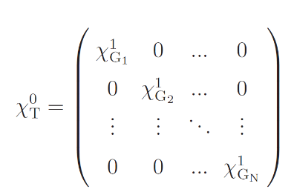 (5)
is the bare response, and the corresponding interaction matrix has the following form:
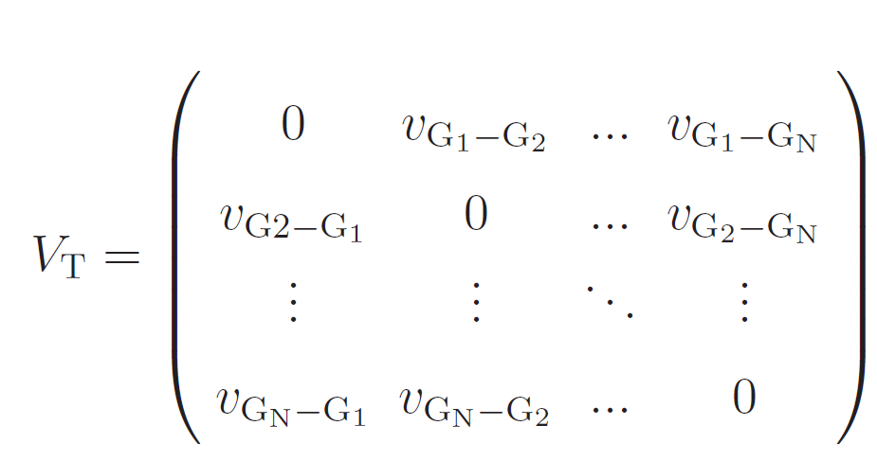 (6)

where we identify with . This interaction matrix is renormalized by the screening factor ε⁻¹ to account for defects and interstitial water/impurities, as described in the manuscript.

To better justify our choice we underline that while defects will essentially renormalize the density response of monolayer graphene, geometrical distortions can also increase the interlayer spacing. Interstitial impurities can also increase the interlayer distance, while also producing an effective screening of the interlayer interaction and an additional attractive substrate-cantilever term. An increased interlayer spacing effectively reduces the interlayer coupling: for instance, when the spacing is increased by ~40%, the dipole-dipole coupling is reduced by a factor ~0.36. If one models the interstitial impurities as a medium with finite electronic gap, where graphene layers are immersed, further reduction of the interlayer coupling should be introduced according to the effective dielectric function of the impurities. At the same time, the impurities can be viewed as an effective slab, which will provide an additional attraction which will amplify the force acting on the cantilever. This term was neglected here, but it will also grow as a function of the number of graphene layers, compatibly with the experiment. Ananlogous considerations hold for the gapped electronic states of graphene.

In the case of (semi-infinite) HOPG, we instead define the substrate response χ_{HOPG}, which depends explicitly on z coordinates that need to be integrated. In this case, we simplify the notation in analogy to the Lifshitz-Zaremba-Kohn theory¹⁴. In fact, after 2D Fourier transforms, one can substitute χ¹_{HOPG} with (where the ε_{HOPG} is the dielectric function of HOPG).
Since the adsorbate is situated at a large distance from the upper G layer, we make use of a second-order perturbative expansion in the surface-adsorbate interaction.
. (7)
The full response function χ_{AT} includes both χ_{A} and χ_{T}, while V_{AT} is the Coulomb interaction matrix between the two susceptibilities:
. (8)
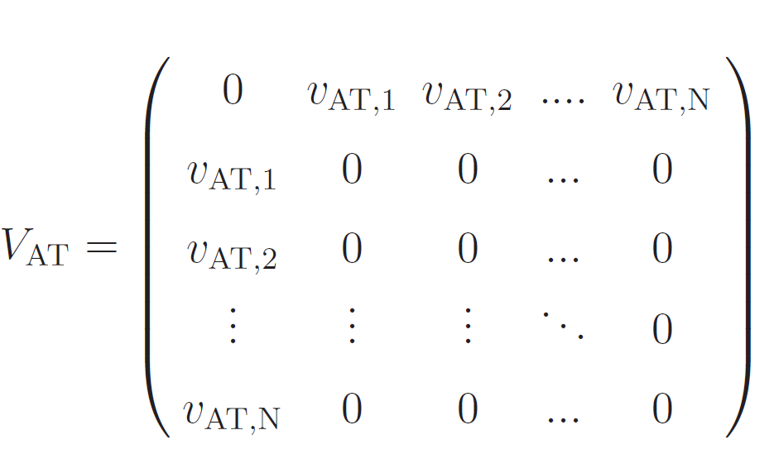 (9)
Here V_{AT,j} is analogous to v_{GS}, although involving the z coordinates relative to the adsorbate (z_{A}) and the coordinate of the j-th substrate element (z_{j}). In the case of HOPG the above expression reduces to a 2 × 2 matrix (only a single response function χ¹_{HOPG} exists in this case).
For sufficiently large adsorption distance d, one can approximate the adsorbate response at the dipole level (α_{A}):
, (10)
where the origin of the coordinates r_{1,2} coincides with the adsorbate position. Isotropic polarizability is assumed, with , and , being the in-plane momentum.

The substrate permittivity was computed exploiting the Clausius-Mossotti approach:

, (11)

where C = 3V/4π, α_{HOPG} is the screened atomic polarizability, and V is the volume per atom in the bulk. In the above equation, the screened polarizability is obtained from the self-consistent (SCS) screening approach.⁽¹³⁾

We observe that adsorbates situated at large distance d from the surface are most sensitive to increases in the number of G layers. The sensitivity to distance can be rationalized looking at the 2D Fourier transformed Coulomb potential, which exhibits exponential decay as a function of qz. In fact, the relative z increase by addition of G layers is larger at small d, and becomes gradually smaller when d becomes large.

Concerning pairwise vdW calculations, these were performed adopting the Tkatchenko-Scheffler⁽¹⁵⁾ approach, always setting the adsorbate polarizability to unity.

Supplementary Note 8
Polarizability of multi-layered graphene stacks
We compare the polarizability of HOPG and 1LG in the next schematic layout, Scheme 2 (MLG can be straightforwardly handled by extension of 1LG, as illustrated later).

Scheme 2. A schematic picture showing the geometry of the two models applied to estimate the polarizability of individual C atoms in HOPG and 1LG thin films. The cantilever is modeled as a semi-infinite slab, at distance Z₀ from (a) HOPG or (b) 1LG. The interlayer spacing in HOPG is indicated as ΔZ_{HOPG}.

Within the pairwise approach, we calculate the force per unit area (S) arising between HOPG and cantilever as:
, (12)
where (V_{at})_{HOPG/Cantilever} is the volume per atom (molecule) in the lattice of HOPG (cantilever), and C₆^{HOPG-C} is the Hamaker coefficient relative to the dipolar vdW interaction between a single C atom in HOPG and a single molecule in the cantilever. In the above equation, the cantilever is treated as a semi-infinite slab, compatibly with the power law scalings observed experimentally at large substrate-cantilever separations. However, the following considerations remain qualitatively valid even if the cantilever is modeled as a pointlike object.

An analogous pairwise vdW force expression is found for 1LG:

, (13)
where the (A_{at})_{1LG} is the area per atom of C in 1LG. Therefore, considering that V_{at}=A_{at}ΔZ_{HOPG}, (ΔZ_{HOPG}~6.7 bohr), we get:
. (14)
When each atom is modeled as a single quantum Drude oscillator (Tkatchenko-
Scheffler approach¹⁵), having static polarizability $α_{i}$ and oscillator frequency $ω_{i}$, one has that the dipolar Hamaker coefficient for atoms 1,2 can be expressed as:

. (15)
Hence, if the oscillator frequencies relative to C atoms do not substantially vary passing from HOPG to MLG, one finds the following equation:

. (16)
Within the pairwise model, at large Z₀ (such that Z₀>>ΔZ) the vdW force contributions due to the different layers are essentially indistinguishable. Hence, in case of MLG (N layers) one can divide the total substrate-cantilever force by N, to get the “effective 1LG pairwise force contribution”. This effective 1LG force can be plugged into eq.(16) to estimate the polarizability ratio for MLG stacks. For instance, when Z₀=500 nm one has ΔZ/Z₀~3*10⁻⁴. Hence, by introducing in eq.(16) the experimental forces measured at the same Z₀ one obtains that the ratio between the polarizability of individual C atoms in HOPG and MGL is $α^{HOPG}/α^{MLG}=1.69⋅{10}^{-4}$. We also underline that the polarizability ratio extracted from the above pairwise theory and experimental forces is not constant, and varies as a function of Z₀. The pronounced polarizability difference found between HOPG and MLG, and the aforementioned variability with respect to Z₀ evidence a major limitation of pairwise approaches in the present context.
Supporting Figures
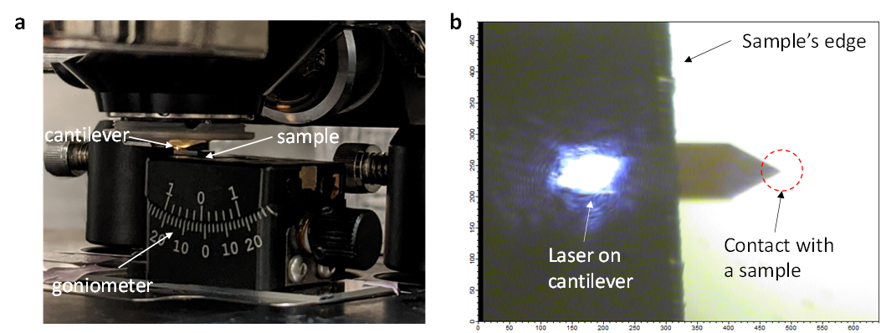
Fig. S1| Experimental setup. (a) An optical image of MFP-3D setup implemented with goniometer applied to the realization of angle-dependent F-ds measurements. (b) Optical image of a typical experiment where the Si cantilever is used for F-ds measurements at sample’s edge when the feedback laser is focused on the cantilever.

Fig. S2| Oscillatory noise due to optical coupling between the cantilever and a substrate. (a) A typical F-ds recorded on the HOPG surface while the feedback laser is focused at the end of the cantilever (overlapping with the substrate). (b) The zoom of the F-ds demonstrates strong oscillatory noise characteristic of tipless cantilever experiments. Such noise stems from the mutual laser light reflections from the substrate and the cantilever.
Fig. S3| F-ds recorded on HOPG surface. (a) An optical image of Si cantilever on top of HOPG surface where the optical feedback laser is focused on the cantilever away from the edge of the surface (i.e., non-overlapping with HOPG surface). The red laser is invisible as it is not reflecting into the optical camera in Multimode 8 AFM, Bruker. (b) A typical F-ds recorded on HOPG surface at α=1˚ showed clear attraction forces reaching 2µm separations.
Fig. S4| Logarithmic plot of angle-dependent F-ds measurements on HOPG. Conducted experiments at different cantilever-substrate angles show a variation in the power law, approaching D⁻³, due to tilting of the cantilever from α=11˚ to 1˚, respectively.

Fig. S5| Measurements of peeling energy between Si cantilever and HOPG. (a) Schematic and an optical image of Si cantilever in contact with HOPG surface. The triangular tip of the cantilever has an angle β=60˚. (b) Upon reduction of the tilting angle between the cantilever and HOPG substrate, an abrupt transition is observed in the increase of the adhesion energy, which stems from the bending of the cantilever towards the substrate. (c) A typical F-ds recorded at α=1˚ on HOPG showing both approach and retraction F-ds curves. (d) The calculated area under the retraction curves is a function of the tilting angle α between the cantilever and HOPG. Peeling energy is calculated by dividing the area under the curve with respect to the contact area (calculated from l=4µm, area 9.28 µm²).

Fig. S6| Experimental strategy for contactless measurements of F-ds on top of HOPG. (a) F-ds were recorded at 5 different time intervals while the bottom HOPG substrate was retracted from the cantilever. Schematic pictures and corresponding F-ds demonstrate that Si cantilever loses contact with the substrate (after force feedback is switched into “non-triggered” regime). (b) Zoom of the F-ds from (2) showing a gentle contact with the surface (shown with a black arrow). (c) F-ds recorded at the beginning and after 1 thousand cycles (1Hz frequency) showed no change in the attraction (40 F-ds, where the averaged F-d is colored in red), amplitude, and attraction range with the HOPG surface.

Fig. S7| Averaged F-ds recorded at fixed location on HOPG surface show high reproducibility with an error bar below 3%.
Fig. S8| Averaged F-ds recorded along the HOPG edge show high reproducibility with an error bar below 5%.

Fig. S9| Averaged F-ds recorded on bare Si/SiO₂ surface. (a) A typical angle-dependent F-ds recorded on top of bare Si/SiO₂ show suppressed vdW forces. (b) Typical adhesion energy of Si cantilever with bare Si/SiO₂ substrate showing ~5x stronger adhesion already at α=3˚. Adhesion energy at α=1˚ was above the detection limits of the experimental setup as measured forces were high leading to strong stiction. To compare, experiments conducted on HOPG are shown as well.
Fig. S10| Averaged F-ds recorded on Si/SiO₂ surface exposed to the same fabrication conditions as 1LG samples. (a) A typical F-ds were recorded on 1LG and pristine Si/SiO₂ on the same sample but at different areas. (b) The top panel shows statistical F-ds recorded across 5 different samples, at 5 different locates. The bottom panel shows corresponding F-ds recorded on the non-covered areas with 1LG. Measurements confirmed that close to 75% screening of vdW forces were seen. All experiments across a single sample showed an error bar of less than 4%.

Fig. S11| Averaged F-ds recorded on 1LMoS₂ and non-covered Si/SiO₂ areas demonstrate close to 60% reduction of attraction forces.
Fig. S12| Averaged F-ds recorded on MLG. (a) Averaged F-ds recorded on MLG. (b) F_{Contact} vs N.

Fig. S13| Experimental data showing forces measured on MLG as a function of separation distance (d).
Fig. S14| Calculated pairwise forces plotted together with many-body results and experimental data (separation distance equals 2.5 nm).

References
1. Liu, P. W. et al., Autoperforation of 2D materials for generating two-terminal memristive Janus particles. Nature Materials 17, 1005-1012, doi:10.1038/s41563-018-0197-z (2018).
2. Rafiee J. et al., Wetting transparency of graphene. Nature Materials 11, 217-222, doi:10.1038/nmat3228 (2012).
3. Marinov, D. et al., Reactive plasma cleaning and restoration of transition metal dichalcogenide monolayers. Npj 2d Mater Appl 5, 1-7, doi:10.1038/s41699-020-00197-7 (2021).
4. Choi, W., Shehzad, M. A., Park, S., Seo, Y., Influence of removing PMMA residues on surface of CVD graphene using a contact-mode atomic force microscope. RSC Adv 7, 6943-6949, doi:10.1039/c6ra27436f (2017).
5. Prosser, A. P., Kitchener, J. A., Direct measurement of long-range van der Waals forces. Nature 178, 1339-1340, doi:10.1038/1781339b0 (1956).
6. Na, S. R., Sarceno, D. A., Liechti, K. M., Ultra long-range interactions between silicon surfaces. Int J Solids Struct 80, 168-180, doi:10.1016/j.ijsolstr.2015.11.001 (2016).
7. Miskin, M. Z., Sun, C., Cohen, I., Dichtel, W. R., McEuen, P. L., Measuring and manipulating the adhesion of graphene. Nano Lett 18, 449-454, doi:10.1021/acs.nanolett.7b04370 (2018).
8. Shih, C. J., Strano, M. S., Blankschtein, D., Wetting translucency of graphene. Nature Materials 12, 866-869, doi:10.1038/nmat3760 (2013).
9. Ambrosetti, A., Silvestrelli, P. L., Faraday-like screening by two-dimensional nanomaterials: A scale-dependent tunable effect. J Phys Chem Lett 10, 2044-2050, doi:10.1021/acs.jpclett.9b00860 (2019).
10. Lifshitz, E. M., The theory of molecular attractive forces between solids. J Exp Theor Phys USSR 29, 94–110, doi:10.1016/B978-0-08-036364-6.50031-4 (1954).
11. Dobson, J. F., White, A., Rubio, A., Asymptotics of the dispersion interaction: Analytic benchmarks for van der Waals energy functionals. Phys Rev Lett 96, 073201, doi:10.1103/PhysRevLett.96.073201 (2006).
12. Stauber, T. et al., Interacting electrons in graphene: Fermi velocity renormalization and optical response. Phys Rev Lett 118, 266801, doi:10.1103/PhysRevLett.118.266801 (2017).
13. Ambrosetti, A., Ferri, N., DiStasio Jr. R. A., Tkatchenko, A., Wavelike charge density fluctuations and van der Waals interactions at the nanoscale. Science 351, 1171-1176, doi:10.1126/science.aae0509 (2016).
14. Zaremba, E., Kohn, W., Van der Waals Interaction between an atom and a solid-surface. Phys Rev B 13, 2270-2285, doi:10.1103/PhysRevB.13.2270 (1976).
15. Tkatchenko, A., Scheffler, M., Accurate molecular van der Waals interactions from ground-state electron density and free-atom reference data. Phys Rev Lett 102, 073005, doi:10.1103/PhysRevLett.102.073005 (2009).

