Supplementary Information

Photocatalytic Reduction for Integrated Single-vat Multimaterial 3D Printing

Author List
Sarah G. Finnegan¹, Holden J. Howard², Shahryar Mooraj², Xinyu Miao¹, Isabel F. Arias-Ponce², Drew S. Melchert², Kathryn M. Weber¹, Quang M. Nguyen³, Alex Abelson², Wonjin Choi⁴, Tehshik P. Yoon¹, Aldair Gongora², Maxim Shusteff², Johanna J. Schwartz ⁴, Andrew J. Boydston^{1,5,6*}

Affiliations
¹Department of Chemistry, University of Wisconsin; Madison, WI 53706, USA
²Materials Engineering Division, Lawrence Livermore National Laboratory; 7000 East Avenue, Livermore, CA, 94550, USA
³DEVCOM Army Research Laboratory; Adelphi, MD, 20783, USA
⁴Physical Life Sciences, Lawrence Livermore National Laboratory; 7000 East Avenue, Livermore, CA, 94550, USA
⁵Department of Materials Science and Engineering, University of Wisconsin; Madison, WI 53706, USA
⁶Department of Chemical and Biological Engineering, University of Wisconsin; Madison, WI 53706, USA
*Corresponding Author. Email: aboydston@wisc.edu

Table S1. Photocatalyst/photoinitiator absorbance spectra comparison.
 | Eosin Y | BAPO(1) | BODIPY F-H(1) | BODIPY Me-H¹ | BODIPY F-Br(1) | Rose Bengal | ZnTPP | DMPA | Irgacure 784(1) | Ivocerin(1) | CQ(2) | TPO(2)
Mes-Acr
TPPT BF4
2,4,6-PMP TPPT
4CzIPN
4DPAIPN
[Ir(dF(CF3)ppy)2(bpy)]PF6
[Ir(dF(CF3)ppy)2(dtbbpy)]PF6
CdS QDs
CdSe QDs
CuInS QDs
tri-(p-tol)-pyrylium
2,4,6-triphenylpyrylium
2,4,6-(p-OMe-Ph)-pyrylium
2,6-(p-tol)-4-(p-OMe Ph)-pyrylium
2,6–(p-OMe-Ph)-4-Ph pyrylium
2,6-(p-OMe Ph)-4-(p-tol)-pyrylium
2,6-p-tol-4-Ph pyrylium
2,6-Ph-4-(p-OMe Ph)-pyrylium
2,6–(2,4-di-OMe-Ph)-4-Ph pyrylium
2,4–(2,4-di-OMe-Ph)-6-(p-OMe Ph) pyrylium
2,4,6–(2,4-di-OMe-Ph) pyrylium
2-(2,4-di-OMe-Ph)-4-Ph-6-(p-OMe Ph) pyrylium
2,6-(p-OMe Ph)-4-(p-CF3 Ph)-pyrylium
2-(2-pyr)-4-Ph-6–(p-OMe-Ph) pyrylium
TBADT
benzophenone
dichlorobenzophenone
acetophenone
fluorenone
xanthone
Black boxes indicate there are no productive areas where the two spectra do not overlap. Gray boxes indicate there are areas of each spectrum that do not overlap the other, but the combination was not screened for chemical selectivity. Red boxes indicate acceptable wavelength selectivity but no chemical selectivity. Green boxes indicate acceptable wavelength and chemical selectivity.

Table S2. Silver salt solubility and background reactivity screening
Silver Salt | Solvent | Soluble | AgNP formation in 24 h
Silver carbonate | MeCN:PEGDA 250 (1:1) | N | N
Silver phosphate | MeCN:PEGDA 250 (1:1) | N | N
Silver (I) oxide | MeCN:PEGDA 250 (1:1) | N | N
Silver acetate | MeCN | N | N
Silver acetate | MeCN:PEGDA 250 (1:1) | N | N
Silver acetate | Hydroxyethyl acrylate | N | Y
Silver acetate | HEMA | N | Y
Silver acetate | Acrylic acid | N | N
Silver acetate | Dimethyl sulfoxide (DMSO) | N | Y
Silver acetate | Water | N | N
Silver acetate | Dimethylformamide | N | Y
Silver (I) acetylacetonate | MeCN | N | Y
Silver (I) acetylacetonate | MeCN:PEGDA 250 (1:1) | N | Y
Silver (I) acetylacetonate | Hydroxyethyl acrylate | N | Y
Silver (I) acetylacetonate | HEMA | N | Y
Silver (I) acetylacetonate | Acrylic acid | N | Y
Silver (I) acetylacetonate | DMSO | N | Y
Silver (I) acetylacetonate | Water | N | Y
Silver (I) acetylacetonate | Dimethylformamide | N | Y
Silver neodecanoate | Hexanes | Y | N
Silver neodecanoate | Toluene | Y | N
Silver neodecanoate | PhMe:PEGDA 250 (1:1) | N | N
Silver neodecanoate | Diethyl ether | Y | N
Silver neodecanoate | Tetrahydrofuran (THF) | Y | N
Silver neodecanoate | Ethyl acetate | N | N
Silver neodecanoate | MeCN | N | Y
Silver neodecanoate | MeCN:PEGDA 250 (1:1) | N | Y
Silver neodecanoate | Hydroxyethyl acrylate | N | Y
Silver neodecanoate | HEMA | N | Y
Silver neodecanoate | Acrylic acid | N | N
Silver neodecanoate | DMSO | Y | N
Silver neodecanoate | DMSO/PEGDA 250 (1:1) | Y | Y
Silver neodecanoate | Water | N | N
Silver neodecanoate | Dimethylformamide | Y | Y
Silver pivalate | Toluene | N | N
Silver pivalate | Diethyl ether | N | N
Silver pivalate | THF | N | N
Silver pivalate | Ethyl acetate | N | N
Silver pivalate | MeCN | N | N
Silver pivalate | MeCN:PEGDA 250 (1:1) | N | Y
Silver pivalate | DMSO | Y | Y
Silver pivalate | Water | N | N
Silver pivalate | Dimethylformamide | N | N
Silver ethyl hexanoate | Hexanes | N | N
Silver ethyl hexanoate | Toluene | N | N
Silver ethyl hexanoate | Diethyl ether | N | N
Silver ethyl hexanoate | THF | N | N
Silver ethyl hexanoate | MeCN | N | N
Silver ethyl hexanoate | Ethyl acetate | N | N
Silver ethyl hexanoate | MeCN | N | N
Silver ethyl hexanoate | MeCN:PEGDA 250 (1:1) | N | Y
Silver ethyl hexanoate | Hydroxyethyl acrylate | N | Y
Silver ethyl hexanoate | HEMA | N | Y
Silver ethyl hexanoate | Acrylic acid | N | Y
Silver ethyl hexanoate | DMSO | N | N
Silver ethyl hexanoate | Water | N | N
Silver ethyl hexanoate | Dimethylformamide | N | Y
Silver ethyl hexanoate | Dichloromethane | N | Y
Soluble: Y indicates solubility, N indicates minimal or no solubility
AgNP formation in 24 h: Y indicates that when left in the dark for 24 h a color change from colorless to brown is visually observable, indicative of nanoparticle formation, N indicates no color change is visually observable, indicating no nanoparticle formation

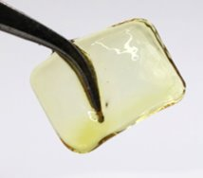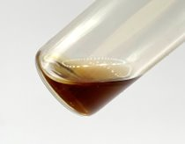
Figure S1. Photo of 370-nm cured material (left) and 427-nm photoreduced material (right).

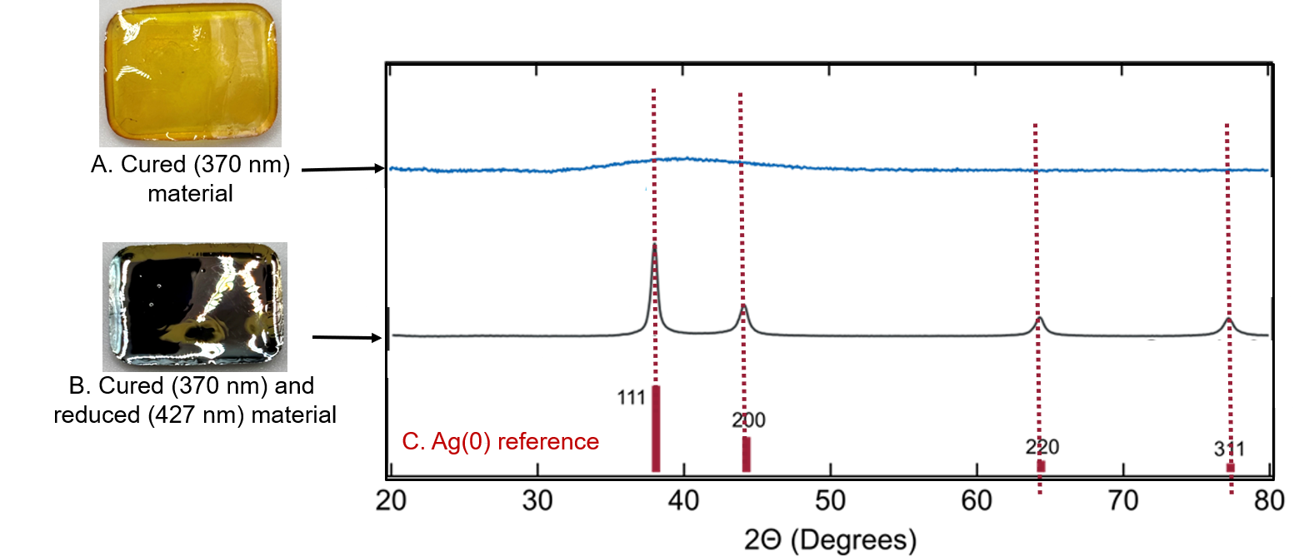
Figure S2. X-ray diffraction spectra of (A) 370-nm cured material, (B) 370-nm cured and 420-nm photoreduced material, (C) Ag(0) reference features.

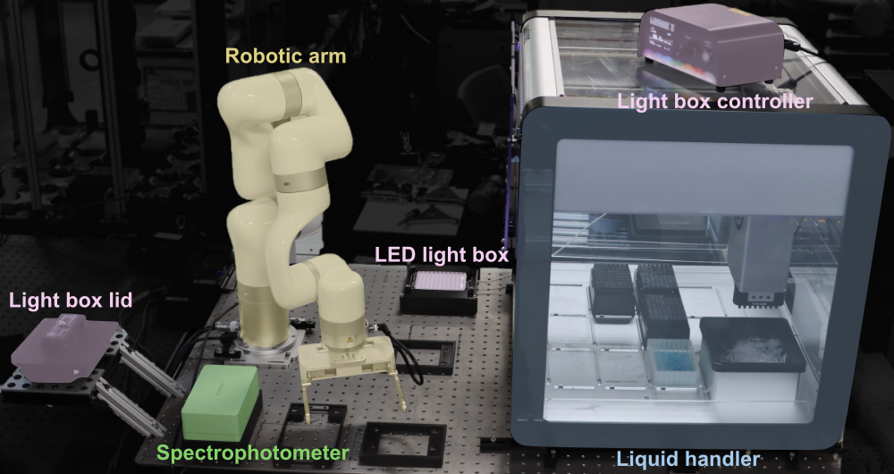Figure S3. Automation platform.

Method S1. Automated high-throughput monomer screening.
All platform elements were mounted onto a THORLABS B3036F Nexus Breadboard. Opentrons OT-2 Robot affixed with p300 pipette was used for resin formulation into Greiner Bio-One 96 Well UV-Star microplates. Pipette parameters were adjusted to accommodate the high viscosity monomers (15 µL/s flow rate, increased pause after aspiration and dispensing). Custom holders to facilitate automated transfer of well plates (well-plate stands, Byonoy stand, light box case, and light box lid) were 3D printed from polyethylene terephthalate glycol filament. 96 Well plates were irradiated with a 420-nm Lumidox II Led Array at 155 mW/cm² per well. Optical density at 400, 600, 700, and 900 nm was measured using a Byonoy Absorbance 96 Automate instrument. A UFACTORY xARM Robotic Arm affixed with a UFACTORY xARM Bio Gripper was used for transferring the well plates between the liquid handler, spectrophotometer, and light box to facilitate an autonomous procedure. The platform was controlled through a custom python script (supplementary files Automation_Loop.py and OT_Protocol.py).

Discussion S1. High-throughput screen result discussion
Ether functionality appeared to be beneficial to AgNP nucleation (cf. THFA, PEGDA, TMPETA performed well; replacement of ethereal monomers with MeCN, LA, or APOSS lead to poorer performance). This observation is consistent with reports that acridinium photocatalysts can react with ethers to facilitate oxidation and formation α-oxy radical cations, with a subsequent deprotonation to form α-oxy radicals.^{4,5} However, the presence of ether functionality does not fully explain the observed trends, as TMPTA demonstrated strong AgNP formation despite lacking ether groups. Therefore, we hypothesized that the rate of AgNP formation may also be impacted by highly coordinating monomers creating an efficient ligand-metal charge transfer pathway (nb. TMPTA, TMPETA performed well).⁶ Lastly, the significant increase in 600-nm absorbance seen in the formulations with MeCN, THFA, and HPA indicated that solution viscosity plays a large role in AgNP aggregation, as these formulations displayed the lowest viscosities in the series (Table S2). This hypothesis is supported by the highest viscosity monomers (APOSS, TMPTA, and TMPETA) having shown the least amount of change in 600-nm absorbance across the entire irradiation interval.

Table S3. Monomer screen structures and viscosities.
Abbreviation | Monomer | Viscosity (cP)
APOSS | AcryloPOSS | 5440 ± 30
TMPETA | Trimethylolpropane ethoxylate triacrylate | 81.7 ± 0.2
PEGDA | Poly(ethylene glycol) diacrylate Mn 575 | 71.32 ± 0.05
TMPTA | Trimethylolpropane triacrylate | 59.19 ± 0.12
TEGDMA | Triethylene glycol dimethacrylate | 8.41 ± 0.06
HPA | Hydroxypropyl  acrylate | 7.50 ± 0.05
HEMA | Hydroxyethyl methacrylate | 5.37 ± 0.07
HEA | Hydroxyethyl acrylate | 4.64 ± 0.03
THFA | Tetrahydrofuranyl acrylate | 4.61 ± 0.09
LA | Lauryl acrylate | 3.66 ± 0.12
PEGMEA | Poly(ethylene glycol) methyl ether acrylate | 1.01 ± 0.08
MeCN | Acetonitrile | 0.35³

Method S2. Actinometry
Experimental Set-up Photon flux for the quantum yield measurements was determined by potassium ferrioxalate actinometry using a 427 nm Kessil lamp. Potassium ferrioxalate actinometry and silver photoreduction were conducted using identical irradiation geometry. A custom 3D-printed holder positioned the masked sample vial at 45˚ relative to the incident light to reduce metallic plating on the surface of the vial, obstructing light penetration. A 10 mm aperture was defined as the illuminated region. The irradiation path length through the custom vial holder was 2 cm.
Ferrioxalate Actinometry A 0.15 M potassium ferrioxalate solution was prepared by dissolving 2.21 g of potassium ferrioxalate hydrate in 30 mL 0.05 M sulfuric acid. Buffered phenanthroline reagent was prepared by dissolving 50 mg of 1,10-phenanthroline and 11.25 g sodium acetate in 50 mL 0.5 M sulfuric acid. Both solutions were prepared in amber vials to prevent ambient light exposure. A 5 mL aliquot of ferrioxalate solution was irradiated for 10 s. 0.875 mL Buffered phenanthroline reagent was added and the mixture was stirred in the dark for 1 h to allow formation of the Fe²⁺-phenanthroline complex. A nonirradiated control was prepared and processed in parallel. Absorbance was measured at 510 nm using a 1 cm quartz cuvette. This analytical path length is distinct from the 2 cm irradiation path length.
Photon-flux Determination The moles of Fe²⁺ formed was determined from the -difference between the irradiated and control absorbances using the following Beer-Lambert relationship where V is the total developed volume, ΔA is the absorbance difference at 510 nm, l is the measurement cuvette pathlength and ε is 11,100 Lmol⁻¹cm⁻¹
$$n\left({Fe}^{2+}\right)=VΔA/(lε)$$
Photon flux was calculated using an actinometer quantum yield (Фact) of 1, 10 s irradiation time (t), and an absorbed-light fraction of unity (fact = 1), corresponding to complete absorption of incident 427 nm light by the actinometer.
$$Photon flux=n({Fe}^{2+})/(Фact)(t)(fact)$$
Silver Photoreduction and Apparent Quantum Yield The resin used for quantum-yield determination consisted of 3:1 HEMA:TEGDMA (v:v), 0.1 M AgTFA, and 0.3 mM acridinium photocatalyst. Following irradiation, silver was quantified by inductively coupled plasma mass spectrometry (ICP-MS) and compared with a non-irradiated control. The incident photon dose was calculated from the actinometry-derived photon flux. The apparent external quantum yield was calculated as the moles of silver reduced divided by the incident photon dose.
ICP-MS Following irradiation, samples were passed through a 0.1 µm syringe filter to remove particulate silver. The filtrate was diluted 20,000-fold gravimetrically using 2 weight % nitric acid. Silver was quantified using an Agilent 8900 ICP-MS with bismuth as the internal standard. ¹⁰⁷Ag and ¹⁰⁹Ag were monitored. Measurements were performed in triplicate. The decrease in silver concentration of the filtrate relative to nonirradiated control was used to determine the apparent extent of silver reduction.
$$\% Ag Reduction=\left(1-\frac{\left[{Ag}_{irradiated}\right]}{{[Ag}_{control}] }\right)(100)$$Apparent External Quantum Yield No correction was applied for the fraction of light absorbed by the reaction mixture, all incident photons were included in the denominator.
$n_{Ag reduced}=\left(fractional Ag reduction\right)[{Ag}_{initial}](sample volume)$
$$Ф_{apparent external}= \frac{n_{Ag reduced}}{(photon flux)(irradiation time)}$$

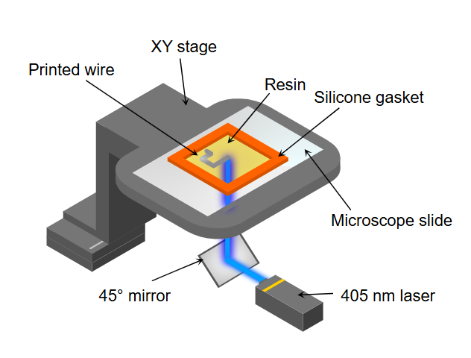
Figure S4. Laser printing apparatus. Laser spot size at the focal surface is 150 µm.

Table S4. Wire printing conditions and corresponding resistivity.
Number of Laser passes at 3 mm/s | Laser intensity at focal point (kW/cm²) | Total exposure^{ǂ} (kJ/cm²) | PC | Resistance (Ω) | Length between contacts (µm) | Cross-sectional area (µm²) | Resistivity (Ω∙m)
10 | 5.09 | 1.27 | Y | 42 | 8524 | 203.3 | 1.00 × 10⁻⁶
10 | 5.09 | 1.27 | Y | 29 | 8311 | 201.63 | 7.04 × 10⁻⁷
12 | 4.24 | 1.27 | Y | 45.9 | 10506 | 81.75 | 3.57 × 10⁻⁷
12 | 4.24 | 1.27 | Y | 18.7 | 10366 | 119.29 | 2.15 × 10⁻⁷
12 | 4.24 | 1.27 | Y | 43 | 9653 | 106.9 | 4.76 × 10⁻⁷
15 | 3.40 | 1.27 | Y | 35 | 9897 | 125.68 | 4.44 × 10⁻⁷
15 | 3.40 | 1.27 | Y | 36 | 10501 | 91.82 | 3.15 × 10⁻⁷
15 | 3.40 | 1.27 | Y | 24 | 9008 | 92.47 | 2.46 × 10⁻⁷
20 | 2.55 | 1.27 | Y | 13.8 | 11088 | 89.68 | 1.12 × 10⁻⁷
20 | 2.55 | 1.27 | Y | 15.5 | 10995 | 77.16 | 1.09 × 10⁻⁷
30 | 1.70 | 1.27 | Y | 37000000 | 7536 | * | -
30 | 1.70 | 1.27 | Y | 46000000 | 10943 | * | -
30 | 1.70 | 1.27 | Y | 63000000 | 10689 | * | -
60 | 0.85 | 1.27 | Y | 188000000 | 9159 | * | -
60 | 0.85 | 1.27 | Y | max | 9013 | * | -
60 | 0.85 | 1.27 | Y | max | 8602 | * | -
10 | 5.09 | 1.27 | N | 10900 | 11765 | 198.32 | 1.84 × 10⁻⁴
10 | 5.09 | 1.27 | N | 48000 | 11151 | 239.15 | 1.03 × 10⁻³
10 | 5.09 | 1.27 | N | 900000 | 11671 | 208.9 | 1.61 × 10⁻²
12 | 4.24 | 1.27 | N | 97 | 9441 | 110.44 | 1.13 × 10⁻⁶
12 | 4.24 | 1.27 | N | 24 | 11395 | 257.47 | 5.42 × 10⁻⁷
12 | 4.24 | 1.27 | N | 54000 | 11251 | 187.51 | 9.00 × 10⁻⁵
15 | 3.40 | 1.27 | N | 3000 | 9924 | 125.68 | 3.80 × 10⁻⁵
15 | 3.40 | 1.27 | N | 39000 | 9840 | 91.82 | 3.64× 10⁻⁴
15 | 3.40 | 1.27 | N | 1100 | 10064 | 92.47 | 1.01 × 10⁻⁵
20 | 2.55 | 1.27 | N | max | - | - | -
20 | 2.55 | 1.27 | N | 600000 | 9788 | 86.275 | 5.29 × 10⁻³
30 | 1.70 | 1.27 | N | max | - | - | -
30 | 1.7 | 1.27 | N | max | - | - | -
30 | 1.7 | 1.27 | N | max | - | - | -
60 | 0.85 | 1.27 | N | no wire | - | - | -
60 | 0.85 | 1.27 | N | no wire | - | - | -
60 | 0.85 | 1.27 | N | no wire | - | - | -
1 | 3.40 | 0.08 | Y | ** | - | - | -
1 | 3.40 | 0.08 | Y | ** | - | - | -
1 | 3.40 | 0.08 | Y | ** | - | - | -
2 | 3.40 | 0.17 | Y | ** | - | - | -
2 | 3.40 | 0.17 | Y | ** | - | - | -
2 | 3.40 | 0.17 | Y | ** | - | - | -
4 | 3.40 | 0.34 | Y | max | - | - | -
4 | 3.40 | 0.34 | Y | max | - | - | -
4 | 3.40 | 0.34 | Y | max | - | - | -
6 | 3.40 | 0.51 | Y | 36000000 | 11551 | 20.50 | 6.39 × 10⁻²
6 | 3.40 | 0.51 | Y | 106000000 | 10693 | 21.78 | 2.16 × 10⁻¹
6 | 3.40 | 0.51 | Y | 1600000 | 10823 | 22.04 | 3.26 × 10⁻³
8 | 3.40 | 0.68 | Y | 2900 | 7656 | 30.26 | 1.15 × 10⁻⁵
8 | 3.40 | 0.68 | Y | 39000 | 7526 | 29.31 | 1.52 × 10⁻⁴
8 | 3.40 | 0.68 | Y | 300000 | 9637 | 29.60 | 9.21 × 10⁻⁴
10 | 3.40 | 0.85 | Y | 134000 | 8452 | 40.34 | 6.40 × 10⁻⁴
10 | 3.40 | 0.85 | Y | 207000 | 8025 | 39.74 | 1.03 × 10⁻³
10 | 3.40 | 0.85 | Y | 70000 | 7469 | 40.41 | 3.79 × 10⁻⁴
15 | 3.40 | 1.27 | Y | 35 | 9008 | 125.68 | 4.88 × 10⁻⁷
15 | 3.40 | 1.27 | Y | 36 | 10501 | 91.82 | 3.15 × 10⁻⁷
15 | 3.40 | 1.27 | Y | 24 | 9897 | 92.47 | 2.24 × 10⁻⁷
20 | 3.40 | 1.70 | Y | 4.6 | 6662 | 136.92 | 9.45 × 10⁻⁸
20 | 3.40 | 1.70 | Y | 4.2 | 6455 | 164.19 | 1.07 × 10⁻⁷
20 | 3.40 | 1.70 | Y | 3.7 | 7495 | 154.29 | 7.62 × 10⁻⁸
1 | 3.40 | 0.08 | Y | no wire | - | - | -
1 | 3.40 | 0.08 | N | no wire | - | - | -
1 | 3.40 | 0.08 | N | no wire | - | - | -
2 | 3.40 | 0.17 | N | no wire | - | - | -
2 | 3.40 | 0.17 | N | no wire | - | - | -
2 | 3.40 | 0.17 | N | no wire | - | - | -
4 | 3.40 | 0.34 | N | ** | - | - | -
4 | 3.40 | 0.34 | N | ** | - | - | -
4 | 3.40 | 0.34 | N | ** | - | - | -
6 | 3.40 | 0.51 | N | ** | - | - | -
6 | 3.40 | 0.51 | N | ** | - | - | -
6 | 3.40 | 0.51 | N | ** | - | - | -
8 | 3.40 | 0.68 | N | max | - | - | -
8 | 3.40 | 0.68 | N | max | - | - | -
8 | 3.40 | 0.68 | N | max | - | - | -
10 | 3.40 | 0.85 | N | 190000000 | 7536 | 31.20 | 7.87 × 10⁻¹
10 | 3.40 | 0.85 | N | 32000000 | 8748 | 39.70 | 1.45 × 10⁻¹
10 | 3.40 | 0.85 | N | 186000000 | 9322 | 41.37 | 8.25 × 10⁻¹
15 | 3.40 | 1.27 | N | 3000 | 9924 | 71.10 | 2.15 × 10⁻⁵
15 | 3.40 | 1.27 | N | 39000 | 9840 | 87.39 | 3.46 × 10⁻⁴
15 | 3.40 | 1.27 | N | 1100 | 10064 | 62.16 | 6.79 × 10⁻⁶
20 | 3.40 | 1.70 | N | 18.5 | 8728 | 102.70 | 2.18 × 10⁻⁷
20 | 3.40 | 1.70 | N | 7.7 | 9559 | 104.38 | 8.41 × 10⁻⁸
8 | 3.40 | 0.68 | Y | 11000000 | 8035 | 15.56 | 2.13 × 10⁻²
8 | 3.40 | 0.68 | Y | 4800000 | 8212 | 15.94 | 9.32 × 10⁻³
10 | 3.40 | 0.68 | Y | 16400000 | 7801 | 16.37 | 3.44 × 10⁻²
10 | 3.40 | 0.85 | Y | 2000 | 7725 | 48.20 | 1.25 × 10⁻⁵
10 | 3.40 | 0.85 | Y | 532 | 7439 | 35.78 | 2.56 × 10⁻⁶
- indicates value was not collected or could not be calculated due to insufficient wire formation
Y indicates formulation included photocatalyst
N indicates formulation did not include photocatalyst
* indicates value could not be collected because significant polymerization occurred that would prevent an accurate measurement to be made
** indicates visible metal formation but no consistent wire (areas of discontinuity or defect visible)
^{ǂ} Total exposure = peak dwell time × laser intensity × number of laser scans

Method S3. Radiant Exposure Quantification
Dwell time was calculated using the following equation where t is peak dwell time, w is Gaussian beam waist (1/e² radius), and ν is scan speed.
$t ≈ \frac{w}{v}=\frac{0.075 mm}{3 mm/s}=0.025 s$
Surface radiant exposure with 1 laser scan was calculated using the following equation where I is irradiance and t is peak swell time
$$Surface radiant exposure=I ×t = \frac{5 kW}{{cm}^{2}}=125 J/{cm}^{2}$$
Laser intensity was calculated using the following equation where I is laser intensity, P is laser power in mW, and A is laser focal area based on a spot diameter of 150 µm
$$I= \frac{P}{A}= \frac{P}{1.77 ×{10}^{-4} {cm}^{2}}$$

Figure S5. Thermogravimetric Analysis of AgTFA under Air.

References
- Chung, K.; Page, Z.A. Boron-Methylated Dipyrromethane as a Green Light Activated Type I Photoinitiator for Rapid Radical Polymerizations. J. Am. Chem. Soc. 145, 17912-17918 (2023).
- Favarão, J.; de Oliveira, D.C.R.S.; Zanini, M.M.; Rocha, M.G.; Ogliari, F.A.; Correr-Sobrinho, L.; Sinhoreti, M.A.C. Effect of light attenuation through veneers on bond strength of adhesives with photoinitiator combinations. Braz. Oral Res. 10(36), e075 (2022).
- DeVito, S.C. Nitriles. Kirk-Othmer Encyclopedia of Chemical Technology. John Wiley & Sons, New York, NY (2007).
- Bell, J.D.; Robb, I.; Murphy, J.A. Highly selective α-aryloxyalkyl C–H functionalisation of aryl alkyl ethers. Chem. Sci. 13(43), 12921-12926 (2022).
- Romero, N.A.; Nicewicz, D.A. Organic Photoredox Catalysis. Chem. Rev. 116(17), 10075-10166 (2016).
- May, A.M.; Dempsey, J.L. A new era of LMCT: leveraging ligand-to-metal charge transfer excited states for photochemical reactions. Chem. Sci. 15(18), 6661-6678 (2024).

